An Option Model for Transactions in a Grid Environment

Version 0.1

About this document

This document introduces the concept of options and options clearing in a transaction model. It should give the reader the understanding of some fundamental challenges of transactions in grid environments and how the options model addresses them.

The document should be viewed as a verbose expression of the idea of options in transaction management. It does not provide the completeness and details of a specification.

Motivation

Problems addressed by conventional IT systems and the related technologies are being widely applied to grid systems. An exception seems to be transactions. Only few attempts have been done in this area, all more or less dealing with conventional transaction management technologies namely either distributed Two-Phase Commit (2PC) or plain compensation. Transactions are employed to transform a system from one consistent state to another [Haerder]). With distributed 2PC and with compensation you can principally achieve this goal. But why are these methods not applied to grid environments? The typical properties of a grid seem to be avoiding this.

- Resources are used very dynamically and with late binding. One can not tell which concrete resource is used at development time and usually not even at deployment time.
- Resources are shared very dynamically and to a large extent by multiple clients.
- A concrete resource can be integrated in and disintegrated from a grid very dynamically.
- There is typically no persistent legal relationship between client and resources. Instead ad-hoc legal relationships are established during runtime.

Distributed 2PC is most problematic in terms of resource sharing (Req. 2). This results in poor scalability, which is the opposite of what the grid promise is. The problem with plain compensation is the resource availability (Req. 3). Without a state in the resource regarding the transaction, a resource may just disappear during the transaction. This may prevent the required successful compensation operations. Another issue with compensation is that it does not always reflect what is happening in real world scenarios, where resources (e.g. a hotel room) is just reserved for a certain period of time, instead of being firmly booked from the beginning. The reservation will automatically expire if there is no confirmation message received in time. With plain compensation one would have had to firmly book the hotel room and then to cancel it, which would potentially involve some cost.

This does not imply that compensation cannot be used to manage transactions in grid scenarios. In contrary, compensation is the basis for modelling and managing long-running transactions and yet creates very scalable systems with regard to highly-concurrent resource usage. But there is something missing: Looking at the just mentioned hotel booking example there should be the concept of options as part of the transaction model as described in the following section.

Options Model for Transactions

Options
An option is a reservation of a resource bound to some condition. The typical condition is a time constraint: If the option is not confirmed within a certain period of time it will automatically expire. The option is not necessarily a reservation of the complete resource. E.g. as with the hotel reservation, the option for a room does not reserve the entire hotel, but rather a fraction (one room, no matter which one physically). To this extend options are very similar to Escrow [O’Neil 1991]. And in fact, Escrow could be the technology of choice for a resource manager to implement and support options.

From an application point of view options can be used for two basic reasons:
- To gather a set of resources required to accomplish a certain task.
- To reserve one or more sets of alternative resources and decide later which ones to confirm.

Option Clearing
From perspective of a resource manager (RM) an option it issues is a guarantee that the requested resource change will be committed in any case, as long as the requestor adheres to the confirmation rules, i.e. it sends the confirmation message in time. But what means “in time” and who decides that the message arrived in time? The clocks of the transaction participants are not synchronized, so the requestor and the RM might have a different opinion on this. Another issue is that the temporary outage of one of the resource managers must not break the entire transaction that also involved other RM.

An ad-hoc approach to solve this problem would be to use distributed 2PC for the confirmation phase. But as stated above, this would introduce scalability problems. For this purpose the options model introduces the concept of transaction clearing management, which will result in very scaleable (Req. 2) and fault-tolerant (Req. 3) transaction management. In this model the transaction monitor has an additional role; it is the option clearing manager (CM). There are three requirements for this concept to be applicable:
- All participants must agree on a common CM instance at least on a per-transaction basis. This agreement is performed at runtime (Req. 1).
- The RM must not drop an option without asking the CM, this includes also the options that have expired from the RM point of view.
- The CM must be highly-available.

This enables a confirmation process that does not involve the RM in a synchronous way. All the requester has to do is to ask the TM / CM to confirm a certain set of options. If the CM does not already have a message from a participating RM to drop one of the options it acknowledges this confirmation to the requestor. The CM may now proactively (and asynchronously to the requestor) inform the RMs that their issued options have been properly confirmed. If a RM concurrently had decided that its option has expired it must ask the CM if it can be dropped. The CM will only allow this if it has no confirmation record for this option. Otherwise the RM must confirm the option now.

In addition the RM may have the freedom to decide that an issued option should be dropped prior to the guaranteed expiration time for some business reasons. Since it will tell this decision to the CM (that will acknowledge it if no confirmation record is there) a later confirmation request sent by the requestor will be refused by the CM. This might be unpleasant for the requestor but it will always bring the transaction to a consistent end.

Finally the concept of CM does also provide a solution for Req. 4 (ad-hoc legal relationships between requestor and RM). The participants have agreed on a common trusted CM, which is a very similar principle to the certificate authorities used to validate certificates exchanged between parties. In principle the CM keeps track of and ensures the ad-hoc legal contracts between requestor and RM.

1-out-of-N Confirmation Groups
As mentioned above one reason for using options is to gather a set of alternative resources and to decide later which one to confirm. To support this usage the concept of 1-out-of-N confirmation groups is useful. The application will group all alternative options into a 1-out-of-N confirmation group and eventually confirms the group. The CM will then make sure that exactly one option out this group is confirmed while all others are cancelled.

Architecture
The architecture to support options is actually not different from the traditional distributed transaction architecture ([DTP 1991]). There are three roles:

- Application (transactional client, requestor of options)
- Transaction Manager (TM), which is also incorporating the clearing manager (CM) for options role.
- Resource Manager (RM, the issuer of options)

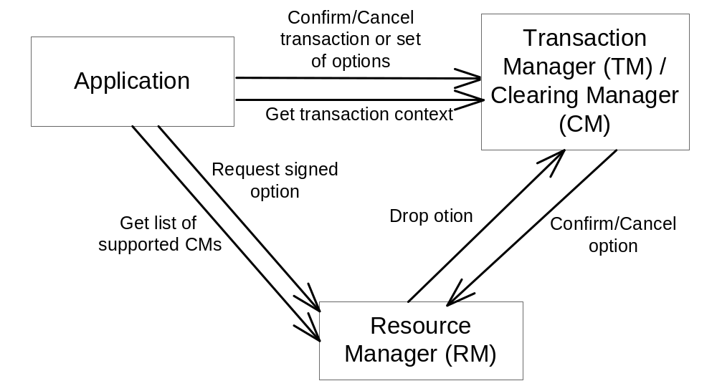

Protocols
The fact that the CM must always know which options have been dropped by the RM and which ones have been confirmed by the application imposes special requirements to the protocols between the architectural components of the options model for transactions.

Since the application and the RMs need to have a common CM they must perform an agreement protocol as a first step. The application could e.g. ask each RM that it intents to use for a list of supported CMs. It will then select a CM that is supported by all RMs and request a transaction context from it.

The application requests an option from RM via domain-specific protocol. With this request the transaction context is passed, which also includes information about the CM that issued this context. The RM returns the option signed with the public key of the CM. Using this procedure the application can gather a couple of options from the same or different RMs. One can imagine this option retrieval as a kind of agreement protocol as well.

The Application-2-RM protocol must allow:
- Application to retrieve list of supported CMs.
- Application to request an option (signed with secret key of RM).

Now the application wants to confirm the options. It communicates this to the CM, which will merely check that none of the given options for the given transaction context are known to be dropped by the issuing RM If this is not the case the CM will put the option to the list of confirmed options and successfully returns to the application. Asynchronously and with lower priority the CM will now work through the list of confirmed options and inform the RMs about the confirmations.

The CM-2-RM protocol must allow:
- RM to ask the CM to drop a certain option it has registered.
- CM to tell RM that a certain option has been confirmed or cancelled.

An extension to this concept is the 1-out-of-N confirmation group. The application can align its options in such groups that are optional parameters of the commit call to the TM/CM.

The Application-2-CM protocol must allow:
- Application to confirm a certain option explicitly.
- Application to open, commit or cancel a transaction.
- Application to pass 1-out-of-N confirmation groups with commit call.

Due to the signing with the secret key of the RM each party can authenticate the option which is relevant for legal proceedings.

Option States
The diagram below shows the semantic states of options. The state change can only be performed by the CM. E.g. the RM would like to consider an option it has issued as being expired. However it must confirm this first with the CM by asking it to drop the option before it can physically drop the option itself.

At a certain point in time the application and RM could have a different view of the option state than the CM:
- The CM informs the RM asynchronously that an option has been confirmed by the application.
- An application will realize that an option has been cancelled or expired by the RM only when it tries to confirm the option.

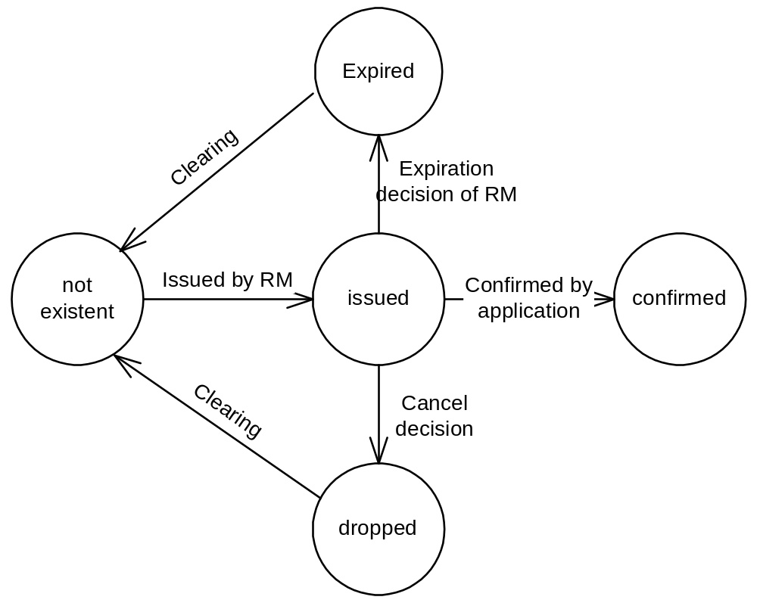

It is important to differentiate between the states expired and dropped. The RM can request the state change from “issued” to “expired” when the conditions of the option are not valid anymore, e.g. when the time the option has been granted for has expired. If the RM requests a state change to “dropped” while the conditions are still valid it is accountable for potential compensation fee since it broke its promise.

Use Cases

Travel Planning
A travel agent wants to book a travel to London including a flight and hotel. It requests a flight option from airline A for Monday and another flight option from airline B for Tuesday. Then the agent tries to get an appropriate hotel. But the only hotel option it can retrieve is for Tuesday. The travel agent now asks the CM to confirm flight option on airline B and the hotel option and to drop flight option on airline A.

At the same time another travel agent plans travel which includes requesting an option on flight B. The two options on the flight with airline A are granted concurrently.

Grid Resource Allocation
A Grid application requires 50 MIPS CPU, 100 MBit network bandwidth and 2 GB storage to perform a 3 hour task sometime between 7 and 11 am. A Grid infrastructure dynamically provisions these resources for the certain amount of time. At 6 am the application begins reserving these resources. First it gets an option for GPU 1 from 7 to 10 am. Next it is able to get an option for network A from 9 to 10 am. But then it could only get an option for 2GB storage from 8 to 11 am. So it now gets an option for CPU 2 and an option for network B from 8 to 11 am. Finally it confirms the options for storage, CPU 2 and network B and drops the option for CPU 1 and network A.

Limitations
It must be understood that this concept is suggested with regard to special requirements of Grid-like environments. It cannot replace in general concepts like distributed 2PC, where the application will notice if its transaction is in-doubt due to a RM failure just in between prepare and commit. This is because with distributed 2PC the entire coordination happens synchronously when the application requests the commit. Since the suggested options model has asynchronous coordination the application assumes that there is no in-doubt state. If a RM is temporarily unavailable for coordination by the CM the transaction is in-doubt only until the RM comes up again. If the RM does not come up at all it is considered legally accountable as if it had committed and later does not remember this.

Summary
The options model as proposed here addresses fundamental requirements of transaction management in grid environment. It provides for a high scalability and yet fault tolerant transactional systems. In addition it provides a solution for the missing legal relationships between the RM and application.

It is important to understand that options are not an alternative to compensation. Options are an extension to this in the sense that they are used in the context of a business transaction. Once an option is confirmed as part of this business transaction it can still be undone using traditional compensation. The proposed model eventually extends business transaction by the notion of options and option clearing.

References

[Haerder] Datenbanksystem, Konzepte und Techniken der Implementierung, Theo Härder, Erhard Rahm. Springer Verlag, ISBN 3-540-42133-5

[Gray/Reuter] Transaction Processing, Concepts and Techniques, Jim Gray, Andreas Reuter, Morgan Kaufmann

[DTP 1991] Distributed Transaction Processing: The XA Specification, 1991: http://www.opengroup.org/onlinepubs/009680699/toc.pdf

[O’Neil 1991] Escrow Promises, Patrick O’Neil, 1991: https://forge.gridforum.org/projects/tm-rg/document/EscrowPromises/en/1

Escrow .....

