Semantic Grid Research Group

Proceedings of the Global Grid Forum
Semantic Grid Research Group

Semantic Grid Workshop

held at the 9th Global Grid Forum

Chicago IL, USA

October 5, 2003

Edited by
David De Roure, Carole Goble
and Geoffrey Fox

www.semanticgrid.org

Contents

Using Semantic Concepts in the myGrid project | 1
Carole Goble, Chris Wroe, Phil Lord, Jun Zhao and Robert Stevens
Planning and Metadata on the Computational Grid | 12
Jim Blythe, Ewa Deelman and Yolanda Gil
Semantic Support for Grid-Enabled Design Search in Engineering | 25
Tao F., Chen L., Cox S.J., Shadbolt N.R., Puleston C. and Goble C.
Knowledge Discovery and Ontology-based services on the Grid | 40
Mario Cannataro
Publishing Semantic Descriptions of Services | 48
Luc Moreau, Simon Miles, Juri Papay, Keith Decker and Terry Payne
Interoperability of Grid Resource Descriptions: A Semantic Approach | 55
John Brooke, Kevin Garwood and Carole Goble
Interoperability Challenges in Grid for Industrial Applications | 63
Mike Surridge and David De Roure
Semantic Grid and Pervasive Computing | 70
David De Roure

Using Semantic Concepts in the ^{my}Grid project
Carole Goble, Chris Wroe, Phil Lord, Jun Zhao and Robert Stevens
University of Manchester, UK
carole@cs.man.ac.uk

Abstract
^{my}Grid is an e-Science pilot research project developing open source high-level middleware to support personalised in silico experiments in biology. In silico experiments use databases and computational analysis rather than laboratory investigations to test hypothesis. The project relies heavily on metadata that associates ontological concepts with its various middleware services in order to operate, interoperate and reason over them intelligently. Thus ^{my}Grid can be thought of as an early Semantic Grid project. In this paper we present ^{my}Grid, the semantic services and the various ways concepts drawn from ontologies are used or proposed to be used.

1. ^{my}Grid Motivation
^{my}Grid aims to develop open source high-level service-based middleware to support in silico experiments in biology. In silico experiments are procedures using computer based information repositories and computational analysis adopted for testing hypothesis or to demonstrate known facts. In our case the emphasis is on data intensive experiments that combine use of applications and database queries. The user is helped to create workflows (a.k.a. experiments), sharing and discovering others' workflows and interacting with the workflows as they run.
Rather than thinking in terms of data grids or computational grids we think in terms of Service Grids, where the primary services support routine in silico experiments. The intention is that the project's middleware services are a toolkit to be adopted and used in a `pick and mix' way by bioinformaticians, tool builders and service providers who in turn produce the end applications for biologists. The target environment is open, by which we mean that services and their users are decoupled. Services are not just used solely by their publishers but by users unknown to the service provider, who may use them in unexpected ways.
^{my}Grid focuses on speculative explorations by a scientistto form discovery experiments. These evolve with the scientist's thinking, and are composed incrementally as the scientist designs and prototypes the experiment. Intermediate versions and intermediate data are kept, notes and thoughts are recorded, and parts of the experiment and other experiments are linked together to form a network of evidence, as we see in bench laboratory books. We aim to collect, share and reuse:
- Experimental design components: workflow specifications; query specifications; notes describing objectives; applications; databases; relevant papers; the web pages of important workers, and so on.
- Experimental instances that are records of enacted experiments: data results; a history of services invoked by a workflow engine; instances of services invoked; parameters set for an application; notes commenting on the results and so on.
- Experimental glue that groups and links design and instance components: a query and its results; a workflow linked with its outcome; links between a workflow and its previous and subsequent versions; a group of all these things linked to a document discussing the conclusions of the biologist and so on.
Discovery experiments by their nature presume that the e-biologist is actively interacting with and steering the experimentation process, as well as interacting with colleagues (in the simplest case by email). [13] gives a detailed motivation for the project.
^{my}Grid has developed, together with its biologist stakeholders, a detailed set of scenarios for the examination of the genetics of Graves' disease, an immune disorder causing hyperthyroidism [9]. This case study is our test bed application, though we are also applying our services to investigations into Williams Syndrome and African sleeping sickness in cattle.
We have built an electronic laboratory workbench demonstrator application in NetBeans as a vehicle to experiment with our services: their functionality, their deployment and their interactions, and to crystallise our architecture [12]; [26] shows the workbench in action. In addition, Talisman is a third party application that is prototyping the use of our workflow components [10].
The ^{my}Grid middlewarefirstly prototyped with Web Services [4] but with an anticipated migration path to the Open Grid Services Architecture (OGSA) [15]. Figure 1 shows the layered middleware stack of services. The primary services to support routine in silico experiments fall into four categories:
- services that are the tools that will constitute the experiments, that is external third party services such databases, computational analyses, simulations etc, wrapped as web services.
- services for forming and executing experiments, that is: workflow management services [3], information management services, distributed database query processing [5]. ^{my}Grid regards in silico experiments as distributed queries and workflows. Data and parameters are taken as input to an analysis or database service; then output from these is taken, perhaps after interaction with the user, as input to further tools or database queries.
- services for supporting the e-Science scientific method and best practice found at the bench but often neglected at the workstation, specifically: provenance management [6] and change notification [8].
- semantic services for discovering services and workflows, and managing metadata, such as: third party service registries and federated personalised views over those registries [18,7], and ontologies and ontology management [11].
The final layer (e) constitutes the applications and application services that use some or all of the services described above.
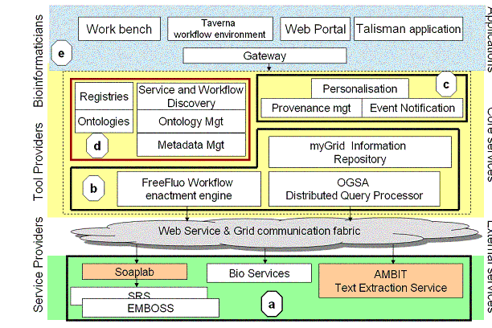
Figure 1: Figure 1: the myGrid services and middleware stack
Section 2 discusses how concepts are served into the ^{my}Grid architecture: the services ontology; the OWL ontology server, the RDF repositories, the reasoning engines and the instance store. Section 3 we tell how semantics are used to describe and discover workflows, services and data; control and validate workflow compositions and service substitutions; annotate workflow execution provenance logs and information repository entries, and link these using reasoning over the annotations. We show that concepts can be used as `glue' to link experiments and experimental components together. We briefly summarise in section 4.

2. Concept Services
^{my}Grid uses a suite of ontologies to represent metadata. Ontologies provide a consensual vocabulary of terms or concepts used descriptions associated with objects such as services, workflows or data; objects are said to be `annotated' with terms. Using free text to describe service, for example, is expressive and flexible, but difficult to search, to reason over, or to automatically organize into classifications. Controlled vocabularies consensually agreed to by a community, give a consistent way to bridge the communication gap between suppliers of items and (potential) consumers.
Ontologies organize the concepts or terms into a classification structure. Other relationships and axioms capture and constrain the properties of the concept. Our ontologies are expressed in DAML+OIL [23], and are subject to a migration to its successor suite of languages OWL [24], the W3C candidate recommendation for a web ontology language.
DAML+OIL (and OWL DL) provides: (a) a means of building concept classifications; (b) a vocabulary for expressing concept descriptions and (c) a reasoning process to both manage the coherency of the classifications and the descriptions when they are created, and the querying and matching when they are deployed. Both DAML+OIL and OWL build upon existing Web standards, such as XML and RDF, and are underpinned by an expressive Description Logic (DL). It is these formal semantics that enable machine interpretation and reasoning support, see [11] for more details. Our key concept services are:
Ontology services An Ontology Server provides a single point of reference for DAML+OIL/OWL concepts. Description logic reasoning of concept expressions is by means of the FaCT Reasoner. A Matchmakermatches query concept descriptions against those in the ontology to find those concepts that are subsumed by (are more specialised) or subsume (are more general) than the query concept. In DLs the query language and the description language are unified, such that you describe the object you want to find (be it concept or instance) and classify it; we then use this classification lattice to explore potential answers to this and more general or specific questions. An Instance Store uses this active concept classification as a sophisticated yet efficient index to a large set of instances held in a database or registry elsewhere. The instance store supports inexact queries i.e. instances are recovered that are not exactly the same as the concept query but are inferred to be included as members of that concept.
Annotation components ^{my}Grid uses semantic web annotation tools such as COHSE to capture annotations. RDF is used as a graph-based model to link resources with OWL concepts, with other URI or LSID identified resources, and with XML Schema data types such as literals. Life Science Identifiers [19] are persistent, location-independent, resource identifiers for uniquely naming biologically significant resources including but not limited to individual genes or proteins, or data objects that encode information about them. We have adopted LSIDs as a unique naming scheme for data objects in external databases as well as objects in our own Information Repository.
The use of semantic web technology such as ontology services and semantic annotation tools makes ^{my}Grid an early example of a `Semantic Grid' [16].

3. Using Concepts in ^{my}Grid
Concepts drawn from the ^{my}Grid ontology are used in several ways.

3.1 Semantic discovery of services and workflows
Much of e-Science depends on pooling, discovering and reusing experimental design components, or even experimental instances. We make no distinction, from the scientist's point of view, between Web or Grid services such as databases, simulations or analysis tools, and the workflows that orchestrate them: they both take inputs and outputs and they both have a function to perform as well as other metadata [20]. Our FreeFluo workflow enactment engine [3] supports two XML workflow languages, one based on IBM's Web Service Flow Language and our own, XScufl, developed as part of the Taverna project, in collaboration with the Human Genome Mapping Project [14]. Workflow templates represent the type or class of service that should be invoked at different stages without specifying a specific instance of the service. To use a workflow template, the abstracted service representations need to be instantiated by available services. Generating enactable workflows from abstracted workflow templates, through the use of service discovery and semantic reasoning, is described in detail in [20].
Services and workflows are published in a federated registry [ref]. We support the UDDI API; however, our registry has been underpinned with a flexible RDF storage component which enables it to support additional metadata. Semantic descriptions in RDF and DAML+OIL attached to registry entries to allow more precise searching by both people and machines. The RDF descriptions cover metadata regarding the operational characteristics of the services or workflows (location, cost, quality of service, availability and so on) that are queried using RDQL. Queries such as `what services offering x currently give the best quality of service?' or `which service would the local bioinformatics expert suggest we use?' involve searching on properties provided by third parties (users, organizational administrators, domain experts, independent validating institutions, etc.) either as opinion, observable behaviour or previous usage. Such metadata might vary from user to user. Thus our registries support third party metadata and multiple semantic descriptions.
DAML+OIL descriptions for the inputs, outputs and function of the registry entries, are based on the DAML-S service profile ontology [25], and queried using the ontology services. Again, a service may attract multiple descriptions reflecting different interpretations of an entry, in particular services that are polymorphic depending on their parameters. For example, seqret service reads and writes (returns) nucleotide sequences; however, depending on the inputs, outputs and configuration it can be a service for extracting sequences from databases; displaying sequences; reformatting a sequence; producing the reverse complement of a sequence; simple extraction of a region of a sequence or a simple sequence beautification utility. Parameterised polymorphic services require multiple semantic descriptions.
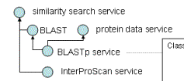
Class (BLASTpService complete WebService
restriction (input someValuesFrom (Protein))
restriction (usesSomeResource someValuesFrom
(protein sequence database))
restriction (isFunctionOf someValuesFrom (BLAST))
Figure 2: Using a classification to discover classes of services to fulfil the task, and a service description concept.
Figure 2 shows an extract of such a service classification and an example of a DAML+OIL/OWL class description used to calculate the hierarchy (in abstract OWL syntax).
The scientist interacts with, personalises and chooses services, workflows and data through a workbench. This workbench acts as a client to two components used for the discovery of workflows, and services that can instantiate parts of a workflow. Discovery components take advantage of the richer metadata within the registry view to enable more sophisticated semantic discovery.
- The personalised view component provides the scientist with a way to personalise the description of services by attaching third-party metadata [7]. The view component draws service descriptions from global or local service registries into a unified RDF based framework and provides the user with functions for attaching metadata to those service descriptions and querying over the metadata. This allows scientists to attach their own recommendations in the form of local service metadata, which can be acted upon during workflow resolution.
- The semantic find component caters for conceptual metadata expressed in DAML+OIL. Thus the registry can use ontology-based indexing of its service and workflow entries against an evolving classification and so assist the process of resolving service classes to service instances. So we can find services and workflows by the types of inputs they use, outputs they produce, and the bioinformatics tasks they perform.
Figure 3 shows a workflow discovery wizard making use of the semantic find component, to find relevant services and workflows in the ^{my}Grid registry that operate on data of a specific semantic type (here an Affymetrix probe set identifier). A registry browser is also available in the workbench to allow the user to browser more freely for a workflow or service using a hierarchical categorisation based on each individual semantic description.
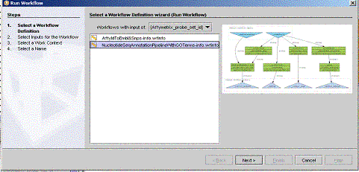
Figure 3: Workbench Workflow Wizard

3.2 Semantic workflow construction: guidance and validation
The construction of workflows by the bioinformatician is guided by constraining the choice to those services, which have semantically compatible inputs and outputs. The semantic type of the output data from a workflow or service constrains the input data of the succeeding step. For example, if the first step produces a set of protein sequence records, the next stage must accept inouts that are classified as a set of protein sequence records, such as a SWISS-PROT record entry or a PIR database entry. The semantic find components are being incorporated into the Taverna workflow development environment. In fact workflow resolution and harmonisation is more complex than this as described in [20].

3.3 Semantic discovery and gluing together of repository elements
The ^{my}Grid Information Repository (mIR) acts as a personalised store of all information relevant to a scientist performing an in silico experiment. It implements an information model tailored to e-Science. Experimental data is stored together with provenance records of its origin. The mIR has also been designed to store information about people and projects both directly linked to the investigation and from the wider scientific community to aid collaboration.
Metadata storage is a central feature of the mIR, with annotation possible for all internally stored objects in addition to objects stored in disparate remote repositories. Annotations are currently stored in an RDF triple like manner. We are considering the use of off the shelf RDF triple stores such as the Jena Semantic Web toolkit [22], which we already use for the registry. Several types of annotation are used. Free-text notes of the object's significance with respect to the investigation, the hypothesis of the experiment, thoughts and opinions by the scientist and quality of results are stored as XML in the mIR or as regular web documents. All mIR entries may have DAML+OIL ontology annotations of what the object represents, and must have provenance attributes regarding who created it, when, in what context, and so on. These annotations answer questions such as `what recent workflows were run by Dr. Pearce using BLAST', `what workflows have been recently run by members of my project?' and `What other workflows can operate over this kind of data?' (as in Figure 3).
^{my}Grid makes liberal use of ontologies to annotate, discover and manage its various components. Together with the LSIDs that identify mIR entries, the DAML+OIL concepts associated with mIR entries and the RDF graphs linking concepts and LSIDs, form the experimental glue we talked about in section 1. We are trying to build a web of related pages relevant to an experimental investigation, marked up with, and linked together using annotations drawn from shared ontologies (see Figure 4). This web includes not only the provenance record of a workflow run but also links to other provenance records of other related or unrelated workflow runs, diagrams of the workflow specifications, web pages about people who ran the workflow or have related study in provenance, literatures relevant to provenance study, notes of the experiment and so on. This is the idea behind a `web of science' as proposed in [21].
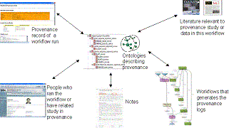
Figure 4: A Web of Experimental Holdings connected through shared concepts forming semantic glue
An organisation would typically have a single mIR, which would be shared by many users, each using it to store their own provenance, data and metadata. Different users can be provided with different views of the information it contains. These types of views can be built by exploiting the rich metadata associated with each object. Not only can views be constructed based on user but ^{my}Grid also aims to provide views based on criteria such as experiment, project and subject topic.

3.4 Semantically annotating and linking workflow provenance logs
When a workflow is executed, FreeFluo generates provenance logs in the form of XML files, recording the start time, end time and service instances operated in this workflow. Data, metadata about the workflow and the provenance logs are stored in the mIR. By annotating provenance logs with concepts drawn from the ^{my}Grid ontology, we can dynamically generate a hypertext of provenance documents, data, services and workflows based on their associated concepts and reasoning over the ontology by using the COHSE (Conceptual Open Hypermedia Services Environment) system. See [17] for details of how we annotate these logs.
The concepts lymphocyte and neutrophil are both subsumed by the concept white blood cell in the Domain Ontology. Figure 5 shows a provenance document (left) that includes an input to the service AffyMetrixMapper that is a ProbeSetId that has been annotated by the concept lymphocyte. When the scientist clicks on the annotation icon (a `C' icon) next to the link anchor, the links that are generated are to other documents that also annotated as lymphocyte. The `More General Links' refer to other documents labelled with subsuming concepts, here white blood cell. On (right), a link anchor is generated for the subsuming concept (white blood cell). Links to documents annotated with more specific concepts (lymphocyte and neutrophil) are displayed as `More specific Links' in the popup window.
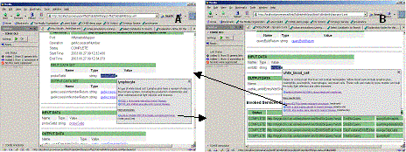
Figure 5: Generated links between provenance documents
Figure 6 shows that other kinds of documents can be annotated and linked into the provenance logs with the help of the Generic Ontology. The web page of the Institute of Human Genetic in the University of Newcastle is linked to the provenance logs based on the common annotated concept Human Genetics. Also links to some other human genetics related literatures are provided for the Human Genetics link anchor.
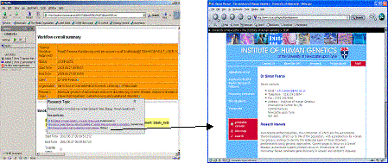
Figure 6: Generated links between provenance documents and other kinds of documents
These two figures also demonstrate different views of linking between documents due to different ontologies applied for conceptual linking. As introduced above, we used two ontologies in this project. By choosing one ontology for conceptual linking each time, different link anchors are recognized by the Linking Service in COHSE and different target links are provided for different concepts.

4. Summary
Semantic web technologies such as annotation, discovery and ontology services are still at an early stage of development. Current ^{my}Grid prototypes have been useful in crystallising requirements for semantics within e-Science and specifically how those semantics are integrated into ^{my}Grid components. The next phase of the project will aim to deliver more robust semantic components tailored to this environment, and to evaluate the utility of the approaches.

Acknowledgements
This work is supported by the UK e-Science programme EPSRC GR/R67743, & DARPA DAML subcontract PY-1149, Stanford University.

References
- Proceedings UK OST e-Science 2nd All Hands Meeting 2003, Nottingham, UK 2-4 Sept, 2003
- M Senger, P. Rice T Oinn, Soaplab - a unified Sesame door to analysis tools in [1]
- M Addis, T Oinn, M Greenwood, J Ferris, D Marvin, P Li, A Wipat Experiences with eScience workflow specification and enactment in bioinformatics in [1]
- S Parastatidis, P Watson The NEReSC Core Grid Middleware in [1]
- MN Alpdemir, A Mukherjee, NW Paton, P Watson, AAA. Fernandes, A Gounaris, J Smith Service-Based Distributed Query Processing on the Grid in [1]
- R Stevens, M Greenwood, CA Goble, Provenance of e-Science #Experiments - experience from Bioinformatics in [1]
- P Lord, C Wroe, R Stevens, CA Goble, S Miles, L Moreau, K Decker, T Payne, J Papay, Semantic and Personalised Service Discovery in Proceedings IEEE/WIC International Conference on Web Intelligence / Intelligent Agent Technology Workshop on "Knowledge Grid and Grid Intelligence" October 13, 2003, Halifax, Canada
- L Moreau, X Liu, S Miles, A Krishna, V Tan, R Lawley ^{my}Grid Notification Service in [1]
- R Stevens, K Glover, C Greenhalgh, C Jennings, P Li, M Radenkovic, A Wipat. Performing in silico Experiments on the Grid: A Users Perspective in [1]
- T Oinn Talisman - Rapid Application Development for the Grid in Proceedings of Intelligent Systems in Molecular Biology, Brisbane Australia, July 2003
- C Wroe, R Stevens, CA Goble, A Roberts, and M Greenwood. A suite of DAML+OIL ontologies to describe bioinformatics web services and data. In International Journal of Cooperative Information Systems, 12(2):197-224, March 2003.
- R Stevens, A Robinson, and CA Goble ^{my}Grid: Personalised Bioinformatics on the Information Grid, in Proceedings of Intelligent Systems in Molecular Biology, Brisbane Australia, July 2003
- CA Goble, S. Pettifer, R. Stevens and C. Greenhalgh Knowledge Integration: In silico Experiments in Bioinformatics in The Grid: Blueprint for a New Computing Infrastructure Second Edition (eds. I Foster and C Kesselman), 2003, Morgan Kaufman, in press
- Taverna workflow environment for bioinformatics: http://sourceforge.net/projects/taverna
- D Talia, "The Open Grid Services Architecture - Where the Grid Meets the Web", IEEE Internet Computing, vol. 6, no. 6, pp. 67-71, 2002.
- Goble and D De Roure Semantic Grid: An Application of the Semantic Web in ACM SIGMOD Record, 31(4) December 2002
- J Zhao, CA Goble, M Greenwood, C Wroe, R Stevens Annotating, linking and browsing provenance logs for e-Science in 2nd Intl Semantic Web Conference (ISWC2003) Workshop on Retrieval of Scientific Data, Florida, USA, October 2003
- S Miles, J Papay, V Dialani, M Luck, K Decker, T Payne and Luc Moreau. Personalised Grid Service Discovery. Performance Engineering. 19th Annual UK Performance Engineering Workshop. pp131-140, 2003
- The Life Science Identifier http://www.i3c.org
- C Wroe, CA Goble, M Greenwood, P Lord, S Miles, L Moreau, J Papay, T Payne, Experiment automation using semantic data on a bioinformatics Grid submitted to IEEE Intelligent Systems
- J Hendler Science and The Semantic Web, Science, Jan 24, 2003.
- Jena Semantic Web Toolkit http://www.hpl.hp.com/semweb/jena.htm
- Horrocks DAML+OIL: a reason-able web ontology language. In Proc. of EDBT 2002, March 2002.
- OWL Web Ontology Language Overview. http://www.w3c.org/TR/owl-features/
- The DAML Services Coalition (alphabetically Anupriya Ankolenkar, Mark Burstein, Jerry R. Hobbs, Ora Lassila, David L. Martin, Drew McDermott, Sheila A. McIlraith, Srini Narayanan, Massimo Paolucci, Terry R. Payne and Katia Sycara), "DAML-S: Web Service Description for the Semantic Web", The First International Semantic Web Conference (ISWC), Sardinia (Italy), June, 2002.
- Goble CA, Wroe C, Stevens R, and the ^{my}Grid consortium The ^{my}Grid project: services, architecture and demonstrator in [1]

Planning and Metadata on the Computational Grid
Jim Blythe, Ewa Deelman and Yolanda Gil
USC Information Sciences Institute
{blythe,deelman,gil}@isi.edu

Abstract
Grid computing provides key infrastructure for distributed problem solving in dynamic virtual organizations. It has been adopted by many scientific projects, and industrial interest is rising rapidly. However, grids are still the domain of a few highly trained programmers with expertise in networking, high-performance computing, and operating systems. We have been working in capturing knowledge and heuristics about how to select application components and computing resources, and using that knowledge to generate automatically executable job workflows for a grid. Our system is implemented and integrated with a grid environment where it has generated dozens of workflows with hundreds of jobs in real time. In order to be applicable to a wide range of existing and new grid applications, the planner needs to be able to work with varying levels of semantic information for processes and the information they consume and create. We discuss our experiences dealing with different levels of data and describe a planning-based system that can provide different levels of support based in the information available.

1. Introduction
Once the realm of high-performance computing for scientific applications, grid computing is arising as key enabling infrastructure for resource sharing and coordinated problem solving in dynamic multi-institutional virtual organizations (Foster et al. 01). Grids build over networking technology to provide middleware components such as locating files over a network of computers, scheduling the distributed execution of jobs, and managing resource sharing and access policies (Foster and Kesselman 99). The need of scientific communities to interconnect applications, data, expertise, and computing resources is shared by other application areas, such as business, government, medical care, and education (Foster et al. 02, Waldrop 03).
Unfortunately, grid computing is today far from reach from regular computer users. Users interact with grids by sending a specification in the form of a detailed executable script of which jobs should be run on which computers using which physical files and sometimes the specific scheduler in the host computer where jobs are to be submitted for execution. We believe that this need not be so. Our work aims to develop intelligent middleware components that encapsulate the expertise required to use grids. In (Blythe et al. 03a), we outlined the use of AI planning techniques to automatically generate executable job workflows from high-level specifications of desired results. In (Blythe et al. 03b) we described the knowledge and heuristics used in the system and how the planner is integrated within a grid environment to extract relevant knowledge from existing grid middleware.
Although grid environments form the application domain for this work, it has broad applications for composition of web services. Indeed, many grid toolkits are now adopting the Open Grid Services Infrastructure (Foster et al. 02) in which grid services are versions of web services. The issues of semantic descriptions of component and data information used in planners discussed in this paper are highly relevant in both domains.
One of the applications where we have used this approach is the Laser Interferometer Gravitational Wave Observatory (LIGO, <>http://www.ligo.caltech.edu) aimed at detecting gravitational waves predicted by Einstein's theory of relativity. The planner can be given the high-level goal of making a pulsar search in certain areas of the sky for a time period. It has been used to generate workflows for 58 pulsar searches, scheduling over 330 jobs and over 460 data transfers, consuming over eleven CPU hours on resources distributed over the Grid.
Our solution for LIGO used semantic characterizations of the processes in the workflow and of the files they require and produce in order to compose the workflow automatically. However, some benefits of AI planning and scheduling can be realised in domains where such characterizations are not yet available. Moreover, greater improvements in efficiency are possible with semantic characterizations of information that can describe related groups of files, or that can be realized by any one of a group of files. In this paper we explore these benefits and describe a planning-based solution that can provide incremental payoff with the level of semantic information about a problem domain on the computational grid.
We start outlining some of the challenges of using the Grid today and the benefits of our approach. We then show the kinds of knowledge available in current Grid infrastructure and capabilities using as an example the specific Grid environment we used for the LIGO application. We describe the system that we have developed, how it extracts the knowledge available in the current Grid and uses it to generate complete executable workflows, and how the workflows are translated into the scripting language required by the Grid environment. We finalize with a discussion of our future work and the potential of AI technology for Grid computing.

2. Motivation
Scientists often seek specific data products, which can be obtained by configuring available application components and executing them on the Grid. As an example, suppose that the user's goal is to obtain a frequency spectrum of a signal S from instrument Y and time frame X, placing the results in location L. In addition to these stated desired results, the user may have additional requirements on intermediate steps. For example, the user may want the results of any intermediate filtering steps to be available in location I, perhaps to examine the filter results to check for unusual phenomena.
Today, users have to transform this kind of high-level requirement into a workflow of jobs that can be submitted for execution on the Grid. Each job must specify which files contain the code to be run, selected by mapping the high level requirements above to available application components (e.g., a Fast Fourier Transform coded by Caltech's group, version 3.0 or higher) and selecting a physical file from the many available replicas of the code in various locations. The job also specifies the location (or host) where it should be run, based on the code requirements (e.g., code is compiled for MPI, parallelized to run on tightly-coupled architecture, preferably with more than 5 nodes) and on user access policies to computing and storage resources. An executable workflow also includes jobs to move input data and application component files to the execution location.
Although Grid middleware allows for discovery of the available resources and of the locations of the replicated data, users are currently responsible for carrying out all of these steps manually. There are several reasons why automating this process is not only desirable but necessary:
- Usability: Users are required to have extensive knowledge of the Grid computing environment and its middleware functions. For example, the user needs to query the Replica Location Service (RLS) (Chervenak et al. 02a) to find the physical locations of input data files.
- Complexity: In addition to requiring scientists to become Grid-enabled users, the process may be complex and time consuming. The user must make many choices when alternative application components, files, or locations are available. The user may reach a dead end where no solution can be found, which would require backtracking to undo some previous choice.
- Solution cost: Lower cost solutions are highly desirable in light of the high cost of some of the computations, the user's limitations in terms of resource access and bandwidth variability. Because finding any feasible solution is already time consuming, users are unlikely to explore alternative workflows that may reduce execution cost.
- Global cost: Because many users are competing for resources, it is desirable to minimize cost within a community. This requires reasoning about individual user's choices in light of other user's choices, such as possible common jobs that could be included across workflows and executed only once. In addition, policies that limit user's access to resources should be taken into account in order to accommodate as many users as possible while they are contending for limited resources.
- Reliability of execution: In today's Grid framework, when the execution of a job fails the job is resubmitted for execution on the same resources. Better recovery mechanisms would be desirable that consider alternative resources and components as the grid changes.
While addressing the first three points would enable wider accessibility of the Grid to users, the latter two simply cannot be handled by individual users and will likely need to be addressed at the architecture level.
Our approach is twofold. First, we use declarative representations of knowledge involved in each choice of the workflow generation process. This includes knowledge about how application components work, characteristics and availability of files, capabilities of the resources available, access control policies, etc. Second, this knowledge is uniformly available to the system at any point during workflow generation. This allows the system to make decisions and assignments in a flexible manner that
- takes into account previous and future choices, searching for a low-cost workflow configuration that satisfies the requirements from the user,
- is feasible in the given execution environment, and
- can adapt to changes in the overall system state.
In our approach, users provide high level specifications of desired results, as well as constraints on the components and resources to be used. These requests and preferences are represented in the knowledge base. The Grid environment contains middleware to find components that can generate desired results, the input data that they require, to find replicas of component files in specific locations, to match component requirements with resources available, etc. The knowledge currently used by Grid middleware (resource descriptions, metadata catalogs to describe file contents, user access rights and use policies, etc) would also be incorporated in the knowledge base. The system would generate workflows that have iteratively add details to the workflow based on the execution of the initial portions of it and the current state of the execution environment.
Much knowledge concerning descriptions of components, resources and the system's state is available from a variety of Grid middleware, as we describe in the next section. However, one must be an experienced Grid user to run jobs on the Grid, which means that much additional knowledge needs to be represented about what terms mean and how they related to one another. For example, an application component may be available in a file where it has been compiled for MPI. MPI is a Message Passing Interface, which means that the source includes calls to MPI libraries that will need to be available in the host computer where the code is to be run. Even a simple piece of Java code implies requirements in the execution host, namely that the host can run JVM (Java Virtual Machine). Our contribution is to organize this knowledge and reason about it within a uniform framework.

3. Overview of the Grid environment
Grid environments, such as Globus (Globus 02), include middleware services that enable users to obtain information about the resources available, component software, data files, and the execution environment. This section describes several of these services, which we have used as sources of knowledge for our system. More details can be found in (Deelman et al 03a; Deelman et al 03b).
Data files can also be replicated in various locations. Each file has a description of its contents in terms of application-specific metadata. A distinction is made between `logical' file descriptions, which uniquely identify the application component or data, and `physical' file descriptions, which in addition uniquely specify the location and name of a specific file. The Metadata Catalog Service (MCS) (Chervenak et al. 02b) responds to queries based on application-specific metadata and returns the logical names of files containing the required data, if they already exist. Given a logical file name that uniquely identifies a file without specifying a location, the Replica Location Service (RLS) (Chervenak et al. 02a) can be used to find physical locations for the file on a grid.
The grid execution environment includes computing and storage resources with diverse capabilities. A specific application may require (possibly indicated in its metadata description) a certain type of resource for execution, for example the existence of certain number of nodes to efficiently parallelize its execution. Executing applications with minimal overhead may require specifying which of the job queues available in the host is more appropriate. The Monitoring and Discovery service (MDS) (Czajkowski et al 01) allows the discovery and monitoring of resources on the grid. Resource matchmakers find resources appropriate to the requirements of application components.
Jobs that are completely specified for execution are sent to schedulers that manage the resources and monitor execution progress. Condor-G and DAGMan (Frey et al. 01) can be used to request a task to be executed on a resource. Condor-G adds an individual task to a resource's queue, while DAGMan can manage the execution of a partially-ordered workflow by waiting for a task's parents to be completed before scheduling a task.
Given that the planning system decides for the user where to generate the data and what software and input files to use, it is very important to provide the user and others accessing this derived data with its provenance information, or how the data arrived at its current form. To achieve this, we have integrated our system with the Chimera Virtual Data System (Annis et al. 02). Our system generates a Virtual Data Language description of the products produced in the workflow. Chimera uses this description to populate its database with the relevant provenance information.

4. Scenario: LIGO pulsar search
Our techniques are general, but we have applied them in the context of the Laser Interferometer Gravitational Wave Observatory (LIGO), and we use this application to illustrate the work. We have focused on a specific LIGO problem: pulsar search, shown in Figure 1, where grid resources are required to search for evidence of gravitational waves possibly emitted by pulsars. The data needed to conduct the search is a long sequence (~4 months, 2x1011 points) of a single channel. The output from the observatory is in small segments of many channels, perhaps 4x105 on each side. The pulsar search looks for coherent signals in this image.
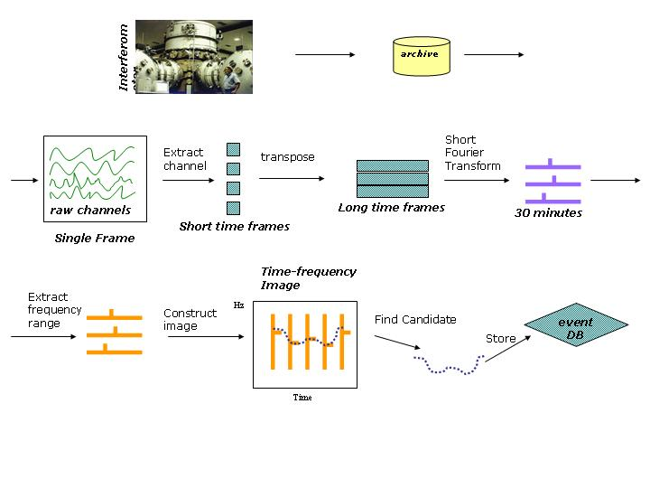
Figure 1: LIGO search.
The pulsar search is both computation and data intensive and requires more resources than those available within the LIGO Scientific Collaboration. In order to take advantage of the Grid resources, LIGO's existing analysis tools were integrated into the Grid environment. The pulsar search conducted at SC 2002 used LIGO's data collected during the first scientific run of the instrument and targeted a set of 1000 locations of known pulsars as well as random locations in the sky. The results of the analysis were made available to LIGO scientists through the Grid.

5. Modeling the task as a planning problem
The problem of assigning a set of coordinated tasks in a workflow and allocating the tasks to available resources is formulated as an AI planning problem as follows. Each application component that may take part in the workflow is modeled as a planning operator. The effects and preconditions of the operators reflect two sources of information: data dependencies between the program inputs and outputs, and resource constraints on the programs, both hardware and software required to run them.
The planner imposes a partial order on the tasks that is sufficient for execution because it models their input and output data dependencies: if the prerequisites of a task are completed before the task is scheduled, then the information required to run the associated program will be available. File transfer across the network is also modeled with a planning operator, accounting for any required data movement. The data dependencies between tasks are modeled both in terms of metadata descriptions of the information and in terms of files used to represent the data in the system. Metadata descriptions, for example a first-order logic predicate that denotes the result of a pulsar search in a fixed point in the sky across a fixed range of frequencies and at a fixed time, allow the user to specify requests for information without specific knowledge of programs or file systems, with the planner filling in the details of the request. Since the operators also model the files that are created and used by a program, the planner knows how the information is accessed and stored. It can then reason about how tasks can share information, and plan for moving information about the network. The planner's representation of information and files is kept up to date with the state of the Grid, so that its plans are both efficient and directly executable, as we describe below.
The planning operators also model constraints on the resources required to perform the desired operations. Hardware constraints may include a particular machine type, minimum physical memory or hard disk space available, or the presence of a certain number of nodes in a distributed-memory cluster. Software constraints may include the operating system and version, the presence of scheduling software on the host machine and the presence of support environments, for example to run Java. In our work on the LIGO scenario, it was sufficient to model requirements on the scheduling software present, because of the close relationship between the software and the hardware configurations of the machines involved.
The initial state given as input to the planner captures information from several sources, including (1) hardware resources available to the user described using the CIM ontology (CIM 02), (2) estimates of bandwidths between the resources.and (3) relevant data files that have already been created and their locations, with metadata descriptions.
Our aim is for this information to be extracted automatically. At present, the process is partially automated, as we describe below.
The goal given to the planner usually represents a meta-data request for information and a location on the network where the data should be available. If there is a preference, the goals can also be used to specify programs or host machines to be used, for intermediate or final steps.
In addition to operators, an initial state and goals, our implemented workflow planner also uses search control rules, to help it quickly find good solutions based on preferences for resources and component operators, and to help it search the space of all plans more efficiently in order to find high-quality plans given more search time. For more details on the planning domain specification and its implementation using Prodigy (Veloso et al. 95), see (Blythe et al. 03a).
We now describe the implementation of our planning-based solution in more detail. The use of the planner can be divided into three phases: preparing the input problem specification for the planner, practical considerations for using AI planning in this problem domain, and interpreting the output plan as an executable workflow.

6. Integration with the Grid environment
Two modules shown in Figure 2 provide input for the planner: the Current State Generator, which produces the initial state description, and the Request Manager, which produces the goal description from a user request. The Current State Generator makes use of two tools that have been independently built for the Grid: the Metadata Catalog Service and the Replica Location Service.
Given knowledge of which data products already exist and where they are located, the planner can choose whether to transfer existing data across the network or re-create it closer to the point where it is needed. This choice is made either by search control heuristics or by simulating a number of plans and picking the one with the best expected run time.
An important design decision in our current implementation was whether to encode information about all possible required data products in the initial state before planning begins, or allow the planner to query for the existence of data products while planning. Although the planner is capable of making the queries, we chose to gather the information before planning because the potentially large number of queries about files can then be combined, reducing bandwidth and the load on the MCS and RLS. The data products to be queried are decided by the Current State Generator based on the goal description. This could be done through a static analysis of the planning operators, but is currently hard-coded.
Once the file information is retrieved, it is sent to the AI planner, along with the goal from the Request Manager. The planner merges this information with a static file describing available resources to create the final initial state and goals used for planning. Our aim in the near future is to use the Globus Monitoring and Discovery Service to retrieve information about computer hosts, rather than use a static file, and also to use the Network Weather Service (Wolski 97) to retrieve timely information about bandwidth estimates between resources. We also intend to use a metadata service to retrieve information about Grid users including their preferences and their access to resources.
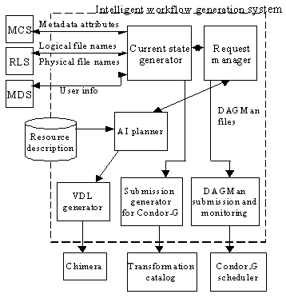
Figure 2: Architecture of the planning system and its interactions with other Grid-based services in Pegasus.
The planning operators are stored separately. We are currently investigating ways to generate the operators from metadata and resource information about the application components.

7. Practical issues in using an AI planner
AI planning is an appropriate tool for constructing workflows because it allows a declarative representation of workflow components with separate search regimes. Heuristic control for constructing good workflows or evenly sampling the set of possible workflows can also be modeled declaratively. In order to make the most efficient use of AI planning, it was necessary to integrate the planner with specialized sub-solvers that were more efficient for certain sub-problems. Similar approaches have been taken to integrate AI planning with scheduling systems (Myers et al. 01).
In this case, a user request for a pulsar search might lead the planner to schedule up to 400 separate short Fourier transform (SFT) tasks on the available machines. These tasks are identical except for their input parameters, are independent of one another and all need to be completed before a concatenation task is applied to their results: a situation sometimes called `parameter sweep'. It is more efficient for the planner to consider the separate instances of the SFT program running on one host as a single instance, and use a separate routine to assign the SFT instances to the available hosts. This routine balances the workload while taking into account the availability of any already existing input files on the Grid. For the planner, reasoning at this slightly higher level of abstraction required re-formulating the operator for the SFT from one that models single instances of the program into one that models multiple instances. This was done by hand but we plan to automate the process, since this situation is common.
In the LIGO application, the planner returned the first plan generated, using local heuristics aimed at generating a plan with low expected run-time. The planner can also be used to evaluate all possible plans and return one with the lowest run-time according to its estimates, or as an anytime algorithm, searching for better plans and returning the best found when queried. To make the estimates, a routine is attached to each operator to estimate its run-time as a function of its input data and the chosen host. The local estimates are combined into an estimate for the whole plan based on the partial order of tasks. In principle the estimates can also be used with partial plans in order to perform an A* search for the best plan, but this is not currently implemented.

8. Executing the plan on the grid
Once the plan is completed, it is sent to the Request Manager as a partially-ordered set of tasks. Any tasks that are combined in the planner, for example the SFT construction tasks in the LIGO scenario, are represented separately. The partial order is used to oversee the execution of the plan as a workflow on the Grid, but two steps must first be taken to complete the workflow.
The plan includes steps to create any needed data products, and these will be stored in files on the Grid. Within the plan, these data products are referred to by their metadata descriptions, and another set of queries to the Metadata Catalog Service is made to create the appropriate logical file names and enter their associated metadata attributes. These files will be created on the host machines where the programs are to be run, but some of them may need to be moved to other storage machines for long-term availability and registered to services like the Replica Location Service so they can be found and re-used in future requests, if the user so chooses. The Request Manager adds the necessary steps to the workflow to store and register these files.
The completed workflow is then submitted to DAGMan for execution. DAGMan keeps track of task dependencies, and schedules each task on the required machine when the parent tasks have completed.

9. Experiences with the planner
The planning system described above was shown at the Super Computing conference SC '02 in November, where it was used to create and execute workflows in the pulsar search domain, using approximately ten machines and clusters of different architectures and computing and storage resources at Caltech, the University of Southern California and the University of Wisconsin, Milwaukee. During the conference it was used to perform 58 pulsar searches, scheduling over 330 tasks and over 460 data transfers, consuming over eleven hours of runtime on high performance computing resources from several organizations. Since then the system was used to generate additional workloads that resulted in 185 pulsar searches, 975 tasks being executed and 1365 data files transferred. The total runtime was close to 100 hours.
Due to the interest from the physics-based user community, the demonstrators were asked at the conference if they could include an alternative algorithm for the pulsar search task that used different resource types, routines and support files. Although the authors of the planning domain were not present, it was possible for them to define additional planning operators for these routines and describe the new hosts in the resource file. The system was then able to create and execute workflows using either the original or the new algorithm, and could choose the most appropriate one depending on the availability of hosts or data products. Our collaborators from the LIGO project expressed great interest in this work and we aim for this initial implementation to become the foundation of a system with which they can perform production-level analysis.

10. Future work
Our initial steps developing this application have shown the usefulness of a planning approach to workflow construction, and of declarative representations of knowledge uniformly available in the Grid. We have also identified a number of issues that we will explore in our future work in this area.
Reasoning about entire workflows allows us to find a globally optimal solution that may not be possible if we seek a locally optimal allocation for each component task. However, a relatively long-term plan may be far from optimal or unachievable in practice because the computational environment can change rapidly while the plan is executed. Scheduling of tasks may simply fail, and resources may become unavailable or be swamped when needed, bandwidth conditions may change and new data may render some later steps pointless.
We intend to incorporate Grid monitoring services in our framework to continually monitor the environment as the plan is executed, and repair or recompute the plan if needed. We will initially exploit the fact that plan creation in this domain is fast compared with execution, so one can continually re-plan as the situation changes, and always schedule the next task from the latest available plan. Other strategies for plan monitoring, re-planning and reactive planning are also applicable, as are strategies to predict and avoid likely sources of failure (Boutilier et al. 98).

11. Conclusions
Our initial work in applying knowledge-based techniques to make Grid computing more transparent and accessible has led to interesting results and an encouraging response from the user community. In addition to considering the challenges listed above, we are currently testing the generality of the approach by developing applications for high-energy physics and with earthquake simulations. If successful, this approach will be of significant help in bringing the benefits of Grid-based computing to a muc\h wider base of users. Many additional AI techniques will be useful towards this goal, including scheduling and resource reasoning, ontologies and description logic reasoning, multi-agent systems, and reasoning about uncertainty. More details can be found at http://www.isi.edu/ikcap/cognitive-grids.

Acknowledgments
We gratefully acknowledge helpful discussions on these topics with our colleagues, including Ann Chervenak, Carl Kesselman, Jihie Kim, Paul Rosenbloom, Tom Russ and Hongsuda Tangmunarunkit. We thank Gaurang Mehta, Gurmeet Singh and Karan Vahi for the development of the demonstration system. We also thank the following LIGO scientists for their contribution to the grid-enabled software: Kent Blackburn, Phil Ehrens Scott Koranda, Albert Lazzarini, Mary Lei, Ed Maros, Greg Mendell, Isaac Salzman and Peter Shawhan. This work was supported by the National Science Foundation under grants ITR-0086044 (GriPhyN) and EAR-0122464 (SCEC/ITR), and by an internal grant from USC's Information Sciences Institute.

References
- Ankolekar, A., Burstein, M., Hobbs, J., Lassila, O., Martin, D., McIlraith, S., Narayanan, S., Paolucci, M., Payne, T., Sycara, K., Zeng, H., DAML-S: Semantic Markup for Web Services, Proceedings of the International Semantic Web Working Symposium (ISWWS), 2001.
- Annis, J., Zhao, Y., Voeckler, J., Wilde, M., Kent, S. and Foster, I., Applying Chimera Virtual Data Concepts to Cluster Finding in the Sloan Sky Survey. in Supercomputing. 2002. Baltimore, MD.
- Berners-Lee, T., James Hendler and Ora Lassila. "The Semantic Web" Scientific American, May 2001.
- Blythe, J., Deelman, E., Gil, Y., Kesselman, C., Agarwal, A., Mehta, G., Vahi, K., The Role of Planning in Grid Computing, in Proc. Intl. Conf. on AI Planning and Scheduling, (ICAPS) 2003a
- Blythe, J., Deelman, E., Gil, Y., Kesselman, C., Transparent Grid Computing, a Knowledge-based Approach in Proc. Innovative Applications of Artificial Intelligence, (IAAI) 2003b
- Boutilier, C., Dean, T., Hanks, S., Decision-Theoretic Planning: Structural Assumptions and Computational Leverage, Journal of Artificial Intelligence Research, 11, 1-94, 1999
- CIM, 2002, http://www.dmtf.org/standards/standard_cim.php
- Chervenak, A., E. Deelman, I. Foster, L. Guy, W. Hoschek, A. Iamnitchi, C. Kesselman, P. Kunst, M. Ripenu, B. Schwartzkopf, H. Stockinger, K. Stockinger, B. Tierney (2002). Giggle: A Framework for Constructing Scalable Replica Location Services. in Supercomputing. 2002. Baltimore, MD.
- Chervenak, A., Deelman, E., Kesselman, C., Pearlman, L. and Singh, G., A Metadata Catalog Service for Data Intensive Applications. 2002, GriPhyN technical report, 2002-11.
- Chien, S. A. and H. B. Mortensen, "Automating Image Processing for Scientific Data Analysis of a Large Image Database," IEEE Transactions on Pattern Analysis and Machine Intelligence 18 (8): pp. 854-859, August 1996.
- Czajkowski, K., Fitzgerald, S., Foster, I. and Kesselman, C., Grid Information Services for Distributed Resource Sharing. in 10th IEEE International Symposium on High Performance Distributed Computing. 2001: IEEE Press.
- Deelman, E., J. Blythe, Y. Gil, C. Kesselman, G. Mehta, K. Vahi, K. Blackburn, A. Lazzarini, A. Arbree, R. Cavanaugh and S. Koranda, "Mapping Abstract Complex Workflows onto Grid Environments", Journal of Grid Computing, vol. 1, 2003a
- Deelman, E., et al., From Metadata to Execution on the Grid: The Pegasus Pulsar Search. 2003b, GriPhyN 2003-15.
- Foster, I. and C. Kesselman, eds. The Grid: Blueprint for a New Computing Infrastructure. 1999, Morgan Kaufmann.
- Foster, I., C. Kesselman, and S. Tuecke, The Anatomy of the Grid: Enabling Scalable Virtual Organizations. International Journal of High Performance Computing Applications, 2001.
- Foster, I., C. Kesselman, J. Nick, S. Tuecke. Grid Services for Distributed System Integration. Computer, 35(6), 2002.
- Frey, J., Tannenbaum, T., Foster, I., Livy, M., Tuecke, S., Condor-G: A Computation Management Agent for Multi-Institutional Grids. in 10th International Symposium on High Performance Distributed Computing. 2001: IEEE Press.
- Globus, 2002 www.globus.org
- Horrocks, I., DAML+OIL, a Reasonable Web Ontology Language, Proceedings of EDBT 2002, LNCS 2287, 2-13, 2002
- Lansky, A., L. Getoor, M. Friedman, S. Schmidler, N. Short, The COLLAGE/KHOROS Link: Planning for Image Processing Tasks, AAAI Spring Symp. on Integrated Planning Applications, 1995
- McDermott, D. "Estimated-Regression Planning for Interactions with Web Services". in Sixth International Conference on Artificial Intelligence Planning Systems, (AIPS) 2002.
- Myers, L. and Smith, S. and Hildum, D. and Jarvis, P. and de Lacaze, R. Integrating Planning and Scheduling through Adaptation of Resource Intensity Estimates. Proceedings of the 6th European Conference on Planning (ECP), 2001
- Veloso, M., J. Carbonell, A. Perez, D. Borrajo, E. Fink, and J. Blythe. (1995) Integrating Planning and Learning: The PRODIGY Architecture. Journal of Theoretical and Experimental AI, 7(1), 1995.
- Waldrop, M, 2003 Grid Computing, in "10 Emerging Technologies That Will Change the World". MIT Technology Review, February 2003
- Wolski, R., Forecasting Network Performance to Support Dynamic Scheduling Using the Network Weather Service, in Proc. 6th IEEE Symp. on High Performance Distributed Computing. 1997: Portland, Oregon.
- Wroe, C., R. Stevens, C. Goble, A. Roberts, and M. Greenwood. (2003). "A Suite of DAML+OIL ontologies to describe bioinformatics web services and data". To appear in Journal of Cooperative Information Science.

Semantic Support for Grid-Enabled Design Search in Engineering
Tao F.¹, Chen L.¹, Cox S.J.³, Shadbolt N.R.¹, Puleston C.², Goble C.²
¹ School of Electronics and Computer Science
University of Southampton, UK
{lc, nrs, ft}@ecs.soton.ac.uk
² Department of Computer Science
University of Manchester, UK
{carole, colin.puleston}@cs.man.ac.uk
³ School of Engineering Sciences
University of Southampton, UK
sjc@soton.ac.uk

Abstract
Semantic Web technologies are evolving the Grid towards the Semantic Grid [2] to yield an intelligent grid which allows seamless process automation, easy knowledge reuse and collaboration within a community of practice. We discuss our endeavours in this direction in the context of Grid enabled optimisation and design search in engineering (“Geodise” project) [3]. In our work we have developed a semantics-based Grid-enabled computing architecture for Geodise. The architecture incorporates a service-oriented distributed knowledge management framework for providing various semantic and knowledge support. It uses ontologies as the conceptual backbone for information-level and knowledge-level computation. We also describe ontological engineering work and a service-oriented approach to ontology deployment. We present several application examples that show the benefit of semantic support in Geodise.

1. Introduction
E-Science [1] offers a promising vision of future large scale science over the Internet where the sharing and coordinated use of diverse resources in dynamic, distributed virtual organisations is commonplace. The Grid [4] has been proposed as a fundamental computing infrastructure to support the vision of e-Science. Convergence between the Grid and recent developments in web service technologies [5] [11] [12] have seen Grid technologies evolving towards an Open Grid Services Architecture (OGSA) [6]. This sees the Grid as providing an extensible set of services and it enables rapid assembly and disassembly of such services into transient confederations in various ways so that tasks wider than that enabled by the individual components can be accomplished. At this time, a number of Grid applications have been developed [3] [7] [26] and there is a whole raft of middleware that provide core Grid functionality such as Globus [9] and Condor [10]. However there is currently a major gap between these endeavours and the vision of e-Science in which there is a high degree of easy-to-use and seamless automation and in which there are flexible collaborations and computations on a global scale. It has been commonly agreed [2] that the realisation of the e-science vision will rely on how the heterogeneous resources of the Grid, which include data, information, hardware (clusters, servers etc.), software (computation codes), capabilities, and knowledge on how to use these assets, can be effectively described, represented, discovered, pre/post-processed, interchanged, integrated and eventually reused to solve problems.
Semantic Grid [2], a future e-Science infrastructure, has been proposed to bridge the practice and aspiration divide of the Grid. The Semantic Grid aims to support the full richness of the e-Science vision by considering the requirements of e-Science and the e-Scientist throughout their use of Grid resources. The enabling technologies that evolve the Grid to the Semantic Grid are the Semantic Web [13] [14] and advanced knowledge technologies [15]. The Semantic Web is an extension of the current Web in which information is given well-defined meaning, better enabling computers and people to work in cooperation. It is the idea of having data on the Web defined and linked in a way that it can be used for more effective discovery, automation, integration, and reuse across various applications. Advanced knowledge technologies are concerned with the process of scientific knowledge management on the Grid in terms of a life cycle of knowledge-oriented activity that ranges over knowledge acquisition, modelling, retrieval, reuse, publishing and maintenance.
In this paper we will illustrate how Semantic Grid technologies are being exploited to assist engineers in engineering design search and optimisation (EDSO). The goal is two folds: the first is to expose EDSO resources with relevant metadata, common vocabulary and shared meaning so that they can be shared and reused seamlessly. The second is to enable EDSO on the Grid by making use of semantic information in these EDSO resources. In the following we first introduce an integrated architecture for Grid-enabled design search and optimisation in engineering. The distinguishing feature of the architecture is the incorporation of the knowledge and ontology components, which migrates the Grid towards the Semantic Grid. Section 3 describes the core underlying technique of the Semantic Grid, i.e. ontology engineering work including ontology development, representation and deployment. Section 4 presents several application examples, which demonstrate how semantic support can facilitate EDSO in various aspects of EDSO processes on the Grid. Finally some initial conclusions are drawn from our work on Geodise.

2. The Semantic Grid Architecture for Engineering Design Search and Optimisation
Grid enabled optimisation and design search in engineering (Geodise [3]) is one of the UK e-Science pilot projects. It is intended to enable engineers to carry out engineering design search and optimisation by seamless access to a state-of-the-art collection of optimisation and search tools, industrial strength geometry modelling and meshing tools (ProE, Gambit) and analysis codes (FLUENT), and distributed computing and data resources on the Grid. To achieve the above objective, Geodise utilise two latest technologies, the Semantic Web and advanced knowledge technologies, to aid engineers in the design process by semantic support and exploiting EDSO domain knowledge, thus enabling new designs to be developed more rapidly, or at lower cost. This requirement suggests that a knowledge infrastructure be developed to support the distributed management and application of scientific knowledge on the Grid. Figure 1 shows the Geodise architecture under the Semantic Grid paradigm. This architecture consists of four main components including the Geodise portal, the application service provider, and the optimisation and computation modules. The application service provider caters for both design and analysis tools integrated with support for databases that provide information about previous designs.
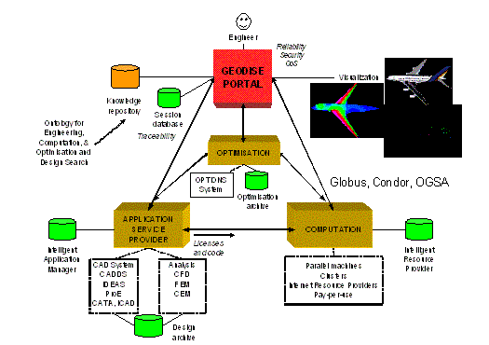
Figure 1: The semantic Grid architecture for engineering design search and optimisation
The optimisation component provides a variety of optimisation algorithms by which each design may be evaluated in terms of a selected objective function. The computation component calculates values for the objective function that is being optimised. All these components are viewed and implemented as web/Grid services and physically distributed. The user front end of Geodise is the Geodise portal, which allows users to locate and compose services they require, seeking advice as necessary.
Though the four modules described above form the main fabric of the Geodise architecture- i.e. the data, computation and applications- the components that are central to providing knowledge and intelligence for the grid, and hence play a key role in the evolution of the Grid towards the Semantic Grid, are: the ontology, knowledge repository and the intelligent systems. The ontology component provides a shared, explicit specification of the conceptualisation for the EDSO domain. It consists of common vocabularies to represent domain concepts and the relationships between them. EDSO ontologies allow engineers to describe EDSO resources in a semantically consistent way so that they can be shared and processed by both machines and humans. Ontologies lay down the foundation on which seamless access to heterogeneous distributed resources on the Grid can be achieved. The knowledge repository component is intended to expose accumulated design expertise and/or practices to designers so that new design runs can be conducted based on previous design experience. The EDSO knowledge repository contains the intellectual and knowledge-based assets of the EDSO domain. These assets include domain dependent, problem specific expertise embodied in a set of semantically enriched resources which have been produced and archived by the EDSO designers during previous design runs and can subsequently be reused in various ways to enhance their design capabilities in the future.
Intelligent systems aim to provide knowledge-based decision-making support for engineers to develop new designs. This may be done in the analysis codes and resources modules, for example, through an intelligent application manager that makes use of intelligence based on domain knowledge and an intelligent resource provider that makes use of intelligence on top of Grid infrastructure and/or middleware. In Geodise we initially concentrate on exploiting EDSO domain knowledge to facilitate problem solving. Knowledge-based support for decision-making can be provided at multiple knowledge intensive points of the design process and at multiple levels of granularity such as at the process level (what should be done next after a previous task), component level (if the next task is optimisation, which methods or algorithms should be chosen from among a suite of 40+ optimisers), or parameter level (if a genetic algorithm optimiser is selected, how to set the control parameters such as population size).
To realise the three key components, i.e. the ontology, knowledge repository and intelligent systems that underpin the idea of the Semantic Grid, we have proposed and developed an integrated service-oriented framework for distributed knowledge management [27] as shown in Figure 2. In this framework, knowledge about a specific domain is acquired, modelled and represented using a variety of techniques and formalisms. It includes ontologies, knowledge bases and other domain related information. This knowledge is then saved in a knowledge warehouse (or repository). All activities related to knowledge consumption and supply are realised as knowledge services. Users are provided with a community knowledge portal as the entrance point. The knowledge portal facilitates the use of knowledge with different levels of access control. The framework has a layered modular structure with each component dealing with a specific aspect of the knowledge engineering process in a co-ordinated way. For example, ontologies can be built from knowledge acquisition, and further used to create knowledge bases or to do semantic annotation. These knowledge bases or their associated annotation archives, having been semantically enriched, can then be exploited by the services. These services have mechanisms for querying or searching semantic content so as to facilitate knowledge publishing, use/reuse and maintenance.
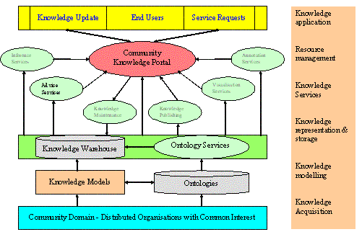
Figure 2: The service-oriented knowledge management framework
As the enabling knowledge infrastructure for the Semantic Grid, the service-oriented knowledge management framework covers all aspects of the knowledge management lifecycle. However, as can be seen from Figure 1, ontologies play a central role for the success of the Semantic Grid and its applications. It serves as a conceptual backbone for automated information access, sharing and reuse, and also enabling semantic-driven knowledge processing on the Semantic Grid [16]. Therefore this paper focuses on the ontological engineering and the use of semantics for e-Science in the context of Geodise. In Geodise ontologies have been created that capture the concepts and terms of the design process, in other words, the common vocabulary used by design engineers to describe what they do. In turn these ontologies are used to describe problem setup, database schemas, computation algorithms, design processes and design results with rich semantics. With the semantic information in place, there will be no communication barriers for people and soft agents. Resources will be transparent for authorised users so that they can be seamlessly shared and aggregated for use. The benefit of conducting EDSO on the Semantic Grid is that engineers, in particular designers wishing to leverage previous expert use of the system, are able to share not only computational resources but also the wider knowledge of the community.

3. Engineering Ontologies for Geodise
We have carried out extensive knowledge acquisition for the EDSO domain using the CommonKADS knowledge engineering methodology [25] and the PC PACK toolkit [31] [27]. The acquired knowledge is modelled as either ontologies or rules in knowledge bases. A set of ontologies has been built to conceptualise the characteristics of the EDSO domain using the OilEd ontology editor [29]. For example, Figure 3 shows the EDSO task ontology. The left panel displays the hierarchical structure of the EDSO tasks, plus all other information types that are relevant to EDSO tasks. The right panel is used to define an individual task by specifying its properties. The definition of a property is actually to establish relationships among concepts within one or multiple ontologies.
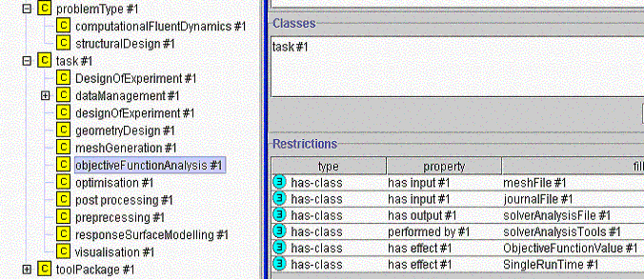
Figure 3: EDSO task ontology
Since components in the Geodise architecture are web/Grid services, concepts in the task ontology are in fact different types of services. An instance of a task is a service specified for accomplishing a designated function. This makes us able to adopt DAML-S web services description framework to describe a (EDSO task) service's properties and functionality. To build EDSO-specific task ontology, we have specialised the high-level concepts of DAML-S with terms from EDSO domain ontologies while preserving the DAML-S service description structure such as service profile, service model and service grounding. This makes the EDSO task ontology consistent in both structural description and content semantics. It in turn guarantees that EDSO task ontology can be shared and understood in EDSO community, thus facilitating dynamic automated service discovery and composition. EDSO ontologies are represented in an expressive markup language with well-defined semantics such as DAML+OIL [17] and OWL [18]. DAML+OIL takes an object-oriented-like approach, with the characteristics of the domain being described in terms of classes and properties. It builds upon existing Web standards, such as XML and RDF, and is underpinned by the expressive description logic. It supports the classification of concepts based on their property description - a description-based reasoning capability. Ontological reasoning can be used for subsumption and/or consistency checking. It can also be used as a concept match-maker. For instance, we can retrieve sets of ontological concepts matching some arbitrarily defined queries through classification and subsumption reasoning. Ontological reasoning provides a foundation for semantics-based service discovery as will be seen later when we use EDSO task ontology to perform service composition. Figure 4 shows a fragment of the EDSO task ontology in DAML+OIL.
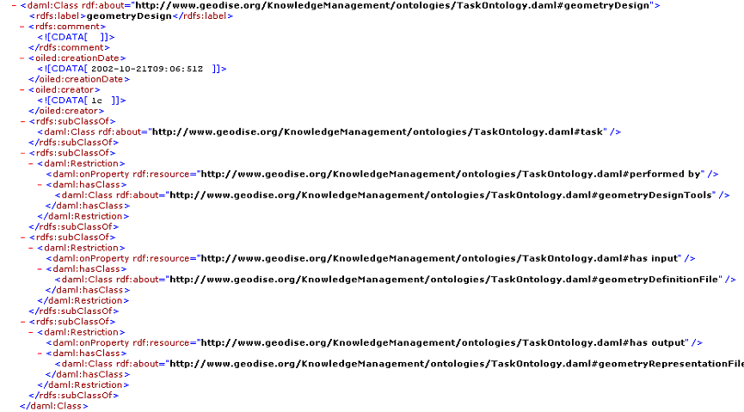
Figure 4: EDSO task ontology - the fragment of the geometry design task
We have developed ontology services to facilitate the deployment of the EDSO ontologies in Geodise. Ontology services are implemented as a typical SOAP-based web service independent of any specific domain. Therefore it can access any DAML+OIL ontology that is available over the Internet. The ontology service consists of four components: an underlying data model that holds the ontology (the knowledge model) and allows the application to interact with it through a well-defined API, an ontology server that provides access to concepts in an underlying ontology data model and their relationships, the FaCT reasoner [30] that provides reasoning capabilities and a set of user APIs that interface user’s applications and the ontology. By using the service’s APIs and the FaCT reasoner, common ontological operations, such as subsumption checking, retrieving definitional information, navigating concept hierarchies, and retrieving lexical information, can be performed when required.
As a standard web service, ontology service itself is a type of knowledge asset and can be accessed, shared, and reused using the service's WSDL. It has been developed using Java technologies and deployed using Apache Tomcat and Axis technologies.

4. Semantic support exemplars in Ontology-enabled Geodise Problem Solving Environment (PSE)
Semantic support can be delivered in GEODISE PSE through the following application scenarios and exemplars.

4.1 Ontology assisted domain script editor
Content in the software manual for the script editor is processed and enriched using a pre-defined ontology. This is demonstrated in Figure 5 where instances of command usages are generated manually in Protégé 2000 based on the usage ontology and the corresponding usage entry in the Gambit command manual, which is a tool for generating meshes from a geometry. Each Gambit command can operate with a set of keywords and parameters in certain syntax and grammar. In Geodise, engineers need to edit these domain scripts frequently with the guidance from the manual to make sure that scripts are correct.
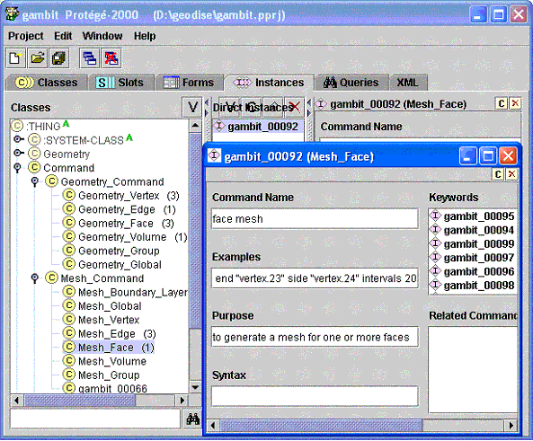
Figure 5: Building Gambit command ontology
The ontology assisted domain script editor makes use of the pre-built command usage instances and colorizing the scripts syntax. It also provides real-time context sensitive hinting and auto-completion as illustrated in Figure 6. All these functionalities operate by consuming the semantically enriched content - the Gambit command usage instances.
Since the editor can load in any ontology, it is domain independent and has the potential to assist script editing in any other domain as long as the corresponding ontology is available.
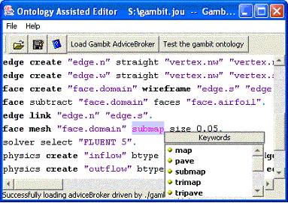
Figure 6: Ontology assisted Gambit script editing
We have also demonstrated not only hints on parameters to configure a command, but also horizontal suggestions of `next steps' based on expert knowledge. To develop this further would require additional knowledge capture.

4.2 Ontology driven forms
In Geodise, Matlab structure as shown in Figure 7 is used to capture all necessary metadata about a problem and produce a high level human readable abstraction. As a problem pre-set, the Matlab structure captures all problem definition related information embedded in the STEP file, such as all the possible design parameters which may be varied to modify the design.
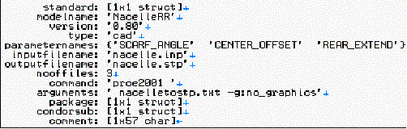
Figure 7: MatLab structure for Geometry
The analysts can also change the default value as necessary. The result is an instance of a problem setup in the problem profile. The analyst can also load existing instances from the problem profile repository to carry on analyzing work conducted previously.
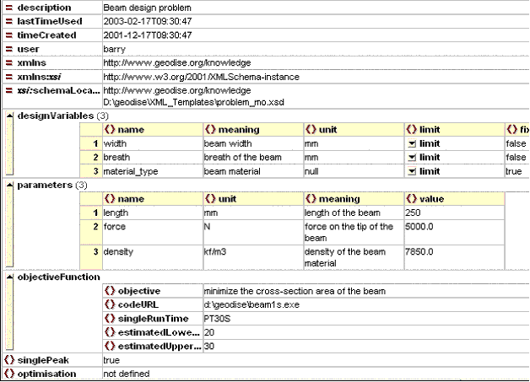
Figure 8: XML Schema of EDSO problem setup
However, in a collaborative environment, different CAD designers may use different metadata to describe a problem in the Matlab structure. This may cause inconsistency and inhibit sharing of previously generated CAD designs. By using ontology, this can be avoided. Also, the Ontologies can be maintained separately at a centralized place, as demonstrated in Figure 8 and used in the construction of a Matlab structure to describe a problem: CAD designers can interact with a set of ontology driven forms demonstrated in 9 and Figure 10, which are automatically generated based on a controlled set of vocabularies and relationships specified in the ontology. Once the form is finished by the CAD designers, an instance of the component description is ready. This instance is passed to the following phases where it can be loaded again by analysts who, according to design requirements, can further specify the desired design variables by manipulating (e.g. checking off some parameters) the list of design parameters, or by changing the range and default value of some parameters, etc. We call this analyst operation `problem setup'. These happen in a similar GUI and once this is finished, we have an instance that represents a particular concrete problem setup. Note that examples here are based on XML/Schema so far and are only for demonstrating the scenario. The auto-GUI rendering uses Jaxfront [38] and the semantics are expressed in XML schema using XML spy [39].
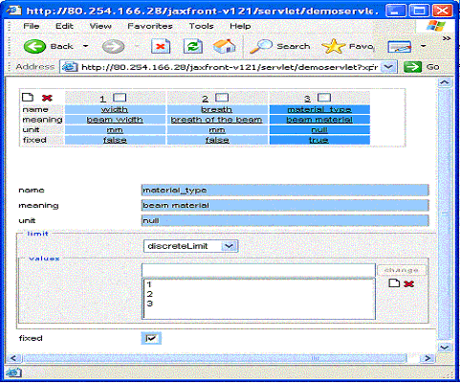
Figure 9: Instances of design variables
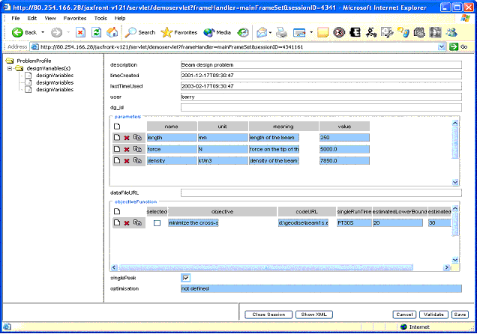
Figure 10: Instance of problem setup

4.3 Workflow editing and semantic instance generation
Scientific activities often involve constructing a workflow. We have developed a Workflow Construction Environment (WCE) as shown in Figure 10 for Geodise, which is intended to (1) exploit the semantically enriched services for semantic-based service discovery and reuse, (2) generate semantic workflows for the use of future problem solving, and (3) provide knowledge-based advice [28] on service composition.
In the service-oriented Grid computing paradigm this process amounts to semantically enrich workflow instances and components so that resources on the Grid can be discovered and assembled easily. In other words, the successful orchestration of component services into a valid workflow specification is heavily dependent on bodies of domain knowledge as well as semantically enriched service descriptions.
Semantic service description is undertaken using ontologies accessed via the ontology services. The process of specifying semantic service descriptions is carried out in two steps. Firstly, domain ontologies, such as the task ontology and the function ontology, are created. Then, the domain specific service ontology is built using concepts from the domain ontologies. The semantic descriptions of domain-specific services are actually instances of concepts from the service ontology. Semantic service descriptions are stored in the Semantic Service Description component.
The main components for semantic resource enrichment, discovery and reuse are the Component (Service) Editor (the middle right panel), Ontology Browser (the left panel) and the Workflow Editor (the middle panel). The Component (Service) Editor is a frame-like data-storage structure. It is used to specify a service description for service discovery or to define a service directly by filling in the required data fields. The structure of the Component Editor is dynamically generated in accordance with the service ontology, thus semantically enriching the service when the service is defined. The Ontology Browser displays ontologies that provide service templates for workflow construction. Workflows are built in the Workflow Editor in which users either discover an appropriate service via semantic service matching or specify a semantically enriched service afresh. These services are connected in a semantic-consistent way to form a workflow.
Each time a workflow is constructed for a particular design problem, it can be archived to form a semantically enriched problem/solution within a knowledge repository. This facilitates the re-use of previous designs, while avoiding the overhead of manually annotating the solution.
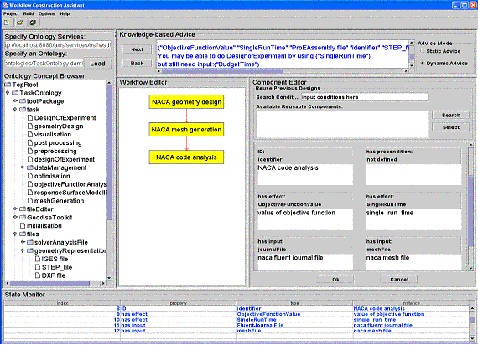
Figure 11: Knowledge guided workflow composition

6. Conclusions
In this paper, we have introduced the Semantic Grid architecture for engineering design search and optimisation. In particular, we presented an integrated service-oriented distributed knowledge management framework, which begins to migrate the Grid to the Semantic Grid. We have made full use of the latest semantic web technologies and developed mechanisms and tools to provide semantic support for EDSO. While the context of present research is design search and optimisation, the underlying infrastructure and approaches could be applied to many other types of Grid application. We believe that the Semantic Grid holds great promise for resource sharing and seamless automation and flexible collaboration on a widely distributed scale. Up to now various ontologies have been built and we have developed a number of scenarios and applications to demonstrate the how these ontologies can be reused in the EDSO domain to maximise semantic web potentials in the grid computation.
It becomes clear through the work, that exploiting semantics is not only desirable but necessary and viable for e-Science on the Grid.

References
- Hey, T. and Trefethen, A.E. 2003. The Data Deluge: An e-Science Perspective. To appear in `Grid Computing - Making the Global Infrastructure a Reality', Wiley, January 2003.
- De Roure, D., Jennings, N. and Shadbolt, N. 2001. Research Agenda for the Future Semantic Grid: A Future e-Science Infrastructure http://www.semanticgrid.org/v1.9/semgrid.pdf
- Geodise project http://www.geodise.org/
- Foster, I. and Kesselman, C. 1999. The Grid: Blueprint for a New Computing Infrastructure. Morgan Kaufmann.
- Chinnici, R., Gudgin, M., Moreau, J. and Weerawarana, S.. (2002) Web Services Description Language (WSDL) 1.2, W3C Working Draft, 9 July 2002. http://www.w3.org/TR/wsdl12/.
- Foster, I., Kesselman, C., Nick, J. and Tucke S. 2002. The Physiology of the Grid. An Open Grid Service Architecture for Distributed Systems Integration. http://www.globus.org/ogsa/
- Allcock, W., Chervenak, A., Foster, I., Kesselman, C., Salisbury, C. and Tuecke, S. The Data Grid: Towards an Architecture for the Distributed Management and Analysis of Large Scientific Datasets. Journal of Network and Computer Applications, 23:187-200, 2001. http://grid.web.cern.ch/grid/
- Cannataro, M. and Talia, D. 2003, The Knowledge Grid, CACM Vol.46, No1, January 2003, pp.89 - 93
- The Globus Project. http://www.globus.org/
- The Condor Project. http://www.cs.wisc.edu/condor/
- UDDI. The UDDI technical white paper, 2000. http://www.uddi.org/
- SOAP 1.2 Working draft, 2001. http://www.w3c.org/TR/2001/WD-soap12-part0-20011217/
- Berners-Lee, T., Hendler, J. and Lassila, O. 2001. The Semantic Web, Scientific American.
- Goble, C. and Roure, D. D. 2002. Semantic Web and Grid Computing (preprint)
- Advanced Knowledge Technologies (AKT) project. http://www.aktors.org/
- Maedche, A., Motik, B., Stojanovic, L., Studer, R. and Volz, R. 2002. Ontologies for Enterprise Knowledge Management. IEEE Intelligent Systems, November/December 2002.
- Horrocks, I., Harmelen, F., Patel-Schneider, P., Berners-Lee, T., Brickley, D., Connoly, D., Dean, M., Decker, S., Fensel, D., Hayes, P., Hein, J., Hendler, J., Lassila, O., McGuinness, D. and Stein, L. A. 2001. DAML+OIL. http://www.daml.org/2001/03/daml+oil-index.html.
- Dean, M., Connolly, D., Harmelen, F., Hendler, J., Horrocks, I., McGuinness, D. L., Patel-Schneider, P. F. and Stein, L. A. 2002. Web Ontology Language (OWL) Reference Version 1.0. W3C Working Draft. http://www.w3.org/TR/2002/WD-owl-ref-20021112/.
- Annotation and Authoring for Semantic Web. http://annotation.semanticweb.org/org/
- DAML Services Coalition. 2002. DAML-S: Web Service Description for the SemanticWeb. In The First International Semantic Web Conference (ISWC).
- Tuecke, S., Czajkowski, K. Foster, I., Frey, J., Graham S. and Kesselman C. 2002. Grid Service Specification Draft. http://www.globus.org/research/papers/gsspec.pdf
- Sirin, E., Hendler, J. and Parsia, B. 2002. Semi-automatic Composition of Web Services Using Semantic Descriptions. "Web Services: Modeling, Architecture and Infrastructure" workshop in conjunction with ICEIS2003.
- Gibbins, N., Harris, S. and Shadbolt, N. 2003. Agent-based Semantic Web Services. Accepted to The Twelfth International World Wide Web Conference, Budapest, Hungary.
- Siddall, J.N. 1982. Optimal Engineering Design: Principles and Applications. Marcel Dekker, Inc., New York and Basel.
- Schreiber S., Akkermans H., Anjewierden A., Hoog R., and Shadbolt N. 1999. Knowledge Engineering and Management. The MIT Press, London.
- The MyGrid project http://mygrid.man.ac.uk/index.shtml
- Chen, L., Cox, S.J., Goble, C., Keane, A.J., Roberts, A., Shadbolt, N.R., Smart, P., Tao, F. 2002. Engineering Knowledge for Engineering Grid Applications. Proceedings of Euroweb 2002 Conference, The Web and the GRID: from e-science to e-business, Oxford, UK, pp12-25.
- Tao, F., Chen, L., Shadbolt, N.R., Pound, G. and Cox, S.J. 2003. Towards the Semantic Grid: Putting Knowledge to Work in Design Optimisation. Submitted to the 3rd International Conference on Knowledge Management I-KNOW '03, Industry meets Science, Austria.
- Bechhofer S, Horrocks H, Goble C, Stevens R. 2001. OilEd: a Reason-able Ontology Editor for the Semantic Web. Proceedings of KI2001, Joint German/Austrian conference on Artificial Intelligence. Springer-Verlag LNAI Vol. 2174, pp 396--408.
- Horrocks, I., Sattler, U. and Tobies, S. 1999. Practical reasoning for expressive description logics. In H. Ganzinger, D. McAllester, and A. Voronkov, editors, Proceedings of the 6th International Conference on Logic for Programming and Automated Reasoning (LPAR'99), no.1705 in Lecture Notes in Artificial Intelligence, pp.161-180. Springer-Verlag.
- PC PACK Knowledge tool http://www.epistemics.co.uk/products/pcpack/
- OntMat-Annotizer Annotation Tool. http://km.aifb.uni-karlsruhe.de/annotation/ontomat.html
- Keane, AJ. OPTIONS Design Exploration System http://www.soton.ac.uk/~ajk/options/welcome.html
- Hendler J. 2003. Science and the Semantic Web. Policy Forum, Science, 24 Jan.
- Laszewski, G. von., Foster, I., Gawor, J., Lane, P., Rehn, N. and Russell, M. 2001. Designing Grid-based Problem Solving Environments and Portals. The 34th Hawaiian International Conference on System Science.
- Pound, G., Eres, H., Wason, J., Jiao, Z., Keane, A.J., and Cox, S.J. 2003. A Grid-enabled Problem Solving Environment (PSE) for Design Optimisation within Matlab. Accepted paper - International Parallel and distributed Processing Symposium IPDPS-2003, Nice, France.
- Chen, L., Shadbolt, N.R., Goble, C., Tao, F, Cox, S.J., Puleston, C. and Smart, P. 2003. Towards a Knowledge-based Approach to Semantic Service Composition. Submitted to the 2nd International Semantic Web Conference (ISWC2003), Florida, USA.
- Generating dynamic user interfaces based on XML Schema, http://www.jaxfront.com/pages/home.html
- XML spy homepage, http://www.xmlspy.com

Knowledge Discovery and Ontology-based services on the Grid
Mario Cannataro
University `Magna Græcia' of Catanzaro, 88100 Catanzaro, Italy
cannataro@unicz.it

Abstract
Main issues to be faced by next-generation Grids are the management and exploitation of the overwhelming amount of data produced by applications but also by Grid operation, and the intelligent use of Grid resources and services. To achieve these very ambitious goals, next-generation Grids should include knowledge discovery and knowledge management functionalities, for both applications and system management. The way how data and information available at different levels of Grid can be effectively acquired, represented, exchanged, integrated, and converted into useful knowledge is an emerging research field known as `Grid Intelligence'. Ontologies and metadata are the basic elements through which such Grid Intelligence can be deployed. Moreover Grids should offer semantic modeling of user's tasks/needs, available services, and data sources to support high level services and dynamic services finding and composition. This document describes some of these emerging services and a first implementation in the KNOWLEDGE GRID, an environment for the design and execution of geographically distributed high-performance knowledge discovery applications.

1. Introduction
Main issues to be faced by next-generation Grids are the management and exploitation of the overwhelming amount of data produced by applications but also by Grid operation, and the intelligent use of Grid resources and services. To achieve these very ambitious goals, next-generation Grids should include knowledge discovery and knowledge management functionalities, for both applications and system management. The way how data and information available at different levels of Grid can be effectively acquired, represented, exchanged, integrated, and converted into useful knowledge is an emerging research field known as `Grid Intelligence'.
The solutions that will be developed will certainly driven by the previous needs and requirements, but will also leverage and probably integrate some key technologies and methodologies emerging in many computer science fields, apparently far and unaware of Grids, such as peer-to-peer [8] and ubiquitous computing [9], ontology-based reasoning, and knowledge management. In particular, ontologies and metadata are the basic elements through which Grid Intelligence services can be deployed. Using ontologies, Grids may offer semantic modeling of user's tasks/needs, available services, and data sources to support high level services and dynamic services finding and composition [4]. Moreover, data mining and knowledge management techniques could enable high level services based on the semantics of stored data. Such services could be employed both at operation layer, where Grid management could gain from information hidden into data, and at application layer, where user could be able to exploit distributed data repository, using the Grid not only for high-performance access, movement and processing of data, but also to apply key analysis tools and instruments.
In this scenario, where resource ontologies and metadata allow intelligent searching and browsing, and knowledge discovery and management techniques allow high level services, peer-to-peer and ubiquitous computing, will be the orthogonal key technologies through which realize basic services such as presence management, resource discovery and sharing, collaboration and self-configuration.
Recent Grid developments [5] aim to simplify and structure the systematic building of Grid applications through the composition and reuse of software components and the development of knowledge-based services and tools. Following the trend emerged in the Web community the Open Grid Services Architecture (OGSA) introduced the service-oriented model [7, 10]. Semantic Grid focuses on the systematic adoption of metadata and ontologies to describe resources, services, data sources over the Grid, to enhance, and possibly automate, processes such as service discovery and negotiation, application composition, information extraction, and knowledge discovery [6]. Finally, Knowledge Grids [1] offer high-level tools and techniques for the distributed mining and extraction of knowledge from data repositories available on the Grid, leveraging semantic descriptions of components and data, as provided by Semantic Grid, and possibly offering knowledge discovery services as Grid Services.
Next section discusses some high-level services useful to build the emerging next-generation Grid. The KNOWLEDGE GRID, an environment for the design and execution of distributed knowledge discovery applications, is then briefly presented [2]. Finally we describe a case study where semantics and knowledge are used to enhance Grid functionalities and create new services: ontology-based semantic modelling is used to enhance component-based programming on the Grid.

2. Services for next-generation Grids
To face the growing complexity of Grids and the overwhelming amount of data to be managed, main requirements of future Grids will be:
- knowledge discovery and knowledge management functionalities, for both user's needs (intelligent exploration of data, etc.) and system management;
- semantic modeling of user's tasks/needs, Grid services, data sources, computing devices (from ambient sensors to high-performance computers), to offer high level services and dynamic services finding and composition;
- pervasive and ubiquitous computing, through environment/context awareness and adaptation;
- advanced forms of collaboration, through dynamic formation of virtual organizations;
- self-configuration, autonomic management, dynamic resource discovery and fault tolerance.
In particular, to fulfill some of the requirements listed before, we envision that next-generation Grids should first provide the following three main classes of services and related architectural framework:
- Knowledge management and ontology-based services. They are used to build, manipulate, and interoperate, in an homogeneous way, the Grid knowledge base. The term Grid knowledge base is used here to indicate all the data stored, maintained, and updated by the Grid, both for user, application, and operation purposes. It comprises, for example, the Globus MDS data and metadata, the Grid services usage data, the application data sources and results, etc. Many of these data are currently maintained by Grid middleware or by Grid applications, so the very main challenge for next-generation Grids will be their seamless integration and utilization. From an architectural point of view, technologies useful for building, manipulating, and reasoning on the Grid knowledge base are ontologies and logic programming. In such scenario, each `object' on the Grid (as in the Semantic Web) is classified through one or more ontologies into the knowledge base. Two important services that could be offered are: ontology-based Grid programming and request-resource matchmaking. In the next Section we will show a simple example of component-based programming based on domain ontology.
- Knowledge discovery services. They are used to extract knowledge from the data stored inside the Grid knowledge base. These services will be used both to build high-level knowledge discovery applications, as in the case of the KNOWLEDGE GRID, and to enhance existing basic Grid services. Two examples of high level services needing distributed data mining functionalities and accessing distributed partitions of a knowledge base are, for example, an enhanced version of the GridFTP protocol that classifies GridFTP usage data with data mining techniques to choose best connection parameters, and a Grid-based document management applications.
- Context-aware access to information and service adaptation. Semantic (lossy or lossless) compression and synthesis of Grid information (metadata) could be used to offer different views of the Grid knowledge base depending on many factors: user/service goals, scope of resource information. Other than usual compression techniques contents can be reorganised according to some aggregation functions (schema extraction and restructuring), resulting in a synthetic (compressed) yet meaningful version [3]. Synthesis techniques, e.g. based on Data Mining metadata exploration, could enable the provision of different views of Grid resources exposing different levels of details, allowing adapting the access and use of such information to different users/services goals. Moreover, adaptation techniques coming from the Adaptive Hypermedia research community [12] could be employed to adapt services to the user's computing environment on the basis of context.
- Dynamic resource discovery. When the Grid goes beyond a static, well established configuration, becoming a Pervasive Grid, i.e. when new devices and resources are allowed to enter and exit the Grid in a very dynamic way, new services able to adapt themselves to the environment have to be developed. Peer-to-Peer technologies could be used to implement dynamic discovery algorithms.
Such services can be incrementally built leveraging current Grid efforts and projects. Figure 1 shows how the recent research initiatives in the Grid community (OGSA, Semantic Grid, and Knowledge Grids) could be composed to provide a coherent architecture of services. Although these initiatives present some overlapping, they complement each others. Some enabling technologies, such as ontologies and reasoning, knowledge management and knowledge discovery, are currently offered by the depicted layers, but their main impact will be really evident when they will be used internally to enhance Grid management and operation. On the other hand, peer-to-peer and ubiquitous computing techniques start to be used very recently. In our opinion peer-to-peer will be the orthogonal technology on which main tasks such as presence management, resource discovery and sharing, collaboration and self-configuration will be based [11].
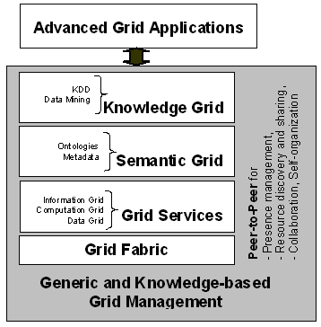
Figure 1: Building Knowledge Discovery and Ontolgy-based services

3. The KNOWLEDGE GRID
Next-generation Grids must be able to produce, use and deploy knowledge as a basic element of advanced applications. In this scenario we designed the KNOWLEDGE GRID system as a joint research project of ICAR-CNR, University of Calabria, and University of Catanzaro, Italy, aiming at the development of an environment for geographically distributed high-performance knowledge discovery applications [2]. The KNOWLEDGE GRID is a high-level system for providing Grid-based knowledge discovery services. These services allow professionals and scientists to create and manage complex knowledge discovery applications composed as workflows that integrate data sets, mining tools, and computing and storage resources provided as distributed services on a Grid.
KNOWLEDGE GRID facilities allow users to compose, store, share, and execute these knowledge discovery workflows as well as publish them as new components and services on the Grid. The KNOWLEDGE GRID can be used to perform data mining on very large data sets available over Grids, to make scientific discoveries, improve industrial processes and organization models, and uncover business valuable information. Other examples of Knowledge Grids are shortly described in [12].
The KNOWLEDGE GRID provides a higher level of abstraction and a set of services based on the use of Grid resources to support all those phases of the knowledge discovery process. Therefore, it allows the end-users to concentrate on the knowledge discovery process they must develop without worrying about Grid infrastructure details.
The KNOWLEDGE GRID architecture is composed of a set of services divided in two layers:
- The core K-Grid layer that contains metadata and ontologies about data sources and software components (data mining tools) and interfaces basic Grid middleware and services. It includes repositories that provide information about resource metadata, application workflows, and knowledge obtained as result of knowledge discovery applications. The core layer is a view over the KNOWLEDGE GRID knowledge base.
- The high level K-Grid layer that interfaces the user by offering a set of services for the design and execution of knowledge discovery applications. In the KNOWLEDGE GRID environment, discovery processes are represented as workflows that a user may compose using both concrete and abstract Grid resources. Knowledge discovery workflows are defined using visual interface that shows resources (data, tools, hosts) to the user and offers mechanisms for integrating them in a workflow. The high level K-Grid layer uses some ontology-based services, as shown in the next Section, and allows to implement knowledge discovery services.

4. A case study: Ontology-based Programming on the Grid
In component-based Grid programming the user designs an application by composing available software components. However, choosing components (i.e., using domain knowledge) and enforcing constraints (i.e., using programming knowledge) are often left to the designer activity. In this case study we will show how ontologies can help users in designing and programming knowledge discovery applications on the KNOWLEDGE GRID. After a brief description of the developed domain ontology, we show how a designer can exploit that knowledge base to formulate its application and choose the software components.
Domain Ontology: a view over the Grid knowledge base. DAMON (DAta Mining ONtology) is an ontology for Data Mining domain that explicitly manages the knowledge about the domain of interest (Data Mining) and related software tools, offering users a reference model for the different classes of data mining tasks, methodologies, and software components available to solve a given problem [4]. The choice of how to structure an ontology determines what a system can know and reason about. We have built our ontology through a classification of data mining software that allows for selecting the most appropriate software to solve a KDD (Knowledge Discovery in Databases) problem. The ontology represents the features of the available data mining software by classifying their main components and evidencing the relationships and the constraints among them. The categorization of the data mining software has been made on the basis of the following classification parameters:
- A (data mining discovery) Task represents a data mining technique for extracting patterns from data, that is a task specifies the goal of a data mining process.
- A Method is a data mining methodology used to discover the knowledge; different methods serve different purposes. It can be thought as a structured manipulation of the input data to extract knowledge.
- An Algorithm is the way through which a data mining task is performed.
- A Software is an implementation (in a programming language) of a data mining algorithm.
- A Suite implements a set of data mining algorithms: every algorithm may perform different tasks and employ different methods to achieve the goal.
- A Data Source is the input on which data mining algorithms work to extract new knowledge.
- The Human Interaction specifies how much human interaction with the discovery process is required and/or supported.
The Data Mining knowledge base used to support knowledge discovery programming has two conceptual layers: at the top layer the DAMON ontology gives general information about the Data Mining domain, whereas specific information about installed software components and data sources are maintained where resources resides. From an architectural point of view the ontology is a central resource, whereas specific metadata are distributed ones. As an example, DAMON stores the fact that the C5.0 Software implements the C5 Algorithm, that uses the Decision Tree method, that is a Classification method. The C5.0 Software node of ontology contains the URLs of the metadata files describing details about all the installed instances of that software.
Ontology-based programming: accessing the Grid knowledge base through ontology. DAMON is used as an ontology-based assistant that suggests the KNOWLEDGE GRID application designer what to do and what to use on the basis of his/her needs as well as a tool that makes possible semantic search of data mining software. In other words, it can be used to enhance the application formulation and design, helping the user to select and configure the most suitable Data Mining solution for a specific KDD process.
Information about Data Mining tasks/methodologies, and specific software components implementing data mining algorithms can be obtained by browsing or searching the ontology. In particular, semantic search (concept-based) of data mining software and others data mining resources has been implemented. The search and selection of the resources (data sources and software components, as well as the type of data mining tasks, methodologies and algorithms), to be used in a knowledge discovery application, are accomplished in the following steps:
- Ontology-based resources selection. Browsing and searching the ontology allows a user to locate the more appropriate tasks, methods, algorithms and finally data mining software to be used in a certain phase of the KDD process. The user can navigate the ontology using different points of access, showing deeper levels of details. Moreover, the user can query very detailed information about Data Mining resources, using several kinds of inference that can serve to broaden queries including equivalence, inversion, generalization, and specialization. For example, if the query result set is empty, the user can at least find objects that partially satisfy the query: some classes can be replaced by their superclasses or subclasses.
- Metadata access. The ontology gives the URLs of all instances of the selected resources available on the KNOWLEDGE GRID nodes, i.e. the URLs of the relevant metadata files stored in the Grid nodes. Such metadata are tightly bounded to the data mining software and data sources installed on a given physical node and contain all the information needed by a client to access and use them (technical parameters, availability, location and configuration of data mining software and tools).
As an example, a user logged on the KNOWLEDGE GRID node KU needs to perform a data mining application composed of two data mining tasks, clustering and classification, on the data set DBX stored on the KNOWLEDGE GRID node KD. The data set must be clustered using three different algorithms running in parallel on a copy of the data set. Clustering results must be analyzed by a classification algorithm that will be executed in parallel on three different nodes, generating three classification models of the same data set.
By using DAMON, the user first searches the clustering algorithms by browsing or querying the ontology on the basis of some user requirements (computational complexity of the algorithm, attitude to solve the given problem or the method used to perform the data mining task), then she/he searches the clustering software implementing the algorithms and working on the data set DBX, and finally locates the metadata URLs referring to the nodes KG1, KG2 and KG3, offering respectively the clustering software K-Means, Intelligent Miner, and AutoClass. Moreover, the user also finds the node KG4 that offers the C5.0 classifier. At this point the user can access specific information about the software by accessing the specific metadata on each identified node.
Such obtained information is then used for the visual composition of those software components and data sources through a graphic interface. The abstract description of this component-based application is then translated into the Grid submission language (RSL in the Globus case). After that the implemented application can be embodied into the DAMON ontology. In this way the knowledge base can be enriched and extended with new complex data mining tasks.
The programming example discussed here is just a case of how ontology-based services can be used for high-level programming of complex applications on Grids. This approach allows the re-use of previously developed applications and software components that can be integrated in new Grid applications.

Acknowledgements
This work has been partially supported by Project `FIRB GRID.IT' funded by MIUR.

References
- F. Berman. `From TeraGrid to Knowledge Grid'. CACM, Vol. 44, N. 11, pp. 27-28, 2001.
- M. Cannataro and D. Talia, `KNOWLEDGE GRID An Architecture for Distributed Knowledge Discovery', CACM, Vol. 46, No. 1, pp. 89-93, January 2003.
- Cannataro M., A. Guzzo and A. Pugliese, `Knowledge Management and XML: Derivation of Synthetic Views over Semistructured Data', ACM SIGAPP - Applied Computing Review Special Issue, Vol. 10, No. 1, pp.33-36, April 2002.
- M. Cannataro and C. Comito, `A Data Mining Ontology for Grid Programming', 1st Int. Workshop on Semantics in Peer-to-Peer and Grid Computing (SemPGrid2003), pp. 113-134, May 2003. Available at www.isi.edu/~stefan/SemPGRID
- D. de Roure, Baker M. A., Jennings, N. R. and Shadbolt, N. `The Evolution of the Grid', In F. Berman, A.J.G. Hey and G. Fox (eds), Grid Computing: Making The Global Infrastructure a Reality, pp. 65-100, John Wiley & Sons, 2003.
- D. de Roure, Jennings, N. R., Shadbolt, N. `The Semantic Grid: A future e-Science infrastructure'. In F. Berman, A.J.G. Hey and G. Fox (eds), Grid Computing: Making The Global Infrastructure a Reality, pp. 437-470, John Wiley & Sons, 2003.
- I. Foster, C. Kesselman, J. Nick, S. Tuecke, The Physiology of the Grid: An Open Grid Services Architecture for Distributed Systems Integration. Open Grid Service Infrastructure WG, Global Grid Forum, June 22, 2002.
- K. Lyytinen and Youngjin Yoo, `Issues and Challenges in Ubiquitous Computing', CACM, Vol. 45, No. 12, pp. 62-65, December 2002.
- D. Schoder and K. Fischbach, Peer-to-Peer Prospects, CACM, Vol. 46, No. 2, pp. 27-29, February 2003.
- D. Talia, `The Open Grid Services Architecture: Where the Grid Meets the Web', IEEE Internet Computing, Vol. 6, No. 6, pp. 67-71, 2002.
- D. Talia, P. Trunfio, `Toward a Synergy Between P2P and Grids', IEEE Internet Computing, vol. 7, no. 4, pp. 94-96, 2003.
- The Adaptive Web (Special issue on), CACM, Vol. 45, No. 5, May 2002.

Publishing Semantic Descriptions of Services
Luc Moreau, Simon Miles, Juri Papay, Keith Decker, Terry Payne
Electronics and Computer Science
University of Southampton, UK
L.Moreau@ecs.soton.ac.uk

Abstract
Service discovery in large scale, open distributed systems is difficult because of the need to filter out services suitable to the task at hand from a potentially huge pool of possibilities. Semantic descriptions have been advocated as the key to expressive service discovery, but the most commonly used service descriptions and registry protocols do not support such descriptions in a general manner. In this paper, we present an approach and implementation for service registration and discovery that uses an RDF triple store to express semantic service descriptions and other task/user-specific metadata, using a mechanism for attaching structured and unstructured metadata. The result is an extremely flexible service registry that can be the basis of a sophisticated semantically-enhanced service discovery engine, an essential component of a Semantic Grid.

1. Introduction
Service discovery is a difficult task in large scale, open distributed systems such as the Grid and Web, due to the potentially large number of services advertised. In order to filter out the most suitable services for the task at hand, many have advocated the use of semantic descriptions that qualify functional and non-functional characteristics of services in a manner that is amenable to automatic processing [2,5,13].
Semantic discovery is the process of discovering services capable of meaningful interactions, even though the languages or structures with which they are described may be different. Typically, a semantic discovery process relies on semantic annotations, containing high-level abstract descriptions of service requirements and behaviour. In this paper, we focus on the means to register such semantic annotations, and discover services using them.
Current standards in the Web Services and Grid communities (including UDDI and WSDL) do not directly support semantic discovery of services [10]. However, given that these standards have been agreed upon by the community, their existence promotes inter-operability with components such as workflow enactment engines.
An essential element in semantic discovery is the ability to augment service descriptions with additional information, i.e. metadata. Providers may adopt various ways of describing their services, access polices, contract negotiation details etc. However, many resource consumers also impose their own selection policies on the services they prefer to utilise, such as provenance, derived quality of service, reputation metrics etc. Furthermore, it is useful to add such metadata not only to service descriptions, but also to any other concept that may influence the discovery process, e.g. supported operations, types of arguments, businesses, users. Such metadata may be structured according to published ontologies, facilitating unambiguous interpretation by multiple users, especially in the case of a public registry; alternatively, such metadata may also be raw and unstructured, in the case of a personal registry used by a single user.
Since current Grid and Web Services standards are not capable of semantic service descriptions, we believe that an information model supporting not only UDDI and WSDL descriptions, but also general metadata attachment [9], would provide us with a uniform way of querying and navigating service information. We see the use of RDF triples [11] (subject, predicate, object) as the means to represent all the information in a uniform manner. This information will be stored in a triple store, which can be queried uniformly through the use of a query language such as RDQL [7]. Besides an information model, it is also critical to offer programmatic interfaces that would allow both publishers and third-party users to register their semantic information. Therefore, we have implemented the UDDI interface to this triple store, and additional interfaces to publish metadata and discover services according to metadata.
Our work is a component of the myGrid architecture for semantic service discovery (www.mygrid.org.uk). The functionality we are discussing here allows the attachment of metadata in the form of semantic annotations to services descriptions; such semantic descriptions can be retrieved, and used for reasoning by a Semantic Find component, whose description and interaction with the current component are discussed in a companion paper [8]. The specific contributions and the remaining sections of this paper are the following:
- A discussion of limitation of existing technologies;
- An illustration of the kind of annotations supported by our service directory;
- An overview of the interfaces we provide to register and use such annotations.

2. Limitation of Existing Approaches
The UDDI service directory (Universal Description, Discovery, and Integration) [12] has become the de-facto standard for service discovery in the Web Services community. Service queries are typically white or yellow pages based: services are located based on a description of their provider or a specific classification (taken from a published taxonomy) of the desired service type. A query typically returns a list of available services, from which a subset may conform to a known and/or informally agreed upon policy and thus can be invoked. Such approaches work well within small, closed communities, where a priori definitions of signatures and data formats can be defined. However, across open systems, no assumption can be made about how desired services are described, how to interact with them, and how to interpret their corresponding results. Additionally, service providers typically adopt different ways to model and present services, often because of the subtle differences in the service itself. This raises the problem of semantic inter-operability, which is the capability of computer systems to operate in conjunction with one another, even though the languages or structures with which they are described may be different. Semantic discovery is the process of discovering services capable of semantic inter-operability.
Current standards in the Web Services and Grid communities do not support semantic discovery of services [10]. UDDI supports a construct called tModel which essentially serves two purposes: it can serve as a namespace for a taxonomy or as a proxy for a technical specification that lives outside the registry [6]. We believe that such a tModel construct has some intrinsic limitations. While there is no doubt that service classifications are useful, services are not the only entities to be classified. For instance, classifications can also be defined for individual operations or their argument types. However, it is not convenient to use searching mechanisms for services that are distinct from those for their argument types. Likewise, a tModel's reference to an external technical specification, such as a WSDL file describing a service interface, also implies that a different mechanism is required for reasoning over service interfaces.
UDDI provides no data structures to represent either the abstract or concrete details contained within a WSDL document, but only a standard way to express that a service implements a particular WSDL interface. A new proposal allows tModels to reference specific bindings and port types [4]. However, this extension still does not provide access to, or queries over, operations or messages, which would allow the discovery of services capable of specific operations.
WSDL, the interface definition language of Web Services, itself suffers from some limitations, as illustrated by Figure 1 displaying the interface of an existing bioinformatics service (BLAST). It identifies a portType composed of one operation, which takes an input message comprising two message parts in0 and in1. These parts are required to be of type string, but the specification does not tell us what the meaning of these strings is supposed to be. In fact, these are supposed to be biological sequences, for which many formats are supported. This example was chosen because it precisely illustrates limitations of existing service descriptions. While this interface specification could easily be refined by using an XSD complex type [3], it is unrealistic to assume that all services in an open environment will always be described with the appropriate level of detail. Moreover, should it be so, we cannot expect all service providers to always use type definitions expressed with the terms of reference adopted by a user.
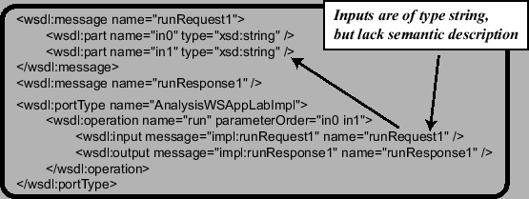
Figure 1: Basic Local Alignment Search Tool (BLAST) Interface Excerpt
Other relevant initiatives are DAML-S and BioMOBY, which we cannot describe here due to space constraints. Both approaches offer some form of semantic annotation, but are restrictive, in particular, because they are not compatible with the UDDI standard.

3. Extending Service Descriptions
Having discussed the limitations of existing technologies, we now focus on the capabilites of our service directory. Specifically, we look at the ways of attaching ratings and functionality profiles to services, and semantic types to operation arguments. Our presentation is based on examples that were generated by dumping the contents of our service directory. The notation adopted in the presentation is N3 format [1].
In Figure 2, we show the representation of a service annotated by two numerical ratings, with different values, and provided by different authors at different time. The node b1 of the linear representation is anonymous node denoting the service with the metadata attachment of type ``NumericRating''.
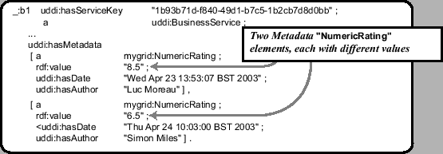
Figure 2: Rating Attachment (N3 Notation)
In myGrid, we describe services by a service profile [13] specifying which kind of method they use (uses_method), which task they perform (perform_task), which resources they use (uses_resources) and what application they are wrapping (is_function_of). A relevant excerpt of the service directory contents is displayed in Figure 3, with b1 denoting a service and Pe577955b-d271-4a5b-8099-001abc1da633 the ``myGrid profile''.
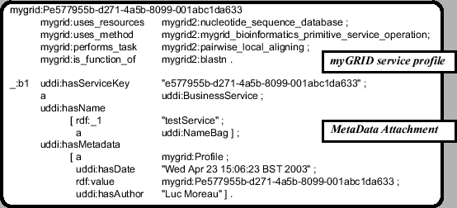
Figure 3: Attachment of a myGrid profile (N3 Notation)
In Figure 4, we show a semantic description of parameter in0 declared in the interface of Figure 1. The node rdf:_1 denotes the message part with name in0. It is given a metadata attachment, with value mygrid2:nucleotide_sequence_data, which refers to a term in an ontology of bioinformatics concepts [13].
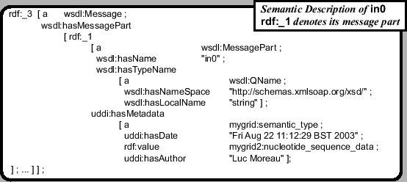
Figure 4: Attachment of Semantic Types to Arguments (N3 Notation)

4. Service Directory Interfaces
We have adopted RDF triples [11] to represent all descriptions of services, which we store in a triple store [7]. We have designed and implemented a set of interfaces to this triple store in order to offer a service directory functionality. In this section, we present the methods that are relevant to metadata attachment.
The interfaces to publish metadata and discover services according to metadata were designed in a similar style to the UDDI interface, so that UDDI clients could easily be extended to support such features. As an illustration, Figure 5 shows some of the methods that allow the attachment of metadata, respectively to a business service, to a business entity and to a message part. All these methods not only attach some metadata to the respective entity, but also add some provenance information such as author and date of creation. The associated metadata can be structured or unstructured. Symmetrically, services can be discovered by using metadata filtering mechanism. An example of metadata-based search method appears in Figure 5.
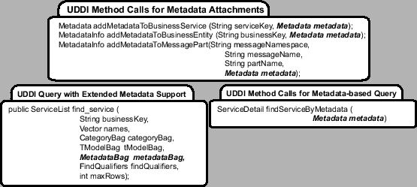
Figure 5: Metadata Attachment Methods
As all the information is represented in a triple store, a more direct interface to the triple store allows users to query the service directory using the RDQL query language [7]. An API that allows users to store triples in the triple store is also provided.
Several interfaces currently provide access to our general information model. Some of them preserve compatibility with the existing standards UDDI, and ensure inter-operability within the Web Services community. Others, such as the interface to the triple store, directly expose the information model, and offer a powerful and radically different way of discovering services through the RDQL interface. While such functionality is very useful, its radically different nature does not offer a smooth transition for clients implementors wishing to adopt semantic discovery.
The benefit of our approach is the ability to extend some existing interfaces in an incremental manner, so as to facilitate an easier transition to semantic discovery for existing clients. For instance, we have extended the UDDI find_service method to support queries over metadata that would have been attached to published services. In the method specification of Figure 5, metadataBag, a new criterion for filtering services is introduced, which contains a set of metadata that a service must satisfy.

5. Conclusion
In this paper, we have presented a mechanism to publish semantic descriptions about services in order to promote semantic inter-operability. Our approach relies on a metadata attachment mechanism, capable of attaching metadata to any entity within a service description. Such metadata need not be published by service providers but can be published by third-party users. Our design extends the standard interface UDDI to provide semantic capabilities, hereby offering a smooth transition to semantic discovery for UDDI clients. We have used these facilities to register service descriptions as specified by the myGrid ontology [13]. Our future work will focus on providing service descriptions to Grid services.

Acknowledgement
This research is funded in part by EPSRC myGrid project (reference GR/R67743/01) and supported by GRIDNET. Keith Decker from the University of Delaware was on sabbatical stay at the University of Southampton when this work was carried out. We acknowledge Carole Goble, Phillip Lord and Chris Wroe for their comments on the paper.

References
- Tim Berners-Lee. Notation 3. http://www.w3.org/DesignIssues/Notation3, 1998.
- Tim Berners-Lee, James Hendler, and Ora Lassila. The Semantic Web. Scientific American, 284(5):34-43, 2001.
- Paul V. Biron and Ashok Malhotra. Xml schema part 2: Datatypes. http://www.w3.org/TR/xmlschema-2/, May 2001.
- John Colgrave and Karsten Januszewski. Using wsdl in a uddi registry (version 2.0). http://www.oasis-open.org/committees/uddi-spec/doc/draft/uddi-spec-tc-tn-wsdl-20030319-wd.htm, 2003.
- DAML-S Coalition:, A. Ankolekar, M. Burstein, J. Hobbs, O. Lassila, D. McDermott, D. Martin, S. McIlraith, S. Narayanan, M. Paolucci, T. Payne, and K. Sycara. DAML-S: Web Service Description for the Semantic Web. In First International Semantic Web Conference (ISWC) Proceedings, pages 348-363, 2002.
- Java API for XML Registries (JAXR). http://java.sun.com/xml/jaxr/, 2002.
- Jena semantic web toolkit. http://www.hpl.hp.com/semweb/jena.htm.
- Phillip Lord, Chris Wroe, Robert Stevens, Carole Goble, Simon Miles, Luc Moreau, Keith Decker, Terry Payne, and Juri Papay. Semantic and personalised service discovery. In Proceedings of Workshop on Knowledge Grid and Grid Intelligence (KGGI'03), in conjunction with 2003 IEEE/WIC International Conference on Web Intelligence/Intelligent Agent Technology, page 8 pages, Halifax, Canada, October 2003.
- Simon Miles, Juri Papay, Vijay Dialani, Michael Luck, Keith Decker, Terry Payne, and Luc Moreau. Personalised grid service discovery. Technical report, University of Southampton, 2003.
- Massimo Paolucci, Takahiro Kawamura, Terry R. Payne, and Katia Sycara. Importing the Semantic Web in UDDI. In Web Services, E-Business and Semantic Web Workshop, 2002.
- Resource Description Framework (RDF). http://www.w3.org/RDF/, 2001.
- Universal Description, Discovery and Integration of Business of the Web. www.uddi.org, 2001.
- Chris Wroe, Robert Stevens, Carole Goble, Angus Roberts, and Mark Greenwood. A suite of daml+oil ontologies to describe bioinformatics web services and data. International Journal of Cooperative Information Systems, 2003.

Interoperability of Grid Resource Descriptions: A Semantic Approach
John Brooke, Kevin Garwood and Carole Goble
ESNW, University of Manchester, UK
j.m.brooke@mcc.ac.uk

Abstract
There is, as yet, no common standard for describing Grid resources. Different Grid middleware systems have had to create ad hoc methods of resource description and it is not yet known how well these can interoperate. We describe work in the Grid Interoperability Project (GRIP) that investigates the possibility of matching the resource descriptions provided by the GLUE schema and implemented in MDS-2 with the resource descriptions provided by the Abstract Job Object framework utilised by UNICORE and stored in the UNICORE Incarnation Database. From this analysis we propose methods of working towards a uniform framework for resource description across different Grid middleware systems.

1. Translation of Resource Descriptions
We describe here a semantic based approach to a particular problem which is becoming increasingly important in the area of establishing standards for interoperability in Grid middleware systems. The problem is now becoming more urgent as Grids are developed for production usage. Much work has been done in setting up Grids for particular purposes, e.g. the various Particle Physics DataGrids [1], Grids on heterogeneous architectures [2,3],Grids for running Application Services[3]. Such Grids have all had to face the key problem of how to describe the resources available on their Grids so as to enable higher-level functions, e.g. resource brokers, to discover resources on behalf of their clients. Furthermore such brokers may wish to delegate requests for resources between themselves, in order to facilitate Grid economies. Now within any Grid or Virtual Organisation there is often a great deal of implied knowledge. In the European Data Grid, for example, Virtual Organisations are created around particular experiments and it is possible to prescribe very precisely the type of hardware and software to be used. Since this is known and defined as part of the VO, it is possible to use this knowledge implicitly in writing workflows and jobs which have to be brokered. On the other hand, on a Grid uniting several organisations in a VO where the hardware and software may be heterogeneous, it is not possible to rely on assumptions such as software version numbers, performance of applications, policies and location of different parts of file systems (temporary storage, staging areas etc..). In this latter case such knowledge has to be made explicit at the local rather than VO level and must be interrogated by brokers and other high level agents.
The work described was developed in the Grid Interoperability Project (GRIP) [4] to create a broker which could interrogate on behalf of its clients two different resource schemas. One schema is the GLUE [5] schema used to provide a uniform description of resources on the Data Grids being developed in the US and Europe and to enable federation of VO in those projects for global analysis of data from particle physics experiments. The other schema is provided by the UNICORE framework [5], in particular the software model used to create local Incarnation Data Base entries, used to `ground' or `incarnate' Abstract Job Objects, which are sent around the Grid as serialised Java objects. The motivation for this second method of describing resources came from the needs of users on Grids with highly heterogeneous architectures running many different types of applications from legacy commercial applications available only in binary format, to sophisticated coupled models incorporating specialist machines (e.g. visual supercomputers). The motivation for providing interoperability between these two systems is that both are widely deployed in Europe (now also in the Asia-Pacific region) and federating Grids on a European level will ultimately face the problem of interoperability between them.

2. Resource Broker and Resource Requestor Spaces.
An important discovery in the preparatory stage of developing the interoperability service was that there exist two important sources of resource description in a Virtual Organization. One comes from the semantic spaces implicit in the Resource Requestors (RR) e.g. the clients and brokers looking for resources on behalf of their clients. The other comes from the semantic spaces implicit in the the Resource Providers (RP), the information services and protocols advertising resources in the VO. Any functioning broker must provide a mapping from RR to RP space since this is its primary function, to find the resources that match a users request for resource consumption. There can be a one-to-many mapping from the space of RR to the space of RP since each resource has its own RP space. In more sophisticated scenarios the RP space can recursively cast itself as an object in the RR space by passing on the resource request onwards as if it had become a Resource Requestor. See Figure 1 for an illustration of this process. In the case of collaborative working (e.g. Access Grid), however, there is a many-to-many model and the interactions of the RR and RP spaces are highly dynamic. The Grid abstraction is particularly useful for examining such complex usage patterns since it allows each physical resource in the Grid to be used in either an RR or RP context. Thus RR and RP spaces come naturally from the consideration of the implications of resource sharing in a Virtual Organization. A well-constructed Grid resource description schema such as GLUE or the UNICORE IDB, ensures that all of the resources and sites joining the VO can describe themselves in some uniform manner, which should be as complete as possible.
Designing an interoperable resource broker with a translator module as outlined above is a test in quite a deep sense of the completeness of the resource description schema of either system, if there are terms which are completely untranslatable between the two systems then at least one cannot be described as complete. A semantic approach can help to decide whether terms in either system really are untranslatable or whether they can be accommodated by a natural extension of either schema which does not break the coherence that the Grid relies on.

3. Translation Service for Resource Interoperability
In this paper we present a case study which provides a means of researching the general problem of interoperability outlined in Section 1. In the EUROGRID project [xx], a broker was developed which could take workflows described in the UNICORE AJO framework and brokered the sites on EUROGRID to received offers from those sites which could enact the workflow and provided mechanisms for this sites to return tickets describing the QoS policy they would offer. We wished to extend this broker to allow it to query the information publishing mechanisms in MDS-2 as well as the UNICORE mechanisms. The architecture is shown in Figure 1. The key components are the Network Job Supervisor which receives the AJO from the broker (our total brokering architecture is multi-tiered [xx}). In a pure UNICORE world the incarnation database is invoked to provide the translation between RR (the AJO) and RP (the detailed description of the resource). To ground the request on a resource or even a whole Grid using MDS-2, we need a translator to ground the AJO abstractions. This is a translation from an RR described in UNICORE terms to an RR described in MDS-2 terms and then Globus does the grounding within its own mechanisms. Note that some schema must be present since this is a translation between two spaces where resource is virtualised, or described in abstract terms, we chose GLUE because of its prevalence and importance in major Grid projects.
A working protoype was produced early in 2003. In this prototype the translator is limited to the terms in the selected AJOs and has to be augmented by hand as the range of AJOs is increased. This is essentially because the Ontology Engine part of the architecture does not exist. This neatly defined the next part of the work, to extract an ontology of resource description from UNICORE and GLUE separately and initially considering mapping of terms in a rapid prototyping phase. Note that this implies a back reaction on each ontology since semantics should come to light in the translation process which are implicit in each systems considered separately. This is indeed what was brought to light in the next phase.

4. Constructing and Mapping the Ontologies
To the best of our knowledge, this translation approach has not been attempted before in a Grid context. We therefore adopted the following procedure. Since the UNICORE abstractions are expressed in a hierarchy of Java classes we could extract an initial ontology from the JavaDocs that encapsulates the semantics in the classes and inheritance tree. We then applied the same approach to the documentation provided by the GLUE schema.
We needed a knowledge capture tool to construct the initial ontologies. We investigated the possibility of using a full Ontology Editor such as DAML-OIL. However this would have involved too much complexity for the scope of the GRIP project. We expected that the ontologies would change rapidly as we started to look at the process of mapping. Also, we considered that we needed to supplement what was in the documentation with the implicit knowledge of the developers which would have to be extracted via structured interviews. We decided to use the PCPack tool from Epistemics Ltd. It allowed us to rapidly compose the ontology, to express the provenance of the terms that we employ and to capture the mappings that we make in XML format. As these mappings are adjusted by the tools graphical interface, the XML is automatically updated. The XML files derived from the knowledge capture process will be used by the Ontology Engine in Figure 1. We show a part of the UNICORE AJO structure captured by PCPack in Figure 2

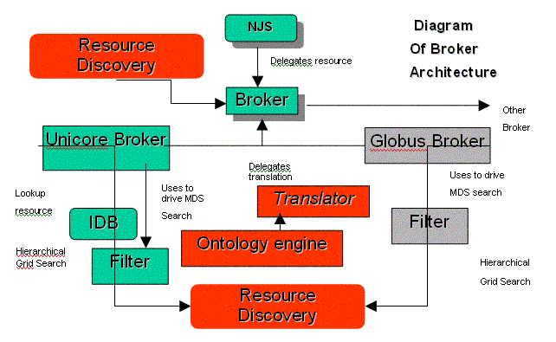
Figure 1: The architecture of the resource broker with a translator mapping from a UNICORE AJO to an LDAP search of the MDS-2 information services

When we came to examine the GLUE schema we found a fundamental difference of philosophy to the UNICORE approach. GLUE models the physical resources available and their dynamic capabilities (loading etc). This dynamic information is not currently provided in the UNICORE IDB, it would have to be requested by the resource broker by launching an AJO that queried the status of the queues for example. On the other hand the GLUE schema we examined does not have a description of Software resource which may be required in a Grid where many differen The intersection of the UNICORE resource description universe with the GLUE resource description universe is represented in very schematic form in Figure 3.
We now show how we have derived an ontology from the GLUE schema. Figure 4 shows a screen dump from PCPack with the GLUE hierarchy.
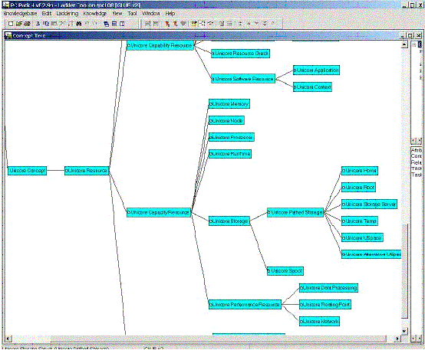
Figure 2: Part of the UNICORE Ontology derived via PCPack
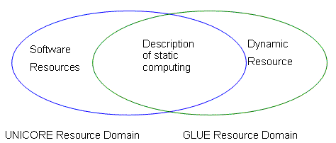
Figure 3: Diagram showing the intersection of the UNICORE and GLUE resource domains
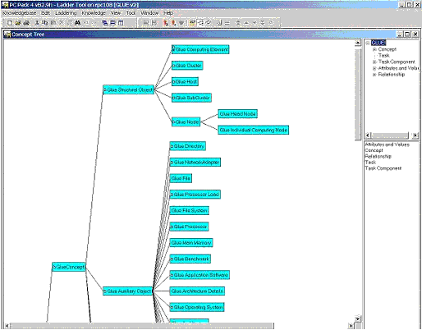
Figure 4: The Glue Ontology in PCPack
We then added provenance for each of the leaves in the tree. This shows how we can justify our semantic definitions in terms of the original GLUE schema.
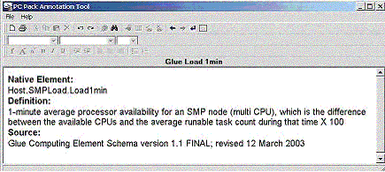
Figure 5: The provenance of one of the terms in the GLUE ontology. This refers to a dynamic resource, SMPLoad, that does not currently exist in UNICORE.
We are now read to describe the translator tool which will map between the ontologies (next section).

4. Ontology Mapping between UNICORE and GLUE
PCPack is able to output XML documents that encapsulate the knowledge in the UNICORE and GLUE ontologies. We used this XML for input into a translator program. We have just recently managed to incorporate this into the architecture shown in Figure 1. We show a snapshot of the running program in Figure 6. Using this tool we can rapidly explore mappings between the ontologies and encapsulate these as XML documents. These can then be used by the ontologically driven translator service shown in Figure 1.
Since the intention is to move the information in the UNICORE IDB and UUDB to XML format, we can see that the architecture is becoming consistent. The ontology also exists in XML and therefore can be integrated in the whole incarnation process. Thus the fundamental basis of the UNICORE architecture is respected and the great flexibility and extensibility of the incarnation process is revealed.
We now intend to use the tool developed in Figure 5 for discussions with the GLUE and UNICORE developers. The Grid Resource Ontology would inform the development of a genuinely semantic Grid Resource Description Language.
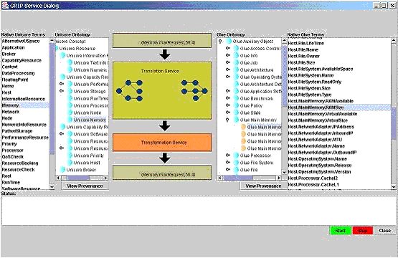
Figure 6: The translator service. On the left is the UNICORE ontology terms, on the right the GLUE ontology and the translation workflow is in between.

6 Future work
We need to further develop the tools outlined in Section 5. The creation of this service is an important driver for a future Semantic Grid. We would estimate that the development of an agreed Grid Resource Ontology will take 18 months to 2 years. However by demonstrating this partial ontological mapping we have at least moved the process out of the realm of theory into practice.
The development of a Grid Resource Ontology will transform services such as resource brokerage and resource discovery. For scalable and dynamic virtual organisations these are essential tools. At present we can only achieve any sort of Grid scaling by imposing homogeneity of resources on a VO. Thus in the EU DataGrid and Cern LCG (probably the largest production grids currently operating) the VO policy in terms of operating system, versioning of Grid software, hardware deployment and architecture is prescribed. This is a valuable experiment in scaling but it is not the future of Grid Computing, whose particular domain is the seamless integration of heterogeneous resources. We believe that our fledging semantic translation service is a small but vital step on this road.

Bibliography
- e.g. Datagrid, http://www.datagrid.org
- e.g. UK Level 2 Grid, information available from the UK National eCentre, http://www.nesc.ac.uk
- EUROGRI, http://www.eurogrid.org
- Grid Interoperability Project, http://www.grid-interoperability.org
- Condor - tools for high-throughput computing, http://www.cs.wisc.edu/condor/

Interoperability Challenges in Grid for Industrial Applications
David De Roure
Electronics and Computer Science
University of Southampton, UK
dder@ecs.soton.ac.uk
Mike Surridge
IT Innovation
University of Southampton, UK
ms@it-innovation.soton.ac.uk

Abstract
The vision of the Grid Resources for Industrial Applications (GRIA) project is to make the Grid usable for business and industry: it enables Grid service providers and consumers to come together within a commercial business environment. This brings a strong requirement for a secure and interoperable Grid system which is open at the standards level, makes use of third-party components and can be used by other Grids. The intention is that the system should employ flexible negotiation techniques to enable other parties to join with ease. This raises a spectrum of interoperability challenges, some familiar (resource description, workload estimation, quality of service) but others which are evidently beyond current off-the-shelf solutions. These include representing quality of service for collections of related jobs which are embedded in complex business processes, and the need to describe the semantics of multiparty negotiations including hierarchical conversations. In this paper we describe the GRIA vision and approach, and highlight some of the challenges.

1. Introduction
The Grid Resources for Industrial Applications (GRIA) project has the clear but challenging aim of making the Grid usable for business and industry. This focus distinguishes GRIA from the many academic Grid infrastructures that are under development in the Grid community. The critical issues for business users include security, service levels and interoperability as high priorities. GRIA is funded under the IST programme of the European Commission, and brings together five organisations, three of whom represent the stakeholders in GRIA's vision of a business deployment of the Grid.
In this paper we focus on interoperability, which is our motivation for adoption of Semantic Web technologies. The interoperability challenge is twofold: GRIA aims to make use of third party components and services, and aims to be used by other Grids. To do this it must be open at the standards level. The ease with which interoperability is achieved is the measure of success of this aspect of the project. At one end of the spectrum we could expect third parties to comply with GRIA, at the other we expect GRIA to comply with the rest of the world.
In this paper we first introduce the GRIA approach, then we identify some exemplar interoperability challenges.

2. A Grid for business
The parties that come together within GRIA include people who wish to buy computational resources and those who wish to provide them. The resource could be a general purpose Grid such as a managed PC cluster. However, it might relate to a specific Grid application in which the provider has expertise. By way of example, imagine an organisation which runs a computationally intensive application as part of its routine business: there may be times of peak demand when this service wishes to outsource some of that computation to another provider; there may also be times when they have spare capacity and are prepared to sell their application service to external customers as a value-added service, or simply to make their high performance computing facility available for external use.
For each computation that a customer wishes to run, GRIA enters several phases:
- Firstly it identifies available resources which may be appropriate for this job;
- It then negotiates access to these resources and agrees service levels;
- The service is then performed and the outcome determined;
- At some stage, the job is billed to the customer's account.
It needs to do this in a way that is compliant with the business processes (and e-business processes) of the companies involved.
Significantly, the GRIA systems itself does not need to operate the computational resource that is used to run the service - it only needs to have sufficient knowledge of the resource in order to perform the above negotiations and agreements. This is analogous to a company issuing quotes for a service without actually reserving the necessary resources at the time of the quotation; i.e. standard practice. This has an important implication on the system design: the GRIA software runs on a computer somewhere within an organisation and not run on the cluster itself.
The GRIA partners provide case studies in this approach. CESI runs a structural analysis application as part of their energy business; similarly, KINO performs post-production tasks within movie production, such as scene rendering and image enhancement. Meanwhile Dolphin are a supplier of high performance computing - they sell products and also, in GRIA, offer a service based on those products. Hence the partners are providers and users in the extended enterprise scenario described above.

These scenarios raise several challenges for GRIA:
- We need to address message security: messages need to be encrypted/decrypted at the appropriate boundaries within the GRIA architecture;
- Authentication and integrity checking is needed for the various parties
- A dynamic authorisation service is needed in order to enforce business workflows and exclude unwanted clients;
- We need capacity management which does not rely on managing the resource pool - the expected behaviour is represented via `pseudo reservation';
- As well as application services, we need negotiation services.

3. Quality of Service
When you wish to send a package by a courier agency, you do not need to specify the details of how your requirements will be implemented by the agency - you simply say how big and heavy the package is, how soon it must arrive and how much you are willing to spend. Similarly, in GRIA, the users submit their jobs with a set of requirements, including the deadline for the execution of the job.
At one end of the spectrum of quality of service (QoS), a system might not take into account these requirements - it will simply run the job with the available resources, without utilising reservations. This is `best effort' QoS. At the other end, the system might reserve all the required resources in order to meet the user's requirements.
In practice, we establish a QoS agreement. The user submits the job with some specific requirements, and the system responds to say whether it can satisfy the requirements. It does this by taking into account the available resources, the other jobs running and the expected future job submissions. There is then a negotiation between the user and the system, in order to arrive at an acceptable level of QoS.
In order to obtain this QoS agreement, it is necessary to predict the execution time of a submitted job on each resource. This can be accomplished by a performance estimation service which, in GRIA, is divided into two parts:
- Workload Estimation. This occurs on the consumer's (client's) side. The execution time of a job, memory usage and disk space requirements are estimated using application specific parameters.
- Capacity Estimation. This occurs on the supplier's (server's) side. The capacity to do the job is estimated using resource specific parameters.
These estimations are represented as vectors containing 10 load parameters which cover CPU, memory, disk, data transfer and network transfer.

4. GRIA interoperability challenges
GRIA is in many ways very conservative, yet it is also adventurous: it uses off-the-shelf e-Commerce technology, and semantic web/semantic grid to do business! In this section we consider three scenarios which raise interoperability challenges.

4.1 Example 1 - querying 3rd party providers
I want to run a very large finite-element analysis, 100000 DOFs, fully dynamic treatment, and I need the result in one hour.
My GRIA client can figure out 10 workload parameters and establish which GRIA service providers can deliver the necessary computation. But none are able to finish the work in the time I need!
I know EPCC carry FEM codes running under GT3, and Stuttgart supplies services over UNICORE to several automotive customers. My needs are small by their standards - but do they have enough spare capacity to meet my deadline, and can I use them?
Question: How can I query other service providers who don't use the same resource and load representations as my grid infrastructure? If they can meet my needs, how will my client-side application submit jobs to their services?
This first challenge is about representing quality of service. We cannot expect everyone to comply with the client's particular representations, but we can expect people to adopt one of a number of available open standards. Hence we need to interoperate between these.
The load and resources vectors are well researched in the Grid community, and in GRIA we have been able to represent these in a variety of ways and demonstrate how we would go about achieving interoperability with other representations. This interoperability issue is also enjoying attention in the GRIP project [1].
This problem becomes more challenging when we need to deal with collections of related jobs (i.e, processes) instead of single jobs.

4.2 Example 2 - multiple related workloads
I work for KINO, and I am making a commercial. KINO is based in Athens and handled much of the TV advertising for the 2004 Olympic Games. Now we are bidding for more business in this lucrative promotional sector, and we need to create a high quality sample as part of our bid. The set is the Olympic Village at the 2012 Games - which doesn't exist yet!
I need a 60-second sequence showing athletes preparing for the final day of competition, and my client (the artistic creator) wants several complete scenarios featuring different athletic events from which to edit the final cut.
I need to render 4500 high-definition frames based on an architect's model. I need the results first thing tomorrow morning, and my budget is only $15 for this job.
Three service providers can meet my needs. One will charge $0.10 per frame, but can handle 25000 frames for overnight delivery. There are cheaper suppliers, and my in-house systems can do it for free (but only if nothing else is running).
Question: how much service should I buy from each service provider, with what cancellation options, and where should I arrange output to be delivered?
Here we have moved from single jobs to combinations of jobs - which may be described as a process. There may be some common inputs, some input-output dependencies and some scope for concurrent execution.
To address this we have been exploring workflow/process representation. It is easy to create and enact (e.g. WSFL) representations, but we cannot reason about them and negotiate QoS. Although there are efforts in this space, such as the vision of OWL-S [2] as regards processes, our experience in GRIA is that there is no off-the-shelf solution to these requirements at this time.
Furthermore, these processes may be embedded in complex business processes, as illustrated by the next example.

4.3 Example 3 - embedding in business processes
Our friend from KINO is desperate. The usual supplier can't take on the excess work after all, and he needs to find other service providers. There are a couple of new guys on the block, but they don't use the normal tender/order/deliver/invoice process:
- The National Technical University of Athens provides access to rendering codes. They post Condor class ads describing resources and assign them to the highest bidder using an auction protocol.
- The local cable company provides rendering services on their digital video on demand servers during off-peak periods. However, they allow access only to signed-up clients, who can then submit jobs with no QoS negotiation. Delivery is on a `best efforts' basis, and tariffs depend on when each computation is submitted and when the result is needed.
Question: how can KINO's grid-enabled virtual digital studio environment seamlessly adapt to these new business models?
Currently GRIA takes a conservative approach to business processes, reproducing established procurement processes such as invitation to tender, proposals, orders, invoices, etc. We envisage a number of negotiation models, from the lightweight (best-efforts, no negotiation) to the highly specified Service Level Agreement, which may be the subject of iterative negotiation.
We want GRIA to handle arbitrary business processes. To do this we need to represent processes and conversations, including multiparty conversations. The GRIA system has a hierarchical conversation model which does not assume a globally agreed namespace (it uses an `our-ref, your-ref' model). In fact the most relevant work that can deal with the conversations between the various entities, and the negotiation possibilities, is in the field of agent-based computing [3].
We are currently investigating the use of FIPA [4] to represent conversations, a similar approach to that adopted in TAGA [5] where the messages are represented using OWL [6].

5. Conclusions
In this paper we have provided an overview of the GRIA approach and presented three scenarios which illustrate the challenges. What we are doing in GRIA is very much part of the Semantic Grid picture - it can be seen as the Semantic Web in the Grid rather than on the Grid, i.e. we are focusing on systems interoperability rather than the discovery and interoperable use of domain specific data. This work also raises questions about the relation ship between the Semantic Grid and business - we see Grid services as an extended enterprise. Figure 1 illustrates this relationship from the perspective of the `layer cake' approach.
GRIA is ultra-conservative and we are applying very basic business processes using off-the-shelf technology. However, even this leads to profound questions for the Semantic Grid:
- What are the standard ways to represent and compute QoS?
- How do we represent, and reason about, multiple related jobs?
- How do we interoperate even with simple negotiation mechanisms?
We suspect a combination of methods are needed, including semantic web representations, agents and autonomous reasoning and adaptive behaviour.
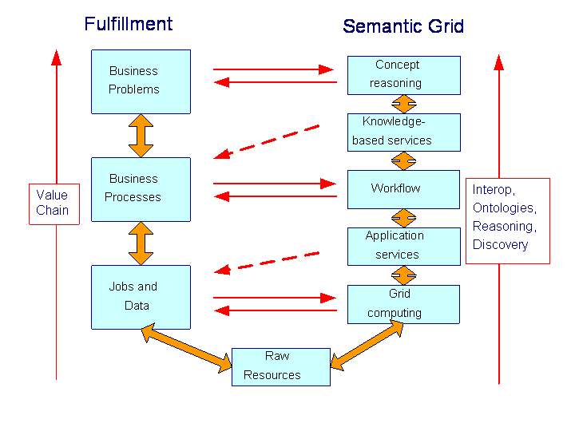
Figure 1: Business fulfilment and the Semantic Grid

Acknowledgements
GRIA is an IST project (Project Number 33240) funded by the European Commission and coordinated by IT Innovation, University of Southampton, UK. The authors acknowledge the contributions of the other GRIA partners: National Technical University of Athens, Dolphin, CESI and Kino. We are grateful to Terry Payne for discussions about OWL-S.

References
- Grid Interoperability Project, http://www.grid-interoperability.org/
- DAML Services, http://www.daml.org/services/
- C. Bartolini, C. Preist and N. R. Jennings (2002) "Architecting for reuse: A software framework for automated negotiation" Proc. 3rd Int Workshop on Agent-Oriented Software Engineering, Bologna, Italy, 87-98.
- Foundation for Intelligent Physical Agents (FIPA), http://www.fipa.org/
- Youyong Zou, Tim Finin, Li Ding, Harry Chen, and Rong Pan. TAGA: Trading Agent Competition in Agentcities, IJCAI-03 Workshop on Trading Agent Design and Analysis, August 2003.
- OWL Web Ontology Language Guide, see http://www.w3.org/2001/sw/WebOnt/

Semantic Grid and Pervasive Computing
David De Roure
Electronics and Computer Science
University of Southampton, UK
dder@ecs.soton.ac.uk

Abstract
The notion of the Grid comes from analogy with the electricity utility, but the interface need not stop at the socket on the wall - the Grid has a more pervasive coupling with the physical world. Pervasive Computing benefits Grid users, such as the e-Scientist in the smart chemistry laboratory or those participating in future advanced collaborative environments; meanwhile the Grid benefits those wishing to process the higher volume of sensor data captured by pervasive devices, such as in environmental monitoring applications or wearable devices. Both share a service-based approach and we can ask how far a middleware architecture designed for the Grid, like OGSA, can be pushed towards the devices; we can also ask how to facilitate assembly of components to meet application requirements. Semantic Web technologies help with service description, discovery and composition in pervasive computing as they do in grid computing. In e-Science they also help describe the rich set of relationships between different data - a vision known as "publication at source" and this extensive digital capture can be assisted by pervasive devices. The paper is illustrated by examples from the CombeChem and CoAKTinG projects, which foresee total digitization of the scientific process using Semantic Grid and pervasive computing technologies.

1. Introduction
Pervasive Computing is the means by which the digital world of the Grid couples into our physical world. This paper presents a case for combined work on grid and pervasive computing, and for a semantic approach to both.
The paper is structured around the triangle of Figure 1, looking at each side in turn. In section 2 we consider the Grid and Pervasive axis - in each direction. We then move up: in section 3 we consider the Semantic Grid side and in section 4 we look at 'Semantic Pervasive'. Section 5 considers the whole vision and section 6 looks at how it is being applied in a case study. We finish in Section 7 with some closing remarks.
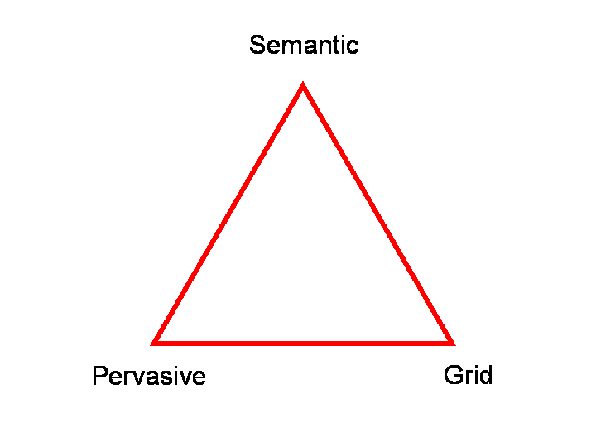
Figure 1: The Pervasive Semantic Grid Triangle.

2. Grid and Pervasive
Moore's Law tells us that if you keep the box the same size (the desktop PC, for example) then it will get increasingly powerful over time. If you want the same power then you can work with smaller and smaller devices - and more of them. We observe that, broadly, this gives us the world of the Grid and the world of pervasive computing, respectively.
Pervasive or ubiquitous computing is about devices everywhere; e.g. in everyday artefacts, in our clothes and surroundings, in the external environment. The term ubiquitous was adopted by Xerox through the work of Mark Weiser[1], who emphasised the 'calm' aspects, where the computing is everywhere but 'stays out of the way'. In Europe, pervasive computing is part of the Ambient Intelligence vision.
Some of our grid applications involve pervasive computing, including the coupling of sensors to the grid (such as in Sensor Networks, or a 'smart laboratory'), signal processing based on data from wearable devices, and the use of collaboration technologies. So the Grid does not necessarily present itself as a socket on the wall (like the electricity utility after which it is named) - it has a more pervasive coupling with the physical world, through what might be described as 'grid appliances'. If the Grid is the "back end" then the devices are the "front end" by which we interact with the Grid and by which data is collected. In other words, pervasive computing provides the manifestation of the Grid in the physical world.
Sometimes it is the Grid application that demands the pervasive computing and sometimes the pervasive computing that demands the Grid. In the former category would be the "grid-enabled" devices in a laboratory - the pieces of scientific equipment connected directly to the grid - and also the handheld devices with which users gather information and access results. Devices, such as novel interfaces, may also be deployed to support the collaborative environment, perhaps facilitating visualisation and annotation of data. In the category of pervasive computing that demands the Grid we have the sensor networks - as sensors and sensor arrays evolve, we can acquire data with higher temporal or spatial resolution, and this increasing bulk of (often realtime) data demands the computational power of the Grid. Meanwhile many pervasive deployments are currently small scale, due to small numbers of devices or small numbers of users, but will demand more grid processing as numbers scale up.
By way of example, both aspects come together in a project in which patients who have left hospital are monitored using wearable computing technology. Since the patient is mobile, we gather position and motion information (using devices such as accelerometers) to provide the necessary contextual information in which to interpret the physiological signals. The signal processing occurs on the Grid and medics are alerted - by pervasive computing - when the patients experience episodes that need attention.[2]
Both Grid and Pervasive computing are about large numbers of distributed processing elements. At an appropriate layer of abstraction, both grid and pervasive computing involve similar computer science challenges in distributed systems. These include service description, discovery and composition, issues of availability and mobility of resources, autonomic behaviour, and of course security, authentication and trust. Both need ease of dynamic assembly of components, and both rely on interoperability to achieve their goals. The peer-to-peer paradigm is relevant across the picture.
This abstracted view blurs the boundary between the Grid and the devices. For example, we can ask to what extent we can push the computation from the Grid back towards the devices? And to what extent can we achieve commonality in the middleware; e.g. how far can the grid services architecture be applied towards the devices side of the picture? We can envisage grid services relating to the sensors, be they pollution monitors, physiological signals, motion or location information.
There is a fundamental trade-off that is being explored here. On the one hand the computational power and storage capability of our portable devices increases as the technology improves. But at the same time we move into a world in which our devices can delegate storage and computation to the Grid, perhaps in real-time through greater connectivity and devices which are increasingly 'always on'. We suspect there is no one correct answer - the best solution for a given application can be clear, and in general we do need to explore both routes.
Perhaps most profoundly, Grid computing and pervasive computing are two visions of the future that really do seem to be upon us, and so surely they must be investigated together rather than in isolation.

3. Semantic Grid
In the Semantic Grid [3] we argue for the application of Semantic Web technologies to grid infrastructure and applications - the right hand edge of the triangle. The increasing extent of discussion about metadata within the Grid computing community is evidence that the Grid is increasingly concerned with issues of metadata and metadata management. The Semantic Web offers tools and techniques to address this.
The Semantic Grid 'holy grail' could be dynamic assembly of Grid components (software, services, data, knowledge) to meet the requirements of the Grid application and users. This requires everything to be machine-processable, i.e. metadata everywhere, with an agreed interpretation. We have argued that the full richness of the e-Science and Grid visions require this.
The Semantic Grid reality is that there are some things we can do now and some things which are still research topics. Clearly we should move towards a 'metadata-enabled' world as soon as we can, as this is a prerequisite for the sophistication of the full vision. The relevant technologies, such as the Resource Description Framework, are available for this. Meanwhile we can track the developments such as the OWL Web Ontology Language and the tools that are emerging to support it. This dual approach is adopted by the Semantic Grid Research Group in the Global Grid Forum.
Some applications of Semantic Web technologies in Grid applications are well aligned with the research and development activities in the Semantic Web community, most notably in areas such as bioinformatics where there is established use of ontologies. However, the application of Semantic Web technologies inside the grid infrastructure is less well developed. The emerging work on Semantic Web Services [4] is synergistic with this aspect of the Semantic Grid, reinforced by the adoption of a service-oriented approach in the Grid through the Open Grid Services Architecture [5] (OGSA).
There is increasing activity in the Semantic Grid arena, with an increasing number of research and development projects. The latest information on Semantic Grid activities can be found on the community portal www.semanticgrid.org.

4. Semantic Pervasive
We can also argue the left hand edge of the triangle - that the full richness of the pervasive vision also needs the Semantic Web technologies. Again this is about semantic interoperability. A key motivation for the semantic interoperability on the Grid is the need to assemble new Grid applications with ease (and preferably automatically), and surely we wish to do this with pervasive applications too. Essentially we have lots of distributed bits and pieces that need to work together to provide the requisite global behaviour, and we wish this to happen without manual intervention. This move towards a more autonomous approach might be achieved through the techniques of agent-based computing, and in the future we look towards self-organisation. This is the vision of autonomic computing.
Again we need service description, discovery and composition, and indeed research areas such as Semantic Web Services are being applied both to Grid and to Pervasive computing. However, semantic interoperability applies to content as well as services and it is clear that pervasive computing research and development projects do not always address these information and knowledge issues - in fact they pay less attention to such issues than Grid projects, which more often are motivated by information processing requirements.
The picture is improving with standards for representing e.g. sensor data, but we need the metadata too - for example, we need to achieve semantic annotation with context information at source. So metadata schema need to be established. To enjoy the promise of the Semantic Web we also need a means of creating and sharing URIs to get the added value of linking up disparate metadata via the objects it describes realizing the 'network effect'. Interestingly there's a whole new way of tying 'stuff' together here in the pervasive world because physical objects and physical space provide further ways of associating the disparate metadata.
We have suggested that pervasive computing needs the Semantic Web. We believe the converse is also true. One of the fundamental obstacles to realising the Semantic Web vision is that it requires metadata, and if we expect users to create that metadata then that in turn is a fundamental obstacle. Hence we need to automate metadata capture as far as possible: We need to take it out of the hands of the users and look instead to the pervasive computing devices to do the dull work. This is part of the total digitization discussed in Section 6.
As with Semantic Grid we will certainly find that we are pushing the Semantic Web technologies quite hard. For example, current solutions (such as triple stores) tend to favour a world of fairly static metadata - grid applications challenge this, and pervasive more so. There is much important work to be done on this edge of the triangle.

5. The Pervasive Semantic Grid
Let us consider all three - the full richness of the grid, pervasive and semantic visions. There are people who will argue that each of these futures will surely happen, and here we argue that there are clear reasons why they need to happen together. It follows that we need to be exploring that combined world - the whole triangle. Through combining grid and pervasive and semantic we see a comprehensive infrastructure for the vision of 'ambient intelligence'. It is the manifestation of the Semantic Grid in the physical world.
Exploring these three visions together requires working across at least three communities. With Semantic Grid we bridge the Web and Grid communities, for the "Semantic Pervasive Grid" we touch the devices and the next generation of the pervasive networking infrastructure too.
A number of projects are driving this forward, including the UK e-Science projects connected with the IRCs (Interdisciplinary Research Collaborations) and some under the Ambient Intelligence banner. As with Semantic Grid, we also need to put in place the community mechanisms to enable this all to happen. Organisations such as the Global Grid Forum (GGF) provide the necessary environment for agreement about those schemes that will provide interoperability. At the time of writing it is not clear what the equivalent body would be for 'semantic pervasive' computing?

6. Annotation and Publication at Source
The Semantic Web has become known for its focus on ontologies. However, there is a very fundamental part of Semantic Web philosophy that is all too often neglected and it is an extremely powerful part of the Pervasive-Semantic-Grid vision. This is the network effect that is achieved through everybody annotating the same URIs with their own metadata, such that the URIs then effectively link this metadata together, increasing its value. As mentioned in section 4, a similar grounding and linking can occur through spatial and temporal references, which is highly relevant in many pervasive applications.
For example, in the smart chemistry laboratory, we can use pervasive computing devices to capture live metadata as it is created at the laboratory bench or in the fume cupboard. As experiments occur we automatically record the data and metadata at source - and we use the devices to relieve the chemist of the burden of metadata creation. We refer to this as 'annotation at source'. This data then feeds into the scientific data processing - new data is derived from it, analysis occurs, as in Figure 2. All usage of the data is effectively an annotation upon it. If we can make sure everything is linked up through the shared URIs then scientists wishing to use these experimental results in the future can chase back to the source; i.e. the provenance is explicit. This is demonstrated in the World Wide Molecular Matrix [6] and we are investigating the pervasive and HCI aspects of this this in the Comb-e-Chem project through Smart Tea. [7]
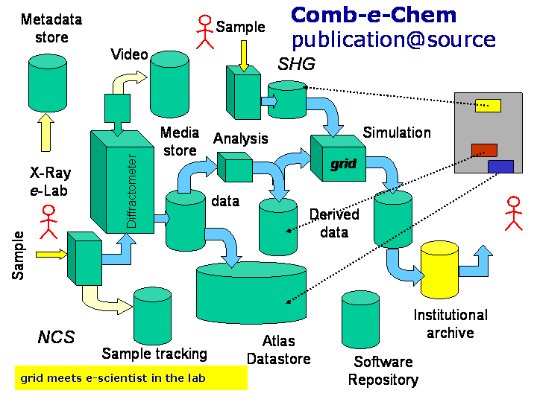
Figure 2: Publication at Source in CombeChem.
In the Access Grid we also see annotation at source - people taking notes, writing on a whiteboard, speaking, entering and leaving the room, etc. For this to be useful in the Semantic Web sense we need this annotation to create metadata with a known semantics. In the COAKTinG project [8] we are using a meeting room ontology to achieve this, with minutes being taken using a tool called Compendium which annotates the meeting with higher level events. Meetings are recorded with all their annotations, and these recordings then become a resource which can, for example, be replayed in a customised fashion in subsequent meetings. In a future case study, we will be bringing this together with the aforementioned chemists in the lab.
The scholarly communications that are part of the scientific process are profoundly affected by the "publication at source" vision we describe here, in which experimental results can be made available with their associated data and the full information on the pipeline of processing that has occurred. In addition to data and papers, it is also possible to capture the entire digital discourse that occurs as part of the scientific process, and to incorporate this too into the densely interlinked outputs. This is a new approach to publication and it challenges the existing models of data repositories and scientific journals.

7. Closing remarks
This paper has argued a case based on engineering - to build the systems we need to build, these are the technologies we need. The measure of success of the Semantic Grid, and of pervasive/ubiquitous computing, and of semantic pervasive etc, is that we have succeeded when nobody knows the system is there!
However, the real motivation for grid computing is the new science - and arts and humanities - that we can achieve with the power and scale of our computers. That is why we want to build the grid applications in the first place. Remember also the power of pervasive computing - such as new ways to augment our experience and improve our quality of life (and of course to assist those scientific discoveries). Those increasingly powerful devices coupled to the increasingly powerful grid fabric are increasingly capable of knowledge processing. Think about that world of knowledgeable devices.
Finally, we should challenge the "disappearing computer" and the aspiration to "seamlessness". Let us use these technologies to do new, interesting, creative and enjoyable things - to provide the e-researcher with new interfaces and artefacts to support their work.

Acknowledgements
This work is partially supported through the UK EPSRC e-Science programme grants Comb-e-Chem (GR/R67729/01), CoAKTinG (GR/R85143/01) and Grid-based Medical Devices for Everyday health (GR/R85877/01), the Equator (GR/R85877/01) and Advanced Knowledge Technologies (GR/N15764/01) Interdisciplinary Research Collaborations, and an an IBM Faculty Partnership Award. The talk on which this paper was originally based was given by the author at the IPv6 Global Summit in Madrid, June 2003.

References
[1] Mark Weiser, "The Computer for the Twenty-First Century," Scientific American, pp. 94-10, September 1991
[2] Grid-based Medical Devices for Everyday Health, http://www.equator.ac.uk/Projects/E-Science/mias.htm
[3] D. De Roure, N. Jennings, and N. Shadbolt. "Research Agenda for the Semantic Grid: A Future e-Science Infrastructure". Technical report UKeS-2002-02, UK e-Science Technical Report Series, National e-Science Centre, Edinburgh, UK. December 2001.
[4] Semantic Web Services Initiative, http://www.swsi.org/
[5] Open Grid Services Architecture (OGSA), http://www.globus.org/ogsa/
[6] World Wide Molecular Matrix, http://wwmm.ch.cam.ac.uk/
[7] Smart Tea, http://www.smarttea.org
[8] CoAKTinG, http://www.aktors.org/coakting/

