GRID Transaction Management Research Group:
Report

Status of this Memo
This document provides information to the community regarding the use of transaction capabilities in a GRID environment. Distribution of this document is unlimited. This is a DRAFT document and continues to be revised.

Abstract
Successful realization of Grid environments may require the use of various transaction capabilities, such as transaction protocol engines and system and resources that can react to transaction stimulus (commands?). The aim of this interim report is to present the conclusions of the Transaction Management Research Group so far. The group is studying use case scenarios of both e-science and e-business applications. A companion Use cases documents describes transaction use cases for commercial infrastructure and application topics, scientific infrastructure and application topics, essential grid technologies, and working group use cases. The list of Grid use cases presented is necessarily incomplete. Also use cases are not described at the detail required for formal requirements. This report summarises the findings of the use case study, and draws tentative conclusions on ways of applying transaction concepts to the Grid environment. This includes an examination of some of the potential pitfalls and challenges in applying transactions capabilities in a typical Grid environment. It goes on to make recommendations for practical application of components, services and protocols.


GLOBAL GRID FORUM
office@gridforum.org
www.ggf.org

Full Copyright Notice
Copyright © Global Grid Forum (2005). All Rights Reserved.
This document and translations of it may be copied and furnished to others, and derivative works that comment on or otherwise explain it or assist in its implementation may be prepared, copied, published and distributed, in whole or in part, without restriction of any kind, provided that the above copyright notice and this paragraph are included on all such copies and derivative works. However, this document itself may not be modified in any way, such as by removing the copyright notice or references to the GGF or other organizations, except as needed for the purpose of developing Grid Recommendations in which case the procedures for copyrights defined in the GGF Document process must be followed, or as required to translate it into languages other than English.
The limited permissions granted above are perpetual and will not be revoked by the GGF or its successors or assigns.
This document and the information contained herein is provided on an "AS IS" basis and THE GLOBAL GRID FORUM DISCLAIMS ALL WARRANTIES, EXPRESS OR IMPLIED, INCLUDING BUT NOT LIMITED TO ANY WARRANTY THAT THE USE OF THE INFORMATION HEREIN WILL NOT INFRINGE ANY RIGHTS OR ANY IMPLIED WARRANTIES OF MERCHANTABILITY OR FITNESS FOR A PARTICULAR PURPOSE.

Intellectual Property Statement
The GGF takes no position regarding the validity or scope of any intellectual property or other rights that might be claimed to pertain to the implementation or use of the technology described in this document or the extent to which any license under such rights might or might not be available; neither does it represent that it has made any effort to identify any such rights. Copies of claims of rights made available for publication and any assurances of licenses to be made available, or the result of an attempt made to obtain a general license or permission for the use of such proprietary rights by implementers or users of this specification can be obtained from the GGF Secretariat.
The GGF invites any interested party to bring to its attention any copyrights, patents or patent applications, or other proprietary rights which may cover technology that may be required to practice this recommendation. Please address the information to the GGF Executive Director (see contact information at GGF website).
Contents
1 Introduction 4
2 The challenges of Transactions in a Grid Environment 6
3 Transactional Requirements 8
4 Overview of Current Transaction Protocols 11
5 Options concept - outline and applicability 16
6 Recommendations 19
7 References 20
8 Editor Information 21

Figures
Figure 1 A transaction tree 12
Figure 2 BTP components and sub-protocols 13

Introduction

Purpose of this document
The goal of this RG is to investigate how to apply transaction management (TM) techniques to Grid systems.

There are application areas that might not need transaction support, e.g. read only access to a data warehouse. A lot of other grid applications however would benefit from, if not require, transactional support. A common grid transaction service would contribute a useful building block for professional grid systems.

This research group is trying to identify and verify possible grid transaction approaches as well as potential technology to implement them. It focuses on finding the required solutions within existing specifications. For this purpose a close partnership with responsible groups handling the existing specifications is desired.

This Research Group provides a forum to track Grid transaction community activities and advise the Grid community on the application of TM technologies in Grid applications and infrastructure, to identify case studies and share good practice.

As an overall result of the research group there will be a set of information regarding transactional support in Grids to the GGF community.

The Projected Tasks in the TM-RG’s charter are:

1. Identify typical use cases of grid application scenarios involving transactional support.
2. Identify and document the requirements of TM within a Grid setting.
2. Identify appropriate existing transaction techniques and specifications that match these requirements.
3. Work out architectural approaches to integrate transactional support with other specifications, e.g. DAIS.
4. Provide a forum to discuss and share insights of Grid transaction management.
5. Work with other RG and WG (also outside of GGF) to both push Grid transactions, to offer a service of expertise and to ensure that TM meets the requirements of other Grid specifications

This document reports progress on meeting these goals and completing these particular tasks.

History of the group
The initial meeting was a birds-of-a-feather session about transactions in the grid, which took place at GGF10 on March 11th 2004 in Berlin. It was organized by a German group of people from universities and IBM. As a result of it was decided to found a research group in data area of GGF on transaction management. The group was initially chaired by Torsten Steinbach together with Jim Webber and Can Tuerker.

After agreeing on a group charter the team began to work on collecting use cases for transaction management in grid environment. The first results of this effort were presented by Jim Webber and Dieter Gawlick at the subsequent GGF11 in Honolulu on June 8th and 9th 2004. The next meeting at GGF12 in Brussels on September 22nd continued the presentation of these effort by presenting the trip support and eDiaMoND use cases to the audience.

While the use case collection continued the group started another effort to educate its members on existing transaction specifications using web services. For this purpose a sequence of three dedicated telephone meetings was arranged to present WS-Coordination/AT/BA (Ian Robinson, IBM), WS-CAF (Malik Saheb, Arjuna) and BTP (Tony Fletcher, Choreology) to the group.

The following meeting at GGF13 in Seoul was chaired by Dieter Gawlick and served mainly to attract more interest from people from Asian and pacific hemisphere.

Through all this time the main work of the group was done via telephone conferences. Whenever possible the group met in a each second week on Wednesday by phone to organize the work and track action items.

The challenges of Transactions in a Grid Environment

Introduction
What is special about Grid environments with regard to transactions? We believe that transactions have to deal with a couple of problems that are unique or at least typical to such environments. Following are the most important properties of grid systems with regard to a transactional support.

- Resources are used very dynamically and with late binding. One can not tell which concrete resource is used at development time and usually not even at deployment time.

- Resources are shared very dynamically and to a large extent by multiple clients.

- A concrete resource can be integrated in and disintegrated from a grid very dynamically.

- There is typically no persistent legal relationship between client and resources. Instead ad-hoc legal relationships are established during runtime.

To investigate in detail what the concrete transactional requirements are the first work item of the group has been to perform a use case survey. Please refer to the use case document provided here:
<link to use case doc>

Transaction Categories
As one result of this work the group has identified four different categories of transactions in a grid in two groups:

Group 1: Information management patterns
Transaction Support for Information Dissemination
This group of transactions serves the purpose to reliably propagate data.

Transaction Support for Information Aggregation
This group of transactions serves the purpose to reliably aggregate data.

Group 2: Process management patterns
Process tracking (Coordination of Processes)
These transactions server the purpose of ensuring that business processes and workflows are completed in an ordered or contingent way.

Agreement negotiation and execution (Provisional-Final Negotiation)
This group of transactions coordinates the retrieval and confirmation of reservations or options. An example is the step-by-step reservation of a sequence of grid resources and then to atomically confirm all reservations.

Transactional Requirements

The Use Case document draws out a number of requirements on and for transaction capabilities. Many of these would apply to any transaction system though some may be more specific to transactions in a Grid environment. This section lists all the requirements to be found in the Use document in the order they are found there, rather than in any other logical order.

Requirements from Use Case document section 3 on "Distributed available-to-promise"

R1 Non-atomic outcomes: the client may not want the whole transaction to fail if one or more participants fail.
R2 Ability to apply business rules to participant failures, which may mean that the client must know the identity of each participant.

Requirements from Use Case document section 4 on "Supporting Long-Running Computations on the Grid"

R3 Results should not be released to the application as a whole until the sub-computation has completed, lest any partial failures become Byzantine faults in the system as a whole.
R4 For the localised failure case, the process needs to be split into sub-processes each of which can be restarted without prejudice in the event of a failure.

Requirements from Use Case document section 5 on "Financial Instrument Trading"

R5 No manual reconciliation will be required to repair transactional inconsistencies.
R6 Each interaction will be guaranteed to achieve not only reliable delivery of the message, but also reliable processing of the message.
R7 Each set of participants will agree on the outcome of their business transaction, that is, no case will arise where one party thinks a transaction succeeded and the other thinks it failed or doesn’t know the outcome.
R8 If a participant or network connection fails temporarily, when it comes back up, the participant will automatically recover and resynchronize with its counter-parties.
R9 A coordinating party such as the Trading Service will be able to monitor the state of all its interactions with all counter-parties.
R10 Each set of participants will be able to keep a reliable audit trail of each business transaction. (To meet both legal / regulatory requirements, and also to aid post transaction dispute resolution in a clear and fair manner.)

Additional requirements:
R11 Ability to handle many transactions simultaneously with a fast response time.
R12 Ability to support a variable number of participants in the transaction.
(In this case sellers and their credit providers.)
R13 Ability to support propagation of a transaction from one participant to another.
(In this case Buyer to Trading Service to Sellers to their credit providers.)
R14 Ability to be able to selectively cancel parts of a transaction while confirming other parts.
R15 Ability to be able to use commit / cancel mechanisms other than do the work then compensate if need to cancel.
R16 Ability for an ‘application’ to determine the desired outcome of the transaction, or parts thereof, and be informed of the actual result of the transaction.
R17 Ability to be able to signal and handle time limited offers.

Requirements from Use Case document section 6 on "Trip Support"

R18 Any support is assumed to be reliable and secure.
R19 Applications programmers should be able to provide this functionality without understanding the complexity of the underlying technology. They should have the perception that they do not need to deal with several users accessing the same resources at the same time.
R20 An important requirement is the support of options by resource managers. Business conflicts on resources are managed by business rules checking the compatibility of all outstanding options.
R21 Another requirement is auditing and tracking of options granted and their confirmations.

Requirements from Use Case document section 7 on "Credit Verification"

R22 Transaction developers need to be able to specify the pattern of application:
- Standard client/sever pattern. The completion of the commit request implies that any changed data are committed and recoverable. Data that are read from other transactions are committed but may not be recoverable.
- Messaging: The completion of the commit request implies that any changed data are committed and but may not be recoverable. Data that are read from other transactions are committed but may not be recoverable.
- Propagation: The completion of the commit request implies that data are committed but not necessarily recoverable. Data that are read from other transactions are committed and are recoverable.

Requirements from Use Case document section 8.4.1 on "GRID Resource Management - Contract or agreement negotiation"

R23 A negotiation transaction may require long, back-and-forth conversations between parties before preparation and commitment.
R24 These conversations may require application messages to be logged along with transaction signals for recovery.
R25 One party may conduct negotiations with several other parties simultaneously, confirming some and cancelling others.

Requirements from Use Case document section 8.4.2 on "GRID Resource Management - Resource allocation, deployment and scheduling"

R26 Ability to support reservation is a provisional promise, subject to eventual use or cancellation (or timed self-cancellation).
R27 Ability to reserve resources from many parties at the same time, confirming some and cancelling others.

Requirements from Use Case document section 8.4.3 on "GRID Resource Management - Resource billing and payment "

R28 Ability to provide alternative resources, such as a payment to compensate for familiar to provide a specified service or level of service.

Overview of Current Transaction Protocols
As a second task the group analyzed the existing protocols for performing transaction via web services. Following is a brief overview of these protocols.

OASIS Business Transaction Protocol (BTP)

References
The BTP specification is available from the OASIS standards organisation web site (http://www.oasis-open.org/apps/org/workgroup/business-transaction/document.php?document_id=9999 also check for a latter version at http://www.oasis-open.org/committees/documents.php?wg_abbrev=business-transaction). The slides on which this summary is based can be obtained from https://forge.gridforum.org/projects/tm-rg/document/BTP_Presentation/en/2

Principles
The Business Transaction Protocol (BTP) is aimed at appropriate transactionality for loosely-coupled systems where loosely-coupled implies autonomous, but cooperating systems that may be inter-enterprise (different owners) or intra-enterprise (linked applications with different purposes) or, of course a mixture of intra and inter enterprise systems. Thus a guiding principle of BTP is that the systems involved are autonomous, but agree to co-operate with each other according to the assigned meanings of the protocol messages. Thus the emphasis is on the messages their meanings and their allowed sequencing rather than the internal behaviour of each system.

In many respects BTP is a conventional distributed transaction coordination protocol and it uses the ‘presumed abort’ paradigm. The messages are defined and given meaning in their abstract form which uses natural language and this is the fundamental form. The BTP specification provides a realisation of the message set in XML and a standards binding to SOAP over HTTP so it is usable in a Web Services environment.

BTP distinguishes between protocol errors and protocol promises. So if a system receives a badly formed message or one that is not permitted for the state it is in then that is a protocol error and is signalled as such. However, if a system is commanded to ‘confirm’, it should respond with a ‘confirmed’ message as when it previously sent a ‘prepared’ message it was promising that it could either confirm or cancel at the superior’s request, but if it actually cancels and responds with a cancelled message that is permitted (even though not desired!) and not treated as a protocol error.

Another very important consequence of the autonomy of the participating systems principle is that the specification does not dictate how the participating systems achieve confirm or cancel. There are a number of well known methods of achieving confirm and cancel that include:
Do-Compensate (where prepare means do and log parameters to enable cancellation, cancel means use the log to reverse the work, and confirm means forget the log),
Validate-Do (where prepare means validate the requested actions and log parameters, confirm means do the requested work according to the logged parameters, and cancel means forget the log), and
Provisional-Final (where prepare means do the requested work but as mark pending and keeping a copy of the original, confirm means mark as final, cancel means delete the pending copy and revert to the originals.

Other variations, permutations and combinations are not prohibited! The choice depends on the requirements of the application using BTP and, of course the application developer. This means that different systems in the same distributed transaction may take different approaches, but equally their design may be coordinated so that each uses a method appropriate for the overall distributed application.

The Protocols
The Business Transaction Protocol organises the systems participating in a transaction into a traditional transaction ‘tree’ structure and the ‘outcome’ sub-protocol is run within this tree to coordinate the termination of the transaction. There are actually three other sub-protocols that make up BTP (four if you include propagation, that is tagging application messages to indicate they are part of a particular transaction).

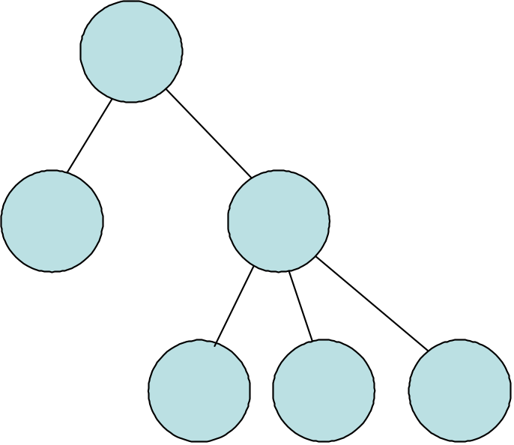

Figure 1 A transaction tree1

The initiation protocol is optional to implement and may be used to request new transaction context (or transaction identification) or associate a new one with an existing one. This context may be used to tag application messages so that they are known to be part of a particular transaction. Following the BTP principle of allowing application designers as much freedom as practicable, the use of this context is optional. If the application protocol can convey the semantics in some other way it is permitted to do so.

The enrolment sub-protocol is required and is the means of building the BTP engine tree. The application at one level of the tree sends an application message to the next level down which is tagged with a context or some other means of indicating it is part of a particular transaction. The receiving application can then use the enrolment sub-protocol back up the tree to enlist in the transaction.

The ‘control’ protocol is optional to implement and may be used by a lightweight BTP implementation (that is one not running the full outcome protocol state machine) to communicate with the top (or root) node of the tree to request partial or complete preparation of the tree, then confirmation or cancellation.

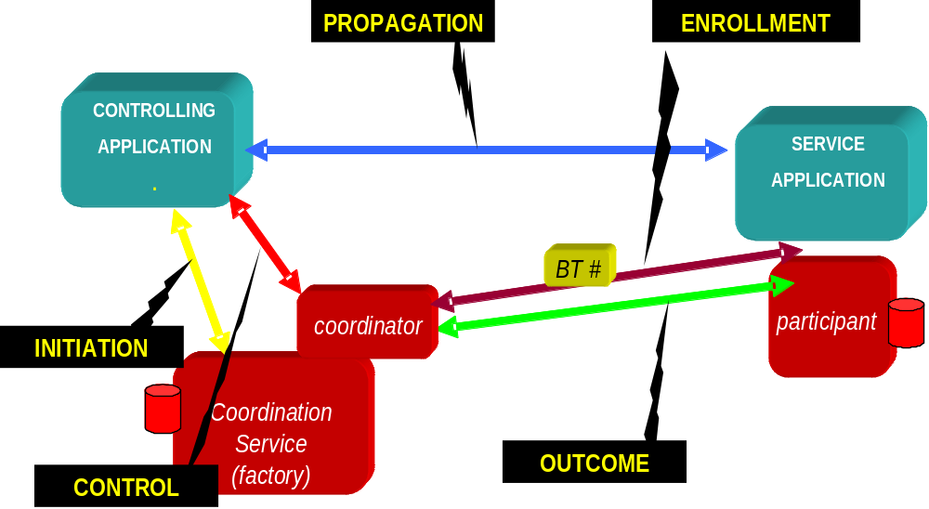

Figure 2 BTP components and sub-protocols2

Atoms and Cohesions
The top or controlling application wants a consistent result (if it does not then there may be little point in using a transaction protocol), but it may not always be necessary to include the work and results from all the participating systems, depending on the logic of the application. BTP copes with this situation by allowing the top node and each intermediate node in a transaction tree to be what it terms ‘cohesive’ or ‘atomic’. For a cohesive node its application will decide the final confirm set when it requests confirmation, prior to which it can tolerate or force exclusion without ending the entire transaction. For an atomic node every participant that enrols is in the final confirm set giving the ‘traditional’ transaction all or nothing characteristic – each node subordinate to this one has veto power. Note that once confirmation at a node has been initiated then the chosen confirm set is always internally atomic.

A complete transaction tree can be set up to be atomic throughout, which gives the distributed transaction the traditional all or nothing characteristics, so in this case either the whole transaction confirms, or if cancellation is requested or one of the participating nodes cancels then the whole transaction cancels (with the caveat that BTP allows heuristic decisions, that is broken promises which means that each individual node may have made its own decision independent of the others). Alternatively each node can be set up to be cohesive and then the application at each of these top and intermediate (i.e. non-leaf) nodes makes its own decision as to what it needs to do to respond to a confirm, including cancelling or confirming nodes in the tree immediately below it. And as might be expected, BTP supports the situation where there is a mix of atomic and cohesive nodes in a transaction tree.

Timed promises
BTP introduces a useful variation on the traditional two phase outcome protocol. It allows the prepare message going down tree (if one is used – it is an optional message in the protocol) to carry a ‘qualifier’ which indicates the minimum time a prepared promise should last for. The prepared message coming back up the tree may then carry a qualifier that indicates how long its prepared promise will last for and whether it is more likely to confirm or cancel if this time expires before it receives a confirm or cancel command. This can assist some application optimisations.

Extensibility
The XML form of the messages can be extended using the XML schema extensibility mechanisms. However, BTP includes an extension mechanism at the abstract message level as well that translates directly to the XML level and this is the qualifier mechanism. There are a few standard qualifiers specified in the BTP specification such as those for timed promises mentioned in sub section 4.1.5 on Timed promises. Users of BTP can specify additional qualifiers to suit their particular application.

Recovery
BTP specifies when the protocol engine has to record information (known as making a log record) for recovery purposes and a recovery algorithm. The aim is to ensure that a system can complete termination of outstanding transaction on recovery from a failure. Some form of recovery should be possible if the log record is intact, though not all situations can be dealt with (destruction of a system for instance!). BTP also supports application recovery even while in the active phase (that is while it is still performing its application work).

Microsoft/BEA/IBM WS-Coordination / WS-AtomicTransaction and WS-Business Activity (WS-C/AT/BA)

OASIS Web Service Composite Application Framework (WS-CAF)

Options concept - outline and applicability

Transaction support is designed to allow users to access and change without dealing with failure and concurrency issues. Allowing users to bundle a set of requests to one or more resource managers to a transaction does this. Users just need to tell when a transaction starts and when a transaction is completed or should be aborted. The support of resource managers is a crucial part of this technology; providing locking to isolate each user from being impacted by any other concurrent user as well as providing recovery.

Current transaction management has the following shortcomings:

- While a user updates a record no other user can do so at the same time – this is not acceptable for long running transactions
- Once a modification becomes part of a transaction it cannot be dropped.
- A commit or abort applies to all resources that have been modified
- All intermediate results will be lost unless a transaction completes

Options are designed to generalize the basic transaction concepts and with it to provide support for a much wider class of applications.

Since transaction technology depends heavily on the support provided by resource managers we will have to provide a new set of resource manager functions that are designed for long running transactions and that complement the existing services - SELECT (FOR UPDATE), INSERT, UPDATE, and DELETE.

The new functions are:

- Find option – in response to a find request the resource manager identifies a set of options satisfying the condition of the requestor. The condition for securing an option as part of the response.
- Secure option – the requestor secures an option that is of interest. Once an option is secured the resource manager is bound to honor the option according to the conditions specified as part of the option. A secure option is like an update request; however, options allow multiple updates to the same data concurrently. This is the crucial element to support long running transactions.
- Confirm option – once a requestor confirms an option; the requestor too is bound to honor the option according to the conditions specified as part of the option. This is like a commit an option.
- Drop option – a requestor can drop a secured – but not yet confirmed – option at any time. This is a special case of the cancel request.
- Cancel option – a requestor maybe be forced to cancel an option even after it has been confirmed. The requestor has to honor the obligations as specified in the option.
- Modify option – a requestor may (be forced to) request a modification of a secured or confirmed option. The requestor has to honor the obligation as specified in the option. A modify request is typically followed by a secure and confirm request. The confirm request implicitly cancels the existing option.

Each single request represents a single classical transaction. Consequently, each interaction is recoverable. The interaction between the requestor and the resource manager will be based on the INFOD technology. INFOD provides a recoverable, auditable and non-reputable communication between requestor and resource manager.

So far, the discussion is focused on a series of request to a single resource manager. The Travel Use case, however, requires an atomic confirm request to multiple resource managers. This can be achieved easily by adding a coordinator. As part of a find option a resource manager specifies acceptable coordinator. Once a requestor has found the desired options, the requestor will attempt to secure them. As part of the secure request the requestor will specify which coordinator will be used in the confirm request. If a requestor likes to atomically confirm a set of options the requestor sends a confirm request to the selected coordinator instead to the various resource manager. The coordinator validates the request and notifies the individual resource managers.

A requestor may but is not forced to confirm all secured options at once, but is able to do so in multiple steps.

The use of INFOD and the processing of options by resource managers ensure that each step is recoverable. Therefore, it is advisable the program representing the requestor is recoverable too after each step. INFOD ensures that the request and responses are recoverable. It is the responsibility of the requestor (program) to save any additional data consistently with the INFOD data. Using classical transaction technology in the context of INFOD makes this easy.

Implementation Notes:

Modern resources managers provide support for extensibility. Extensibility allows the specification and implementation of new services to complement the existing services. Using such a framework, one would create an option service. The option services would implement the various option requests for a set of data collections or tables. The option services would access and changes these tables or data collection using the basic access and manipulation services. The use of these basic services is exclusively reserved for the option service.

The option service interacts with requestors using a modern messaging service: once a request has arrived, the option service is activated. It starts a transaction, consumes a message, does the required processing, creates the response as a message and commits the transaction. This makes the service recoverable, auditable, and non-reputable.

The option service consists of a core service, the one that understands the domain neutral logic and is complemented by a set of domain specific services. Theses domain services deal with the domain specific logic.

Other Notes:

- One should add a set of functions tracking the delivery process for a more complete coverage of the use case; e.g.; a delivered option cannot be changed or cancelled. This will not be done as of now

- The option model eliminates need for compensation; compensations are far too hard to design and implement.

- One could create functions on top of the basic services; such as waiting lists.

- One could think about the core service as the one that deals with the protocol layer whereas the domain services would represent service applications.

Recommendations

References

[1] O'Neil, Patrick E., "The Escrow Transactional Method", TODS, V 11, No 4 (December 1986), pp. 405-430.

Editor Information
Tony Fletcher, Choreology Ltd
68, Lombard Street, London EC3V 9LJ
Phone: +44 1473 729537 mobile: +44 7801 948219
Email: tony.fletcher@choreology.com or amfletcher@iee.org

Acknowledgements
We gratefully acknowledge the contributions made to this document by Torsten Steinbach, Mark Little, Dieter Gawlick, Bob Haugen, GGF Working groups and all other members of the TM-RG working group members who discussed and reviewed the material.

End of Document

It is assumed that the user is familiar with this Use Case document, especially with Trip Support
A resource manager represents a service provider
The resource manager may also be forced to cancel, we will ignore this case for now
The resource manager may also be forced to cancel, we will ignore this case for now
https://forge.gridforum.org/projects/infod-wg
This works only if there is at least one coordinator that is acceptable for all resource managers, furthermore, a requestor can unconditionally change a selected coordinator for a secured resource
A simple protocol can deal with race conditions and broken connections.

