The SAP Use Cases and Requirements for Reservoir

30/5/07, Version 1.0

Eliezer Levy, SAP Research, eliezer.levy@sap.com
This document contains draft versions of sections of the emerging Architecture Specification of Reservoir.

Use Cases

Abstraction of an “SAP System”
An SAP system is a three-tier system consisting of a presentation layer, application layer and a database layer. Figure 1 shows the basic components of an SAP system.

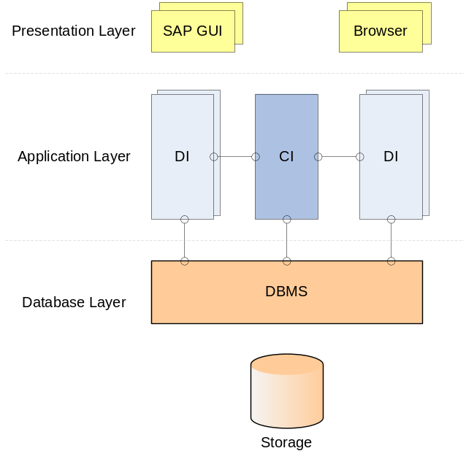
- Abstraction of an SAP System
The main components as depicted in Figure 1 are:
- The Dialog Instance (DI) hosts the work processes that execute the ABAP programs as a response to user requests. The number of DIs can be configured for scalability. Moreover, the number of work processes within each DI can be configured. It is important to emphasize that DIs maintain conversational and stateful user sessions.
- There is only a single Central Instance (CI) per SAP system. The CI communicates with the DIs and performs central services such as locking, messaging, registration of DIs, and session initiation and load balancing among DIs. The CI and DIs of the same system are tightly coupled.
- A single Database Management System (DBMS) serves the SAP system. The DBMS accesses its storage either as a Network-Attached Storage (NAS) or by a Storage Area Network (SAN). It is important to emphasize that SAP applications require classic database transactions and strong data consistency.
Some SAP systems employ NetWeaver, a double stack system combing the original ABAP application server and a more recent J2EE implementation. In principle, NetWeaver is built using the same architecture of CI and DIs, and therefore it is not mentioned explicitly in the sequel.
From a scalability and robustness point of view, one can add and remove DIs while the system is running, as well as adapt the number of work processes of a specific DI or CI.
The components can be arranged in a variety of configurations, from a minimal configuration where all components run on a single machine, to larger ones where there are several DIs, each running on a separate machine, and a separate machine with the CI and the DBMS. Figure 2 depicts these configurations, where the components are realized as virtual machines in a virtual execution environment (VEE) host.
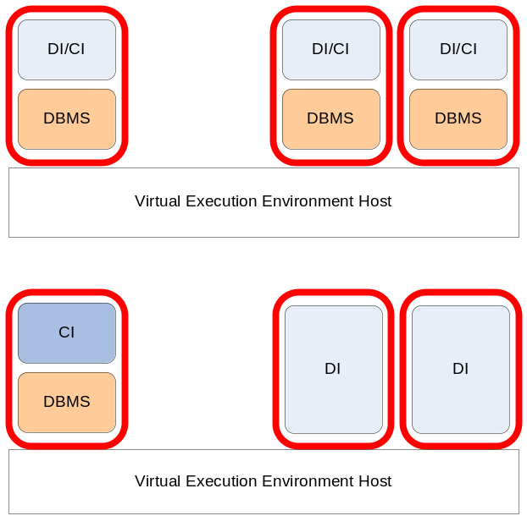
- Sample SAP System Configurations with Virtualization
SAP systems are used for a variety of SAP applications that differ by version and functionality (e.g., CRM, ERP, SCM). For a given application type, the SAP system components consist of generic parts that are customized by configuration, as well as parts that custom-coded for a specific instance. An SAP system used for a specific application is an example of a complex service application. Typically, an installation consists of several systems that differ by their target usage (e.g., production, test and development).
Certain SAP applications are composed of several loosely-coupled systems. These systems are referred to as Deployment Units (DU). DUs have their independent databases and they communicate asynchronously by messages with each other.

Enterprise Scale-Out Use Case
Actors:
- An enterprise that is a SAP customer, and runs SAP applications on-premise. The applications are deployed using virtualization technology. The enterprise in this case is the service provider.
- Infrastructure Provider that manages a data center site. The provider may be internal to the enterprise (i.e., the enterprise’s IT department), or an external provider operating on a different site (and then this is a multi-site scenario).
Scenario:
The SAP customer anticipates a period of peak load that will be beyond his on-premise resources’ capacity. He negotiates an agreement with the Infrastructure provider in advance such that before and during the surge, part of the load is directed to the provider‘s site, where newly created DIs handle it. This scale-out happens without disrupting the on-line users of the application. There are a few variants to the use-case:
- The SAP customer cannot migrate the storage used by the SAP application. In this variant, additional components of the application layer (mainly DIs) are created in the provider site to handle the additional load. The fact that DIs may run in a different site should not have impact on the response times of the application.
- Since the application is composed of independent DUs, it is possible to off-load complete DUs (including DBMS and storage) to the infrastructure provider. This variant may be enabled when the infrastructure provider already plays the role of a disaster recovery site for the customer and holds a replica of the storage.
Once the surge is over, as indicated either by the actual load or according to a pre-defined schedule, components running on the provider site should be either shut-down or migrated to the original site, and the application setup is reverted to its original state.
Outcome:
In both cases, the application is allocated more resources during the surge. These resources are allocated in proportion to the actual load. Moreover, the application latency does not deteriorate during the surge.

The Virtualized Data Center Use Case
This use case has many significant variations. For brevity, we present two major cases:
- The Consolidated Data Center. The data center consolidates the operation of different types of SAP applications. The applications are offered as a service to external customers, or alternatively the data center is operated by the IT department of an enterprise and then users are internal (i.e., enterprise employees). This distinction is very significant for security, but less significant for managing the capacity of the data center which is the crux of this use case.
- The Multi-Tenant Data Center. The data center is built to serve an on-demand, SaaS setup, where customers are external, and where each customer (tenant) gets the same base version of the application. It is reasonable to assume that a tenant in this case is a Small-Medium Business (SMB) tenant.
We present the use cases together since they have a lot in common in terms of the data center management. There are real cases where both types of use cases are mixed in the same data center. In principle, the multi-tenant case should be viewed as a special case of a data center where certain optimizations can be applied due to the fact that all tenants use the same service application.

Consolidated Data Center Management and Optimization
Actors:
- A provider that offers several types of SAP applications as a service to external and/or internal customers. The provider operates a data center where all the types of the SAP applications and all their respective environments (e.g., test, production) are consolidated using virtualization technology on the same physical resources.
Scenarios:
The essence of this use case is management of a large number of possibly different instances of SAP applications in the same data center. The key challenges in this scenario are:
- Managing thousands of different service components that comprise a variety of service applications that are executed by thousands of VEEs, with varying workloads and SLAs, on top of a complex infrastructure of servers, network and storage.
- Controlling the HW factor of the Total Cost of Ownership (TCO) of the data center by increasing server utilization as a result of consolidation of applications on same servers and adaptive resource allocation.
- Performing the above management and optimization while keeping the operational factor of the TCO at minimum.
We describe this use case by describing a series of scenarios. These scenarios are essential for operating and managing the data center. All scenarios follow the following common skeleton:
- The scenario can be initiated manually from a management console, or via an API call or from an automation script.
- Regardless of the method of initiation, the credentials of the initiator with respect to the relevant scenario and the relevant resource(s) are verified.
- Perform the operation that is the essence of the scenario
- A verification check that the scenario succeeded is performed.
- The management repository is updated to reflect the results of the scenario.
For brevity, this common skeleton is not repeated in each of the scenarios. It is important to observe that when the data center is a Reservoir site, all these scenarios are executed by the VEEM. Still, it should be possible to execute these scenarios manually and compose automation scripts that are different from the automation offered by Reservoir.

Creating a Manifest of a Service Application
This scenario enables creating a manifest for a complete composite service application. In particular, the manifest should include or point to all the images, contextualization scripts, order of initiation of components, DB content, and all other configuration data that are required to deploy a fresh instance of the application. The manifest is stored in a central repository in the data center and it can be retrieved and examined by name. The manifest should be reusable. That is, the same manifest should be reused to provision multiple and different instances of the application. Means to contextualize and customize a manifest must be provided.

Provisioning a Service Application from a Manifest
This scenario focuses on the complete provisioning of a live service application from a manifest. Given a manifest name, and the specification of the hosts for all VEEs in the manifest, it should be possible to provide a live instance of the application for usage with “one-click”.

Dynamic Adjustment of Resources Allocated to VEEs
This scenario covers the dynamic adjustment of resources assigned to an individual VEE. It should be possible to adjust and affect resource allocation parameters (memory, CPU) while the VEE is running.

Elastic Arrays of VEEs
The purpose of this scenario is dynamically control the number of identical VEEs (for the purpose of adapting this number according to the load, for example). The relevant service application manifest must indicate this potential elasticity. Given a master image, and a pre-defined adaptation script, it should be possible to create a new VEE, a clone, and apply the minor changes to its configuration as defined by the script. The cloned VEE should join its already running siblings in the sense of serving some of the workload.
It should be possible to create an image that creates a warm VEE with all its context (e.g., warm caches, established connections), configuration and state (but without any user session state).
For example, this is scenario is used for spawning a new DI in a given running application in order to address increased load.
It should be possible to stop a running VEE that was defined as part of an array without disrupting the service of the overall service application.

Live Migration of a VEE
The purpose of this scenario is to transfer a running VEE to a new host, in a manner that is transparent to the clients of this VEE.
- Live migration of is initiated by specifying a VEE and a destination host.
- Check whether the destination host can satisfy the resource requirements of the to-be-migrated VEE (e.g., memory, CPU, storage).
- Check whether the to-be-migrated VEE is authorized to run on the destination host
- Live-migrate the VEE
- Check that the VEE runs correctly at the destination
- Check that the original host is cleaned up
- Update the management repository with the new host for the migrated VEE

Mass Operations
This scenario focuses on the application of mass operations to a large set of VEEs. The mass operation can be of various types, e.g. migrate, adjust resources, or apply an arbitrary script. Note, mass operation means that many parallel operations can be performed by the system. Furthermore, the number of parallel operations that can be performed must scale with an increasing data center size.
It should be possible to specify whether the mass operation succeeds only if all of its instances succeed, or to allow individual failures. If individual failures are allowed, the entire mass operation should not fail and all successful operations should take place. It should be possible to re-submit the failed operations in this case.
It should be possible to specify declaratively the set of target VEEs for the mass operation. For instance, apply a SW patch to all VEEs of a specific component group (e.g., all web servers) of a specific service application, or to all VEEs of a specific service application.

Capacity Planning
This scenario describes the capacity planning functionality of the system. Whenever a new VEE is deployed on and whenever the resource assignment is going to be changed, the system should present the available resource (memory, CPU, storage) capacity. This capacity planner has to be involved in many other scenarios, like live migration, and provisioning.

Automating Complex Operations
It should be possible to automate complex, mult-step operations by composing scripts that invoke the primitive operations and mass operations described above. For example, it should be possible to automate the scale-out scenario, or upgrade scenarios using the API primitives.

Automatic Adaptive Resource Allocation
This scenario describes the ability of the system to self-optimize resource allocation in reaction to actual load monitored for the service application. The system should be able to adapt the resource allocation for VEEs automatically in reaction to actually monitored loads without violating the SLAs of the service application.
Outcome:
Streamlined management of the complex data center, high resource utilization and low TCO are enabled by the extensive use of automation.

The Multi-Tenant Data Center
Actors:
- Infrastructure provider that manages a large data center and offers SAP application as a service to external customers.
- Customers that subscribe to the SAP SaaS offering and use it to manage their business. Each such customer is referred to as a tenant in the site.
Scenario:
This is a typical multi-tenant, on-demand, SaaS setup. Each tenant gets the same base version of the application. However, each tenant configures and customizes the application, using the built-in capabilities, to suit his specific needs.
The application manipulates a private instance of the data for each tenant separately. Each tenant sees only his instance of the data.
Setting-up a new tenant is completely automated by a web-based wizard. The new tenant runs through a series of configuration questions, uploads master data items (e.g., product catalogue and customer lists). Following these steps, the tenant is up and running (typically using a trial version). The provisioning of the resources (storage, database and application server) is part of this automated setup.
The provider guarantees the tenants that the infrastructure can dynamically adjust to the fluctuating loads the tenants introduce. Notice that in spite of the fact each tenant uses the same application, each tenant may introduce a very different workload.
The tenants are billed a fixed monthly subscription fee, or a variable fee based on their usage of the application. The provider has to manage the lifecycle of the application for hundreds or thousands of tenants while keeping a very low TCO. This includes setting up new tenants, backing-up and restoring the databases, managing the customizations and configurations of tenants, getting patches and newer versions of the software from SAP, managing power consumption, etc. In order to streamline the provisioning and management of storage and computing resources in the data center, the provider uses virtualization technology.
The fact that all tenants use the same service application can be leveraged for optimizations of the image repository and mass operations.
Most of the scenarios mentioned above are special cases of the scenarios mentioned in the Consolidated Data Center use case. Nevertheless, in order to illustrate this specific use case, a few specific scenarios are highlighted:
- When a tenant registers over the web for service, the provisioning of the service must be rapid (a few minutes at most), and the contextualization and customization should be based on the information the new tenant provided during the registration process.
- Mass operations are applied on the basis of tenants and groups of tenants. For example, live-migrate the complete service application of a specific tenant or of all “golden” tenants. Another example is mass provisioning for a group of very similar tenants in batch (as opposed to the interactive process described above). The notion of a service application template is critical in this context of mass provisioning. Lifecycle management (applying patches and upgrades) is also applied en-masse to groups of tenants.
- There are several well-known approaches to multi-tenancy at the database level [1]. Regardless of the approach taken, multi-tenancy calls for flexible virtualization schemes where, for example, the DBMS component and the storage system are shared between multiple tenants. The main reason for this sharing is keeping the TCO per tenant at minimum.
Outcome:
By leveraging the homogeneity of the service applications, the multi-tenant data center is operated with a very low TCO.

Requirements
The requirements are presented in the following bottom-to-top order:
- Requirements from the lower-level virtual execution environment (VEE)
- Requirements from the VEE Host interface which is the interface used to manage multiple VEEs on a single physical host
- Requirements from the VEE manager (VEEM) that manages multiple hosts in a single site
- Requirements from the Service Manager that deals with the highest level of Service Applications

Virtual Execution Environment Requirements

Virtualization Performance
The underlying assumption is that virtualization adds an overhead of at most 10% to the end-to-end performance of the application. Otherwise, the use cases make no sense to begin with. The most stringent consequence is that the throughput of a virtualized setup of the application does not degrade by more than 10% compared to a native setup running on the same HW, and all this without compromising the end user experience.

Migration Performance
Typically, the DI and CI handle many concurrent stateful and conversational sessions and maintain a very large context in-memory for each session. As a result the state of the application server can be very large (tens of GBytes). Live migration degrades the performance of the migrated application as it consumes CPU and I/O resources while preparing for the migration. In addition, live migration requires an actual downtime of the application during the actual migration. The application relies on complex stack that is sensitive to timeouts at different levels (e.g., network, database). The performance degradation and the downtime should not have averse affect in terms of too many aborted user transactions.

Migration and Cloning Transparency
The following requirements specify that behaviour (as observed externally and between its components) of a service application does not change as a result of cloning and migration its components.
First, the following assumptions should be stated explicitly:
- In most cases, it can be assumed that storage can be (logically) shared between the origin and destination hosts of the migration.
- The service application has a built-in elasticity capability. That is, the application is capable of dynamically adding and removing components while running.
Under these assumptions, the relevant requirements are:
- The networking and storage views of VEEs are kept intact when VEEs are migrated. That is, if a VEE accessed particular storage device and communicated with particular network entity, the same view is preserved in spite of migrations.
- A VEE that is cloned in a VEE array inherits the storage and networking view of the other array members.
- The public end-points of the service application are kept intact in spite of VEE migration and cloning.
[TBD] If the application has a time-dependent behaviour (e.g., the application has a scheduler), the application must be able to handle gracefully the non-continuous time advances that are a result of suspending and migrating VEEs.

VEE Host Interface Requirements

Interface for Standardization
The host interface should be implemented as a management API that hides the details of the virtualization technology. The goal is to standardize this API.

Using the API
It should be possible to compose API primitives in scripts for the streamlined automation of more complex tasks in the data center.

Plug-Ins
The VEEM should expose a plug-in architecture, such that various implementations of the API can be created. Moreover, a VEEM should be able to manage hosts of different virtualization technology using the API.

VEE Management Requirements

Service-Oriented Resource Allocation
A service application is an infinite computation that is characterized by a workload that changes (sometimes dramatically) over time. This is in contrast to job-oriented resource allocation where resources are allocated to jobs with a finite duration. Resources, therefore, should be allocated in reaction to the changing workload.

Cost-Based Optimization
The resource allocation optimization should be driven by a configurable cost-model. The cost-model should approximate the relative anticipated latencies associated with the different allocations options. The cost model, for example, should factor the cost of cross-site migrations.

Autonomous Local Optimizations
Provide means for a VEEM to autonomously improve and optimize the utilization of the site local resources regardless of the service-level monitoring and optimization. That is the VEEM should be able to take advantage of opportunities of free local resources on its own right as longs as SLAs are not violated.

Service Management Requirements

Provisioning Service Application
The SAP application is composed of inter-related components. It is required to completely specify the application components and setup using a declarative language in the form of a manifest. The manifest should specify, for example, all the VM images, the storage configuration, the database content and the relevant applicative configuration. Moreover, the application should be provisioned as a single logical unit.
The actual creation of the manifest is out-of-scope for Reservoir, but the format of the manifest is definitely in-scope.
In principle, once provisioned, managing the application should be done by the means the application itself provides and not by the service manager. This requirement is in line with the observations that service applications should be always on-line. For example, starting, stopping, pausing and resuming an application should be done only from within the application itself.
[TBD] There may be some well-defined exceptions to the rule that once the system should not manage an already provisioned application (for example, time-dependent starting of applications, very simple fail-start applications).

Template-Based Provisioning
It should be possible to use the service manifest as a template for easily provisioning instances of the application. The template must allow for instance-specific components due to instance-specific configuration and customization. This requirement is important for multi-tenant scenarios where the template should be parameterized by tenant.

Service Application Definition Requirements

Flexible Virtualization Configurations
A virtualization configuration maps the components specified in the service manifest to physical hosts. Figure 2 depicts two virtualization configurations, both for a single host. The manifest should support expressing flexible virtualization configurations of the applications in order to satisfy various performance and TCO requirements. In particular, it should be possible to specify dependencies and starting order among components. It should be possible to specify sharing of a component by more than a single service application. For example, a DBMS service component may be shared by multiple service applications.

Extensibility of the Service Definition Manifest
In order to handle all the specific details of the SAP application, the service description manifest should be extensible.

Security Requirements

Authorization Scheme and User Management
[TBD] It should be possible to control application of host interface operations (e.g., clone, provision, migrate) on resources (e.g., VEE, service applications) by VEEM users. The VEEM should provide means to define these users and assign them credentials. These users should be distinguished from guest-OS users (and host-OS users). VEEM users should be mapped by the VEEM to guest-OS users on the different VEEs.

References
- “Multi-Tenant Databases for Software as a Service”, S. Aulbach, T. Gurst, D. Jacobs, A. Kemper, J. Rittinger, in Proceedings of ACM SIGMOD 2008, Vancouver, BC, Canada.

