Scheduling Attributes

Objective

This document is a starting point for specification of scheduling attributes needed for interaction of Grid schedulers. The goal is to agree on a basic set of attributes to be referenced in SLAs between Grid schedulers.

Since scheduling attributes and objectives are out of scope of JSDL, the additional specification is needed either as JSDL scheduling attributes extension or a separate Scheduling Description Language (see Section 2). Section 3 contains a comparison of scheduling attributes supported by considered Grid schedulers with the scheduling attributes proposed in this document.

Scheduling Attributes

The Scheduling Attributes SHOULD contain information needed by a Grid scheduler to schedule a job(s) according to user’s requirements and preferences. They MAY include scheduling attributes that belong to different categories such as:
- time constraints
- job dependencies
- job priorities
- scheduling objectives/preferences
- data-dependent scheduling information
- queue-based scheduling information
- miscellaneous

Table 1 presents a proposal of scheduling attributes. In particular, time constraints attributes are defined in detail since they are essential for time-based scheduling (e.g. using advance reservation). The remaining categories contain only examples of possible attributes since a definition of the whole scheduling description language is out of scope of the GSA group (?).These attributes can be used as service level objective terms for a Grid scheduling.

Table 1 Scheduling attributes
Category | Scheduling Attribute | Multiplicity | Description
Time Constraints | Duration | 0..1 | Maximal job execution time.
Time Constraints | TimePeriod | 0..n | Defines a time period within which a job must be executed (e.g. between 17-11-2006 and 20-11-2006). It MAY contain EarliestStartTime, LatestStartTime, and Deadline. TimePeriod may occur multiple times – the set of TimePeriod elements defines many periods within which a job can be executed.
Time Constraints | EarliestStartTime | 0-1 | Specifies start time of a period during which a job must be started (e.g. 31st January 10.00AM). In other words this is the earliest start time of a job. If EarliestStartTime is not specified a default value of a period start time is a current time.
Time Constraints | LatestStartTime | 0-1 | Specifies the end of a period (e.g. 12th February 2005 16:00PM). In other words this is a deadline for the job start time. If LatestStartTime is not specified then there is no upper limit for job start time.
Time Constraints | Deadline | 0-1 | Deadline for the job finish time.  Note: to satisfy this requirement the scheduler needs to know the job execution time.
Time Constraints | IncludingDates | 0-1 | Limits a period within which a job can be executed to certain days of a week and/or dates, e.g. execute a job only on Fridays.
Time Constraints | ExcludingDates | 0-1 | Excludes certain days of a week and/or dates from a period within which a job can be executed, e.g. do not execute jobs on Sunday.
Time Constraints | DayTimeWindow | 0..n | Defines a time window within a day when a job must be executed (e.g. between 10.00AM and 4.00PM). It must include the DayTimeWindowStart and DayTimeWindowEnd elements.
Time Constraints | DayTimeWindowStart | 0-1 | Specifies start time of the time window (as time of a day). A job must be started after that time.
Time Constraints | DayTimeWindowEnd | 0-1 | Specifies end time of the time window (as time of a day). A job must be started before that time.
Job Dependencies | … |  | Description of job precedence constraints…
Job Priorities | JobPriority | 0-n | Defines a priority of a job. It may occur multiple times but at most once for each job.
Job Priorities | …
Scheduling Objectives | CompletionTime | 0-n | Minimize the completion time of a particular job.
Scheduling Objectives | StartTime | 0-n | Minimize the start time of a specific job.
Scheduling Objectives | Cost | 0-n | Minimize the cost of execution of a specific job.
Scheduling Objectives | CPUCount (+other resource requirements available in JSDL) | 0-n | Maximize the number of CPUs allocated for a specific job (or maximize/minimize other parameter available in JSDL).
Scheduling Objectives | QueueLength | 0-n | Minimize a length of a queue to which a specific job will be submitted.
Scheduling Objectives | …
Scheduling Objectives | MeanCompletionTime | 0-1 | Minimize mean job completion time (of all jobs)
Scheduling Objectives | MeanStartTime | 0-1 | Minimize mean job start time (of all jobs)
Scheduling Objectives | TotalCost | 0-1 | Minimize cost (of all jobs)
Scheduling Objectives | Makespan | 0-1 | Minimize the maximal job completion time (for a set of all jobs), i.e. makespan
Scheduling Objectives | …
Data-dependent Scheduling Requirements | RunWhereData | 0-n | Specifies whether scheduler should execute a job at the location of data
 | …
Queue-based Scheduling Requirements (?) | QueuePolicy? | 0-n | Defines a preferable queuing policy, e.g. FCFS, SJF, etc.
Queue-based Scheduling Requirements (?) | MaxQueueLength? | 0-n | Specifies the maximal length of a queue to which a specific job will be submitted.
Queue-based Scheduling Requirements (?) | QueueName | 0-n | Specifies a name of a queue to which a specific job will be submitted.
Queue-based Scheduling Requirements (?) | …
Miscellaneous | ReRunOnFailure | 0-n | Specifies if scheduler must schedule and run a job again in case of failure
Miscellaneous | NoCoallocation | 0-n | Defines whether resources required for a given job can be located at more that one site.
Miscellaneous | …

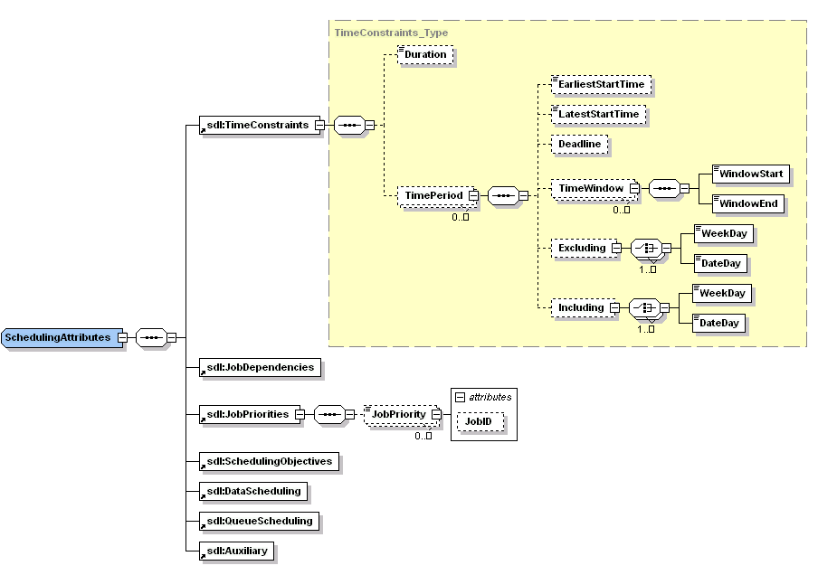
Figure 2 The scheduling attributes schema

As mentioned above, since the full scheduling description language specification should be a separate activity, a subset of these attributes must be selected (taking into consideration Table 2 from section 3). In the future, in addition to JSDL and WS-Agreement specifications, the Scheduling Description Language would be useful to define preferences and requirements related to Grid scheduling.

Scheduling attributes supported by Grid Schedulers

Table 2 presents scheduling attributes that are supported by particular Grid schedulers. By support we understand that a scheduler provides a translation of a given scheduling attribute to its native attribute that has the same semantics.

Table 2 Support of scheduling attributes by Grid schedulers
Section | Attribute | Grid Scheduler
Section | Attribute | UNICORE (VIOLA?) | GRMS | …
Time Constraints | Duration | ? | +
 | TimePeriod | ? | +
 | EarliestStartTime | ? | +
 | LatestStartTime | ? | +
 | Deadline | ? | -
 | IncludingDates | ? | +
 | ExcludingDates | ? | +
 | DayTimeWindow | ? | +
 | DayTimeWindowStart | ? | +
 | DayTimeWindowEnd | ? | +
Job Dependencies | … | + | + (workflow – dependencies between job states)
Job Priorities | JobPriority | ? | -
 | … | ?
Scheduling Objectives | CompletionTime | ? | -
 | StartTime | ? | -
 | Cost | ? | -
 | CPUCount (+other resource requirements available in JSDL) | ? | +
 | QueueLength | ? | -
 | …
 | MeanCompletionTime | ? | -
 | MeanStartTime | ? | -
 | TotalCost | ? | -
 | Makespan | ? | -
 | …
Data-dependent Scheduling Requirements | RunWhereData | ? | -
 | …
Queue-based Scheduling Requirements (?) | QueuePolicy? | ? | -
 | MaxQueueLength? | ? | -
 | QueueName | ? | +
 | …
Miscellaneous | ReRunOnFailure | ? | -
 | NoCoallocation | ? | +
 | …

