CASE 1 : CDDLM stand alone system
When CDDLM is used without any remote storage services, it assumes the existence of an internal file server which is visible from the deployed system and components. It might be NFS, HTTP server or anything. The user can upload files through “AddFile” method of the System Endpoint. The Deployment API says that this is an interim solution and the preferred solution to this is a remote asset store of some form, with an efficient transport and secure, version-based access to assets. (see section 3.2 of the Deployment API)
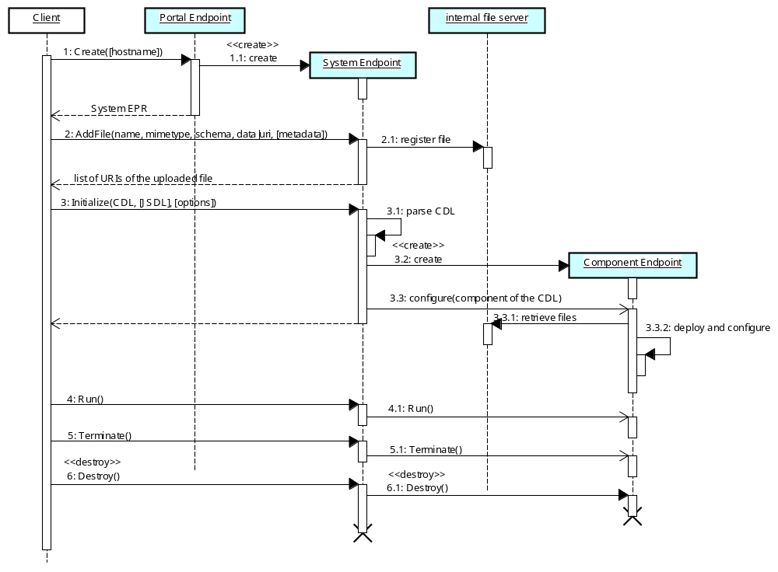
Methods whose names begin with a capital letter are defined in the normative CDDLM specs, and others are implementation-specific.
The lifecycle operations, i.e. Initialize, Run and Terminate, are performed asynchronously. This is defined in the Deployment API.
The actual process to configure, run and terminate each component is hard-coded in the deployment component, i.e. “ApacheDeployer” class in this case.
URIs of the uploaded files are contained in the “options”, which can be used to rewrite the CDL late-binding parameters.
One or more Component Endpoints are instantiated as defined in the CDL.
In the case below, a single component named “WebApplication” is created using “com.exns.ApacheDeployer” class that is included in the file.jar.
How to instantiate the Component Endpoints is platform specific.

<cdl:cdl targetNamespace=”http://example.org/webapp-template”>
<cdl:system>
<WebApplication>
<cmp:CodeBase>http://server/file.jar</cmp:CodeBase>
<cmp:CommandPath>com.exns.ApacheDeployer</cmp:CommandPath>
<port>80</port>
<hostname>www.example.org</hostname>
</WebApplication>
</cdl:system>
</cdl:cdl>
(This sample is from “Component Model”)

This is the scope of the possible interaction between ACS and CDDLM
CASE 2 : Collaboration of ACS and CDDLM (1)
Case 2 and 3 are possible sequences when CDDLM works with ACS. (NOTE: the possibility is not limited to these sequences)
In the case 2, the interfaces of the CDDLM services need no changes from current specs. AA EPR is passed to the System Endpoint implicitly included in the “options“ parameter of the Initialize method.
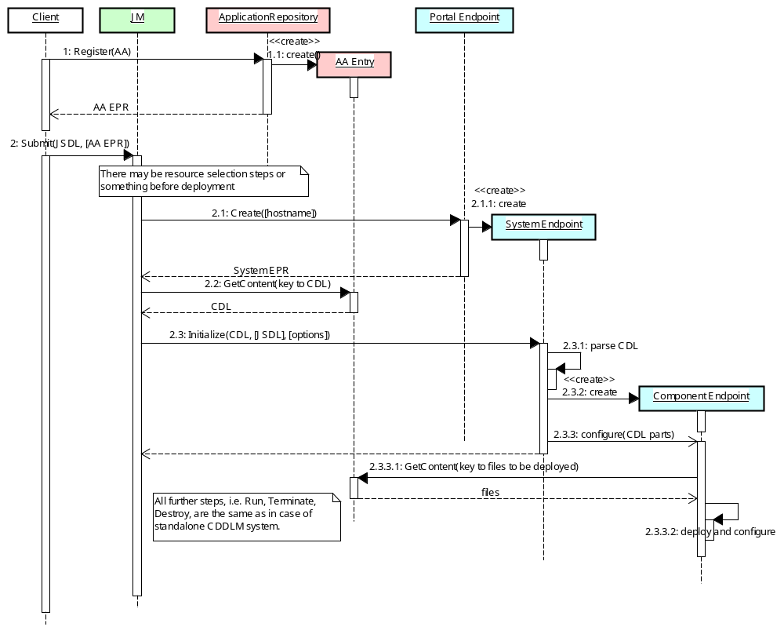
The user must register the AA (Application Archive) file to the ACS repository in advance of deployment.
Methods whose names begin with a capital letter are defined in the normative CDDLM and ACS specs, and others are implementation-specific.
Files to be deployed are directly pulled from ACS by each Component Endpoint.
The keys to the files which is used as a parameter of the GetContent are likely to be hard-coded in the Deployment Component code.
The AA EPR can be included in the “options” parameter.
JM (or something) retrieves the CDL document from ACS repository which is passed to the System Endpoint.
The AA EPR is somehow passed to the Component Endpoint.
CASE 3 : Collaboration of ACS and CDDLM (2)
In the case 3, System Endpoint retrieves the CDL document from ACS service. JM ( or something ) need not know the key which is required to retrieve the CDL. In this case, the parameter “CDL” in the Initialize method should be optional. The AA EPR may be included in the options parameter in the same way as in the case 2.
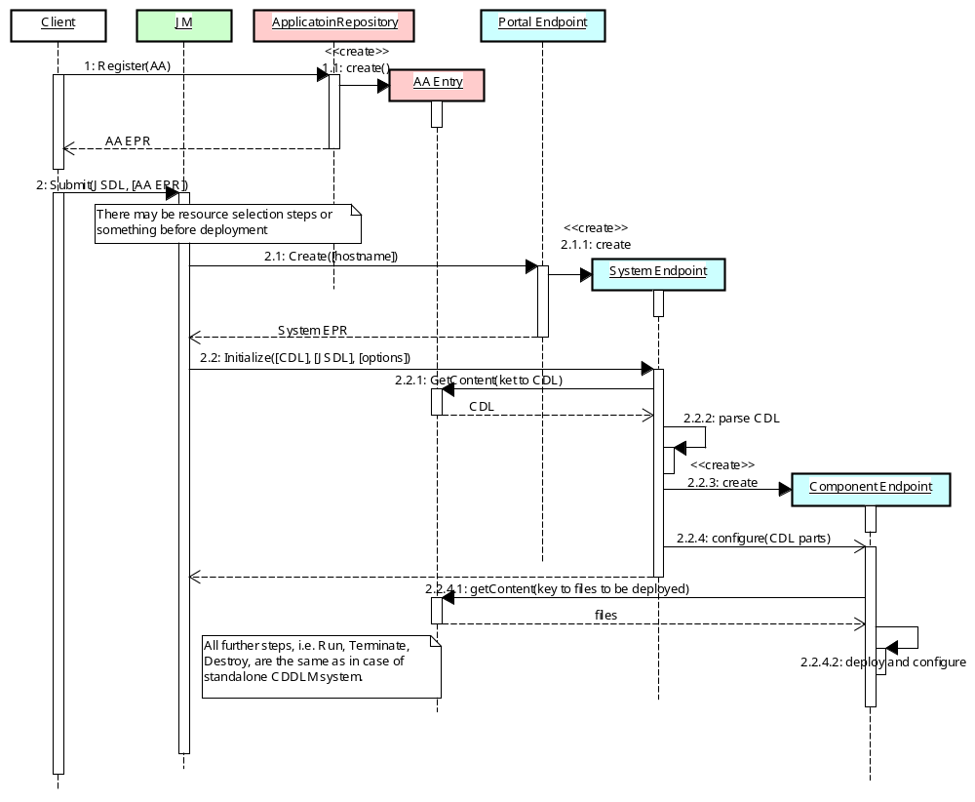
The CDL document is directly retrieved by System Endpoint instead of being passed by JM.
The “CDL” parameter should be NULL in this case.
The AA EPR is included in the “options” parameter .
Explanatory Notes on the Diagrams
Client:
A client is an application which provide user interface to deploy and execute a job.
Job Manager (JM) (will be defined within the EMS):
An JM is an OGSA service which accepts the job submission request and creates and manages a job. The detailed has not defined yet.
CDDLM services:
Portal Endpoint:
A Portal Endpoint is a WS-Resource which is used to create a new System Endpoint within the set of nodes that it manages. The actual process for obtaining a Portal EPR is not in the scope of CDDLM.
System Endpoint:
A System Endpoint is a WS-Resource which represents a deployed system and provides access to the state and operations of the system. It accepts a request for lifecycle operations (initialize, run, terminate...) and delegates to its child Component Endpoints.
Component Endpoint:
A Component Endpoint is a WS-Resource which represents a unit of deployment called “component (deployment object)” and provides access to the state and operations of the component.
Internal file server:
The "internal file server" is not described in the CDDLM specs explicitly but we believe some sort of file sharing mechanism is assumed to be used from System Endpoint and Component Endpoints.

ACS services:
ApplicationRepository:
An ApplicatoinRepository is a WS-Resource which represents the Application Repository, which is a store of the Application Archive (AA). AA is a logical bundle of Application Contents associated with applications for a unit of task. Contents in AA include files such as the application binaries, configuration data, procedure descriptions for lifecycle management, requirements descriptions for the hardware and underlying middleware, policy rules, and anything needed to create a unit of the task on grid systems. The actual process for obtaining a ApplicationRepository EPR is not in the scope of ACS.
ApplicationArchiveEntry (AAEntry):
An ApplicationArchiveEntry is a WS-Resource which represents each AA entry in the Application Repository. An ApplicationArchiveEntry is referred by an AA EPR.

