RSS Service Description

Status of This Memo

This memo provides information to the Grid community on the services the OGSA-RSS WG is going to define. It does not define any standards or technical recommendations. Distribution is unlimited.

Copyright Notice

Copyright © Global Grid Forum (2002). All Rights Reserved.

Abstract

This document describes the services to be defined by the OGSA-RSS working group.

Contents

Abstract 1
1. Outline 2
2. Use-Case Analysis 2
2.1 Use Case 1: Scheduling Complex Workflows 2
2.2 Use Case 2: Scheduling Component-based Applications for High Performance Heterogeneous Computing 2
2.3 Application-Oriented Scheduling in the KNOWLEDGE GRID 3
2.4 GRASP (Grid Resource Allocation Services Package) 4
2.5 Scheduling in Loosely-Coupled Grids with GridWay 4
3. Conclusion of the use cases 4
3.1 Performance Considerations 4
3.2 Data format considerations 5
3.3 Architecture considerations 5
The GSA-RG provides another document, the GSA Requirements: 5
https://forge.gridforum.org/projects/gsa-rg/document/GSA-Requirements/en/1 5
It tries to identify the properties of a future grid scheduling architecture, but is at a very early stage of development.Author Information 5
Author Information 6
Glossary 6
Intellectual Property Statement 6
Full Copyright Notice 6
References 6

Outline
This document provides a description of the Resource Selection Services as outlined in the OGSA V1.0 document. Specifically, these services are:

- The Candidate Set Generator (CSG) and
- The Execution Planning System (EPS).

In order to identify the needs of the services, an analysis of the existing use-cases follows. The subsequent sections outline both CSG and EPS.

Use-Case Analysis
The Grid Scheduling Architecture-RG maintains a use-case document, containing use-cases from various existing and upcoming grid scheduling system [GSA-Use Case]. In the following sections, we list the requirements identified within this document.

Use Case 1: Scheduling Complex Workflows
This use-case deals with the coordinated allocation of storage, CPU, network and other resources in order to execute a workflow. The scheduler should reserve resources as needed and plan the whole workflow at once.
The scheduler traverses the following steps:
- Composition and submission the job request
- Pre-processing of the job request
- Gathering of static resource information
- Pre-selection of resources
- Query of dynamic resource information.
- Generation of schedule and initialization of required reservations
- Execution of workflow
- Completion of workflow
The use case does not specify concrete data dependencies. Nevertheless, the following information seems to be needed:
- A specification of individual jobs
- A description of the workflow along with expected data transfers between execution locations
- The information system should provide all necessary information in order to map resources
Since the whole workflow is scheduled at submission time, this scheduler relies on advance reservation.

Use Case 2: Scheduling Component-based Applications for High Performance Heterogeneous Computing
Component-based programming tries to compose applications out of several smaller compoments, which can be used for different applications. This seems to be a promising attempt in terms of interoperability and reuse of components, but also poses a strong need for coallocation on the scheduler service.
In order to implement coallocation, one has to rely on advance reservation to keep track of various simultaneous coallocations.
The scheduler traverses the following steps:
- Search for existing components
- Composition of the application description and performance evaluation. When all the components needed by the application are known (by direct compilation or successful search) the application has to be described in some kind of language and its performance model compiled and evaluated in order to drive the resource selection, orchestration and scheduling phases.
- Gathering of resource information
- Selection of the single resources, including computational, storage and network resources
- Orchestration of the selected resources. If no coallocation is possible, back to step 3. Generation of the schedule and initialization of required reservations. If reservation fails. Back to step 3.
- Launch of the application
- Monitoring
- Re-scheduling
- Completion of execution
Again, this use case doesn’t state which concrete information is needed. In addition to the observations in section 3.1, an application-specific performance model is needed.

Application-Oriented Scheduling in the KNOWLEDGE GRID
The Resource Allocation and Execution Management Service (RAEMS) uses application-specific knowledge to optimize the allocation. The architecture is described as follows:
“The architecture of the scheduler [..] comprises three main components (Figure 2-1):
- Mapper. It computes schedules employing a scheduling algorithm and making use of resource descriptions and computational and I/O cost evaluations.
- Cost/Size Estimator. It builds the I/O and computational cost estimation functions. The CSE comprises data gathering modules collecting dynamic information about current and future availability and performance of resources, and estimation modules dealing with the actual construction of estimation functions, on the basis of the perceived status of resources with respect to time.
- Controller. It guides the scheduling activity by receiving abstract applications, requesting the corresponding schedules to the Mapper, and ordering the execution of scheduled jobs to the Execution Manager. The Controller also receives notifications about significant events occurred and re-schedules unexecuted parts of the application.
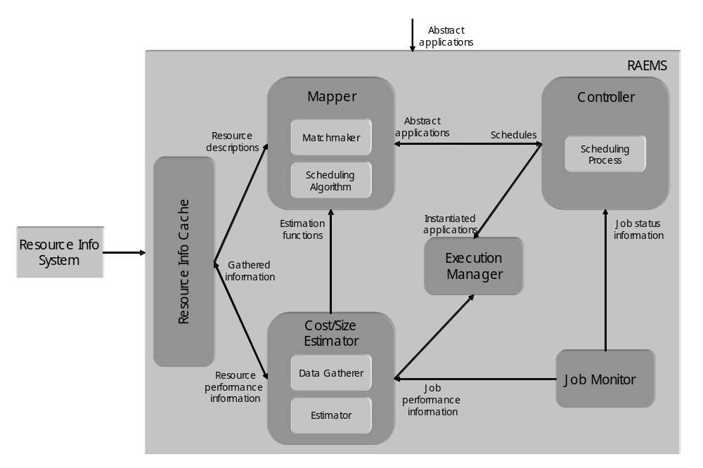
Figure 2-1: K-GRID scheduler architecture
“
Although extensible, the architecture can be characterized as centralized. For each application to be scheduled, the scheduler instantiates a different Controller. Moreover, the following logical steps are performed:

- The Cost/Size Estimator gathers data about characteristics and performances of available resources and builds the cost estimation functions (this step can be done offline).
- The Matchmaker selects resources usable to execute the jobs composing the application, using information coming from the Resource Information Cache.
- The Mapper evaluates a certain set of possible schedules, using information coming from the Estimation modules of the Cost/Size Estimator, and chooses of the one minimizing the completion time.
- The Controller requests job execution to the Execution Manager.
- The Controller waits for job status notifications from the Job Monitor or new information about availability and performance of resources and adapts the schedule to such changes.
In contrast to the previous use cases, the RAEMS focuses on the usage of application-specific agents. This way, the behaviour of an application can be taken into account more accurately.

GRASP (Grid Resource Allocation Services Package)
This package provides a job submission and scheduling framework on top of Globus. It supports the following functions:
- Grid Job Submission Service which provides coallocation facilities for MPI jobs
- Resource Brokering and Meta-Scheduling
- Local Job Execution
- Fault Tolerant Job Execution
The workflow of scheduling is described as follows:
- Queue the job for the scheduling
- Gather information about available resources from an information service
- Filter unsuitable resources using matchmaking between the job specification and the resource owner policies which should be offered by the information service
- Select the resources and number of nodes using various scheduling algorithm
- Reserve the resources based on the schedule
- Generate sub-job request scripts for each resource
- Submit each sub-job request to the resources
- Authenticate and authorize the user on the resources
- Verify the reservations
- Stage the required files on the resources
- Execute sub-jobs on the computing nodes
Again, GRASP tries to utilize advance reservation, although this is not fully implemented according to the use-case.

Scheduling in Loosely-Coupled Grids with GridWay
GridWay is a Globus-based tool to simplify job submission. It incorporates a scheduler which is capable to move jobs and recover from faults.
The workflow of the scheduling process can be described as follows:
- Resource discovery and selection: Based on a set of job requirements, like operating system or platform architecture, a list of appropriate resources is obtained by accessing to an information service mechanism. Then a single resource is selected among the candidate resources in the list.
- Preparation: The selected host is prepared for job execution. This step usually requires staging executable of input files.
- Submission and migration: The job is submitted to the selected resource. However, the user may decide to restart its job on a different resource, if a performance slowdown is detected or a better resource is discovered.
- Monitoring: The job evolution is monitored over time.
- Termination: When the job is finished, its owner is notified and some completion tasks, such as output file staging and cleanup, are performed.

Conclusion of the use cases
The use cases describe existing and complex scheduling systems. In addition to the proposed ones, simpler scenarios need to be taken into account, e.g. a simple mapping of a well-specified JSDL job on a resource. The GridWay use case comes close to this.

Performance Considerations
In the use-case in section 3.1 gives the following information regarding performance issues:
- Scalability. If the amount of resources which are part of a Grid increases, the communication between local resource managers and the scheduling service or the extended information service may have a negative impact on the overall system performance. Solutions like information caching (e.g. based on WS-Notification Error: Reference source not found) may be applied.
- Choice of the service programming model. Assuming that instances of that use case are performed in a Web Service based environment using SOAP Error: Reference source not found to exchange messages, one has to be aware that the performance is in general seen to be worse than that of other solutions like e.g. CORBA Error: Reference source not found.
- Communication failure. In a service-oriented architecture as described above the failure of communication between services is not unusual. To realize a reliable system and enforce a certain level of service quality (and therefore increase performance), mechanisms are needed to manage services. One activity which is to be monitored here is the Web Services Distributed Management TC Error: Reference source not found.
These considerations are true for all other use cases as well.

Data format considerations
The use cases use various different formats to describe entities. Within OGSA, we need to specify which formats to use for:
- the specification of atomic jobs (maybe JSDL).
- the specification of workflows,
- the specification of scheduling request, including jobs, workflows and user preferences
- an information model that allows us to
  - select suitable resources (should be mostly static information)
  - select the best resource (this depends heavily on user preferences)

Architecture considerations
We must provide interfaces that allow the various projects to integrate their specific functionality, e.g. advance reservation, user preferences or caching mechanisms.

The GSA-RG provides another document, the GSA Requirements:

https://forge.gridforum.org/projects/gsa-rg/document/GSA-Requirements/en/1

It tries to identify the properties of a future grid scheduling architecture, but is at a very early stage of development.

Author Information

Mathias Dalheimer
dalheimer@itwm.fhg.de
Fraunhofer ITWM
Gottlieb-Daimler-Str. Geb. 49
67663 Kaiserslautern, Germany

Glossary

Recommended by not required.

Intellectual Property Statement

The GGF takes no position regarding the validity or scope of any intellectual property or other rights that might be claimed to pertain to the implementation or use of the technology described in this document or the extent to which any license under such rights might or might not be available; neither does it represent that it has made any effort to identify any such rights. Copies of claims of rights made available for publication and any assurances of licenses to be made available, or the result of an attempt made to obtain a general license or permission for the use of such proprietary rights by implementers or users of this specification can be obtained from the GGF Secretariat.

The GGF invites any interested party to bring to its attention any copyrights, patents or patent applications, or other proprietary rights which may cover technology that may be required to practice this recommendation. Please address the information to the GGF Executive Director.

Full Copyright Notice

Copyright (C) Global Grid Forum (date). All Rights Reserved.

This document and translations of it may be copied and furnished to others, and derivative works that comment on or otherwise explain it or assist in its implementation may be prepared, copied, published and distributed, in whole or in part, without restriction of any kind, provided that the above copyright notice and this paragraph are included on all such copies and derivative works. However, this document itself may not be modified in any way, such as by removing the copyright notice or references to the GGF or other organizations, except as needed for the purpose of developing Grid Recommendations in which case the procedures for copyrights defined in the GGF Document process must be followed, or as required to translate it into languages other than English.

The limited permissions granted above are perpetual and will not be revoked by the GGF or its successors or assigns.

This document and the information contained herein is provided on an "AS IS" basis and THE GLOBAL GRID FORUM DISCLAIMS ALL WARRANTIES, EXPRESS OR IMPLIED, INCLUDING BUT NOT LIMITED TO ANY WARRANTY THAT THE USE OF THE INFORMATION HEREIN WILL NOT INFRINGE ANY RIGHTS OR ANY IMPLIED WARRANTIES OF MERCHANTABILITY OR FITNESS FOR A PARTICULAR PURPOSE."

References

[GSA-UseCase] | GSA-RG: Grid Scheduling Use Cases V1.2. Available from https://forge.gridforum.org/projects/gsa-rg/document/GridSchedulingUseCasesV1.2_doc/en/1

More details in the use case document
Except for centralized scheduling systems.
Taken from [GSA Use Case]

