RSS Service Description

Status of This Memo

This memo provides information to the Grid community on the services the OGSA-RSS WG is going to define. It does not define any standards or technical recommendations. Distribution is unlimited.

Copyright Notice

Copyright © Global Grid Forum (2002). All Rights Reserved.

Abstract

This document describes the services to be defined by the OGSA-RSS working group.

Contents
1. Outline 3
2. Use-Case Analysis 3
2.1 Use Case 1: Scheduling Complex Workflows 3
2.2 Use Case 2: Scheduling Component-based Applications for High Performance Heterogeneous Computing 3
2.3 Application-Oriented Scheduling in the KNOWLEDGE GRID 4
2.4 GRASP (Grid Resource Allocation Services Package) 5
2.5 Scheduling in Loosely-Coupled Grids with GridWay 5
2.6 Agent-based scheduling with Calana 5
2.7 Metascheduling/Coallocation in the VIOLA Testbed 6
2.8 Usage patterns 6
3. Conclusion of the use cases 7
3.1 Common scheduler functions 7
3.2 Performance Considerations 8
3.3 Data format considerations 8
3.4 Architecture considerations 9
4. OGSA-EMS Reference Architecture 9
4.1 Candidate Set Generator (CSG) 10
4.2 Execution Planing System (EPS) 10
4.3 Job Manager (JM) 10
4.4 Information Service (IS) 10
4.5 Open issues 11
5. Simple Resource Selection Service description 11
5.1 Service interaction scenarios 11
5.3 Candidate Set Generator (CSG) Definition 12
5.3.1 Service Interface 13
5.4 Execution Planning Service (EPS) Definition 13
5.4.1 Service Interface 13
5.4.1 Open topics 13
6. Advanced scheduling features 13

6

1. Outline
This document provides a description of the Resource Selection Services as outlined in the OGSA V1.0 document. Specifically, these services are:

1. The Candidate Set Generator (CSG) and
2. The Execution Planning System (EPS).

In order to identify the needs of the services, an analysis of the existing use-cases follows. In the next section, we review the OGSA-EMS ecosystem. An outline of both CSG and EPS follows.

2. Use-Case Analysis
The Grid Scheduling Architecture-RG maintains a use-case document, containing use-cases from various existing and upcoming grid scheduling system [GSA-Use Case]. In the following sections, we list the requirements identified within this document.

2.1 Use Case 1: Scheduling Complex Workflows
This use-case deals with the coordinated allocation of storage, CPU, network and other resources in order to execute a workflow. The scheduler should reserve resources as needed and plan the whole workflow at once.
The scheduler traverses the following steps:
- Composition and submission the job request
- Pre-processing of the job request
- Gathering of static resource information
- Pre-selection of resources
- Query of dynamic resource information.
- Generation of schedule and initialization of required reservations
- Execution of workflow
- Completion of workflow
The use case does not specify concrete data dependencies. Nevertheless, the following information seems to be needed:
- A specification of individual jobs
- A description of the workflow along with expected data transfers between execution locations
- The information system should provide all necessary information in order to map resources
Since the whole workflow is scheduled at submission time, this scheduler relies on advance reservation.

2.2 Use Case 2: Scheduling Component-based Applications for High Performance Heterogeneous Computing
Component-based programming tries to compose applications out of several smaller components, which can be used for different applications. This seems to be a promising attempt in terms of interoperability and reuse of components, but also poses a strong need for coallocation on the scheduler service.
In order to implement coallocation, one has to rely on advance reservation to keep track of various simultaneous coallocations.
The scheduler traverses the following steps:
- Search for existing components
- Composition of the application description and performance evaluation. When all the components needed by the application are known (by direct compilation or successful search) the application has to be described in some kind of language and its performance model compiled and evaluated in order to drive the resource selection, orchestration and scheduling phases.
This can be seen as a job pre-processing phase.
- Gathering of resource information
- Selection of the single resources, including computational, storage and network resources
- Orchestration of the selected resources. If no coallocation is possible, back to step
- Generation of the schedule and initialization of required reservations. If reservation fails. Back to step 3.
- Launch of the application
- Monitoring
- Re-scheduling
- Completion of execution
Again, this use case doesn’t state which concrete information is needed. In addition to the observations in section 2.1, an application-specific performance model is needed.

2.3 Application-Oriented Scheduling in the KNOWLEDGE GRID
The Resource Allocation and Execution Management Service (RAEMS) uses application-specific knowledge to optimize the allocation. The architecture is described as follows:
“The architecture of the scheduler [..] comprises three main components (Figure 21):
- Mapper. It computes schedules employing a scheduling algorithm and making use of resource descriptions and computational and I/O cost evaluations.
- Cost/Size Estimator. It builds the I/O and computational cost estimation functions. The CSE comprises data gathering modules collecting dynamic information about current and future availability and performance of resources, and estimation modules dealing with the actual construction of estimation functions, on the basis of the perceived status of resources with respect to time.
- Controller. It guides the scheduling activity by receiving abstract applications, requesting the corresponding schedules to the Mapper, and ordering the execution of scheduled jobs to the Execution Manager. The Controller also receives notifications about significant events occurred and re-schedules unexecuted parts of the application.

Figure 21: K-GRID scheduler architecture
“
Although extensible, the architecture can be characterized as centralized. For each application to be scheduled, the scheduler instantiates a different Controller. Moreover, the following logical steps are performed:
- The Cost/Size Estimator gathers data about characteristics and performances of available resources and builds the cost estimation functions (this step can be done offline).
- The Matchmaker selects resources usable to execute the jobs composing the application, using information coming from the Resource Information Cache.
- The Mapper evaluates a certain set of possible schedules, using information coming from the Estimation modules of the Cost/Size Estimator, and chooses of the one minimizing the completion time.
- The Controller requests job execution to the Execution Manager.
- The Controller waits for job status notifications from the Job Monitor or new information about availability and performance of resources and adapts the schedule to such changes.
In contrast to the previous use cases, the RAEMS focuses on the usage of application-specific agents. This way, the behaviour of an application can be taken into account more accurately.

2.4 GRASP (Grid Resource Allocation Services Package)
This package provides a job submission and scheduling framework on top of Globus. It supports the following functions:
- Grid Job Submission Service which provides coallocation facilities for MPI jobs
- Resource Brokering and Meta-Scheduling
- Local Job Execution
- Fault Tolerant Job Execution
The workflow of scheduling is described as follows:
- Queue the job for the scheduling
- Gather information about available resources from an information service
- Filter unsuitable resources using matchmaking between the job specification and the resource owner policies which should be offered by the information service
- Select the resources and number of nodes using various scheduling algorithm
- Reserve the resources based on the schedule
- Generate sub-job request scripts for each resource
- Submit each sub-job request to the resources
- Authenticate and authorize the user on the resources
- Verify the reservations
- Stage the required files on the resources
- Execute sub-jobs on the computing nodes
Again, GRASP tries to utilize advance reservation, although this is not fully implemented according to the use-case.

2.5 Scheduling in Loosely-Coupled Grids with GridWay
GridWay is a Globus-based tool to simplify job submission. It incorporates a scheduler which is capable to move jobs and recover from faults.
The workflow of the scheduling process can be described as follows:
- Resource discovery and selection: Based on a set of job requirements, like operating system or platform architecture, a list of appropriate resources is obtained by accessing to an information service mechanism. Then a single resource is selected among the candidate resources in the list.
- Preparation: The selected host is prepared for job execution. This step usually requires staging executable of input files.
- Submission and migration: The job is submitted to the selected resource. However, the user may decide to restart its job on a different resource, if a performance slowdown is detected or a better resource is discovered.
- Monitoring: The job evolution is monitored over time.
- Termination: When the job is finished, its owner is notified and some completion tasks, such as output file staging and cleanup, are performed.

2.6 Agent-based scheduling with Calana
Calana is an agent-based scheduler which uses auctions to incorporate the preferences of both resource providers and users. It is usually used in combination with a grid workflow engine at the grid level an local resource management systems like torque/maui at the resource level.
The scheduling workflow corresponds to an auction. We can distinguish these steps:
- The request is received.
- A “Call for Bids” is sent to all attached agents, containing information about the job and the estimated runtime of the job (e.g., a normalized wall time) along with information about the user.
- The provider’s agent consider the creation of a bid. It has to judge whether the job can be executed at the local site or not. The GADL description contains all needed static information. If the local strategy suggests bid creation, the agent obtains an advance reservation from the target machine and submits a bid to the broker.
- The broker then judges all bids, taking the user’s preferences into account.
- The agents are notified about the winner of the auction.
- The schedule is delivered.
The result is a schedule which can be used by the GridJobHandler to execute the job. Rescheduling must be done within the workflow engine, which also allows the latter one to react to execution failures etc. In addition, no dynamic queries or resource discovery is necessary: the agents register at the broker, and they interact directly with the local resource management system in order to retrieve dynamic information.

2.7 Metascheduling/Coallocation in the VIOLA Testbed
The VIOLA testbed allows users to run jobs across several sites. Therefore, the Metascheduler allows the coallocation of resources, including computational resources and network resources (QoS). The system integrates with Unicore, but can be adopted to work with other middleware systems.
For each meta-application to be scheduled, the UNICORE-client, the MetaScheduling Service and the UNICORE middleware perform the following logical steps:

- After the user finished the description of the job and the resource requirement the UNICORE-client (in VIOLA - or any other appropriate Grid middleware front-end in the case of another Grid middleware) sends an Agreement offer specifying the resources requested by the user and the user’s ids at the remote systems to the MetaScheduling Service
- The MetaScheduling Service starts the negotiation with the remote RMS to identify a common time-slot to run the job of the user.
- Once the negotiation completes successfully the MetaScheduling Service does the reservation of all requested resources for the identified common time-slot.
- Finally the MetaScheduling Service sends the offer response back, i.e. the agreement, back to the client.
- The client creates the UNICORE Abstract Job Object (AJO) and sends this through the UNICORE gateway to the UNICORE Network Job Supervisor.
- The NJS analyses and processes the AJO, enables monitoring and tracking of the job, and hands the job-date over to the UNICORE Target System Interface.
- The TSI finally does the mapping from the AJO to a concrete job for the local system and passes the job to the local system.

2.8 Usage patterns
In addition to the use cases, the Use-Case documents provides typical scheduler usage patterns. These patterns describe the typical usage scenarios:
- Simple job submission
- Single-site execution with service guarantee
- Job execution with advance reservation
- Co-allocation
- Complex workflow
- Data staging
For OGSA-RSS, we will use a rather simple usage scenario as described below, therefore we do not introduce them specifically.

3. Conclusion of the use cases
The use cases describe existing and complex scheduling systems. In addition to the proposed ones, simpler scenarios need to be taken into account, e.g. a simple mapping of a well-specified JSDL job on a resource. The GridWay use case comes close to this.

3.1 Common scheduler functions
The following table lists the facilities needed by the individual use cases. Since there is no unified terminology used in the use cases, the table lists all properties as mentioned above. Please consult the description of the corresponding use case for more information. The rows in grey designate advanced scheduling features which are implemented by some scheduling systems.

Function / Use case | Complex Workflows | Component-based Apps | Knowledge Grid | GRASP | Calana | GridWay | Viola Metasch.
Job submission | Yes | Yes | Yes | Yes | No | No | No
Component retrieval |  | Yes |  |  | No |  | No
Job Preprocessing | Yes | Yes |  |  | Yes
Static information gathering | Yes |  | Yes | Yes | Yes | Yes | Yes
Application performance estimation | No | Yes | Yes |  | Yes
Pre-selection of resources | Yes | Yes | Yes | Yes | Yes | Yes | Yes
Dynamic resource information query | Yes | Yes | Yes | Yes | No | Yes | No
Generation of schedule | Yes | Yes | Yes | Yes | Yes | Yes | Yes
Advance Reservation | Yes | Yes |  | Yes | Yes | No | Yes
Execution of workflow/ application start | Yes | Yes | Yes | Yes | No | Yes | No
Completion of workflow/ Job monitoring | Yes | Yes | Yes | Yes | No | Yes | No
Re-Scheduling | No | Yes | Yes | No | No | No | No
Billing | No | No | No | No | Yes |  | No
Coallocation |  | Yes |  | Yes | No | No | Yes
Data Handling | No | No | No | No | No | No | No

In order to be able to fulfill these scheduler’s requirements, the resource selection services need to interact with the following services of the OGSA-EMS framework:
- The Job Manager (JM) which fulfills the functions of job submission, component retrieval and job preprocessing. It then hands the request to the two scheduler services. After having retrieved the schedule, the workflow is executed and monitored by the JM.
- The Information Service (IS) provides access to both static and dynamic information.
- The Reservation Service (RS) can be used to get reservations for resources.
Therefore, the functionality of the Candidate Set Generator (CSG) and the Execution Planing System (EPS) can be described as follows:
- The Candidate Set Generator (CSG) provides the application performance estimation (which may be based on information retrieved from the IS) and the pre-selection of resources.
- The Execution Planing System (EPS) generates the schedule and maybe uses the Reservation Service in order to get an advance reservation. Especially in the case of coallocation this is important.
The issues of data handling and billing are open at the moment. In addition to the functionalities above, the next table shows the data dependencies for the use cases. Since the use cases do not mention the data used, this is a best-effort deduction based on the description of the use case.

Dependencies / use case | Complex Workflows | Component-based Apps | Knowledge Grid | GRASP | Calana | GridWay | Viola Metasch.
Individual job specification | Yes | Yes | Yes | Yes | Yes |  | Yes
Workflow specification | Yes | Yes | No | Yes | No |  | No
Central Information system: static information | Yes | Yes | Yes | Yes | Yes |  | Yes
Central Information system: dynamic information | Yes | Yes | Yes | Yes | No |  | No

3.2 Performance Considerations
In the use-case document, section 2.1 gives the following information regarding performance issues:
- Scalability. If the amount of resources which are part of a Grid increases, the communication between local resource managers and the scheduling service or the extended information service may have a negative impact on the overall system performance. Solutions like information caching (e.g. based on WS-Notification) may be applied.
- Choice of the service programming model. Assuming that instances of that use case are performed in a Web Service based environment using SOAP) to exchange messages, one has to be aware that the performance is in general seen to be worse than that of other solutions like e.g. CORBA.
- Communication failure. In a service-oriented architecture as described above the failure of communication between services is not unusual. To realize a reliable system and enforce a certain level of service quality (and therefore increase performance), mechanisms are needed to manage services. One activity which is to be monitored here is the Web Services Distributed Management TC.
These considerations are true for all other use cases as well.

3.3 Data format considerations
The use cases use various different formats to describe entities. Within OGSA, we need to specify which formats to use for:
- the specification of atomic jobs (maybe JSDL).
- the specification of workflows,
- the specification of scheduling request, including jobs, workflows and user preferences
- an information model that allows us to
  - select suitable resources (should be mostly static information)
  - select the best resource (this depends heavily on user preferences)

3.4 Architecture considerations
We must provide interfaces that allow the various projects to integrate their specific functionality, e.g. advance reservation, user preferences or caching mechanisms. The use-cases show two different philosophies regarding their design: On the one hand, there are schedulers that integrate all necessary functionality like job submission and workflow management. On the other hand, there are schedulers that rely on other systems to provide this functionality. Within OGSA, the latter philosophy seems to match best.
The GSA-RG provides another document, the GSA Requirements:
https://forge.gridforum.org/projects/gsa-rg/document/GSA-Requirements/en/1
It tries to identify the properties of a future grid scheduling architecture, but is at a very early stage of development. and therefore not considered here.

4. OGSA-EMS Reference Architecture
The OGSA-EMS document sets the boundaries of the Resource Selection Services. An overview of the various services within OGSA-EMS is given in figure 1. While the OGSA-RSS WG deals with the Execution Planing Services and the Candidate Set Generator, these services also interact with various other services within this framework. We will address them in the next sections.

4.1 Candidate Set Generator (CSG)
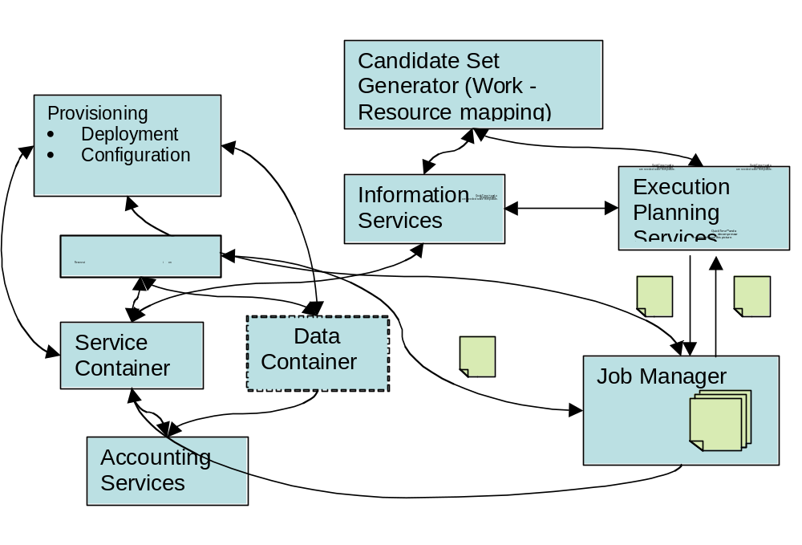
Figure 1: The OGSA-EMS architecture overview.
The CSG provides a list of service containers which are capable of running a given job. This list answers the question “where is it possible to execute this job”. It refers to the static part of job scheduling: Does the execution location fulfill the requirements of the given job, e.g. does it run the right OS and provide enough memory?
The CSG takes a job description as input. It may query an information system or interact with the service container directly. Then, it maps the job on the list of available resources by judging the requirements of the job. As result, the resource list for this job is sent back.

4.2 Execution Planing System (EPS)
The EPS calls the CSG in order to retrieve a list of possible service containers to run a given job. When the candidate list is received, it applies a planning technique to this list and selects the service container which is suited best. It returns this information in the form of an EPR to the service container.

4.3 Job Manager (JM)
The JM is responsible for managing jobs during their entire lifetime. It submits a job described in a JSDL document to resources (i.e., service containers) and controls the execution of jobs as well. The JM uses the protocol and interfaces defined in the OGSA BES (Basic Execution Service) specification to submit jobs to resources which understand JSDL documents. As seen in the Figure 1, JM submits a JSDL document describing a single job to the Service Container (SC) which the EPR returned from EPS points to.

4.4 Information Service (IS)
The IS is a service that contains attribute metadata about resources. For example, service containers publish information about their resource attributes along with their own EPRs to the IS. The container’s resource attributes, what is often called resource properties, describe both static information such as hostname, architecture, OS version, CPU clock speed, as well as dynamic information such as CPU load and queue length.

4.5 Open issues
At the moment, it is not clear which impact the following scheduling techniques will have on this architecture:
- Data management: So far, a job doesn’t contain any information about the size and location of data sets needed by the job. Therefore, a schedule cannot take data placement into account.
- Workflow management: A workflow is a relation between single, atomic jobs. The jobs are related in a certain order and may be executed in sequence or parallel. Data dependencies may occur between individual jobs.
- Although used by many scheduling systems, no advance reservation is supported. In our current model. This needs more discussion.

5. Simple Resource Selection Service description
In this section, we describe the settings of the resource selection services. We concentrate on a simple use case for a simple job submission, which we will describe in this section. By now, we only consider resource selection services for running a single job. We do not consider scheduling of
- an array of jobs with no interaction between them as often seen in the parameter sweep applications and
- a workflow consisting of a set of single jobs with some kind of dependency relationship between them.
More complex scenarios may be considered in subsequent drafts.

The Resource Selection Services do not change the state of any other system. There is no interaction with a Reservation Service. Therefore, the RSS may only provide best-effort decisions. We expect the Job Manager to retry after failures. Similarly, it may be difficult to implement coallocation services with this model.

5.1 Service interaction scenarios
The general service interaction scheme can be described as follows:
- The JM sends to the EPS an abstract JSDL document with a job’s resource requirement description. The resource requirement includes architecture, memory size, CPU speed, available library and licenses. Along with a JSDL, the EPS is also given some kind of selection policy which can be used to select the best one on which to run the job among the candidate set of resources returned by the CSG.
- EPS hands the JSDL document to CSG.
- CSG consults the Information Service (IS) to find a list of resources that meet the resource requirement of the job and returns the candidate set back to EPS.
- EPS selects the best one on which to run based on a selection policy, and passes a concrete JSDL document along with an EPR (End Point Reference) to the selected resource.
- JM submits the concrete JSDL document to the service container that was selected.
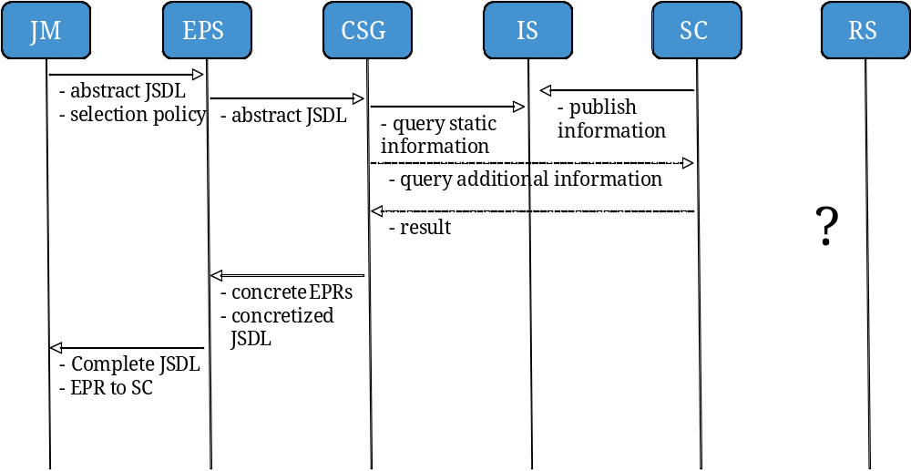
Figure 2: RSS interaction diagram
The interaction graph in figure 2 shows this sequence of actions:

5.2 Functional Design
We use JSDL as a language for describing (1) the resource requirements and (2) the specification of a job. There are two types of JSDL document:
- An abstract JSDL document refers to a JSDL document where some of elements necessary for describing a job specification have yet to be complete. For example, if JM sends to EPS a JSDL document with its “HostName” element unspecified because JM has no idea of where it should be run at that moment, the JSDL document can be called as an abstract JSDL document.
- A concrete JSDL document refers to a JSDL document where all the element needed for executing a job on resources are specified in a JSDL document.
As seen in figure 2, EPS turns an input abstract JSDL document into a concrete JSDL document and returns it back to JM after collecting all necessary information from interacting with CSG.

It is important to be noted that the interface and protocol definition of CSG is independent of both the implementation of the IS and the information model used in the IS. However, the implementation of CSG could be affected depending on the implementation of the IS, for example, whether the IS is implemented as a database server, or LDAP server, or a Grid service on top of WSRF.

5.3 Candidate Set Generator (CSG) Definition
The CSG is responsible for locating a set of candidate resources for running a job. Based on the resource requirement information in the abstract JSDL sent from EPS, CSG interacts with the IS, performing a simple matchmaking to identify a list of container services that have resource capability attributes that meet the job’s resource requirements. With the attributes of resources along with EPRs (End Point Reference) retrieved from the IS, CSG concretizes the abstract input JSDL from EPS, for example, by filling in the CandidateHosts element. CSG then passes back to EPS both the refined JSDL document and EPRs to the candidate service containers.

5.3.1 Service Interface
The service provides the following interface: TBD

5.4 Execution Planning Service (EPS) Definition
The EPS is responsible for the mapping of a job to resources on which to run the job. The EPS basically selects the most appropriate resource (i.e., container service) among the set of candidate resources returned from CSG. If necessary, the EPS is allowed to fill in additional resource requirements as well by looking up the IS. The EPS uses a selection policy to select the best one. The selection policy includes:
- user preference on resource requirement specified in the JSDL document
- some objective function such as minimum execution time, lowest cost, reservation-offering, etc.
- maybe an application-specific selection algorithm that optimizes some objective function

5.4.1 Service Interface
The service provides the following interface: TBD

5.4.1 Open topics
Other topics that need further discussion are:
- Selection Policy
- User Preference Structure and representation
- Objective function
- Application-specific selection algorithm.

6. Advanced scheduling features
During the analysis of the use cases, we found that many existing scheduling systems provide features like advance reservation, data scheduling, coallocation, rescheduling and – although not a native scheduler feature - billing. These features are currently not considered within this draft.

In addition, as described above, the current architecture does not change the state of other systems in the EMS architecture. This may limit the applicability of the current model to existing schedulers.

Author Information

Mathias Dalheimer
dalheimer@itwm.fhg.de
Fraunhofer ITWM
Gottlieb-Daimler-Str. Geb. 49
67663 Kaiserslautern, Germany

Soonwook Hwang

Donal Fellows

Intellectual Property Statement

The GGF takes no position regarding the validity or scope of any intellectual property or other rights that might be claimed to pertain to the implementation or use of the technology described in this document or the extent to which any license under such rights might or might not be available; neither does it represent that it has made any effort to identify any such rights. Copies of claims of rights made available for publication and any assurances of licenses to be made available, or the result of an attempt made to obtain a general license or permission for the use of such proprietary rights by implementers or users of this specification can be obtained from the GGF Secretariat.

The GGF invites any interested party to bring to its attention any copyrights, patents or patent applications, or other proprietary rights which may cover technology that may be required to practice this recommendation. Please address the information to the GGF Executive Director.

Full Copyright Notice

Copyright (C) Global Grid Forum (date). All Rights Reserved.

This document and translations of it may be copied and furnished to others, and derivative works that comment on or otherwise explain it or assist in its implementation may be prepared, copied, published and distributed, in whole or in part, without restriction of any kind, provided that the above copyright notice and this paragraph are included on all such copies and derivative works. However, this document itself may not be modified in any way, such as by removing the copyright notice or references to the GGF or other organizations, except as needed for the purpose of developing Grid Recommendations in which case the procedures for copyrights defined in the GGF Document process must be followed, or as required to translate it into languages other than English.

The limited permissions granted above are perpetual and will not be revoked by the GGF or its successors or assigns.

This document and the information contained herein is provided on an "AS IS" basis and THE GLOBAL GRID FORUM DISCLAIMS ALL WARRANTIES, EXPRESS OR IMPLIED, INCLUDING BUT NOT LIMITED TO ANY WARRANTY THAT THE USE OF THE INFORMATION HEREIN WILL NOT INFRINGE ANY RIGHTS OR ANY IMPLIED WARRANTIES OF MERCHANTABILITY OR FITNESS FOR A PARTICULAR PURPOSE."

References

[GSA-UseCase] | GSA-RG: Grid Scheduling Use Cases V1.2. Available from https://forge.gridforum.org/projects/gsa-rg/document/GridSchedulingUseCasesV1.2_doc/en/1
[OGSA Spec] | OGSA-WG: The Open Grid Services Architecture, V. 1.5.

