Takuya Mori, NEC Corp.
Nov. 19th, 2003

A Summary of OGSA Security Roadmap
Abstract
This document describes a summary of the “OGSA Security Roadmap” document submitted by OGSA-SEC WG. This document is written intended to evaluate and share current status of activities around the Grid security area. Some comments in this document are very tentative and need to be reviewed.

Table of Contents

1 Overview 1
2 OGSA Security Architecture Summary 2
3 Web Service Security Specifications 6
4 Proposed OGSA Security Specifications 7
5 Table of Proposed Specifications 10
6 References 13

Overview
“OGSA Security Roadmap” [Roadmap Document] was submitted to GFD Editor as a GFD-I document on July, 2002. The authors of the document are Frank Siebenlist(ANL), Von Welch(UC), Steven Tuecke(ANL), Ian Foster(ANL), Nataraj Nagaratnam(IBM), Philippe Janson(IBM), John Dayka(IBM), and Anthony Nadalin(IBM). The Roadmap document summarizes a previously released document, “OGSA Security Architecture”[Security Architecture], describes relationships between existing and emerging standards or technologies, and also proposes a set of specifications to be defined in the Global Grid Forum for the security architecture.

OGSA Security Architecture Summary
  - OGSA Security Components/Model
In the chapter two of the Roadmap document, a summary of the architecture document is introduced. First, the brief description of the security architecture is described. Then, the relationships between the security services and existing standards/technologies are introduced. Finally, key relationships among requestor, service provider, and many of the security services in the proposed architecture are described.
In the roadmap document, Figure 1 that is originally introduced in the architecture document shows security components in the OGSA-Security architecture.
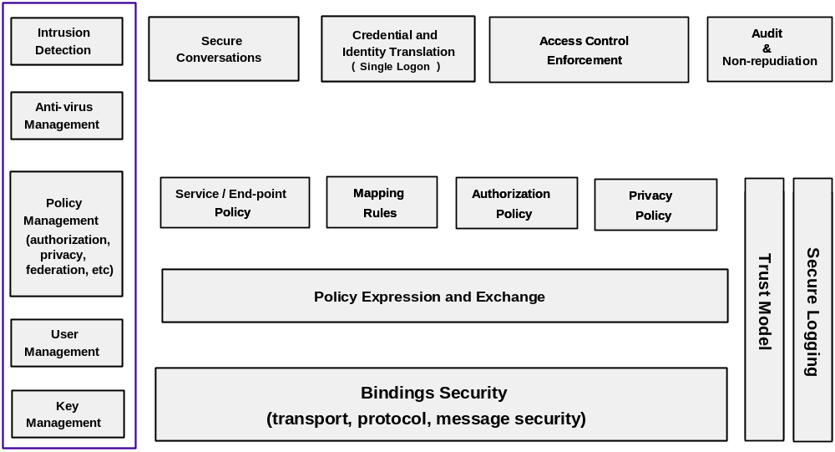Figure 1 Security Component Layering
On the top of the layers in Figure 1, application specific components (security services?) such as “Secure Conversation”, “Credential and Identity Translation (Single Logon)”, “Access Control Enforcement”, and “Audit & Non-repudiation” are shown. These components provide specific security services to Grid Services hosted by hosting environment. On the next layer, policies and rules such as “Service/End-point Policy”, “Mapping Rule”, “Authorization Policy”, and “Privacy Policy” are shown. “Service/End-point Policy” provides syntax and processing of polices that are used to describe required security and service level for each end-to-end communication channels between requestors and service providers. “Mapping Rules” provides a way to describe and evaluate rules for mapping an identity or capability across security domains. Authorization Policy provides a way to describe and evaluate policies that are used to make decision whether a requester has a privilege to access a resource. Privacy Policy is used to negotiate privacy information handling between a requester and a service provider. “Policy Expression and Exchange” provides a way to apply and manage these policies. At the bottom of the figure, “Binding Security” provides end-to-end secure communication channels through bindings to transport protocols. On the side, “Trust Model” provides trust a management mechanism that is a fundamental for each security services to evaluate policies. And the “Secure Logging” provides an audit and logging service that may be required for a secure system to satisfy security requirements for them. Finally, the left boxes are management and administration components of the infrastructure.
  - Relationships with the existing standards and technologies
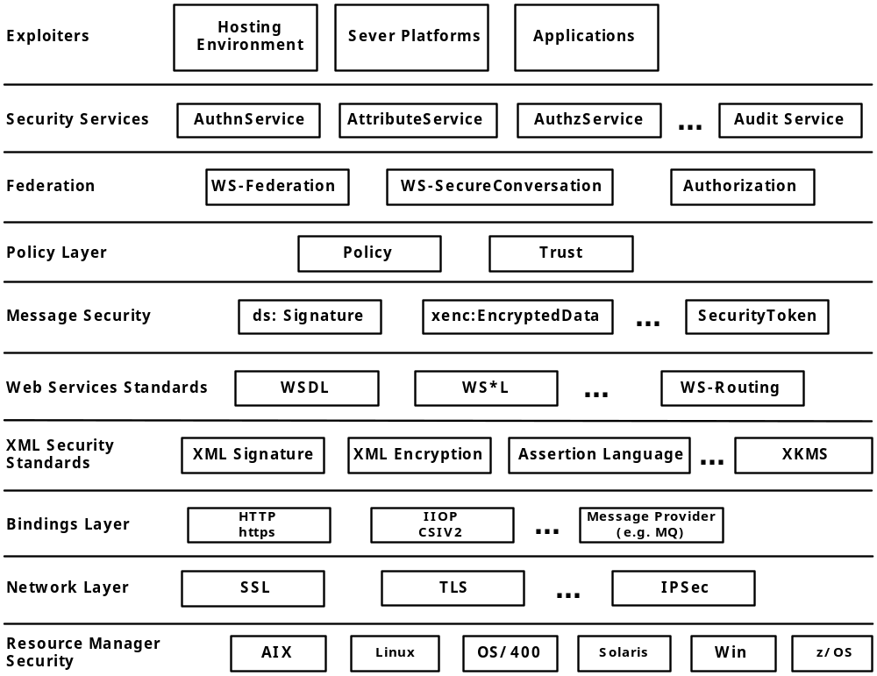Figure 2 Security Specifications “Stack”
In Figure 2, the roadmap document shows the relationships between existing security standards/technologies and the security components. Each higher level layers represents a dependency on their lower neighbors or a higher level in abstraction.
“Network Layer” security standards such as SSL (Secure Socket Layer), TLS (Transport Layer Security) [SSL, TLS], and IPSec provides point-to-point security such as authentication and confidentiality on transport or network layer protocols.
In “Binding Layer”, HTTPS and IIOP CSIv2 also provides point-to-point security on binding layer protocols. According to the Roadmap document, MQ can also provide point-to-point message security in this binding layer.
On top of these layers, “XML Security Standards” is shown in the figure. In this case, these standards are independent on the underlying layers. XML –Signature [XML-Signature] provides authentication mechanism to XML documents, while XML Encryption [XML Encryption] enables confidential XML documents. Assertion Language such as SAML (Security Assertion Markup Language) [SAML] defines syntax and exchanging protocols for assertions, messages declaring security related information, written in XML. In addition, XKMS (XML Key Management Service) [XKMS] defines protocols for validating and exchanging key information such as public key certificate.
In the next layer, “Web Services Standards” are shown, but they don’t provide any security functionality in this “Specifications Stack”.
On top of the “Web Services Standards”, some XML elements such as “ds:Signature”, “xenc:EncryptedData”, and “SecurityToken” are shown as “Message Security” layer. “ds:Signature” is an element defined in the XML-Signature standard. “xenc:EncryptedData” is an element that conveys an encrypted XML document or document subset, defined in the XML Encryption standard. “SecurityToken” is defined in WS-Security [WS-Security] specification to attach security related information into an SOAP header. And it can be used to hold key information for “ds:Signature” and “xenc:EncryptedData” elements. So, this layer can also be called WS-Security layer, and this layer can achieve end-to-end message security.
“Message Security” layer, “Policy Layer” and “Federation Layers” is introduced. WS-Policy [WS-Policy] and WS-Trust [WS-Trust] specifications can be adapted to this “Policy Layers”. “WS-Federation”, “WS-SecureConversation” [WS-SecureConversation], and “WS-Authorization” can be adapted in the “Federation” layer.
These layers described above are the existing specifications and technologies which the Grid security services relies on. As illustrated in Figure 2, AuthnService (Authentication Service), Attribute Service, AuthzService (Authorization Service), and Audit Service are shown.
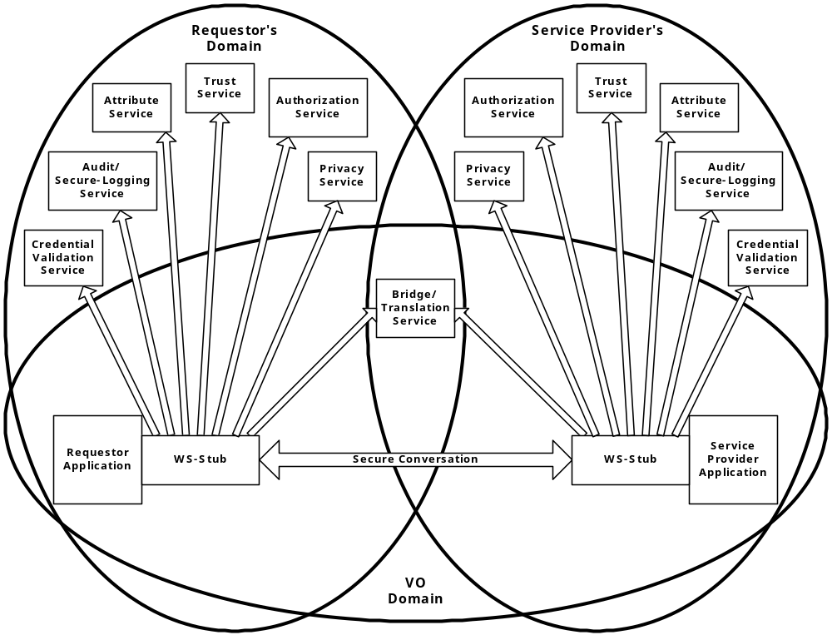Figure 3 Grid Security Services
In Figure 3, key relationships among requester, service provider, and detailed security services are illustrated. In the Virtual Organization configuration shown in the figure, the requester and the service provider are subject to the policy set in their domains, which means that the requester has its identity valid in its domain, and so does the service provider. However, the Bridge/Translation Service has credentials in both domains and is able to the requester and the service provider by issuing identity and capability assertions which is valid in each other domains.
Outgoing arrows from WS-Stub boxes of the requester and the provider indicate OGSA interfaces to the security services. Each security services provide specific services. For example Attribute Services, Trust Services, Authorization Services, and Privacy Services evaluate appropriate policies such as Mapping Rules, Trust Policies, Authorization Policies, and Privacy Policies, and finally make decisions if accesses are permitted and so on.

Web Service Security Specifications
The roadmap document proposes a set of OGSA security specifications that leverage WS Security specifications, proposed in the WS Security Architecture. The architecture introduces a set of specifications such as WS-Security, WS-Policy, WS-Federation, WS-SecureConversation, WS-Privacy, WS-Trust and WS-Authorization as shown in the figure below.
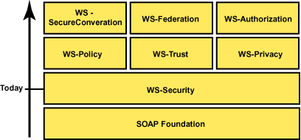
Figure 4 Web Services Security Specifications
These specifications will serve as building blocks for the OGSA security specifications proposed in the Roadmap document. Among these specifications, SOAP Foundation is the existing part. And, only the WS-Security is in its last stage of standardization in WSS-TC (Web Services Security Technical Committee) in OASIS. WS-Policy (now it is divided into four specifications such as WS-Policy, WS-PolicyAttachment, WS-PolicyAssertions, and WS-SecurityPoilcy), WS-Trust, WS-SecureConversation and WS-Federation were proposed by Microsoft, IBM, and BEA, but they have not been submitted to any standardize organization. Still other two are remaining.
Other specifications that may be related the OGSA security specifications are XKMS, SAML, XrML [XrML], XACML, WS-Routing [WS-Routing], WS-Referral [WS-Referral], XML-Signature and XML Encryption.
Some of these specifications define a generic framework, so that OGSA specific profiles for message format or interfaces need to be defined. And also, there may be the case where some WS security specifications will not meet all OGSA security requirements. In such case, those specifications must be modified as a part of GGF specifications. Furthermore, some specifications may not be available at the time they are needed. In those cases, tactical solutions should be generated as specifications in GGF to allow the OGSA security specifications to be generated.

Proposed OGSA Security Specifications
In this chapter, proposed specifications are listed. Lines begins with ‘#’ are comments made by Takuya Mori.
  - Naming
The methods for expressing names for requesters, services, attributes for them, and actions, needs to be consistent because they are evaluated or referenced in various situations across security domains.
- OGSA Identity Specification: This specification defines how the identity for an OGSA entity should be formed based on its identity of the security realm. The OGSA identity can support cross-realm uniqueness, anonymity, and identity-mapping.
- OGSA Target/Action Naming Specification: This specification defines how a name of an action and a request from a requestor to a service provider is described. Names defined in this specification will be used in descriptions of authorization policies.
# This specification may be included in a policy language document that will be discussed in OGSA-AuthZ-WG.
- OGSA Attribute and Group Naming Specification: This specification defines a standard method of expressing attributes and group names that can be used in policy descriptions.
# This specification may be included in the attribute document discussed in OGSA-AuthZ-WG., or they are discussing a part of this specification in their attribute discussions.
- Transient Service Identity Acquisition Specification: This specification defines a method that a transient service instance can use to obtain a unique identity. This specification might consider various configurations for naming authority for the transient services. The possible naming authority might be a factory or hosting environment for the services, a requestor for the services, or services its self.
  - Translating between Security Realms
- Identity Mapping Service Specification: This specification defines an OGSA service that allows a client requestor to determine what identity mappings are allowed, by policy, for a particular pair of realms.
- Generic Name Mapping Specification: This specification generalizes the previous specification to define an OGSA service for mapping any sort of defined name for groups, attributes, actions, etc.
- Policy Mapping Service Specification: Building on the previous name mapping specification, this specification defines an OGSA service for mapping policies between security realms. This specification should consider the WS-Policy specification.
- Credential Mapping Service Specification: This specification defines an OGSA service that enables the conversion of credentials from one security realm to another in order to enable inter-realm interoperability.
  - Authentication Mechanism Agnostic
- Certificate Validation Service Specification: This specification defines a Certificate Validation Service. XKMS may meet the requirements on this service.
- OGSA-Kerberos Services Specifications: This specification defines OGSA services to enable the tunneling of Kerberos authentication protocols.
  - Pluggable Session Security
- GSSAPI-SecureConversation Specification: This is a tactical specification that defines context establishment and per-message protection for OGSA end-to-end communication.
# Will this be overridden by WS-SecureConversation?
  - Pluggable Authorization Service
- OGSA-Authorization Service Specification: This specification defines an OGSA service that act as a Policy Decision Authority.
# On-going OGSA-AuthZ-WG activity covers this specification.
  - Authorization Policy Management
- Coarse-grained Authorization Policy Management Specification: This specification defines mechanisms for managing coarse-grained (i.e.: services porttype level granularity) authorization policy.
# Current on-going effort of OGSA-AuthZ-WG will cover this specification as a part of their policy specification.
- Fine-grained Authorization Policy Management Specifications: A set of further specifications may be defined to support the management of more sophisticated and fine-grained policies.
# Will these specifications discussed in the phase two activities in OGSA-AuthZ-WG?
  - Trust Policy Management
- OGSA Trust Service Specification: This specification defines an OGSA services that will use the WS-Trust specification to manage and publish trust policies, that are used to evaluate if another entity is trustworthy or not.
  - Privacy Policy Management
- Privacy Policy Framework Specification: This specification defines a framework through which privacy policy can be stated and enforced. This policy is used not only to declare service providers’ policy on their usage of privacy information, but also to request service requesters’ preferences on it.
  - VO Policy Management
- VO Policy Service Specification: This specification defines one or more OGSA services that act as a repository of VO membership and policy information.
  - Delegation
- Identity Assertion Profile Specification: This specification defines a profile for expressing identity assertions that allow an entity to assert the identity name associated with a key, a request, or a communication channel.
# a SAML profile will be defined.
- Capability Assertion Profile Specification: This specification defines a profile to express capability assertions.
# OGSA-AuthZ-WG discusses on this matter.
  - Firewall “Friendly” (Firewall Traversal Mechanism)
- OGSA Firewall Interoperability Specification: This specification defines the functionality that OGSA service requestors and providers must support in order to interoperate through intervening firewalls. This specification may also define new OGSA services needed to assist in this effort.
  - Security Policy Expression and Exchange
- Grid Service Reference and Service Data Security Policy Decoration Specification: This specification will describe how a requestor determines the information that is required to communicate securely with a service.
# WS-SecurityPolicy and WS-PolicyAttachment define an attachment of policies to WSDL descriptions.
  - Secure Service Operation
- Secure Service’s Policy and Processing Specification: This specification defines the various policy checks that a service is expected to perform, and defines interfaces to specified external security services.
- Service Data Access Control Specification: This specification defines both coarse- and fine-grained access control policy that should be enforced on Service Data accesses.
# OGSA-AuthZ-WG works on this matter.
  - Audit and Secure Logging
- OGSA Audit Service Specification: This specification defines an OGSA Audit Service that allows requestors to submit information for inclusion in secure logs. An associated management interface would control policy on the logging – e.g. filters on what logs are actually stored, possible notification if certain logs are received, etc.
# This specification is closely related to “Logging Services”.
- OGSA Audit Policy Management Specification: This specification defines the management interface (porttype, operations and message formats) for normal OGSA services such that they can be externally managed as to what audit entries they generate and how those entries are logged (e.g. to what Audit Service).

Table of Proposed Specifications
The following table lists all the specifications proposed in the roadmap, grouped by category.
# | Categories
# | Specifications | Priority | Assigned To/  Who cares? | Depends on/ Will Use /  Will be replaces by...
1 | Naming
1-1 | OGSA Identity | High | None | Depends on OGSI?
1-2 | OGSA Target/Action Naming | High | OGSA-AuthZ | Will use XACML.
1-3 | OGSA Attribute and Group  Naming | High | OGSA-AuthZ | Will use SAML, or  X.509 Attribute Cert.?
1-4 | Transient Service Identity  Acquisition | High | None | Depends on OGSI?
2 | Translating between Security Realms
2-1 | Identity Mapping Service | Medium | None
2-2 | Generic Name Mapping | Medium | None
2-3 | Policy Mapping Service | Medium | None | Will use WS-Policy.
2-4 | Credential Mapping Service | Medium | None
3 | Authentication Mechanism Agnostic
3-1 | OGSA Certificate Validation Service | High | None | XKMS and OCSP might be used.
3-2 | OGSA-Kerberos Services | Low | None | Will use Kerberos.
4 | Pluggable Session Security
4-1 | GSSAPI-SecureConversation | High | None | Will use  WS-SecureConversation
5 | Pluggable Authorization Service
5-1 | OGSA-Authorization Service | High | OGSA-AuthZ | Will use SAML,  XACML.  WS-Authorization?
6 | Authorization Policy Management
6-1 | Coarse-grained Authorization Policy Management | High | OGSA-AuthZ | Will use WS-Policy
6-2 | Fine-grained Authorization Policy Management | High | OGSA-AuthZ  (Phase 2?) | Will use WS-Policy
7 | Trust Policy Management
7-1 | OGSA Trust Service | High | None | Will use WS-Policy and  WS-Trust
8 | Privacy Policy Management
8-1 | Privacy Policy Framework | Medium | None | Will use WS-Policy and  WS-Privacy
9 | VO Policy Management
9-1 | VO Policy Service | High | None | Will use WS-Policy
10 | Delegation
10-1 | Identity Assertion Profile | High | OGSA-AuthZ? | Will use SAML.
10-2 | Capability Assertion Profile | High | OGSA-AuthZ | Will use SAML.
11 | Firewall “Friendly”
11-1 | OGSA Firewall  Interoperability | Low | None | ?
12 | Security Policy Expression and Exchange
12-1 | Grid Service Reference and Service Data Security Policy Decoration | High | None | Will use  WS-SecurityPolicy  WS-PolicyAttachement,
13 | Secure Service Operation
13-1 | Secure Service’s Policy and  Processing | High? | OGSA-AuthZ?
13-2 | Service Data Access Control | High? | OGSA-AuthZ
14 | Audit and Secure Logging
14-1 | OGSA Audit Service | High? |  | Closely related to Logging Service  discussions in OGSA.
14-2 | OGSA Audit Policy  Management | Medium? |  | WS-Policy (?)

References
- [SSL,TLS] The TLS Protocol, Version 1.0, RFC2246
- [Roadmap Document] OGSA Security Roadmap,
<https://forge.gridforum.org/docman2/ViewProperties.php?group_id=59&category_id=293&document_content_id=289>
- [Security Architecture] Security Architecture for Open Grid Services,
<https://forge.gridforum.org/docman2/ViewProperties.php?group_id=59&category_id=293&document_content_id=290>
- [WS-Security] Security in a Web Services World: A Proposed Architecture and Roadmap,
<http://www-106.ibm.com/developerworks/library/ws-secmap/>
<http://www-106.ibm.com/developerworks/library/ws-secroad/>
- [WS-Policy] Web Services Policy Framework (WS-Policy),
<http://msdn.microsoft.com/webservices/default.aspx?pull=/library/en-us/dnglobspec/html/ws-policy.asp>
- [WS-Trust] Web Services Trust Language (WS-Trust),
<http://msdn.microsoft.com/webservices/default.aspx?pull=/library/en-us/dnglobspec/html/ws-trust.asp>
- [WS-SecureConversation] Web Services Secure Conversation Language,
<http://msdn.microsoft.com/webservices/default.aspx?pull=/library/en-us/dnglobspec/html/ws-secureconversation.asp>
- [WS-Routing] Web Services Routing Protocol (WS-Routing)
<http://msdn.microsoft.com/library/default.asp?url=/library/en-us/dnglobspec/html/ws-routing.asp>
- [WS-Referral] Web Services Referral Protocol (WS-Referral),
<http://msdn.microsoft.com/library/default.asp?url=/library/en-us/dnglobspec/html/ws-referral.asp>
- [XKMS] XML Key Management Specification (XKMS),
<http://www.w3.org/TR/xkms/>
- [SAML] Assertions and Protocol for the OASIS Security Assertion Markup Language (SAML),
<http://www.oasis-open.org/committees/security/docs/cs-sstc-core-01.pdf>
- [XrML] eXensible rights Markup Language, <http://www.xrml.org/>
- [XACML] OASIS eXtensible Access Control Markup Language (XACML),
<http://www.oasis-open.org/committees/xacml/>
- [WS-Routing] Web Services Routing Protocol (WS-Routing),
<http://msdn.microsoft.com/library/en-us/dnglobspec/html/ws-routing.asp>
- [WS-Referral] Web Services Referral Protocol (WS-Referral),
<http://msdn.microsoft.com/library/en-us/dnglobspec/html/ws-referral.asp>
- [XML-Signature] XML Signature WG, <http://www.w3.org/Signature/>
- [XML Encryption] XML Encryption WG, <http://www.w3.org/Encryption/2001/>

