NGOSS Release 4.5
Release Notes

RN302

Member Evaluation version 3.1 November 2004
©TeleManagement Forum 2004
NOTICE

The TeleManagement Forum (“TM Forum”) has made every effort to ensure that the contents of this document are accurate. However, no liability is accepted for any errors or omissions or for consequences of any use made of this document.

This document is a draft working document of TM Forum and is provided to its members solely for formal comments and evaluation. It is not a Forum Approved Document and is solely circulated for the purposes of assisting TM Forum in the preparation of a final document in furtherance of the aims and mission of TM Forum. Any use of this document by the recipient is at its own risk. Under no circumstances will TM Forum be liable for direct or indirect damages or any costs or losses resulting from the use of this document by the recipient.

Members of TM Forum are granted limited copyright waiver to distribute this document within their companies. They may not make paper or electronic copies for distribution outside their companies. The only purpose of the provision of this draft document to members is for making formal comments thereon to TM Forum.

This document may involve a claim of patent rights by one or more TM Forum members, pursuant to the agreement on Intellectual Property Rights between TM Forum and its members, and by non-members of TM Forum.

Direct inquiries to the TM Forum office:

89 Headquarters Plaza North – Suite 350
Morristown, NJ 07960 USA
Tel No. +1 973 292 1901
Fax No. +1 973 993 3131
TM Forum Web Page: www.tmforum.org

Table of Contents

NOTICE 2
Table of Contents 3
List of Figures 4
List of Tables 5
1 Introduction 6
2 Overview of NGOSS Release 4.5 7
3 Release Definition 9
4 The NGOSS Framework - Integrating the Elements 11
5 NGOSS Release 4.5 Reference Framework Deliverables 14
5.1 Lifecycle & Methodology Framework 14
5.1.1 Features in the Latest Version 14
5.1.2 Business Application and Benefit 14
5.2 eTOM – Business Process Framework 16
5.2.1 Features in the Latest Version 17
5.2.2 Business Application and Benefit 18
5.3 SID – Information Framework 20
5.3.1 Features in the Latest Version 21
5.3.2 Business Application and Benefit 21
5.4 Architectural Framework 22
5.4.1 Features in the Latest Version 22
5.4.2 Business Application and Benefit 22
5.5 Service Framework 23
5.5.1 Features in the Latest Version 23
5.5.2 Business Application and Benefit 23
5.6 Compliance Test Framework 23
5.6.1 Features in the Latest Version 25
5.6.2 Business Application and Benefit 25
6 Administrative Appendix 26
6.1 Document History 26

List of Figures

Figure 1 NGOSS Lifecycle and Methodology 11
Figure 2 Detailed View of NGOSS Lifecycle 15
Figure 3 The Enhanced Telecom Operations Map® (eTOM) 16
Figure 4 SID Level 1 of SID Business Entity Framework 20

List of Tables

Table 1 Summary of NGOSS R4.5 Features 8
Table 2 NGOSS Release 4.5 Deliverables 10

Introduction

NGOSS is the TM Forum’s New Generation Operations Systems and Software (NGOSS) program of the TeleManagement Forum that is driving the direction of OSS/BSS systems for the telecom industry. NGOSS is a comprehensive, integrated framework for analyzing, designing, developing, procuring and deploying operational and business support systems and software. The NGOSS Framework contains a readily available suite of reference artifacts that enable service providers to architect automated business processes having the agility to respond to ever changing customer needs and market landscapes. It is available as a comprehensive suite of industry-agreed specifications and guidelines that cover critical business and technical areas including the following key elements:
- Description of Lifecycle and Methodology for using and deploying NGOSS within an organization. Covering the identifying and describing of business problems and the expressing of specifications used to direct development and deployment of practical solutions.
- Definition of next generation Business Process Map for analysis and classification of business processes (both current and planned), delivered as the Enhanced Telecom Operations Map® (eTOM)
- Definition of common Information Model providing the language for creating the necessary and sufficient View artifacts, delivered as the Shared Information and Data (SID) Model
- Definition of architectural elements used to construct NGOSS-styled solutions: Business and System View Contracts described as part of the Technology Neutral Architecture (TNA) and delivered as part of the TNA suite of documents. A Contract is the fundamental unit of interoperability within an NGOSS solution.
- Description of a compliance program to certify solutions and products for conformance to the NGOSS Architectural style of OSS/BSS solutions.
To enhance the ability to use the NGOSS artifacts, NGOSS is packaged and delivered as “Releases” approximately once every six months. The appropriate versions of the Lifecycle & Methodology, eTOM, SID, Architecture and Compliance documents are grouped to create each release, and are specified within these release notes. An overview of the relationships between the various NGOSS frameworks is also presented in this document.

Overview of NGOSS Release 4.5

The NGOSS suite of documents have been expanded to include the Service Framework guide book, GB924 version 2.0 which discusses the problems associated with managing complex service delivery architectures and the need for interoperable OSS implementations to support these new demands. Key to this solution is the need for a common approach to modeling services and their components into an underlying NGOSS framework. The Service Framework outlines a methodology for mapping the ‘user domain’ terminology into the NGOSS SID and eTOM.

In addition, NGOSS Release 4.5 consists of the following new documents;
- GB921P, An eTOM Primer
- GB921T, eTOM – M3400 Mapping Application Note
- GB922 Addendum 1C, a SID model of the NGOSS Lifecycle Business View Contract

Along with changes to the following existing documents:

- GB921, enhanced Telecom Operations Map, has had a minor update to include references to updated documents in the rest of the GB921 Solution Suite. Addendum S has been eliminated and its contents merged with Addendum D, Process Decompositions and Descriptions. And Addendum F has been updated to include new process flow examples for billing.

- The main GB922 ‘Concepts, Principles and Business Entities’ document has been revised to include updated SID ABE to eTOM Process mappings. Addendum 1A Agreement has been revised to support the new Pricing model, and Addendum 1R has been updated to include additional Entity Identification examples.

- GB927, NGOSS Lifecycle and Methodology, has been revised to include templates that support creating the NGOSS Business View Use Case artifact, and to include TMF Member comments received during the open review period. Additionally, an Executive Overview slide set has been created for use in communicating the value proposition of NGOSS to C-level stakeholders.

And finally NGOSS Release 4.5 provides the SID UML model in XMI, HTML, and Rational Rose.

A summary of the new features of NGOSS Release 4.5 are listed in Table 1 below:

NGOSS Element | Features
Lifecycle & Methodology | - For NGOSS R4.5 GB927 has been revised to include TMF Member comments received during the open review period. An Executive Overview slide set has been created for use in communicating the value proposition of NGOSS to C-level stakeholders. Additionally, templates are provided to support creating the NGOSS Business View Use Case artifact.
eTOM Business Processes | - This Release 4.5 of the eTOM Framework builds on the existing TMF Approved Release 4.0, that has also being incorporated into ITU-T Recommendation M.3050 and has been approved and published by ITU-T as a new international standard.  - GB921 Release 4.5 integrates additional detailed process decompositions and process flows, together with a new introductory “Primer” on eTOM and further material agreed jointly with ITU-T on the relationship with their M.3400 Recommendation. Note that linkage between eTOM and SID is also documented in GB922.
Shared Information/Data (SID): Business Entities | - The main GB922 ‘Concepts, Principles and Business Entities’ document has been revised to include updated SID ABE to eTOM Process mappings. Addendum 1A Agreement has been revised to support the new Pricing model, Addendum 1R has been updated to include additional Entity Identification examples.  - A new deliverable is GB922 Addendum 1C, a SID model of the NGOSS Lifecycle Business View Contract.
Service Framework | - New guidebook describing a methodology for a hierarchical approach to describing service topology and for mapping the associated attributes to the NGOSS SID and eTOM

Table 1 Summary of NGOSS R4.5 Features

Release Definition

The NGOSS Release 4.5 suite of deliverables is composed of the following documents:

Document | Name | Version | Date | New/  Updated in Rls 4.5
GB927 | NGOSS Lifecycle & Methodology | 1.3 | November 2004 | ✓
GB927A | NGOSS Use Case Template | 0.2 | November 2004 | ✓
GB921 | eTOM Main Document | 4.6 | November 2004 | ✓
GB921B | eTOM – B2B Integration: Using B2B Inter-enterprise integration with the eTOM | 4.0.1 | March 2004
GB921C | Public B2B Business Operations Map Application Note | 4.0.1 | March 2004
GB921D | Process Decompositions & Descriptions | 4.6 | November 2004 | ✓
GB921F | Process Flow Examples | 4.6 | November 2004 | ✓
GB921L | eTOM – ITIL Application Note | 4.0.1 | March 2004
GB921P | eTOM Primer | 4.6 | November 2004 | ✓
GB921T | eTOM – M.3400 Mapping Application Note | 4.6 | November 2004 | ✓
GB922 | SID Business View: Concepts & Principles | 5.1 | November 2004 | ✓
GB922 – 0 | Primer for the SID Business View | 1.0 | February 2004
GB922 – 1A | SID Agreement | 5.5 | November 2004 | ✓
GB922 – 1BI | SID Business Interaction | 3.1 | July 2003
GB922 – 1BT | SID Business Entity Base Types | 3.1 | July 2003
GB922 – 1C | SID Business Contract | 0.7 | November 2004 | ✓
GB922 – 1J | SID Project | 1.1 | July 2003
GB922 – 1L | SID Location | 3.1 | July 2003
GB922 – 1P | SID Party | 3.1 | July 2003
GB922 – 1POL | SID Policy | 1.0b | July 2003
GB922 – 1R | SID Root Business Entities | 1.6 | November 2004 | ✓
GB922 – 1T | SID Time Related Entities | 1.1 | July 2003
GB922 – 1U | Using the SID (UML models) | 1.0 | February 2004
GB922 – 2 | SID Customer | 3.1 | July 2003
GB922 – 3 | SID Product | 3.1 | July 2003
GB922 – 4S-O | SID Service Overview | 2.0 | July 2003
GB922 – 4S-QoS | SID Quality of Service | 1.0 | July 2003
GB922 – 5LR | SID Logical Resource | 1.0 | July 2003
GB922 – 5PR | SID Physical Resource | 3.0 | July 2003
GB926 | SID System View: Concepts & Principles | 1.0 | February 2004
GB924 | Service Framework Guidebook | 1.9 | November 2004 | ✓
TMF053 | Technology Neutral Architecture | 4.0.1 | February 2004
TMF053B | TNA: Business & System View Contracts | 4.4 | February 2004
TMF053C | TNA: Behavior & Control Services | 1.0 | February 2003
TMF053D | TNA: Metamodel | 1.0 | February 2003
TMF053F | TNA: Framework Services | 1.0 | February 2004
TMF053S | TNA: Security Addendum | 1.0.1 | February 2004
TMF050 | NGOSS Compliance Testing Strategy Technical Specification | 4.1 | April 2004
TMF050A | NGOSS Compliance Testing Information Model & Testing Rules | 4.1 | April 2004

Table 2 NGOSS Release 4.5 Deliverables

The NGOSS Framework - Integrating the Elements

This NGOSS release represents one stage in a continuing evolution for the NGOSS approach. Understanding how the NGOSS elements fit together requires a view of both the overall NGOSS integration strategy as well as how this applies for NGOSS Release 4.5.

One of the distinguishing factors of the NGOSS program is its use of a methodology to govern the development of NGOSS styled solutions. The NGOSS Lifecycle as defined in GB927 is a formalized specification for defining the characteristics and behavior of NGOSS components. It also enables the interests of various stakeholders to be protected by representing the evolution of their interests as the solution progresses from the definition of its business concerns, through a mapping to a particular architecture and implementation, through to deployment. Specifically, the NGOSS Lifecycle contains two planes of interest, the Logical, or Technology Neutral, plane and the Physical, or Technology Specific, plane. These planes intersect with the two perspectives of influence, the Service Provider Perspective and the Service Developers Perspective to yield the four NGOSS Lifecycle Views, as depicted in Figure 1 below.

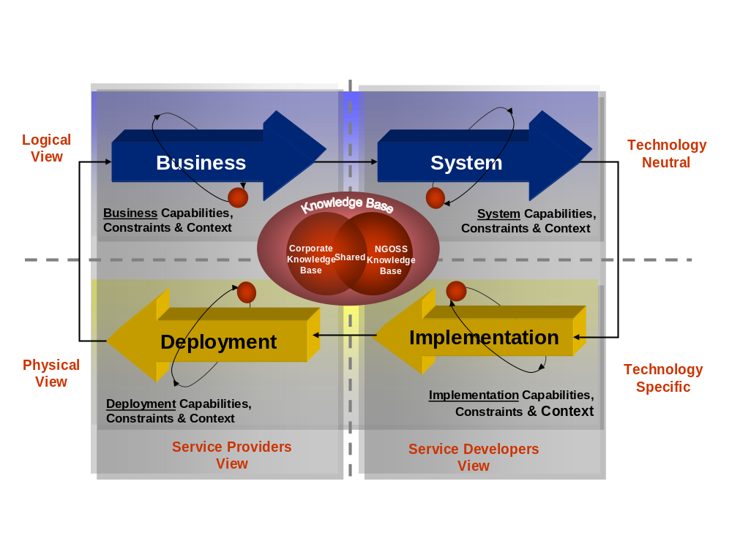
Figure 1 NGOSS Lifecycle and Methodology

Thus, NGOSS is not just for developers or business analysts. NGOSS, rather, caters to a wide range of stakeholders that are concerned with different aspects of the problem throughout the entire lifecycle of an NGOSS solution. These stakeholders may be assigned specific responsibilities within the Lifecycle Views that represent the aspects of analyzing, designing, implementing and operating an NGOSS Solution. The NGOSS Lifecycle identifies the four Views as the Business, System, Implementation, and Deployment Views.
In the NGOSS Business View, the eTOM and the SID are used to focus on the concerns of the business: processes, policies, entities and interactions. The eTOM and SID work together to aid in identifying business processes and information entities that support those business processes, which are guided by the governing business policies. The business view represents the goals, obligations, and policies that describe the managed environment and the services that it provides in high-level, technology-independent terms. These various tasks and functions are modeled as interactions in which contracts are used to specify the behavior for how information is exchanged between collaborating entities. Significantly, these models and additional supporting artifacts are collected and carried inside the contract (see TMF053B for more details) .
In the NGOSS System View, the SID, the eTOM, and the NGOSS Architecture are used to focus on the system concerns: managed objects, behavior and computational interactions. The system view is primarily concerned with the modeling of system processes and information in a technology neutral manner. Additionally, interactions are used as above; the difference is that in the system view, contracts also specify the behavior (in a technology-neutral manner) for how the functionality can be used to exchange information between the collaborating entities.
The NGOSS Implementation View focuses on how to build hardware, software, and firmware to implement the system being designed. This view uses the NGOSS architectural style to map the technology neutral specification of the solution to a particular target architecture. This mapping may include the use of available off-the-shelf solutions. Again, interactions are used as before; the difference being that contracts will now also contain the implementation artifacts, such as code, technology specific interface definitions, APIs, or Web Service invocations.
Finally, the NGOSS Deployment View is concerned with operating and actively monitoring the system to ensure that the observed behavior is what is expected – if not, then that behavior is adjusted appropriately using the NGOSS behavior and control mechanisms: process and policy based management. Once again, interactions are used to specify the details of the desired behavior. Thus, deployment contracts can contain a wide range of data (e.g., statistical performance data to evaluate the performance of the solution, policies to define specific behavior in response to particular stimuli, and so forth).
The advantage of this approach is that it provides traceability from the business definition and understanding of the solution (represented by the Business View) through the architecture, implementation and deployment definition stages. This NGOSS-styled approach also enables the information and data entities to be refined and extended through further development as each part of the development process is being worked.

The NGOSS Architecture, using the vehicle of the NGOSS Contract (with representation in each NGOSS Lifecycle View) moves beyond the traditional focus on Application Programming Interfaces (API) in order to provide an interface definition mechanism that offers end-to-end Lifecycle visibility, traceability and linkage. This work on the Contract lifecycle definition is documented in the new GB927 Lifecycle & Methodology and the revised TMF053B Technology Neutral Architecture Contract deliverables.

The functionality specified by a Contract presents a different view depending on the particular constituency (e.g., the business analyst vs. the programmer) being addressed. This means that a Contract has its own lifecycle, enabling the description, specification and implementation of its functionality to evolve during each phase of the solution. Specifically:
- The Business View of a Contract specifies the high-level goals and obligations that a resource and/or service must supply. This is done using concepts and terminology appropriate for communication and understanding by business personnel.
- The System View of a Contract specifies the computational requirements necessary to design the Contract, as defined by the Business View. This is done in a technical, though technology-neutral, manner appropriate for communication and understanding by the technical staff.
- The Implementation View of a Contract specifies the configuration, programming, and other implementation factors of the components necessary in order to provide the functionality specified by the Contract. This is done using one or more technology-specific mechanisms, including vendor-specific products, devices, protocols, languages, and other artifacts as necessary.
- The Deployment View of a Contract specifies mechanisms for monitoring the performance, cost, and other aspects of the functionality delivered by the Component and for administering the Contract to enable the Contract Instance’s activation and deactivation. This view contains artifacts to monitor the contractual obligations of the solution and to ensure that if those contractual obligations are violated, appropriate corrective action can and will be taken.
It is convenient to think of the functionality of a Contract in terms of a service (even though resources and other objects are required to deliver the functionality). The Contract specification covers the functional and non-functional characteristics and behavior of a service, along with its goals and obligations. Note that a Contract can have different obligations to different stakeholders.
In creating a Contract, the eTOM is used to establish the proper business context for defining and using the service. The eTOM’s industry vetted descriptions of business processes as well as its hierarchical classification scheme for storing and retrieving descriptions provides a means for ‘sketching out’ the desired sequence of activities that describe the new service. All the data that will be used and exchanged in a Contract invocation are defined using the SID, thereby enabling the common information to be shared and reused.

By using a common information vocabulary, the needs of each particular constituency (e.g., the business analyst vs. the programmer) can be accounted for through the use of a particular View, as previously explained. The SID supplies the language for describing the NGOSS information entities for each of the views, and it’s through usage of this common and shared vocabulary that all the Views can be linked together. This is a fundamental concept that underpins NGOSS as it provides the necessary end-to-end visibility and traceability – information for one constituency isn’t lost, it is used and represented appropriately in each of the other views.

Taken collectively, the deliverables packaged as NGOSS Release 4.5 provide a Lifecycle Framework supported by an Architecture that provides the necessary constructs for the Methodology to be used to assemble reference artifacts extracted from the eTOM and SID in order to express a specific View on the concerns of the key stakeholder constituents by capturing their requirements as Use Cases and a specification of points of solution interoperability as Contracts. Adherence to this NGOSS-styled approach for OSS/BSS solution creation is gauged using the Compliance test criteria.

The specifics of the major revisions and new additions being delivered by this release of NGOSS are described in the remaining sections of these Release Notes.

NGOSS Release 4.5 Reference Framework Deliverables

Lifecycle & Methodology Framework

Features in the Latest Version
For NGOSS R4.5 GB927 has been revised to include TMF Member comments received during the open review period. An Executive Overview slide set has been created for use in communicating the value proposition of NGOSS to C-level stakeholders. Additionally, templates are provided to support creating the NGOSS Business View Use Case artifact.

Business Application and Benefit
The GB927 NGOSS Lifecycle and Methodology approach provides traceability, from Business needs through the System, Implementation and Deployment Views of the solution, as well as traceability describing how policies, processes, information processing entities and other NGOSS artifacts, interacting through Contracts, are formed into a Component based solution (see Figure 2).

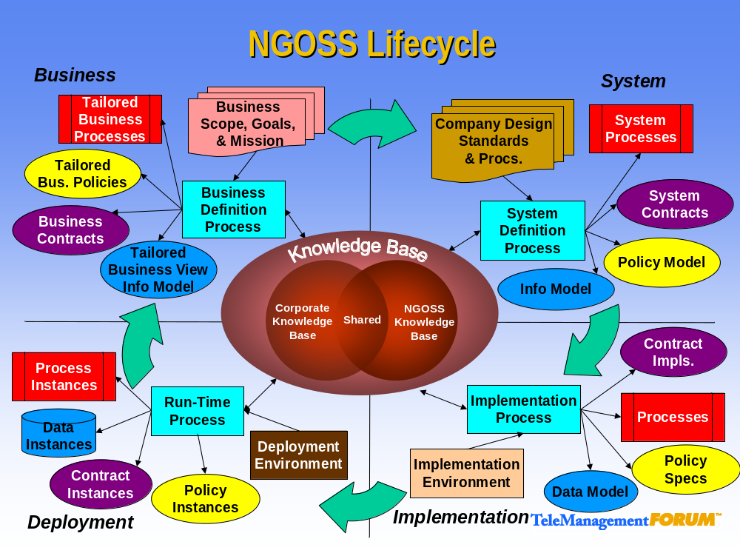

Figure 2 Detailed View of NGOSS Lifecycle

By balancing the implementation and deployment views against the business and system views, through use and application of the NGOSS Lifecycle and Methodology, it becomes possible to re-use and refine existing specifications, models and designs in a controlled manner. By making use of these abstractions, you can avoid having to make technology decisions too early; rather, the focus can be put on refining and evolving businesses processes, policies and models. By moving work into this logical realm, it becomes possible to map decisions onto more than just one implementation solution. In fact, the solution decisions documented in the logical realm become ‘blueprints’ ready for re-use and application in other areas of the business, which may be governed by different implementation choices but can still re-use the solution blueprint.

eTOM – Business Process Framework
The Enhanced Telecom Operations Map® (eTOM) is the ongoing TM Forum initiative to deliver a business process model or framework for use by service providers and others within the telecommunications industry. The TM Forum eTOM describes all the enterprise processes required by a service provider and analyzes them to different levels of detail according to their significance and priority for the business. For such companies, it serves as the blueprint for process direction and provides a neutral reference point for internal process reengineering needs, partnerships, alliances, and general working agreements with other providers. For suppliers, eTOM outlines potential boundaries of software components to align with the customers' needs and highlights the required functions, inputs, and outputs that must be supported by products.

A particular strength of eTOM as a business process framework is that it is positioned within the NGOSS program and links with other work underway in NGOSS. In particular, eTOM provides the Business Map for NGOSS and is a prime driver for business requirements to feed through from the NGOSS Business View to the System View and eventually into the NGOSS Implementation and Deployment Views.

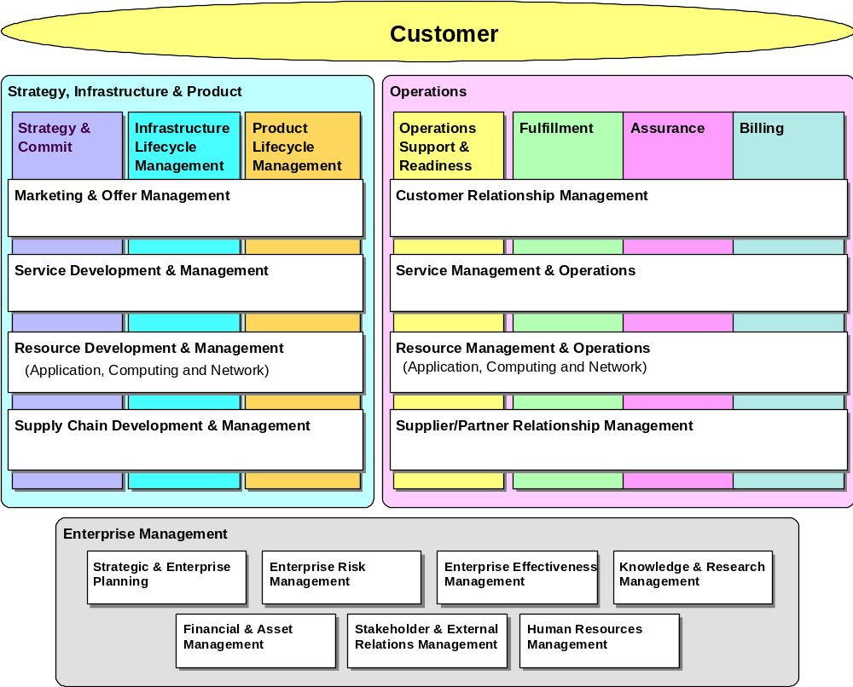

Figure 3 The Enhanced Telecom Operations Map® (eTOM)

The process structure in eTOM uses hierarchical decomposition, so that the business processes of the enterprise are successively decomposed in a series of levels. Process descriptions, inputs and outputs, as well as other key elements are defined. The eTOM process modeling depicts process flows in a vertical swim lane approach that drives end-to-end process and process flow-through between the customer and the supporting services, resources and supplier/partners.

The Framework also includes views of functionality as they span horizontally across an enterprise’s internal organizations. For example, managing customer relationships spans an enterprise from marketing to ordering to billing to after-service support and follow-on sales.

Features in the Latest Version
This Release 4.5 of the eTOM Framework builds on the existing TMF Approved Release 4.0, that has also being incorporated into ITU-T Recommendation M.3050 and has been approved and published by ITU-T as a new international standard.

Release 4.5 is part of NGOSS 4.5. It integrates additional detailed process decompositions and process flows, together with a new introductory “Primer” on eTOM and further material agreed jointly with ITU-T on the relationship with their M.3400 Recommendation.

GB921 4.5 is a new Member Evaluation version of eTOM. The following features are new in this version, from the existing TMF Approved version (GB921 4.0):
- New process decompositions with new process detail. The primary new work is in the SIP domain, where processes are decomposed to Level 3 throughout (this work was previously provided to members as a separate document - GB921S 4.1 - but this document has been merged in this Release into GB921D 4.5)
- Example process flows showing application of the eTOM processes and how eTOM can be used in the user’s business, with relation to Billing and associated areas
- A new “eTOM Primer” document as an introduction to the eTOM Framework
- A new Application Note showing mapping between eTOM process elements and the ITU-T M.3400 functional view
- Linkage with SID (published separately as part of the SID GB922 Concepts Y Principles document, showing mapping between SID information and eTOM process elements

GB921 v4.5 has grown to include a number of new components. The overall eTOM document set includes:
- A main document (GB921) that provides an overview of the eTOM Business Process Framework, from both Intra-Enterprise and Inter-Enterprise viewpoints, and describes the main structural elements and approach
- An Addendum (GB921D) describing the Service Provider enterprise processes and sub-processes in a form that is top down, customer-centric, and end-to-end focused. Process decompositions are provided for all processes from the highest conceptual view of the eTOM framework to the level of detail agreed for use by the industry. For Release 4.5, this has absorbed GB921S 4.1, which is therefore superseded.
- An Addendum (GB921F) describing selected process flows at several levels of view and detail that provides end-to-end insight into the application of eTOM.
- An Addendum (GB921B) describing the implications and impact of e-business for service providers and their business relationships, and how eTOM supports them, including a description of handling of business-to-business Interactions by eTOM. Associated with this is a separate Application Note (GB921C) describing a Business Operations Map for processes involved in business-to-business interaction
- An Addendum (GB921P), not included at time of release in the GB921 v4.0 document set, providing an “eTOM Primer” to assist new users of eTOM
- A separate Application Note (GB921L) that shows how eTOM can be used to model the ITIL processes
- A separate Application Note (GB921T), not included at time of release in the GB921 v4.0 document set, that shows how eTOM processes relate to the functional view provided by the ITU-T M.3400 Recommendation (this work was developed in conjunction with ITU-T within the joint Telecom Management Collaboration Focus Group)

Business Application and Benefit
The eTOM Business Process Framework can be used as a tool for analyzing your organization’s existing processes and for developing new processes. Different processes delivering the same business functionality can be identified, duplication eliminated, gaps revealed, new process design speeded up, and variance reduced. Using eTOM, you can assess the value, cost and performance of individual processes within your organization.

You can facilitate your relationships with suppliers and partners by identifying and categorizing the processes you use in interactions with them. In a similar manner, you can identify the all-important customer relationship processes and evaluate whether they are functioning as required to meet your customers’ expectations.

Some of the specific business benefits of using the eTOM within your organization are:
- It develops a scope addressing all enterprise processes.
- It distinctly identifies marketing processes to reflect their heightened importance in an ebusiness world.
- It distinctly identifies Enterprise Management processes, so that everyone in the enterprise is able to identify their critical processes, thereby enabling process framework acceptance across the enterprise.
- It brings Fulfillment, Assurance and Billing (FAB) onto the high-level framework view to emphasize the customer priority processes as the focus of the enterprise.
- It defines an Operations Support & Readiness vertical process grouping, that relates to all the Operations functional layers. In integrating ebusiness and making customer self-management a reality, the enterprise has to understand the processes it needs to enable for direct and (more and more) online customer operations support and customer self-management.
- It recognizes three process groupings within the enterprise that are distinctly different from operations processes by identifying the SIP processes, i.e., Strategy & Commit, Infrastructure Lifecycle Management and Product Lifecycle Management.
- It recognizes the different cycle times of the strategy and lifecycle management processes and the need to separate these processes from the customer priority operations processes where automation is most critical. This is done by decoupling the Strategy & Commit and the two Lifecycle Management processes from the day-to-day, minute-to-minute cycle times of the customer operations processes.
- It moves from the older customer care or service orientation to a customer relationship management orientation that emphasizes customer self-management and control, increasing the value customers contribute to the enterprise and the use of information to customize and personalize to the individual customer. It adds more elements to this customer operations functional layer to represent better the selling processes and to integrate marketing fulfillment within Customer Relationship Management. Note that Customer Relationship Management within the eTOM framework is very broadly defined and larger in scope than some definitions of CRM.
- It acknowledges the need to manage resources across technologies, (i.e., application, computing and network), by integrating the Network and Systems Management functional process into Resource Management & Operations. It also moves the management of IT into this functional layer as opposed to having a separate process grouping.
- It recognizes that the enterprise interacts with external parties, and that the enterprise may need to interact with process flows defined by external parties, as in ebusiness interactions.

SID – Information Framework
The SID must serve many masters as it is the common language used to create NGOSS Use Cases and Contracts. As explained by the GB927 Lifecycle & Methodology these Use Cases and Contracts are used to convey meaning to at least four main sets of constituents as represented by the Business, System, Implementation and Deployment Views of NGOSS. Building out the SID to fully support all four views is the vision for NGOSS. However, much of the work is still being developed and while the documents available today cover a substantial part of a Service Provider’s core information needs (see Table 2 and Figure 4), they do not yet cover all of them.
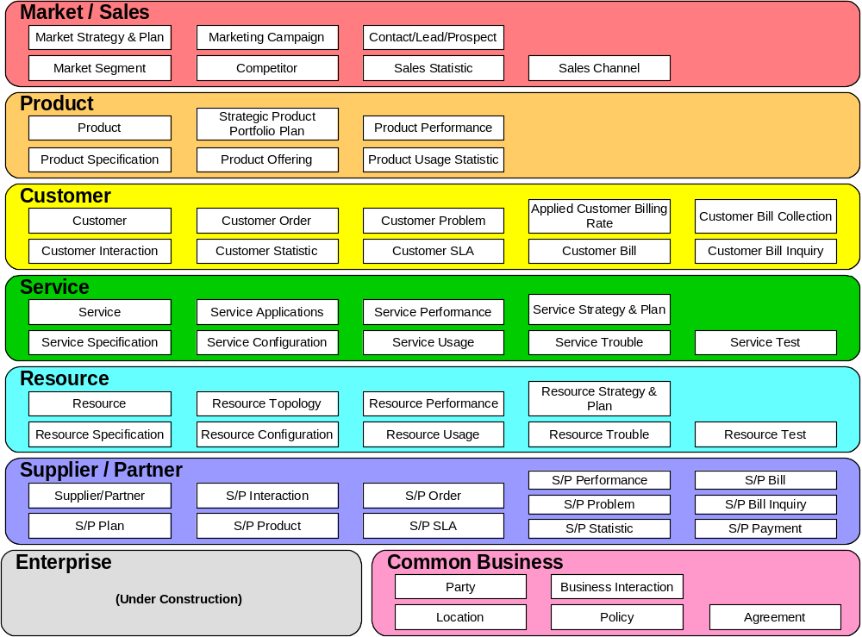
Figure 4 SID Level 1 of SID Business Entity Framework

The SID, as the NGOSS information model, provides an information/data reference model and a common information/data vocabulary from a business as well as a systems perspective. Put another way, the SID provides a knowledge base that is used to describe the behavior and structure of business entities as well as their collaborations/interactions. The SID uses UML to formalize the expression of the needs of a particular view: Business, System, Implementation or Deployment.

Features in the Latest Version
The main GB922 ‘Concepts, Principles and Business Entities’ document has been revised to include updated SID ABE to eTOM Process mappings. Addendum 1A Agreement has been revised to support the new Pricing model, Addendum 1R has been updated to include additional Entity Identification examples.

A new deliverable is GB922 Addendum 1C, a SID model of the NGOSS Lifecycle Business View Contract. This Addendum defines the concept of a business contract for the Shared Information and Data (SID) program, which is part of the NGOSS knowledge base. As such, the addendum is intended primarily for business stakeholders, though it will be of use to other stakeholders, such as designers and implementers. This is because the notion of an NGOSS contract [TMF053B] spans all views of the management environment, as shown in 2 above.

The NGOSS Contract Model is based on the Design by Contract [DBC] notion pioneered by Bertrand Meyer and the concept of contractually defined interfaces developed by Bellcore in the INA [INA] project. The principal idea behind this approach is that an object and its clients communicate using contracts. It should be noted that this original definition was focused on building reusable, object-oriented software components – specifically, designing classes and class methods. DEN-ng and NGOSS have taken this idea and expanded it to cover the production of the requisite artifacts across all four stages of the NGOSS Lifecycle.

Business Application and Benefit
The SID provides the common language for communicating the concerns of the four major groups of constituents represented by the four NGOSS Views. Used in combination with the eTOM business process and activity descriptions it becomes possible to create a bridge between the business and Information Technology groups thereby providing definitions that are understandable by the business, but are also rigorous enough to be used for software development.

The benefit of using the NGOSS SID and its common information language is that it enables business benefits relating to cost, quality, timeliness and adaptability of enterprise operations, thus allowing an enterprise to focus on value creation for their customers.

Architectural Framework
The Contract is the fundamental unit of interoperability within an NGOSS solution and is the architectural construct used to capture the specification of how a managed entity will interact with its environment. As described previously (refer to GB927) the NGOSS Lifecycle is a formalized specification for defining the characteristics and behavior of NGOSS components. It also enables the interests of various stakeholders to be protected by representing the evolution of their interests as the solution progresses from the definition of its business concerns, through a mapping to a particular architecture and implementation and on to deployment. Thus, NGOSS is not just for developers or business analysts. NGOSS, rather, caters to a wide range of stakeholders that are concerned with different aspects of the problem throughout the entire lifecycle of an NGOSS solution. These stakeholders may be assigned specific responsibilities within the Lifecycle Views that represent the aspects of analyzing, designing, implementing and operating an NGOSS Solution.

Within the NGOSS Architecture, Contract-based interaction builds from work done by ANSA as documented in the RM-ODP specifications as well as from current software technologies like Java. However, none of these approaches addressed the issue of different users requiring multiple tailored views of the same inherent Contract. Indeed, most preceding work has focused on the definition of Application Programming Interface (API) aspects of interactions and thus where focused on the implementation and run-time concerns of software interaction. The NGOSS Architecture, using the vehicle of the NGOSS Contract (with representation in each NGOSS Lifecycle View) moves beyond this traditional focus in order to provide an interface definition mechanism that offers end-to-end Lifecycle visibility, traceability and linkage in addition to the traditional functional API definition.

Features in the Latest Version
No changes in this NGOSS Release.

Business Application and Benefit

The NGOSS Technology Neutral Architecture defined by the TMF053 suite of documents provides the necessary structural underpinnings and building constructs to support the analysis, design, implementation and deployment of open distributed computing solutions. By using the NGOSS Architecture and the vehicle of the NGOSS Contract it now becomes possible to move away from the traditional focus on providing interface definitions and begin offering more of an end-to-end view of the Lifecycle to include visibility, traceability and linkage that enables the interests of the various stakeholders to be protected by representing the evolution of their interests as the solution progresses from the definition of the business concerns, through the mapping to a particular architecture and implementation and on to deployment.

Service Framework
The Service Framework guide book discusses the problems associated with managing complex service delivery architectures and the need for interoperable OSS implementations to support these new demands. Key to this solution is the need for a common approach to modeling services and their components into an underlying NGOSS framework. The Service Framework outlines a methodology for mapping the ‘user domain’ terminology into the NGOSS SID and eTOM.

Features in the Latest Version
Version 2 of the guide book expands the concept of mapping from the user domain to the underlying SID entities through the application of role based context. The document provides the following key deliverables:
- A common methodology for the definition of a service through the decomposition into service components that are both reusable across multiple services, where appropriate, and that match the service providers functional organization.
- The identification of the key roles within an organization and the key processes associated with those roles.
- Through the context of roles, processes and associated data flows, the Service Framework provides a methodology for the mapping of user terminology into the NGOSS SID and hence the requirements on service management products to provide interoperable solutions.
(Note: for the version 2 release of GB924, only the mapping for the service creation processes are described in detail)

Business Application and Benefit
Through the use of a common methodology for the definition of service topology and mapping of associated data entities into the NGOSS framework, the Service Framework provides a methodology that enables service providers and service management solution vendors to map their end user requirements into the NGOSS SID. The combination of the common approach to defining the user view of service topology and the linkage into the common information model of the SID will enable greater interoperability between OSS products, reduce integration time and cost, and support the management of complex service delivery architectures.

Compliance Test Framework
The NGOSS Compliance activities aim to define how components and solutions may ultimately qualify as being compliant with all the various aspects of NGOSS. The NGOSS Compliance documentation (TMF050 and TMF050A) describe the overall testing strategy and approach used, as well as identifying specific tests able to be performed for this NGOSS release.

The goal of the TMF050 series of documents is to define a comprehensive suite of tests, which can be used by the industry to validate conformance of individual products and solutions to specific aspects of NGOSS.

This version of TMF050 defines an approach that tests for compliance to most of the core architectural principles, specifically those at the foundation layer. It also highlights the business process and information areas covered by the solution as per the Enhanced Telecom Operations Map® (eTOM) and the Shared Information/Data Model (SID).

The eTOM, SID and core architectural principles focus primarily on the NGOSS Framework Business and System View activities, with plans to expand into the Implementation and Deployment Views in future releases. On the other hand, the current scope of compliance testing is primarily focused on testing the deployed component/solution and does not yet address the full scope of the NGOSS Lifecycle as defined in GB927 v1.0. Compliance within any of the other key areas of the NGOSS Views, e.g., complete NGOSS lifecycle coverage or functional coverage, will be addressed in future versions of this document.

Additionally, this version of the NGOSS Compliance documentation describes the concept of recording compliance test results using a matrix approach with embedded levels of compliance for some specific matrix elements. This means that NGOSS testing records whether a solution has been tested against specified core NGOSS principles and when tested, whether it abides to them. NGOSS testing is also about identifying the business process and informational scope, and in future releases the functional scope that the solution is covering in order to help identify the target point of integration.

The matrix elements of interest in this version are:
- Core NGOSS principles:
  - Architecture is inherently distributed,
  - Architecture uses interfaces to communicate, also described as Contract Defined Interfaces,
  - Architecture is component-based,
  - Business processes are separated from Component Implementation, also described as Externalized Process Control,
  - Architecture uses shared information and data, also known as the Shared Information/Data Model (SID),
  - Architecture uses a common repository, that encompasses the use of Contract Registration and Trading and a Common Communications Vehicle;
- OSS coverage
  - Business process domain with regard to eTOM,
  - Information domains with regard to the Shared Information/Data Model (SID).

Missing from the current scope of the Matrix are:
- Core NGOSS principles:
  - Architecture is security enabled,
  - Architecture may be policy enabled;
- OSS coverage
  - Functional domains (no map yet defined within the NGOSS guidebooks).

OSS components designed in compliance to these NGOSS principles get most of the benefits of NGOSS (TMF 051) thus allowing for more flexible solutions and a simplification of component integration. The current compliance testing scope covers 6 of the 8 core principles as defined in TMF 053 version 4.0. Integration is further eased by the detailed identification of the business processes covered and the information supported by each OSS component, although the detailed identification of the covered functions is still missing.

Features in the Latest Version
No changes in this NGOSS Release.

Business Application and Benefit
NGOSS promises to deliver many business advantages to the industry. However, as with any standardization activity, it is critical to ensure that the level of conformance to the various NGOSS specifications is actually measurable. This ensures that end-customers can validate the level of compliance, thereby maximizing the benefits available through using NGOSS.

It is anticipated that service providers, testing houses and testing tool vendors will use the NGOSS Compliance documentation to help understand and validate the real level of product and solution compliance with the various aspects of the NGOSS program, in a more rigorous and scientific manner than simple text in RFx responses.

TMF050 highlights business benefits associated with various aspects of NGOSS, and these benefits could be used to help guide OSS component purchase by determining the most important NGOSS principles to achieve his/her requirements. This decision in turn will guide the choice of NGOSS compliance tests with regard to the business-critical aspects of NGOSS that must be adhered to.

Once these decisions have been made, the appropriate compliance tests can be implemented and the results can be analyzed, providing validation of the claims of vendors, as well as reassurance that the business benefits promised by NGOSS can be achieved using a particular product or solution.

Administrative Appendix
This Appendix provides additional background material about the TeleManagement Forum and this document.

Document History
Version Number | Date Modified | Modified by: | Description of changes
0.1 to 3.0 |  | TMF Staff | Un-recorded
3.1 | 24/Nov/2004 | TMF Staff | Updated Release Defn table with correct versions and Dates. Other minor updates prior to Release 4.5 Member Evaluation.

Future SID work will also provide implementation and deployment entities.
Please note OSS coverage cannot lead to any non-compliance flag being raised but helps better understanding the footprint of the tested component/solution in order to facilitate the identification of integration points.
Please note that the current testing specification provides some tests for 6 of the 8 core principles. At the current stage, the testing specification is not exhaustively testing these principles as the specification of these principles is still under development.

