GWD-I | T. Goss-Walter, Deutscher Wetterdienst
Category: Informational | R. Letz, Deutscher Wetterdienst
 | Dr. D. Snelling, Fujitsu Laboratories of Europe
Individual Posting | Initial Release: February 2003
 | Last Revision: October 2003

The GRIP PKI and CA Policy

Status of This Memo

This memo provides information to the Grid community. Distribution is unlimited.

Document Version: 1.2

Copyright © Global Grid Forum (2003). All Rights Reserved.

Abstract
This document provides information about the GRIP PKI and important aspects of the Certification Policies involved.
As UNICORE does no longer have a centralized Public Key Infrastructure, the various UNICORE sites have to set up their own PKI or participate in already existing (commercial) PKIs.
This document considers important aspects of such a heterogeneous Public Key Infrastructure based upon X.509v3 certificates and outlines the impact on the GRIP project.
Because of the diversity of Public Key Infrastructures and their Certificate Policies, the current as well as the future PKI of the Deutscher Wetterdienst is outlined in this document.
Finally, an outlook to general security aspects of UNICORE and Globus is given and an example of a dedicated GRIP Virtual Organization is described which could improve Globus security viewed from the administrator’s perspective.

Contents

1 The UNICORE PKI 4
1.1 DWD’s PKI Strategy 4
1.2 Certificate Chain 5
1.3 Accepting Third Party PKIs by Cross Certification 6
1.4 Concept of Virtual Organizations 6
1.5 The GRIP PKI 7
2 Working with disjunctive CAs and Certification Policies 9
2.1 Multiple Certificate Policies 9
2.2 Basic Requirements for Certificate Policies 10
2.3 Certificate Validity 11
2.4 Types of UNICORE Certificates 11
3 Interfacing UNICORE PKI and Globus PKI 12
3.1 Authenticating and Authorizing UNICORE Users for Globus 12
3.2 Creating temporary Certificates with the Grid-Proxy-Init-Plugin 12
3.3 Comparison of UNICORE and Globus security 12
3.4 What a UNICORE User has to know about Globus 13
4 Results 14
4.1 Dedicated CA for Globus-enabled UNICORE sites. 14
5 Bibliography 16
6 Appendix A : Glossary 17
7 Appendix B : Security Considerations 18
7.1 Author Information 18
7.2 Intellectual Property Statement 18
7.3 Full Copyright Notice 18
8 Appendix C : Change History 20

The UNICORE PKI
The centralized PKI driven by the Leibniz Rechenzentrum (LRZ) will be suspended by end of 2003. As a consequence the various HPCs offering UNICORE services to internal and external customers have to either set up an own CA or join an already existing CA like a commercial CA or a CA run by any partner. Alternatives to a centralized UNICORE PKI are outlined in [Goss].
The Deutscher Wetterdienst has chosen to set up an own CA until a more general solution will be available.

DWD’s PKI Strategy
In the UNICORE and UNICORE Plus projects, preceding the current GRIP project, PKI and certificates issued by LRZ Munich have been used, as described in [Boet1] and [Boet2]. The existing certificates may be used further till September 2003 latest, but no new certificates will be issued.
DWD is subordinate to the Ministry for Traffic, Building and Housing (BMVBW) like a number of other federal bureaus. Within the administrative range of BMVBW a common PKI (BVBW-PKI) is being set up and will be available by end of 2003. To allow further progress within UNICORE and to have a working PKI environment available for GRIP DWD decided to set up a private Root-CA and issue an own Root-CA certificate.
With this private Root-CA DWD can
- create and sign UNICORE client certificates for new UNICORE users,
- create and sign UNICORE gateway certificates and
- create and sign UNICORE NJS certificates.
As UNICORE has become productive in 2003 a professional PKI is needed to
- register new users and to
- create appropriate user certificates.
A Registration Authority (RA) has been set up within DWD which new users apply for certificates through. Each federal bureau within the area of BMVBW has also established an own RA.
While DWD’s private CA is for UNICORE use only, the RA is part of the BVBW Public Key Infrastructure as can be seen in Figure 1. Currently, the RA is used for both DWD’s UNICORE PKI and the BVBW-PKI. This might be subject to change if the number of UNICORE users grows and a dedicated UNICORE RA becomes reasonable.
All Federal Bureaus (F.B.) are running their individual RAs. Those RAs belong to the common CA of the BVBW-PKI within the area of BMVBW. The common CA might be driven by any Federal Bureau or even by an external company. At present and for the next couple of years, it is owned by Deutsche Telekom T-Systems.
In parallel DWD is running their own UNICORE CA, which also relies on DWD’s RA. Currently, new users who apply for UNICORE certificates have to contact DWD’s RA in order to get registered for DWD’s HPC.
DWD’s UNICORE CA (U-CA) will be liquidated when the common CA is available and capable of issuing the appropriate UNICORE certificates. All certificates issued by DWD’s U-CA will expire at the same time by revoking both the certificates as well as the root certificate. All existing as well as new UNICORE users may then contact their local RA in order to get registered for UNICORE.
Users being external to the area of BMVBW do not have access to an appropriate RA and won’t get a certificate signed by the common CA of the BVBW-PKI.
To ease migration from the UNICORE project phase towards production DWD’s interim U-CA continues issuing user certificates to external users, though. However, all certificates issued by DWD’s interim CA are only valid for a maximum of 365 days.
In a final step users who want to access DWD’s computing resources have to
- Contact DWD’s UNICORE administration and ask for Certification Authorities which are accepted by DWD. Accepted CAs might be commercial CAs like T-Systems, VeriSign, Thawte, etc. or private CAs of selected partners like universities, research facilities, etc.
- Apply for a certificate at one of those accepted CAs.
- Contact DWD’s UNICORE administration again to make sure that the root certificate of the accepted CA is stored in the UNICORE gateway as well as in the UUDB.
- Send the user certificate (public key) to the UNICORE administration of DWD to get registered with the UUDB.

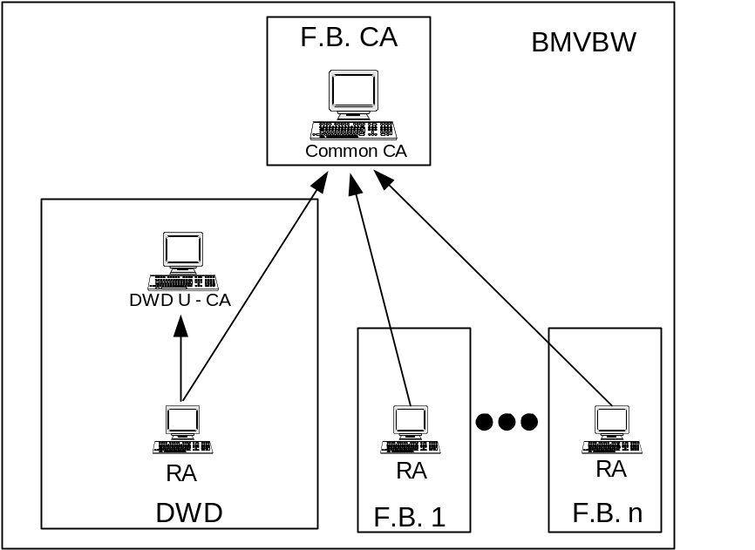
Figure 1

Alternatively, a bridge CA might be set up by the UNICORE partners as described in [Goss]. However, there are no plans to set up a bridge CA in the near future (see section 1.3 for further details).

The common CA of the BVBW-PKI is rooted by the CA of the Federal Office for Security of Information Technology (BSI), whose Certificate Policy (CP) defines the basic rules for all subordinate CAs [PCACP]. In particular, the CP defines the communication between CA and RA, user authentication, validity, obligations and range of application of the certificates.
The DWD RA will be operated by two persons, validating the identities of applicants, using encrypted communications with the super-ordinate CA through a dedicated web interface.

Certificate Chain
For a secure communication between users and UNICORE sites and among UNICORE sites as well as for validation of AJOs UNICORE supports seamless certificate validation and CRL checking as outlines in [Goss]:

While importing the certificates into its keystore, the client checks each certificate whether it is
- not outdated,
- not listed in the appropriate CRL and
- issued by a trusted (“well-known”) CA.
Certificate chain validation is terminated as soon as
- all certificates in the chain are valid (successful termination) or
- an invalid certificate is found within the chain (unsuccessful termination).
If there is an invalid certificate within the chain all subordinated certificates are considered invalid and have to be exchanged.
The current PKI basing upon DWD’s private Root-CA relies on the following certificate chain:
- top level certificate of DWD’s private Root-CA.
- user certificates created and signed by DWD’s UNICORE CA
Because of the very limited number of certificates issued by DWD’s private U-CA, the U-CA’s Certificate Revocation List (CRL) has not been published yet. Instead, a list of all sites having requested the U-CA’s root certificate is retained. In the unlikely event that certificates have to be revoked the UNICORE administrators of those sites will be notified accordingly. Nevertheless, publishing the CRL as well as the root certificate through DWD’s web server is being considered for beginning of 2004.
Making use of the later common CA of the BVBW-PKI the certificate chain will consist of
- the top level PCA certificate of the BSI,
- the root certificate of the common CA and
- the user certificates created and signed by the common CA.
The common CA will be a “full-CA” supporting CRL, CP, and CPS.

Accepting Third Party PKIs by Cross Certification
Many sites have no common root CA, so they are not immediately able to use each others’ resources. There are different ways to solve this problem:
- Sites mutually accept each others’ certificates by exchanging their CA certificates. This practice is called Certificate Exchange.
- Certificate Authorities mutually accept each others’ CA certificates by exchanging them. This practice is called Cross Certification.
- A dedicated Bridge CA may be set up to import the CA certificates of all sites involved. So it will authorize resource access among the sites.
As the number of participating sites grows, the complexity of certificate exchanges has to be taken into account:
- Given cross certification of N sites, the number of exchanges is N²-N, i.e. growing quadratically.
- Using a bridge CA, only N certificates have to be transferred. Nevertheless, a bridge CA is a costly measure for a small number of sites and thus not required within the GRIP project for the near future until the number of participating sites grows.

Concept of Virtual Organizations
The PKI at the level of DWD will imply several public sector authorities, like the Federal Office for Shipping and Hydrography (BSH) or the Federal Office for Waterways. Partners in various projects will be included in this PKI on a temporary basis as well.
We call such a dynamic federation of real organizations and loosely coupled project partners a Virtual Organization (VO) within a PKI. Benefits of this concept are a flexible structure and a limited number of users per VO. Possibly security issues like VO overlaps and administrative considerations are the price, that has to be paid for more flexibility.
A “natural VO” includes all partners and customers under a common CA. This group of UNICORE users need not exchange their root certificates to authenticate themselves at each other’s sites.
DWD’s current UNICORE PKI allows all users holding a certificate issued by DWD’s U-CA as well as old users having an LRZ certificate to work at DWD’s HPC.
The later common CA will automatically allow all users within the area of BMVBW to authenticate themselves at DWD’s HPC. However, each user who wants to use UNICORE resources must be registered with the appropriate UUDB for authorization.
Virtual Organizations spanning multiple CA domains, i.e. consisting of users with certificates issued by different CAs, need to exchange their CA certificates and the appropriate top level certificates as outlined in [Goss].
This certificate exchange is possible for both DWD’s interim UNICORE PKI and for the later PKI empowered by the common CA of the BVBW-PKI.

The GRIP PKI
There will be no dedicated CA, RA or other PKI components for GRIP during the project phase. GRIP will relay on existing Public Key Infrastructures basing upon UNICORE, EUROGRID and Globus.
In order to interwork with Globus-enabled UNICORE sites and to submit jobs into the Globus sphere more than one Certificate Authorities are involved. Figure 2 gives an overview about required CAs, certificates and job flow.
Like in normal UNICORE the user is issued a UNICORE user certificate by a “(User) CA”. In case of DWD this is DWD’s U-CA and will later be the so called “common CA”. For use of Globus, the user is also issued a Globus certificate by the Globus CA. Note that in case the Globus target site accepts UNICORE user certificates for user authentication the user does not need a separate Globus user certificate.
The Globus-enabled UNICORE site consists of the Gateway, the NJS and a Globus TSI. All three components require certificates in order to allow SSL encrypted inter-communication. For encrypted communication with the TSI the NJS may use its NJS certificate while the TSI must be issued a new certificate by the UNICORE CA or any other (well-known) CA. In normal UNICORE the TSI does not carry an own certificate, see [HCH2] for further details.
The U-Site might operate its own CA or make use of another commercial or non-commercial CA. However, in order to allow users to identify the U-Site the users must be provided with the site’s root certificate. Vice versa, the U-Site must receive the root certificates of the users’ CAs in order to identify them.
Within the GRIP project it has been decided to use the existing EUROGRID CA operated by the University of Manchester as the “UNICORE CA” as can be seen in Figure 2. Note that DWD user certificates are still issued by DWD’s U-CA.
Globus jobs need to be accompanied by a so called “Globus Proxy”. A Globus Proxy is created by the Grid-Proxy-Init-Plugin and consists of
- A newly created private key in PKCS#1 encoding.
- A X509v3 certificate self signed with the user’s original (Globus) private key containing the newly created public key.
- The user’s X509v3 (Globus) certificate containing the original public key.
A detailed description of the software architecture can be found in [HCH1] and [HCH2].
The Globus Proxy may be encrypted with the NJS certificate (public key) in order to enhance security, so that only the target NJS can read the Globus Proxy. Encrypting the Globus Proxy requires to provide the NJS certificate (public key) to the user sites.
A graphical user interface allows the user to adjust some configuration parameters like the expiration time of the Globus proxy certificate.
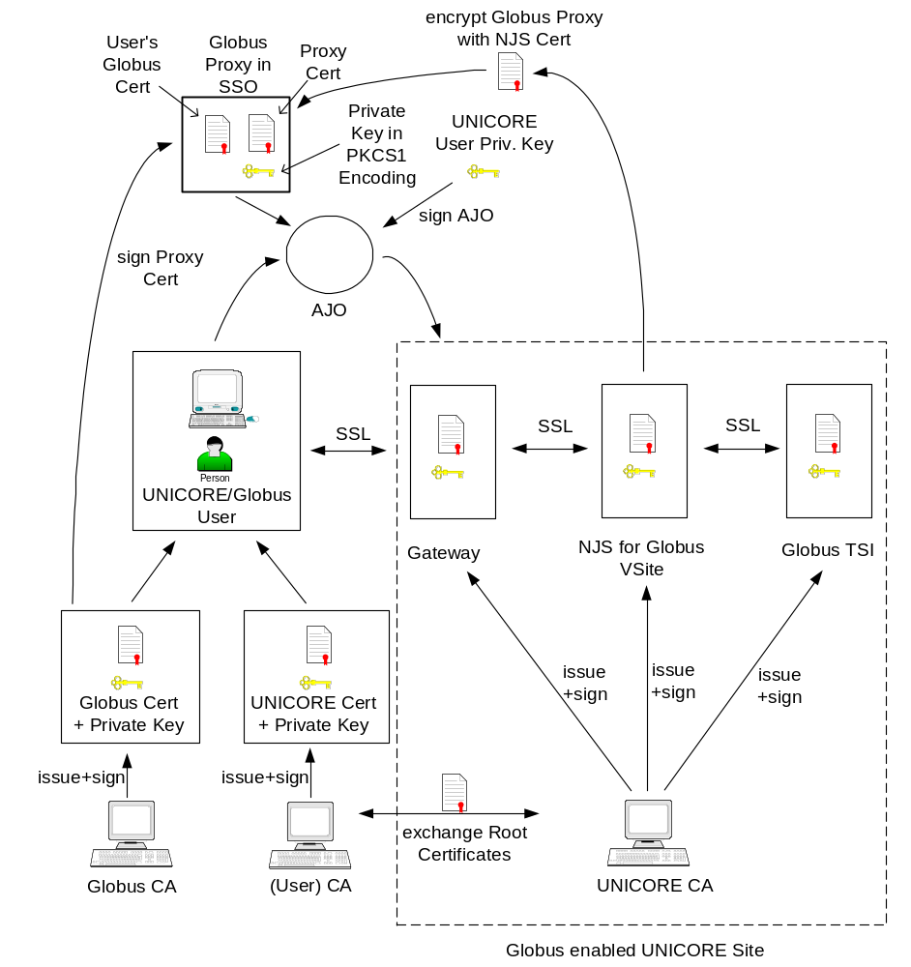
Figure 2

There will be no dedicated GRIP user certificates issued for the GRIP project. Users who want to submit jobs into the Globus sphere will use their existing UNICORE certificates to access a Globus-enabled UNICORE site like the site of the University of Manchester.
The so called “Proxy Certificates” created by the Grid-Proxy-Init-Plugin are part of the Globus submission process. They are not intended to authenticate users accessing a (Globus-enabled) UNICORE site.
DWD will make use of their private U-CA for the whole GRIP project phase.

Working with disjunctive CAs and Certification Policies
With the former centralized LRZ driven Public Key Infrastructure UNICORE used to have a common Certificate Policy (CP) valid for each site. Now, as the UNICORE PKI becomes decentralized, individual CPs are issued by the respective CAs given each site its own Certificate Policy.
As a result the UNICORE sphere will consist of multiple sites with different Certificate Policies.
Globus-enabled UNICORE sites allow a UNICORE user to submit jobs into the Globus sphere which require to have a closer look at Globus security [Goss] and Certificate Policies within Globus.

Multiple Certificate Policies
The private UNICORE CA of DWD is used as an interim solution and to empower the GRIP project for DWD. Thus, no dedicated CP is needed. Instead, the existing UNICORE CP issued by LRZ remains valid for DWD’s interim UNICORE PKI.
The common CA in the realm of German offices of the Ministry of Transportation, Building and Housing (BMVBW) is being established mainly to support secure e-mail transfer. But it is suitable for securing applications like UNICORE as well. Each office represents one Registration Authority (see Figure 1).
In the area of BMVBW there will be one common Certificate Policy. However, a Virtual Organization (VO) may consist of partners using disjunctive Certification Authorities with different CPs. So, each partner within a VO must necessarily prove the other partners’ CP in order to check for security mismatches with the own security policy.
DWD will only allow those partners to work at DWD’s HPC who apply a strict CP. Figure 3 visualizes the situation within a VO allowing for users with disjunctive CAs.
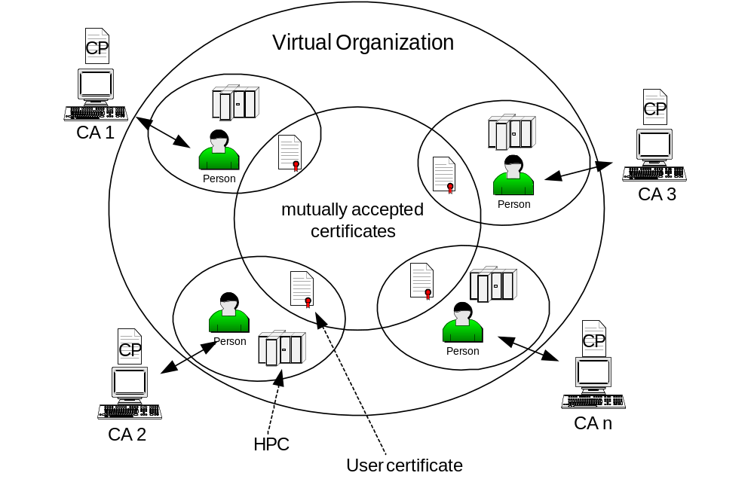
Figure 3
Three major aspects must be considered when evaluating other parties certificates:

- Proper user authentication
A UNICORE user must be unambiguously identifiable through his user certificate. Thus, a HPC site must be able to rely on the certificate a well-known UNICORE user has submitted in order to get approved for this site.
Certification Authorities apply their individual policies on user authentication and registration. E.g., applying for a VeriSign Class 1 certificate an e-mail to VeriSign is sufficient. Because e-mail is not safe, a VeriSign Class 1 certificate should not be considered reliable.
- Validity of certificates
User Certificates should not be valid forever. E.g., a certificate of a retired user which hasn’t been deleted from the UUDB will expire automatically after its validity period and thus increasing overall security.
It depends on the local HPC’s security policy how long user certificates may be valid.
- Existence of Certificate Revocation Lists
For retrieving the status of a user certificate it is essential that the issuing CA features a Certificate Revocation List, so that the UNICORE site can check whether a user certificate is valid or not.
Before a UNICORE site allows a user to access its HPC resources it has to
- Check the Certification Policy of the CA which issued the user certificate whether
- user authentication is appropriate and matches the local security policy
- the CA features a (signed) CRL
- validity of user certificates is within the appropriate time frame depending on the local security policy
- Check the user certificate whether it applies to the Certification Policy
- See the user if there is any doubt that the authentication process has not been good enough.

Basic Requirements for Certificate Policies
While a UNICORE site has to thoroughly validate an applicants certificate and the appropriate CP, each applicant on the other hand has to make sure that its user certificate matches the requirements of the other partners within the VO.
In particular, each partner has to verify her Certificate Policy, especially the items discussed in section 2.1. Special care has to be taken for CA, RA and user interaction:

- Registered and certified users have access to target systems if they are locally admitted. This means for UNICORE, that their certificates are matched to a target system login in the UNICORE User Database (UUDB). They may start jobs without having root permissions for the requested purposes only. They are required to keep their private key inside the protected UNICORE key store of their client only and inform the RA or CA when they suspect their private key to be lost or compromised.
Conclusion: CA and RA have always to be up to date about each issued certificate.
- Each RA has to verify the identities of applicants thoroughly by checking their ID documents.
Conclusion: The RA has to make sure that a certificate is only issued to a well-known user.

- Compromised certificates and certificates of untrustworthy users have to be listed onto the CRL.
Conclusion: A UNICORE site must be able to retrieve the status of each user certificate to make sure whether the user certificate is still valid and thus the user permitted to work at the HPC site.
- The responsible RA staff themselves are authenticated with the CA. They have to store issued certificates in a secure place and have those certificates revoked with the CA, that are declared to be compromised.
Conclusion: The RA to CA inter-working has to be safe. RAs and CA have to make sure that data exchange between them is secured/encrypted. The RA itself must be “trusted” by the CA.
- Each CA has to observe the rules given by the Root CA or give notice if it is not able to do so. Further, the CA has to hand out all relevant documents and electronic data, if the Root CA demands an auditing.
Conclusion: A CA must be trustworthy.

Certificate Validity
The validity is a compromise between usability and security. Short term user certificates may be considered safer because the users have to see the respective RAs more frequently. Long term certificates on the other hand are easier to use, because they don’t have to be permanently renewed.
For DWD’s interim UNICORE PKI all user certificates will be valid for 1 year if not revoked before. A user certificate cannot be extended. A user has to apply for a new certificate before the old one outdates. Old and new certificates may overlap, so that a user can seamlessly work at a UNICORE site.

Types of UNICORE Certificates
UNICORE makes use of up to four different kinds of certificates:
- Client certificates prove the users’ identity to a UNICORE site.
- Gateway certificates ensure encrypted connection via SSL between UNICORE sites and their users. They also enable the gateway to establish encrypted connections to the NJS (for Globus-enabled U-Sites only).
- NJS certificates allow UNICORE sites to forward sub-jobs of the top-level job to other UNICORE sites passing the appropriate gateway. They also allow the NJS to establish encrypted connections to the UNICORE gateway and the TSI (for Globus-enabled U-Sites only)
- TSI certificates allow the TSI to establish encrypted connections to the NJS and the Globus target host (for Globus-enabled U-Sites only)

In contrast to user certificates Gateway and NJS certificates are server certificates and underlie different security considerations. In particular, the validity of server certificates is normally much longer than that of user certificates (5 years and longer). A server certificate has also be requested through the appropriate RA. In case of DWD the Gateway and NJS certificates are currently issued by DWD’s private UNICORE CA and will be created and signed by the common CA when available.
The different UNICORE site administrations are responsible for server certificates. They have to make sure that the private keys of the appropriate server certificates do not get compromised. In contrast to user certificates, private keys of server certificates need not be protected by pass phrases. However, if a site decides to protect the private keys of their server certificates by pass phrases, server administrators have to enter the appropriate pass phrases after each server reboot.

Interfacing UNICORE PKI and Globus PKI
Globus jobs are run through the well-known UNICORE user interface. With the Globus-enabled UNICORE environment a UNICORE user can now decide to submit jobs to a UNICORE or Globus site. From UNICORE’s point of view a Globus site appears like a UNICORE V-Site.
A GRIP user must be aware that both UNICORE’s and Globus’ security models are different which may have an impact on job security.

Authenticating and Authorizing UNICORE Users for Globus
A UNICORE user will be authenticated with his Globus-aware UNICORE site using his existing UNICORE user certificate.
The user’s UNICORE client must be equipped with the Grid-Proxy-Init-Plugin which generates Globus proxy-certificates on behalf of the user.
Furthermore the Globus-aware UNICORE site has to have the Globus TSI installed. The Globus TSI translates UNICORE AJOs to the appropriate Globus scripts.
The details of the Globus system remains transparent to the UNICORE user. However, she might need to explicitly authenticate herself against the Globus target site. For this purpose she is issued a valid Globus certificate to get access to the Globus target site.

Creating temporary Certificates with the Grid-Proxy-Init-Plugin
A Globus grid is modeled as a UNICORE site:
- The UNICORE client is augmented by a “Grid-Proxy-Init-Plugin”, which enables the user to transparently acquire temporary Globus proxy certificates.
- The NJS is complemented by a special Globus TSI, which consists of scripts mainly, that use Globus commands to communicate to Globus server modules.
- Target system specific details of Globus are matched in the UNICORE IDB.

This way it is possible to send jobs to Globus sites and to receive job output and resource information.

Comparison of UNICORE and Globus security
Both architectures submit jobs over Secure Socket Layer (SSL) using X.509v3 certificates. The UNICORE consignor/endorser model is described elsewhere [UNICORE].
There are four types of certificates in Globus :
- User certificates enable users to get access to services of a Globus site,
- Host/Server certificates ensure encrypted connections via SSL between Globus client and Globus host or between two Globus hosts,
- LDAP certificates are used in conjunction with LDAP servers. Globus supports LDAP as a common database infrastructure.
- Proxy certificates can be created through the “globus-personal-gatekeeper – start” command executed at a Globus client. They give full access to server-side Globus services for 12 hours and make it possible to spawn multiple secondary proxies within that period.
Globus does not make use of signed objects (jobs or data), like UNICORE does. Instead, the authorized user (a user holding a Globus user certificate) creates a so-called proxy certificate for a session which is valid for typically 12 hours and entitles the bearer to submit any kind of job.
The proxy certificate authorizes the user’s job against the Globus target system. At this point the Globus target system is not able to reliably prove the user’s identity. Although, a proxy certificate contains the user’s identity together with the extension \cn=proxy, it is less reliable than the user’s original Globus user certificate. Therefore the original Globus user certificate shall be sent along with the Globus Proxy according to [Globus]. However, the Globus proxy certificate might easily be compromised as its private key cannot be protected.
According to the Globus Security Infrastructure’s (GSI) requirements the target system has to verify the proxy certificate’s signature as well as the whole certificate chain bottom-up [Globus]. However, it must rely on the authenticity of the proxy certificate it receives.
Data transfer via GridFTP also relies on proxy certificates.

Benefit:
- Proxy certificates allow for submission of jobs from within running Globus jobs (highly dynamically). This is not possible for UNICORE.
- Globus certification enables users to submit jobs or use other services of any Globus site, they have access to.
- Proxy certificates allow for Single-Sign-On.

Risks:
- The private key resides unencrypted and thus unsecured in the file system of both the client and the target host. Pass-phrase protection of the Proxy’s private key is not possible due to its dynamic character.
- As Globus uses proxy certificates, users can only be re-assigned to jobs and made responsible for them by validating the proxy certificate’s signature and by using the appropriate log files of the Globus gatekeeper (GRAM) and the users’ clients creating the proxy certificates, if available.
UNICORE users on the other hand, can easily be traced back, because each AJO is signed and contains the user’s own certificate.

What a UNICORE User has to know about Globus
A user within an integrated UNICORE/Globus environment has to observe that the security concepts of both systems differ. Security relevant jobs or secret data may be well protected in one system but not so in the other.
As the access from UNICORE to Globus resources is transparent to the user, the user may not realize potential dangers, such as missing data integrity through non-signed jobs in Globus or reduced confidentiality.
Before a job is submitted to a Globus site a UNICORE user has to answer himself the following questions:
- What are the requirements of my job in terms of job and data integrity, availability and confidentiality?
- Do job and data need to be signed? Globus does not support job and data signing.
- Is the remote Globus site trustworthy?
Detailed security considerations will follow in deliverable 1.2c, GRID Security Interoperation.

Results
The concept of GRIP to enable UNICORE sites to access Globus through an enhanced TSI makes Globus to appear to the user like a UNICORE V-Site.
As a result the existing Public Key Infrastructure(s) already existing within UNICORE remain unchanged and may be used for GRIP without any modifications.
Thus, a UNICORE user who has registered with a Globus-enabled UNICORE site and the appropriate Globus target site is enabled to submit jobs into the Globus sphere without the necessity to apply for new UNICORE certificates or to change the authentication and authorization processes with RAs, CAs and (UNICORE) target HPCs. However, she might need the appropriate Globus certificate(s) depending on the Globus target site’s certification and security policies.
However, UNICORE users accessing Globus target sites must be aware that job security models quite differ between UNICORE and Globus, e.g. Globus does not support job and data signing.
Proxy certificates are generated by the Grid-Proxy-Init-Plugin which operates transparently to the UNICORE user.
For a Globus site administrator it is not as easy to reliable track down a user as it is in UNICORE, because Globus jobs are not signed and proxy certificates might much easier be compromised than in UNICORE because of their unprotected private keys.
To identify a user the administrator of a Globus target site would both have to prove the proxy certificate’s signature as well as the whole certificate chain bottom-up and to contact the administrator of the respective Globus-enabled UNICORE site which issued the Globus job. Then, the UNICORE administrator would have to search his log files for the appropriate entry to identify the user who has submitted the Globus proxy certificate together with the job to the Globus-enabled U-Site.
As a result he has to more or less rely on the authenticity of the proxy certificate.
Although, discussion of Globus HPC security is not topic of this paper the next section tries to outline an alternative which would improve Globus security by strengthen the UNICORE Certificate Policy for Globus-enabled UNICORE sites.

Dedicated CA for Globus-enabled UNICORE sites.
As a consequence of supposable raising security demands within Globus, i.e. particular Globus target sites, a more strict Certification Policy might emerge.
To give Globus-enabled UNICORE sites a flexible way to follow more strict Certification Policies in Globus, they must be able to control the group of possible Globus users within UNICORE.
In the GRIP model as is, there are no limitations, so that any UNICORE user who has registered with a Globus-enabled UNICORE site and the appropriate Globus target site may submit jobs into Globus. This implies that Globus uses the same or even a more relaxed security model than the Globus-enabled UNICORE site. Currently, this is the case for the GRIP project and so no further security considerations are necessary for Globus.
In case the security demands in Globus increase it might become necessary to limit the number of UNICORE users who are allowed to access Globus.
A GRIP VO running a dedicated CA could solve this potential problem by issuing special GRIP certificates. A Globus-enabled UNICORE site would then just need to accept the GRIP CA’s certificate only to exclude all other UNICORE users from using the “Globus gateway”.

Bibliography

[Boet1] Ernst Bötsch:
UNICORE Certification Authority (U-CA)
June 28th, 2000 (Version 1.3)
Leibnitz Rechenzentrum Munich

[Boet2] Ernst Bötsch:
UNICORE CA (U-CA) Policy – Zertifizierungs-Richtlinien für UNICORE.
February 1st, 2001 (Version 1.0)
Leibnitz Rechenzentrum Munich

[Butl] Randy Butler, Tony Genovese:
Global Grid Forum Certificate Policy Model
September 2001
Global Grid Forum
[Goss] Torsten Goss-Walter, Reinhard Letz:
An Analysis of the UNICORE Security Model
October 2002
Global Grid Forum
[HCH1] Hans-Christian Hoppe, Thomas Kentemich, Dr. David Snelling:
Interoperability Software Requirements Specification
Mai 2002
GRIP, Deliverable D2.1a, IST-2001-32257
[HCH2] Hans-Christian Hoppe, T. Kentemich, Dr. D. Snelling, P. Wieder:
Specification of interoperability modules
August 2002
GRIP, Deliverable D2.1b, IST-2001-32257
[PCACP] http://www.bsi.bund.de/aufgaben/projekte/sphinx/dokumente/pca_polv3_2.pdf

[DFNP] http://www.pca.dfn.de

[UNICORE] http://www.unicore.org

[Globus] http://www.globus.org

[GRIP] http://www.grid-interoperability.org

[GGF] http://www.gridforum.org

Appendix A : Glossary
AJO | Abstract Job Object
CA | Certifying Authority
CP | Certificate Policy
CRL | Certificate Revocation List
CSR | Certificate Signing Request
DFN | Deutsches Forschungs-Netz e.V.
GCP WG | Grid Certificate Policy Working Group
GGF | Global Grid Forum
GRIP | Grid Interoperability Project
GSI | Globus Security Infrastructure
G-TSI | Globus-enabled TSI
HPC | High Performance Computing Center
NJS | Network Job Supervisor
PKI | Public Key Infrastructure
RA | Registration Authority
SSL | Secure Socket Layer
SSO | Site Specific Security Object
TSI | Target System Interface
U-CA | UNICORE CA
U-RA | UNICORE RA
U-Site | UNICORE-Site
UUDB | UNICORE User Database
V-Site | Virtual Sites (within a U-Site)

Appendix B : Security Considerations

Author Information
Torsten Goss-Walter | Deutscher Wetterdienst  Kaiserleistrasse 44  63067 Offenbach  Germany | Torsten.Goss-Walter@dwd.de
Reinhard Letz
Dr. David Snelling | Fujitsu Laboratories of Europe  Hayes, Middlesex, UB4 8FE  United Kingdom | d.snelling@fle.fujitsu.com

Intellectual Property Statement

The GGF takes no position regarding the validity or scope of any intellectual property or other rights that might be claimed to pertain to the implementation or use of the technology described in this document or the extent to which any license under such rights might or might not be available; neither does it represent that it has made any effort to identify any such rights. Copies of claims of rights made available for publication and any assurances of licenses to be made available, or the result of an attempt made to obtain a general license or permission for the use of such proprietary rights by implementers or users of this specification can be obtained from the GGF Secretariat.

The GGF invites any interested party to bring to its attention any copyrights, patents or patent applications, or other proprietary rights which may cover technology that may be required to practice this recommendation. Please address the information to the GGF Executive Director.

Full Copyright Notice

Copyright (C) Global Grid Forum (date). All Rights Reserved.

This document and translations of it may be copied and furnished to others, and derivative works that comment on or otherwise explain it or assist in its implementation may be prepared, copied, published and distributed, in whole or in part, without restriction of any kind, provided that the above copyright notice and this paragraph are included on all such copies and derivative works. However, this document itself may not be modified in any way, such as by removing the copyright notice or references to the GGF or other organizations, except as needed for the purpose of developing Grid Recommendations in which case the procedures for copyrights defined in the GGF Document process must be followed, or as required to translate it into languages other than English.

The limited permissions granted above are perpetual and will not be revoked by the GGF or its successors or assigns.

This document and the information contained herein is provided on an "AS IS" basis and THE GLOBAL GRID FORUM DISCLAIMS ALL WARRANTIES, EXPRESS OR IMPLIED, INCLUDING BUT NOT LIMITED TO ANY WARRANTY THAT THE USE OF THE INFORMATION HEREIN WILL NOT INFRINGE ANY RIGHTS OR ANY IMPLIED WARRANTIES OF MERCHANTABILITY OR FITNESS FOR A PARTICULAR PURPOSE."

Appendix C : Change History
Date | Comment | Author
02/27/03 | First draft release for GGF 7 | R. Letz /  T. Goss-Walter
03/21/03 | First DWD’s internal review | R. Letz /  T. Goss-Walter
03/26/03 | Final DWD’s internal review | T. Goss-Walter
03/28/03 | Review | D. Snelling
03/31/03 | Update according to review | T. Goss-Walter
05/07/03 | Final release | T. Goss-Walter
10/01/03 | Updates according to running project | T. Goss-Walter
10/29/03 | Updates according to running project | T. Goss-Walter

The proxy certificate is signed with the user’s private key belonging to his/her Globus user certificate.
In this context a GRIP certificate means a certificate which enables a UNICORE user to access a Globus-enabled UNICORE site.

