GRID Transaction Management Research Group:
Uses Cases

Status of this Memo
This document provides information to the community regarding the Grid use case scenarios used in deducing requirements for transaction capabilities in a GRID environment. Distribution of this document is unlimited. This is a DRAFT document and continues to be revised.

Abstract
Successful realization of Grid environments may require the use of various transaction capabilities, such as transaction protocol engines and resource managers that can react to transaction commands. The aim of the use cases in this document is to identify the requirements for any such components and capabilities. It aims to cover use case scenarios of both e-science and e-business applications. Use cases described in this document cover commercial infrastructure and application topics, scientific infrastructure and application topics, essential grid technologies, and working group use cases. The list of Grid use cases presented here is necessarily incomplete. Also the use cases are not necessarily described at the detail required for formal requirements.


GLOBAL GRID FORUM
office@gridforum.org
www.ggf.org

Full Copyright Notice
Copyright © Global Grid Forum (2005). All Rights Reserved.
This document and translations of it may be copied and furnished to others, and derivative works that comment on or otherwise explain it or assist in its implementation may be prepared, copied, published and distributed, in whole or in part, without restriction of any kind, provided that the above copyright notice and this paragraph are included on all such copies and derivative works. However, this document itself may not be modified in any way, such as by removing the copyright notice or references to the GGF or other organizations, except as needed for the purpose of developing Grid Recommendations in which case the procedures for copyrights defined in the GGF Document process must be followed, or as required to translate it into languages other than English.
The limited permissions granted above are perpetual and will not be revoked by the GGF or its successors or assigns.
This document and the information contained herein is provided on an "AS IS" basis and THE GLOBAL GRID FORUM DISCLAIMS ALL WARRANTIES, EXPRESS OR IMPLIED, INCLUDING BUT NOT LIMITED TO ANY WARRANTY THAT THE USE OF THE INFORMATION HEREIN WILL NOT INFRINGE ANY RIGHTS OR ANY IMPLIED WARRANTIES OF MERCHANTABILITY OR FITNESS FOR A PARTICULAR PURPOSE.

Intellectual Property Statement
The GGF takes no position regarding the validity or scope of any intellectual property or other rights that might be claimed to pertain to the implementation or use of the technology described in this document or the extent to which any license under such rights might or might not be available; neither does it represent that it has made any effort to identify any such rights. Copies of claims of rights made available for publication and any assurances of licenses to be made available, or the result of an attempt made to obtain a general license or permission for the use of such proprietary rights by implementers or users of this specification can be obtained from the GGF Secretariat.
The GGF invites any interested party to bring to its attention any copyrights, patents or patent applications, or other proprietary rights which may cover technology that may be required to practice this recommendation. Please address the information to the GGF Executive Director (see contact information at GGF website).
Contents
1 Introduction 4
Category 1 Use Cases: Information dissemination 6
2 Speculative Computation 6
Category 2 Use Cases: Information aggregation 7
3 Distributed available-to-promise 7
Category 3 Use Cases: Process tracking 9
4 Supporting Long-Running Computations on the Grid 9
Category 4 Use Cases: Agreement negotiation and execution 12
5 Financial Instrument Trading 12
6 Trip Support 17
7 Credit Verification 19
8 GRID Resource Management 22
9 TM-RG Use Case Template 28
10 Appendix A e-DiaMoND 29
11 Editor Information 31

Figures
Figure 1 Distributed Available To Promise 7
Figure 2 A Virtual Supercomputer 10
Figure 3 Trading Service physical architecture 13
Figure 4 Trading Service typical message sequence 14

Tables

Table 1 Use cases and contributors in this document 4

Introduction

Purpose and overview
One component of the TM-RG’s charter is:

“This RG will provide a forum to track Grid transaction community activities and advise the Grid community on the application of TM technologies in Grid applications and infrastructure, to identify case studies and share good practice.
As an overall result of the research group there will be a set of information regarding transactional support in Grids to the GGF community.

Projected Tasks
1. Identify typical use cases of grid application scenarios involving transactional support.”

This document is a collection of the use case scenarios contributed by TM-RG participants or solicited from others. This document contains use cases in the specified TM-RG template.

Based on the use case documents the TM-RG will (a) specify, in broad but somewhat detailed terms, the scope of important services required, (b) identify a core set of such services that are viewed as essential for many Grid systems and applications, and (c) specify at a high-level the functionalities required for these core services and the interrelationships among those core services.

It is intended that these use cases will lead to a set requirements for and on transactional capabilities as applicable to Grid environments. We expect to expand the number of use cases in future revisions of this document.

Table 1 Use cases and contributors in this document1
Section | Title | Contributors
2 | Speculative computation | mike.beckerle@ascentialsoftware.com
3 | Distributed available-to-promise | Bob Haugen
4 | Supporting Long-Running Computations on the Grid | Jim Webber with Jim Smith
5 | Financial Instrument Trading | Tony Fletcher and Bob Haugen from TWIST material provided by Bill Specht and Mathew Arrott
6 | Trip support | Dieter Gawlick, Torsten Steinbach
7 | Credit Verification | Dieter Gawlick
8 | GRID Resource Management | Bob Haugen from GGF materials
8.4.1 | Contract or agreement negotiation
8.4.2 | Resource allocation, deployment and scheduling
8.4.3 | Resource billing and payment
A | e-DiaMoND | via Jim Webber

Transaction Categorisation
Having found some use cases, it is useful to study them and note their similarities and distinctions. This can lead naturally on to the idea of categorising the transaction use cases into a number of categories. What follows is probably one of several different ways that the use cases could be categorised.

We found four broad patterns of business transaction behaviour.

Information management patterns:

Category 1. Information dissemination:
For example, the reliable propagation of reference or static data from a key application or master file to other applications, together with the assurance that the propagation has succeeded (completely), or that it has failed (completely or according to a reported pattern).

Category 2. Information aggregation:
For example, the reliable aggregation of inventory information from subsidiary systems, including those of third parties, together with the assurance that the aggregation has succeeded (completely), or that it has failed (completely or according to a reported pattern).

Process management patterns:

Category 3. Process tracking:
For example, ensuring that business processes and workflows are completed in an ordered or contingent way, or check pointing and restarting a process.

Category 4. Agreement negotiation and execution:
For example, when financial trading businesses need to obtain multiple quotes for the purchase/sale of a financial instrument and/or simultaneously execute trades across multiple financial instruments. Reservations or allocations for grid resource deployment also fit this pattern.

Category 1 Use Cases: Information dissemination

Speculative Computation

At the BOF on 2004-06-09 I (mike.beckerle@ascentialsoftware.com) brought up this use case for discussion.

This use case is clearly related to transactional behaviours, but is not clearly "ordinary TP". However, it is related to the kinds of computations that some people want to run on Grids.

The use case is large-scale computations involving speculative computation. Think simulated annealing, or other kinds of optimization problems. What is meant by speculative computation is this. When doing this class of computation in parallel, you are essentially doing wasted work. You are racing different search/optimization calculations against each other. Generally this class of algorithms maintain a data structure called a blackboard or scoreboard. Each separate computation writes onto the scoreboard indicators of its progress. A computation also inspects the blackboard periodically and generally tries to determine if some other computation has already put up a score that obviates the need for this computation to continue. In that case, the computation stops. In this way computation activities that have a chance of improving the outcome will continue to gain resources, and activities that no longer have a chance of improving the outcome are self-pruning.

The transaction aspect comes from the maintenance of this blackboard/scoreboard data structure. Clearly people want to carry out this kind of computation in a massively parallel way, and grids are good for that. On the other hand, if the scoreboard is a single centralized data structure then that limits the scalability. The scoreboard must be updated with new information atomically, or at least monotonically, and in a deadlock free way by multiple competing computations, but we also must distribute the results of each update to the scoreboard proactively so as to avoid a bottleneck.

The algorithms for doing this distributed coordinated update to the scoreboard may involve some sort of virtual transaction combining networks. That is, multiple activities which are trying to update the central scoreboard ought to have opportunities to encounter each other and combine their actions while still at some distance from the central scoreboard. This kind of combining limits the transaction to monotonic changes in state using associative operations. Similarly, after a change in the state has occurred, then the change needs to be proactively fanned-out not from the centre to the end points, but in a way which avoids the need for every activity to query the central scoreboard. One activity should be able to piggyback its request for information on the query made by another.

Category 2 Use Cases: Information aggregation

Distributed available-to-promise

"Available To Promise" (ATP) is a function or query in an order processing system that determines whether the quantity of an item ordered will be available at the required time. The requester is usually somebody who wants something at a particular time in the future, often a retailer or distributor, not a manufacturer. It matters if any participating facility fails to delivery its information, so a transaction would be useful.

Early versions of ATP considered only finished goods inventory in one location. Supply chain or distributed versions consider also work-in-process (in manufacturing), goods-in-transit, and inventory (whether finished or in previous stages, that is, "in the pipeline") in many locations and often controlled by many companies – refer to Figure 1.

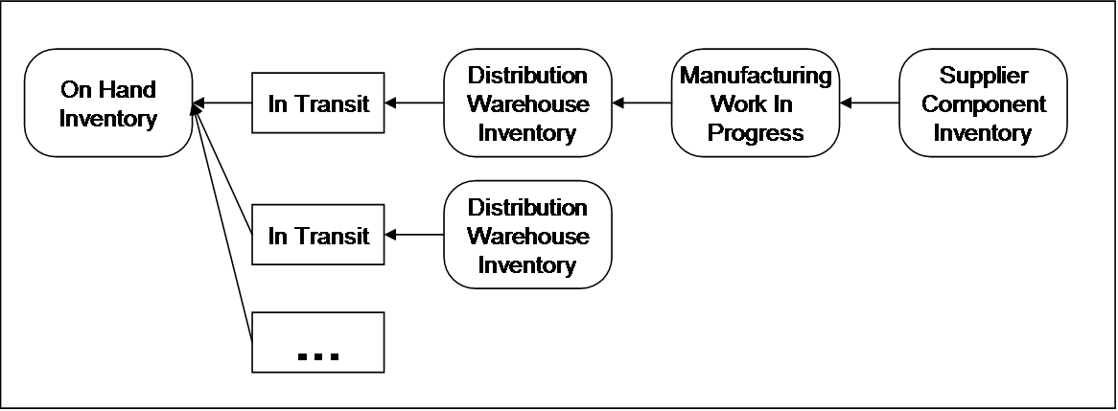

Figure 2 Distributed Available To Promise2

Two versions of ATP:
1) All available "in the pipeline" for a particular product or product family, often for a defined time span;
2) Sufficient to satisfy a particular demand.

ATP to satisfy a particular demand usually means "to fill a customer order". Such an ATP aggregation might want to be transactional, that is, provide assurance that the aggregation succeeded (completely), or that it failed (completely or according to a reported pattern).

Failing according to a reported pattern" in this case might mean that business rules would be applied to the reported failures, for example:
- if one supplier did not respond, but the demand was satisfied anyway, it doesn't matter;
- if the demand was not satisfied, the interaction with the supplier might be retried, or tried in some other way;
- if a particular supplier has a service-level contract with the client company which was violated by its failure, a penalty might be applied.

Specific Transactional Requirements:

R1 Non-atomic outcomes: the client may not want the whole transaction to fail if one or more participants fail.
R2 Ability to apply business rules to participant failures, which may mean that the client must know the identity of each participant.

The workaround for the absence of distributed application-level transactions may be lots of error-handling code. Thus the benefit of using a transaction is a reduction in error handling code and greater certainty as to whether a successful outcome has been achieved for a particular request.

Category 3 Use Cases: Process tracking

Supporting Long-Running Computations on the Grid

Introduction
Historically one key aspect of the Grid has been to support extremely large computations by linking together numerous (super-) computers. Such powerful computer resources are seen as paramount for compute-intensive tasks ranging from protein folding through to virtual car crash testing. However, even with the availability of a powerful virtualised computer infrastructure, such modelling and computation may still require a significant amount of time to complete. Whenever computations occur within a distributed system, there is the potential for failure modes far more complex than within a single machine, and while this has been investigated to some extent in the local area [1], the Grid-scale implications are somewhat unknown.

This use-case examines introduces the notion of long-running computations in a Grid environment and presents potential hazards which may be alleviated by the application of transaction technology.

Architectural Overview
In a classical Grid environment, numerous computers (typically supercomputers in their own right) are virtualised to become one extremely powerful processing platform, as shown in Figure 3.
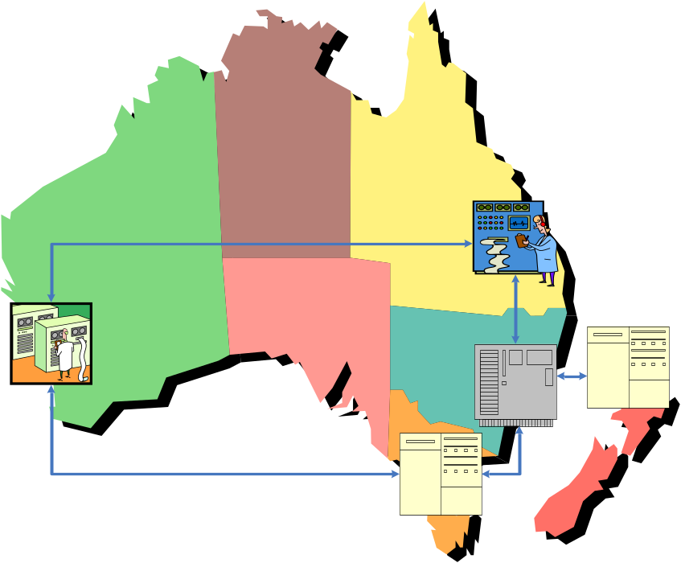
Figure 4 A Virtual Supercomputer4
In theory, jobs can be submitted to the virtualised computer and reap the benefits of its combined power to execute more complex and detailed models that could be envisioned on any of its constituent (super-) computers. This leap of processing power is extremely desirable from the point of view of the computational scientist, but it does however mean that the system is susceptible to failures which a single physical system may not.

Scenario(s)

Partial Failure
The partial failure scenario is a classic manifestation in a distributed computing environment. Unlike a single computing system where failures tend to be total (the machine is either working or not) in a distributed environment some machines may fail and yet others may continue working normally.

In this case we require that the failure of one or more nodes in the virtualised machine does not upset the execution of the computation as a whole, though we would be prepared to accept a performance hit within certain tolerances.

Local failure
Given that computations are expected to run for a significant amount of time on each processing element of the Grid, there is the chance that a large amount of work may have been completed just prior to a node failure. In this case it would clearly be undesirable to have to repeat that work since it may have taken many hours or days to have made such progress. As such we require a mechanism to periodically make the progress of our computation durable such that in the even of a crash, the computation can resume from a point close to its actual progress rather than restarting from the beginning of the process.

Specific Transactional Requirements
For the partial failure case, the transactional requirements are straightforward.

R1 Results should not be released to the application as a whole until the sub-computation has completed, lest any partial failures become Byzantine faults in the system as a whole.

Preliminary analysis indicates that this would be considered a relatively standard long-running transaction problem.

R2 For the localised failure case, the process needs to be split into sub-processes each of which can be restarted without prejudice in the event of a failure.

Preliminary thinking on this matter suggests that a nested transaction model or a check pointing system may be appropriate.

Summary
Long running computations across a virtual computer introduce the possibility of failure cases not normally associated with high performance computing on a single physical machine. In particular because of the distributed nature of the computations, partial failures can occur in the system, and because of the long-running nature of the computations there is the possibility of loss of significant amounts of work in the event of failure.

References

[2] Smith, J. Fault-Tolerant Parallel Applications Using a Network of Workstations.
Department of Computing Science, University of Newcastle upon Tyne, 1997
British Lending Library DSC stock location number: DXN015493. See also: http://www.cs.ncl.ac.uk/research/pubs/theses/abstract.php?id=22

Category 4 Use Cases: Agreement negotiation and execution

Financial Instrument Trading

Introduction
The TWIST standardization initiative (www.TWISTstandards.org) is concerned with the financial derivatives wholesale trade lifecycle. They have produced a set of standard XML messages that can be used by all the parties involved to process wholesale trades and to enable interoperable delivery of services, together with some message sequence charts that illustrate the basics if each process [3]. This use case is one of these processes.

The overall TWIST wholesale trade lifecycle covers the full life of these trades, beginning with the initial creation, followed by price discovery, execution and confirmation, and ending with final payouts dictated by the trade. During the life of the trade any processes that are required to modify the original trade specification are also specified. In general, it should be possible to process a trade completely using the processes defined in the TWIST specification. Manual intervention would be required only the event of very unusual circumstances.

Currently these protocols and message sets are being run on a ‘conventional’ network. However, one can imagine enterprise type grid technologies being used at some point in the future for this sort of trading scenario to get the volume and speed of throughput required, or maybe just because all of this type of enterprise computing has migrated onto Grid infrastructure.

The scenario is currently handled by systems that just exchange messages without any transaction wrapping / protection, but this does lead to problems. A transaction capability would help in at least two ways. Firstly several parties have to agree for the trade to go through (seller has to agree to sell and credit has to agree to provide credit) so need to get agreement of all the required parties. Secondly need to be able to cancel with no bad effects, if there is a problem (buyer withdraws at last moment, seller or credit fails / withdraws etc).

This use case illustrates two more points. Firstly, a single transaction with 'atomic' rule is not adequate as quotes are requested from more than one 'potential' seller and then one chosen and the others stood down (i.e. rejected). Secondly this is a case were a 'compensating transaction' is not the best approach - although this is exactly what has to happen in the present non- transactional system. For the forward trade the buyer can chose the item, the quantity, and the exact time of the trade, and does not have to trade at all, so they only need go through with the trade if they think they are making a good deal.

However, if something goes wrong and the trade needs to be undone then the compensating transaction has to deal in precisely that item at the set quantity and will have very little flexibility in the time of the trade, and the reverse trade has to be done (though can of course fail itself which is another problem with the compensation approach). So this is a case were a transaction wrapping with a provisional - final approach pays dividends. First the trade is agreed with a specified seller and credit is obtained, but all is provisional. If there is a problem then all are reset and legally no trade is done, so there is not a trade to undo. When everything is in place then the trade can be confirmed and everyone is legally committed to the trade. (Obviously if the buyer, for instance, changes their mind after confirming and the transaction has confirmed correctly then transaction protocol is not going to help them! In that case the buyer will need to choose to do another transaction to sell or take some other action.)

Architectural Overview
Figure 5 shows a possible physical architecture for the network of systems involved in this use case.
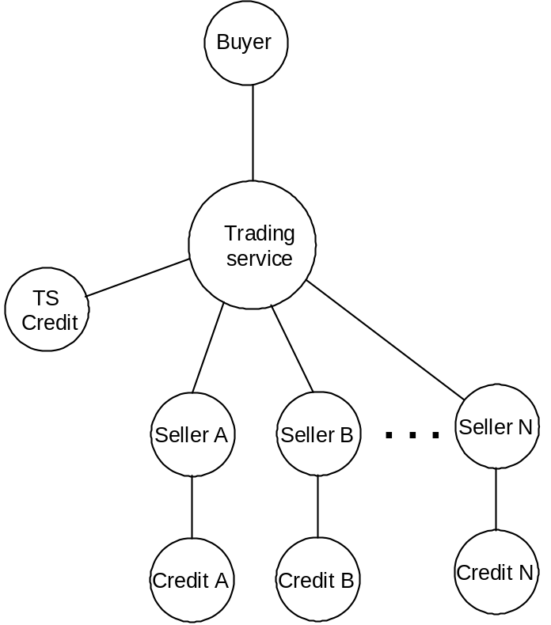

Figure 6 Trading Service physical architecture6

Scenario(s)

RFQ using a trading service with credit checks for all relationships
In this example a trading service is being used to route requests and prices between buyer and seller. The buyer has also elected to use a credit service provided by the trading service. There are two price makers in the example, only one can win.

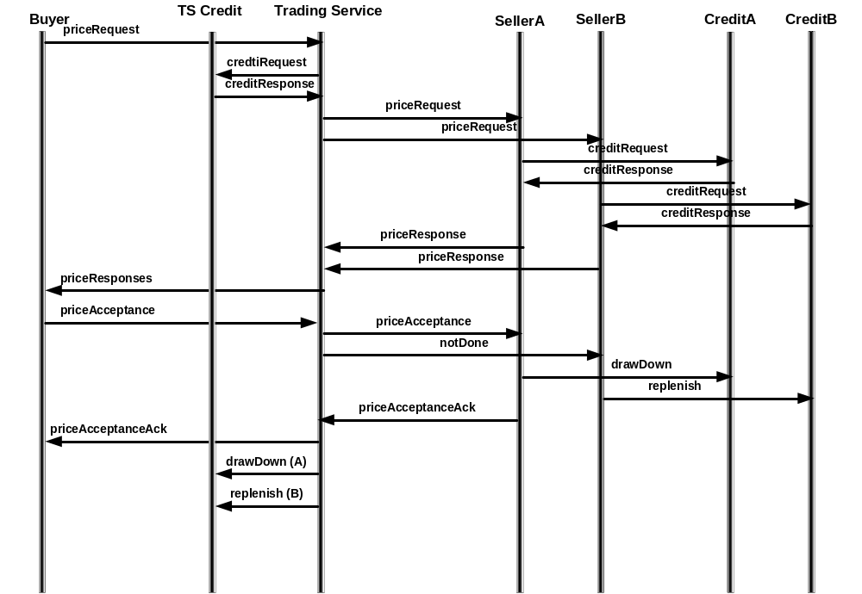
Figure 7 Trading Service typical message sequence7

The process begins when the Buyer sends a priceRequest to the Trading Service. The request indicates which sellers will see the request. Prior to sending the request credit is checked on both of these. In this example all is well and the credit is reserved for both after which a priceRequest is sent to each of the sellers. The sellers in turn check credit for the buyer. Although the diagram indicates these processes are sequential, they need not be. Again all credit is OK in this example and priceResponses are sent back to the service which forwards these on to the buyer. The buyer accepts the price from SellerA. The service then informs SellerA that the price is accepted and to SellerB a simple notDone is issued. SellerA will the drawDown the credit used while SellerB will replenish the credit. After the priceAcceptanceAck is delivered to the buyer, sellerA’s credit will be drawDown and sellerB’s credit will be replenished. This requires two messages one for each counterparty.

Specific Transactional Requirements
The aim is to provide transactional integrity over all of the interactions and relationships in this diagram such that:
R3 No manual reconciliation will be required to repair transactional inconsistencies.
R4 Each interaction will be guaranteed to achieve not only reliable delivery of the message, but also reliable processing of the message.
R5 Each set of participants will agree on the outcome of their business transaction, that is, no case will arise where one party thinks a transaction succeeded and the other thinks it failed or doesn’t know the outcome.
R6 If a participant or network connection fails temporarily, when it comes back up, the participant will automatically recover and resynchronize with its counter-parties.
R7 A coordinating party such as the Trading Service will be able to monitor the state of all its interactions with all counter-parties.
R8 Each set of participants shall be able to keep a reliable audit trail of each business transaction. (This would be to meet both legal / regulatory requirements, and also to aid post transaction dispute resolution in a clear and fair manner.)

Additional requirements:
R9 Ability to handle many transactions simultaneously with a fast response time.
R10 Ability to support a variable number of participants in the transaction.
(In this case sellers and their credit providers.)
R11 Ability to support propagation of a transaction from one participant to another.
(In this case Buyer to Trading Service to Sellers to their credit providers.)
R12 Ability to be able to selectively cancel parts of a transaction while confirming other parts.
R13 Ability to be able to use commit / cancel mechanisms other than do the work then compensate if need to cancel.
R14 Ability for an ‘application’ to determine the desired outcome of the transaction, or parts thereof, and be informed of the actual result of the transaction.

Variation
As a possible variation on this use case one can imagine a situation in which the credit draw down is a time limited offer, so if the specified time elapses without the credit being used then the offer may be withdrawn. This leads to another requirement.

R15 Ability to be able to signal and handle time limited offers.

Summary
This use case from the Financial Services industry sector shows a need in this case to be able to support a large number of transactions simultaneously where each one may have to operate on a number of different reasonable sized databases and involve the coordination of several different participants. In any one transaction some of the participants may need to cancel or be cancelled out of the transaction whilst not cancelling the whole transaction. That is some chosen part of the transaction ends up committing. Because a compensating trade is much more constrained than the original trade it will almost always incur a loss. Thus use case highlights the fact that compensation is not the best commit / cancel strategy in this case and the there is a need to use another mechanism that has the effect of producing a single desired trade or no trade.

References
[4] TWISTWholesaleTradeRequirements.doc Draft Version 0.51, March 25, 2004

Trip Support

Introduction
This use case is intended to represent a whole class of use cases, which have in common that a user (you) needs to acquire a set of distributed resources to reach a business goal in a long running process or (business) transaction. In all these cases you need to get confirmed options on a set of resources. You may need to confirm, reject, or modify one or more options once or several times during the process.

Architectural Overview
Almost all trip elements can be booked online. Using an application (or some software on behalf of the application) you can place options for a trip. Once you gathered enough options you are allowed to define sets of options based on your objectives; e.g., one set of options defines one or more flights and hotels, other define sets define activities at the various place that you visit. You can confirm, modify, and/or reject each set individually and atomically – (you are not required to confirm or reject all options at the same time). Options that are not interesting any longer can be discarded or may expire automatically. Options may be added or removed at any point in time.
Remember, in the real world, each element of the schedule stays an option until it has been executed. Your plans may change, the airline may cancel a flight, and the hotel may overbook.

The travel context is only used to illustrate the ideas; however, the ideas could be illustrated with other business contexts.

Scenario(s)
The specific scenario is about travel booking.
Use Case Element 1
You plan a trip and want to pre-reserve as much as possible. You want to arrange for transport (flight, train, ship), taxi, hotel rooms, and even reserve a table in a restaurant, order theatre tickets, and other activities. So you select a set of options that will be reserved by the provider for a specified time and at no or some cost.
Use Case Element 2
Of course it is important that related elements of the trip match and that you don’t have a hotel room reserved for London but you could not get a flight there on the same day and pay fees for a cancellation or a change. So you group the trip elements that should be confirmed together.

Booking the entire trip together is a process where you consider multiple alternative trip variants. This includes that you reserve e.g. alternative flights to the same destination city, but different airports. In conjunction you make two alternative rental car reservations etc. So you try to line up as much as possible. You finally decide to confirm the options related to the flight and the rental car as appropriate. Instead of explicitly cancelling the alternative flight and rental car options you decide to just let them expire. Finally you decide to wait for another day or so to confirm or reject the remaining trip options.
Use Case Element 3
After everything has been confirmed changes happen. A ‘better’ flight or a cheaper fare has become available. You may want to change your reservation with the basic objective to release the old flight if and only if the new flight is actually confirmed.
Use Case Element 4
Finally, at check-in, you learn that your flight has been cancelled. The flight schedule and other arrangements have to be changed. You do this in cooperation with the agent. You provide the agent access to the affected options and the agent changes them. You confirm these changes and get any reimbursement. The agent’s airline pays any cancellation fees or other related costs.
Use Case Element 5
When you arrive at the hotel, your reservation is shown as being cancelled. When changing the arrival date your reservation was not properly updated, it was ‘externally’ confirmed but ‘internally’ cancelled. You can easily win this dispute by showing a signed confirmation record originating from the hotel on you PDA.

Specific Transactional Requirements

R16 Any support is assumed to be reliable and secure.
R17 Applications programmers should be able to provide this functionality without understanding the complexity of the underlying technology. They should have the perception that they do not need to deal with several users accessing the same resources at the same time.
R18 An important requirement is the support of options by resource managers. Business conflicts on resources are managed by business rules checking the compatibility of all outstanding options.
R19 Another requirement is auditing and tracking of options granted and their confirmations.

Summary
Users need to be able to secure a set of options and perform transactional operations (confirm, drop, change) on subsets. It must be possible to define and changes these subsets fully dynamically.

References

[5] O'Neil, Patrick E., "The Escrow Transactional Method", TODS, V 11, No 4 (December 1986), pp. 405-430.

Credit Verification

Introduction
Credit card companies have to verify the credit and protect themselves and their customers against fraud. Both functions have to be achieved with high accuracy, very scalable, very fast, and very secure. Everything must be auditable. The underlying technology has to provide tools to achieve this objective in the most efficient way, e.g., optimize the use of development and compute resources.

Architectural Overview
Database, transaction, messaging, and rules technology are some of the major elements that can be used to achieve credit checking and fraud detection at a high rate (say 10 K transactions/second).

Two frequently overlooked elements of the transaction technology will be crucial to achieve the goal.
- Leverage the difference between being committed and being recoverable
- Make sure that the application architect is able to leverage this difference.

Scenario(s)
Bob, who is responsible for the credit checking, decided to use ‘modern’ technology for a new and extended credit checking and fraud detection application. Here are some of the things Bob experienced:
- Early tests showed that any system requiring distributed transactions would not provide the required performance due to the inherent loss of performance of distributed 2 phase commit (A reply needed to be ready within 50 ms, each LWA took about 20 ms). Therefore he decided to use a database with integrated messaging including support for message retention. Using this approach, Bob solved the performance and the auditing problem.
- Bob realized that the number of application processes was much higher than he was used from his mainframe technology. Since all data was cached and the logic could be executed in one ms, Bob figured that he should need little over 10 application processes for 10 K transactions/second; but he ended up using in excess of 200. This was due to the fact that the database did not return control to the application after the transaction was committed, but waited unnecessarily until it became recoverable.
- Bob decide to develop his own processes to send the reply messages to the requestors. These (propagation) processes retrieved messages as soon as they became available, sent them to the recipient, and committed the transaction once the signed receipt was received. With this approach Bob solved the problem of auditing and non-repudiation. Unfortunately he found out that he sent messages that he could not recover. A close examination showed that this only happened when the system failed. His propagation processes had seen and sent committed but not yet recoverable data.
- Finally, Bob was ready to add fraud analysis to his application. Using rules technology, Bob found out that in most cases fraud analysis could be completed within 2 ms, however, in 15% of the cases the analysis took up to 40 ms. Bob was not allowed to go over his 50 ms limit. Bob decided to activate the fraud analysis after the verification was completed but delay sending the response until the fraud analysis was done.

Specific Transactional Requirements

R20 Transaction developers need to be able to specify the pattern of application:
- Standard client/sever pattern. The completion of the commit request implies that any changed data are committed and recoverable. Data that are read from other transactions are committed but may not be recoverable.
- Messaging: The completion of the commit request implies that any changed data are committed and but may not be recoverable. Data that are read from other transactions are committed but may not be recoverable.
- Propagation: The completion of the commit request implies that data are committed but not necessarily recoverable. Data that are read from other transactions are committed and are recoverable.
The requirements to allow propagation after fraud analysis are not included here; it seems to be related to messaging requirements.

An Architectural Overview
Transaction and messaging processing have been considered as two separate issues. As a consequence the existing technology neither provides the required reliability nor the desirable performance characteristics in all environments. The objective of this discussion is to show how transaction processing can be improved so that message processing and transactions can be done reliably and with the desired performance in every environment.

A standard client server pattern assumes that a program receives a request for processing outside the transactions. Once the request has been received the program starts a transaction. Upon completion of the processing a commit request is issued and after the commit request has been executed a response is sent out to the requestor; again outside of the transaction protection. It is important to note two elements in the execution:
- All data that are read by the applications have been committed, however, they are not necessarily recoverable yet.
- The commit request does not return until all changes related to the transaction that issued the commit request are recoverable to ensure that no change is externally confirmed until is it recoverable.

In many cases, however, it is important that each request is processed exactly once and that additionally each result is delivered exactly once. Messaging technology has been used to achieve this goal. When messaging is used, the consumption of each message and the creation of each response is part of the transaction. This ensures exactly once behaviour and delegates the delivery of the response to the messaging systems; e.g., the application does not need to externalize any data reflecting the outcome of the transaction.

If the messaging services are provided by a service that is independent from the database service, the distributed two-phase protocol provides the right functionality at a cost: increased use of system resources and slower response time. If the messaging support is provided as part of the database service, there is no need for distributed two-phase commit. However, two additional application patterns are required.
- If an application creates a response using a messaging system, it – the applications – does not externalize any data. Therefore, the commit request can return to the application without ensuring that the results of the transaction are recoverable. This is the No Wait at Commit pattern. It is assumed that the reader understands the difference between a transaction being committed and recoverable.
- Additionally, there are applications, typically called propagations, which are used to deliver messages. These applications request messages to be delivered within the protection of a transaction and deliver these messages before they commit. The consequence is that messages could be externalized before they are made recoverable. To prevent this, a Recoverable Read pattern is required. It is assumed that the reader is aware that every database makes data available once they are committed without ensuring recovery – this is not a problem in a client/server context.
Technically, both patterns are extremely easy to implement. If No Wait at Commit is specified the check for recoverability is simply bypassed whereas a Recoverable Read specifications adds one whenever data are requested. The additionally parameters should be part of the Begin Transaction request. Optionally they could be added as part of start session parameters.

Here is the matrix showing the various options:

 | Wait on Commit | No Wait on Commit
Non Recoverable Read | Client/Server | Messaging
Recoverable Read | N/A | Propagation

Summary
The use of message processing has become crucial in business environments. Unfortunately, the basic support for message processing in the context of transactions has not been specified in Web Service standards (as it is in CORBA and J2EE).

GRID Resource Management

Introduction

The GRID resource management lifecycle teems with transactional requirements.

Consider this a superficial survey based on a quick scan of GRID projects. Next round, it might be better to separate this lifecycle into several transaction use cases.

Architectural Overview

This overview will focus on GRID resource management projects that have transactional requirements. A rough lifecycle emerges from these projects, including:
- Contract and agreement negotiation
- Resource allocation, scheduling, and deployment
- Resource usage billing and payment

Agreements and Contracts

GRID resources are economic resources: that is, their use is worth money. Often the resources used for a grid computation will belong to different parties than the end user. Like any other economic resources, the use of grid resources will often be preceded by business agreements and contracts.

Even where all the resources belong to the same party, pre-deployment service agreements and technical contracts will be useful.

At least two GRID projects exist to negotiate and manage agreements and contracts: the Grid Resource Allocation Agreement Protocol (GRAAP-WG) [6 & 7], and the Grid Economic Services Architecture WG (GESA) [8].

GRAAP specifies agreement formats and an agreement negotiation protocol. GESA specifies a whole computational Grid lifecycle, from contract negotiation to service charging.

CDDLM

The Configuration Description, Deployment, and Lifecycle Management [9] project overlaps somewhat with GRAAP and also with the Grid Scheduling Architecture project.

CDDLM focuses on resource “provisioning”, which according to them “consists of several phases. Those phases can be categorized into
1) Execution and Monitoring,
2) Analysis and Projection,
3) Resource allocation Planning, and
4) Deployment.”

Scheduling

The Grid Scheduling Architecture research group (GSA-RG) [10] focuses (as the name implies) on scheduling grid resources for jobs.

Billing and payment

Grid Economic Services Architecture WG appears to be the most interested in billing and paying for grid resource usage, although GSA-RG mentions “accounting considerations” in their use cases, and the GRAAP Agreement Specification includes quality of service Guarantees and mentions Rewards and Penalties (for failures to meet QOS service guarantees).

Scenario(s)

The Grid project documents listed in the References section include many transactional scenarios. This document includes only brief selections.

Agreement or contract negotiation

The GRAAP “Web Services Agreement Negotiation Specification” includes a protocol for agreement negotiation that is a lot like a Provisional-Final transaction.

Here’s their state chart:
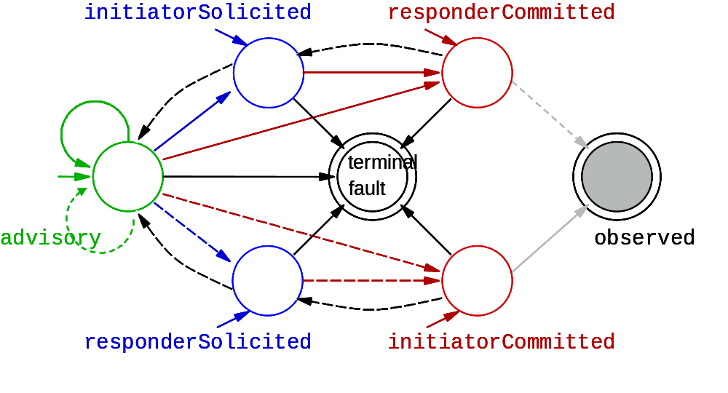
Their protocol is essentially the same as a quote-to-order provisional-final transaction.

* GRAAP Advisory or Soliciting are quotes. The initial messages would require enrolling in something like a transaction context.
* GRAAP Committing = transaction preparing
* GRAAP Accepting = transaction committing
* GRAAP Rejecting = transaction cancelling or aborting.

Resource allocation, deployment and scheduling
These scenarios were excerpted from the GSA-RG “Grid Scheduling Use Cases”. The GSA-RG document contains a lot more detail about each use case, including failure considerations.

Scheduling complex workflows

Many Grid applications require the coordinated processing of complex workflows which includes scheduling of heterogeneous resources within different administrative domains. Here, a typical scenario is the coordinated scheduling of computational resources in conjunction with data, storage, network and other available grid resources, like software licenses, experimental devices etc. The Grid scheduler should be able to coordinate and plan the workflow execution. That is, it should reserve the required resources and create a complete schedule for the whole workflow in advance.

Application-Oriented Scheduling in the KNOWLEDGE GRID

The Knowledge Grid (K-Grid) is an architecture built atop basic Grid middleware services that defines more specific services for the definition, composition, validation and execution of knowledge discovery applications over Grids, and for storing and managing discovered knowledge [..]. The K-Grid Resource Allocation and Execution Management Service (RAEMS) is a service used by the Knowledge Grid to map applications onto available resources and to coordinate their execution. The K-Grid scheduler is part of the RAEMS; it can be seen as an “application agent” associated to each application to be executed. Indeed, the scheduler produces job assignments (along with timing constraints) for each application, with the goal of improving its performances, on the basis of knowledge or prediction about computational and I/O costs. Afterwards, it follows each application execution to adapt generated schedules to new information about job status and available resources.

GRASP (Grid Resource Allocation Services Package)

GRASP(Grid Resource Allocation Services Package) is designed to meet the requirements of the resource management problem concerning about delivering the users plentiful computing power with distributed resources. Currently, Managed Job Service in Globus Toolkit 3 is the service to be used to run the job on a remote resource. However, in order to build a more useful grid, there should be added some user-friendly resource allocation manners including resource brokering, scheduling, monitoring, and so forth in the collective layer. GRASP is aiming at this upper-GRAM level scheduling and job submission system.

Resource billing and payment

Brief excerpts from the GESA-WG’s “Grid Economic Services”:

Any service invocation will consume a wide range of resources. However, a service provider may only be interested in a relatively small subset of these resources for the purposes of deciding a price to use a service. The Usage Records Working Group within the GGF have defined an initial subset of base properties, such as:
• Network
• Disc
• Memory
• Wall Clock Time
• CPU Time
• Node Count
• Processors
which could be used as part of the service pricing policy.

[…]

A statement of compensation is required for any organisation offering a service or monetary reward. The level and complexity of compensation MAY vary from one organisation to another and from different pricing methods offered by the same organisation or even the same service.

Billing rates may depend on negotiated contracts.

Specific Transactional Requirements

Contract or agreement negotiation

R21 A negotiation transaction may require long, back-and-forth conversations between parties before preparation and commitment.
R22 These conversations may require application messages to be logged along with transaction signals for recovery.
R23 One party may conduct negotiations with several other parties simultaneously, confirming some and cancelling others.

Resource allocation, deployment and scheduling

Before Grid resources are deployed for a job, they will probably be pre-allocated or reserved. Reservation may go hand-in-hand with scheduling: that is, if a resource does not have available time slots within the job scheduling parameters, it may not be allocated. A reservation is a provisional promise, subject to eventual use or cancellation (or timed self-cancellation).
R24 Ability to support reservation is a provisional promise, subject to eventual use or cancellation (or timed self-cancellation).

Grid resource scheduling is probably similar to “Escrow Promises” [11] Example 2.2. An Escrow System for scheduling runs on production machines.

Even more than negotiations, a Grid client is likely to reserve resources from many parties at the same time, confirming some and cancelling others.
R25 Ability to reserve resources from many parties at the same time, confirming some and cancelling others.

Resource billing and payment

According to GESA-WG, resource billing and payment transactions require payments for failure to meet QOS guarantees, called Refunds by GESA and Penalties by GRAAP. These may be compensations as in Sagas, or separate compensatory transactions after-the-fact. (Note: GESA uses the word “Compensation” its economic sense, as payment for services rendered.)
R26 Ability to provide alternative resources, such as a payment to compensate for familiar to provide a specified service or level of service.

Summary
Most of the transactional requirements for Grid resource management follow some variant of the Provisional-Final or Escrow Promises pattern, where the participants make provisional promises in the prepared stage, and then either confirm or cancel the promises in the final stage. The exception is resource billing and payment, which according to GESA may use a compensation approach.

Contract negotiation and resource allocation may require selective transaction outcomes à la BTP Cohesions.

All of the Grid project documents emphasize transactional-integrity requirements like “self-healing”, “disaster recovery”, “failure considerations”, etc.

In many cases, application messages may need to be logged along with transaction signals for recovery and resynchronization.

References

[12] “Web Services Agreement Specification (WS-Agreement)” August 23, 2004
http://forge.gridforum.org/projects/graap-wg/document/WS-AgreementSpecification/en/6

[13] “Web Services Agreement Negotiation Specification (WS-AgreementNegotiation)” Version 1.0 September 19, 2004
http://forge.gridforum.org/projects/graap-wg/document/WS-AgreementNegotiationSpecificationDraft.doc/en/1

[14] “Grid Economic Services” June, 2003
http://www.doc.ic.ac.uk/%7Esjn5/GGF/draft-ggf-gesa-services-1.pdf

[15] “Configuration Description, Deployment, and Lifecycle Management (CDDLM) Foundation Document” Draft Version 12 February 23, 2004
https://forge.gridforum.org/projects/cddlm-wg/document/CDDLM_Foundation_Document_v12/en/1

[16] “Grid Scheduling Use Cases” Version 1.0 July 19, 2004
https://forge.gridforum.org/projects/gsa-rg/document/Grid_Scheduling_Use_Cases/en/1

[17] O'Neil, Patrick E., "The Escrow Transactional Method", TODS, V 11, No 4 (December 1986), pp. 405-430.

[18] “[tm-rg] BTP, WS-BA and compensations”, May 26, 2004
http://www-unix.gridforum.org/mail_archive/tm-rg/2004/05/msg00009.html

TM-RG Use Case Template

Use Case Title

Introduction
[The introduction should contain an overview of the system such that a competent systems architect/developer can derive a useful understanding of the general problem that the use case addresses. It should not contain any specific detailed technical information about the system]

Architectural Overview
[An architectural overview of the system providing a breakdown of the major subsystems sufficient for the competent architect or developer to grasp the basic functionality major system components]

Scenario(s)
[One or more process-oriented scenarios of the system in use. Only those scenarios where transactional support is/may be needed should be considered here. Each scenario should begin with a new title and number]

Specific Transactional Requirements
[For each transactional aspect identified in the scenarios, the characteristics of the required transactional support should be elucidated here. Note that several scenarios may share the same transactional requirements and so there may be less transactional requirements than scenarios]

Summary
[A brief recap of the identified transactional requirements. This summary should be read in conjunction with the introduction text to provide an executive overview of the entire use case]

References
[Any references required to support the above]

Appendix A e-DiaMoND

Introduction
The main aim of the e-DiaMoND project is to develop a prototype for a Grid-enabled national database of mammograms that is sympathetic to the work practices employed within the United Kingdom's NHS Breast Screening Programme. The motivation for the project is derived from the fact that a large database with fast access would provide an invaluable resource to the breast imaging community by (amongst other things) aiding in the breast screening process, improving the quality of training, and providing a huge resource for epidemiological studies.

There are, of course, many definitions of what constitutes a grid.

What commonly runs through each of these definitions is the notion of a virtual organisation – many disparate logical and physical entities that span different administrative domains coming together to form a single logical entity. Any UK-based e-Science project concerned with healthcare has a particular virtual organisation in mind: the National Health Service.

Architectural Overview
The e-DiaMoND grid consists of a number of nodes each of which contains both a relational database and a content management system. All data stored in the grid is input in the form of DICOM files, which contain either images or reports. In either case the binary file is parsed and the information extracted is stored in the relational database, the binary files being stored in the content management system. Referential integrity is maintained using unique identifiers.

Both the relational database and the content management system are accessed via an OGSA-DAI grid service. In the case of the content management system the binary files are not passed directly, but they are passed as URLs, which are then accessed using https.

The data is federated between the nodes using product specific federation layers, these appear as a single data source to the OGSA-DAI services.

Scenario(s)
There are a number of use cases which such a system needs to support, with examples being:
- distributed queries of patient data;
- doctors working at remote hospitals who want to query information at their "home" hospital;
- delegation of access permissions;
- external access of information by a professional perhaps working at home;
- modification of data; and
- transfer of patient records.
For the more complicated of these use cases, such as the transfer of patient records, some level of transactional support is needed. Although there have been some proposed standards for transactions between web services, at the time of writing these are not commonly supported.

Specific Transactional Requirements
Although IBM's DB2 and Content Manager offer transactional support in isolation, our concept of a data store requires transactional support that spans both applications.
In brief, the requirement can be described thus:

R27 there is a need to maintain referential integrity between DB2 (database) and Content Manager.
.This requirement has to be met under the following constraints:
- reversing an insert into DB2 would be non-trivial, so compensation would not be appropriate;
- there is a need to tolerate the time it takes for Content Manager to retrieve DICOM files (which are typically 32MB).
- being able to simultaneously load multiple files is desirable (but not essential).

Summary
The e-DiaMoND use case exemplifies a straightforward transactional scenario where the data held by two heterogeneous systems must be kept consistent. The underlying application architecture does not lend itself towards a compensation based model yet the chosen model must support relatively long-lived activities.

Questions and Issues

1) Does the content management system support resource management at any level?
David Power: I think the short answer to this is yes, IBM DB2 Content Manager consists of two main components a Library Server and a number of Resource Managers.

2) Is the use of DB2 important, or is it just a side-effect of collaboration with IBM on this project, and could we therefore just say "relational database" instead?
David Power: No, the use of DB2 is not important. Relational Database will do fine.

3) Are the any requirements for members of your virtual community to have data "pushed" to them, or is it a pull-only environment?
David Power: Currently there is no requirement for data to be pushed.

Editor Information
Tony Fletcher, Choreology Ltd
68, Lombard Street, London EC3V 9LJ
Phone: +44 1473 729537 mobile: +44 7801 948219,
Email: tony.fletcher@choreology.com or amfletcher@iee.org

Acknowledgements
We gratefully acknowledge the contributions made to this document by Torsten Steinbach, Jim Webber, Dieter Gawlick, Bob Haugen, Mark Little, GGF Working groups and all other members of the TM-RG working group members who discussed and reviewed the material.

References
Each chapter has a reference section.

End of Document

