Use of WS-TRUST and SAML to access a CVS

Status of This Document

This document provides information to the Grid community about a proposed standards track protocol. Distribution is unlimited.

Copyright Notice

Copyright © Global Grid Forum (2006). All Rights Reserved.

Abstract

This document provides a protocol for a policy enforcement point (PEP) to access an external credential validation service (CVS) prior to calling a policy decision point (PDP). The protocol is a profile of SAML [SAML] attribute assertions carried by WS-Trust [WSTRUST].

Contents

Abstract 1
1. Introduction 2
2. Notational Conventions 2
3. Model and Definitions 2
3.1 Credential Push vs. Credential Pull 3
3.2 Relationship of CVS to STS and PIP 4
4. Request Protocol, Push Model 4
4.1 SAML attribute assertion profile 4
4.2 WS-TRUST request profile 5
5. Request Protocol, Pull Model 6
5.1 SAML assertion profile 6
5.2 WS-TRUST request profile 7
6. Response Protocol 7
6.1 SAML attribute assertion profile 7
6.2 WS-TRUST response profile 8
7. Element <SubjectAttributeReferenceAdvice> 8
8. Security Considerations 9
9. Contributors 9
10. Glossary 9
11. Intellectual Property Statement 10
12. Disclaimer 10
13. Full Copyright Notice 10
14. References 10

Introduction

This document describes a protocol for accessing a credential validation service (CVS) by a policy enforcement point (PEP) or a policy decision point (PDP). It is based on the model in [ARCH]. The CVS is a necessary functional component in authorization which performs the task of validating the user’s presented credentials before the valid attributes (extracted from the credentials) are used by the policy decision point (PDP) in order to make an access control decision. The protocol is a profile of SAMLv2 [SAML] attribute assertions carried by WS-Trust [WSTRUST].

Notational Conventions

The key words ‘MUST,” “MUST NOT,” “REQUIRED,” “SHALL,” “SHALL NOT,” “SHOULD,” “SHOULD NOT,” “RECOMMENDED,” “MAY,” and “OPTIONAL” are to be interpreted as described in RFC 2119 [BRADNER1]

Model and Definitions

The authorization architecture is described in [ARCH]. Figures 1 to 4 are simplified versions of the figures in [ARCH] and show the different ways in which the CVS access protocol might be used. The protocol might be called by the context handler in either the PEP or the PDP, and might carry the authenticated name of the subject with or without a bag of credentials, and with or without references to various CISs that should be contacted to pull credentials.

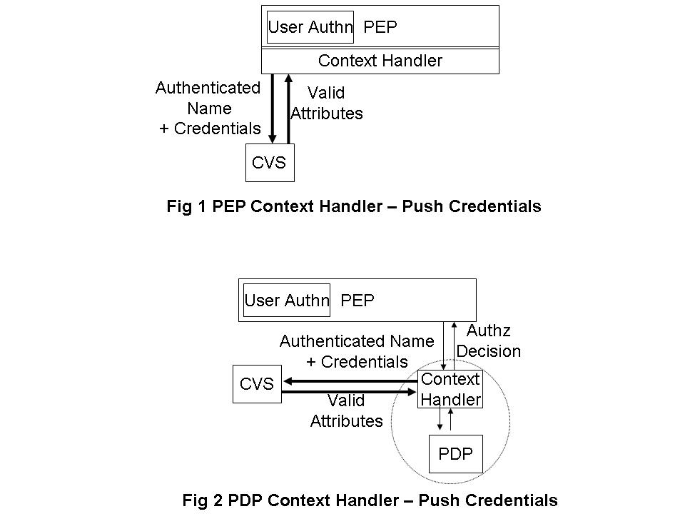

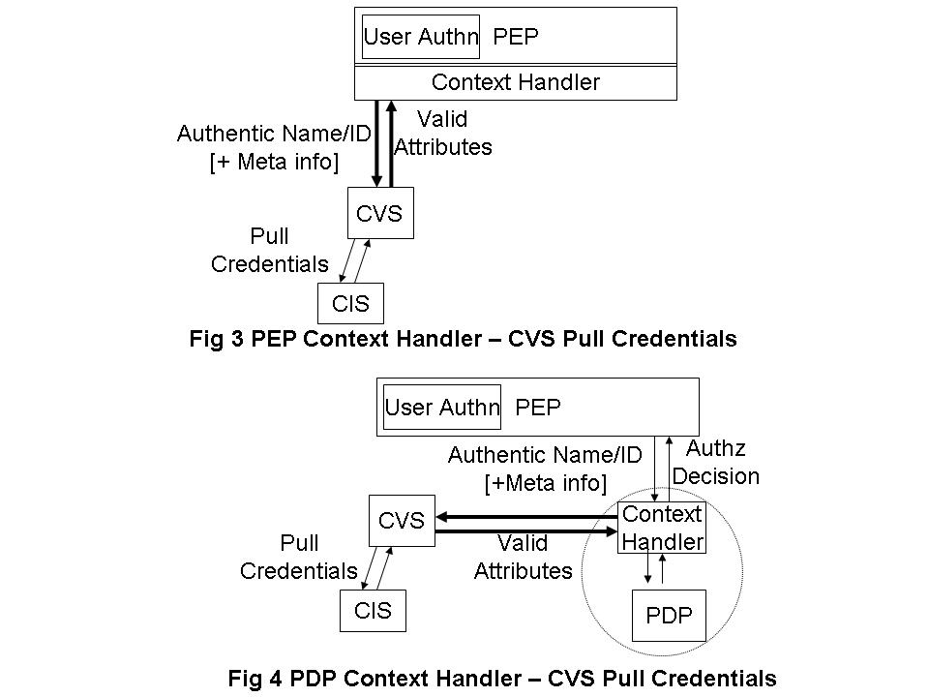
The PEP may provide any arbitrary set of credentials, e.g. member of university X, member of grid project Y, registered doctor, certified engineer etc. issued by any arbitrary set of attribute authorities (AAs) or credential issuers; as well as any arbitrary set of references (meta-information) to credential issuing services. This document does not specify how the PEP obtains these credentials or CIS meta-information, but they might be provided by the end user, or the end user’s client software, or by another component of the authorization infrastructure.

The target resource will only trust a limited set of CISs, and these trust relationships will be configured into its Credential Validation Services (CVSs) in the form of a Credential Validation Policy. A CVS will validate the presented credentials according to its configured Credential Validation Policy, and will return the set of valid attributes to the PEP. The PEP may then pass these to the PDP for it to make an access control decision.

Note. It is not within the scope of this document to define the contents of the credential validation policy, but it might contains such rules as “University X is trusted to issue doctoral degrees to anyone”, “Steve Jones is trusted to say who is a member of Project Y”. “Gold credentials > Silver credentials > Bronze credentials”. “No credentials can be older than n minutes”. “Steve Jones can delegate issuing member credentials to any project manager within Project Y” etc.

Credential Push vs. Credential Pull

The CVS can operate in three ways – credential push mode, credential pull mode or both modes. In credential push mode, the invoker will pass the credentials that it has received from the user to the CVS for validation. This is the way that VOMS works today, although VOMS does not specifically refer to “a CVS” as the module that validates the pushed VOMS ACs. In credential pull mode, the CVS is passed the DN of the authenticated user and it pulls the credentials of this user from the CIS, and validates them. This is the way that GridShib works today, when the GridShibPIP goes to fetch the Shibboleth attributes of the user from the Shibboleth IdP. Details of the Shibboleth IdP (the CIS) are currently hardcoded into the GridShibPIP module, rather than being dynamically passed as CIS meta-information. An advanced CVS may operate in both modes simultaneously, being given one set of user credentials, and pulling more in order to fully process the first set. The PERMIS CVS can operate like this. The output of all three modes of operation is always the same – the CVS returns a set of valid attributes to the PEP, that are in the correct format for passing to the PDP. Note that valid in this context means attributes that are trusted according to the credential validation policy configured into the CVS. If this policy is changed, then a different set of attributes may well be returned for an identical request.

The only difference from the protocol initiator’s perspective, is that in push mode the request message contains a bag of credentials, in pull mode it does not contain any credentials and may contain meta information to one or more CISs, and in both modes the request message will contain a bag of credentials and may contain a set of CIS meta-information.

Relationship of CVS to STS and PIP

WS-Trust [WSTRUST] is a proposal from Microsoft, IBM and others that enables security token interoperability by defining a request/response SOAP protocol whereby clients can request from some trusted authority that a particular security token be exchanged for another one. The security token service (STS) is the trusted authority that responds to WS-Trust requests.

Madsen identifies that an STS actually has three different functionalities, namely: security token exchange, security token issuing and security token validation. The last two functions are special simplified cases of the first. In this document we are only interested in the third piece of functionality, security token validation. Therefore we have decided to give this specialized functionality its own name – the credential validation service (CVS) – rather than the generic name STS, since STS implies a much greater functionality than that which is required here.

XACML [XACML] is a proposal from OASIS that defines a language for expressing access control policies in XML. XACML has nothing to say about security tokens or credentials. The nearest it comes is to define a Policy Information Point (PIP) as the system entity that acts as a source of (asserted) attribute values. Since the CVS described in this document is a source of attribute values that are ready to be passed to an XACML conformant PDP, then one can consider that the CVS is a specialized type of PIP that can process credentials and/or security tokens according to a credential validation policy, and that can return valid attributes in exchange for the input credentials.

CVS Request Protocol

The request comprises a set of SAML attribute assertions, embedded in a WS-Trust request protocol message.

SAML attribute assertion profile

This profile is based on SAMLv2 [SAML].

There should be one SAML assertionEach SAML assertion SHOULD contain the following fields:

  - Version SHOULD be set to “2.0”. Conformant implementation MUST support version 2.0 and MAY support other versions.
  - the issuer element is mandatory and contains the name of the issuer of this assertion. The Format SHOULD be entity or X.509 subject name. The use of any other format is not specified in this profile.
  - Ds-signature is optional.
  - Subject MUST be present. The NameID option MUST be used, and the Format SHOULD be X.509 subject name. The use of any other format is not specified in this profile. The SubjectConfirmation element SHOULD NOT be present, but if present this profile does not specify how it is to be used.
  - The Conditions element is optional, but if present MUST contain the NotBefore and NotOnOrAfter attributes, which specify the validity time of the assertion. This profile does not specify the use of any of the restrictions elements.
  - The Advice element SHOULD NOT be present, but if present MAY be ignored by the CVS.
  - A set of zero or more attribute statements MUST be present.

The Authentication Statement, if present, SHOULD contain

(1) The SubjectLocality element is optional. If present it specifies the DNS domain name (by its DNSName attribute) and/or IP address (by its Address attribute) for the system from which the assertion subject was apparently authenticated.
(2) The AuthnInstant attribute is mandatory. It MUST have a time value (i.e. xs:dateTime type and encoded in UTC) which specifies the time at which the authentication took place.
(3) The SessionIndex attribute is optional. If present it specifies as a string the index of a particular session between the principal identified by the subject and the authenticating authority.
(4) The SessionNotOnOrAfter attribute is optional. If present it specifies a time instant (i.e. xs:dateTime type and encoded in UTC ) at which the session between the principal identified by the subject and the SAML authority issuing this statement MUST be considered ended. There is no required relationship between this attribute and the NotOnOrAfter attribute in the Condition element that may be present in the assertion.
(5) The AuthnContext element is mandatory, which specifies the context of the authentication event that yielded this statement. It MUST contain an authentication context class reference (i.e. the AuthnContextClassRef attribute), an authentication declaration (i.e. the AuthnContextDecl attribute) or declaration reference (i.e.the AuthnContextDeclRef attribute), or both. The class reference and the declaration (or declaration reference) are represented as URIs.
(6) Zero or more AuthenticationAuthority element MAY be present in the Authentication Statement. This element MUST contain a URI to indicate the unique identifier of an authentication authority that was involved in the authentication of the principal.

Each Attribute Statement SHOULD contain the following fields
- It SHOULD contain Attribute elements and SHOULD NOT contain EncryptedAttribute elements.
- Each Attribute element SHOULD be encoded according to the X.500/LDAP Attribute Profile specified in section 8.2 of [SAMLPROF]

WS-TRUST request profile

This profile is based on the WS-Trust specification from February 2005 [WSTRUST].

The <wst:RequestSecurityToken> element is used to request a security token. This element MUST contain the following fields:

- The Context attribute is optional. If present it MUST contain a URI identifying this request. The corresponding response will carry the same Context attribute so that PDP can correlate the request and response.

- wst:TokenType describes the type of security token being requested and is specified as a URI. The WS-Trust security token type MUST be set to the SAML XACML profile, defined in [SAMLPROF] as

urn:oasis:names:tc:SAML:2.0:profiles:attribute:XACML

- wst:RequestType is used to indicate the class of function that is being requested and is specified as a URI. The WS-Trust request type for validating credentials from a CVS MUST be set to

http://schemas.xmlsoap.org/ws/2005/02/trust/Validate

- wst:Claims carries the set of SAML attribute assertions defined in Section 4.1.

- The Dialect attribute of the Claims (wst:Claims@Dialect) has a URI value, which MUST indicate the message carried in the wst:Claims field is a set of SAML attribute assertions for the push model.

urn:oasis:names:tc:SAML:2.0:assertion:AttributeStatementType

Request Protocol, Pull Model

The request comprises a WS-Trust request message containing a single SAML assertion. The SAML assertion contains either a single authentication statement or no statement at all.

SAML assertion profile

This profile is based on SAMLv2 [SAML].

The assertion SHOULD contain the following fields:

  - Version SHOULD be set to “2.0”. Conformant implementation MUST support version 2.0 and MAY support other versions.
  - The issuer element is mandatory and contains the name of the issuer of this authentication assertion. The Format SHOULD be entity or X.509 subject name. The use of any other format is not specified in this profile. The issuer name SHOULD refer to WHOM? Should this be to the PEP that validated the proxy certificate, or to the CA that issued the user’s certificate, or to user who issued the proxy certificate?
  - Ds-signature is optional.
  - Subject MUST be present. The NameID option MUST be used, and the Format SHOULD be X.509 subject name. The use of any other format is not specified in this profile. The SubjectConfirmation element SHOULD NOT be present, but if present this profile does not specify how it is to be used.
  - The Conditions element is optional, but if present it SHOULD contain the NotBefore and NotOnOrAfter attributes, which specify the validity time of the proxy certificate. This profile does not specify the use of any of the restrictions elements.
  - The Advice element MAY be present, and if present SHOULD contain a SubjectAttributeReferenceAdvice statement defined in clause 7.
  - Optionally a single Authentication Statement (AuthnSatatement).

5.2 WS-TRUST request profile

This profile is based on the WS-Trust specification from February 2005 [WSTRUST].

The <wst:RequestSecurityToken> element is used to request a security token. This element MUST contain the following fields:

(1) The Context attribute is optional. If present it MUST contain a URI identifying this request. The corresponding response will carry the same Context attribute so that PDP can correlate the request and response.

(2) wst:TokenType describes the type of security token being requested and is specified as a URI. The WS-Trust security token type MUST be set to the SAML XACML profile, defined in [SAMLPROF] as

urn:oasis:names:tc:SAML:2.0:profiles:attribute:XACML

- wst:RequestType is used to indicate the class of function that is being requested and is specified as a URI. The WS-Trust request type for validating credentials from a CVS MUST be set to

http://schemas.xmlsoap.org/ws/2005/02/trust/Validate

- wst:Claims carries the single SAML assertion defined in Section 5.1.

- The Dialect attribute of the Claims (wst:Claims@Dialect) has a URI value, which MUST indicate the message carried in the wst:Claims field is a SAML assertion for the pull model.

urn:oasis:names:tc:SAML:2.0:assertion:AuthnStatementType

Response Protocol

The response message comprises a single SAML attribute assertion embedded in a WS-TRUST response message.

SAML attribute assertion profile

This profile is based on SAMLv2 [SAML].

The single SAML assertion SHOULD contain the following fields:

  - Version SHOULD be set to “2.0”. Conformant implementation MUST support version 2.0 and MAY support other versions.
  - the issuer element is mandatory and contains the name of the CVS. The Format SHOULD be entity or X.509 subject name. The use of any other format is not specified in this profile.
  - Ds-signature is optional.
  - Subject MUST be present. The NameID option MUST be used, and the Format SHOULD be X.509 subject name. The use of any other format is not specified in this profile. The SubjectConfirmation element SHOULD NOT be present, but if present this profile does not specify how it is to be used.
  - The Conditions element is mandatory and MUST contain the NotBefore and NotOnOrAfter attributes, which specify the validity time of the assertion. This profile does not specify the use of any of the restrictions elements.
  - The Advice element SHOULD NOT be present, but if present MAY be ignored by the PEP.
  - A set of zero or more attribute statements MUST be present.

Each Attribute Statement SHOULD contain the following fields
- It SHOULD contain Attribute elements and SHOULD NOT contain EncryptedAttribute elements.
- Each Attribute element SHOULD be encoded according to the XACML Attribute Profile specified in section 8.5 of [SAMLPROF]

WS-TRUST response profile

This profile is based on the WS-Trust specification from February 2005 [WSTRUST].

The <wst:RequestSecurityTokenResponse> element is used to return a security token or a response to a security token request. This element MUST contain the following fields:

(1) The Context attribute MUST be present if it was present on the request, and must contain the same value, otherwise it MUST be absent.

(2) wst:TokenType describes the type of security token being returned and is specified as a URI. The WS-Trust security token type MUST be set to the SAML XACML profile, defined in [SAMLPROF] as

urn:oasis:names:tc:SAML:2.0:profiles:attribute:XACML

- wst:RequestedSecurityToken MUST be present if the status code is set to valid, or MUST NOT be present if the status code is set to invalid. If present it MUST contain the single SAML attribute assertion described in Section 6.1
- wst:Status. The wst:Code MUST be set to either valid or invalid as defined in Section 9 of [WS-TRUST]. Wst:Reason MAY be set.

Element <SubjectAttributeReferenceAdvice>

The <SubjectAttributeReferenceAdvice> element, defined in GFD.66, supplies a statement that the designated attributes associated with the specified subject may be obtained from the referenced URI. Its purpose is to advise the CVS as to where it may find attributes for the subject when working in the credential pull mode of operation.

<SubjectAttributeReferenceAdvice> is of type SubjectAttributeReferenceAdviceType, which extends the Advice element with a set of SubjectAttributeReferences. Each SubjectAttributeReference contains the following:
AttributeDesignator [Any number]
These elements list the attributes that may be located at the referenced URI(s). If this component is absent, then it implies that all attributes can be found at the referenced URI(s).
Reference Attribute [Required]
This attribute provides the URI(s) from which the above attributes may be obtained.

The following schema fragment defines the <SubjectAttributeReferenceAdvice> element and its SubjectAttributeReferenceAdviceType complex type:

<element name="SubjectAttributeReferenceAdvice"
type="ogsa-saml2:SubjectAttributeReferenceAdviceType"/>
<complexType name="SubjectAttributeReferenceAdviceType">
<complexContent>
<extension base="Advice">
<choice minOccurs=”0” maxOccurs=”unbounded”>
<element ref="ogsa-saml2:SubjectAttributeReference" />
</choice>
</extension>
</complexContent>
</complexType>

The following schema fragment defines the <SubjectAttributeReference element and its SubjectAttributeReferenceType complex type:

<element name="SubjectAttributeReference"
type="ogsa-saml2:SubjectAttributeReferenceType"/>
<complexType name="SubjectAttributeReferenceType">
<sequence>
<element ref="saml:AttributeDesignator" minOccurs=”0” maxOccurs=”unbounded” />
</sequence>
<attribute name="Reference” type=”anyURI” use="required" maxOccurs="unbounded"/>
</complexType>
Editor’s note. CIS meta-information may require more data than simply the URI of the CIS, for example, the authentication methods and tokens that are needed to make a successful connection. It is for further study what additional information should be added to the SubjectAttributeReference.

Security Considerations

This entire document is concerned with security.

Contributors

David W. Chadwick
The Computing Laboratory
University of Kent
D.W.Chadwick@kent.ac.uk

Linying Su
The Computing Laboratory
University of Kent
L.Su-97@kent.ac.uk

Glossary

CVS – credential validation service
PEP – policy enforcement point
PIP – policy information point
PDP – policy decision point
STS – security token service

Intellectual Property Statement

The GGF takes no position regarding the validity or scope of any intellectual property or other rights that might be claimed to pertain to the implementation or use of the technology described in this document or the extent to which any license under such rights might or might not be available; neither does it represent that it has made any effort to identify any such rights. Copies of claims of rights made available for publication and any assurances of licenses to be made available, or the result of an attempt made to obtain a general license or permission for the use of such proprietary rights by implementers or users of this specification can be obtained from the GGF Secretariat.

The GGF invites any interested party to bring to its attention any copyrights, patents or patent applications, or other proprietary rights which may cover technology that may be required to practice this recommendation. Please address the information to the GGF Executive Director.

Disclaimer

This document and the information contained herein is provided on an “As Is” basis and the GGF disclaims all warranties, express or implied, including but not limited to any warranty that the use of the information herein will not infringe any rights or any implied warranties of merchantability or fitness for a particular purpose.

Full Copyright Notice

Copyright (C) Global Grid Forum (applicable years). All Rights Reserved.

This document and translations of it may be copied and furnished to others, and derivative works that comment on or otherwise explain it or assist in its implementation may be prepared, copied, published and distributed, in whole or in part, without restriction of any kind, provided that the above copyright notice and this paragraph are included on all such copies and derivative works. However, this document itself may not be modified in any way, such as by removing the copyright notice or references to the GGF or other organizations, except as needed for the purpose of developing Grid Recommendations in which case the procedures for copyrights defined in the GGF Document process must be followed, or as required to translate it into languages other than English.

The limited permissions granted above are perpetual and will not be revoked by the GGF or its successors or assignees.

References

Note that only permanent documents should be cited as references. Other items, such as Web pages or working groups, should be cited inline (i.e., see the Global Grid Forum, http://www.ggf.org). References should conform to a standard such as used by IEEE/ACM, MLA, Chicago or similar. Include an author, year, title, publisher, place of publication. For online materials, also add a URL. Some sample citations:

[BRADNER1] Bradner, S. Key Words for Use in RFCs to Indicate Requirement Levels, RFC 2119. March 1997.
[BRADNER2] Bradner, S. The Internet Standards Process – Revision 3, RFC 2026. October 1996.
[CATLETT] Catlett, C. GFD-1: Grid Forum Documents and Recommendations: Process and Requirements. Argonne, Illinois: Global Grid Forum. April 2002.
[GFD.66] Von Welch, Rachana Ananthakrishnan, Frank Siebenlist, David Chadwick, Sam Meder, Laura Pearlman. “Use of SAML for OGSI Authorization”, Open Grid Forum, Grid Final Documents, GFD.66. March 2006,
[SAML] OASIS. “Assertions and Protocol for the OASIS Security Assertion Markup Language (SAML) V2.0”, OASIS Standard, 15 March 2005
[SAMLPROF] OASIS “Profiles for the OASIS Security Assertion Markup Language (SAML) V2.0”, OASIS Standard, 15 March 2005
[WSTRUST] Anthony Nadalin (Editor) “Web Services Trust Language (WS-Trust)”, Feb 2005 available from ftp://www6.software.ibm.com/software/developer/library/ws-trust.pdf
[XACML] “OASIS eXtensible Access Control Markup Language (XACML)” v2.0, 6 Dec 2004, available from http://www.oasis-open.org/committees/tc_home.php?wg_abbrev=xacml

For example, some shop keepers trust Visa, some trust Amex, and some trust both. The credentials are always authentic in each shop, but they are not always valid.
The WS-Trust specification is available from ftp://www6.software.ibm.com/software/developer/library/ws-trust.pdf
Paul Madsen “WS-Trust: Interoperable Security for Web Services“ Available from http://www.xml.com/pub/a/ws/2003/06/24/ws-trust.html
Coordinated Universal Time, with no time zone component.

