Agenda for OGSA-WG and fellow WGs F2F meeting
- July 17-20, 2006 in Chicago -
Draft 11 (July 16, 2006)

Hosted by Argonne National Laboratory

Venue: Argonne National Laboratory
Address: 9700 S. Cass Avenue, Argonne, IL 60439
Directions to ANL: http://www.anl.gov/Visiting/anlil.html
Argonne & Chicago Map: http://www.anl.gov/Visiting/chimap.html
ANL Map: http://www.anl.gov/Visiting/anlemap.html

Formal registration for Argonne's site entrance
Formal registration is REQUIRED in order to enter Argonne's site. Please provide the information on the last page to ASAP.

Entrance procedure (US citizen)
Upon your arrival to ANL, you must present your drivers license.

Entrance procedure (NON US citizen)
Upon your arrival to ANL, you must present your original passport, original visa and/or I-94 or I-94W (Departure Record). If the expiration date on the I-94 or I-94W reads D/S (Duration of Status), you must present the supporting immigration documentation (i.e., I-20, DS-2019). Failure to do so may delay your access to the site.

Meeting room:
Meeting room C101 on the 1st floor of building 221.

Dial-in:
US Toll number: +1 408-961-6509 (San Jose) and +1 718-354-1071 (New York)
UK Toll number: +44 (0)207 365-5269
JP Toll number: +81 (0)3 3570 8225
The pass code: 4371991

Glance network:
Address: http://ogsa.glance.net
Pass code: MMDD (0815 for Aug. 15)

Contact:
1-312-399-3176 (Hiro’s mobile)

Accommodation: Argonne Guest House

Argonne Guest House: http://www.aps.anl.gov/travel/anlghhome.html
Call Argonne Guest House (800 632-8990 or 630 739-6000) or make researvation online
http://www.aps.anl.gov/travel/accomodation-form.html

Argonne Contact Person: Ian Foster
Argonne Contact Telephone Number: +1-630-252-4619
Argonne Contact Division/Department: DSL MCS

Attendees List

Hiro Kishimoto (Fujitsu)
Andreas Savva (Fujitsu)
Andrew Grimshaw (University of Virginia)
David Snelling (Fujitsu)
Ian Foster (ANL)
Jay Unger (IBM)
Marvin Theimer (Microsoft)
Glenn Wasson (University of Virginia)
Michel Drescher (Fujitsu)
Steve McGough (Imperial College)
Chris Smith (Platform)
Nick Werstiuk (Platform)
Ravi Subramaniam (Intel)
Steve Tuecke (Univa)
Pete Ziu (Northrop Grumman)
Ellen Stokes (IBM)

Telephone Bridge
Allen Luniewski (IBM)
Dave Berry (NeSC)
Steven Newhouse (University of Southampton)
Jun Tatemura (NEC)
Chris Jordan (SDSC)
Susanne Balle (HP)
Fred Maciel (Hitachi)
Jem Treadwell (HP)
Darren Pulsipher (EMC)

Apologies
Marty Humphrey (University of Virginia)
Donal Fellows (University of Manchester)
Dejan Milojicic (HP)
Mark Morgan (University of Virginia)
Frank Siebenlist (ANL)
Keisuke Fukui (Fujitsu)
Takuya Mori (NEC)
Michael Behrens (R2AD, LLC)

Unconfirmed
Tom Maguire (EMC)
Duane Merrill (University of Virginia)
Mathias Dalheimer (Fraunhofer ITWM)
Neil Chue Hong (EPCC)
Patricia Kovatch (SDSC)
Manuel Pereira (IBM)
Jim Pruyne (HP)
Alan Sill (Texas Tech University)
Steve Loughran (HP)
Kazushige Saga (NAREGI)
Stuart Schaefer (Softricity)
Mary Thompson (LBNL)
Von Welch (NCSA)
Bahareh Rahmanzadeh (Amirkabir university of technology)

Meeting schedule at a glance

 | am  8:30am-12:30pm |  | pm  1:30-5:30pm
July 17 (Mon) | 8:30-10:20 | Info model #1 | 1:30-3:20 | HPC profile
July 17 (Mon) | 10:40-12:30 | OGSA-data | 3:40-5:30 | BES #1
July 18 (Tue) | 8:30-10:20 | Info model #2 | 1:30-3:20 | OGSA-naming
July 18 (Tue) | 10:40-12:30 | BES #2 | 3:40-5:30 | GFS
July 19 (Wed) | 8:30-10:20 | DMIS | 1:30-3:45 | Roadmap
July 19 (Wed) | 10:40-12:30 | GGF 18 planning | 4-6 | Joint GGF Management Committee meeting
July 20 (Thu) | 8:30-10:20 | CDDLM joint
July 20 (Thu) | 10:30-11:30 | EMS scenarios
July 20 (Thu) | 11:40-12:30 | Geoffrey’s comments

Known constraints:
- HPC profile must be on Monday (Marvin Theimer)
- Info model must be Tuesday or before 10:30 Monday (Ellen Stokes and Fred Maciel)
- EMS scenarios must be in the morning (Steven Newhouse)
- BES (and also Info Model and HPC profile) any time except Tuesday afternoon and Wednesday (Dave Snelling and Jay Unger)
- OGSA-naming must be before Tuesday 3:30 (Andrew Grimshaw)

July 17 (Mon), 8:30am ~ 10:20am
Information Modeling Session #1
OGSA-WG RM design team (Fred Maciel and Ellen Stokes)

1) Early discussion (20 min)
  - Note taker
  - Role call and self introduction
  - Agenda bashing
  - Group dinner plan (Tuesday evening?)

2) Continue the discusson of the data model (concrete vs abstract) (90 min)
  - Discuss pros and cons for schema-based and schema-less approach based on existing experiences (Condor, LSF, JSDL, …).
  - See July 10 teleconference minutes.
  - Build a consensus of choosing one of two approaches.

July 17 (Mon), 10:40am ~ 12:30pm
OGSA Data Architecture Session
OGSA-Data WG (Dave Berry and Allen Luniewski)

- Update of status and plans

- Introduction to the data architecture
  - Goal: to encourage OGSA WG members to review the documents
    - Overview
    - Five sample scenarios
  - The current drafts of the OGSA Data Architecture and OGSA Data scenario documents can be found at
    - https://forge.gridforum.org/sf/go/doc13635?nav=1 and
    - https://forge.gridforum.org/sf/go/doc13605?nav=1.

- Relation with other OGSA activitiy
  - Goal: to encourage greater integration between OGSA Data and the rest of OGSA
  - OGSA gap analysis from a Data perspective
  - OGSA Data gap analysis

- Actions

Lunch 12:30 ~ 1:30 pm

July 17 (Mon), 1:30 ~ 3:20pm
OGSA HPC Profile Session
OGSA-HPCP WG (Marvin Theimer and Glenn Wasson)

(1) BES, JSDL and Information model discussion
  - Marvin has started that have been taking place in the BES and JSDL mailing lists and teleconference calls. In particular, we will discuss whether the proposed changes to BES and JSDL represent the correct set of changes for then being able to write a complete HPC Profile specification over.

(2) "Rendering" discussion (e.g., WSRF, WS-I)

(3) closure on the HPC profile use case document

July 17 (Mon), 3:40 ~ 5:30pm
BES Session #1
OGSA-BES WG (Darren Pulsipher and Andrew Grimshaw)

July 17 (Mon), 5:30 ~ 6 pm
Movie Time

Official Group Dinner ??

July 18 (Tue), 8:30am ~ 10:20am
Information Modeling Session #2
OGSA-WG RM design team (Fred Maciel and Ellen Stokes)

- Early discussion (10 min)
  - Note taker
  - Role call and self introduction
  - Agenda bashing

- General discussion on information modeling
  - see June 22 teleconference minutes.

- - Review the plans on contents, completion and release of information modeling specifications.

- - Review latest version (v7) of the modeling guidelines document (if there is time left)
  - posted on July 11.

July 18 (Tue), 10:40am ~ 12:30pm
BES Session #2
OGSA-BES WG (Darren Pulsipher and Andrew Grimshaw)

Lunch 12:30 ~ 1:30 pm

July 18 (Tue), 1:30 ~ 3:20pm
OGSA-naming Session
OGSA-naming WG (Andrew Grimshaw)

- WS-Naming Specification review (110 min)
- Recall that a new version of the proposed specification was placed on gridforge in May. We will close out the trackers (most of which have been discussed and resolved) and present the final draft at the OGSA F2F next week in Chicago on Tuesday afternoon. Please, if you have an intention to comment - read the document before then.

July 18 (Tue), 3:40 ~ 5:30pm
RNS and GFS Session
GFS WG (Chris Jordan)

(1) RNS/Human-Readable Hierarchical namespaces RNS-based "profiles" (60 min)

(2) Grid File Systems requirements from OGSA/OGSA-Data groups BES and JSDL (50 min)

July 19 (Wed), 8:30am ~ 10:20am
Data Movement Interface Session
OGSA-DMI WG (Michel Drescher)

- OGSA-DMI Agents Definition (30 min)
  - Introducing ETD

- 2) Status Model (30 min)

July 19 (Wed), 10:40am ~ 12:30am
GGF18 planning session
OGSA-WG (Tom Maguire and Hiro Kishimoto)

- GGF18 session plan (50 min)
  - We’ve asked 4 session slots for GGF18. We will discuss owner, contents, and expected attendees for each session.

- B2B F2F meeting on Friday (30 min)
  - Session plan and logistics for the meeting

- Document status review (30 min)
  - Development status check for all working documents

Lunch 12:30 ~ 1:30 pm

July 19 (Wed), 1:30 ~ 3:45pm
OGSA roadmap Session
OGSA WG Roadmap design team (Chris Jordan)

- Introduction of Roadmap team, roles, and contact information (15 minutes)

- Current status presentation (15 minutes)

- New document additions (30 minutes)
  - Current planned additions, discussion of new document inclusion

- Information Modeling documents discussion (30 minutes)

- Gap Analysis:
  - Presentation of current known gaps (15 minutes)
  - Attendee input and discussion of additional gaps (30 minutes)

July 19 (Wed), 4 ~ 6 pm
Joint OGF Management Committee Session
OGF Management Committee (Mark Linesch and Dave Snelling)

- Introduction, background, goals, and initial plans for standards project – (Mark, 30 mins)

- Review of survey and other input to the OGSA – (Dave, 30 mins)

- Discussion (45 mins)

- Action identification and planning (15 mins)

July 20 (Thu), 8:30am ~ 10:20am
Joint CDDLM session
CDDLM WG (Jun Tatemura and Hiro Kishimoto)

- GGF18 session plan (110 min)
  - Complete CDDLM scenario and related CDDLM documents

July 20 (Thu), 10:30am ~ 11:30am
EMS scenario Session
OGSA-WG EMS design team (Steven Newhouse and Andreas Savva)

- Document review: OGSA EMS Scenarios first draft
  - Assign owners to missing pieces
  - Milestones till submission at or around GGF18

- Other work
  - What is the relation to other activities: HPC Profile, Data Scenarios, etc
  - Future work: More scenarios, EMS architecture document, or ...?

July 20 (Thu), 11:30am ~ 12:30pm
Geoffrey’s comments Session
OGSA-WG (Andreas Savva)

- Discussion of OGSA 1.5 tracker artifacts originating from G. Fox's presentation
  - https://forge.gridforum.org/sf/tracker/do/listArtifacts/projects.ogsa-wg/tracker.ogsa_1_5

- Decide what documents or activities the group should start to address these comments;
- assign owners
- Any other related topics

ANL campus map
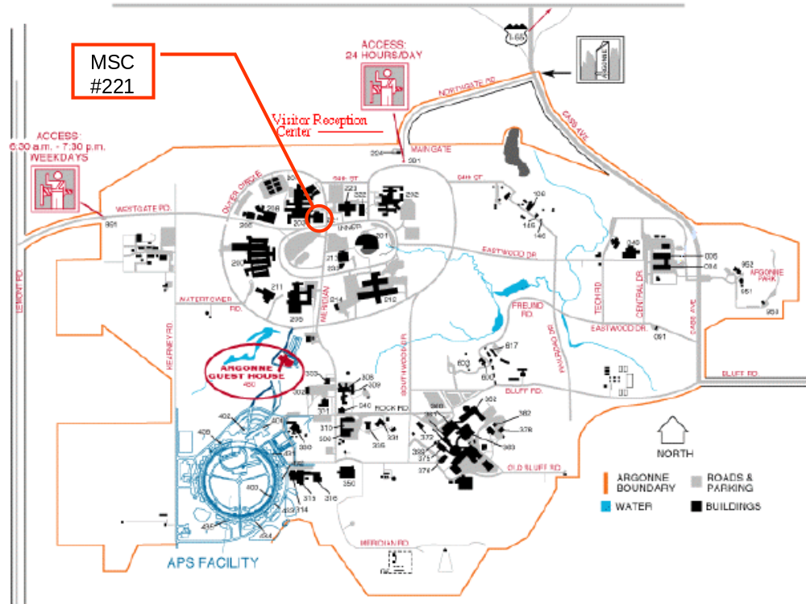
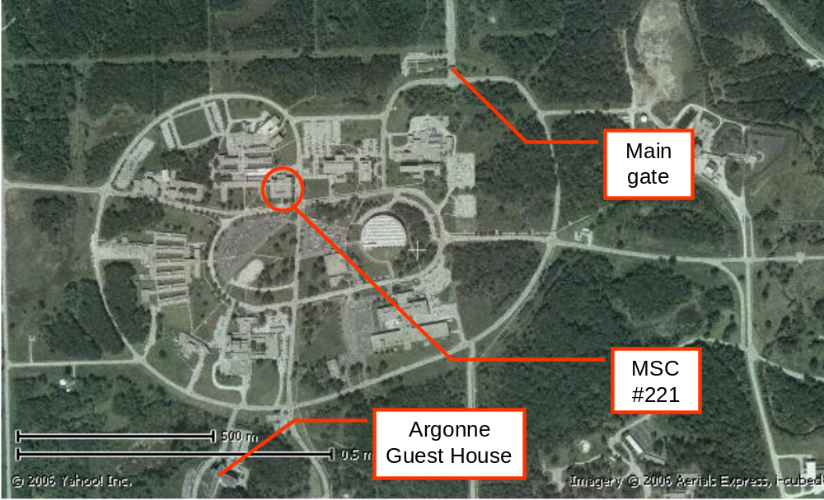
GGF OGSA-WG 2006 July F2F meeting
- Argonne National Laboratory Visit -
REQUIRED DETAILS
Please send to:
FOR US CITIZENS:
First Name
Middle Name
Last Name
Organization represented
Arrival Date and approximate time
Departure Date

If US citizen – just bring drivers license

If you are not a US citizen then please complete the following:
FOR NON US CITIZENS:
First Name
Middle Name
Last Name
Country of Citizenship
Date of Arrival and appropriate time
Date of Departure
Gender
Place of Birth (City, Country)
Date of Birth
Passport Number
Country of Issue
Passport Expiration date
Organization Represented/Employer
Address of Current Employer
Telephone Number
Title or description of work
Legal Permanent Resident (Yes or No)
Type of Visa Green Card/Permanent Resident Card Number
Expiration Date
IF not a Legal Permanent Resident:
Type of Visa
Visa Number
Visa Expiration Date
Please bring passport, visa and I-94.

Argonne requires either a visa or a visa waiver. This waiver (I-94) is usually attached to your passport when you leave your country. If this is not attached to your passport when you leave your country, one can be obtained on the airplane by asking the attendant for a waiver.

