Production Grid Infrastructure Roadmap
Version 0.1

Status of This Document

This document provides information to the Grid community regarding the roadmap of numerous production Grid infrastructures that agree on a well-defined set of standard specifications. It does not define any standards or technical recommendations, but is based on experiences gained by the OGF Grid Interoperation Now (GIN) Community Group. Distribution is unlimited. This document contains schedule information for work being carried mainly by the OGF Production Grid Infrastructure (PGI) working groups. The document will be updated periodically to reflect schedule changes.

Copyright Notice

Copyright © Open Grid Forum (2006-2008). All Rights Reserved.

Abstract

TBD…

Contents

1. Introduction 3
2. PGI: Process, Specifications and Profiles, and Software 4
2.1 PGI Requirements 4
2.2 PGI Specifications and Profiles 5
2.3 PGI Software 6
3. PGI: Use Cases 7

1. Introduction
TBD…GIN and PGI…

2. PGI: Process, Specifications and Profiles, and Software
TBD…GIN and PGI…

2.1 PGI Requirements

PGI requirements… meet GIN infrastructure requirements taking its experience into account.

2.2 PGI Specifications and Profiles

Well defined set of specifications.

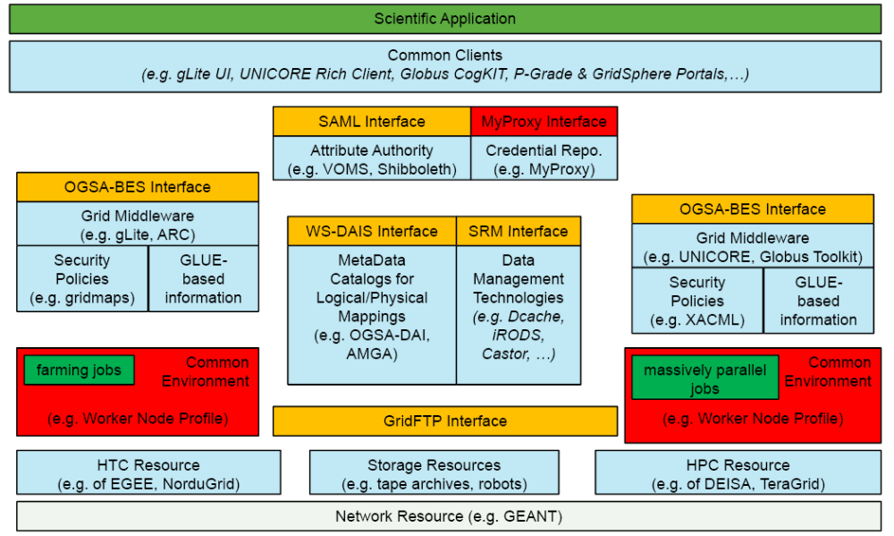

2.3 PGI Software

Main middlewares are gLite, ARC, and UNICORE representing Grids such as EGEE, NorduGrid, and DEISA.

3. PGI: Use Cases
TBD…GIN and PGI…

TBD:OXANAS USE CASE?!

WISDOM USE CASE:

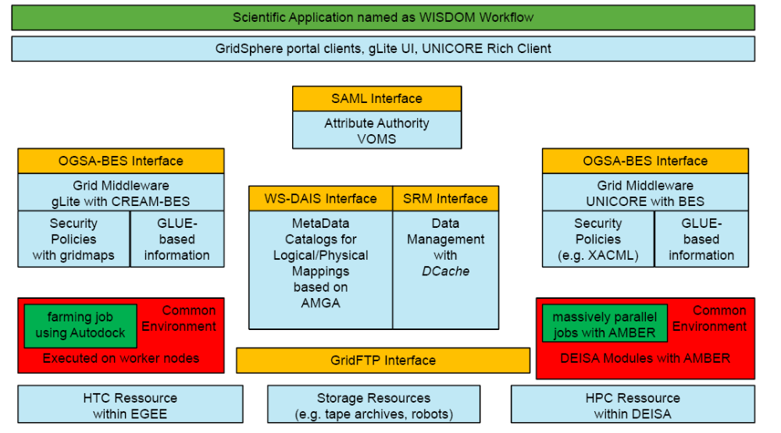

COVENEY USE CASE:

