Fact-Sheet PGI Compute: Create Operation

Context
- ‘Create operation’ to submit one ore more computational activities to a software providing access to a computational resource
- (Stephen Covey Habit #5 :Seek first to understand – then try to be understood)

PortType
- ‘Create operation’ should be part of the JobExecution portType of the service

Must Understand JSDL Elements
- Not supported by OGAS-BES specification [4]
- Addressed [2]: Validity flag for JSDL parsing or common agreements on every element
- During parsing the job description, the service has to ‘understand’ every single XML element provided in it so that not any element can be ignored by the implementation
  - TBD: Throws fault: Job Description Elements Unknown

Input: List of activities
- Addressed [1]: MUST be able to accept multiple creates, i.e., a vector of creates, and return a vector of responses.
- Addressed [1]: MUST support GLUE2 schema for resource description
- Addressed [2]: CreateActivity Operation input
- List of activities described in a well-defined format
  - TBD: Which format: Tuned JSDL??? In combination with GLUE elements

Input: Immediate start of activities
- Not supported by OGAS-BES specification [4]
- Addressed [1]: Must be able to start activity in Pending state (implies pending state)
- Addressed [1]: SHOULD start in RUNNING/READY by default
  - TBD: Default as agreement
- Addressed [2]: CreateActivity Operation input
- Information for each activity whether it should be started immediately or not
  - TBD: Encoding style

Input: XSD:Any
- Supported by OGAS-BES specification [4] using the XSD:Any type.
- Possibility to extend the input of a service with a proprietary extension
  - TBD: Encoding style

Output: Unique ID of Activities
- Supported by OGAS-BES specification [4] using the EPR of WS-Addressing [5]
- Addressed [2]: CreateActivity Operation output
- For each activity there must be unique identifier
  - TBD: Encoding: EPR, plain Resource URL?

Output: Stage-in data location
- Not supported by OGAS-BES specification [4]
- Addressed [1]: MUST support service directed staging in and out of data.
- Addressed [2]: CreateActivity Operation output
- For each activity must be a remote location in order to perform manual data-staging-in
  - TBD: Encoding: EPR, plain Resource URL?

Output: Stage-out data location
- Not supported by OGAS-BES specification [4]
- Addressed [1]: MUST support service directed staging in and out of data.
- Addressed [2]: CreateActivity Operation output
- For each activity must be a remote location in order to perform manual data-staging-out
  - TBD: Encoding: EPR, plain Resource URL?

Output: Session Directory location
- Not supported by OGAS-BES specification [4]
- Addressing [1]: MUST provide mechanism to interact with a “session directory” while activity exists
- Addressed [2]: CreateActivity Operation output
- For each activity must be a remote location in order to interact with running jobs
  - TBD: Encoding: EPR, plain Resource URL?

Faults: Job Description Elements Unknown
- Not supported by OGAS-BES specification [4]
- Thrown by ‘Create Operation’ if one XML element is unknown to the implementation
  - TBD: Encoding

Faults: Unable to Create Activity
- Addressed [1]: MUST throw a fault if it is unable to create the activity.
- Thrown by ‘Create Operation’ once the activity could not be created
  - TBD: Encoding

Faults: Invalid Job Description
- Addressed [1]: MUST throw a fault if an invalid document is submitted
- Thrown by ‘Create Operation’ if the job description can not be interpreted by the implementation
  - TBD: Encoding

Open Issues: Notification
- Addressed [1]: SHOULD support notification on activity state change
  - TBD: Encoding via WS-Notification or WS-Eventing…

Open Issues: Parallel Support
- Addressed [1]: MUST support parallel jobs. (Does this mean all containers MUST support parallel jobs?)
  - TBD: Should not support parallel jobs in every case…

Related Work: OGSA-BES Operation CreateActivity
- Example of a CreateActivity() operation request and response as in [4]:

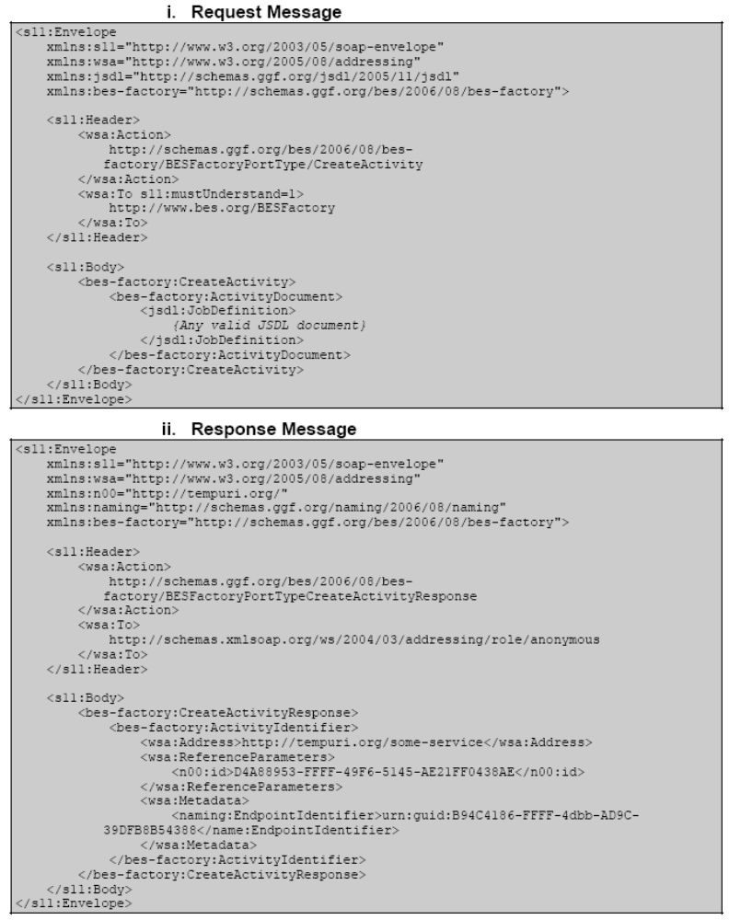

Disclaimer
- This factsheet is only considered to be a document for discussion purposes in the PGI working group and thus are no final definitions.

Links
- [1] GES Realization via Existing specifications,
Version V1, May 12 - 2009
http://forge.gridforum.org/sf/docman/do/downloadDocument/projects.pgi-wg/docman.root.input_documents.execution_service/doc15630
- [2] Strawman Rendering,
Version draft version 0.1 2009/05/11
http://forge.gridforum.org/sf/docman/do/downloadDocument/projects.pgi-wg/docman.root.input_documents.execution_service/doc15628
- [3] Execution Service Strawman,
Version 11/05/2009,
http://forge.gridforum.org/sf/docman/do/downloadDocument/projects.pgi-wg/docman.root.input_documents.execution_service/doc15624
- [4] OGSA – Basic Execution Service,
Version 1.0
http://www.ogf.org/documents/GFD.108.pdf#
- [5] WS-Addressing,
Version 1.0
http://www.w3.org/Submission/ws-addressing/

