OGSA-Interested Party Survey (rev. 07)
Dec. 6, 2004
Information provided in a survey is not considered the official position of the stakeholder unless so stated. Further, even if information provided is the official position of the stakeholder the survey is not binding and does not imply any obligation on the stakeholder.

Name
Business Grid Computing Project

Outline

Category
Table 1 category of the party
 | Standards development group or research group (e.g. GGF WG/RG, OASIS TC, etc.)
✓ | Open source software development or distribution project (e.g. Globus, NMI, OMII, etc.)
 | Grid testbed or application project (e.g. TeraGrid, National Fusion Collaboratory, etc)
 | Commercial software and / or hardware vender
 | Grid user company

Description
The recent global diffusion of the Internet has increased the importance of e-business and created new opportunities and challenges. One effect is that the business cycle, from planning to development to operation, is becoming shorter and shorter. Therefore, there is increased pressure on companies and public institutions to construct and manage reliable and flexible application systems at low cost. The Business Grid Computing project is aiming to address these new requirements by developing Grid technology based on virtualization, autonomous control, and unified management of IT resources.
This project was started to address the requirements of systems providing essential social services as part of the Focus 21 project of the Ministry of Economy, Trade, and Industry in Japan. This project is scheduled to run for three years from fiscal 2003 to 2005 with the participation of Fujitsu Ltd., Hitachi Ltd., NEC Corp., and the National Institute of Advanced Industrial Science and Technology. Around 300 developers are working for this project and its outcomes are intended be available as open source software.
Reference:
- “Business Grid Middleware Goals and Status”, January 20, 2004, Hiro Kishimoto, Takashi Kojo, Fred Maciel, GlobusWorld 2004 http://www.globusworld.org/program/slides/3c_1.pdf
- “Business Grid Project Grid Project Objectives & Key Technical Issues Objectives & Key Technical Issues”, Nobutoshi Sagawa, Hiro Kishimoto, Toshiyuki Nakata, “Enterprise Grid Solutions and Deployments Workshop” EGR-RG, GGF12, https://forge.gridforum.org/projects/egr-rg/document/WS_slide_Hitachi/en/1

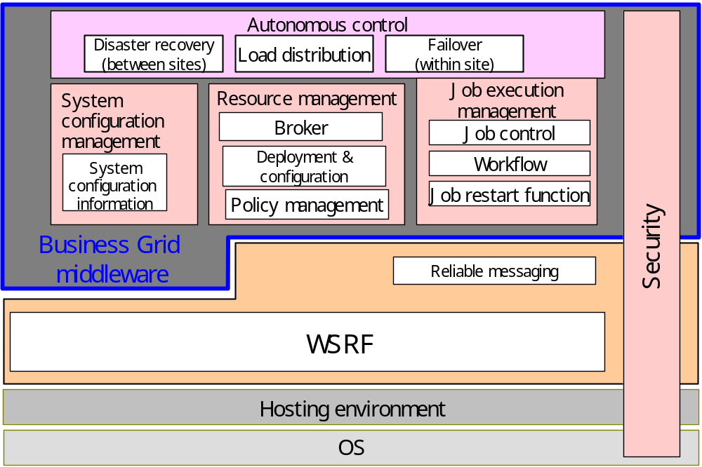
Fig 1 Business Grid Middleware Architecture

Contact person
Hiro Kishimoto, standards activity lead, hiro.kishimoto@jp.fujitsu.com
Andreas Savva, andreas.savva@jp.fujitsu.com
Fred Maciel, fred-m@crl.hitachi.co.jp
Toshi Nakata, t-nakata@cw.jp.nec.com

Schedule
This project is scheduled to run for three years from fiscal 2003 to 2005. The first prototype was completed in ’04 March. And next one is planed to be available in ’05 March. Although the project will complete ’06 March, developed technologies and software will be a part of participated venders’ commercial middleware products.

Synergy with OGSA

Role
Table 2 Table role of the party
✓ | Grid requirements gathering
✓ | High level architecture design
✓ | Low level architecture design
✓ | Specification (e.g. API) development
✓ | Grid software development
✓ | Grid operation

Area or capability
Table 3 role-involvement table
Area | Involvement |  |  | Role |  |  | N/A
Area | High | Med | Low | HLA | ASD | IMP | N/A
Grid application |  |  |  |  |  |  | ✓
Execution management services |  | ✓ | ✓ | ✓ | ✓ | ✓
Data services | TBD
Resource management services | TBD
Security services | TBD
Self-management services | TBD
Information services | TBD
Naming service: | TBD
Infrastructure services | TBD

Input to OGSA
Table 4 OGSA input table
Area | Conflicts, Gaps, Inputs |  | N/A
Execution management services | Conflicts
Execution management services | Gaps | This project develops “Job Execution Manager (JM)” and it aligns to OGSA EMS at high level. However, JM defines specific API based on WS-Agreement and JSDL with some extension. This JM API is a candidate for standard APIs of EMS services. The project is actively involved in the GRAAP-WG and JSDL-WG.
Execution management services | Inputs | Since the project is also developing many components which are listed up as OGSA EMS services (for example, execution planning services, candidate set generator service, reservation service), the project can contribute to define service description for each services.  API design will complete ’05 March and reference implementation will be available at ’05 December.
Data services | Conflicts | TBD
Data services | Gaps | TBD
Data services | Inputs | TBD
Resource management services | Conflicts | TBD
Resource management services | Gaps | TBD
Resource management services | Inputs | TBD
Security services | Conflicts | TBD
Security services | Gaps | TBD
Security services | Inputs | TBD
Self-management services | Conflicts | TBD
Self-management services | Gaps | TBD
Self-management services | Inputs | TBD
Information services | Conflicts | TBD
Information services | Gaps | TBD
Information services | Inputs | TBD
Naming service | Conflicts | TBD
Naming service | Gaps | TBD
Naming service | Inputs | TBD
Infrastructure services | Conflicts | TBD
Infrastructure services | Gaps | TBD
Infrastructure services | Inputs | TBD

Expected output from OGSA
Table 5 Spec development / use schedule
Area | Specifications and their schedule |  | N/A
Execution management services | Develop | Our JM API spec will be available ’05 March at earliest.
Execution management services | Use | If the emerging EMS specification on WS-Agreement and JSDL are reflecting our requirements and feedbacks, proposed schedule (GGF14, ‘05/6) satisfies our needs.
Data services | Develop | TBD
Data services | Use | TBD
Resource management services | Develop | TBD
Resource management services | Use | TBD
Security services | Develop | TBD
Security services | Use | TBD
Self-management services | Develop | TBD
Self-management services | Use | TBD
Information services | Develop | TBD
Information services | Use | TBD
Naming service | Develop | TBD
Naming service | Use | TBD
Infrastructure services | Develop | TBD
Infrastructure services | Use | TBD

General comments for OGSA

In OGSA version 1.0 document, naming service is explained as a service under information capability.

