Minutes
BES/JSDL/GLUE Workshop

CERN, Geneva
513 R 070
CH-1211 Geneva 23
Tuesday, 2 September 2008 to Thursday 4 September 2008

Agenda at http://indico.cern.ch/conferenceDisplay.py?confId=38455

Agenda
Tuesday, 2 September 2008
09:20-14:30 Part 1: Presentations (overview, implementation status)
- JSDL and its Extensions
- BES and its extensions
- BES, HPC, JSDL, GLUE Profiling
- OGF-Europe: BES/JSDL Workshop
- Adoption of OGSA-BES in UNICORE
- CREAM-BES
- JSDL support within WMS
- GIN: JSDL/BES feedback from KnowARC/NorduGrid

15:15-16:20 Part 2: Brainstorming Session and Discussion
Discover problems with the existing standards

16:20- 17:45 Part 2: Discussion continued

Wednesday, 3 September 2008
09:20-18:00 Part 2: Discussion continued

Thursday, 4 September 2008
09:10-12:45 Part 3: Setting up an Action List
- Find solutions for the identified problems
- Generate an action list to implement the found solutions

Participants
No. | Name | Organisation | Country | Remarks
1 | Mr. FIELD Laurence | CERN | Switzerland | Workshop chair
2 | Dr. ANDREOZZI, Sergio | INFN-CNAF | Italy | Left on Thursday morning
3 | Mr. FRåGåT, Thomas | University of Oslo | Norway | Left on Wednesday morning
4 | Dr. KONSTANTINOV, Aleksandr | University of Oslo | Norway | Arrived on Tuesday afternoon
5 | Dr. KONYA, Balazs | Lund University | Sweden
6 | Dr. MARZOLLA, Moreno | INFN-Padova | Italy | Left on Thursday morning
7 | Mr. MEMON, Shahbaz | Forschungszentrum Jülich | Germany | Left on Thursday before lunch
8 | Mr. PETRONZIO, Luca | ElsagDatamat | Italy
9 | Mr. RIEDEL, Morris | Forschungszentrum Jülich | Germany
10 | Dr. SMIRNOVA, Oxana | Lund University | Sweden
11 | Mr. WATZL, Johannes | Ludwig Maximilians Universiät München | Germany
12 | Mr. QING Di | CERN | Switzerland | Guest (Tuesday)
13 | Mr. SCHNICHERATH Ulrich | CERN | Switzerland | Guest (Tuesday)

Part 1: Presentations

The workshop was opened by Laurence Field at 9.20 by mentioning the experiments at CERN with the LHC (Large Hadron Collider), which constitute a major test for the grid.
Currently there exist systems featuring short term interoperations between different grids. The goal of the workshop was to focus on standards enabling long term interoperability by discussing how to put the different grid systems together, building the infrastructure for interoperability and giving feedback to the definers of the standards.
The major parts of the workshop were specified as follows:
  - Experiencing the existing standard
  - Discussing possible solutions to solve problems
  - Finding proposals for future work
The presentation session followed the opening:
- Balazs Konya started with an introduction of JSDL (Job Submission and Description Language) + Extensions. He mentioned that JSDL should become the common language for different grid systems.
The core element set of JSDL includes the following elements:
  - Resource element
  - File system element
  - Data staging element
There exist extensions to every JSDL element e.g. POSIX.
- The second presentation held by Balazs Konya was about BES (Basic Execution Service). Basically BES is a webservice for creating, monitoring and controlling computation entities (UNIX, Windows processes). In GIN we should settle an own state model.

- The title of Sergio Andreozzi’s presentation was BES, HPC, JSDL, GLUE Profiling.
With GLUE one is able to describe grid resources.
GLUE 2.0 will become an OGF standard.
The problem with GLUE now is the integration in JSDL - how to express required BES concepts in JSDL based on GLUE (JSDL, BES interface).
- Morris Riedel talked about the two sessions at the OGF24 conference in Singapore. The first one is about security and the second one about the current activities concerning BES and JSDL.
Moreover Morris mentioned that the work should not only concentrate on the standards but on making the standards useable by improving and changing them.

Morris introduced the GIN production profile (Figure 1):

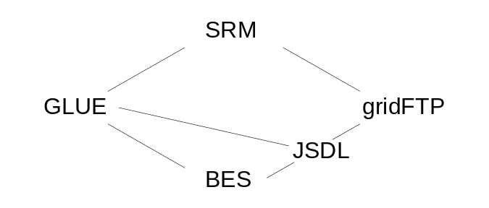Figure 1

- Shahbaz Memon’s presentation was about the Adoption of OGSA-BES in UNICORE. He showed how they managed to fit BES in the UNICORE architecture with adoption of OGSA-BES.
The job description uses JSDL.
The current implementation in the HPC-BP (High Performance Computing- Basic Profile) makes use of a model with low security (only username and password).
Every JSDL is transformed to HPC.

After this presentation Shahbaz and Balazs discussed about BES-UNICORE, JSDL and SMS.
Morris commented that it is very hard to find a JSDL supporting every supercomputer.
The data transfer is a “black hole”in BES (Balazs) whereas in UNICORE it is fixed delicately and in Jülich JSDL is supported for nearly all clients (Shahbaz).

- Moreno Marzolla’s talk was about CREAM-BES. The original CREAM is not BES and JSDL compliant. The goal of their work was to implement BES and JSDL into CREAM. Their work is finished and only needs to be certificated for gLite. The extension to the existing CREAM implementation is depicted in in Figure 2.

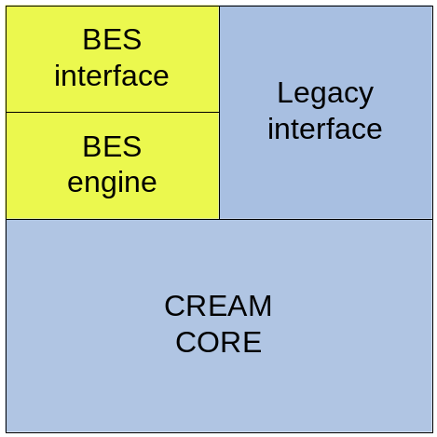
Figure 2

The Legacy interface of CREAM supports JDL. Now form the BES interface creates a JSDL.
Moreno mentioned that there is no purge operation for deleting job related temporary files. (hole in BES)

- Luca Petronzio presented JSDL support within WMS (Workload Manager). He showed a WMProxy enabling JDL <-> JSDL mapping. This mapping is done by serverside translation (Figure 3).
Luca introduced XSLT (extensible stylesheet language transformation) which does the translation from JSDL to JDL. Using this WMProxy makes services directly support JSDL job descriptions.
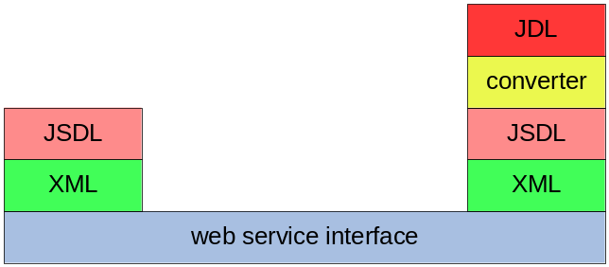
Figure 3

The current status of the WMProxy project is given as follows: The JSDL to JDL translation function is almost finished.
A small JSDL extension for supporting GLUE attributes is defined.
WMProxy supports BES too with a BES-Factory implementation and operation mapping.

- After the lunch break Aleksandr Konstantinov talked about GIN: JSDL, BES feedback from KnowARC/NorduGrid.
In ARC’s A-REX job execution service all required JSDL 1.0 elements are fully supported. An ARC extension to JSDL exists.
Currently BES is fully implemented and tested in A-REX. BES-Management and undefined BES-Activity is not supported. The implementation status of GLUE 2.0 in ARC is about 20%. The implementation makes use of XML rendering.
Aleksandr mentioned that no client up to now uses GLUE 2.0 information.

After the presentations it was decided to do a brainstorming session for identification of problems with the current standards of JSDL, BES and GLUE with respect to the requirements of the different grid architectures.
The brainstorming outcome was divided into four main parts leading us to Part 2:
- JSDL
- BES
- GLUE
- AOB

Part 2: Brainstorming Session

JSDL

Questions to the core specification GFD136 including POSIX Extension:
Are there mandatory elements that we think are irrelevant.
Are there optional elements that we think are mandatory.
Are the semantics well defined?

Create a list of list of elements that we need.
Identify which are existing and which are missing.

JSDL experience document errata for JSDL core. Use this feedback to start the process.

- starting merge UNICORE =ARC reply of experiences doc → intersection of JSDL mandatory
- Then compare merge document with gLite JSDL → intersection of middle wares with respect to JSDL
How to structure the GIN JSDL? Which elements to use?
  - Core JSDL Elements
  - Job identification
  - Application
  - Resources
  - Data Staging
- Identify missing element required for UNICORE, ARC, gLite.
  - Check pull data staging is fully supported.
- Is this element defined in some HPC/PA, HPCSPMD, POSIX...? If so copy the naming and semantics.
Which elements from the following extensions are important.
  - Application Extension (GFD111)
  - SPMD Application Extension(GFD115)
  - File Staging Profile(GFD135)
- How to specify data sources. (DMI)
Input scripts, Data files, application software, databases?
Encoding queries in the URL eg http with php script?
Simple starting point: URL, + Type
use EPR's instead of URL?
More complexity may be required. eg.
How do we deal with LFNs? Name + Meta data catalog URL?
Maybe necessary to add an additional element to describe a meta data catalog.
- Define GIN extension. (GIN Production Profile)
- How to express requirements based on information published in Glue.
JSDL wraps query.
(Requirements are expressed as an xpath/xquery)
Embed a flat Glue structure as the requirements.
How do we do “and” “or” “if” “not” “nor”
Obsolete ranges(Upper bounds and Lower bounds), use xquery for complex inequalities.

What to do with none interpreted elements?
Use the concept of strictness. The user can specify in the JSDL how strict the acceptant of the JSDL should be. Requested compatibility level. Compare with soap header mechanisms for similar.
The current BES method to reject all uninterpreted JSDL elements is to coarse.
NorduGrid does not reject
Cream and Unicore reject (strictly following specification)

Take a look at the extensions (Together)

WMProxy is only using the POSIX extensions.
Would like to see:
Virtual Organization:
Rank: How the priority of the ranting is handle, eg, which attribute should be taken.
FuzzyRank: Same as Rank but using a different algorithm.
UserTag: User defined tag.
Expiretime: Remove the job from the queue after this time.
Prologue: Executable to run before the job is started.
Epilogue: Executable to run after the job has finished.
OutputStorageEndpoint: URL of the storage element. (Data staging out requires an endpoint which is currently missing)

NorduGrid Extensions
CredentialServer: eg (MyProxy Endpoint)
RemoteLogging: Target location for accounting data.
ReRuns: The number of retries.
Notify: Email address to which defined job notifications should be sent.
ProcessingStartTime: Time before which the job processing should not start including data staging.
AccessControl: Who else can manipulate the job.
LocalLogging: local grid service directory where logging should go.
GridTimeLimit: Scale requested running time based on some benchmark.
RunTimeEnvironment: Pre installed software tag.
Middleware: Which Middleware tag to use.
CandidateTarget: Endpoint where to run including queue
HostName: Part of the candate target.
QueueName: Part of the candidate target.
SessionLifeTime: How long the information about the job is available after the job has finished.
IsExecutable: Extension for data staging.

Incorporate SPMD (GFD115).
Required as some attributes need to be passed to the LRMS for scheduling and not used for match matching.
But we require the SMP elements for describing parallel jobs.

Number of Processes
Number Processes per host
Number of Threads per process
Type of MPI

How to inform the LRMS that you want the jobs to run on the same host?
Define environments and request the environment.

How do we integrate into GIN profile?
Morris thinks that the semantics descriptions of this document require more work. There are fundamental differences between the different architectures.

HPC Profile (GFD111) - Not needed

File Staging Profile (GFD135) – Will not use

BES

BES Factory

CreateActivity seems to be ok, suggestion on supporting multiple activity creations. Not for the moment.
What to do with the unsupported elements from the JSDL?
The create activity response should not contain the activity document.

Need a ChangeState Operation.
Need a parameter in the CreateActivity to halt before specific state transitions.
Do we need to expose this to the user? Submit option and consider an addition to JSDL.

GetActivityStatuses
This should require at least one activity.
Use the BES state model which will be extended.

GetActivityDocuments
This should require at least one activity.
Require a parameter to specify the Type of activity document. Type is enumerated, GLUE, JSDL, most recent JSDL, accounting record (usage record), ....
Consider whether multiple types should be allowed in one call.

GetFactoryAttributesDocument
Always show the minimal BES attributes to maintain compatibility.
Add a type to request the type of document. This will also return the minimal BES attributes to maintain compatibility. Type is enumerated BES, GLUE,

Add Verbosity enumeration: Resource Description, + EPRs, + Job Activity Information
or
Add a Filter to control the verbosity.

TerminateActivities

Add PurgeActivities, with paramter to kill running jobs. By default running activities are not purge and an error message is returned.

For the GIN production profile the Activity port type is not required.
Note: it may be required for data staging and if so will revisit this topic.

Note: To consider the work of the work of the information services group.
Until then, then information is available and query processing will be done in the client.

For the GIN production profile the Management Port type is not mandatory.

Put a strong requirement on the epr that it should contain minimal information.
Data Staging

Add the staging URLs to the response message of the CreateActivity operation but not into the epr by using the standard extensibility of BES operations.
This information must be available in the activity document.
Need to check what Glue Attribute to use.

It should check the JSDL document for staging in and staging out requests. Throw an unsupported data staging fault.
There is a Glue attribute for publishing data staging capabilities. Attribute of the computing endpoint.

The URL directory locations to get the output data is found in the activity document.
Note: Recursive gets should be supported.

BES state model.
Pending
Running
Three final states, Finished, Failed and Terminated

ARC Internal States: Accepted, Preparing, Prepared, Submitting, Executing (State where the job is in the batch system), Executed, Finishing, Finished, Failed, Killing, Cancelled, Deleted,

BES Running state = Activity Active.
All active state are a sub state of the Running state.

New sub states for the moving data phases: Staging In, Staged In, Staging Out, Stated Out.

Suggestion for hierarchical state model.
Running:Stage In: Staging
Running:Stage In: Staged

First Level,
Running; Stage In, LRMS (Assigned), Stage Out, Terminating.

Assigned: Activity is delegated to another service and nesting states is possible.

Second Levels
Running:Stage In: Staging
Running:Stage In: Staged

Running : LRMS : Submitted
Running : LRMS : Queued
Running : LRMS : Running
Running : LRMS : Finished
Running : LRMS : Hold
Running : LRMS : Other

Running:Stage Out: Staging
Running:Stage Out: Staged

WMS example with a BES delegating and activity to another BES (nesting states)

Running:Assigned:Running:LRMS:Queued

How to select a computing share when submitting a computing activity to BES.
Add a parameter CandidateTarget to the JSDL. This parameter is passed to the LRMS.
The Candidate Target Object is the BES endpoint plus the queue.

BES should be able to accept none interpreted JSDL elements if the user has requested this functionality by setting the respective parameter in the JSDL

Go though BES extensions:
HPC Basic Profile: Will go through document and move any relevant points, but will not reference the specification.
File Staging Profile: State Model is the same the the first level but we provide more details, may consider the Error reporting in section 4.1
Advanced Filtering Profile: This is too advanced for the moment, we will just return the whole document. Any filtering should be done by the client.

Changes that we would to make which would break BES:
The need to carry the old junk from the BES activity and factory documents.
Do we really need the epr for the job id.

Glue
Glue 2.0 next steps
Wait until Singapore
Restart phone meeting to address comments.
Short public comment (10 days? )
GSFG check .
Editor: Final

est. End Nov

Adoption plans.
EGEE
Rollout schema after document has been finalized (2 weeks - 2 months).
Update Information Providers ( 6 months )
Removal of the 1.3 schema after migration of the middleware (1 - 2 years)

ARC
Information Providers (6 months )
Full use of information in ARC ( 1 year )

GIN Glue Profile. Optional Values → Must Values

Unicore
Information Providers (6 months )
Full use of information in Unicore ( 6 – 1 year )

Public vs private parts of Glue. The activity document and GlueJobStatus may be private. Policies may also be private.

Privacy levels All, User, VO, Gird Operators, Service Administrators.

This has to be discussed with the Security group, maybe the need to define the profile.

WS-RF
This is optional but we will define how it should be used.
Minimal subset of WS-RF which is supported.
GetResourcePropertyDocument
Will be defined by ARC and Unicore.

Security
How to handle delegation – This will be address in the GIN session in Singapore.
Need to have a security section but will discuss with the Security Group.

AOB
Usage of SRM in the context of this.
Used for data staging in and out.

Part 3: Setting up an Action List

List of actions:

Action No. | Person in charge | Task
001 | Shiraz | Unicore to send Glue examples to the Glue group to add to the examples page
002 | Moreno | glite(cream) needs to provide feedback to the JSDL experience document. (Maybe in public comments)
003 | Balazs with Sergio | Go through the Glue model and flatten it to find what would be required for Job Request. -
004 | Laurence with Flavia | Investigate how to specify data sources –  How to specify a meta data catalogue if one is required.
005 | Shahbaz | Investigate methods to specific JDSL compliance (the soap method) (use scrict).
006 | Morris | Need to check how DMI relates to BES for data staging.
007 | Sergio with Shiraz | Check computing activities vs usage record schema and act upon this.
008 | Laurence with Shabaz | Collect state models for other systems, WMS, Cream, Unicore etc.
009 | Balazs | Someone needs to compare batch system states and make a proposal for the LRMS states.
010 | N.N. | Find the useful point in the HPC profile document and move them to the GIN Profile document.
011 | Morris | Identify the correct Security Group to discuss security policies with
012 | Laurence | Discuss with Flavia the usage of the SRM in JSDL for data staging.
013 | Laurence | Investigate redirecting calls to a different service – postpone. Glue Attribute (Related Services?), should not be done automagically
014 | Laurence with EGEE and Moreno | Proposal for the core JSDL structure  Create a list of list of elements that we need.  Identify which are existing and which are missing.
015 | Laruence | Need to define action items on BES
016 | Johannes | Write up this into a document. Start of GIN profile.  See up email list and place for document.

