Data Grid in Life Science

Summary

By deploying a low-overhead infrastructure for effective, secure sharing of research data across locations, departments, and companies, a data grid should be able to make the fresh data available to users and analytical applications - with updates ranging from none to real-time. Moreover, a data grid should be able to pull data directly from geographically distributed data sources without creating a data warehouse or managing costly replicas and transform and integrate data from multiple sources for ancillary analysis.

Customers

Today’s large pharmaceutical companies comprise centers of research excellence in multiple locations and frequently multiple countries, making data sharing across locations essential. Selective data sharing with research partners is an additional challenge consuming time and resources. Today’s pharmaceutical companies are looking to streamline IT infrastructure in order to reduce equipment and management costs and improve organizational efficiency; projects include reducing the number of redundant data stores that must be managed, making the most of software licenses, and automating the flow of information. Companies looking to streamline operations are not anxious to embark on expensive data warehousing projects or programming-intensive data integration.

For pharmaceutical companies, a data grid can shorten research cycles, reduces IT costs, and streamlines IT infrastructure. The data grid will accelerate drug discovery and other research processes by helping research and scientific computing specialists provision critical data across disciplines, departments, and geographic locations. By making current data from relational databases or files more widely available to users and applications, enabling easy, secure access to data, and transforming or integrating data for a variety of special-purpose analyses, the data grid is able to increase the company’s ability to make the most of available public and private data in its research efforts while eliminating the overhead of separate groups managing the same data independently.

Scenarios

Researchers in drug discovery and other life science disciplines use public, subscription, and proprietary data found in a variety of formats: relational databases, XML documents, flat files, and application data stores. Some databases can be quite large and challenging to manage. The success and timely completion of research processes is based increasingly on the organization’s ability to analyze data efficiently and effectively. Analytical and other applications range from public domain tools such as BLAST to vendor-supplied productivity tools like Rosetta Resolver® and Scitegic Pipeline Pilot™ to home-grown analysis scripts. When the organization acquires data for one purpose, that same data might be very useful for several additional forms of analysis. But as many scientific computing specialists are discovering, making data available to other groups can be harder than it sounds.

A data grid must simplify provisioning, access, and integration of life science research data across departments, locations, and companies. The data grid is designed to meet the needs of large, distributed companies seeking more efficient ways to provision structured and unstructured data to users and applications for analysis. A data grid creates a single, federated data service - a low-overhead infrastructure that enables a unified view of and access to data, retrieves data from any number of existing distributed sources, tailors it in ways users and applications need, and makes it available securely across the organization. With a data grid life sciences companies deploy a streamlined mechanism for making any data available in any form to developers and users in any location on demand, so they can make the best use of research data within and across locations. Streamlined access to data leads to faster completion of research, and shorter product delivery cycles. A data grid can be used to address a single data access and integration challenge or to implement a common mechanism for sharing data across the organization, one that serves many different applications with diverse data requirements. In addition to sharing data within the organization, a data grid can be used to share data with partners, streamlining the infrastructure needed to provision data securely to research colleagues in partner organizations.

A data grid may possess the following desirable features.

- Leaves data in place: provides unifying access to multiple distributed data sources and providing a unified access control mechanism. No need for a centralization of data into a warehouse or data mart, or require a large-scale integration project. Instead, data remains under control of local owners, with access controlled by people who know the data and its value to the business.

- Creates a single federated data service: makes data available across locations, departments, and companies, subject to access control. The same data service can be used to address a wide variety of challenges, achieving significant economies of scale and streamlining infrastructure costs.

- Manages both structured and unstructured data
■ Flat file data including very large files
■ Relational data
■ XML documents
■ XSL transformations
■ Data encapsulated in applications such as CGI scripts, servlets, or web services

Usecase situation analysis

SOLUTION EXAMPLE 1:
Feeding data from multiple sources to analysis applications

A data grid enables analytical applications to retrieve data from multiple locations automatically without programming

Five sites of a global pharmaceutical company use Scitegic Pipeline Pilot, a cheminformatics data analysis system for high-throughput screening. This system accesses data from multiple sources, performs a series of analysis and computational steps on the data, and presents the results to the user. Scitegic Pipeline Pilot uses ODBC to connect to remote data sources, and returns data in XML form. ODBC connections over a wide area are very time consuming; when deployed in its standard configuration the application can spend more time fetching required data than it does running analyses. To solve this problem, one site has a custom web service to fetch the required data and pre-cache it so that the majority of cycles are used for computation and analysis. But deploying this approach at the other sites would not be an acceptable solution because it would require a significant investment, and because the solution does not support accessing data from multiple sources or multiple administrative domains. Because it provides the ability to share relational and application data in a data service, a data grid can address this company’s requirements easily. The data grid can make the data available to the application from multiple data sources and from multiple locations. Users can run analyses using Scitegic Pipeline Pilot, which in turn retrieves data from the local file system which transparently accesses the data service. Behind the scenes, the data grid stores a query that is periodically run against the remote Oracle database with the results cache for performance. Results of this query are then transformed, using an XSL style sheet, into the tab-delimited file format preferred by Scitegic Pipeline Pilot. Because the data service can incorporate data from multiple sources spread across multiple locations, it is an ideal staging area for data that is fed to the application.

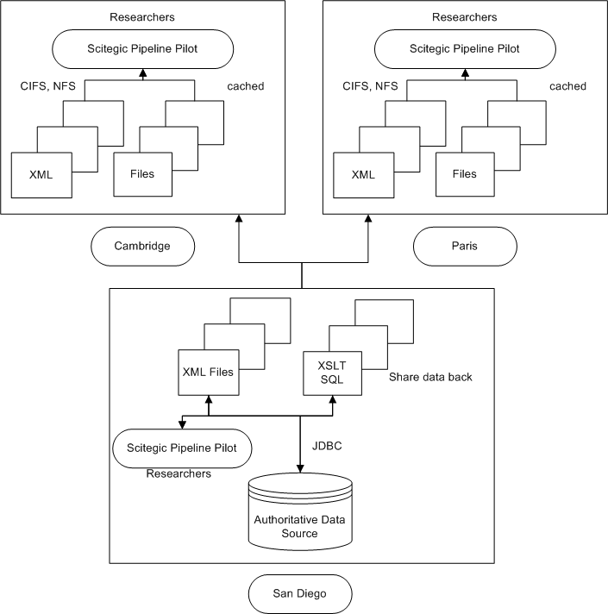

SOLUTION EXAMPLE 2:
Wide-area sharing and analysis of gene expression data

A data grid can help companies speed up analysis and take full advantage of valuable research data

Researchers working for a global pharmaceutical company in three different countries use Rosetta Resolver software for gene expression analysis. Rosetta Resolver stores over 20,000 gene expression profiles in an Oracle database using a proprietary schema. In addition to the standard
Rosetta analyses, researchers want to use this data as input to internally-developed applications (such as a Trend Analysis application) and as annotations for other R&D findings. For example, researchers working on specific diseases want to be able to annotate their work with gene expression data relating to the specific disease site under study. So the data needs to be available to end users and applications across multiple locations. As an intermediate format the company uses an XML variant, the MicroArray Gene Expression Markup Language (MAGE-ML). Scientific computing specialists are finding that generating MAGE-ML profiles in real time from Rosetta’s proprietary database format is too computationally expensive. They prefer instead to pre-compute the profiles and stage them so they can be accessed quickly and easily by remote users and by the Trend Analysis application that requires MAGEML input. Today a single trend analysis takes approximately 5,000 Rosetta profiles as input. The Trend Analysis application must query the Rosetta DB 5,000 times and run 5,000 MAGE-ML transformations, requiring a minimum of 139 hours (5.8 days) to complete an analysis. Developers have written a Java servlet to retrieve individual profiles from the Rosetta database and transform them into MAGE-ML documents. A second servlet, Trend Analysis, identifies statistical trends across multiple MAGE-ML profiles.

A data grid is an ideal solution to this organization’s challenges. The data grid enables access to the MAGE-ML-based profiles (results of the MAGE-ML transformation servlet), the servlet that creates and updates them, and the Trend Analysis servlet. Sharing the profiles on the data service makes them accessible to remote users, to the Trend Analysis application, and to any other applications that need them. The data can be accessed by remote users with no additional programming, without replicating data across sites, and without burdening the Rosetta Resolver database. Each of the objects on the data service stores information about how often it should refresh itself using the source data. That is, the MAGE-ML documents update themselves at appropriate intervals using the data in the Rosetta Resolver database. With this approach, researchers can obtain trend analysis results approximately one week faster, and the average operational load on the Rosetta Resolver application and back-end database are significantly reduced. No changes to applications or data management practices are required. This solution takes full advantage of the ability of the data grid to provision XML documents and servlets across multiple locations. With a data grid in place, the company can streamline the IT infrastructure needed to share data across locations, and makes data available to a wider community of researchers.

SOLUTION EXAMPLE 3:
Wide-area access to research data without replication

A data grid provides data caching approach to reduce storage costs

A major pharmaceutical company with fifteen locations needs to make research data available across locations. The company manages hundreds of terabytes of genomic, proteomic, and molecular structure data, mostly in large flat files. Given the company’s many acquisitions, its research organization is highly distributed. Each group needs access to consistent, up-to-date data but the company wants to manage data acquisition at a single location so as to reduce redundant effort and improve consistency of data used by researchers. The company had considered a replication solution based on network-attached storage. Data would be replicated to remote locations on a regular schedule. But the specialized storage devices proved very costly. In addition, due to the company’s limited bandwidth and the difficulty of the replication process itself, the data could not be replicated reliably. A data grid can make data available across the fifteen locations without replicating all the data. With the data caching approach, only the data specifically requested by a user or application is cached. As a result, much less network traffic is generated. Because commodity hardware can be used for the caches, the company’s total cost for this solution is 75% lower than that of the replication solution.


Local Data
Local Data
Linux
NT
Solaris
Data Grid
Data mapped to the Data Grid namespace
Multi LAN + WAN Users/Apps
Data Grid Server
Local Data

References
[1] Avaki Corporation, Solution Briefs Life Sciences
[2] A.S. Grimshaw, Avaki Data Grid – Secure Transparent Access to Data

