Remote Instrumentation Services In Grid Environment (RISGE-RG)
Information about project/research involved in work of the group

(Logo - optional)
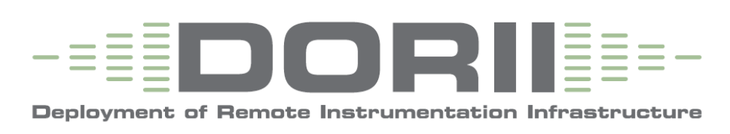

Project acronym: DORII
Project (Research) full name: Deployment of Remote Instrumentation Infrastructure
Start date: February 1st, 2008
Duration: 30 months
Project web site: http://www.dorii.eu/
Project coordinator:
Norbert Meyer, PSNC (Poznań Supercomputing and Networking Center)
Contact person (in terms of OGF): Norbert Meyer (meyer@man.poznan.pl), Marcin Płóciennik (marcinp@man.poznan.pl)
Project participants (institution name, country):

CNIT, Italy
CSIC, Spain
ECOHYDROS, Spain
ELETTRA, Italy
EUCENTRE, Italy
GRNET, Greece
GUP, Austria
OGS, Italy
PSNC, Poland
UC, Spain
USTUTT, Germany
Project (Research) summary (1/4-1/2 page max):
The DORII project aims to deploy e-Infrastructure for new scientific communities, where on the one hand the ICT technology is still not present at the appropriate level, but on the other hand it is demanded to empower its daily work. We deal with a group of scientific users, and this is a reference for DORII, with experimental equipment and instrumentation that are not integrated or are only partially integrated with the European infrastructure.
The DORII is focusing on the following selected scientific areas:
- earthquake community, with various sensor networks;
- environmental science community;
- experimental science community, with synchrotron and free electron lasers.
The scientific communities represented by the project are well recognised and organised even in the industry area represented by SME. This means the organisations are members of bigger consortia which deal with similar topics mentioned above but also focus on research aiming to have a better experimental environment. IT will be provided by partners with experience in supporting scientific communities in general as well as particular needs of the communities targeted by DORII. Working closely with end-users, solutions will be put in place that build upon the success of past and ongoing projects in such areas as remote instrumentation (GRIDCC, RINGrid), interactivity (int.eu.grid), software frameworks for application developers (g-Eclipse) and advanced networking technologies (GN2) with EGEE-based middleware. These efforts have all shown that quite positive results can be achieved by integrating applications with e-Infrastructure, and DORII expects to continue delivering such positive results. Finally, to insure interoperability and sustainability of DORII, the project will promote standardisation and knowledge transfer via e-IRG and OGF research groups. Our goal is to deliver solutions based on proven methodologies and technology while minimizing risk through regular communication with end-users and exploitation of results with recognized organizations.

User communities (short description):
The project plans to support three well-established communities at all the required levels:
- Earthquake community with the following selected applications:
  - Network-centric seismic simulations;
  - Earthquake early warning system design and simulation;

- Environment community with selected applications:
  - Oceanographic and coastal observation and modelling the Mediterranean Ocean Observing Network - an integrated system from sensors to model predictions;
  - Oceanographic and coastal observation and modelling using imaging;
  - Monitoring inland waters and reservoirs.

- Experimental science community
  - On-line data analysis in experimental science coming from increased efficiency of the light sources (synchrotron and free electron lasers) and of the detectors with higher and higher resolution and faster readouts.

Project (Research) relation with objectives of RISGE-RG group:
DORII research are very closely related to the RISGE-RG group objectives – it touches the same area of interest.
The development and spreading of remote instrumentation techniques and technologies that allow virtualized, remote and shared access to such infrastructure opens up new opportunities for DORII scientific communities. Remote assisted use will, proposed by DORII project will substantially reduce the human and financial cost of using remote instruments, as it provides the possibility of sharing the results live with other researchers at their home institution or even at other institutions, making better use of senior researchers' time. For example in the case of a synchrotron light source, remote assisted use would also provide a more efficient way to take advantage of the available unique techniques.

DORII project is aiming:
- - To deploy and operate persistent, production quality, distributed instrumentation integrated with e-Infrastructure;
- - To give added value in terms of performance and access to scientific equipment and instruments, regardless of their location;

Even more, setting up this research group and continuation of the research within the group is one of the major measurable parameter of the DORII project.

