An Analysis of the UNICORE Security Model

General Editor Note; This paper assumes a familiarity with the UNICORE software and organizational structure and architecture and therefore is very difficult to follow. I have attempted to suggest changes below but I feel it is important for the authors to consider a short introduction or appendix on the UNICORE concepts. In addition, many terms are used without definition (and the glossary does not define terms- it only expands acronyms).

Status of this Memo

This memo provides information for the Grid Forum community. This memo does not specify a Grid Forum standard of any kind. Distribution of this memo is unlimited.

Copyright Notice

Copyright © Global Grid Forum (2003). All Rights Reserved.

Abstract

This document provides information about the UNICORE security model. It summarizes the current architecture of the UNICORE PKI, describes the certificate generation process and the range of application of certificates within UNICORE.

A key feature of the UNICORE security model is job authentication and secure transmission of data. The security model supports both job signing and data encryption, which protects remote users against data theft and data manipulation. It also offers the HPC centers a high level of assurance against illegal usage as well as jobs containing malicious code.

The focus of this document is on the UNICORE Public Key Infrastructure (PKI). It outlines the hierarchy of Certifying Authorities (CA) and Registration Authorities (RA) and describes the different kinds of certificates.

The UNICORE PKI will be restructured before UNICORE becomes fully operational in 2003. So, the second section summarizes the current PKI architecture. The third section analyzes the PKI architecture and outlines alternative solutions to overcome limitations of the current model.

The fourth section discusses the UNICORE certificate policy and compares it to the common CP reference model of the Grid Certificate Policy working group of the Global Grid Forum.

Contents
1 The UNICORE PKI 3
1.1 An Overview about the UNICORE PKI 3
1.2 The CA and RA Infrastructure 5
1.3 Process Flow on the Application Layer 7
1.4 User Authorization 9
2 Analysis of the UNICORE Security Model 10
2.1 Disadvantages of a Single U-CA vs. Multiple CAs 10
2.1.1 Single U-CA 10
2.1.2 Multiple U-CAs 10
2.1.3 Summary 12
2.2 Private Keystore 12
2.3 Certificate Chain Validation 13
3 Review of the UNICORE CA Policy 14
3.1 Security Levels and User Identification 14
3.2 Common Certification Policy Reference Model 15
3.2.1 Security in Globus 16
3.2.2 UNICORE and GRIP 17
4 Bibliography 18
5 Glossary 19
6 Security Considerations 20
7 Author Information 20
8 Intellectual Property Statement 21
9 Full Copyright Notice 21

The UNICORE PKI
The UNICORE Public Key Infrastructure (U-PKI) as set up within the UNICORE Plus project [UNICORE] is based on a centralized PKI architecture with a single Certificate Authority (CA) and multiple Registration Authorities (RAs) utilizing X.509 certificates. It consists of the following entities:
- Trusted Root CA (currently the CA of Deutsches Forschungsnetz e.V. (DFN)),
- UNICORE CA (currently hosted by Leibniz Rechenzentrum in Munich),
- Certificate Revocation Lists (CRLs) of Root CA and U-CA,
- UNICORE RAs,
- Gateway Certificates on each UNICORE Gateway, [what is a UNICORE Gateway?]
- Network Job Supervisor (NJS) certificates for distributing sub-jobs to different V-Sites, [what is a NJS? What is a sub-job? What is a V-site?]
- Client (or user) Certificates for all accepted UNICORE users and
- Client Certificates for UNICORE developers used for code signing.
This section summarizes the role of the individual components and outlines the certification process.
We also provide a process flow diagram showing where and how both user and server certificates are used.

An Overview about the UNICORE PKI
UNICORE is an integrated Grid middleware system used in the Virtual Organization (VO) set up by the project partners in the UNICORE Plus project. The UNICORE Plus project VO includes large computing centers, public offices, universities, commercial sites and private users.

The sites within a VO need to work together across a common, prevalent network infrastructure. However, using the Internet as the communications platform introduces significant security risks. As the Internet is a very heterogeneous public network, all job and data transmissions have to be protected against:
- data manipulation or deletion and
- data theft (e.g. wire tapping).
In particular for commercial sites data theft is a potential growing risk in a distributed computing environment.

At the same time, participating sites need to verify the identity and access rights of users, who submit jobs to run on the resources at those sites. Sites must also verify that the jobs they receive for execution belong to the appropriate users.

For secure data communication and user authentication the UNICORE Plus project employs a Public Key Infrastructure. Certificates are used to
- authenticate users,
- authenticate UNICORE Gateways, (as above- what is a UNICORE gateway?)
- authenticate the NJS (for distributing sub-jobs), (as above, what a NJS and what are sub-jobs and how do they compare with jobs?)
- sign jobs, and
- sign software.
Error: Reference source not found illustrate the U-PKI. Currently, there is a two level CA hierarch : the Root CA (DFN-CA), which isfexternal to the UNICORE Pusfproject, and the UNICORE CA (U-CA). The Root CA is used to sign the certificate of the UNICORE CA and to guarantee the integrity of the UNICORE CA. The Certificate Revocation List (CRL) of the Root CA may revoke the self-signed certificate of the Root CA as well as the certificate of the UNICORE CA.
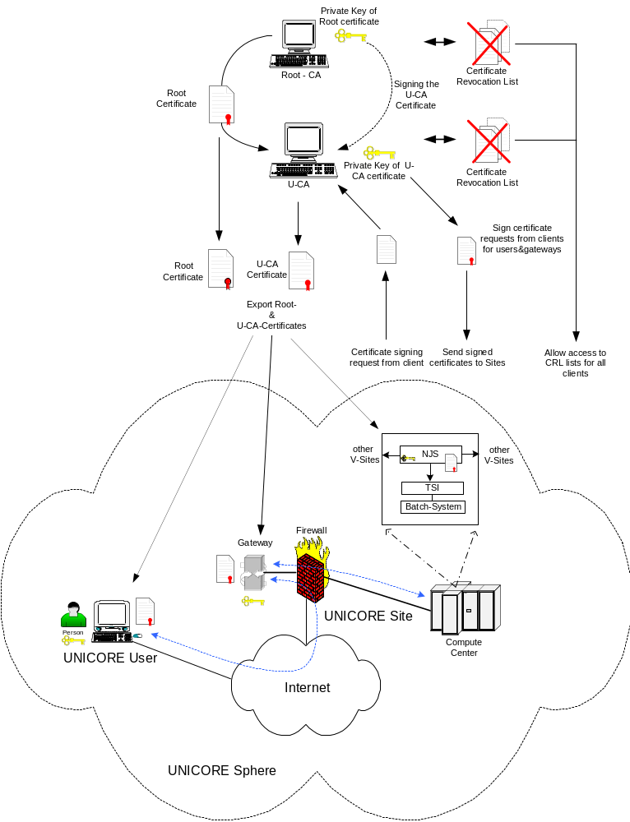
Figure 1
The Root CA should always be a trusted, “well-known” CA. Such a CA is operated according to applicable law and with strict security standards.

The UNICORE CA (U-CA) currently is a dedicated CA which is central to the UNICORE Plus project community.

The certificate of the U-CA is signed by the Root CA and is given the necessary rights to sign subordinated user- and server certificates. The U-CA utilizes its own CRL to revoke obsolete certificates and certificates with a broken seal, i.e. certificates whose private key got stolen or lost. Both the root and the U-CA certificates as well as the CRLs are made available to all clients, so that they can verify the certificate chain. A low level certificate, e.g. a user or a server certificate, is only valid if all superordinated certificates are valid. Otherwise the whole chain must be rebuilt starting with the first invalid certificate and then moving down the chain.

The lowest level certificates are the Client, Gateway and NJS certificates. These are signed by the U-CA and may be revoked by the U-CA if they become invalid. A UNICORE user uses his Client certificate to authenticate himself against the UNICORE Gateway of the target site(s) where he wants to run his job(s), to endorse the jobs (by signing with the private key) and to consign the job to the primary target site. The Gateway may be located within the Service Network of the target site’s firewall, but this is not mandatory. In essence, then, the user certificate serves as an electronic ID card.

EDITOR NOTE: in the above paragraph there is the beginning of an overview of the UNICORE architecture but it does not go far enough to help an unfamiliar read to understand the function of the components, which were already introduced without definition earlier (gateway, NJS, etc.) Just below, there is reference to V-Sites and sub-jobs, but these are not defined earlier either. The reader wonders what is the difference between a U-Site, V-Site, or Target site, and the difference between a job and a sub-job.
The Gateway certificate is used to authenticate the UNICORE Gateway to the user. When communicating to a (remote) UNICORE site (U-Site) the user can thus validate the authenticity of the remote gateway. Only the signer of the gateway certificate is checked; the user does not have the gateway’s public key.
There is another type of Client certificate which is used by the NJS to establish secure SSL connections with virtual sites (V-Sites) and to consign sub-jobs there. These certificates are used to authenticate the NJS against the target sites.
The current U-CA architecture is described in more detail in [Boet1].

The CA and RA Infrastructure
The security within a PKI depends on three contributing factors:
- how well a user is authenticated by the RA before the certificate is issued
- how safe the private key of the certificate is stored within the client system
- how well the certificate chain and the CRLs are verified for each communications relation
User verification is done through RAs proving the identity of a user by checking his ID card, for instance.
EDITOR QUESTION: Earlier it is stated that a user’s certificate serves as an “electronic ID card” and so using the term “his ID card” in this sentence is potentially confusing. Do you mean this? →“The RA verifies the identity of a user through the use of real-world identification such as passport or other ID.”
Each UNICORE Plus project partner should have his own RA which is registered with the U-CA. Partners who want to have their own RA should use an appropriate RA of one of the other partners, e.g. the RA of a U-Site where the partner’s target machines are located.
EDITOR Note: the above paragraph is confusing, do you mean this?:
Each UNIXORE Plus project partner site should ideally run a local RA that is registered with the U-CA. However, some sites may elect instead to use an RA operated by another partner site.
Figure 2 shows the CA & RA structure as well as the certification process. The following steps need to be performed in order to get a signed Client certificate for a user. Server certificatesyfollow the same steps, except for the fact that the “user” in such cases is actually the respective U-Site administratos.
- A user generates a certificate signing request (CSR) with a corresponding private/public key pair. The private key is safely stored within the client’s local keystore.
- The CSR is sent to the responsible RA. This could be the local RA or an appropriate remote RA. The RA tells the user how validation should be performed. This could be done through:
- personal identification (user visits the RA) or
- identification through video conferencing.
- The RA validates the user and user’s CSR. In the current security model only method (a) is specified. However, method (b) is currently being tested.
- The RA registers and/or updates the status of the user’s CSR in the UNICORE User Database (UUDB) operated in conjunction with the U-CA. [note- Figure 2 does not show a UUDB]
- The U-CA generates a valid, signed certificate using the CSR and delivers it to the user via email (?). The certificate is then stored in the public LDAP server of the user’s local site.
The certificate policy (CP) written to accommodate the needs for the UNICORE Plus project can be found in [Boet2].
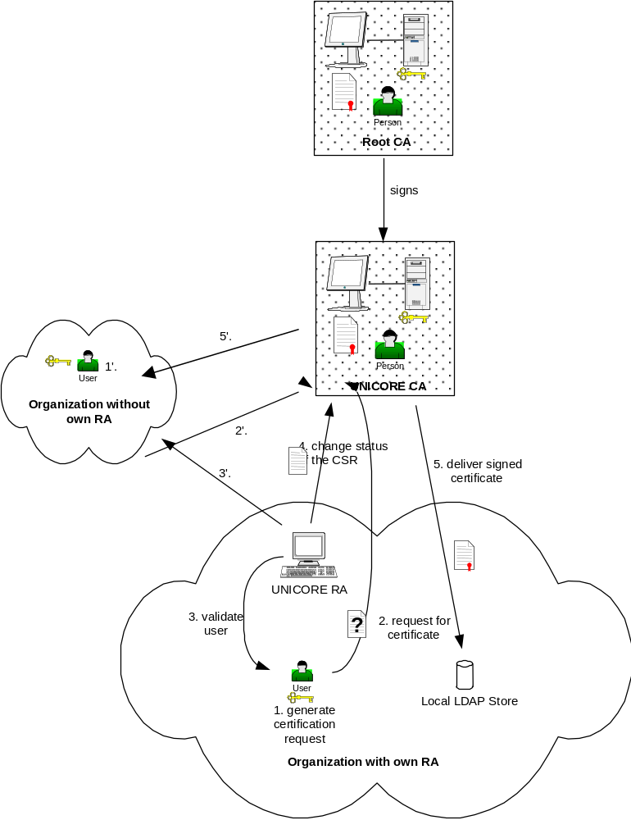
Figure 2

Process Flow on the Application Layer
Once the certificates have been generated and delivered to the participating users and sites, communication and job distribution can take place.
There are two kinds of actions that rely on certificates for user and server verification and authorization:
- establishment of secure communication channels using SSL
- endorsing of. UNICORE jobs (also called Abstract Job Objects, or AJO’s) by signing them
Before running UNICORE jobs all participating sites must import both the certificate of the Root CA and the certificate of the U-CA. They are needed to verify the client and server certificates. The PCs and workstations involved must have access to the CRLs in order to check for revoked and therefore invalid certificates. Figure 3 gives an overview about the process flow.
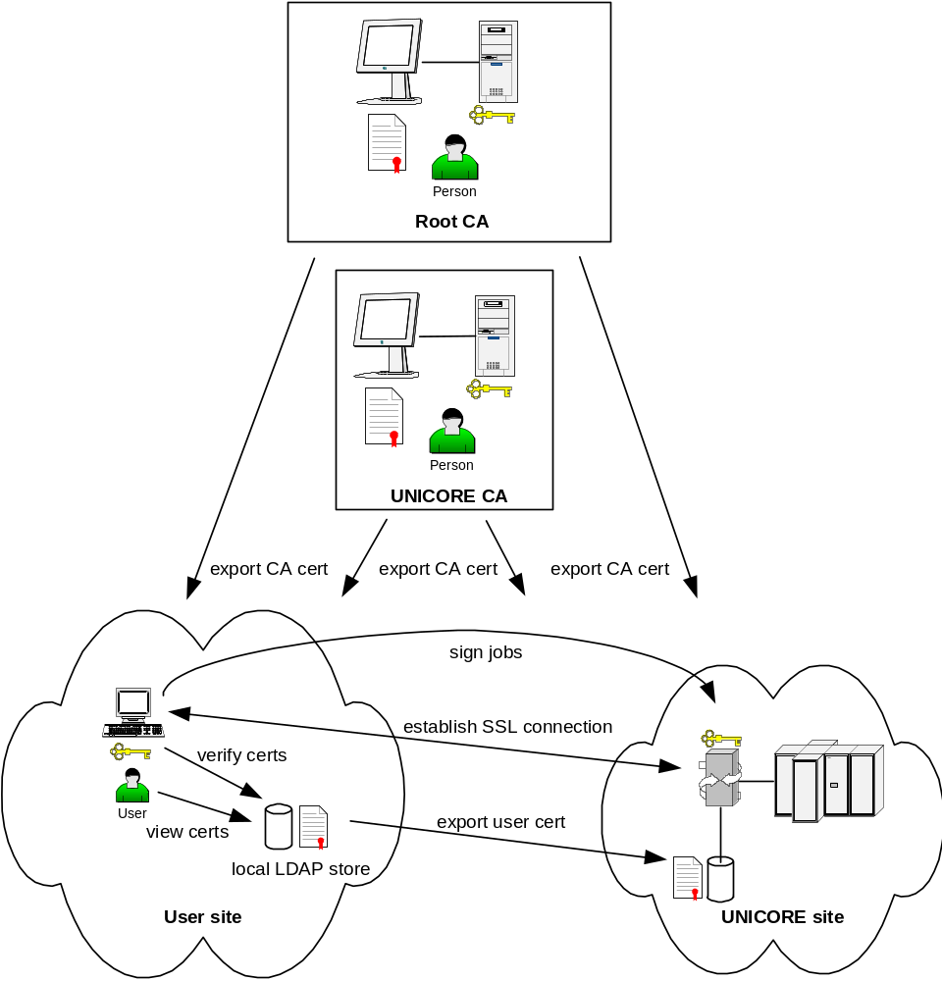
Figure 3

The local LDAP directory servers shown in Figure 3 are optional. It is also possible to store the required certificates within the appropriate server and clients. However, a public directory server offers convenient administration and access of certificates.
The following scenarios must be considered:
- Establish an SSL connection between a user site and a UNICORE site (target site where a job is to run).
The two involved sites mutually authenticate by verifying the certificates’ signatures and the certificate chain.
However, neither client nor UNICORE gateway verifies the identity of its respective counterpart. Instead, only the certificates’ signatures are validated by the appropriate signer certificates. Client (user) identification and authorization is done by the NJS in a next step. The client has to rely on the authenticity of the gateway certificate’s signature which it validates with the appropriate signer certificate (U-CA certificate). [NOTE – as above, the average reader does not know what a Gateway is or what an NJS is, so the significance of this information is unclear and confusing. If this is key information then these concepts need to be laid out earlier in the paper so the reader can understand the significance]
- Endorse UNICORE jobs.
The user endorses a job by signing it with his private key. The signature can be verified using the user’s certificate, which is passed as part of the job.
- Consign sub-jobs. [NOTE- an average user will not understand what it means to take a job and then “consign sub-jobs” to distribute them to “V-Sites” – this text assumes in-depth knowledge of the UNICORE architecture which most readers will not have]
The NJS consigns sub-jobs for distributing them via SSL connections to corresponding V-Sites. To identify itself and to establish secure SSL connections to target sites the NJS uses its certificate similar to (1).

User Authorization
Before a user is allowed to submit jobs to a target system he must be given access. Authentication and authorization take place at the target site:
- User authentication
To establish a connection to a target site via SSL, the UNICORE client has to present a valid client certificate to identify a UNICORE user, and the Gateway of the target site has to present its Gateway certificate to identify itself. [Gateway?]
As described above, UNICORE only makes use of signature validation during this step.
- User authorization
Before the user is allowed to submit a job to the target supercomputer she must be given authorization. So, the NJS of the target site validates the user’s signature on the AJO against its local UNICORE user database (UUDB).
If both the certificate and the certificate chain are valid and the user is registered with the UUDB, user authorization is successful.
EDITOR NOTE: Earlier it was said that the UUDB was “at the U-CA” which implies it is operated in conjunction with the U-CA, and there is one central UUDB. Here it is said that there are local UUDB’s, but these are not previously mentioned in any of the steps. If a local UUDB must be maintained, then the detail of how the information gets into the local UUDB should be included in the steps outlined in section 1.2, explaining Figure 2 (which shows neither a central nor local UUDB ? Those familiar with the UNICORE architecture may not be confused, but most readers will not be familiar with the UNICORE architecture.

A user is currently administered on two levels: first, he is given a user certificate to allow access to resources at UNICORE Plus project sites, and secondly, his certificate is registered with the U-Sites granting access rights to him. [in local UUDB’s?]
Recommendations for a future UNICORE PKI can be found in [Schu].

Analysis of the UNICORE Security Model
Overall security within UNICORE heavily depends on
- the security within the UNICORE PKI (CA security & RA authentication policy),
- the security of the private keystores within the user clients and servers and
- the diligence with which the individual certificates and certificate chains are validated before trust is granted.
The current PKI model is based upon a single central U-CA which signs the certificates of all UNICORE users.
This model was good for the project phase and is now subject to change as the German HPC centers set up a virtual organization for production.

Disadvantages of a Single U-CA vs. Multiple CAs
UNICORE is a distributed computing infrastructure adaptable to a wide variety of target systems. Also, it is still growing and might have thousands of users across several countries in a few years. A centralized PKI with one central UNICORE CA would not easily scale to this extent.

On the other hand, there are existing PKIs which already provide certificates to UNICORE partners for other purposes, e.g. secure communications via SSL, mail signing and Single-Sign-On. It is desired to re-use those PKIs to generate UNICORE certificates.
Furthermore, different user groups with distinct projects do not need to interwork very closely. Those considerations result into the concept of Virtual Organizations (VO).

Single U-CA
Use of UNICORE within the UNICORE Plus project is currently based upon a single U-CA which is signed by a Root CA. A single U-CA issues certificates for all UNICORE users, system components and resources, and developers. By this means, there are neither interworking problems nor compatibility issues. All users and sites may work together, because they share common CAs.
This model is good for a limited number of users and sites. As soon as the number of users and/or sites increases, the load for the U-CA steps up, too. A higher U-CA load means:
- increasing delays in issuing certificates
- increasing number of RAs which condition a higher administrative load and possible security problems due to more frequent RA status changes (new RAs, diminishing RAs, changing RA representatives, etc.)
- in case the U-CA certificate expires or gets compromised (stolen private key) all subordinated certificates have to be exchanged against new ones. This would cause a total freeze of the whole UNICORE sphere.
- a single U-CA leaves no space for redundancy (no backup certificates from a separate U-CA).

Multiple U-CAs
UNICORE users might already base their other services like secure mail or Single-Sign-On on existing PKI infrastructures. In theory, existing user certificates might be re-used for UNICORE purposes. However, there are a couple of issues that have to be considered:
- PKI clusters have to be set-up. A cluster is a logical entity which consists of one CA, several RAs, a number of sites and a group of users who run most of their applications on resources within the cluster. Disjunctive clusters may interwork by importing each other’s Root and U-CA certificates or by cross-signing those certificates on the CA level.
EDITOR NOTE: In the HPC community, the term “cluster” is not used in this fashion. Is the term “cluster” typically used among security and PKI experts in this fashion, or have you introduced this term in this paper or within the UNICORE project? It seems dangerous to use this term, in this community, for multiple things. If the term is typically used this way in PKI discussions then a footnote is necessary at the very least. I have heard the term “domain” used to describe this concept, but never “cluster.”
- Server certificates (Gateway certificates, NJS certificates) are still issued by the appropriate U-CA individually. They are not subject to re-usage.
- Re-using existing user certificates could be dangerous if the security requirements of the individual applications are different.
In the current UNICORE environment all certificates comply with a high security level according to [Butl]. When re-using user certificates it has to be made sure that the existing certificates satisfy the appropriate security level.
- The security of the user certificate also depends on how safe the private key is stored on the client computer. So, it is not always possible to re-use an existing user certificate, especially if the private key has to be copied from a secure to a less secure keystore.
A solution would be a common keystore for all applications running on the client computer which is accessed through a dedicated interface (see 2.2).
Nevertheless, multiple PKIs require that UNICORE partners who have a communications relation (user/server or server/server) need to import their partner’s root and U-CA certificates (see Figure 4).
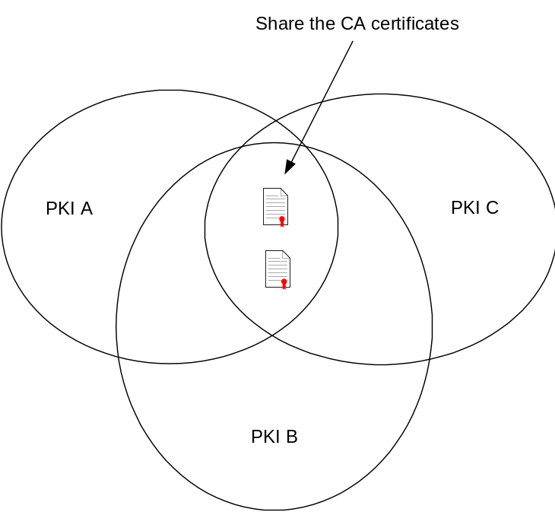
Figure 4

An alternative to sharing CA certificates is to cross-sign the different Root and UNICORE CAs. When using public CAs this may not always be possible, because the CAs are in charge of accepting or not accepting other CAs’ certificates. So it is not advisable to rely on cross-signed CAs.
Instead of getting local copies of the different CA certificates it may be possible to access the appropriate LDAP servers of the required Root and UNICORE CAs, if the CAs provide such directory servers. This would also prevent having obsolete copies of expired CA certificates on local computers.

Summary
The current single CA environment has a couple of weaknesses which can be overcome with introducing multiple CAs:
- In a multi CA environment the load per UNICORE CA is reduced, so requests can be processed faster compared to a single CA environment.
- U-CAs have a much smaller set of registered U-RAs in a multi CA environment. The risk of being compromised by a bogus RA is reduced.
- If a central U-CA is compromised all UNICORE certificates become obsolete. In a distributed U-CA environment only a limited set of certificates have to be re-issued.
- If a central CA gets compromised the whole UNICORE Grid needs to be frozen until all certificates are replaced. This is not only a very expensive and long lasting process, but it also means that no-one within the UNICORE community could work. This would be a knock-out criteria for commercial, high availability applications.
In a distributed environment normally only partial outages occur. For commercial and/or very important applications there could be backup certificates from a different U-CA, so that those jobs could be re-submitted immediately.
- A distributed CA infrastructure best matches the actual communication relations between partner sites within a UNICORE Grid. It is most likely that there will evolve groups whose members work closely together while there are only loose relationships between different groups. This concept is called “Virtual Organizations”. Members within closely related group should use the same U-CA.
- The GRIP project [GRIP] has been established to develop an interface between the two worlds of UNICORE and Globus. So, GRIP users need special certificates which they may access the Globus gateways with and which are valid within Globus.
Optionally, GRIP may use distinct U-CAs issuing GRIP compliant UNICORE certificates with a
- distinct policy which is easier to adapt to security requirements of Globus
- limited set of certificates
Currently, it is not necessary to use distinct U-CAs for GRIP because the security level of Globus is not higher than that of UNICORE.

Note that disjunctive UNICORE CAs can, but need not, share one single Root CA. A common Root CA does not avoid cross-signing or sharing of U-CA certificates.

Private Keystore
The most critical factor in running UNICORE with single or multiple CAs is the safety of the local keystore which holds the users private keys.
Assume the user runs three different applications, secure mail, VPN and UNICORE, all based upon certificates. If those applications cannot share a common keystore, it is recommended to use dedicated UNICORE certificates instead of re-using existing user certificates.
Having just one certificate for all applications, but no common keystore would mean to make copies of the certificate’s private key to three different keystores. The chance that the key gets compromised by security holes within the keystores grows with the number of keystores which corresponds to the number of copies of the private key.
A common keystore with a dedicated interface library would solve the problem of running multiple keystores with different security levels. All applications which should be accessible through Single-Sign-On must be provided with an interface to the appropriate library which grants access to the common private keystore.
The user would then be able to use one certificate for all different applications like secure mail, VPNs and UNICORE.
The UNICORE client is able to access a common JAVA- or PKCS#12-based keystore. The disadvantage of a PKCS#12-based keystore is that there is no enforcement to the pass phrase which encrypts the private keys within the store. So, a user may choose a bad pass phrase which may easily be compromised by a malicious hacker through a brute-force attack. Enforcing secure pass phrases with the UNICORE client has the potential to alienate users, since they would need to use the (more cumbersome) pass phrases for all applications using this keystore.
The JAVA-based keystore supports pass phrase enforcement.
UNICORE Gateways and NJS’ do store certificates and private keys within PKCS#12-based keystores.
A future improvement to a common, software-based keystore is to store the private key on a smart card.

Certificate Chain Validation
The current UNICORE architecture implements a seamless check of the certificate chain. While importing the certificates into its keystore, the client checks each certificate whether it is
- not outdated,
- not listed in the appropriate CRL and
- issued by a trusted (“well-known”) CA.
Certificate chain validation is terminated as soon as
- a known certificate is found (successful termination) or
- an invalid certificate is found within the chain (unsuccessful termination).
If there is an invalid certificate within the chain all subordinated certificates are considered invalid and have to be exchanged.

Review of the UNICORE CA Policy
The existing UNICORE CA policy is designed for a single CA issuing certificates for all UNICORE users, NJS’ and gateways. It is adopted to the DFN-PCA [DFNP] and is described in [Boet2].
For a future PKI, especially when UNICORE is interfaced to Globus through the GRIP project, it is essential to adapt the UNICORE CA policy to the GGF certificate policy reference model as described in [Butl].
Contradictory certificate policies would make it difficult to guarantee a common level of security among the different Grid communities.
This chapter outlines important differences between the UNICORE CA policy and the GGF certificate policy reference model. This discussion is all about policy – technically, the UNICORE software can accommodate any X.509–compliant certificates.

Security Levels and User Identification
The UNICORE CA policy currently defines one level of security, while the GGF CP defines four different levels:
- Rudimentary
- Basic
- Medium
- High
The current UNICORE CA policy offers a high level of security according to the definitions made in [Butl]:
- The subscriber has to personally appear in front of the RA.
- The subscriber has to present a valid photo ID card.
Validation by video conference is currently used for identifying remote users to avoid travelling. It is in a testing phase and needs to be defined in a future UNICORE CA policy. In [Butl] user identification by videoconferencing is also mentioned as a possible alternative for in-person appearance.
It is recommended to adopt further authentication procedures, especially for those users whose organizations do not have own RAs. They should use the RAs of their partners’ organizations, i.e. organizations where they want to run their applications.
The authors of this document suggest the following identification procedures for a future U-RA policy:
- well-known users (users who are personally known by the administrator of the RA):
identification through telephone
- known-users (users who are already registered with the RA):
identification through video conference, showing a valid photo ID card in front of the camera
- new users (users who are new to the RA):
in-person identification requiring a valid photo ID card
Other identification methods as described in [Butl] may also be adopted, e.g. using valid signed certificates (certificates signed by a trusted CA) for online identifications of users.
A graded authentication policy reduces travelling and speeds up the process of issuing certificates compared to the current model.
The user’s private key is stored in software, but should be stored in hardware according to [Butl].

Common Certification Policy Reference Model
A distributed Grid architecture consisting of multiple PKI clusters should base on a common CP reference model like the GGF CP reference model described in [Butl] to permit interoperability while keeping a common level of security.
The current UNICORE CA policy is based upon a single U-CA, so the policy applies for all UNICORE entities (users, Gateways, NJS’ and developers).
In a multi PKI environment a common CP reference model must be the basis for choosing appropriate Root CAs and U-CAs. While the CP of an own CA can arbitrarily be adapted, the policies of the various commercial CAs normally cannot be modified to match a given reference model. While setting up an own CA means a high administrative load for the organization, contracting a commercial CA is far more effective.
A commercial CA already applies to certain security, legal and availability standards which may especially be important to commercial UNICORE users who demand a high level of security and availability.
Choosing a commercial CA (Root CA, U-CA) the following aspects have to be taken into account:
- The CA shall be internationally known and accessible.
- The CA shall be a “well-known”, trusted CA which complies to certain security, legal and availability requirements as outlined in [Butl]. As mentioned above, legal requirements may be of high importance especially for commercial users.
- A UNICORE CA policy, which complies to the requirements of the GGF CP reference model, must be derived from the general policy issued by the CA. Especially, the security levels shall be equal or higher than those defined in [Butl].
- The CA of choice must accept the subordinated RAs as specified by the contractual partner.
- An RA policy, which complies to the requirements of the GGF CP reference model, must be derived from the general policy issued by the CA.
- The CA must offer a signed CRL.

Figure 5 illustrates how a common certificate policy reference model would underlie the different grids (“intra-grid”, i.e. within UNICORE, as well as “extra-grid”, i.e. UNICORE and Globus).
A PKI within a Grid sphere bases upon a common CA and comprises all users, developers, and HPCs closely working together.
There may be individual users and HPCs who need to co-operate with other PKIs within the same Grid sphere. Those entities need to exchange resp. be able to access the appropriate certificates, namely the
- root certificate (if Root CAs are different and are not cross-signed) and
- U-CA certificate
of the remote PKI to successfully establish communications relations with each other.
It is also required that each PKI gets access to the other PKI’s
- Root CA CRL,
- U-CA CRL and
- Directory Server containing the users’ certificates.
Those requirements can easily be matched by using publicly accessible CAs. The common CP reference model ensures a homogenous certificate management (e.g. certificate revocation lists, unbroken certificate validation chain) and a common security level (level of trust, keystore safety).

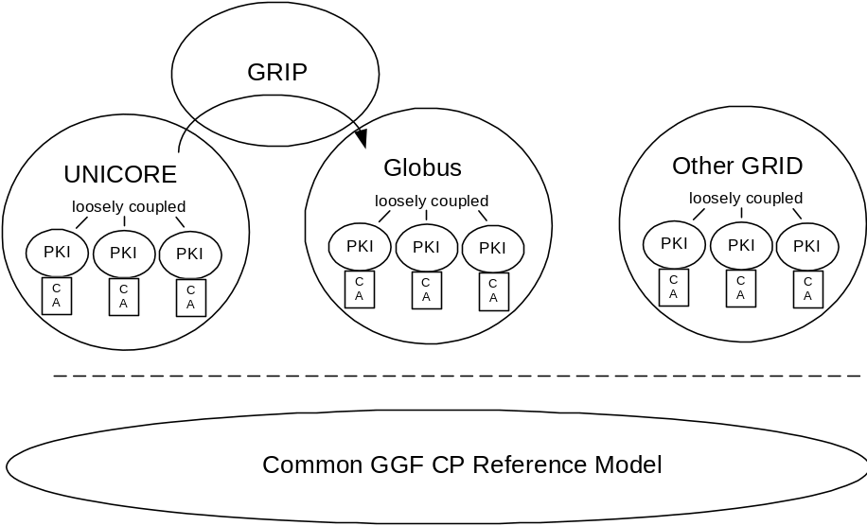
Figure 5

Security in Globus

Like UNICORE the Globus system also relies on a Public Key Infrastructure to authenticate users as well as HPC sites and to secure their communication relations.
However, Globus does not use any signed objects for transmission of the job, though the actual transfer is also performed via a SSL connection.
Most commands executed on Globus target systems use so called “proxy certificates” in order to simplify access and to implement a “single–sign–on” policy.
A Globus proxy certificate is a standard X.509v3 certificate. The Globus “proxy structure” contains the following items:
- An unencrypted private key (key protection is through file system permissions only)
- An X.509 certificate self signed by the user
- The user original certificate signed by the CA containing the users public key
They usually expire after a few hours (currently 12 hours) and are stored in the TMP directory of the users workstation. This has the drawback that if someone gets hold of the certificate containing the users private key he/she can submit jobs on behalf of that user.
To avoid a permanent misuse by hackers getting hold of Globus’ sensible proxy certificates, they are only valid for a short period of time.
On the other hand, the use of proxy certificates allows support for highly dynamic jobs in Globus, like for instance the construction and submission of jobs from within a running Globus job. This is not possible with the stricter UNICORE security model described above.
In Globus those temporary “proxy” certificates are used to establish secure SSL connections between sites to distribute jobs. A Globus job is not signed, so a target system is not able to validate the Globus job itself.
The information about the user submitting a Globus job is only known by the Globus gateway creating proxy certificates after identifying the Globus user through his user certificate.
Thereafter a Globus job may be changed by any of the traversed gateways undetectable to the target system where the job shall be executed.
So, for a UNICORE HPC it would not be possible to
- clearly identify a Globus user who submits a job to UNICORE
- validate the integrity of a submitted job

UNICORE and GRIP
For GRIP, the UNICORE client uses a proxy–init plugin to generate a temporary Globus certificate basing upon a valid UNICORE client certificate. This temporary certificate is passed as part of the UNICORE through an unmodified gateway to the NJS server, which unpacks the temporary certificate and passes it to the TSI for interaction with Globus. So, GRIP does not require an own PKI, but relies on
- valid UNICORE certificates which have been checked against the appropriate CRLs
- valid certificate chain (valid U-CA certificate, valid root certificate)
For use in GRIP, the UNICORE security is not compromised for UNICORE sites; only Globus resources that (parts of) UNICORE jobs run on are accessed with the (weaker) Globus–specific mechanisms. In the current phase of GRIP development only the UNICORE to Globus gateway will be implemented. As the PKI of Globus, which makes use of proxy certificates as described above, is weaker than that of UNICORE, it is not feasible to build a bi-directional gateway maintaining UNICORE’s high security standards.

Bibliography
[Boet1] Ernst Bötsch, UNICORE Certification Authority (U-CA), June 28th, 2000 (Version 1.3), Leibnitz Rechenzentrum Munich
[Boet2] Ernst Bötsch, UNICORE CA (U-CA) Policy – Zertifizierungs-Richtlinien für UNICORE, February 1st, 2001 (Version 1.0), Leibnitz Rechenzentrum Munich
[Schu] W.D. Schubring, H. Richter, C. Wimmer, Analysis of Alternatives to the UNICORE PKI and Recommendations for its Future, August 5th, 2002, Leibnitz Rechenzentrum Munich
[Uproj] UNICORE Partners, Joint Project Report for the BMBF Project: UNICORE Plus – Uniform Interface to Computing Resources, June 2002, UNICORE Forum e.V.
[Butl] GFD-I.13, Global Grid Forum Certificate Policy Model, Randy Butler, Tony Genovese, May 2003, Global Grid Forum
[DFNP] http://www.pca.dfn.de
[UNICORE] http://www.unicore.org
[Globus] http://www.globus.org
[GRIP] http://www.grid-interoperability.org
[GGF] http://www.gridforum.org

Glossary
AJO | Abstract Job Object
CA | Certifying Authority
CP | Certificate Policy
CRL | Certificate Revocation List
CSR | Certificate Signing Request
DFN | Deutsches Forschungs-Netz e.V.
GCP WG | Grid Certificate Policy working group
GGF | Global Grid Forum
GRIP | Grid Interoperability Project
HPC | High Performance Computing Center
NJS | Network Job Supervisor
PKI | Public Key Infrastructure
RA | Registration Authority
SSL | Secure Socket Layer
U-CA | UNICORE CA
U-RA | UNICORE RA
U-Site | UNICORE-Site
UUDB | UNICORE User Database
V-Site | Virtual Sites (within a U-Site)

Security Considerations
NOTE: The document should make a statement here about security considerations. Perhaps a very brief enumeration of the security issues raised such as security of the CA, of the UUDB, etc. It might be useful to look at similar RFC’s to see what the security consideration statements are for RFC’s that, like this one, are almost entirely dealing with security.

Author Information
Torsten Goss-Walter | Deutscher Wetterdienst  Kaiserleistrasse 44  63067 Offenbach  Germany | Torsten.Goss-Walter@dwd.de
Reinhard Letz | Deutscher Wetterdienst  Kaiserleistrasse 42  63067 Offenbach  Germany | Reinhard.Letz@dwd.de
Dr. Thomas Kentemich | Pallas GmbH  Hermülheimer Str.10  50321 Brühl  Germany | Thomas.Kentemich@pallas.com
Hans-Christian Hoppe | Pallas GmbH  Hermülheimer Str.10  50321 Brühl  Germany | Hans-Christian.Hoppe@pallas.com
Dr. David Snelling | Fujitsu Laboratories of Europe  Hayes, Middlesex, UB4 8FE  United Kingdom | d.snelling@fle.fujitsu.com
Philipp Wieder | Forschungszentrum Jülich  52425 Jülich  Germany | ph.wieder@fz-juelich.de

Intellectual Property Statement

The GGF takes no position regarding the validity or scope of any intellectual property or other rights that might be claimed to pertain to the implementation or use of the technology described in this document or the extent to which any license under such rights might or might not be available; neither does it represent that it has made any effort to identify any such rights. Copies of claims of rights made available for publication and any assurances of licenses to be made available, or the result of an attempt made to obtain a general license or permission for the use of such proprietary rights by implementers or users of this specification can be obtained from the GGF Secretariat.

The GGF invites any interested party to bring to its attention any copyrights, patents or patent applications, or other proprietary rights which may cover technology that may be required to practice this recommendation. Please address the information to the GGF Executive Director.

Full Copyright Notice

Copyright (C) Global Grid Forum (2003). All Rights Reserved.

This document and translations of it may be copied and furnished to others, and derivative works that comment on or otherwise explain it or assist in its implementation may be prepared, copied, published and distributed, in whole or in part, without restriction of any kind, provided that the above copyright notice and this paragraph are included on all such copies and derivative works. However, this document itself may not be modified in any way, such as by removing the copyright notice or references to the GGF or other organizations, except as needed for the purpose of developing Grid Recommendations in which case the procedures for copyrights defined in the GGF Document process must be followed, or as required to translate it into languages other than English.

The limited permissions granted above are perpetual and will not be revoked by the GGF or its successors or assigns.

This document and the information contained herein is provided on an "AS IS" basis and THE GLOBAL GRID FORUM DISCLAIMS ALL WARRANTIES, EXPRESS OR IMPLIED, INCLUDING BUT NOT LIMITED TO ANY WARRANTY THAT THE USE OF THE INFORMATION HEREIN WILL NOT INFRINGE ANY RIGHTS OR ANY IMPLIED WARRANTIES OF MERCHANTABILITY OR FITNESS FOR A PARTICULAR PURPOSE."

In practice, it is a three level PKI hirarchy consisting of the DFN-CA, UNICORE-CA and UNICORE Signer CA. For the purpose of this discussion, the UNICORE-CA and UNICORE Signer CA are considered as a single entity, the U_CA.
International CA which complies to the different countries’ laws. [Editor note- what does this mean? It complies to all partipating countries’ laws? Which laws related to operation of CAs? Is it possible to operate according to multiple countries’ laws? What if they are mutually conflicting?
The CA of choice for the Deutscher Wetterdienst is “TeleTrust”, the CA of Deutsche Telekom.

