X.X Deployment

The deployment can be positioned at a part of provisioning cycle that optimizes data center resource allocation and configuration to the changing system environment or usage load from time to time. The provisioning is a conceptual cyclic process consists of several phases. Those phases can be categorized into 1) Execution and Monitoring, 2) Analysis and Projection, 3) Resource allocation Planning, 4) Deployment. The provisioning manages various layers of the target systems from hardware to application layer. The application layer includes components such as application program, content data or DB schema for specific application. The infrastructure layer includes middleware component such as Web Server, Application server or DBMS, Operating systems or configuration set ups of hardware components such as server, storage, firewall, load balancer or network switch.

Deploying any complex, distributed service presents many challenges related to service configuration and management. These range from how to describe the precise, desired configuration of the service to how to automatically and repeatably deploy and remove the service onto and from the resources available. Description challenges include how to represent the full range of service and resource elements, how to support service "templates", service composition, correctness checking, and so on. Deployment challenges include automation, correct sequencing of operations across distributed resources, service lifecycle management, clean service removal, security, and so on. Addressing these challenges is highly relevant to Grid computing at a number of levels ─ from configuring services that comprise the Grid infrastructure, up to describing and deploying Grid applications themselves. Hence, the Configuration Description, Deployment and Lifecycle Management (CDDLM) will address how to: describe configuration of services; deploy them on the Grid; and manage their deployment lifecycle (instantiate, initiate, start, stop, restart, etc.).
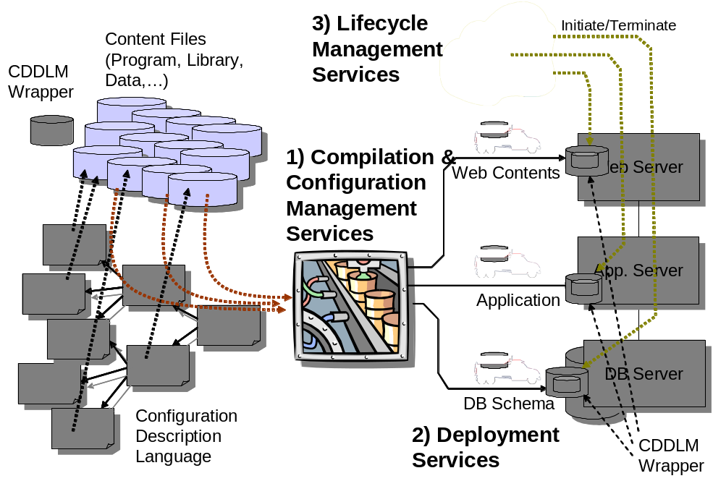

Figure xx. CDDLM Services
Figure x.x depicts assumed deployment procedure performed by basic services. The services include following categories of services.
1) CDL Compilation and Configuration Services
This category of services parses descriptions of components in CDL, verifies consistency of the descriptions, resolves component references as far as it is resolvable before the deployment and composes a package ready for deployment.
2) Deployment Services
This category of services transfer the deployment package to hosting environment which include servers, storage or network devices.
3) Lifecycle Management Services
This category of services manage lifecycle of the deployed system. The operations include initialize, start and terminate the system.

Figure xx describes the assumed use case of CDDLM in program execution environment. The deployment and lifecycle management services are triggered by either the scheduler or by manual or automated job management. Configuration has to be determined by outside of CDDLM by services such as a resource broker and given as a set of component description. CDDLM assumes manipulation mechanism of respective target components through interface provided by Wrapper.

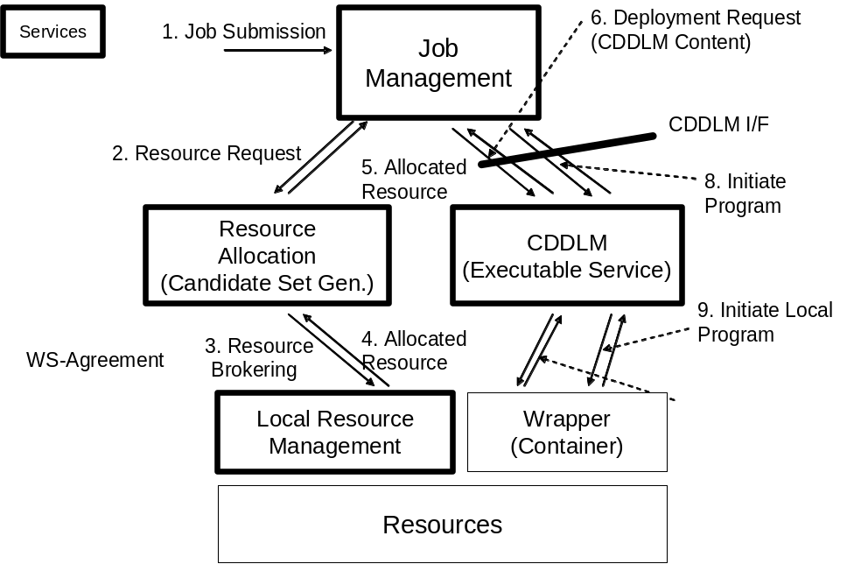

Figure xx. CDDLM and Other Services

