Configuration Description, Deployment,
and Lifecycle Management

CDDLM Deployment API
Draft 2005-02-25
Status of this Memo
This document provides information to the community regarding the specification of the Configuration Description, Deployment, and Lifecycle Management (CDDLM) Language. Distribution of this document is unlimited. This is a DRAFT document and continues to be revised.
Abstract
Successful realization of the Grid vision of a broadly applicable and adopted framework for distributed system integration, virtualization, and management requires the support for configuring Grid services, their deployment, and managing their lifecycle. A major part of this framework is a language in which to describe the components and systems that are required. This document, produced by the CDDLM working group within the Global Grid Forum (GGF), provides a definition of the service API whereby a Grid Resource is configured, instantiated, and destroyed.

GLOBAL GRID FORUM
office@ggf.org
www.ggf.org

Full Copyright Notice
Copyright © Global Grid Forum (2004-2005). All Rights Reserved.
This document and translations of it may be copied and furnished to others, and derivative works that comment on or otherwise explain it or assist in its implementation may be prepared, copied, published and distributed, in whole or in part, without restriction of any kind, provided that the above copyright notice and this paragraph are included on all such copies and derivative works. However, this document itself may not be modified in any way, such as by removing the copyright notice or references to the GGF or other organizations, except as needed for the purpose of developing Grid Recommendations in which case the procedures for copyrights defined in the GGF Document process must be followed, or as required to translate it into languages other than English.
The limited permissions granted above are perpetual and will not be revoked by the GGF or its successors or assigns.
This document and the information contained herein is provided on an "AS IS" basis and THE GLOBAL GRID FORUM DISCLAIMS ALL WARRANTIES, EXPRESS OR IMPLIED, INCLUDING BUT NOT LIMITED TO ANY WARRANTY THAT THE USE OF THE INFORMATION HEREIN WILL NOT INFRINGE ANY RIGHTS OR ANY IMPLIED WARRANTIES OF MERCHANTABILITY OR FITNESS FOR A PARTICULAR PURPOSE.
Intellectual Property Statement
The GGF takes no position regarding the validity or scope of any intellectual property or other rights that might be claimed to pertain to the implementation or use of the technology described in this document or the extent to which any license under such rights might or might not be available; neither does it represent that it has made any effort to identify any such rights. Copies of claims of rights made available for publication and any assurances of licenses to be made available, or the result of an attempt made to obtain a general license or permission for the use of such proprietary rights by implementers or users of this specification can be obtained from the GGF Secretariat.
The GGF invites any interested party to bring to its attention any copyrights, patents or patent applications, or other proprietary rights which may cover technology that may be required to practice this recommendation. Please address the information to the GGF Executive Director (see contact information at GGF website).

Table of Contents
1 Table of Contents 3
2 Introduction 4
2.1 CDDLM-WG and the Purpose of this Document 4
3 Purpose of the Deployment API 4
3.1 Use Cases 4
3.2 Fault Tolerance 5
4 Architecture 5
4.1 Core Architecture 5
4.2 Lifecycle 8
4.3 Fault Tolerance 8
4.4 Other Architectural Features. 9
5 Deployment API Overview 12
5.1 Architecture of the Deployment System 13
5.2 Portal Endpoint 14
5.3 System Endpoint 15
6 Portal 18
6.1 Portal Properties 18
6.2 Operations 19
7 System 21
7.1 System Properties 21
7.2 System Operations 22
8 Notification 27
8.1 Notification Policy 27
8.2 WS-Notification Support 27
8.3 Fault-Tolerant Notification 28
9 Fault Policy 28
9.1 Fault Categories 28
9.2 Fault Security 30
9.3 Internationalization 30
9.4 Faults 30
9.5 Fault Error Codes 32
10 Security 32
11 Editor Information 33
12 References 33

Introduction
The CDDLM framework needs to provide a deployment API for programs submitting jobs into the system for deployment, terminating existing jobs, and probing the state of the system.
This document defines the WS-Resource Framework-based deployment API for performing such tasks. It is targeted at those who implement either end of the API.
The key words "MUST", "MUST NOT", "REQUIRED", "SHALL", "SHALL NOT", "SHOULD", "SHOULD NOT", "RECOMMENDED", "MAY", and "OPTIONAL" in this document are to be interpreted as described in RFC 2119 [RFC2119]

CDDLM-WG and the Purpose of this Document
The CDDLM WG addresses how to: describe configuration of services; deploy them on the Grid; and manage their deployment lifecycle (instantiate, initiate, start, stop, restart, etc.). The intent of the WG is to gather researchers, developers, practitioners, and theoreticians in the areas of services and application configuration, deployment, and deployment life-cycle management and to explore the community need for a broader effort in this area. The target of the CDDLM WG is to come up with the specifications for CDDML a) language, b) component model, and c) basic services.
This document defines the WS-Resource Framework-based deployment API for performing such tasks. A CDDLM deployment infrastructure must implement this service in order for remote callers to create applications on the infrastructure.
This document is accompanied by an XML Schema (XSD) file and a WSDL service declaration. The latter two documents are to be viewed as the normative definitions of message elements and service operations. This document is the normative definition of the semantics of the operations themselves.

Purpose of the Deployment API
The deployment API is the SOAP/WS-ResourceFramework (WS-RF) API for deploying applications to one or more target computers, physical or virtual.
The API is written assuming that the end user is deploying through a console program, a portal UI or some automated process. This program will be something written by a third party to facilitate deployment onto a grid fabric or other network infrastructure which is running the relevant CDDLM services.

Use Cases
There are three different use cases that it is designed to support:
- The deployment target is an OGSA-compliant Grid Fabric. Resource allocation and Job submission (using the JSDL language [JSDL] or equivalent) is part of the deployment process. In this use case, the deployment API must integrate with the negotiation, and deploy a CDDLM-language described system over the machines allocated by the resource manager.
- The deployment target is a pre-allocated cluster set of machines. The resource allocation process is bypassed -it can be presumed to have happened out of band.
- One instance of a CDDLM runtime is delegating part of a deployment to another host. There is no guarantee that the two runtimes are the same implementation of CDDLM, or, if they are, that they are the same version.

Fault Tolerance
The architecture is intended to support fault tolerant implementations, to the extent that a failure of the deployment endpoint may not terminate the application, and may not render the application unreachable.
To be achieve this goal, any set of nodes onto which a system is deployed, must be visible to and manageable by more than one deployment endpoint. Furthermore, if the failure of this endpoint is not to prevent access, any SOAP endpoints that provide direct access to the system, must be hosted on the system nodes themselves.

Architecture

Core Architecture
The API comprises a model for deployment, and a WS-ResourceFramework [WS-RF] based means of interacting with this model.
A deployment client is an application that wishes to use the deployment API to deploy to ore more hosts that have been pre-allocated using a resource allocation system. A deployment portal is a WS-RF service endpoint that the deployment client communicates to, in order to deploy applications, and endpoint addressed via a WS-Addressing Endpoint Reference (EPR) [WS-A]. This specific EPR is referred to as the portal EPR.
To deploy, the client first issues a request to the portal EPR to create a system. This request includes a deployment descriptor in one of the CDDLM supported languages and potentially other information that describes and configures the application. This creation request returns a new EPR, which provides access to the state and operations of the system, the system EPR.
The system EPR can be bound to any node that the portal EPR chooses; there is no requirement that it is bound to the same portal node. For maximum availability, hosting the system EPR on the same node of the system may be the best approach. An example of this is shown in Figure 1 .
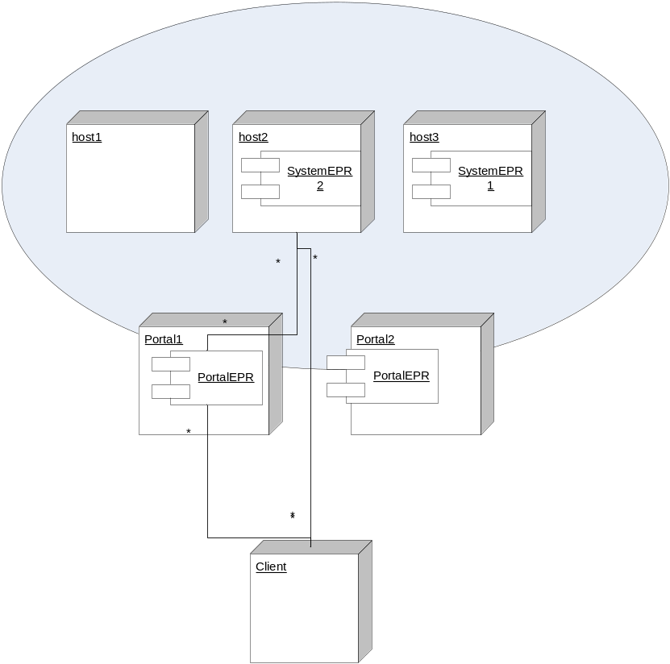
- Model of deployment and EPRs. Multiple Portal EPRs can manage the same set of deployment nodes.
The caller can then make a request to the system EPR to initialize the system. If successful, the application asynchronously enters the next state in its lifecycle, initialized. Once a system has been initialized, it can be moved through other stages of its lifecycle. The complete lifecycle is defined in section 4.2, and illustrated in figure 2.
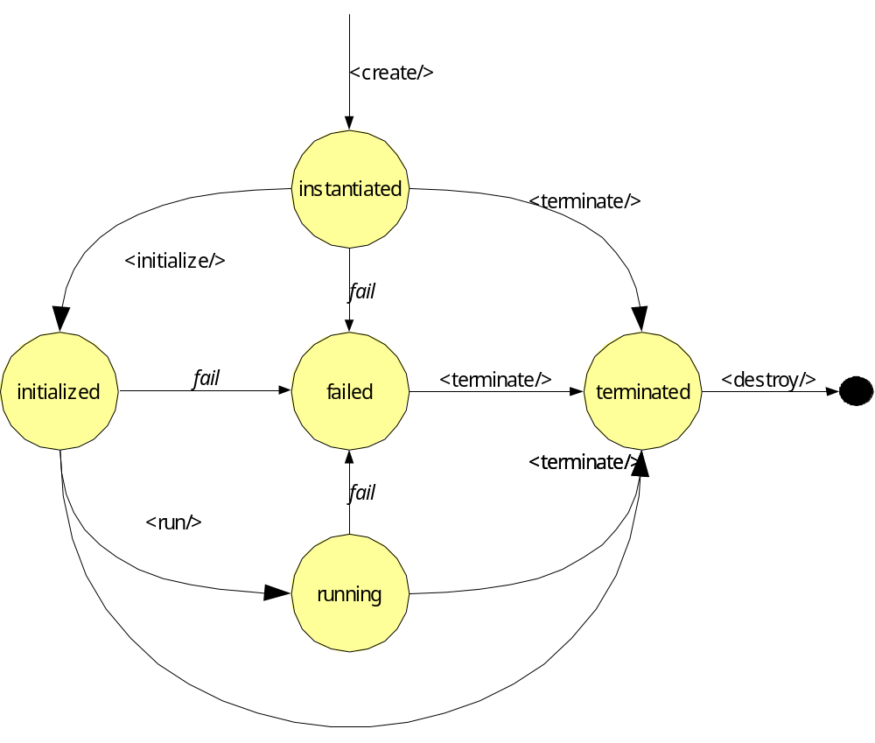
- The lifecycle of a deployed application
As a deployed system moves through its stages of its lifecycle, it can send lifecycle event notification messages to registered listeners, using a mechanism such as WS-Notification [WS-Notification]. The lifecycle state of the system can also be determined by querying the appropriate resource property of the system, according to the WS-Resource Properties [WS-ResourceProperties] specification. There is also a synchronous, blocking call to probe the health of a system; this must be routed to the system itself, so that it can determine its own health. This will return its current state, and any custom status information the system chooses to return. If the system has failed, or terminated after a failure, the status information will include the fault information.
The portal EPR supports other properties and operations. The list of currently deployed systems can be determined, along with their system EPRs. There are also static information and dynamic information documents which can be retrieved from the server; again these are represented as properties following the WS-Resource Properties specification.
The portal EPR can raise events when new systems are created, using the WS-Notification protocol.

Lifecycle
CDDLM components have a uniform lifecycle, one that is normatively described in the component model specification [Schaeffer05]. The lifecycle of a deployment matches the lifecycle of the components within. This is essential to permit aggregation of systems. The main difference is the notion of a destroyed component. When a system is destroyed, all record of it is lost. A terminated system, may still have state that is remotely accessible.
The states of a system are as follows:
instantiated | The system has just been instantiated.
initialized | The system has been initialized.
running | The system is running
failed | The system has failed
terminated | The system has terminated
destroyed | The system is destroyed.
Instantiation and initialization represent the creation and configuration of a component, and when it is moved into running then it is actually functional, The state failed is entered automatically when a failure is detected; termination is the only exit condition; terminated is the end state of a component and can be entered through a termination request.
The lifecycle is exposed through the operations¹ of the service. The create operation is will create and instantiate a system. The run operation will move the system to the running state, and terminate will move it to the terminated state.

Fault Tolerance
As stated, the architecture must enable fault tolerant implementations. Here is how this is accomplished:
- Multiple Portal EPRs can provide access to the same set of nodes.
- The failure of a portal does not imply the failure of a system.
- The failure of a node hosting a system EPR will result in the destruction of that system.
- Issuing a <wsrl:Destroy> request to a system EPR will destroy the system.
- Every system instance must have a WS-RF property "ID" of type xsd:URI property that must be unique; this can be used for equality tests through simple string comparison.
- Portal EPRs servicing a set of nodes should be discoverable by a client in some manner. Registration in a service group is one option [WS-ServiceGroup].
- Implementations may implement fault tolerant EPRs through the use of a dynamic DNS service, one in which the DNS entries for the hostname(s) of the portal are updated as portal instances appear and disappear. Client systems should to be written with the knowledge that the IP addresses of an EPR may change, and not to cache resolved IP addresses indefinitely.

Other Architectural Features.

Named systems
Callers may provide a string name for a system. This system name, if provided, must be unique amongst all systems that a portal EPR can manage.
The system name must begin with one of the characters in the set [A..Za..z_.] and continue with characters in the range [A..Za..z09_.]. This is a proper subset of the XSD type NCName element names, and is also a subset of the valid characters in a URL. This is intentional, and while the specification does not itself take advantage of the fact, languages may choose to do so.

Deployment Language Agnostic
The deployment API is agnostic as to which particular language, or version thereof, is used for a deployment descriptor. When a remote deployment is created, the language and version of the descriptor must be supplied. The sole requirement of a language is that it can either be nested inside an XML document, or that a URL to the descriptor is remotely accessible to the destination. In the case of the latter, the URL to the descriptor must be provide when initializing the system.
Every language is identified by a unique URI. This language URI must be supplied with the deployment descriptor or URI.

Job Language Agnostic
Just as the API allows implementations to support deployment languages/versions, the API also permits multiple Job specification languages. That is, alongside JSDL, an implementation may support the Globus Resource Specification Language [GlobusRSL].

Deploy-time properties in the language and service API
Consider a deployment descriptor that wants to control onto which machine that it wants different components deployed onto. When the descriptor is written, the actual hosts are unknown. It is only during deployment that the mapping becomes apparent. Either the descriptor is rewritten with the fixed values, or we provide a way for subsidiary information to be passed alongside the descriptor.
The SmartFrog language [Goldsack04] supports this with the PROPERTY and IPROPERTY keywords, which bind keys in a Java java.System.Properties hashtable to string and integer values. For example, a deployment descriptor could be bound to three properties:
database extends Database {
sfHostname PROPERTY hosts.database;
password PROPERTY database.password;
localhost LAZY PROPERTY local.hostname
}

At deployment time, each property string is looked up and assigned to the attribute, or a fault is raised. The LAZY keyword indicates that the evaluation must not take place in the context of the process interpreting the deployment descriptor, but instead the system actually hosting it. The XML language does not explicitly contain such a feature [XML-CDL], a standardized component could be designed to extract the values from the name/value list.
To enable this functionality within the Service interface, one of the deployment options declares a set of name/value pairs. How these tuples are exposed to a deployment language/framework is a language-specific feature.

Extensibility
The deployment API is designed to support extensible implementations, and future enhancements to the API over time.

Extra Operations
A service implementation may offer extra operations at any EPR. Such extensions must not add new declarations to the XML namespaces used in this document: they must be in their own, private, namespace. Implementations should document these operations and provide updated WSDL descriptions.
There is no requirement for the extra operations supported by an EPR to remain constant over any period of time.

Extra WS-RF operations
This specification and the accompanying WSDL defines the minimum set of WS-RF operations that an endpoint must implement. There are other operations that the various specifications list as optional: these have been omitted from this specification. An implementation may choose to support these extra operations.
If this is done, the messages and operations must match the relevant XSD and WSDL documents of the appropriate specification, and the semantics of the operations must match that of the specification itself.

Extra WS-Resource Properties
A service implementation may offer extra WS-Resource properties at any EPR. Again, they must be in their own, private, namespace. Implementations should document these properties and provide updated WSDL descriptions.

Extra deployment options
It is possible that extra deployment options will be desired on different implementations or over time. The core of such customization should be in deployment descriptors themselves, yet there may be a need to provide extra deployment metadata.
This is implemented through an <options> element in the <initialize> message. This (optional) element contains a list of zero or more deployment options. These are extra parameters to the deployment request. Every option is named with a URI, and can have a string or integer attribute value, or contain nested XML. A mustUnderstand attribute is used to indicate whether or not an option must be understood.
The option list is a very powerful aspect of the API, but potentially dangerous. Any protocol standard which has optional aspects is harder to write clients against than one which does not, as there is likely to be less consistency between different implementations. To manage this risk, the deployment API has the following requirements on optional metadata parameters:
- All options must be that: optional. It must not be an error to deploy a system with no options declared.
- Every option is named by a URI.
- All URIs that begin with http://gridforum.org/cddlm/ are reserved for options defined by the CDDLM working group.
- Options must contain either string, integer, Boolean or arbitrary XML values. String and integer values are supported via attributes; XML is supported as nested data.
- An option must contain only one value type. Implementations must raise a fault if multiple nested or attribute values are declared on the same option.
- All options that an implementation supports must be enumerated in the server information property of the portal EPR.
- It is an error to include multiple options of the same URI in a descriptor. Implementations must raise a fault when this occurs.
- Options may be processed in any order. Options must not require a specific order of processing.
- Service implementations must ignore any options that they do not recognize, if mustUnderstand="false" for that option.
- Service implementations must understand all options which are supplied with mustUnderstand="true" for that option. If any such option is not understood, a fault must be raised.
The processing rules for deployment are as follows:
- Option processing must take place before the system is moved to the running state.
- An implementation must be able to deploy a system when the entire options portion of the request is empty or omitted.
- Any option that is marked mustUnderstand="true" MUST be understood. If not, the Fault "not-understood" must be raised, identifying the particular option by its URI in the extraData field of the fault.
- Implementations must not raise this fault when they do not understand any options that are marked mustUnderstand="false", or for which there is no mustUnderstand attribute. These must be ignored.
- Duplicate options must cause the operation to be rejected with a bad-argument fault, identifying the particular option by its URI in the extraData field of the fault.

Deployment API Overview
The service API consists of two endpoint types, portal endpoints, addressed by portal EPRs, and system endpoints, addressed by system EPRs. Portal EPRs return system EPRs to callers, either in response to lookup/mapping messages, or when a system is successfully created.
The two endpoint types are Resources within the terminology of the WS-Resource Framework specifications.
In this section of the document, the following listed prefixes refer to the stated namespaces:
prefix | URI | description
xsd | http://www.w3.org/2000/10/XMLSchema | XML Schema Types
wsa | http://schemas.xmlsoap.org/ws/2003/03/addressing | WS-Addressing types
api | http://www.gridforum.org/cddlm/serviceAPI/2004/10/11 | Deployment API
cdl | http://www.gridforum.org/2004/12/CDDLM/XML-CDL/1.0 | XML CDL
cmp | http://www.gridforum.org/cddlm/components/2004/11/06 | Component Model
wsrf-bf | http://docs.oasis-open.org/wsrf/2004/06/wsrf-WS-BaseFaults-1.2-draft-01.xsd | WS-BaseFaults
wsrf-rl | http://www.ibm.com/xmlns/stdwip/web-services/WSResourceLifetime | WS-Resource Framework
wsrf-rp | http://www.ibm.com/xmlns/stdwip/web-services/WSResourceProperties | WS Resource Properties
wsrf-nt | http://www.ibm.com/xmlns/stdwip/web-services/WSBaseNotification | WS-Notification
wsrf-top | http://www.ibm.com/xmlns/stdwip/web-services/WSTopics | WS-Topics
s12 | http://www.w3.org/2003/05/soap-envelope | SOAP1.2 Envelope
xml | http://www.w3.org/XML/1998/namespace | XML attributes
muws-p1-xs | http://docs.oasis-open.org/wsdm/2004/12/muws/wsdm-muws-part1.xsd | Management using web services
Unprefixed types in the document and accompanying schema are in the api namespace.

Architecture of the Deployment System
Everything is implemented as a resource in the WSRF framework, everything is manageable in the context of the MOWS infrastructure.
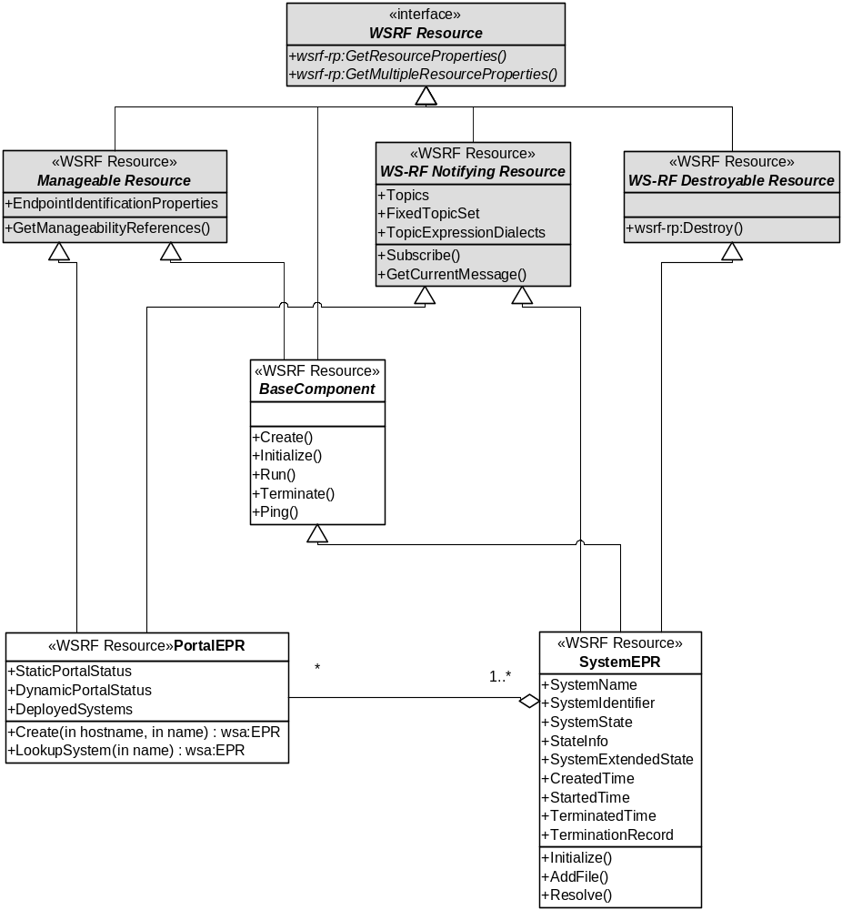
- Endpoint architecture. The items in grey are specified externally.

Portal Endpoint
The portal endpoint is the endpoint that the caller initially locates and communicates with. It can be used to create a new system within the set of nodes that it manages, it can be used to locate an existing system, and it can be used as a source of system creation events.

Portal EPR Properties
Name | Type | Meaning
StaticPortalStatus | StaticPortalStatusType | Static portal information; constant for the lifetime of the portal itself
DynamicPortalStatus | DynamicPortalStatusType | Dynamic server information; may be different on every read
DeployedSystems | SystemReferenceListType | List of system EPRs
Topics | wsrf-nt:TopicExpressionType | List of topics
FixedTopicSet | xsd:boolean | flag to indicate whether topic set is fixed
TopicExpressionDialects | xsd:anyURI | Dialect of topicset
mows-xs: EndpointIdentificationProperties | mows-xs: EndpointIdentificationPropertiesType | MOWS identifier

Portal EPR Operations
Name | In | Out
Create | hostname: xsd: string | wsa:EPR
 | Create a system; hostname is optional
LookupSystem | xsd:string | wsa:EPR
 | Map from system name to a system EPR
GetResourceProperties | wsrf-rp: GetResourcePropertyRequest | wsrf-rp: GetResourcePropertyResponse
 | Get the value of a resource
GetMultipleResourceProperties | wsrf-rp: GetMultipleResourcePropertiesRequest | wsrf-rp: GetMultipleResourcePropertiesResponse
 | Read multiple resources
Subscribe | wsrf-nt:Subscribe | wsrf-nt:SubscribeResponse
 | Subscribe to events
GetCurrentMessage | wsrf-nt: GetCurrentMessageRequest |  | wsrf-nt: GetCurrentMessageResponse
 | Get the current message for a topic
GetManageabilityReferences | mows-wsdl: GetManageabilityReferencesRequest |  | mows-wsdl: GetManageabilityReferencesResponse
 | Get the EPR(s) of the management service for this resource

If a portal has a managed lifetime, then it may also implement WS-ResourceLifetime properties and operations

System Endpoint
This represents a system that has been deployed. System EPRs are obtainable by creating one at the portal EPR, or through lookup operation offers by a portal.

System EPR Properties
Name | Type | Meaning
SystemName | xsd:string | user-defined name
SystemIdentifier | xsd:anyUri | unique identifier
SystemState | cmp:LifecycleStateEnum | current system state
StateInfo | xsd:string | Text state info
SystemExtendedState | UnboundedXMLAnyNamespace | Component state
CreatedTime | xsd:dateTime | Time system was created
StartedTime | xsd:dateTime | Time system was terminated
TerminatedTime | xsd:dateTime | end time (not present until system is terminated)
TerminationRecord | TerminationRecordType | termination record (present after termination)
Topics | wsrf-nt:TopicExpressionType | List of notification topics
FixedTopicSet | xsd:boolean | flag to indicate whether topic set is fixed
TopicExpressionDialects | xsd:anyURI | Dialect of topicset
mows-xs: EndpointIdentificationProperties | mows-xs: EndpointIdentificationPropertiesType | MOWS identifier

System EPR Operations
Name | In | Out
Initialize | job JobDescriptorType  descriptor DeploymentDescriptorType | void
 | Initialize a system; pass in the job and component descriptors and build up the component graph.
AddFile | mimetype xsd:string  data xsd:base64Binary | xsd:anyURI
 | Add a file to this document so that it is accessible by a URI from within the deployment descriptor.
Run | void | void
 | Start running an initialized system
Ping | void | StatusType
 | Probe a system's health.
Resolve | xsd:string path | xsd:any
 | Resolve a reference relative to this system. Can return EPRs to components; string or other data
Terminate | xsd:string Message | void
 | Terminate a system; pass in a message
wsrf-rp:Destroy
 | Destroy the System EPR, terminating the System if it is not yet terminated
wsrf-rp:GetResourceProperties | wsrf-rp: GetResourcePropertyRequest | wsrf-rp: GetResourcePropertyResponse
 | Get the value of a resource
wsrf-rp:GetMultipleResourceProperties | wsrf-rp: GetMultipleResourcePropertiesRequest | wsrf-rp: GetMultipleResourcePropertiesResponse
 | Read multiple resources
wsrf-nt:Subscribe | wsrf-nt:Subscribe | wsnt:SubscribeResponse
 | Subscribe to events
GetCurrentMessage | wsrf-nt: GetCurrentMessageRequest |  | wsrf-nt: GetCurrentMessageResponse
 | Get the current message for a topic
GetManageabilityReferences | mows-wsdl: GetManageabilityReferencesRequest |  | mows-wsdl: GetManageabilityReferencesResponse
 | Get the EPR(s) of the management service for this resource

Portal

Portal Properties
    - StaticPortalStatus:
This property contains static portal information; information constant for the lifetime of the portal instance. The portal elements details contains static diagnostics information, such as product name and timezone portal. The information lists are all lists of URIs that can be used to determine features.
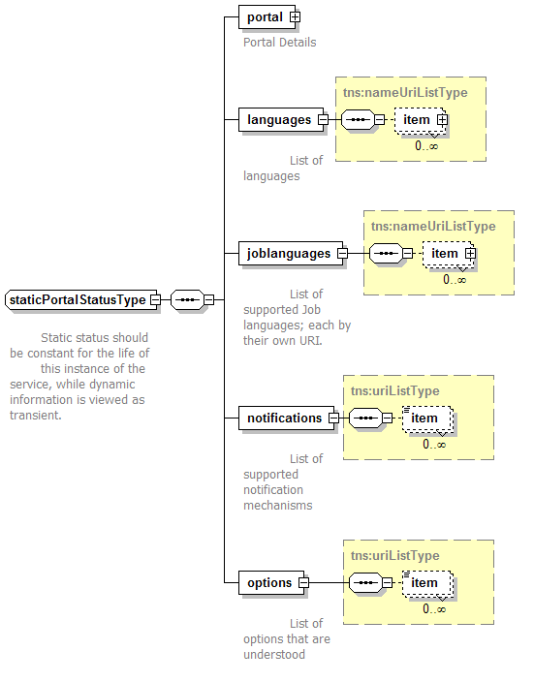
    - DynamicPortalStatus
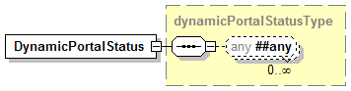
This is any dynamic status information.
    - DeployedSystems
This is a list of deployed systems which the portal is aware of. This may include systems which the portal did not deploy, but which a peer portal deployed. It may also be restricted to those systems to which the caller has access rights. Network partitioning and other events may cause systems to be temporarily invisible to this list, and return later.
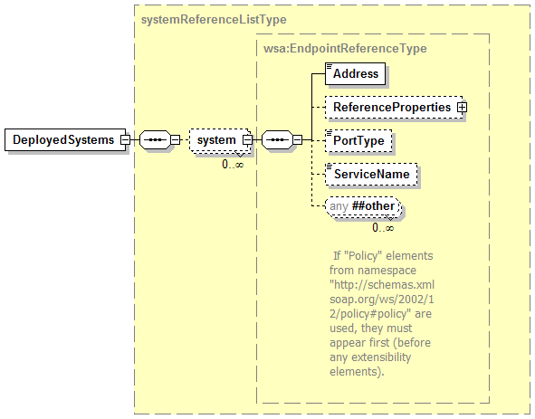

EndpointIdentificationProperties
This property provides a unique identifier of the Portal EPR, adhering to the MOWS specification [MOWS].

Topic, FixedTopicSet,TopicExpressionDialects
These three properties are published in adherence with the WS-BaseNotification specification.

Operations
    - Create([hostname],[name])
This requests the portal implementation to create a new system, ready for deployment.
The hostname element specifies an optional hostname. If set, it nominates a host onto which the port should instantiate the System, and hence the system EPR. If unset, or if the identified host is deemed unsuitable/unavailable, the portal can instantiate the system on a host of its choosing. Thus the hostname is merely a hint, a hint to improve availability and performance.
The name is an optional name of the system. One will be generated if none is supplied.
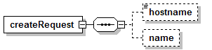
System names are constrained strings:
<xsd:simpleType name="systemNameType">
<xsd:annotation>
<xsd:documentation>
This is the policy for the naming of systems
</xsd:documentation>
</xsd:annotation>
<xsd:restriction base="xsd:NCName">
<xsd:pattern value="[a-zA-Z_\-\.][a-zA-Z_\-\.\P{Nd}]*"/>
</xsd:restriction>
</xsd:simpleType>
The response is an EPR to the instantiated system, an EPR which can be immediately used for direct communications. Creation of a system EPR is therefore a synchronous operation.
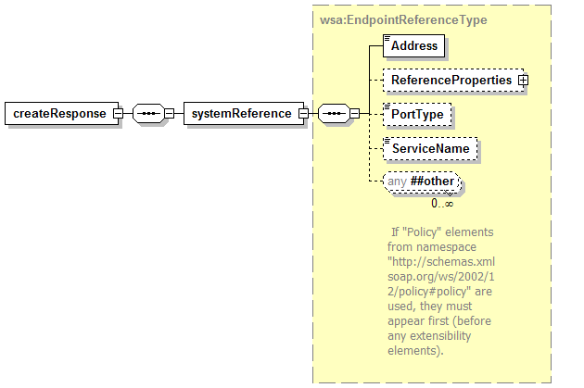
If an entity is registered with the portal for creation events, then the portal must send notification to that entity that new system has been created. The notification must not be sent until the system is ready for direct communication. There is no specification of the ordering of returning from the create operation and the sending of any notification mechanism. If there are multiple portals supporting deployment to a cluster of nodes, notification events may be sent to listeners on one portal, even if the deployment was requested on the other.
    - LookupSystem(name)
This maps from an system name to a system EPR
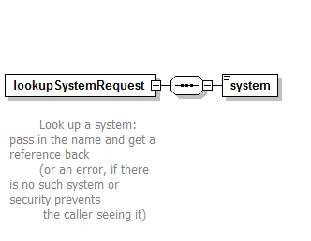
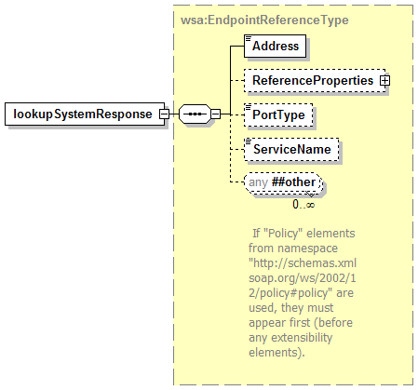

GetResourceProperty/GetMultipleResourceProperties
These two operations are defined by the WS-ResourceProperties specification.

Subscribe/GetCurrentMessage
These two operations are defined by the WS-BaseNotification specification.

GetManageabilityReferences
This operation is defined by the Management of Web Services specification [MOWS].

System
The System EPR represents the deployed system. After creation, it is still undefined, and must be configured before it can be moved to a running state.

System Properties
    - SystemName
This is the name of the system.
    - CreatedTime/StartedTime/TerminatedTime
These are all xsd:dateTime timestamps of when a system entered a particular state.
    - SystemTerminationRecord
This contains a cmp: type, terminationRecordType
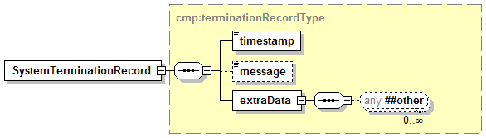
It contains information about the reason for the system's termination. It is only present after a system has been terminated.

EndpointIdentificationProperties
This property provides a unique identifier of the Portal EPR, adhering to the MOWS specification.

Topic, FixedTopicSet,TopicExpressionDialects
These three properties are published in adherence with the WS-BaseNotification specification.

System Operations
    - Initialize
This is a complex request, as it configures the system and moves it into the initialized state.
A deployment descriptor must be supplied; it consists of a language URI, and either an inline deployment descriptor or a URL to a location where the descriptor can be located.
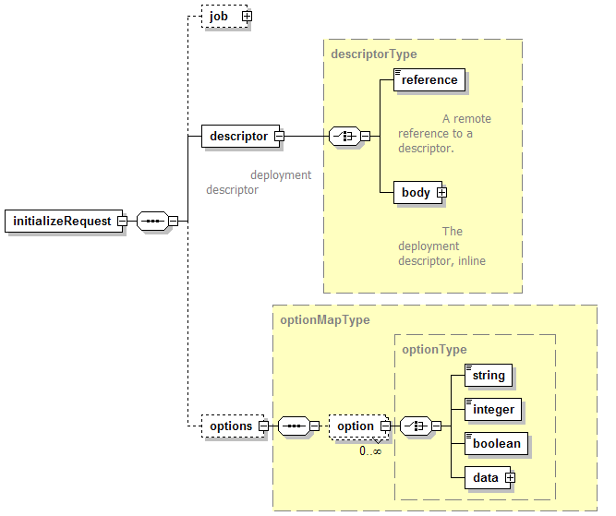
The optional <jsdl> element contains the job description that was used when submitting the job to the front-end portal. As with the <descriptor>, it is of type descriptorType; it must have a language URI and either an inline body or a URL to the descriptor. The interpretation of this data by the service implementation is undefined.
The optional <options> element contains a list of zero or more configuration options. These are late-binding parameters to the deployment request, or to the deployment runtime.
When the request message is received, the system EPR must validate it (synchronously) and initialize the system. For CDDLM implementations, initialization implies that the deployment descriptor and JSDL descriptor may be retrieved (if needed) and parsed. The application is then configured, and resolution begins. If successful, the system enters the initialized state. This can be a time consuming process, so is an asynchronous operation.
The response to a successful request is an empty response, <initializeReponse/>:
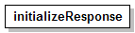
Its presence implies that the initial validation was successful, and that initialization has begun, or has at least been scheduled.

The propertyMap schema type
To aid those options that take a map of name/value pairs, there is a predefined XML Schema type that can represent the construct:
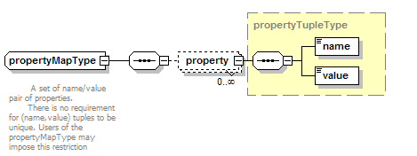
propertyMap elements can be placed into the <xml> child element of an option. Both the name and value of a propertyTuple within a propertyMap element are of type xsd:string; individual options are free to declare extra restrictions on the value of properties, restrictions which can be validated when processing the option.
There is no requirement that the name/value pairs are unique within a propertyMap element; that is also a restriction that can be declared in a specification of a particular option.
    - AddFile(file)
This request uploads a file to the infrastructure, such that it is visible by deployed programs, and by the System EPR itself.
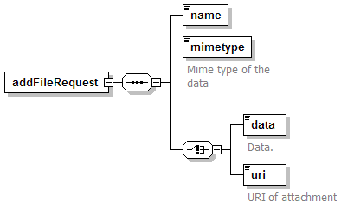
The request can include the file as base-64 encoded data. Unless both ends of the communication are specially written to stream large base-64 elements directly to and from storage, the addFileRequest/data contents must be sent as using the MTOM transmission mechanism. If DIME or Soap with Attachments is used then the attachment must be assigned a URI, a URI that must then be declared in the addFileRequest/uri element.
Implementations may resolve remote URL references in the addFileRequest/uri element, rather than just attachments in the message, but there is no requirement for implementations to do so.
The response returns a URI to the uploaded file, a URI either of type file:, https: or http:.
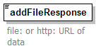
The file must be visible to programs deployed by this descriptor. They may be visible to other programs running with the same credentials, but this can not be guaranteed. If exposed as a file: URL, the file should be read-only.
The lifespan of the uploaded file is bound to that of the created system; when the System EPR is destroyed, all uploaded files are destroyed.
There is no guarantee of high-availability in deployment; failure of a single node may render the URL unreachable.
Note that the WSDL accompanying this document does not declare how binary attachments are to be sent with the document. If the MTOM transmission mechanism is used [MTOM], then the addFileRequest/data element must contain the binary-marshaled data.
    - Run
This request runs a system. This triggers an asynchronous action, as it may take some time to enter the running state. It is only valid from a state in which the lifecycle permits running to be reached; initialized and, implicitly, running. In the case of the latter, the operation is a no-op. If the system is initializing itself, as a result of an Initialize request, the request should be queued for processing after the state transition is completed.
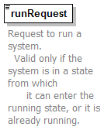
The response is an empty element:
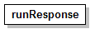
A response means that the system has been queued to enter the running state asynchronously, or that it now is in that state.
    - Ping
This is a synchronous request to the system, to query its health.
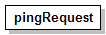
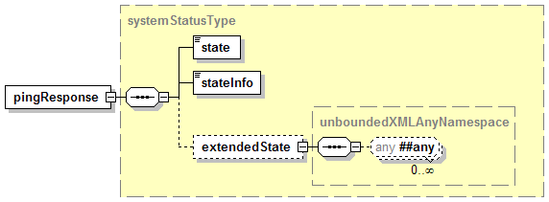
If the system is not running, the System EPR must return with the current state. If the system is running, the request must be forwarded to the application, which can return any extended state information.
This effectively acts as a liveness test upon the application.
    - Resolve
This operation resolves a path and returns its value or an error. It must be a valid operation when a system is initialized or running. It may be valid in a failed or terminated system.
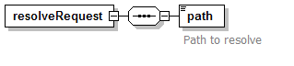
The response is arbitrary XML data, the contents of which depend upon what the path resolved to.
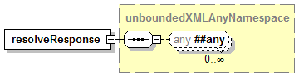
    - Terminate
This request terminates the system. To be idempotent, this call does not raise a fault when the system is already terminated.
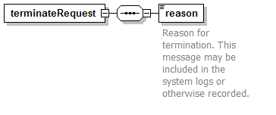
Upon receipt, system termination should commence. Termination is asynchronous.
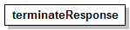
The response is an empty element.
    - Destroy
The WS-ResourceLifetime <Destroy/> operation destroys the System EPR itself. All files uploaded are destroyed, and the system is terminated if it is not already terminated.
After sending this message and receiving a response, service consumers should not make calls of the EPR, as it may not be valid.

GetResourceProperty/GetMultipleResourceProperties
These two operations are defined by the WS-ResourceProperties specification.

Subscribe/GetCurrentMessage
These two operations are defined by the WS-BaseNotification specification.

GetManageabilityReferences
This operation is defined by the Management of Web Services specification [MOWS].

Notification
Notification enables front-end applications to receive notification when a system finishes. It also enables management tools to track the number of running systems.
All implementations of the deployment API must support WS-Notification (WS-N), as specified in the document. The implementations are free to implement alternate mechanisms; that is beyond the scope of this document. What is covered, however, is a means of listing all notification mechanisms supported by an implementation. Every server instance is required to enumerate all supported mechanisms in a list included in its static server information property.

Notification Policy
- Implementations MUST support WS-Notification.
- Implementations MAY support alternate notification mechanisms.
- Implementations MUST list all supported notification mechanisms in the StaticPortalStatus/notification list.
- Implementations MUST support the topics defined below, on the relevant EPR types.
- Implementations MAY also support Terminate notification events of WS-ResourceLifetime, which are raised after a EPR is destroyed.
- There is no guarantee of fault tolerant subscriptions. Implementations MAY include WS-Policy metadata that informs callers how to renew subscriptions in the event of system failure.

WS-Notification Support
As stated above, implementations MUST support WS-Notification; this does not prevent them also implementing supplementary mechanisms. There are specific topic spaces [WS-Topics] defined:
- Portal EPRs must support a WS-TopicSpace that contains one topic: system creation events. This notifies callers that a new system has been created.
- System EPRs must support a WS-TopicSpace that contains one topic: lifecycle events. This notifies callers of changes in a system's lifecycle state.

Fault-Tolerant Notification
Implementations are not required to provide fault-tolerant notification. The failure of portal may result in the loss of portal event subscriptions, and the failure of a system may result in the loss of system event subscriptions.

Fault Policy
Faults are based upon the WS-BaseFault model [WS-BF], taking on some of the lessons of [Loughran02], namely that extra information such as hostname and process is essential for locating which process among many has failed on a clustered system.
Faults are raised in response to errors either at the remote endpoint, in the local framework, or between the remote endpoint and other parts of the distributed system. They can be returned to callers in response to a an operation on an endpoint, or sent as part of a notification event.
All faults that will be explicitly sent are derived from WS-BaseFault faults. Service implementations may implicitly raise SOAPFault faults, as that is inherent in most implementations.

Fault Categories

Service Faults
These are the faults that are raised by the service. They are grouped into a hierarchy of WS-BaseFault faults. There is a base fault class DeploymentFault, from which all others are derived.
All Service interfaces must declare that they raise these DeploymentFault instances, rather than list the specific faults. This is to provide forward extensibility.
The API lists specific subclassed faults of DeploymentFault that may be generated by a service or received by a client. These faults represent some of the faults that a service implementation may send.
If an implementation has a fault state whose meaning matches that of the predefined fault, the predefined fault must be thrown. If this predefined fault has standard elements for embedded fault information, the implementation should fill them in. The implementation may add implementation-specific data within the extra-data element of the fault, to supplement this information. This extra data must not add new types to the XML namespaces of this deployment data. The XML schema and semantics of this extra data should be documented.
If an existing fault type is not suitable, implementations may create new fault types.
If an implementation creates new fault types, these must extend the existing fault types which operations are declared as throwing, which effectively means that they must extend DeploymentFault. These new faults must not change the XML schemas of the deployment API, and they must be in a new namespace. The new faults and XML content should be publicly documented.
If an implementation adds new operations or properties at the existing endpoints, these new operations may raise whatever faults they see fit, within the constraints of the WS-BaseFault specification. Again, the implementation must not add new types to the deployment API namespace.

Transport faults
Transport faults will inevitably be raised as the appropriate fault for the system. For example, the Apache Axis SOAP client raises AxisFault faults for all SOAP events, wrapping stack trace and even HTTP Fault data within the fault as DOM elements. Microsoft .NET WSE has a similar fault class.

Relayed Faults
Relayed faults are those received by the far end and passed on. They may be WS-BaseFault Faults; HTTP error codes, SOAP faults, native language faults wrapped as SOAPFaults, or predefined deployment faults.
WS-BaseFault uses fault nesting for relaying faults; however, all faults must be a derivative of WS-BaseFault. This is addressed by defining a new WS-BaseFault derivative, a WrappedSOAPFault. This type is actually an extension of DeploymentFault. This fault can nest any received SOAPFault, with an element containing the received XML data. Well-known elements in this fault data (such as the Apache Axis stack trace and HTTP fault code) should be copied into any fields in the main fault that fill the same role.

Fault Hierarchy
The UML representation of the fault hierarchy is as follows:
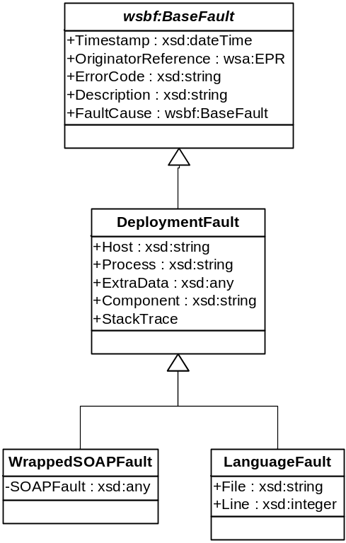
- Fault Hierarchy

Fault Security
Sites offering deployment services, may, for security reasons, wish to strip out some information, such as stack trace data. Implementations should provide a means to enable such an action prior to transmitting faults to callers.
Host name and process information may be viewed as sensitive, yet again, this is exceedingly useful to operations. Implementations may provide a means to disguise this information, so that it does not describe the real hostname or process ID of a process, but instead pseudonyms that can still be used in communications with any operations team.

Internationalization
The WS-BaseFault specification makes no statement upon which language error descriptions are described..
If an implementation can return descriptions in one language, it must use xml:lang attributes to indicate the language of a description. Multiple descriptions, in different languages may be included. The client application should extract the description(s) whose language is the nearest match to that of the client.

Faults
    - DeploymentFault
This type represents any fault thrown by the deployment infrastructure. All endpoint operations must declare that they throw this fault, and must not explicitly declare any derivative faults that they may throw.
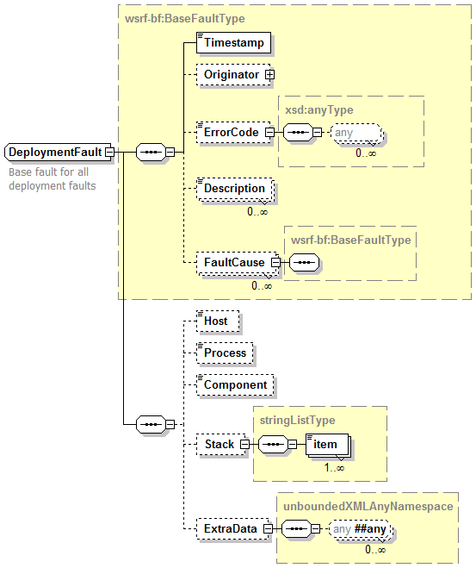

Element | Type | Meaning
Host | xsd:string | Hostname or pseudonym
Process | xsd:string | Any process identifier suitable for diagnostics
ExtraData | unboundedXMLAnyNamespace | Extra fault data
Component | xsd:string | Path to component raising the fault
Stack | stringListType | Optional stack trace
Implementations must include a component reference if it is known. Implementations should include hostname and process information. Process information may be a low-level identifier (such as an operating system process ID), or it may be some application specific identifier. Its role is merely to distinguish which process amongst many in a load-balanced implementation raised the fault.
    - LanguageFault
A language fault represents any fault in language processing for which a file and line number are relevant.
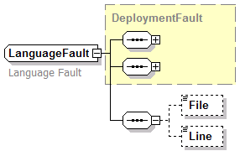
Element | Type | Meaning
File | xsd:string | Filename/URI of file at fault
Line | xsd:integer | Line number within the file
If the error is in the inline deployment descriptor, the File element must be empty "" or omitted. Furthermore, the Line element must be relative not to the deployment request, but to the inline descriptor. Recipients of faults can then infer from the empty/absent file element that the fault was in the inline request.
Note that a consequence of this design is that implementations should preserve white space in the deployment descriptor when saving them to file.
    - WrappedSOAPFault
This type represents a mapping of a classic W3C SOAPFault [SOAP1.2] to a WS-BaseFault, as an extension of DeploymentFault. It adds two new elements to contain data unique to SOAPFaults.
Element | Type | Meaning
SoapFault | s12:Fault | Fault code information
The normative mapping of SOAPFault elements to WrappedSOAPFault elements is as follows:
SOAP1.2 | WrappedSOAPFault
/s12:Fault | WrappedSOAPFault/api:SoapFault
SOAP endpoint | WrappedSOAPFault/wsrf-bf:originator
The SOAP endpoint must be translated into a wsa:EndpointReference if it is a simple URL/SOAPAction tuple.
Detail from SOAP stacks with well-known fault fields, such as the Apache Axis stack trace, may be imported into appropriate fields in the DeploymentFault.

Fault Error Codes
Specific fault error codes, and their meaning, will be covered in a separate informative document.

Security
The deployment requests must only be granted by suitably authorized individuals, or their suitably authorized agents. For deployment to a Grid infrastructure, that means that the standardized security model of the infrastructure must be used to authenticate callers. Only callers with the relevant rights may deploy systems.
When delegating deployments across nodes, the node issuing the deployments needs to have the rights to do so, and the deployment itself still needs to be authenticated as a legitimate request of the sender.
Along with deployment, the ability of a caller to list and manipulate running systems, introduces another security issue: that of who has access to the set of deployed systems.
Files uploaded via System::addFile must only be visible to the deployed application, and potentially other applications deployed under the same credentials.
There are a number of places in the system in which remote URLs to data may be supplied, as an alternative to sending the information inline. In these situations, the service implementation must not retrieve this content with greater rights than that of the caller. Furthermore, to ensure that the content is that which the caller has chosen to publish, the HTTPS/TLS protocols should be preferred over HTTP, unless the downloaded content is itself authenticated by some form of signing mechanism.

Editor Information
Steve Loughran, HP Laboratories
steve_loughran@hpl.hp.com

References
[Axis] Apache Software Foundation, Apache Axis,
[DIME] Nilesen et al., Direct Internet Message Encapsulation. Microsoft, 2002.
[Foster04] Foster et al., Modeling Stateful Resources with Web Services, 2004.
[Goldsack04] Goldsack, SmartFrog Language, 2004
[GlobusRSL] Globus, Resource Specification Language, 2004
[JSDL] Job Service Description Language, 2004.
[Loughran02] Loughran, Making Web Services that Work, HP Laboratories,
TR-HPL-2002-274, 2002.
[MOWS] Sedukhin I. et al, Web Services Distributed Management: Management of Web
Services (WSDM-MOWS) 1.0, OASIS, 2004.
[MTOM] Gudgin, M., SOAP Message Transmission Optimization Mechanism, W3C, 2005.
[Parastatidis03] Parastatidis et al., A Grid Application Framework based on Web Services Specifications and Practises, University of Newcastle, 2003.
[RFC2119] S. Bradner, RFC 2119 - Key words for use in RFCs to Indicate Requirement Levels, 1997
[Schaeffer05] Schaeffer., CDDLM Component Model Specification, 2005
[SOAP1.2] W3C, SOAP Version 1.2, 2003.
[XML-CDL] CDDLM XML Configuration Description Language Specification version 1.0 draft 2004-12-10.
[WS-A] Gudgin, M. and Hadley S., Web Services Addressing -Core, 2004.
[WS-BF] Tuecke et al., Web Services Base Faults (WS-BaseFaults), 2004.
[WS-BaseNotification] Graham et al., Web Services Base Notification 1.0 (WS-BaseNotification), 2004.
[WS-BrokeredNotification] Graham et al., Web Services Brokered Notification 1.0 (WS-BrokeredNotification), 2004.
[WS-Policy] Schlimmer et al., Web Services Policy Framework (WS-Policy), 2004
[WS-ResourceLifetime] Frey et al., Web Services ResourceLifetime 1.1 (WS-ResourceLifetime), 2004.
[WS-RF] Tuecke et al., Web Services Resource Framework (WS-RF), 2004.
[WS-ResourceProperties] Graham et al., Web Services Resource Properties 1.1 (WS-ResourceProperties), 2004.
[WS-ServiceGroups] Graham et al., Web Services Service Group Specfication 1.0 (WS-ServiceGroups), 2004.
[WS-Topics] Graham et al., Web Services Topics (WS-Topics), 2004.

