Enterprise Grid Requirements – Research Group
(egr-rg@ggf.org)

Use Case Template

This is a template for submitting use cases to the EGR-RG. We solicit your active participation to submit use case so that we can build the requirements for standardization efforts in the Grid. Your contributions are valuable. Please submit your use case(s) and/or any suggestions that you may have to improve this template or process to egr-rg@ggf.org. Thank you!
Co-chair: Ravi Subramaniam (ravi.subramaniam@intel.com)
Co-chair: Toshiyuki Nakata (t-nakata@cw.jp.nec.com)
Secretary: Satoshi Itoh (satoshi.itoh@aist.go.jp)

Wide Area Load Balancing System

Authors
Shinya Miyakawa (NEC)
Toshiyuki Nakata (NEC)
Hiro Kishimoto (Fujitsu)
Nobutoshi Sagawa (Hitachi)

Abstract/Summary
Recently, services using several data centers such as a large scaled sales site (see Figure 1), CDN (Content Delivery Network) services are increasing.
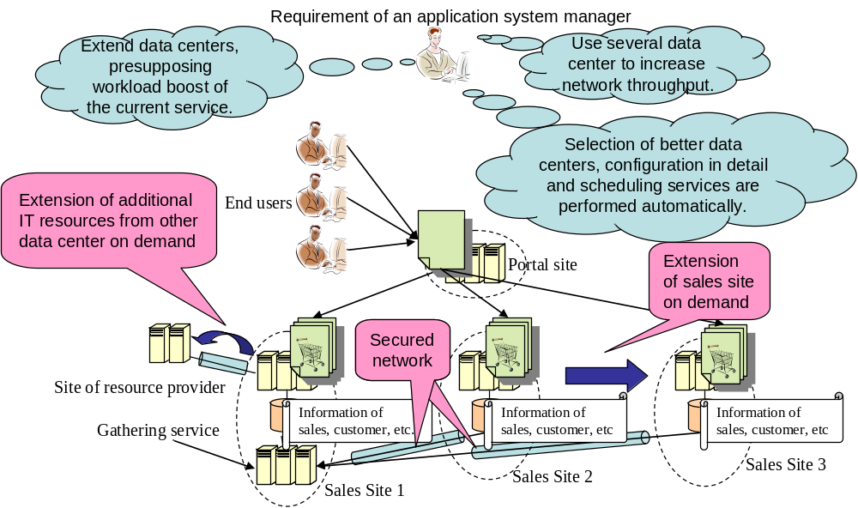
The reasons using several data centers are due to the fact that IT resources’ performance of one data center is not enough, network throughput provided by one data center is not enough, and so on.
When an application system manager starts up a service in one data center, they have to perform some procedures such as settling contracts with the data center, creating accounts, and configuring and managing the service. If the service requires using several data centers, these procedures have to be performed in each data center. Because these procedures are different for each data center, much know-how of starting up the service is required. In these circumstances, grid technologies are expected to provide seamless interoperation of multiple data centers to make them seem as to be just one data center.
As a first step to archive these aims, this use case introduces scenarios of supporting configuration of an application system using several data centers and management of the distributed application system with well-defined operations. We assume that several data centers have settled contracts each other in advance to cooperate with grid middleware because it is very difficult for grid technologies to settle contract dynamically.

Keywords
Data Centers’ Cooperation, Globally Distributed Application System

Category
This use case is categorized with following taxonomies.
- Scope: Infrastructure
- Organization Type: Company
- Deployment type: Inter-Organization, Internet
- Production status: Experimental, Production
- Existing implementation: Implementation available

Perspective
Following perspectives are bought to this use case.

Individual
- The data center manager has a responsibility for settling contracts of IT resources’ usage with application system managers and other data centers’ managers.
- The application system manager provides services to end users, managing an application system distributed among several data centers.
- The IT resource manager manages heterogeneous IT resources in a data center. He/She provides IT resources requested from the application system manager, updates OSs/middlewares of IT resources, and repairs troubled IT resources, and so on.
- The end users are customers or users of the services provided by the application system managers. They do not know which data centers are used for the services and where their requests forwarded, but they know only a portal address.

Organization
- Data centers (MSP, ASP, ISP, etc) which can cooperate with other data centers, sharing their IT resources based on their contracts.

Industry vertical or segment
The following large scaled systems are targeted.
- In-house System
- Web Site Service

Application Type
Large scale systems such as ticket sales service, searching engine, or contents delivery network services are targeted as application types.

Expectations
Grid technologies are expected to satisfy the following requirements.
- Using IT resources of several data centers seamlessly in the case that the company owns several data centers or the company out-sources parts of IT resources
- Extending services using other data centers on demand to realize large scale services which can not be managed in one data center, such as large scale sales site or CDN.

Motivations & Goals
Goals of this use case are that grid middleware provides the following functions.
- Setting up application systems among several data centers from one data center
- Managing distributed application systems with well-defined operations

Problems
Following procedures are required generally to start up a service using several data centers.
- Making a contract to use IT resources in each data center
- Creating accounts to management systems
- Setting up the application system, such as allocating IT resources, deploying application executables, configuring IT resources and network, and starting the application system.
- Managing the application system, such as scheduling operations, monitoring variation of IT resources, and updating application executables.
Above procedures require high skill because they are very complex depended on vendors and structures of IT resources in each data center.

Benefits or Value
This use case aims reducing TCO of an application system among several data centers. In this use case, it is just one data center called “main data center” to where application managers can access, though managers of current application systems have to manage their systems in each data centers. The application managers can set up and manage their application systems with well-define operations through one data center. For example, they can operate, synchronize, schedule and update the application systems using several data centers through the main data center.

Scenarios
- Pre-conditions
Several data centers have agreed to supply their IT resources among each other, connecting with secured network, such as VPN (Virtual Private Network). An application manager has made a contract with just one data center called “main data center”.
- Job creation and resources’ reservation
The application systems manager inputs application definitions and resource requirement descriptions. The application definitions contain application information to construct application systems in several data centers. The resource requirement descriptions contain kinds and amounts of IT resources to allocated application systems in each data center.
The grid middleware (1) decides which data centers satisfy the resource requirement descriptions, (2) creates jobs to managed application systems in each data center, (3) reserves IT resources in each data center, and (4) allocates the IT resources to the jobs.
- Application system setup
The grid middleware deploys application executables on the reserved IT resource using the application definitions. It configures networks between data centers, starting all application systems in each data center.
If the grid middleware of the main data center forwards these operations to the proper data centers, an application system manager is not aware which data centers are used.
- Updating an application system
If same application information is used with several application systems, updating the information is expected to reflect to all of them simultaneously. Using this function, application system managers do not have to manage versions of application information among several data centers.
- Scheduling site extension
If the grid middleware can add other data centers dynamically, it is possible to extend service regions or to run large scale campaigns.
The application system manager performs management operations to the additional application systems through the main data center.

Standards
The following interfaces and protocols between application system managers and a data center, and between data centers have to be standardized.
- Job relation management
- Data center selection

Miscellaneous
None.

Reference
Provide Web links or bibliographic references for more information on the use case or aspects of the use case.

