Enterprise Grid Requirements – Research Group
(egr-rg@ggf.org)

Use Case Template

This is a template for submitting use cases to the EGR-RG. We solicit your active participation to submit use case so that we can build the requirements for standardization efforts in the Grid. Your contributions are valuable. Please submit your use case(s) and/or any suggestions that you may have to improve this template or process to egr-rg@ggf.org. Thank you!
Co-chair: Ravi Subramaniam (ravi.subramaniam@intel.com)
Co-chair: Toshiyuki Nakata (t-nakata@cw.jp.nec.com)
Secretary: Satoshi Itoh (satoshi.itoh@aist.go.jp)

GridASP

Authors
Satoshi Itoh (AIST)
Hirotaka Ogawa (AIST)
Tetsuya Sonoda (AIST)
Satoshi Sekiguchi (AIST)

Abstract/Summary
The GridASP is a utility computing framework for technical computing in the enterprise. The concept of the GridASP is to separate the function of ASP (Application Service Provider) into three independent providers. The resource provider (RP) manages computer resources and executes jobs. The Application provider (AP) prepares the application packages and manages the licenses. The service provider (SP) manages web portal for end-users and mediates between end users and RP. These three independent organizations federate to work as an ASP using grid technologies.

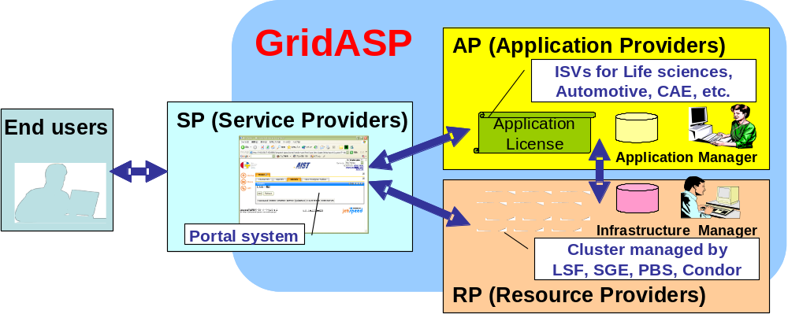

Keywords
ASP, Virtual organization, technical computing in enterprise, utility computing

Category
Define taxonomy to categorize this use case
- Scope: Business model and infrastructure, tool
- Organization Type: Enterprise
- Deployment type: Inter-Organization
- Production status: Experimental
- Existing implementation: Implementation available

Perspective
The GridASP is provided by federating three independent providers. At least four players are involved in this use case.

Individual
- End user
The end users are very important for this model, because end users belong to the different organization from providers.
- Infrastructure Manager
The infrastructure Manager manages the IT resources in RP. IT resources are mainly constructed as cluster systems and are managed by cluster management tool (batch queue system software) such as LSF, PBS, SGE, Condor.
- Application Manager
The application Manager prepares application packages including executable binaries and installation/un-installation scripts.

Organization
- Seller (software, hardware)
The AP and the RP are sellers of usage about software and hardware, individually. The RP is managed by the infrastructure managers. They received the end user’s request for job submission through the SP. The AP is managed by the application managers. They prepare application packaged and manage application licenses.
- Solution provider
The SP is a kind of solution provider for enterprise users. The SP manages grid portal for application job execution environment.

Industry vertical or segment
Technical computing in the enterprise is the target of this model. For instance, pharmaceutical, financial, automobile, aerospace and semiconductor are typical segments. However, target is not restricted in these segments.

Application Type
CAD in manufacture, CFD in aerospace, collision analysis in automobile, Risk analysis in financial computing, are typical target applications.

Expectations
There are four players in this use case. The expectations of them are different each other.
Generally, providers can start their business without preparing all of equipments for ASP.
- The SP selects the useful services from available services provided by several the AP and the RP. The collection of the services makes a value of the SP against the end users.
- The AP has new approach for selling applications to small and medium sized enterprises. Large size of enterprises may pay for the application licenses. But small and medium sized enterprises may not pay the license even though they want to use the application, because they may not use so much time.
- Because the RP can operate and sell the large scale of clusters using the professional skills, the price for resource usage is expected to be lower than the usual ASP.

Motivations & Goals
The ASP is an object to compare with the GridASP.

Problems
In the case of ASP,
The providers need to prepare all of equipments for ASP, such as applications, computing resources, and the portal systems. It takes long term and need large investment to start the business.
The system is constructed for pre-determined applications. If the requirement for the applications is not so many, resources will not be used so much and the income will be small.
If the requirements of users are a lot, the computing resources may not be enough to execute all of the requested jobs.
The providers need to recognize who is requested the jobs and what is the input/output data. However, some of end users, especially such as pharmaceutical company and financial company, do not want to be known by the providers.

Benefits or Value
In the case of GridASP,
The providers need to prepare at least one of the equipments, applications, computing resources and the portal systems. It is easy to start the business without taking long term and needing large investment.
The RP can contract with several SPs. Even though one of the SPs does not have many requests, the remaining SPs can send the requests to the RP. So, the applications are need to be dynamically deployed.
The SP can contract with several RPs. If the SP has the many requests, they can be distributed those RPs.
The SP needs to recognize who is requested the jobs and the RP needs to recognize what is the input/output data for the computation. The RP can not recognize the end user, if the SP uses anonymous ID for the delegation to the RP. The SP can not recognize the input/output data, if the encryption system is shared by the end users and the RP.

Scenarios
The actors in the GridASP are mainly four, the SP, the AP, the RP and the end user.
AIST is developing the software toolkit for the grid portal to realize the GridASP framework. The grid portal has the function so that the independent providers can federate each other.
The computing resources are managed by a kind of cluster management tool in the RP. The end user requests the job through the grid portal operated by the SP. The job execution request is submitted by the SP to the RP. The cluster management tool in the RP executes the job. After the SP get the output of the job from the RP, all of the files created in the RP are removed.
The AP prepares the application packages including executable binaries and the installation (un-installation) scripts. The packages are registered to the SP with the information about the application. The infrastructure manager in the RP downloads the packages from the SP and executes the installation script. Then the application is deployed.
When the end user uploads the input file to the SP, the input file is automatically encrypted. The encrypted file is transferred to the RP and is decrypted in the storage area at the RP. After executed the job, the results will be transferred to the end user in the same encryption method. Furthermore, when the SP transferred the job to the RP, the user ID is replaced by an anonymous ID. Thus, the RP does not know who the actual end user is.
The grid technologies what are used in the GridASP scenarios are federation of three independent providers and the authentication (GSI) of users and providers. The three providers can be globally distributed.
The RP is virtualized beyond the portal system. The end users do not need to know which resource companies executed their requested jobs. The RP removes the all of information about the requested jobs, input and output data and logging information. Namely the RP is basically stateless.

Standards
In the business model of the GridASP, independent providers need to be federated each other. The interfaces between them are necessary to be interoperable. The job submission interfaces are being standardized in the JSDL-WG. But the information services about the resources including accounting information are not established yet. In order to establish the federation of providers, those standardization are necessary.

Miscellaneous
None.

Reference
The authors are preparing the Web page. It will be opened shortly.

