G-lambda
http://www.g-lambda.net/

BASIC ARCHITECTURE
Figure 1 shows the basic architecture of G-lambda [1]. In response to a request from a user or from a middleware suite, a resource coordinator communicates with network resource managers (NRM) and compute resource managers (CRM) to make a reservation of a set of resources. Multiple resource coordinators and multiple resource managers can exist in this model. A resource belongs to a domain. A domain has one or more resource managers to manage resources in the domain. In this figure, two network domains exist, and each domain has its own NRM. GNS-WSI is the interface between a resource coordinator and an NRM.
Reserve, release, and modify are the basic functions of GNS-WSI. In the reserve operation, bandwidth between two endpoints can be reserved. Parameters of the reserve operation include a pair of endpoints, the start time and end time of the reservation request, and the required bandwidth. An existing reservation can be canceled by the release operation. A reservation can be modified (e.g. shortening/extending the reservation period, adding or removing resources) by the modify operation.

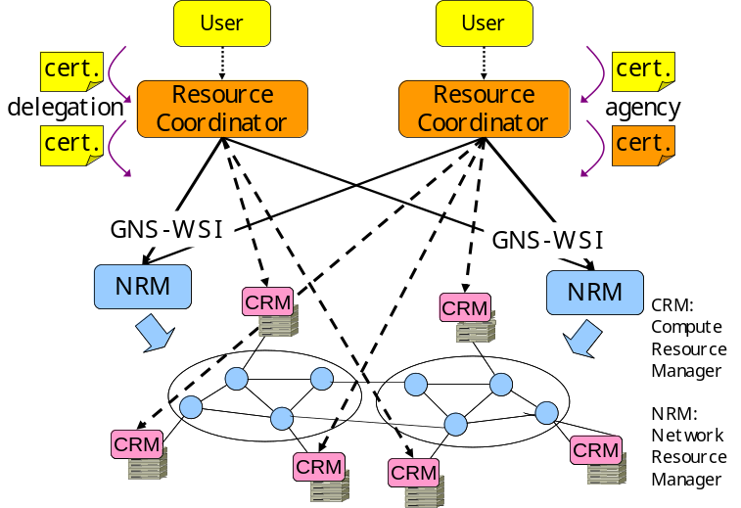
Figure 1. Basic architecture of G-lambda.

2-PHASE COMMIT
We use the 2-phase commit [2] protocol for reserve, release, and modify operations. In the 2-phase commit protocol, an operation is made in two phases. At the first phase, a request from a resource coordinator is granted and held if the resource manager can accommodate the request. If anybody says “no” to a request, something in the operation’s request may need to be changed before committing in the 2nd phase. If the resource coordinator has sufficient held resources, the resource coordinator commits the held resources to the operation.
2-phase commit introduces flexibility for booking multiple resources, and modification of existing reservations can be handled properly.

PER-REQUEST HIERARCHICAL REQUEST
A reservation request from a service client propagates hierarchically through resource coordinators to resource managers, as shown in Figure 2. A request tree is formed for a request. There is no fixed relationship between resource coordinators. A coordinator (called A) which makes a request to another coordinator (called B) may receive a request from B for another request.
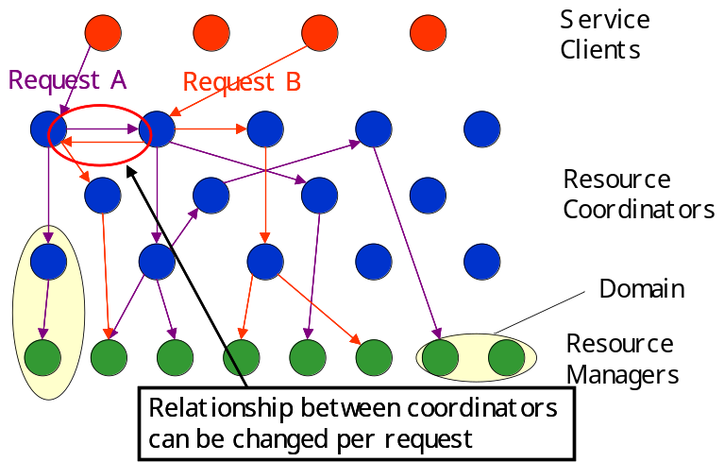

Figure 2. Per-request hierarchical request model

INFORMATION SERVICES
To find available resources, information such as supported end points and supported bandwidth should be provided. In the G-lambda architecture, such information can be provided through information services and/or direct queries to resource managers. An information service can be provided by a network operator, or another service provider.
For commercial services, network operators may not want to disclose the topology and availability information for their network. Therefore, each network operator can select what information is to be provided to a client based on a pre-determined policy. The policy is determined according to the contract with the client. For example, an inquiry asking for the availability of all the resources the operator has may not be supported. In addition, each network operator can select the information services through which the operator provides information to clients. How a contract is made between a user, or a middleware suite, and a resource manager is out of the scope of the G-lambda architecture.

AUTHENTICATION
Certificate-based authentication can be used in G-lambda. When a resource coordinator propagates a request from a client to a resource manager or another resource coordinator, G-lambda supports both delegation and agency models (Figure 1.). In the delegation model, a certificate from a client is delegated. In this case, resources are used in the name of the client. In the agency model, a certificate of the coordinator is used. In this case, resources are used in the name of the coordinator. Depending on the functions provided by the coordinator, an appropriate model can be chosen.

WEB SERVICES
Web Services are application components which can be accessed through open-standard web protocols (XML, SOAP, etc.). A Web Services interface enables interaction between application components, and provides a very high level interoperability among the components. GNS-WSI is supposed to be used in an enterprise environment. Therefore, GNS-WSI uses a WSRF-based Web Services protocol to maximize the interoperability.

REFERENCES
[1] A. Takefusa, et al. G-lambda: Coordination of a Grid Scheduler and Lambda Path Service over GMPLS. Future Generation Computing Systems, 22(2006):868–875, 2006.
[2] A. S. Tannenbaum. Distributed Operating Systems, Prentice Hall (1994).

