Use of XACML Request Context to access a PDP

Status of This Document

This document provides information to the Grid community about a proposed standards track protocol. Distribution is unlimited.

Copyright Notice

Copyright © Global Grid Forum (2006). All Rights Reserved.

Abstract

The purpose of this document is to specify a protocol for accessing a Policy Decision Point (PDP) by a Grid Policy Enforcement Point (PEP) in order to obtain access control decisions. The protocol is a profile of XACML

Contents

Abstract 1
1. Introduction 2
2. Notational Conventions 2
3. Security Tokens 2
4. XACML Request and Response 2
4.1 Resource 2
4.2 Subject, Action and Environment 3
4.3 Result 3
4.4 Obligations 4
5. Security Considerations 4
6. Contributors 4
7. Intellectual Property Statement 5
8. Disclaimer 5
9. Full Copyright Notice 5
10. References 5

Introduction

This document describes how an XACML request context can be created and transferred by a Grid Policy Enforcement Point (PEP) to a Police Decision Point (PDP) in order to obtain authorisation decisions for Grid applications. The XACML request context contains attributes of the subject, resource, action and environment, and is transported to the PDP in a SAML request message.

Notational Conventions

The key words ‘MUST,” “MUST NOT,” “REQUIRED,” “SHALL,” “SHALL NOT,” “SHOULD,” “SHOULD NOT,” “RECOMMENDED,” “MAY,” and “OPTIONAL” are to be interpreted as described in RFC 2119 [BRADNER]

Model and Definitions

Figure 1 provides a model of the steps that are taken by a Grid Service provider to authorize a user’s request to access its services.
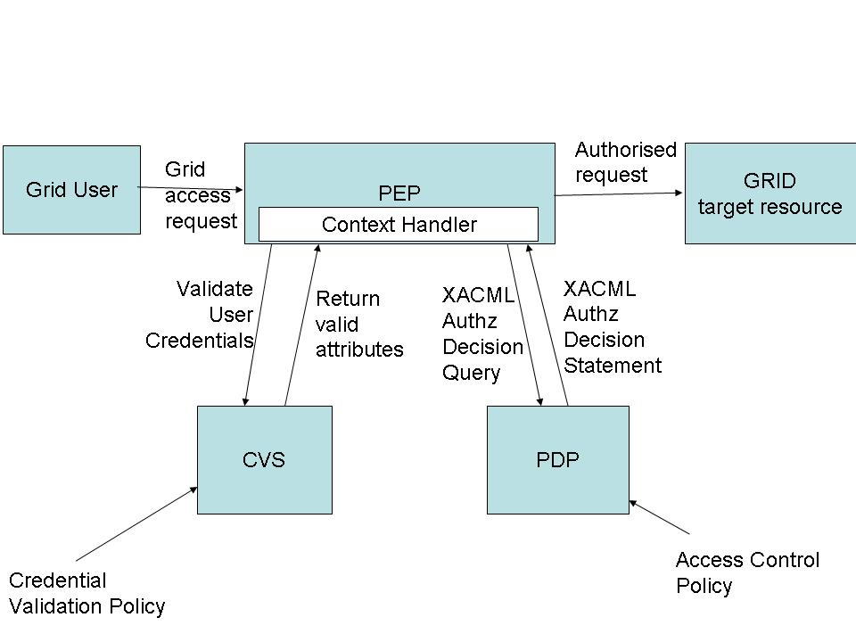
Figure 1. Access Control Model

The Policy Enforcement Point (PEP) is the component of the authorization service that intercepts the user’s request and enforces the access control decisions that are made by the Policy Decision Point (PDP). However, before the PDP can make an access control decision, it has to be given the validated attributes of the user. The Credential Validation Service (CVS) is the functional component that validates the user’s credentials according to its configured Credential Validation Policy, and returns the set of valid user attributes to the PEP. The protocol for accessing the CVS is specified in [CVS]. The context handler component of the PEP is responsible for mapping the attributes returned from the CVS into the correct format for passing to the PDP. This mapping is described in Section 4. The context handler is also responsible for marshalling the attributes that describe the user’s requested action and target resource, as well as any environmental attributes, and placing these into the authorization decision query. This is also described in Section 4. The protocol for accessing the PDP is described in Section 5.

XACML Request Context

The Authorisation Decision Query contains a data structure known as the XACML request context, defined in [XACML] and [XAC-SCHEMA]. An XACML request context contains:
- the validated attributes of the user (in the Subject element),
- the attributes of the Grid target resource being accessed (in the Resource element),
- parameters of the user’s access request (in the Action element), and
- any other attributes that may be needed (in the Environment element).
The XACML request context may also optionally contain the resource that is being accessed e.g. rows from a database, but this profile does not specify how a resource may be transferred to the PDP.

Attributes that the PEP fills into the various elements of the XACML request context can be divided into two categories: application independent attributes and application specific attributes. Application independent attributes are derived from the SOAP header of the service invocation that is under access control. Application specific attributes may be based on content from the SOAP body, or may be derived from application specific knowledge.

Resource Element

The Resource element MUST contain an Attribute element which has the AttributeId attribute with the value "urn:oasis:names:tc:xacml:1.0:resource:resource-id". This is obtained from the wsa:To element of the Soap header, viz:

Description | Address of the invoked service. Value of <wsa:To> element.
XACML request section | Resource
Attribute id | urn:oasis:names:tc:xacml:1.0:resource:resource-id
Value | Content of /soap:Envelope/soap:Header/wsa:To element
Type | http://www.w3.org/2001/XMLSchema#anyURI

The Resource element MAY also contain other Attribute elements. Each Attribute element SHOULD contain at least one AttributeValue element. There MUST be an AttributeId and DataType attribute in each Resource Attribute element.

Subject Element

All the user’s validated attributes are returned from the CVS in a single SAML attribute assertion, encoded in the XACML attribute profile format [SAMLPROF] as specified in [CVS]. These attributes need to be placed into the Subject element of the XACML request context. How this mapping is performed is described in Section 2.1 of [XAC-SAML].

Action Element

The action being requested by the user is derived from wsa:Action element of the SOAP header as follows:

Description | Value of <wsa:Action> element
XACML request section | Action
Attribute id | urn:oasis:names:tc:xacml:1.0:action:action-id
Value | content of /soap:Envelope/soap:Header/wsa:Action element
Type | http://www.w3.org/2001/XMLSchema#anyURI

The Action element MAY also contain other Attribute elements. Each Attribute element SHOULD contain at least one AttributeValue element. There MUST be an AttributeId and DataType attribute in each Action Attribute element.

Environment Element

Each XACML request context MAY contain an Environment element. This document does not specify how the PEP obtains the environmental attributes, but it may use the system clock to obtain the time and date attributes.

An Example XACML Request Context

The following is an example XACML request context for a student from My Org, who wishes to perform get access for 3 (GB) of MRAM (ID = 12345) on the 29th October 2005

<?xml version="1.0" encoding="UTF-8"?>
<Request xmlns="urn:oasis:names:tc:xacml:2.0:context:schema:os"
xmlns:xsi=http://www.w3.org/2001/XMLSchema-instance
xsi:schemaLocation=”urn:oasis:names:tc:xacml:2.0:context:schema:os http://docs.oasis-open.org/xacml/access_control-xacml-2.0-context-schema-os.xsd”>
<Subject>
<Attribute AttributeId="urn:oasis:names:tc:xacml:2.0:subject:role"
DataType="http://www.w3.org/2001/XMLSchema#string">
<AttributeValue>student</AttributeValue>
</Attribute>
<Attribute AttributeId="http://www.ieft.org/rfc/rfc2256.txt#o"
DataType="http://www.w3.org/2001/XMLSchema#string">
<AttributeValue>My Org</AttributeValue>
</Attribute>
</Subject>
<Resource>
<Attribute AttributeId="://www.ieft.org/rfc/rfc2256.txt#objectClass"
DataType="http://www.w3.org/2001/XMLSchema#string">
<AttributeValue>MRAM</AttributeValue>
</Attribute>
<Attribute AttributeId="urn:oasis:names:tc:xacml:1.0:resource:resource-id"
DataType="http://www.w3.org/2001/XMLSchema#string">
<AttributeValue>12345</AttributeValue>
</Attribute>
</Resource>
<Action>
<Attribute AttributeId="urn:oasis:names:tc:xacml:1.0:action:action-id"
DataType="http://www.w3.org/2001/XMLSchema#string">
<AttributeValue>get</AttributeValue>
</Attribute>
<Attribute AttributeId="http://sec.cs.kent.ac.uk/GGF/XACML/MRAM.get.size"
DataType="http://www.w3.org/2001/XMLSchema#integer">
<AttributeValue>3</AttributeValue>
</Attribute>
</Action>
<Environment>
<Attribute AttributeId="urn:oasis:names:tc:xacml:1.0:environment:current-date"
DataType="http://www.w3.org/2001/XMLSchema#date">
<AttributeValue>2005-10-29</AttributeValue>
</Attribute>
</Environment>
</Request>

XACML Response Context

The data structure returned by an XACML conformant PDP is called an XACML Response Context. This contains one or more Result elements.

Result Element

Each Result element contains a Decision element, an optional Status element and an optional Obligations element.

A Result element MAY have a ResourceId attribute and MUST contain a Decision element. It MAY contain a Status Element and MAY contain an Obligation element. The PEP MAY ignore the Status element but MUST act on the returned obligations, if any. If the PEP is unable to fulfill any of the returned obligations then it MUST deny access to the subject.

The Decision element MUST be set to either: Permit, Deny, Indeterminate or NotApplicable.

The value of the ResourceId attribute is obtained from the corresponding resource attribute in the XACML Request Context i.e. the attribute having the name “urn:oasis:names:tc:xacml:1.0:resource:resource-id”.

Obligations Element

An obligation is defined as a set of attribute assignments that MUST be carried out by the PEP.

Each obligation element MUST contain an ObligationID attribute and a FulfillOn attribute. The FulfillOn attribute MUST take the value of Permit or Deny, and MUST be set to the same value as the Decision element. This means that Obligations cannot be returned for Indeterminate and NotApplicable decisions.The PEP MUST act on any returned obligations. If the PEP is unable to fulfill any of the returned obligations then it MUST deny access to the subject.

An example XACML Response Context

The following example XACML Response Context permits the student from My Org to access the MRAM, but places an obligation on the PEP to record the amount of memory being used and to add it to the account balance

<?xml version="1.0" encoding="UTF-8"?>
<Response xmlns="urn:oasis:names:tc:xacml:2.0:context:schema:os"
xmlns:xsi="http://www.w3.org/2001/XMLSchema-instance"
xsi:schemaLocation="urn:oasis:names:tc:xacml:2.0:context:schema:os
http://docs.oasis-open.org/xacml/xacml-core-2.0-context-schema-os.xsd">
<Result ResourceId="12345">
<Decision>Permit</Decision>
<Status>
<StatusCode Value="urn:oasis:names:tc:xacml:1.0:status:ok"/>
</Status>
<Obligations>
<Obligation
ObligationId="http://sec.cs.kent.ac.uk/GGF/XACML/obligation/example"
FulfillOn="Permit">
<AttributeAssignment AttributeId="http://sec.cs.kent.ac.uk/GGF/XACML/environment/balance" DataType="http://www.w3.org/2001/XMLSchema#integer">
&lt;Apply FunctionId="urn:oasis:names:tc:xacml:1.0:function:integer-add"&gt;
&lt;Apply FunctionId="urn:oasis:names:tc:xacml:1.0:function:integer-one-and-only"&gt;
&lt;ActionAttributeDesignator AttributeId="http://sec.cs.kent.ac.uk/GGF/XACML/MRAM.get.size"
DataType="http://www.w3.org/2001/XMLSchema#integer"/&gt;
&lt;/Apply&gt;
&lt;Apply FunctionId="urn:oasis:names:tc:xacml:1.0:function:integer-one-and-only"&gt;
&lt;EnvironmentAttributeDesignator AttributeId="http://sec.cs.kent.ac.uk/GGF/XACML/environment/balance"
DataType="http://www.w3.org/2001/XMLSchema#integer"/&gt;
&lt;/Apply&gt;
&lt;/Apply&gt;
</AttributeAssignment>
</Obligation>
</Obligations>
</Result>
</Response>

XACML Authorization Decision Query and Response

The SAML2.0 profile of XACMLv2.0 [XAC-SAM] specifies extensions to SAML2.0 to enable:
- an XACML request context to be carried in a SAML request message to a PDP
- an XACML response context to be carried in a SAML response message to the PEP

This profile uses the SAML2.0 profile of XACMLv2.0 specified in Section 3 of [XAC-SAM] to carry the authorization decision query and response.

Security Considerations

The whole of this document is concerned with security.

Contributors

David W. Chadwick
The Computing Laboratory
University of Kent
D.W.Chadwick@kent.ac.uk

Linying Su
The Computing Laboratory
University of Kent
L.Su-97@kent.ac.uk

Romain Laborde
The Computing Laboratory
University of Kent
R.Laborde@kent.ac.uk

Acknowledgments

The authors would like to thank the UK JISC and the EC TrustCoM project for jointly funding this work. The authors would also like to thank Erik Rissanen of SICS who produced a related profile for use in the EC TrustCoM project, and upon which some of this document is based.

Intellectual Property Statement

The GGF takes no position regarding the validity or scope of any intellectual property or other rights that might be claimed to pertain to the implementation or use of the technology described in this document or the extent to which any license under such rights might or might not be available; neither does it represent that it has made any effort to identify any such rights. Copies of claims of rights made available for publication and any assurances of licenses to be made available, or the result of an attempt made to obtain a general license or permission for the use of such proprietary rights by implementers or users of this specification can be obtained from the GGF Secretariat.

The GGF invites any interested party to bring to its attention any copyrights, patents or patent applications, or other proprietary rights which may cover technology that may be required to practice this recommendation. Please address the information to the GGF Executive Director.

Disclaimer
This document and the information contained herein is provided on an “As Is” basis and the GGF disclaims all warranties, express or implied, including but not limited to any warranty that the use of the information herein will not infringe any rights or any implied warranties of merchantability or fitness for a particular purpose.

Full Copyright Notice

Copyright (C) Global Grid Forum (2006). All Rights Reserved.

This document and translations of it may be copied and furnished to others, and derivative works that comment on or otherwise explain it or assist in its implementation may be prepared, copied, published and distributed, in whole or in part, without restriction of any kind, provided that the above copyright notice and this paragraph are included on all such copies and derivative works. However, this document itself may not be modified in any way, such as by removing the copyright notice or references to the GGF or other organizations, except as needed for the purpose of developing Grid Recommendations in which case the procedures for copyrights defined in the GGF Document process must be followed, or as required to translate it into languages other than English.

The limited permissions granted above are perpetual and will not be revoked by the GGF or its successors or assignees.

References

[CVS] Credential Validation Service
[HUGHES] Hughes J. and Maler E. Technical Overview of the OASIS Security Assertion Markup Language (SAML) V1.1, May 2004.
[BRADNER] Bradner, S. Key Words for Use in RFCs to Indicate Requirement Levels, RFC 2119. March 1997.
[SAMLPROF] OASIS “Profiles for the OASIS Security Assertion Markup Language (SAML) V2.0”, OASIS Standard, 15 March 2005
[XACML] OASIS “eXtensible Access Control Markup Language (XACML) Version 2.0”
OASIS Standard, 1 Feb 2005
[XAC-SCHEMA]
[XAC-SAM] OASIS “SAML 2.0 profile of XACMLv2.0”. OASIS standard. 1 February 2005

