

The GGF Grid File System Architecture Workbook

Status of This Memo

This memo provides information to the Grid community on the design issues and requirements that the standard Architecture of Grid File System. Distribution is unlimited.

Copyright Notice

Copyright © Global Grid Forum (2002). All Rights Reserved.

Abstract

This is a working document that describes the design issues and requirements that need to be considered while designing the standard architectural framework for Grid File System (GFS) logical namespace, which enables the plug-n-play of resources from different organizations/vendor implementations. This document is based on the information exchanged at the GFS-WG (F2F, Weekly Telecom, Mailing list) and is expected to provide significant input to the Standard recommendation document on GGF Grid File System Architecture. Any comments on this document could be discussed at gfs-wg@ggf.org

Contents
Abstract 1
1. Introduction 3
1.1 Background 3
1.2 Purpose and Status of this document 3
1.3 Intended Audience 3
1.4 Document Organization 3
1.5 Terminology Used 3
1.5.1 Autonomous Administrative Domain 4
1.5.2 Service (or Web Service) 4
1.5.3 Data Grid 4
2. What and Why GFS? 4
3. Vendor/Implementer Expectations on GFS 5
4. Design Goals for GFS 5
4.1 Facilitate Grid and Utility Computing Models 5
4.2 Location and Infrastructure Independent Inter/Intra organizational Namespace 5
4.3 Virtual namespace of WAN file system resources from autonomous domains 6
4.4 Independent of physical data access/transport, authentication mechanisms 6
4.5 Standard Interfaces 7
5. Design issues that need to be discussed and resolved for the GFS Architecture 7
5.1 Criteria for Choosing an Option to Solve an Issue 7
5.2 An Example Scenario 8
5.3 Outstanding issues/concepts requiring attention 9
5.3.1 Logical grid namespace and traditional file system resource namespace 9
5.3.2 Intra-domain user visibility and associated data ownership/access model 9
5.3.3 Logical Storage Resources 10
5.3.4 Work with existing standards without loosing advanced functionalities 10
5.3.5 Vendor Interoperability without loosing advanced functionalities 10
5.3.6 If and/or Can we take advantage of the GGF-Data area stack 10
5.3.7 XML (data format) based messages for interoperability between servers 11
5.3.8 Grid/Web Services and Traditional Clients 11
6. Other standard bodies or Organizations 11
6.1 Enterprise Grid Alliance (EGA) 11
6.2 Distributed Management Task Force (DMTF) 11
6.3 The Internet Engineering Task Force (IETF) 11
6.4 Storage Networking Industry Association (SNIA) 11
6.5 Related Efforts 11
6.5.1 NFSv4 (IETF) 11
6.5.2 CIM (DMTF) 11
7. Summary 11
Author Information 12
Glossary 12
Intellectual Property Statement 12
Full Copyright Notice 12
References 12

Introduction

Background

A Grid is a distributed computing infrastructure formed by combining heterogeneous resources from autonomous administrative domains, as an ensemble to support the execution of large-scale, resource-intensive, and distributed applications. The Resources in a Grid are shared via standard mechanisms based on local site policies along with a coordinated global grid policy.

The autonomous administrative domains that take part in a grid could be either from different organizations (forming an inter-organizational grid or virtual organization), or from the same organization (forming an intra-organizational grid or Enterprise). The resources shared in a grid could possibly include computational resources, information, storage, services etc., Grid users and applications require a logical namespace for using and managing distributed data and other shared resources in the grid.

A Grid File System provides a human-readable logical namespace for management of heterogeneous distributed resources including data, services and other digital representations that are shared amongst the autonomous participants in a grid. This logical namespace consists of human-readable persistent identifiers to represent logical organization of data, storage, services and other digital entities shared in a data grid.

The Grid File System Working Group (GFS-WG) [GFS-WG] in the Global Grid Forum (GGF) [GGF] aims to provide recommendations that lead to standard specifications of Grid File System Directory Services and Architecture of Grid File System Services.

Purpose and Status of this document

This document is aimed at organizing the requirements and design issues that need to be considered in the proposed standard recommendation on the architecture of the Grid File System Services. This is a public information document produced by the GGF Grid File System Working Group, which is part of the Data Area in GGF.

The evolution of this document is an open processes influenced by the discussions in the e-mailing lists and at the GFS-WG sessions. Discussion of this document is invited on our GFS-WG mailing list (gfs-wg@gridforum.org)

Intended Audience

This document is intended for a diverse audience. Expected readers include: People making technical decisions about Grid technologies; Designers and developers of Grid File System Services; Architects of data grid tools and products; and others interested in distributed information storage management standards.

Document Organization
In Section 2 of this workbook (document), we provide some uses of GFS in enterprise architecture. Vendor expectations we have gathered are presented in Section 3. Our design goals are provided in Section 4. The design issues are summarized in section 5.

Terminology Used

This section prepares the reader by introducing some well-known terms and their interpretation as per this GFS document. Additionally a glossary of other terms used in this document is also available towards the end of this document.

Autonomous Administrative Domain
An autonomous administrative domain is a grid entity that:
- Manages one or more grid resources independently
- Can make its own policies
- Might abide by a superior or global grid policy
Each GFS contains one or more autonomous administrative domains with distributed resources that are usually heterogeneous. In simple terms, an autonomous administrative domain could be an organization, or sub-organizational business unit, or a department in a university.

Service (or Web Service)
“A Web service is a software system designed to support interoperable machine-to-machine interaction over a network. It has an interface described in a machine-processable format (specifically WSDL). Other systems interact with the Web service in a manner prescribed by its description using SOAP messages, typically conveyed using HTTP with an XML serialization in conjunction with other Web-related standards.” [W3C WS Architecture]

Data Grid
A data-grid is a location independent federated logical resource namespace consisting persistent global identifiers for data resources, storage resources and users in an inter/intra organizational enterprise formed by the coordinated confluence of autonomous administrative domains.

What and Why GFS?
A Grid File System is a logical namespace of digital entities that can span across multiple autonomous administrative domains and/or multiple file system resources that could be separated by a Wide Area Network (WAN). The GFS logical namespace provides a traditional file system like view that allows plug-n-play of data storage resources and interoperable management of heterogeneous storage systems from different vendors.

Arun Comment (to be removed later): If we add logical resources to this logical namespace, it will result in true utility/grid computing oriented view that can be used to provide storage provisioning across multiple organizations using different vendors. (This had been very useful for us at SDSC for our academic data grid software that manages more than 210 TB using storage resources from different vendors and storage media)

The value addition GFS will provide for enterprises and data centers include (but not limited to):
- Single logical namespace across multiple organizational sub-units that enables ease of data sharing
(Application: Enterprise Mergers, inter/intra-organizational collaboration of sub-units)
- Single logical namespace across multiple file system resources allows ease of ILM (Information Lifecycle Management) across online data and offline archived data
(Application: Backups, data load balancing, data management based on storage resource type)
- Single view of replicated data in multiple data centers
(Application: management of replication and backups)
- Resource Provisioning
(Application: Resource utilization based on supply and demand)
- WAN based multi-vendor supported file system resource management standard using simple interface
(Application: No vendor lock-in for enterprise customers for data storage management solutions)

It is anticipated that the GFS becomes a fundamental standard over which other data grid standards could be built for inter/intra organizational, multi-vendor supported file system resource management.

Vendor/Implementer Expectations on GFS
In this section, we briefly describe the expectations on the GFS standards as expressed by different vendors.
- Multi-vendor Participation
  - Standard interface
- Plug-n-play of resources
  - Storage resources could be added or removed dynamically inter-intra organizational storage pool
  - Management of context of the resources
- Global Namespace Federation
  - Unifies heterogeneous distributed data sources
  - Inter/Intra organizational
  - Online and Offline data
- Inter/Intra Organizational
  - Dynamic usage by users from different organizations
  - Avoid cross-registration of users at sites
- Support existing client protocols
  - Don’t introduce new clients
- Well defined interface
  - Simple interface for clients
- Enables ILM on demand
  - Background data management in an enterprise could be automated easily using a single logical namespace
  - GFS namespace spreads across both online, near-online and offline data that could be used to seamlessly move only selected components of data with affecting the applications/users view
- Object based Storage
  - Define standard remote operations that can be performed on the stored entities

Design Goals for GFS
The overall design goals of GFS are:

Facilitate Grid and Utility Computing Models
The idea here is that GFS is able to act as a virtual namespace manager of file system resources distributed over a Wide Area network. Each enterprise or autonomous administrative domain manages the amount and QoS of the file system resources it needs by adding or removing resources for its online and offline file system resources.

Multiple inter/inter organizational file system resources that are under distributed control of their individual autonomous administrative domains must be able to independently coordinate with the GFS to provide a logical namespace that spans all the participants of the data grid.

Location and Infrastructure Independent Inter/Intra organizational Namespace
The namespace that is rendered by GFS is dynamic and reflects the changes when autonomous domains that provide the resources join or leave the GFS. The namespace rendered is independent of location and infrastructure details allowing the data to be replicated/migrated to any file system resource at any location in the data grid. The user applications still see the same logical namespace and are transparent to physical changes in data (even if the data is physically migrated from one storage system to another in a different organization based on the business demands or ILM processes).

The GFS namespace as shown in Figure 1, is logical and could be different from the underlying file system resources namespace. Each data entry in the in the GFS namespace represents a data endpoint that would be mapped to a file (or any digital entity) in the underlying file system resources (represented as “GRP” in Figure 1). Each GFS maintains this mapping between each GFS entry to its data endpoint including the protocol and authentication mechanism needed to access the physical data. The GFS-WG standards might not provide implementation details on how this mapping or state information will be stored by a GFS implementation. Vendors/ Implementers can store this catalog information using LDAP or any database.

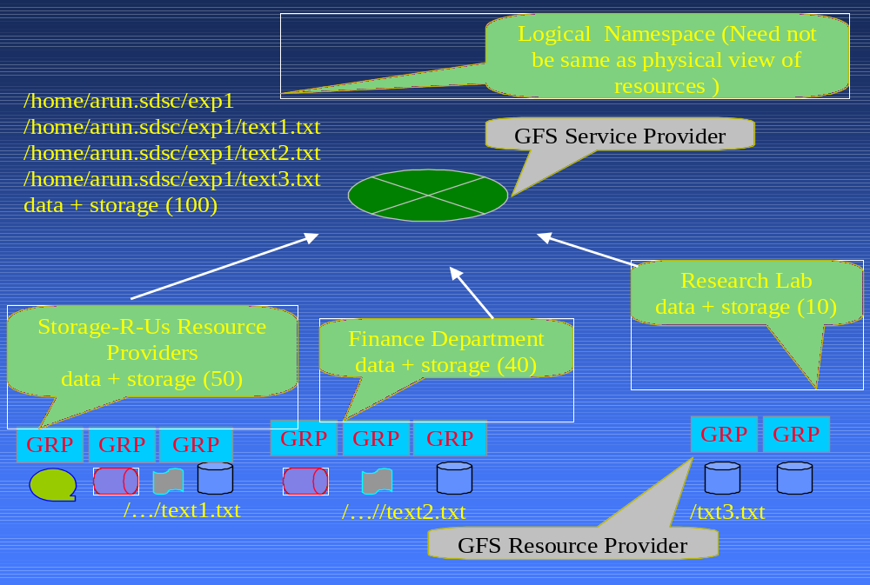
Virtual namespace of WAN file system resources from autonomous domains
Figure 1: Architecture of Grid File System
The file system resources that take part in the GFS from different domains will be distributed across multiple administrative domains and data centers separated by a WAN. The control messages that need to be sent from each of the file system resources to the GFS have to be designed to work well in a WAN (Internet) environment. Bulk and asynchronous operations must be provided.

Independent of physical data access/transport, authentication mechanisms
The underlying file system resources used in the GFS could have their own transport, access, authentication/authorization protocols, which might be standardized or vendor specific. Each of the data endpoints have their own transport and own authentication mechanism.

In addition to the regular file system resources, some of the underlying resources in GFS could also be HTTP, FTP, or GridFTP servers with their files named using URLs. In the GFS namespace, they are represented using logical name, which hides the protocol and location.

Standard Interfaces
The GFS-WG based on the architecture decisions made, would provide the standard interfaces. The standard interfaces MIGHT be the following
- GFS Client Interface: This interface would allow GFS clients to use a GFS namespace. The interface would define the protocol or messages passed between a GFS client and the GFS server.
- GFS Resource Interface: This interface would allow any underlying file system resource to plug into the GFS. The communication between the GFS provider and a GFS Resource Provider would take place using this interface
- GFS Peer Interface: This interface would allow peer-to-peer communication of the GFS Resources (e.g.) when data has to be physically replicated or migrated from one GFS resource to another.
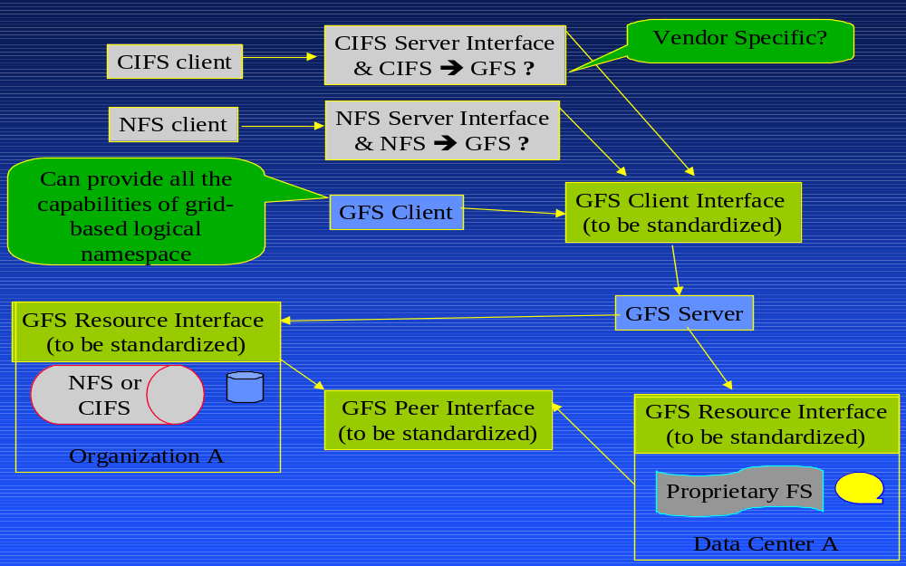
Arun Comment (to be removed later): This section including the above picture has not been discussed elaborately in GFS-WG yet.
Figure 2: GFS Standard Interfaces

Status:
- The GFS Client Interface is being standardized now as VFDS services.
- We need to start working on GFS Resource Interface based on the design decision made regarding the design issues mentioned in the next section
- The GFS Peer Interface standardization MIGHT be started during the next version of the GFS Standards

Design issues that need to be discussed and resolved for the GFS Architecture
In this section, we introduce the major issues that need to be resolved before we can standardize the architecture for the GFS.

Criteria for Choosing an Option to Solve an Issue
The issues mentioned here are actually design decisions on how a common multi-vendor supported GFS infrastructure could be designed. It must be noted that different possibilities or options exist to solve these issues. The challenge is in using the technical or engineering options that:
- Add value to data storage products that will confirm to the GFS standards (rather than provide the same old technology or standard with a new name tag)
- “Community-acceptable” and feasible for implementation by the participants of our GFS Working Group
- Focus on standards for products/implementations required to manage very large-scale inter/inter-organizational file system storage resources, present in distributed enterprises or distributed data centers (rather than LAN based file systems for a single organizational unit).

An Example Scenario
Before describing the issues, we provide a usage scenario of GFS that we will use later in this workbook and in our discussions in GFS sessions:
Lets postulate a scenario where a1.x.com and a2.x.com are two autonomous administrative domains of the enterprise x.com, which are interested in using data grid technologies. Let a1-d1 and a2-d1 be a logical sum of all the file system resources managed by a1 and a2 respectively. In addition, let us assume the existence of int-d1.x.com, a data center exclusively used for x.com’s enterprise file sytem storage including a1 and a2. In addition, let us assume an external data center managed outside their enterprise say ext-d1 used by x.com for its backup or archival data.
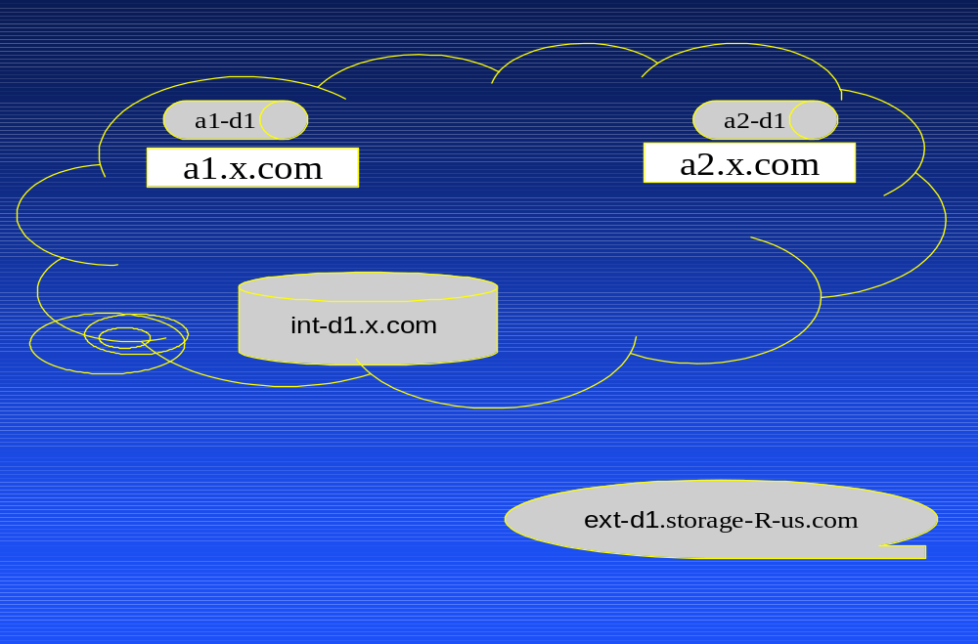
The above-mentioned explained scenario is analogous to the academic data grids in production today. The university labs, with their own local IT resources would be analogous to the autonomous administrative domains a1.x.com and a2.x.com in the figure above. These university labs produce or consume data autonomously sharing resources with other labs occasionally. In a similar way, the supercomputer centers would be analogous to the data centers int-d1 or ext-d1 in the figure above.
Figure 3: Example scenario

Outstanding issues/concepts requiring attention
The following are the outstanding major issues. We will keep updating this list and the options based on the discussions at the GFS-WG.

- Logical grid namespace and traditional file system namespace
- Data-ownership and access control models
- Use of logical storage resources
- Work with existing standards without loosing advanced functionalities
- Vendor interoperability without loosing advanced functionalities
- If/can we take advantage of the GGF-Data area stack
- XML (data format) based messages for interoperability between servers
- Usage of grid and web Services. How can they be taken advantage off?
- Grid File System Standard Interface
- Basic data types

For the rest of this section, we discuss each issue outlined above and the different possible options or the solutions. It must be noted each solution has it advantages and disadvantages and we try (or need) to mention all these here in this section. The reader is requested to provide comments or suggestions to the GFS mailing list regarding this Architecture Workbook.

Logical grid namespace and traditional file system namespace
The logical GFS grid namespace could be a super set that is made of entries from different traditional file system resources. Hence, the GFS grid logical namespace could have different users, different access controls, etc from the traditional file system resources. Even though, the hierarchical view of directories in GFS might be similar to the traditional file systems, the operations that could be performed (like migration, replication, etc.,) and the presence of multiple domains differentiates the GFS namespace from the traditional file system namespace.

[Resolution: The whole WG agreed that the GFS and Traditional FS eventhough might present a similar hierarchical view, are different and need different methodologies]

Intra-domain user visibility and associated data ownership/access model
In our example scenario described in section 5.2 (refer Fig.3), the location-independent logical namespace created by GFS could spread across all file storage system resources from different domains. This would enable user form one domain accessing a file system resource transparently from another domain, which in turn would require the optimal visibility of users across domains required for authentication and authorization.

The following are some possible options:
  - Cross-registrations of users: Information about users are exchanged and cross-registered amongst all the participating domains. This is administratively difficult – but makes it easier for the GFS. This also allows the flexibility to provide granular access controls.
  - Organization as user: Each domain knows only about other domains (but not their internal users). All users from an external domain are mapped to a user account based on their home domain or organization. This would require each domain to have a single account for each other domain in the data grid.
  - Template Roles: Each domain has some pre-defined user-ids to which external users would be mapped. This would allow flexibility for the host domain to manage the external-user ids as well as create more customized user-id for their external users.

Additionally, other related questions need to be discussed:
- Who owns and manages the logical namespace viewed by each autonomous administrative domain that participates in the enterprise GFS?
- Can data from one domain be placed physically in a file system resource from another domain? Who owns the data in such a scenario?
- Who owns the physical data that might be shared or cached as replicas in the enterprise?

- Who owns the data in the archives whose lifetime might exceed the lifetime of the users?
- Do we need different Access controls from the traditional file systems? Who can replicate what data? Who can migrate from one physical data store to another? Who can create logical hierarchy or virtual directories?
- How is intra-domain user authentication/access control handled?

Logical Storage Resources
Can the storage resources from different organizations categorized into different logical resource pools based on their QoS and used in the GFS namespace. This will allow virtualization and “plug-and-play” of the heterogeneous inter/intra organizational resources. We will analyze the advantages and disadvantages of this approach, and provide a model for this if feasible.

Work with existing standards without loosing advanced functionalities
Is it possible that GFS can work with other widely used traditional file system standards including CIFS and NFS? Can such architecture provide the advanced (new) functionalities to end-users?
This has to be discussed further and is mentioned in Figure 2.

Vendor Interoperability without loosing advanced functionalities
Different organizations with different vendor implementations must be able to merge or interoperate on some set of specific data/storage resources. This requires that the vendors follow the same standards that result in GFS interoperability amongst vendor software. If we use a common or minimal denominator, the features set available might not be that impressive. At the same time if we are more stringent and aggressive to have more features in the GFS standards, vendors might not find it easy to implement all the features set list (some of which might not be needed by their customers). To solve this problem, multiple levels of GFS-compatibility could be introduced. Vendors can choose to be compatible with a higher-level GFS service standard with more features and QoS or they can just begin with a lower level compatibility, which provides the basic capabilities for their users.

We will have to analyze the different possibilities and provide a matrix of different levels of GFS-compatibility and the corresponding features set and QoS, the customers can expect.

If and/or Can we take advantage of the GGF-Data area stack
The GGF Data Area has other working groups including:
- DAIS-WG (Data Access and Integration Services)
- GridFTP-WG (Grid File Transfer)
- INFOD-WG (Information Dissemination)
- PA-WG (Persistent Archives)
- OREP-WG (OGSA Replication Services)
- DFDL-WG (Data Format Description Language)
Also outside the data area,
- Grid Security Area: https://forge.gridforum.org/projects/sec (has related working groups)

We need to make sure if/how we relate to this groups and how we can take advantage of their specifications if any. This will make sure the GFS standard is used as a grid technology with any other related products or services seamlessly. We need to analyze on what standards we need to keep in mind while presenting our recommendation to the GGF.

XML (data format) based messages for interoperability between servers
As shown in Figure 2 (section 4.5), the GFS resources would have to exchange control messages between themselves for during data replication, migration and so on. The structure and content of these messages between the GFS file system resources have to be defined. We need to also discuss if these messages could be based on an XML Schema. Using XML Schema provides us the advantages needed for interoperability.

Grid/Web Services and Traditional Clients
One of the aspects of Grid Computing is to provide resources as services. Once grid based utility computing becomes mainstream, enterprises will manage most of their IT infrastructure resources as services that can be offered to their internal or external users. IT infrastructure could be updated based on the user demand or the load on existing resources. The end users will be transparent to these changes and the utility model used by their IT team.

Applying this model to file system resources requires GFS to provide a service-oriented interface that could be used by other Enterprise IT Infrastructure Management applications. In addition, grid applications would require a WS-Resource Framework compliant client interface that can be used to manage files and treat Grid File System as well a any data (including files) as just a resource in the WS-Resource Framework.
On the other hand, most existing enterprise applications and existing vendor software investments require using non-client (or traditional CIFS client) based interface. A service-oriented architecture at the file-level to manage the raw data might have significant performance penalties be paid for the flexibility to change between the service providers. Nevertheless, file system resources generally are used on a longer time frame and the need for the flexibility to change providers might not be significant.

Can the GFS be used as a service for management of the location independent logical namespace alone? How does this relate with traditional file system clients?

Grid File System Standard Service Interface
Grid users and developers would like to see a single interface that represents the entire GFS. This single interface could provide functionalities that are provided as Grid File System.
- VFDS (Virtual File Directory Services)
- RLSS (Replica Location and Selection Service)
- MDS (Meta Data Service)
- Resource Manager (Logical Resource with respect of File Systems only)
- File I/O
- User Access control management

All these functionalities represented in the GFS Service Interface would be from a GFS perspective. The implementer of this service can either build this whole interface as a single software stack (for efficiency purposes) or assemble the different components from the other service interfaces from (VFDS, OREP-WG, Grid-FTP) etc.,

[Resolution: Most of this was discussed and decided at the GGF12. Refer the [GFS Blackboard Picture] drawn in Brussels]

Basic data types

We need to define the schema for basic data types needed like:
Collection or Virtual directory and its listing
- Dataset or File
- Resource
- Access Permission
These have to be consistent with the requirements of GFS. For example we might have complex or esoteric requirements to list a collection which might have millions of files and the GFS server needs a way to batch or split the listing in those cases to multiple sets and relay the information to the GFS clients.

In addition, we need to find the applicability of any existing or emerging industry standards like DMTF CIM Schema [CIM] that might have schema definitions for systems similar to GFS or data grids.

Other standard bodies or Organizations

Enterprise Grid Alliance (EGA)
http://www.gridalliance.org/en/index.asp

Distributed Management Task Force (DMTF)
http://www.dmtf.org/home

The Internet Engineering Task Force (IETF)
http://www.ietf.org/

Storage Networking Industry Association (SNIA)
http://www.snia.org/home

Related Efforts

NFSv4 (IETF)
http://www.nfsv4.org/

CIM (DMTF)
http://www.dmtf.org/standards/cim/

Summary
The standardization is slow, but steady process. Once some critical issues are resolved and initial prototypes are developed by early adopters, community acceptance that would result in compliance by more vendors would be observed. For now, we need more “engineering management” and support from vendors with real people who can participate regularly in the WG and build reference implementations that align with their data storage solutions.

Author Information
This workbook is intended to have contents provided by the members of the GFS-WG. This initial version of this workbook was written by Arun swaran Jagatheesan (arun@sdsc.edu) of the San Diego Supercomputer Center who would continue to edit/update this Workbook. Again, your suggestions and participation to make this workbook more useful are welcome.

Glossary
TBA

Intellectual Property Statement
The GGF takes no position regarding the validity or scope of any intellectual property or other rights that might be claimed to pertain to the implementation or use of the technology described in this document or the extent to which any license under such rights might or might not be available; neither does it represent that it has made any effort to identify any such rights. Copies of claims of rights made available for publication and any assurances of licenses to be made available, or the result of an attempt made to obtain a general license or permission for the use of such proprietary rights by implementers or users of this specification can be obtained from the GGF Secretariat.

The GGF invites any interested party to bring to its attention any copyrights, patents or patent applications, or other proprietary rights which may cover technology that may be required to practice this recommendation. Please address the information to the GGF Executive Director.

Full Copyright Notice

Copyright (C) Global Grid Forum (date). All Rights Reserved.

This document and translations of it may be copied and furnished to others, and derivative works that comment on or otherwise explain it or assist in its implementation may be prepared, copied, published and distributed, in whole or in part, without restriction of any kind, provided that the above copyright notice and this paragraph are included on all such copies and derivative works. However, this document itself may not be modified in any way, such as by removing the copyright notice or references to the GGF or other organizations, except as needed for the purpose of developing Grid Recommendations in which case the procedures for copyrights defined in the GGF Document process must be followed, or as required to translate it into languages other than English.

The limited permissions granted above are perpetual and will not be revoked by the GGF or its successors or assigns.

This document and the information contained herein is provided on an "AS IS" basis and THE GLOBAL GRID FORUM DISCLAIMS ALL WARRANTIES, EXPRESS OR IMPLIED, INCLUDING BUT NOT LIMITED TO ANY WARRANTY THAT THE USE OF THE INFORMATION HEREIN WILL NOT INFRINGE ANY RIGHTS OR ANY IMPLIED WARRANTIES OF MERCHANTABILITY OR FITNESS FOR A PARTICULAR PURPOSE."

References
[GFS-WG] https://forge.gridforum.org/projects/gfs-wg

[GGF] http://www.ggf.org/

[W3C WS Architecture] http://www.w3.org/TR/ws-arch/

[GFS Blackboard Picture] http://users.sdsc.edu/~arun/Research/dataGrid/GGF/GFS-BlackBoardDesign.jpg

[CIM] http://www.dmtf.org/standards/cim/

