OGSA™ EMS Architecture Scenarios

Version 1.0 (draft 011010)

Status of This Document
This document provides information to the community on the scenarios used to refine the OGSA™ EMS architecture. This is an early draft and is still in flux. It does not define any standards or technical recommendations. Distribution is unlimited.

Copyright Notice
Copyright © Open Grid Forum (2006). All Rights Reserved.

Trademarks
OGSA is a trademark of the Open Grid Forum.

Abstract
The OGSA EMS Architecture defines a number of services and XML document types. To illustrate their combined use a set of scenarios is described in this document. The scenarios cover basic job submission, selection of resources, and deployment of resources.

Contents
1 Introduction 3
2 Fundamental Job Execution 3
2.1 Direct Job Execution 3
2.2 Indirect Job Execution 5
2.3 Job Termination 6
3 Selected Job Execution 8
4 Deployment and Configuration 9
4.1 Deploying an Application 9
4.2 Deploying an Application Using ACS 13
5 Security Considerations 15
6 Glossary 16
Intellectual Property Statement 17
Disclaimer 17
Full Copyright Notice 17
Appendix A. Running a BLAST (Basic Local Alignment Search Tool) job 19
A.1. JSDL Document Submitted to the Job Manager 19
A.2. CDL Document retrieved by JM to prepare for deployment 21
A.3. CDL Document submitted by JM to DS 23
A.4. CDL document after DS has finished deployment 25
A.5. JSDL Document submitted to the BES Instance 26

Introduction
The OGSA EMS architecture has been under discussion for many years. In its entirety it is, quite rightly, a complex set of interdependent services. However, not all of these services are required to perform simpler operations within the EMS space. This document describes a set of scenarios that build upon each other to move towards the full EMS architecture.
The initial focus is on fundamental job execution scenarios as these are well understood and in common use in Grid infrastructures such as EGEE and OSG. Scenarios describing the selection of resources for execution as well as the deployment of the necessary software on the resources are also included. Scenarios build on each other and are presented in order. Later versions of this document will expand on other more advanced EMS scenarios.
The emphasis is on using already published specifications, or specifications in the last stages of approval. In all scenarios a list of required specifications is included.

Fundamental Job Execution
Fundamental job execution deals with direct or indirect job submission and management. “Direct” here means that the user, through some user agent, submits and monitors a job execution. In the “indirect” scenario the user “delegates” the management of the job to a job manager.

Direct Job Execution

Assumptions
- The user agent already knows which BES container to use.
- The required BES container is already setup.

Entities
- User Agent
- BES

Description
The client (user agent) contacts the BES container directly and submits a request to start an activity described by a simple JSDL document. Progress is monitored directly by the user agent.
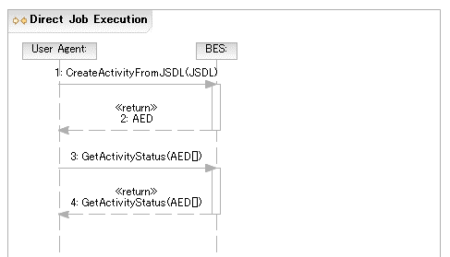
Figure 1 Direct Job Execution

Required Specifications
This scenario requires the BES and JSDL[GFD.56] specifications.

Indirect Job Execution

Assumptions
- The user agent already knows which Job Manager to use.
- The Job Manager already knows which BES container to use.
- The required BES container is already setup.

Entities
- User Agent
- Job Manager
- BES

Description
To enable more sophisticated EMS scenarios it is important that the user can delegate decision making and control to an entity that is more sophisticated than a “user agent”—a Job Manager. The user agent contacts the job manager, specifying the job, which is then executed on an established BES container. Once the activity is established it is monitored by the Job Manager.

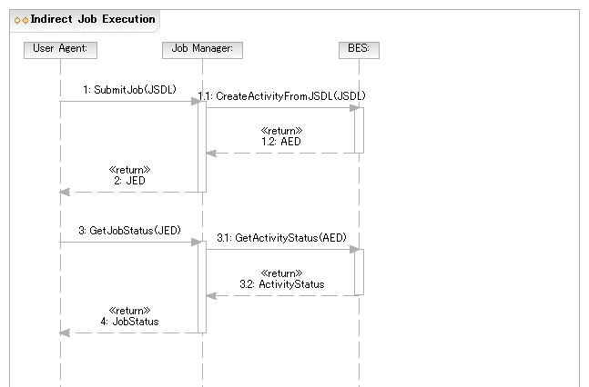
Figure 2 Indirect Job Execution

Required Specifications
This scenario requires the BES, JSDL, and Job Manager specifications.

Job Termination
The user agent may wait for the activity to terminate—successfully or not—or request that the activity is terminated.

Normal Termination of Job

Assumptions
- The user agent already has a reference to the BES container.

Entities
- User Agent
- BES
- Activity

Description
The user agent waits until the activity terminates normally. The User Agent detects this by polling or receiving a notification (not shown).
It may also be possible for the user agent to poll or receive notifications directly from the Activity (not shown).

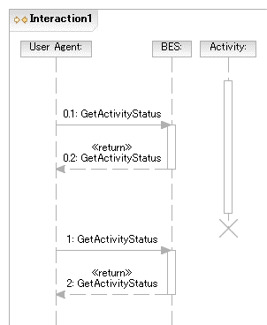
Figure 3 Normal Job Termination

Required Specifications
This scenario requires the BES specification.

Job killed by User Agent

Assumptions
- The user agent already has a reference to the BES container.

Entities
- User Agent
- BES
- Activity

Description
The user agent requests that the activity is terminated.
It may also be possible for the user agent to terminate the Activity directly (not shown).

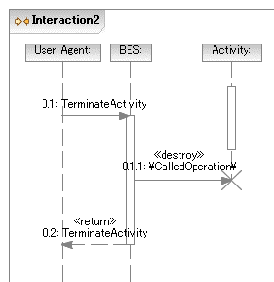
Figure 4 Job killed by User Agent

Required Specifications
This scenario requires the BES specification and an Activity specification.

Selected Job Execution

Assumptions
- The user agent already has a reference to a Job Manager.
- The Job Manager already knows which EPS to use.
- The BES container has not been determined at submission time.
- There is a BES container already setup that can run the submitted job.

Entities
- User Agent
- Job Manager
- BES
- EPS

Description

The user agent submits a JSDL document requiring the BLAST application to the Job Manager as in the scenario described in §2.2. The Job Manager uses the Execution Planning Service (EPS) (part of the Resource Selection Services (RSS)) to select a BES instance. It submits the JSDL document to the EPS and receives a, possibly null, list of activity execution candidates for the job. An activity execution candidate (plan) is made up of at least a JSDL document (possibly refined) and a reference to a BES container.

For the purposes of this scenario the first plan returned is considered to be the best choice. The JM starts the requested activity by submitting the JSDL document returned in the activity execution candidate to the selected BES instance.
If the submission to the BES container in the first plan fails (not shown) then the next plan may be chosen instead as a failover option, or if there are no other plans left, the job execution overall fails.

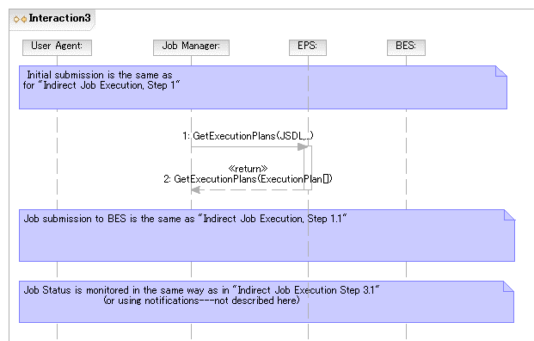
Figure 5 Selected Job Execution

Required Specifications
This scenario requires the BES, JSDL, JM, and RSS specifications.

Notes
- The JSDL document returned in the activity execution candidate may be refined to allow the rewriting of things such as abstract resources (such as one identifying the abstract name of some sequence database) into a set of requirements for making that resource available at the suggested BES container (e.g. by extending the set of DataStaging elements, or by providing an appropriate CDL document).
- Internally, the RSS may use a simple selection algorithm (e.g., number of pre-defined BES instances to round-robin the job request from the job manager to one of these interfaces; or could obtain and select BES instances using an information service such as a service registry). With a defined selection language the RSS implementation can be more sophisticated by allowing a user defined selection policy to be applied to the available services in the registry.

Deployment and Configuration

Deploying an Application
A simple POSIX application (BLAST) needs to be deployed to support an activity that is to be initiated within a BES container.

Assumptions
- The user agent already has a reference to a Job Manager.
- The Job Manager already knows which EPS to use.
- The BES container is determined at submission time---but the actual resource, a.k.a. host, will be chosen at deployment time.
  - For example, the BES instance reference is specified as an argument to the submission operation and is not included in the JSDL document.
- The BES container is not already setup to run the job.
- The JM has suitable binaries and other relevant information required to setup the BES container.
  - For example a BLAST binary, a BLAST database—possibly created by an earlier preparatory job—as well as a “BLAST Application” CDL document describing the deployment requirements. The scenario described in §4.2 describes how these can be retrieved from a repository service.
  - The “BLAST Application” document may have a number of ‘lazy elements’, e.g., “Hostname” and “PathName.” In other words it is a CDL document template. Also it can be assumed that the JSDL and CDL documents are created by tooling and are consistent—but not necessarily complete.
- The JM knows which deployment service (DS) can be used to deploy to the specified BES instance.

Entities
- User Agent
- Job Manager
- Information Service
- Deployment Service
- BES
- BLAST System

Description

The User Agent submits to the JM a JSDL document requiring a BLAST application execution on a specific BES instance.
The JM queries the Information Service (IS), or the platform directly, and discovers that the specified BES instance (manages resources that) does not have the BLAST application installed on it.
The JM submits the BLAST CDL document to the DS. The DS completes any remaining lazy elements in the CDL document—e.g., the name of the resource (host) on which to deploy is a lazy element in this scenario—carries out the installation and returns an EPR to the JM providing a reference to the installed software.
The IS entry of the resource is updated with the location of the BLAST application. (This update may be done by the resource itself, the DS, the JM, etc.) This prevents the removal of the resource as ‘something’—the BLAST application—is ‘using’ it.
The JM uses the EPR to the installed software to retrieve information it needs to refine the JSDL document. This is effectively an operation to retrieve relevant chunks of the XML deployment tree (i.e. the instantiated CDL document) back to the JM for insertion into JSDL document.
The, now complete, JSDL document is sent to the BES instance on that platform.
The IS entry of the BLAST application is updated with the information that the BES Activity now has an “interest” in the application. (This update may be done by the BES Activity, the JM, etc.) If another BES Activity uses this BLAST application its “interest” can be registered in the same way to make sure that the BLAST application remains available to it.
Once the BES Activity completes successfully the IS entry of the BLAST application is updated to remove the “interest” of the BES Activity.

The User Agent is informed that the job is complete.

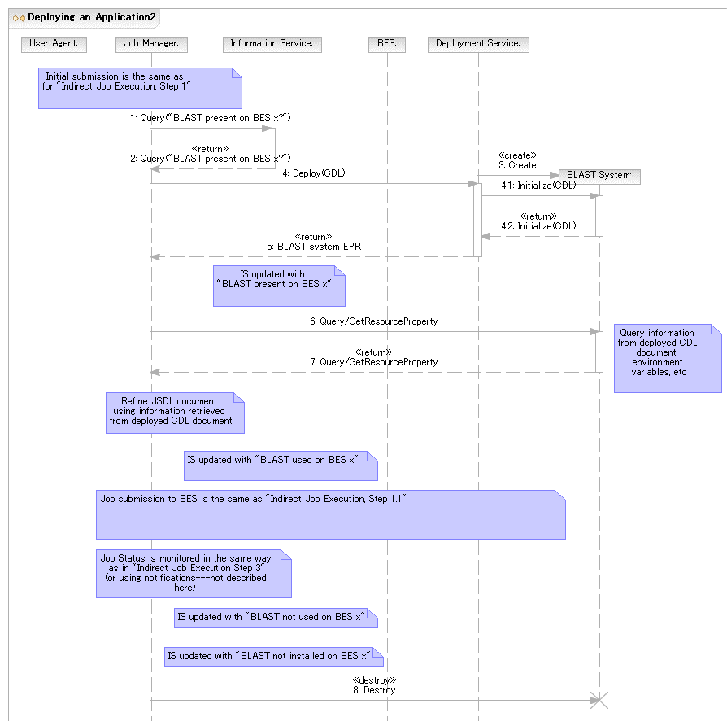
Figure 6 Deploying an Application

Required Specifications
This scenario requires the JSDL, Job Manager, CDL and other supporting component specifications like the POSIXApplication component, Deployment Service and (unspecified) Information Services specifications.

Notes
In the simplest case the DS may be located on the platform hosting the BES instance, or there is some other well known (pre-configured) relationship. In general the DS may, however, act as a proxy for deployment on platforms other than the one it is running on. It may also be possible that there are multiple DS in a system. It is therefore recommended that a DS advertise (somewhere, in a currently unspecified manner) where it is capable of deploying stuff to, e.g., front end node for a cluster.

Deploying an Application Using ACS
In this scenario a simple POSIX application (BLAST) needs to be deployed to support an activity that is to be initiated within a BES container.

Assumptions
- The user agent already has a reference to a Job Manager.
- The Job Manager already knows which EPS to use.
- The BES container is determined at submission time---but the actual resource, a.k.a. host, will be chosen at deployment time.
  - For example, the BES instance reference is specified as an argument to the submission operation and is not included in the JSDL document.
- The BES container is not already setup to run the job.
- The JM does NOT have suitable binaries and other relevant information required to setup the BES container.
- The Job Manager has a reference to an Application Contents Service Repository.
- The Application Contents Services (ACS) Repository already has registered an Application Archive (AA)—addressable by an EPR—that contains all information required to install and configure BLAST.
- The JM knows which deployment service (DS) can be used to deploy to the specified BES instance.

Entities
- User Agent
- Job Manager
- Application Contents Service
- BLAST Archive
- Deployment Service
- BES

Description

As in the previous scenario the User Agent submits a JSDL document, which requires the BLAST application, to the JM. The BES container is specified as an argument to the submission operation. The JM determines that the BES container does not have BLAST.
The JM uses the contents of the JSDL ApplicationName and ApplicationVersion elements to search for a matching AA in the ACS Repository using the LookupArchives operation. The EPR of the AA that has the matching BLAST application is returned.
Alternatives to using the LookupArchives operation to locate an appropriate AA exist and may be preferable in real deployments. For example, it is possible to provide the EPR to required AA as part of the submission, e.g., inside the JSDL document as an extension to the Application element. Also systems using RNS (Resource Namespace Service) may support naming applications using RNS, e.g., the JSDL ApplicationName element may contain an RNS application name, which can then be used to locate the corresponding AA in an ACS Repository.
The JM uses the AA GetContents operation to retrieve the CDL document describing the BLAST deployment requirements. (Comments made in previous scenarios about this CDL document also apply here.)
The CDL document (which may still contain lazy elements) is then submitted to the DS that can deploy to the platform hosting the BES instance (see previous scenarios).
There is behind-the-scenes interaction (to be shown) between the DS and the ACS Repository. For example, the DS retrieves the binary corresponding to the BLAST application from the ACS Repository.
The remaining steps are the same as in previous scenarios.

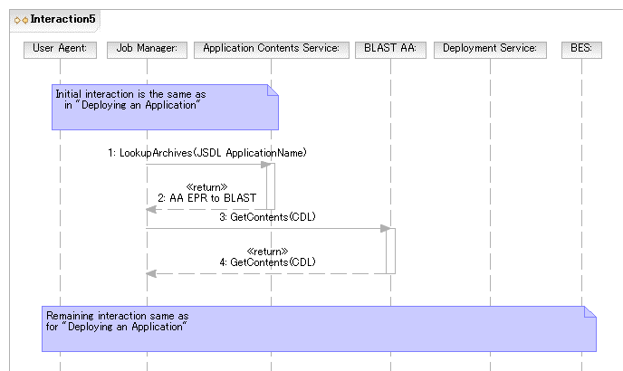
Figure 7 Deploying an Application using ACS

Required Specifications
This scenario requires the JSDL, Job Manager, ACS, CDL and supporting component specifications, and (unspecified) Information Services specifications.

Notes
For simplicity it is assumed that matching ApplicationName and ApplicationVersion with an AA is sufficient. In scenarios using the EPS this search-and-match may be done by the EPS and it may include a matching of Archive requirements with the job description.

Undeploying an Application

Assumptions
- …

Entities
- Information Service
- Deployment Service
- BES
- BLAST System

Description
Once a BES Activity completes successfully the IS entry of the BLAST application is updated to remove the “interest” of the BES Activity. When no other activities are registering an interest in a specific instance of a BLAST application on a resource then the “undeploy” operation may be invoked on the Deployment Service to remove this BLAST application from the resource.
The application may remain installed for some period of time if it is expected that it may be re-used, even if no Activity is registering a specific interest for it.
If the BLAST application is removed then its entry in the IS is also removed.

Figure 8 Undeploying an Application

Required Specifications
This scenario requires the CDL and other supporting component specifications like the POSIXApplication component, Deployment Service and (unspecified) Information Services specifications.

Notes

Security Considerations
…
Editor Information
…
Contributor
…
Donal Fellows
Jun Tatemura
Acknowledgements
…
OGSA-WG member reviewing

Glossary
For the purposes of this document we define:
- Life Cycle: Both provisioning and deployment actions have a life cycle – they are created, used, and eventually destroyed. A mechanism is needed for activities to ‘register’ their use and interest in a particular activity. Before an activity is destroyed there have to be no outstanding references. [Look at EGA provisioning state model.]
- Provisioning: The instantiation of an environment on a resource (i.e. a deployment activity) that may be used by more than one activity. Generally these deployments are ‘heavyweight’ in that they may take substantial time to instantiate. Provisioning actions may be triggered by a specific activity (e.g. following a manual job submission) or as a result of general response (as defined by a policy) to the state of current resources in the system.
  - For example, “if my available free RHEL4 resources have dropped to 5%, dynamically provision new nodes until the total free nodes have increased to 15%.”
- Deployment: The instantiation of an environment on a resource to meet the needs of a specific activity such as a submitted job. This is generally a ‘lightweight’ action in that may just provide a binary, dataset, etc., onto the resource. Once used by the specified activity that environment may be removed immediately; or left as part of a ‘cache’ to be cleaned up or reused at a later date. (A ‘keep alive’ model might be needed in the latter case.)
  - For example, an activity wants to run Gaussian: download and install the required version for this platform.
- Activity: The smallest part of possibly a larger sequence of activities generated from a single submitted job.
- Job Manager (JM): The entity that accepts a ‘job’ (defined by a JSDL document) from the user agent. The JM coordinates further invocations and interactions with other elements of the EMS architecture.
- JSDL: Job Submission Description Language (GFD.56)
- Deployment Service (DS): The entity that accepts a ‘deployment’ action (defined by a CDL document) to instantiate an environment on the resource to support a BES job. The DS provides the bootstrapping for all deployment/provisioning actions. (GFD.69)
- CDL: Configuration Description Language
- CDL document template: A CDL document that still contains unresolved type references, e.g., lazy elements. (Note that this is not a CDDLM defined term. It is used for convenience.)
- Basic Execution Service (BES): The entity that accepts a JSDL document and instantiates an Activity. BES does not do provisioning/deployment.

Intellectual Property Statement
The OGF takes no position regarding the validity or scope of any intellectual property or other rights that might be claimed to pertain to the implementation or use of the technology described in this document or the extent to which any license under such rights might or might not be available; neither does it represent that it has made any effort to identify any such rights. Copies of claims of rights made available for publication and any assurances of licenses to be made available, or the result of an attempt made to obtain a general license or permission for the use of such proprietary rights by implementers or users of this specification can be obtained from the OGF Secretariat.
The OGF invites any interested party to bring to its attention any copyrights, patents or patent applications, or other proprietary rights which may cover technology that may be required to practice this recommendation. Please address the information to the OGF Executive Director.

Disclaimer
This document and the information contained herein is provided on an “As Is” basis and the OGF disclaims all warranties, express or implied, including but not limited to any warranty that the use of the information herein will not infringe any rights or any implied warranties of merchantability or fitness for a particular purpose.

Full Copyright Notice
Copyright (C) Open Grid Forum (2006). All Rights Reserved.
This document and translations of it may be copied and furnished to others, and derivative works that comment on or otherwise explain it or assist in its implementation may be prepared, copied, published and distributed, in whole or in part, without restriction of any kind, provided that the above copyright notice and this paragraph are included on all such copies and derivative works. However, this document itself may not be modified in any way, such as by removing the copyright notice or references to the OGF or other organizations, except as needed for the purpose of developing Grid Recommendations in which case the procedures for copyrights defined in the OGF Document process must be followed, or as required to translate it into languages other than English.

The limited permissions granted above are perpetual and will not be revoked by the OGF or its successors or assignees.
References
BES
[GFD.56] A. Anjomshoaa, F. Brisard, M. Drescher, D. Fellows, A. Ly, S. McGough, D. Pulsipher, and A. Savva (ed.) Job Submission Description Language (JSDL) Specification, Version 1.0, Global Grid Forum, Lemont, Illinois, U.S.A., GFD.56, November 2005. http://www.ggf.org/documents/final.htm
RSS
Deployment API
CDL
…
- Running a BLAST (Basic Local Alignment Search Tool) job
  - JSDL Document Submitted to the Job Manager
According to the scenario above the JSDL document must contain at a minimum:
- The application name
Highlighted text indicates portions that may need refinement or have linkage to CDL.

<?xml version="1.0" encoding="UTF-8"?>
<jsdl:JobDefinition
xmlns:jsdl="http://schemas.ggf.org/jsdl/2005/11/jsdl"
xmlns:jsdl-posix="http://schemas.ggf.org/jsdl/2005/11/jsdl-posix"
xmlns:xsi="http://www.w3.org/2001/XMLSchema-instance"
xsi:schemaLocation="http://schemas.ggf.org/jsdl/2005/11/jsdl jsdl.xsd
http://schemas.ggf.org/jsdl/2005/11/jsdl-posix jsdl-posix.xsd">
<jsdl:JobDescription>
<jsdl:JobIdentification>
<jsdl:JobName>Blast1</jsdl:JobName>
<jsdl:Description>Blast query number 1</jsdl:Description>
<jsdl:JobProject>BlastProject</jsdl:JobProject>
</jsdl:JobIdentification>
<jsdl:Application>
<jsdl:ApplicationName>BlastN</jsdl:ApplicationName>
<jsdl:ApplicationVersion>2.2.13</jsdl:ApplicationVersion>
<jsdl:Description>BlastN performs nucleotide similarity
searching</jsdl:Description>
<jsdl-posix:POSIXApplication>
<!-- EXECUTABLE LOCATION NOT KNOWN YET -->
<jsdl-posix:Argument>-p</jsdl-posix:Argument>
<jsdl-posix:Argument>blastn</jsdl-posix:Argument>
<jsdl-posix:Argument>-d</jsdl-posix:Argument>
<jsdl-posix:Argument>/db/ncbiblast/est</jsdl-posix:Argument>
<jsdl-posix:Argument>-T</jsdl-posix:Argument>
<jsdl-posix:Argument>T</jsdl-posix:Argument>
<jsdl-posix:Input filesystemName="HOME">
sequences1.txt</jsdl-posix:Input>
<jsdl-posix:Output filesystemName="HOME">
sequences1.html</jsdl-posix:Output>
<jsdl-posix:Error filesystemName="HOME">
sequences1.err</jsdl-posix:Error>
<jsdl-posix:WorkingDirectory filesystemName="HOME">
blastqueries</jsdl-posix:WorkingDirectory>
<!--ENVIRONMENT TO BE INSERTED POST DEPLOYMENT-->
<!--Limits to be defined based on what the user is allowed-->
<jsdl-posix:UserName>csmith</jsdl-posix:UserName>
<jsdl-posix:GroupName>bio</jsdl-posix:GroupName>
</jsdl-posix:POSIXApplication>
</jsdl:Application>
<jsdl:Resources>
<!--Once the host is determined it is included here-->
<jsdl:FileSystem name="TMP">
<jsdl:FileSystemType>temporary</jsdl:FileSystemType>
<jsdl:Description>Well-known ‘name’ for temporary space that
does not necessarily persist after the job terminates.
</jsdl:Description>
<jsdl:DiskSpace>
<jsdl:LowerBoundedRange>10737418240.0</jsdl:LowerBoundedRange>
</jsdl:DiskSpace>
<!--Detailed setup to be provided by a CDL document.
Some values may be added here when refining.-->
</jsdl:FileSystem>
<jsdl:FileSystem name="HOME">
<jsdl:FileSystemType>normal</jsdl:FileSystemType>
<jsdl:Description>Chris's home directory</jsdl:Description>
<!--Detailed setup to be provided by a CDL document.
Some values may be added here when refining.-->
</jsdl:FileSystem>
<jsdl:FileSystem name="DB">
<jsdl:FileSystemType>normal</jsdl:FileSystemType>
<jsdl:Description>Formatted BLAST database</jsdl:Description>
<!--Detailed setup to be provided by a CDL document.
Some values may be added here when refining.-->
<jsdl:MountPoint>/db/ncbiblast</jsdl:MountPoint>
</jsdl:FileSystem>
<jsdl:ExclusiveExecution>true</jsdl:ExclusiveExecution>
<jsdl:TotalCPUCount>
<jsdl:Exact>1.0</jsdl:Exact>
</jsdl:TotalCPUCount>
</jsdl:Resources>
<jsdl:DataStaging>
<jsdl:FileName>blastqueries/sequences1.txt</jsdl:FileName>
<jsdl:FilesystemName>HOME</jsdl:FilesystemName>
<jsdl:CreationFlag>overwrite</jsdl:CreationFlag>
<jsdl:Source>
<jsdl:URI>
http://csmith.otherhost.com/blastqueries/sequences1.txt
</jsdl:URI>
</jsdl:Source>
</jsdl:DataStaging>
<jsdl:DataStaging>
<jsdl:FileName>blastqueries/sequences1.html</jsdl:FileName>
<jsdl:FilesystemName>HOME</jsdl:FilesystemName>
<jsdl:CreationFlag>overwrite</jsdl:CreationFlag>
<jsdl:Target>
<jsdl:URI>
http://csmith.otherhost.com/blastqueries/sequences1.html
</jsdl:URI>
</jsdl:Target>
</jsdl:DataStaging>
<jsdl:DataStaging>
<jsdl:FileName>blastqueries/sequences1.err</jsdl:FileName>
<jsdl:FilesystemName>HOME</jsdl:FilesystemName>
<jsdl:CreationFlag>append</jsdl:CreationFlag>
<jsdl:Target>
<jsdl:URI>
http://csmith.otherhost.com/blastqueries/sequences1.err
</jsdl:URI>
</jsdl:Target>
</jsdl:DataStaging>
</jsdl:JobDescription>
</jsdl:JobDefinition>
  - CDL Document retrieved by JM to prepare for deployment
This appendix shows an example initial CDL document (template) that may be retrieved by the JM.
This CDL document assumes the definition of “BasicPosixComponent,” which is not described in this document.
<?xml version="1.0" encoding="UTF-8"?>
<cdl:cdl
targetNamespace="http://cddlm.org/component-model-example"
xmlns="http://cddlm.org/component-model-example"
xmlns:cdl="http://www.gridforum.org/namespaces/2005/02/cddlm/CDL-1.0"
xmlns:cmp="http://www.gridforum.org/cddlm/components/2005/02"
xmlns:bpc="http://www.gridforum.org/ogsa/BasicPosixComponent/2006/06"
xmlns:xsd="http://www.w3.org/2001/XMLSchema">
<cdl:system>
<Blast cdl:extends="bpc:PosixApplication">
<cdl:documentation>
Configuration data for BLAST binary deployment.
</cdl:documentation>
<BlastApp cdl:extends="bpc:Application">
<Binary type="tar">http://blast.app.com/blast.tar</Binary>
<UserName>csmith</UserName>
<GroupName>bio</GroupName>
<Mode>755</Mode>
</BlastApp>
<TmpFileSystem cdl:extends="bpc:FileSystem">
<cdl:documentation>
Configuration data for temporary file system.
</cdl:documentation>
<FileSystemType>temporary</FileSystemType>
<DiskSpace>
<LowerBoundedRange>10737418240</LowerBoundedRange>
</DiskSpace>
</TmpFileSystem>
<HomeFileSystem cdl:extends="bpc:FileSystem">
<cdl:documentation>
Configuration data for home file system.
</cdl:documentation>
<FileSystemType>normal</FileSystemType>
<MountSource>server.acme.com:/home/csmith</MountSource>
<MountPoint>/home/csmith</MountPoint>
</HomeFileSystem>
<DataBaseFileSystem cdl:extends="bpc:FileSystem">
<cdl:documentation>
Configuration data for formatted database file system.
</cdl:documentation>
<FileSystemType>normal</FileSystemType>
<MountSource>server.acme.com:/db/ncbiblast</MountSource>
<MountPoint>/db/ncbiblast</MountPoint>
</DataBaseFileSystem>
<PATH cdl:extends="bpc:EnvironmentVariable"/>
<cdl:documentation>
Proper value of PATH environment variable will be
available after
deployment.
</cdl:documentation>
<TMPDIR cdl:extends="bpc:EnvironmentVariable"/>
<cdl:documentation>
Proper value of TMPDIR environment variable will be
available after
deployment.
</cdl:documentation>
<HOSTNAME cdl:extends=”bpc:HostName”/>
<cdl:documentation>
Proper value of HOSTNAME ‘variable’ will be
filled in before submission. Note this is not according
to the CDDLM spec and is mainly for illustration.
</cdl:documentation>
</Blast>
</cdl:system>
</cdl:cdl>
  - CDL Document submitted by JM to DS
The CDL template after the JM has (possibly) added some values. In this example the JM has added the hostname value.
Otherwise the CDL document is identical to to the one shown in A.2.
<?xml version="1.0" encoding="UTF-8"?>
<cdl:cdl
targetNamespace="http://cddlm.org/component-model-example"
xmlns="http://cddlm.org/component-model-example"
xmlns:cdl="http://www.gridforum.org/namespaces/2005/02/cddlm/CDL-1.0"
xmlns:cmp="http://www.gridforum.org/cddlm/components/2005/02"
xmlns:bpc="http://www.gridforum.org/ogsa/BasicPosixComponent/2006/06"
xmlns:xsd="http://www.w3.org/2001/XMLSchema">
<cdl:system>
<Blast cdl:extends="bpc:PosixApplication">
<cdl:documentation>
Configuration data for BLAST binary deployment.
</cdl:documentation>
<BlastApp cdl:extends="bpc:Application">
<Binary type="tar">http://blast.app.com/blast.tar</Binary>
<UserName>csmith</UserName>
<GroupName>bio</GroupName>
<Mode>755</Mode>
</BlastApp>
<TmpFileSystem cdl:extends="bpc:FileSystem">
<cdl:documentation>
Configuration data for temporary file system.
</cdl:documentation>
<FileSystemType>temporary</FileSystemType>
<DiskSpace>
<LowerBoundedRange>10737418240</LowerBoundedRange>
</DiskSpace>
</TmpFileSystem>
<HomeFileSystem cdl:extends="bpc:FileSystem">
<cdl:documentation>
Configuration data for home file system.
</cdl:documentation>
<FileSystemType>normal</FileSystemType>
<MountSource>server.acme.com:/home/csmith</MountSource>
<MountPoint>/home/csmith</MountPoint>
</HomeFileSystem>
<DataBaseFileSystem cdl:extends="bpc:FileSystem">
<cdl:documentation>
Configuration data for formatted database file system.
</cdl:documentation>
<FileSystemType>normal</FileSystemType>
<MountSource>server.acme.com:/db/ncbiblast</MountSource>
<MountPoint>/db/ncbiblast</MountPoint>
</DataBaseFileSystem>
<PATH cdl:extends="bpc:EnvironmentVariable"/>
<cdl:documentation>
Proper value of PATH environment variable will be
available after deployment.
</cdl:documentation>
<TMPDIR cdl:extends="bpc:EnvironmentVariable"/>
<cdl:documentation>
Proper value of TMPDIR environment variable will be
available after deployment.
</cdl:documentation>
<HOSTNAME cdl:extends=”bpc:HostName”>cluster1</HOSTNAME>
<cdl:documentation>
Value of HOSTNAME was filled in by JM.
Note this is not according to the CDDLM spec and is
mainly for illustration.
</cdl:documentation>
</Blast>
</cdl:system>
</cdl:cdl>

  - CDL document after DS has finished deployment
After deployment the completely resolved CDL document contains no lazy elements.
<?xml version="1.0" encoding="UTF-8"?>
<cdl:cdl
targetNamespace="http://cddlm.org/component-model-example"
xmlns="http://cddlm.org/component-model-example"
xmlns:cdl="http://www.gridforum.org/namespaces/2005/02/cddlm/CDL-1.0"
xmlns:cmp="http://www.gridforum.org/cddlm/components/2005/02"
xmlns:bpc="http://www.gridforum.org/ogsa/BasicPosixComponent/2006/06"
xmlns:xsd="http://www.w3.org/2001/XMLSchema">
<cdl:system>
<Blast cdl:extends="bpc:PosixApplication">
<cdl:documentation>
Configuration data for BLAST binary deployment.
</cdl:documentation>
<BlastApp cdl:extends="bpc:Application">
<Binary type="tar">http://blast.app.com/blast.tar</Binary>
<UserName>csmith</UserName>
<GroupName>bio</GroupName>
<Mode>755</Mode>
</BlastApp>
<TmpFileSystem cdl:extends="bpc:FileSystem">
<cdl:documentation>
Configuration data for temporary file system.
</cdl:documentation>
<FileSystemType>temporary</FileSystemType>
<DiskSpace>
<LowerBoundedRange>10737418240</LowerBoundedRange>
</DiskSpace>
</TmpFileSystem>
<HomeFileSystem cdl:extends="bpc:FileSystem">
<cdl:documentation>
Configuration data for home file system.
</cdl:documentation>
<FileSystemType>normal</FileSystemType>
<MountSource>server.acme.com:/home/csmith</MountSource>
<MountPoint>/home/csmith</MountPoint>
</HomeFileSystem>
<DataBaseFileSystem cdl:extends="bpc:FileSystem">
<cdl:documentation>
Configuration data for formatted database file system.
</cdl:documentation>
<FileSystemType>normal</FileSystemType>
<MountSource>server.acme.com:/db/ncbiblast</MountSource>
<MountPoint>/db/ncbiblast</MountPoint>
</DataBaseFileSystem>
<PATH cdl:extends="bpc:EnvironmentVariable">
/usr/bin:/usr/local/bin:/usr/local/bio/bin</PATH>
<TMPDIR cdl:extends="bpc:EnvironmentVariable">
/tmp</TMPDIR>
<HOSTNAME cdl:extends=”bpc:HostName”>
node0.cluster1</HOSTNAME>
</Blast>
</cdl:system>
</cdl:cdl>
  - JSDL Document submitted to the BES Instance
The final, refined, JSDL document submitted to BES for execution. Refinements of the initial document are highlighted.
<?xml version="1.0" encoding="UTF-8"?>
<jsdl:JobDefinition
xmlns:jsdl="http://schemas.ggf.org/jsdl/2005/11/jsdl"
xmlns:jsdl-posix="http://schemas.ggf.org/jsdl/2005/11/jsdl-posix"
xmlns:xsi="http://www.w3.org/2001/XMLSchema-instance"
xsi:schemaLocation="http://schemas.ggf.org/jsdl/2005/11/jsdl jsdl.xsd
http://schemas.ggf.org/jsdl/2005/11/jsdl-posix jsdl-posix.xsd">
<jsdl:JobDescription>
<jsdl:JobIdentification>
<jsdl:JobName>Blast1</jsdl:JobName>
<jsdl:Description>Blast query number 1</jsdl:Description>
<jsdl:JobProject>BlastProject</jsdl:JobProject>
</jsdl:JobIdentification>
<jsdl:Application>
<jsdl:ApplicationName>BlastN</jsdl:ApplicationName>
<jsdl:ApplicationVersion>2.2.13</jsdl:ApplicationVersion>
<jsdl:Description>BlastN performs nucleotide similarity
searching</jsdl:Description>
<jsdl-posix:POSIXApplication>
<jsdl-posix:Executable>/usr/local/bin/blastall
</jsdl-posix:Executable>
<jsdl-posix:Argument>-p</jsdl-posix:Argument>
<jsdl-posix:Argument>blastn</jsdl-posix:Argument>
<jsdl-posix:Argument>-d</jsdl-posix:Argument>
<jsdl-posix:Argument>est</jsdl-posix:Argument>
<jsdl-posix:Argument>-T</jsdl-posix:Argument>
<jsdl-posix:Argument>T</jsdl-posix:Argument>
<jsdl-posix:Input filesystemName="HOME">
sequences1.txt</jsdl-posix:Input>
<jsdl-posix:Output filesystemName="HOME">
sequences1.html</jsdl-posix:Output>
<jsdl-posix:Error filesystemName="HOME">
sequences1.err</jsdl-posix:Error>
<jsdl-posix:WorkingDirectory filesystemName="HOME">
blastqueries</jsdl-posix:WorkingDirectory>
<jsdl-posix:Environment name="PATH">
/usr/bin:/usr/local/bin:/usr/local/bio/bin
</jsdl-posix:Environment>
<jsdl-posix:Environment name="TMPDIR" filesystemName="TMP"/>
<jsdl-posix:WallTimeLimit>60</jsdl-posix:WallTimeLimit>
<jsdl-posix:FileSizeLimit>1073741824</jsdl-posix:FileSizeLimit>
<jsdl-posix:CoreDumpLimit>0</jsdl-posix:CoreDumpLimit>
<jsdl-posix:DataSegmentLimit>32768
</jsdl-posix:DataSegmentLimit>
<jsdl-posix:LockedMemoryLimit>8388608
</jsdl-posix:LockedMemoryLimit>
<jsdl-posix:MemoryLimit>67108864</jsdl-posix:MemoryLimit>
<jsdl-posix:OpenDescriptorsLimit>16
</jsdl-posix:OpenDescriptorsLimit>
<jsdl-posix:PipeSizeLimit>512</jsdl-posix:PipeSizeLimit>
<jsdl-posix:StackSizeLimit>1048576</jsdl-posix:StackSizeLimit>
<jsdl-posix:CPUTimeLimit>30</jsdl-posix:CPUTimeLimit>
<jsdl-posix:ProcessCountLimit>8</jsdl-posix:ProcessCountLimit>
<jsdl-posix:VirtualMemoryLimit>134217728
</jsdl-posix:VirtualMemoryLimit>
<jsdl-posix:ThreadCountLimit>8</jsdl-posix:ThreadCountLimit>
<jsdl-posix:UserName>csmith</jsdl-posix:UserName>
<jsdl-posix:GroupName>bio</jsdl-posix:GroupName>
</jsdl-posix:POSIXApplication>
</jsdl:Application>
<jsdl:Resources>
<jsdl:CandidateHosts>
<jsdl:HostName>node0.cluster1</jsdl:HostName>
</jsdl:CandidateHosts>
<jsdl:FileSystem name="TMP">
<jsdl:FileSystemType>temporary</jsdl:FileSystemType>
<jsdl:Description>Well-known ‘name’ for temporary space that
does not necessarily persist after the job terminates.
</jsdl:Description>
<!--Mount point could also be defined in the initial JSDL
Added here because this value may be needed to construct
full paths for other elements.-->
<jsdl:MountPoint>/tmp</jsdl:MountPoint>
<jsdl:DiskSpace>
<jsdl:LowerBoundedRange>10737418240.0</jsdl:LowerBoundedRange>
</jsdl:DiskSpace>
</jsdl:FileSystem>
<jsdl:FileSystem name="HOME">
<jsdl:FileSystemType>normal</jsdl:FileSystemType>
<jsdl:Description>Chris's home directory</jsdl:Description>
<!--Mount point could also be defined in the initial JSDL
Added here because this value may be needed to construct
full paths for other elements.-->
<jsdl:MountPoint>/home/csmith</jsdl:MountPoint>
</jsdl:FileSystem>
<jsdl:FileSystem name="DB">
<jsdl:FileSystemType>normal</jsdl:FileSystemType>
<jsdl:Description>Formatted BLAST database</jsdl:Description>
<jsdl:MountSource>server.acme.com:/db/ncbiblast</jsdl:MountSource>
<jsdl:MountPoint>/db/ncbiblast</jsdl:MountPoint>
</jsdl:FileSystem>
<jsdl:ExclusiveExecution>true</jsdl:ExclusiveExecution>
<jsdl:TotalCPUCount>
<jsdl:Exact>1.0</jsdl:Exact>
</jsdl:TotalCPUCount>
</jsdl:Resources>
<jsdl:DataStaging>
<jsdl:FileName>blastqueries/sequences1.txt</jsdl:FileName>
<jsdl:FilesystemName>HOME</jsdl:FilesystemName>
<jsdl:CreationFlag>overwrite</jsdl:CreationFlag>
<jsdl:Source>
<jsdl:URI>
http://csmith.otherhost.com/blastqueries/sequences1.txt
</jsdl:URI>
</jsdl:Source>
</jsdl:DataStaging>
<jsdl:DataStaging>
<jsdl:FileName>blastqueries/sequences1.html</jsdl:FileName>
<jsdl:FilesystemName>HOME</jsdl:FilesystemName>
<jsdl:CreationFlag>overwrite</jsdl:CreationFlag>
<jsdl:Target>
<jsdl:URI>
http://csmith.otherhost.com/blastqueries/sequences1.html
</jsdl:URI>
</jsdl:Target>
</jsdl:DataStaging>
<jsdl:DataStaging>
<jsdl:FileName>blastqueries/sequences1.err</jsdl:FileName>
<jsdl:FilesystemName>HOME</jsdl:FilesystemName>
<jsdl:CreationFlag>append</jsdl:CreationFlag>
<jsdl:Target>
<jsdl:URI>
http://csmith.otherhost.com/blastqueries/sequences1.err
</jsdl:URI>
</jsdl:Target>
</jsdl:DataStaging>
</jsdl:JobDescription>
</jsdl:JobDefinition>
ISSUES
- Terminology needs fixing, e.g., job/activity.
- Make a new sub-section for the Assumptions of each scenario
- Refer to UML sequence steps in the explanation
- Get latest CDL and include in Appendix
- Cross-check JSDL and CDL examples for consistency
- How to refer to JSDL/CDL documents in the scenarios
- References section
- …

