Reconciling OGSA™ Architecture and EGA Reference Model

Title of Document

Status of This Document

This document provides information to the Grid community on Reconciling OGSA and EGA Reference Model. It does not define any standards or technical recommendations. Distribution is unlimited.

Copyright Notice

Copyright © Open Grid Forum (2007). All Rights Reserved.

Trademark

Open Grid Services Architecture and OGSA are trademarks of the Open Grid Forum.

Abstract

OGSA is SoA and web services based instantiation of OGF Reference Model. Appling OGF Reference Model to current OGSA specs brings forth multiple useful findings including extensive use cases, revealing dependencies among components, and well-defined state transition.

Contents

Abstract 1
1. Introduction 2
2. Background 2
3. Interpretation 2
4. Example HPC cluster 2
5. Benefits 5
6.4 extensive use cases 5
6.5 revealing dependencies among components 5
6.6 well-defined state transition 5
6. Future Plan 5
6.4 Reference model v2.0 5
6.5 Apply reference model to OGSA spec development including OGSA v2.0 5
7. Security Considerations 5
8. Contributors 5
9. Glossary 6
10. Intellectual Property Statement 6
11. Disclaimer 6
12. Full Copyright Notice 6
13. References 7

Introduction

OGSA is SoA and web services based instantiation of OGF Reference Model. Appling OGF Reference Model to current OGSA specs brings forth multiple useful findings including extensive use cases, revealing dependencies among components, and well-defined state transition.

Background

Interpretation

OGSA is an instantiation of EGA Reference Model

Example HPC cluster
In order to show the benefit of using EGA reference model to OGSA system, we use OGSA HPC cluster system as an example.
HPC cluster is set of computational servers connected high-speed network. It is not grid in general sense. Administrator deploy multiple applications on computing nodes. Users submit computational jobs to cluster (management host). Each job runs on one or more computing nodes exclusively. More than one job can run on each node in turns. EPS (scheduler) prioritize submitted jobs based on administers policy. EPS monitors and logs note usage for accounting and billing
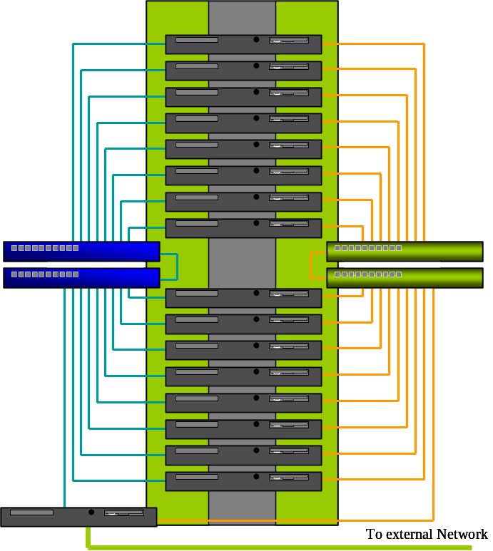

Workload is Non interactive batch workload. User may submit multiple jobs
E.g. workload consists of 100 jobs. Each job last several seconds to several days. Single job (run on single node) or parallel job (run on multiple nodes). Each job is “abstract application”: top level entity of Grid Component tree diagram. Job is different form “transactions” of online shopping application
Batch job: grid component mapping can be depict as follows:
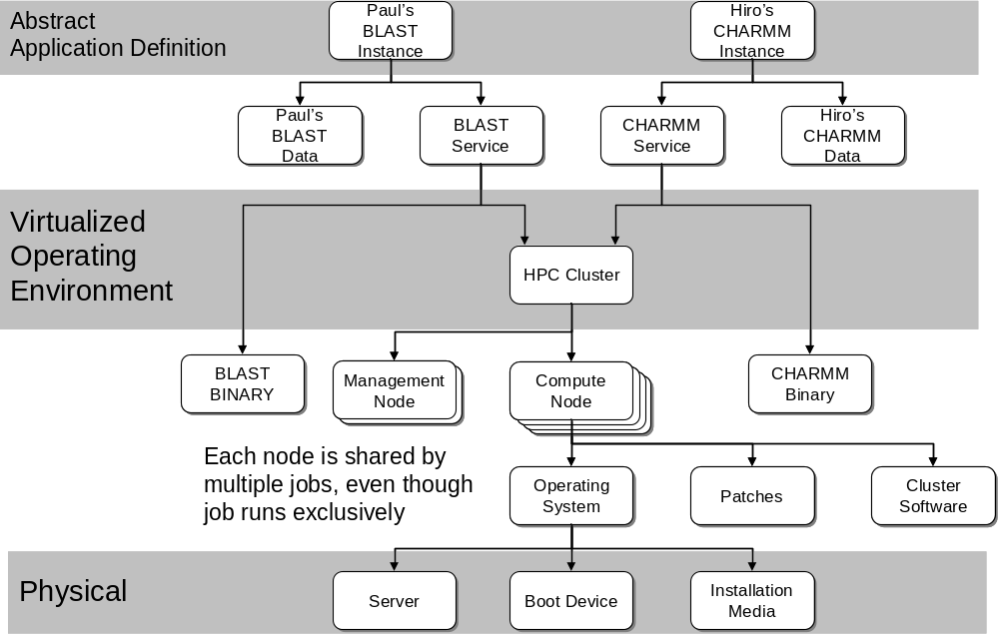

The following is the OGSA HPC usecase diagram.

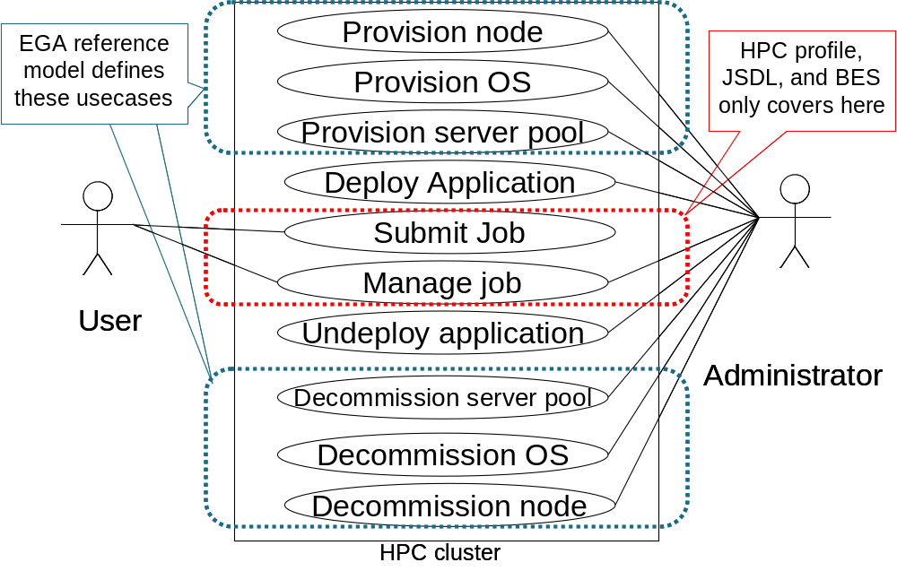

Use case for Manage Service for enterprise apps will include the following
- Create
- Configure
- Start
- Update
- Notify
- Monitor
- Control
- Stop
- Unconfigure
- Destroy

EGA Reference model’s general life cycle is as follows:
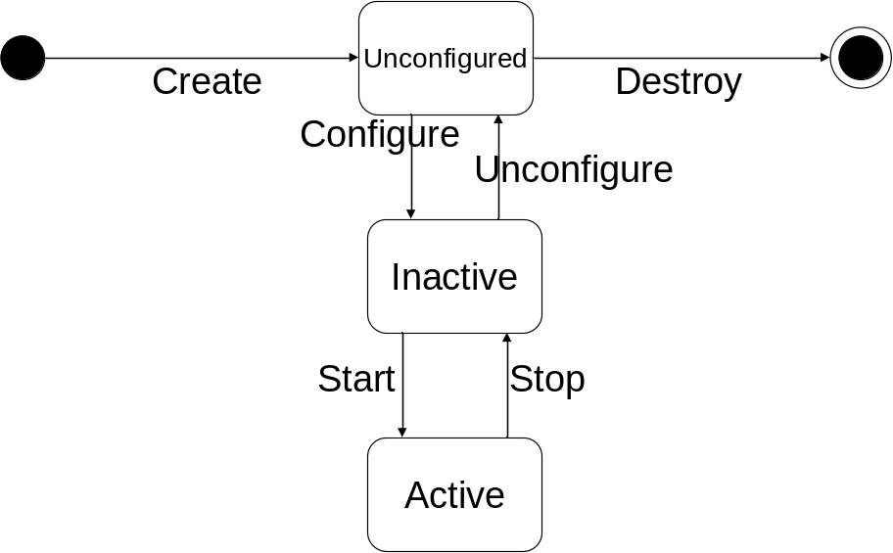
Based on this, OGSA-BES’s Job life cycle can be shown as:

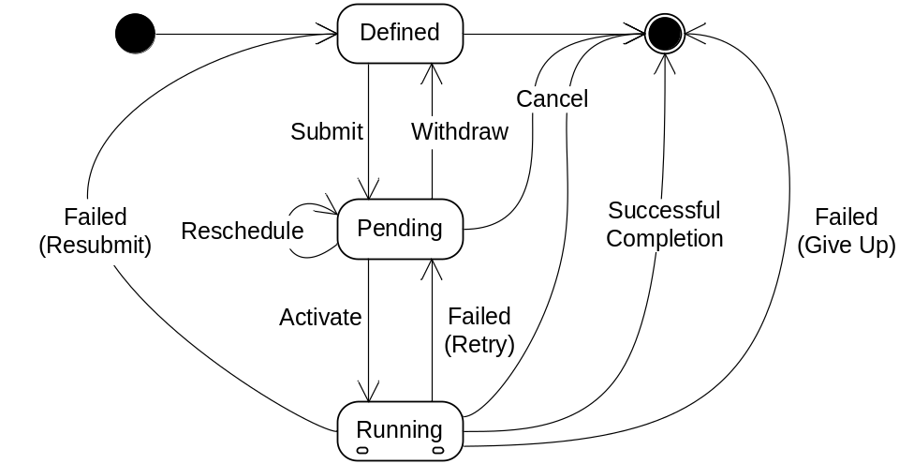

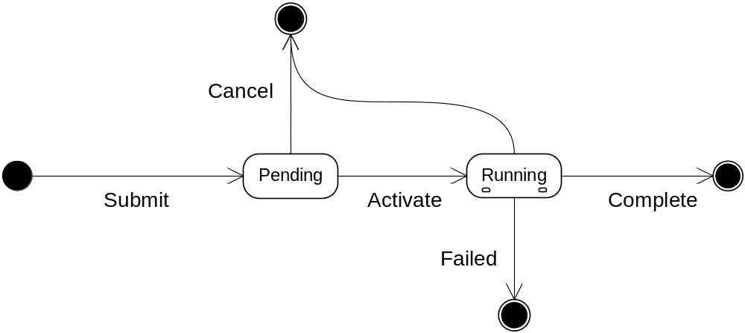
Or

Benefits

extensive use cases

revealing dependencies among components

well-defined state transition

Future Plan

Reference model v2.0

Apply reference model to OGSA spec development including OGSA v2.0

Security Considerations

Please refer to RFC 3552 [RESCORLA] for guidance on writing a security considerations section. This section is required in all documents, and should not just say “there are no security considerations.” Quoting from the RFC:

“Most people speak of security as if it were a single monolithic property of a protocol or system, however, upon reflection, one realizes that it is clearly not true. Rather, security is a series of related but somewhat independent properties. Not all of these properties are required for every application.

We can loosely divide security goals into those related to protecting communications (COMMUNICATION SECURITY, also known as COMSEC) and those relating to protecting systems (ADMINISTRATIVE SECURITY or SYSTEM SECURITY). Since communications are carried out by systems and access to systems is through communications channels, these goals obviously interlock, but they can also be independently provided.”

Contributors

Hiro Kishimoto
Email: hiro.kishimoto@jp.fujitsu.com
Information Technology Core Laboratories
Fujitsu Laboratories
4-1-1, Kamikodanaka, Nakahara, Kawasaki City, Japan
Dr. David Snelling
Email: David.Snelling@UK.fujitsu.com
Fujitsu Laboratories of Europe
Hayes Park Central
Hayes End Road
Hayes, Middlesex UB4 8FE

Paul Strong
Email: pstrong@ebay.com
eBay

We are grateful to numerous colleagues for discussions on the topics covered in this document, and to the people who provided comments on the public drafts. Thanks in particular to (in alphabetical order, with apologies to anybody we have missed) …

Glossary

Please refer to the OGSA Glossary of Terms Error: Reference source not found and EGA reference model document [EGA Ref Model].

Intellectual Property Statement

The OGF takes no position regarding the validity or scope of any intellectual property or other rights that might be claimed to pertain to the implementation or use of the technology described in this document or the extent to which any license under such rights might or might not be available; neither does it represent that it has made any effort to identify any such rights. Copies of claims of rights made available for publication and any assurances of licenses to be made available, or the result of an attempt made to obtain a general license or permission for the use of such proprietary rights by implementers or users of this specification can be obtained from the OGF Secretariat.

The OGF invites any interested party to bring to its attention any copyrights, patents or patent applications, or other proprietary rights which may cover technology that may be required to practice this recommendation. Please address the information to the OGF Executive Director.

Disclaimer
This document and the information contained herein is provided on an “As Is” basis and the OGF disclaims all warranties, express or implied, including but not limited to any warranty that the use of the information herein will not infringe any rights or any implied warranties of merchantability or fitness for a particular purpose.

Full Copyright Notice

Copyright (C) Open Grid Forum (2007). All Rights Reserved.

This document and translations of it may be copied and furnished to others, and derivative works that comment on or otherwise explain it or assist in its implementation may be prepared, copied, published and distributed, in whole or in part, without restriction of any kind, provided that the above copyright notice and this paragraph are included on all such copies and derivative works. However, this document itself may not be modified in any way, such as by removing the copyright notice or references to the OGF or other organizations, except as needed for the purpose of developing Grid Recommendations in which case the procedures for copyrights defined in the OGF Document process must be followed, or as required to translate it into languages other than English.

The limited permissions granted above are perpetual and will not be revoked by the OGF or its successors or assignees.

References

[OGSA] Foster, I., Kishimoto, H., Savva, A., Berry, D., Djaoui, A., Grimshaw, A., Horn, B., Maciel, F., Siebenlist, F., Subramaniam, R., Treadwell, J., and Von Reich, J.: The Open Grid Services Architecture, Version 1.5, Global Grid Forum, Lemont, Illinois, U.S.A., GWD-I.080, July 2006. http://www.ggf.org/documents/final.htm
[OGSA Glossary] ﻿Glossary] Treadwell, J. (ed.) Open Grid Services Architecture Glossary of Terms Version 1.5. Global Grid Forum, Lemont, Illinois, U.S.A., GFD-I.081, July 2006. http://www.ggf.org/documents/final.htm
[EGA Ref Model Part 1] Beckerle, M. et.al, : EGA Reference Model and Use Cases v1.5 Part 1 of 2, Enterprise Grid Alliance, 10 March 2006.
[EGA Ref Model Part 2] Beckerle, M. et.al, : EGA Reference Model and Use Cases v1.5 Part 2 of 2, Enterprise Grid Alliance, 10 March 2006.

