Defining the Grid:
A Roadmap (version 1.0) for the Open Grid Services Architecture

Status of This Memo
This memo provides information to the Grid community regarding the roadmap of the Open Grid Services Architecture. It does not define any standards or technical recommendations. Distribution is unlimited.
This document contains schedule information for work being carried out by multiple GGF working groups and external organizations. The document will be updated periodically to reflect schedule changes.
Copyright Notice
Copyright © Global Grid Forum (2004, 2005). All Rights Reserved.

Abstract
The Global Grid Forum (GGF) has embraced the Open Grid Services Architecture (OGSA) as the industry blueprint for standards-based grid computing. “Open” refers to both the process to develop standards and the standards themselves. It is “service-oriented” because it delivers functionality as loosely-coupled, interacting services aligned with industry-accepted Web service standards. The “architecture” defines the components, their organizations and interactions, and the design philosophy used.
While much progress has been made with OGSA, there remains a lack of clarity concerning exactly what OGSA is, who defines it, what will be defined when, and who is contributing to its development. This informational document answers these questions by providing a snapshot of the evolving OGSA space and an explanation of the direction chosen by OGSA-WG and GGF.

Contents
1. Introduction 3
2. OGSA: Process, Profiles, Specifications and Software 4
2.1 OGSA Requirements 5
2.2 OGSA Profiles 5
2.3 OGSA Branding 6
3. OGSA Informational Document Schedule 6
3.1 OGSA Architecture Version 1.5 6
3.2 OGSA Glossary Version 1.5 7
3.3 OGSA ByteIO Use-Cases Version 1.0 7
3.4 OGSA Data Architecture Version 1.0 8
3.5 Naming Issues in Distributed Systems Version 1.0 8
3.6 OGSA Information and Monitoring Architecture Version 1.0 9
4. OGSA Normative Document Schedule 9
4.1 OGSA ByteIO Interface Document Version 1.0 9
4.2 OGSA Basic Execution Services Interface Document Version 1.0 10
4.3 Job Submission Description Language Specification Version 1.0 11
4.4 Resource Namespace Service Specification Version 1.0 12
4.5 WS-Naming Specification Version 1.0 14
4.6 Application Content Service Specification Version 1.0 14
4.7 WS-Agreement Specification Version 1.0 16
5. OGSA Recommended Profile Schedule 17
5.1 OGSA WSRF Basic Profile Version 1.0 17
5.2 Future Profiles 18
6. OGSA Informational Profile Schedule 19
7. Collaboration with Other Organizations 19
7.1 Liaisons 19
7.2 Standards Development Organizations Collaboration on Networked Resources Management (SCRM) 20
8. Open-Source Software Projects 20
9. Security Considerations 21
10. Editor Information 22
11. Contributors 22
12. Acknowledgments 22
13. Intellectual Property Statement 22
14. Full Copyright Notice 22
15. References 23
Appendix A – Summary of Referenced Standards 24

Introduction
The Global Grid Forum (GGF) has embraced the Open Grid Services Architecture (OGSA) as the industry blueprint for standards-based grid computing. “Open” refers to both the process to develop standards and the standards themselves. It is “service-oriented” because it delivers functionality as loosely-coupled, interacting services aligned with industry-accepted Web service standards. The “architecture” defines the components, their organizations and interactions, and the design philosophy used.
GGF’s OGSA Working group (OGSA-WG) has recently completed two major work products:
- The OGSA Use Cases document [OGSA Use Cases] describes a set of use cases from a range of enterprise and scientific settings, intended as a source of requirements for OGSA services.
- The Open Grid Services Architecture, Version 1.0 document (also called OGSA Architecture 1.0 in this document) [OGSA Arch] collates requirements for an Open Grid Services Architecture and identifies a large number of service interfaces that may be required to meet those requirements.
The completion of these two documents leads to the question: what is the path by which OGSA should now be further developed and defined? An answer to this question is important to a variety of people:
- Many GGF participants have bought into the notion that OGSA can serve as an overarching architectural framework for different GGF activities. They now want to understand what this framework implies for their work.
- Developers and users want to know “what they can expect when” in terms of standards, so that they can make plans for product developments and technology acquisitions.
Arguably the credibility of OGSA, GGF, and Grid as a whole depends in part on a coherent answer to this question.
These and other pressures encourage the view that we must move quickly to fill out the OGSA definition and produce a set of normative specifications that define in great detail what it means to be OGSA-compliant.
However, before rushing into this task, we must also be aware of a number of other factors:
- The broad importance of Grid and the tight alignment of OGSA with Web services means that further work on OGSA cannot proceed as a purely GGF activity, but must rather be viewed as one (hopefully important) input to a larger process aimed at defining service-oriented solutions to distributed computing problems.
- As in any standardization process, we need to be careful not to standardize prematurely, i.e., standardize without adequate experience and/or buy-in from its eventual users. These issues are particularly important in the case of OGSA, due to the particularly large gap between our ambition and experience.
- While the OGSA design teams have worked hard and considered a variety of use cases, the teams remain relatively small. It would seem likely that there are important perspectives that have not yet been considered.
- The human resources available to work on OGSA activities are small, certainly far fewer than are needed to do justice to the full spectrum of issues described in OGSA Architecture 1.0.
These considerations motivate this document, which seeks to clarify the role of OGSA and the steps required to refine its definition by addressing the following issues:
- With a view to clarifying the process by which OGSA definition may proceed, we recommend a process by which technical specifications developed within or outside GGF can be identified as meeting OGSA requirements. The selection and combination of element specifications that are required to achieve interoperability are described in chapter 2.
- With a view to identifying factors that might help prioritize work on OGSA, we identify dependencies among different OGSA interfaces and the interfaces that appear needed within different deployment and application scenarios. The schedule of the first set of informational documents, normative documents, and profiles is described in chapters 3 through 6.
- With a view to identifying external constraints on OGSA, we review major relevant standardization activities external to GGF. We discuss both past activities that have produced specifications on which OGSA can build, and current and planned future activities that may contribute to, and/or constrain, OGSA’s evolution. The collaborations among major standards development organizations are outlined in chapter 7.
- With a view to illustrating the breadth of interest in OGSA across the grid community, we describe in chapter 8 a range of open-source software projects that are actively engaged in implementing grid components and applications based on OGSA and related specifications. These projects are yielding valuable experience that enables their participants to contribute to the further development of OGSA.

OGSA: Process, Profiles, Specifications and Software
We distinguish between the OGSA architectural process, OGSA specifications and profiles, and OGSA Software: all of these are important to maintain coherence around OGSA and grid standards. These three areas are:
- OGSA is first and foremost an architectural process, managed by the OGSA-WG, which works to collect requirements, evaluate the maturity of specifications, and produce periodic updates to the following OGSA informational documents:
- A set of informational OGSA Use Case documents list end-user application scenarios that are thought to be relevant to OGSA design.
- The Open Grid Services Architecture, Version 1.0 [OGSA Arch] identifies framework, taxonomy, and functionality that should be provided to address use case requirements.
- Service Description documents describe the services in the area in natural language, listing the interfaces and operations defined by each service.
- Scenario documents demonstrate how these services can implement the use cases, using a combination of natural language and UML.
- An OGSA Roadmap, this document, expresses OGSA-WG views on the likely future evolution of OGSA to address unmet requirements and/or respond to technology evolution.
We emphasize that these informational documents are intended to provide guidance to OGSA designers, but are not binding on current or future versions of normative OGSA documents.
- Normative OGSA documents are specifications and profiles. Profiles identify sets of broadly adopted normative technical specifications that collectively capture current understanding of what software must do to operate and manage interoperable grid environments. In developing such normative documents, OGSA-WG is informed by, and aligned with, user experiences with software that implements the relevant specifications. When we talk about “OGSA” in any normative or technical sense, we refer to such normative documents. See section 2.2 for further discussion of OGSA Profiles.
- OGSA Software adheres to OGSA normative specifications and profiles, and thus enables customers to deploy grid solutions that interoperate even when based on different open source and/or commercial software vendors’ implementations.
At the time of writing, we have OGSA Use Case documents, Open Grid Services Architecture, Version 1.0, and an OGSA WSRF Basic Profile document [OGSA WSRF Basic Profile]. We do not yet have any OGSA-compliant software implementations or OGSA compliance tests. (See§section 2.3 for more details.)
OGSA documents will evolve over time. Thus, any discussion of OGSA must always be qualified with a version number: e.g., “This software is compliant with OGSA WSRF Basic Profile 1.0,” or “OGSA WSRF Basic Profile 1.0 addresses X, Y, and Z in the OGSA Architecture 1.0.”

OGSA Requirements
OGSA requirements are derived from the study of use cases that are felt to be relevant to OGSA’s goals of service-oriented infrastructure and grids. Major sources of such use cases and the requirements that derive from them are GGF members, the Enterprise Grid Alliance, and potentially other organizations.

OGSA Profiles
OGSA, in the normative sense, is defined by a set of specifications and OGSA Profiles. The term profile is adopted from the WS-Interoperability (WS-I) organization, which has defined a Basic Profile 1.1 [WS-I BP 1.1] as a foundation for Web services interoperability, and also other profiles such as the Basic Security Profile [WS-I BSP 1.0] and Basic Attachments Profile [WS-I AP 1.0] that build on the Basic Profile.
An OGSA Profile, like a WS-I Profile, references a set of technical specifications and prescribes the ways in which those specifications should be implemented and used in order to perform various classes of operation in an interoperable fashion. However, the OGSA profile is different from WS-I Profile in the sense that OGSA defines feature-rich combinable functionalities while WS-I profile defines infrastructure-level specifications.
Individually and collectively, the specifications that are combined in an OGSA Profile:
- Address important end-user requirements, such as those described in the OGSA Use Case and Architecture documents;
- Are specified at a level sufficient to enable the development of interoperable implementations;
- Complement the other specifications contained in this and other OGSA Profiles;
- Have implementation experience; and
- Have been adopted—i.e., are already in use by, or have a high degree of expectation that they will soon be in use by—numerous technology providers and consumers.
OGSA Profiles are thus concerned above all with documenting acceptable practice and enabling interoperability, rather than with prescribing practice for the future.
In addition, OGSA Profiles seek to fill apparent gaps in the specifications. For example, the OGSA Security design team has created an XML Schema fragment to include a service's public credential in an endpoint reference (EPR), and the OGSA WSRF Basic Profile team has specified a number of resource property elements that a client can expect to find—e.g. ResourcePropertyNames.
We expect that various OGSA Profiles will be defined over time, each independently versioned. We propose in this document an initial set of such profiles, some of which might be augmented with extension profiles for more advanced functionality.
This approach of defining multiple independent profiles is important because as OGSA grows, no single vendor is likely to implement everything. Profiles allow vendors to claim unambiguously compliance to relevant portions of OGSA. For example, a scheduler vendor might claim compliance to the OGSA Basic Execution Management Profile 1.0, but not to the OGSA Basic Data Profile 1.0.
We will also define OGSA Informational Profiles, which are meant to inform the development of technical specifications that might be referenced by OGSA Profiles in the future. An important task of the OGSA-WG is thus, periodically, to identify and document in revised OGSA Profiles the sets of specifications that meet the criteria outlined above, and to revise the Informational documents based on the latest specifications and community views.
Members of the OGSA-WG will also engage in development of specifications within appropriate working groups (not within the OGSA-WG itself), as well as in coordination and promotion activities aimed at bringing other specifications to the point where they are ready for inclusion in future versions of relevant OGSA Profiles.
The OGSA Profile Definition document [OGSA Profile Definition] outlines how to write recommended and informational profiles that describe collections of specifications and their interactions, and defines the criteria to be used in determining the status and adoption levels of the underlying specifications.

OGSA Branding
The OGSA normative documents are expected to be implemented by multiple open-source software (OSS) projects and commercial software vendors. Authors of OGSA Software may claim one of three levels of agreement with the OGSA normative documents:
- A claim to implement a specification or profile is a statement of “best effort” to satisfy the requirements of the specification. There are no test mechanisms to guarantee the correctness of the implementation.
- A claim of conformance to a specification or profile is a statement of intent to interoperate with other conformant implementations. Two or more implementations may test their conformance by testing how well they interoperate. A conformance claim mechanism as defined in the profile should be used to communicate conformance.
- A claim of compliance would imply acceptance by a set of OGSA Compliance Tests. At the time of writing no such tests exist.
We may expect that OGSA compliance tests will be developed that define the practical criteria that must be satisfied for a software system to be called “OGSA-compliant.” Until such a suite is available, claims of OGSA compliance should not be made.
Given the requirement for consistency across OGSA specifications and other documents, GGF must consider the criteria to be used in determining whether to brand entities such as working groups and documents with an OGSA prefix. This topic will be discussed in the forthcoming GGF Roadmap document.

OGSA Informational Document Schedule
This chapter provides the development schedule of OGSA-related informational documents. Informational documents include Use Case documents, Architecture documents, Service Description documents, and Scenario documents.

OGSA Architecture Version 1.5
The OGSA Architecture 1.0 was released in January 2005. This document will be reviewed and updated to reflect progress by working groups and technical committees within and outside of GGF, and to resolve outstanding tracker items.

Development Schedule
Changes to this document will be made by OGSA-WG.
Milestone | Date
First draft available | August 2005
Ready for public comment review | October 2005
GFD-I publication | January 2006
Table 3-1 OGSA Architecture 1.5 document schedule

Related Documents
This document will refer to the OGSA profile documents, and many other documents produced by OGSA-WG, by other GGF working groups, and by other standards development organizations.
The OGSA Glossary 1.5 will be published as a companion document.

OGSA Glossary Version 1.5
The OGSA Glossary 1.0 was released in January 2005, along with the OGSA Architecture 1.0. It will be updated to include terms that are required as a result of changes made in the OGSA Architecture 1.5, and will be released in conjunction with that document. Existing terms will be reviewed and revised where appropriate, and outstanding tracker items will be resolved.

Development Schedule
Changes to this document will be made by OGSA-WG.
Milestone | Date
First draft available | August 2005
Ready for public comment review | October 2005
GFD-I publication | January 2006
Table 3-2 OGSA glossary 1.5 document schedule

Related Documents
This document is a companion to the OGSA Architecture 1.5 document.

OGSA ByteIO Use-Cases Version 1.0
The purpose of this document is to identify the requirements for the OGSA ByteIO interface. It is expected that the use cases will include reading from a binary file, reading the results of certain DAIS queries and reading data from a sensor, among other scenarios. The intention is that existing APIs, such as the POSIX API, should map easily to the ByteIO Web service interface.

Development Schedule
The OGSA ByteIO working group (ByteIO-WG) is now developing this document.
Milestone | Date
First draft available | June 2005
Ready for public comment review | October 2005
GFD-I publication | March 2006
Table 3-3 OGSA ByteIO use-case 1.0 document schedule

Related Documents
This use-case document is intended to be an input to the normative OGSA ByteIO interface document.

OGSA Data Architecture Version 1.0
The purpose of this document is to describe an overall data architecture for OGSA. It will identify message patterns and interfaces that form part of that architecture. Where possible, it will use existing specifications to form appropriate parts of this architecture, liaising with the groups defining those specifications to encourage them to fit into the overall OGSA picture. Where existing specifications are not available, the document will point out the need for work by other GGF working groups to fill the gaps. The document will not define detailed specifications; these are for other specifications.

Development Schedule
The OGSA Data Architecture working group (OGSA-D) is now developing this document.
Milestone | Date
First draft available | June 2005
Ready for public comment review | December 2005
GFD-I publication | June 2006
Table 3-4 OGSA Data Architecture 1.0 document schedule

Related Documents
This document will make extensive cross-references to other specifications, including WS-DAI, SRM, ByteIO, CGS, DFDL, GridFTP, MTOM, SwA, RNS, and WS-Naming.

Naming Issues in Distributed Systems Version 1.0
Naming in distributed systems has a rich history and literature, and the basics are very well understood. Traditional distributed systems often have a three-layer naming scheme. Human names such as paths or attributes are mapped to abstract names, which are then mapped to some form of address.
The purpose of this document is to provide background on naming in distributed systems, and the motivation and requirements for naming in OGSA.

Development Schedule
The OGSA-Naming WG developed an early draft of this document while the working group was a design team of the OGSA-WG, and is continuing to develop it for publication.
Milestone | Date
First draft available | June 2005
Ready for public comment review | December 2005
GFD-I publication | June 2006
Table 3-5 OGSA Naming Issues in Distributed Systems 1.0 document schedule

Related Documents
This document is informational only. It does not depend on any other specifications, although it refers to, for example, WS-Addressing, DNS, SGNP, WSRF, and JXTA.

OGSA Information and Monitoring Architecture Version 1.0
The purpose of this document is to describe an overall architecture for publishing and consuming information for the purpose of monitoring and discovery of Grid resources, as well as for higher functionality such as accounting. It will identify the necessary components and describe their relationship and the exposed interfaces.
This document will build on existing GGF documents and use relevant specifications from other groups both within and outside GGF. Continuous involvement with those groups is required in order to align those specifications that are still evolving with OGSA requirements. Where gaps are identified in the overall OGSA picture the document will point them out, to allow the OGSA-WG to take appropriate action. The document will not define any normative specification.

Development Schedule
The development schedule will be discussed at GGF14.
Milestone | Date
First draft available | TBD
Ready for public comment review | TBD
GFD-I publication | TBD
Table 3-6 OGSA Information and Monitoring Architecture 1.0 document schedule

Related Documents
This document will leverage the Grid Monitoring Architecture final GGF document and reference the InfoD specification once it is published. It will also particularly reference OGSA security and identity management as well as OGSA information and resource models and schemas.

OGSA Normative Document Schedule
This chapter provides the development schedule for OGSA-related normative interface documents. These documents are the products of domain-expert working groups other than OGSA-WG. The OGSA Profiles reference these documents.

OGSA ByteIO Interface Document Version 1.0
Various OGSA design, research, and working groups have identified a need for a simple interface for reading and writing sequences of bytes to and from various sources. This interface document specifies a minimal Web service interface for this functionality. The resultant interface will fit into the overall architecture, and the OGSA ByteIO working group will liaise with other GGF groups, especially the OGSA, GFS, GSM, DAIS, InfoD and SAGA working groups, and also with active projects such as OGSA-DAI, Globus, NextGrid and WSRF.Net.

Development Schedule
The OGSA ByteIO working group (ByteIO-WG) is now developing this interface.
Milestone | Date
First draft available | June 2005
Ready for public comment review | October 2005
GFD-P-R publication | March 2006
Table 4-7 OGSA ByteIO interfaces 1.0 document schedule
An experience document which describes interoperability test among two or more implementations based on this interface will also be produced, and is planned to be available in September, 2005.

Referenced Specifications
This interface should be based on the OGSA WSRF Basic Profile 1.0 [OGSA WSRF Basic Profile]. The following table shows the referenced specifications and their “Status” and “Adoption” levels.
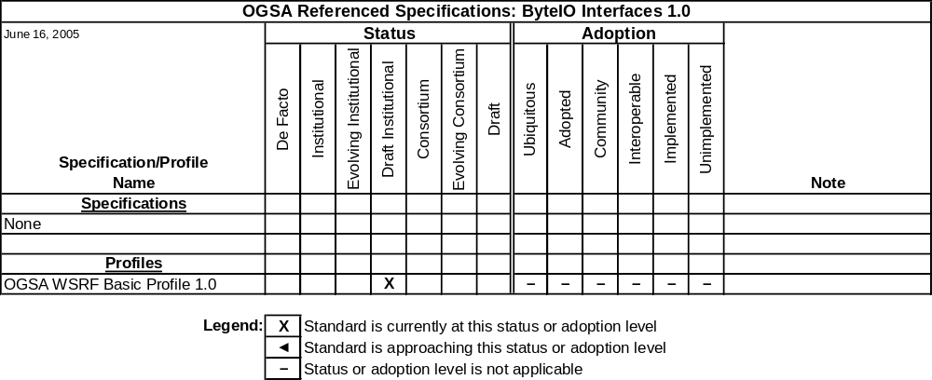
Table 4-8 OGSA ByteIO Interfaces 1.0 referenced specifications

Expected Use
The Basic Data profile, to be developed by the OGSA Data working group, is expected to reference this specification.

OGSA Basic Execution Services Interface Document Version 1.0
OGSA Basic Execution Services Working Group (BES-WG) is concerned with the interfaces (port types, resource properties, etc.) of service containers as defined in the OGSA Architecture 1.0 document. Recall that service containers are execution environments in which other services—including legacy applications—execute. They (service containers) represent execution in the grid. A service container may represent a single processor, a virtual processor, a hosting environment such as .Net, a supercomputer, or a cluster managed by a queue management system such as LSF, PBS, or SGE. Service containers are one part in the overall EMS architecture (also described in OGSA Architecture 1.0).

Development Schedule
The OGSA Basic Execution Services Working Group (BES-WG) is now developing this document.
Milestone | Date
First draft available | June 2005
Ready for public comment review | October 2005
GFD-P-R publication | June 2006
Table 4-9 BES Interfaces 1.0 document schedule

Referenced Specifications
BES exists in the context of a large number of documents, including the OGSA Architecture 1.0 document.
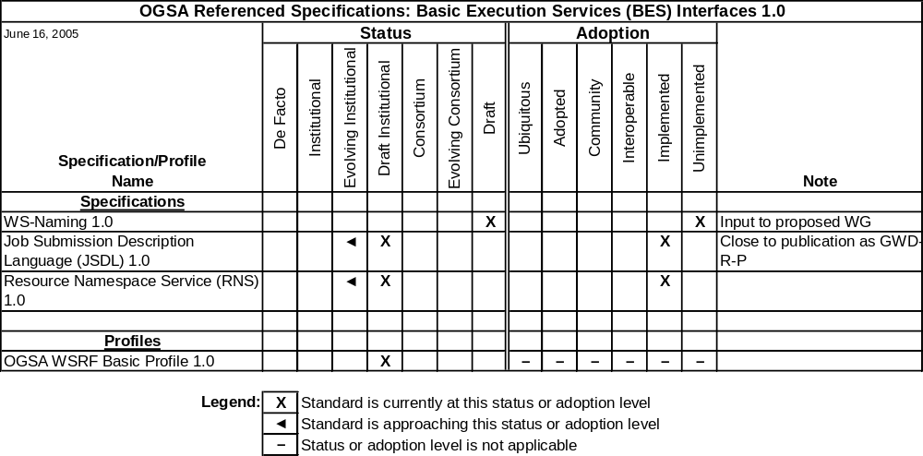
Table 4-10 BES Interfaces 1.0 referenced specifications

Expected Use
BES is at the “base” of the EMS architecture and is expected to be widely used both for legacy application management and for Web service instantiation.

Job Submission Description Language Specification Version 1.0
The Job Submission Description Language (JSDL) is a language for describing the submission requirements of computational jobs. JSDL 1.0 defines a normative XML schema. No submission API is defined and no assumptions are made about how a JSDL document may be submitted to a job execution system.
In OGSA, JSDL 1.0 is expected to be combined with the work of other groups: WS-Agreement (GRAAP-WG), Basic Execution Service (BES-WG), etc.

Development Schedule
The JSDL-WG is close to GGF editor submission of JSDL 1.0.
Milestone | Date
First draft available | February 2004
Ready for public comment review | June 2005
GFD-P-R publication | October 2005
Table 4-11 JSDL 1.0 specification schedule
An experience document which describes interoperability test between two or more implementations based on this specification will also be produced in 2006.

Referenced Specifications
JSDL 1.0 references CIM version 2.9 and ISO/IEC 9945:2003 (POSIX v3).
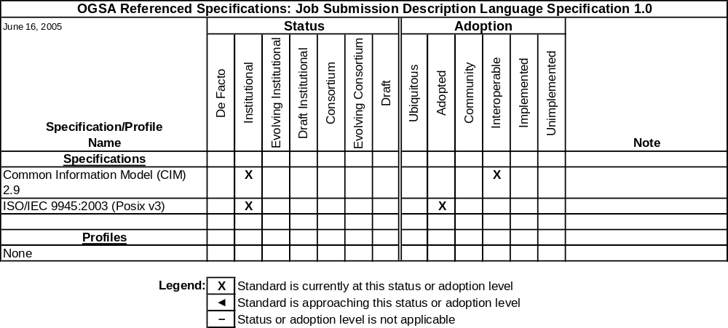
Table 4-12 JSDL 1.0 referenced specifications
Note that implementations of these two specifications are not required to implement JSDL 1.0.

Expected Use
The BES 1.0 is expected to use JSDL 1.0 for the definition of the submission interface. The Basic EMS profile is also expected to use JSDL 1.0 in conjunction with WS-Agreement.

Resource Namespace Service Specification Version 1.0
Various OGSA design, research, and working groups, including the Grid File System Working Group (GFS-WG), have identified a need for a simple namespace service to accommodate a wide variety of grid applications. This service can be employed to manage the namespace of federated and virtualized data, services, or effectively any resource capable of being referenced in a grid/web service environment, with a particular emphasis on hierarchically managed names that may be used in human interface applications.
The RNS specification describes the operations, resource properties, and semantics of the namespace service. The resultant Web service will fit into the overall architecture, providing a core feature of OGSA.

Development Schedule
The GFS-WG is currently finalizing the recommendation draft of the RNS specification. Ownership will transition to the OGSA-Naming WG after the document has been published as a proposed recommendation.
Milestone | Date
First draft available | November 2004
Ready for public comment review | June 2005
GFD-P-R publication | October 2005
Table 4-13 RNS specification 1.0 document schedule
The RNS specification document is based on a previously posted specification document for Virtual Filesystem Directory Services (VFDS) and was first made available in June of 2004.

Referenced Specifications
RNS exists in the context of the OGSA three-level naming scheme—it makes use of WSRF, WS-Notification, WS-Naming, and WS-Addressing.
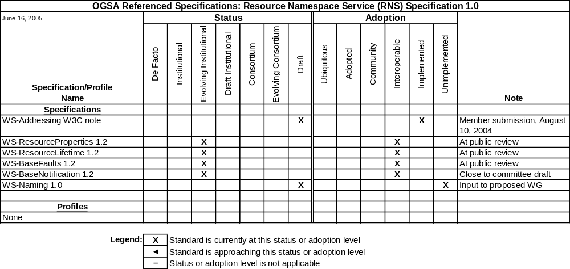
Table 4-14 RNS 1.0 referenced specifications
Note that a future revision of RNS is expected to reference the OGSA WSRF Basic Profile.

Expected Use
Naming is ubiquitous in OGSA. Thus many documents, including OGSA Architecture 1.5, OGSA Data Architecture 1.0, and OGSA Information and Monitoring Architecture 1.0, may refer to RNS names in one context or the other. Also, multiple normative specifications, including The Grid File System Profile being developed by the GFS-WG, are expected to reference this specification.

WS-Naming Specification Version 1.0
Rather than target unreasonable or unlikely changes in the WS-Addressing specification, the WS-Naming Specification is designed to extend WS-Addressing. Neither Web service clients nor Web service endpoints need to be aware of this extension, and both are free to fail to generate or understand the WS-Naming elements described within. In such a case, the normal WS-Addressing behavior still works exactly as described in the specification. However, should a client which is aware of the WS-Naming specification encounter WS-Naming elements in a WS-Addressing endpoint reference, it will have the option to take additional actions with its communication to that Web service endpoint in the event of certain communication failures.

Development Schedule
The OGSA-Naming WG is now developing this specification.
Milestone | Date
First draft available | June 2005
Ready for public comment review | November 2005
GFD-P-R publication | March 2006
Table 4-15 WS-Naming 1.0 document schedule

Referenced Specifications
This specification is based on WS-Addressing, and is combinable with the OGSA WSRF Basic Profile 1.0.
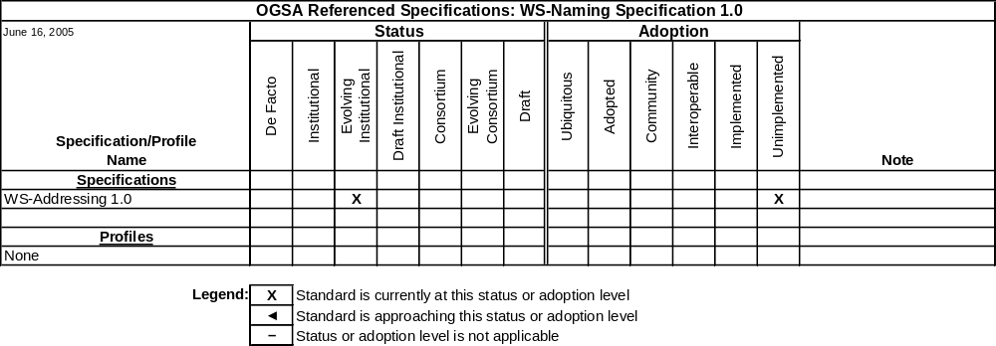
Table 4-16 WS-Naming Specification 1.0 referenced specifications

Expected Use
This specification is expected to be used by OGSA and many other documents, including OGSA Architecture 1.5, OGSA Data Architecture 1.0, OGSA Information and Monitoring Architecture 1.0, RNS 1.0, and BES 1.0.

Application Content Service Specification Version 1.0
The grid community currently manually creates and manages grid application content consisting of executables, scripts, and data. The Application Content Service (ACS) specification specifies a set of Web services that provide a way to archive components for stable storage and retrieval within a standardized format. This allows grid applications and their data to be packaged, stored, and then referenced over time as needed across domains.
ACS does not interpret or execute information in the contents; rather it just manages the contents for use by other OGSA services.

Development Schedule
The Application Content Service Working Group (ACS-WG) is now developing this specification.
Milestone | Date
First draft available | June 2005
Ready for public comment review | September 2005
GFD-P-R publication | December 2005
Table 4-17 ACS Specification 1.0 document schedule
The final specification is expected to be completed during 2005. The Business Grid Computing project will provide an open-source reference implementation by early 2006.

Referenced Specifications
This specification will use the Installable Unit Deployment Descriptor (IUDD) specification under OASIS SDD-TC. RNS or WS-Naming is also expected to be referenced since application archives can be referenced externally.
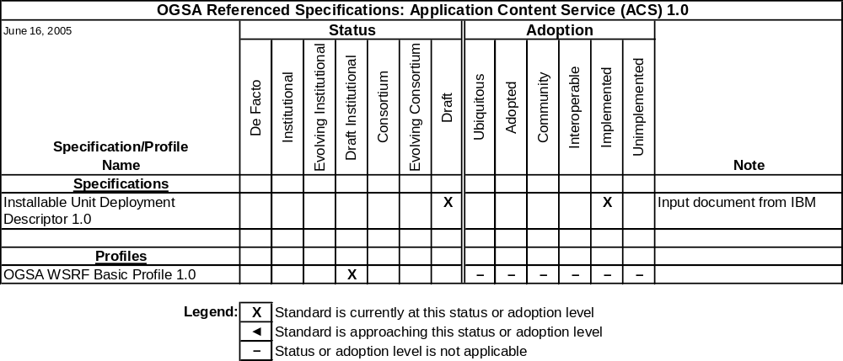
Table 4-18 ACS 1.0 referenced specifications

Expected Use
Given that ACS and IUDD are complementary, IUDD will refer to ACS in order to cover grid scenarios. Since ACS provides an API to an archive for applications and data, it is anticipated that job management and advanced execution specifications would use the application archive interface for applications under the control of a business manager. Thus future EMS architecture documents and advanced EM profiles may refer to the ACS specification. Also, since the application archive may include multiple component types, including configuration description and job control flow, future versions of the XML-CDL specification may refer to the ACS specification.

WS-Agreement Specification Version 1.0
This specification defines the Web Services Agreement Specification (WS-Agreement), a Web services protocol for establishing agreement between two parties, such as between a service provider and a consumer. WS-Agreement uses an extensible XML language for specifying the nature of the agreement, and agreement templates to facilitate discovery of compatible agreement terms.

Development Schedule
This specification went through public comment review in December 2004 and January 2005 and received a significant amount of very valuable feedback. The authors are now working to resolve these comments, and plan to re-enter the public comment phase late in 2005.
Milestone | Date
First draft available | August 2004
Ready for public comment review | June 2005
GFD-P-R publication | October 2005
Table 4-19 WS-Agreement 1.0 document schedule

Referenced Specifications
WS-Agreement normatively refers to WS-ResourceProperties and WS-Addressing.
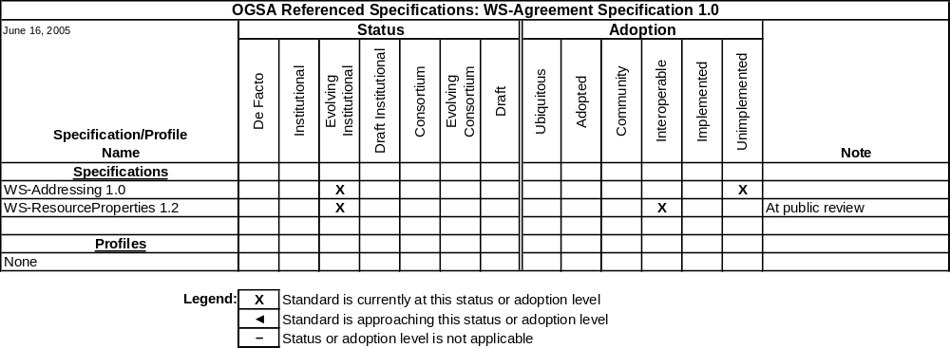
Table 4-21 WS-Agreement Specification 1.0 referenced specifications

Expected Use
In OGSA, it is expected that WS-Agreement v1.0 may be used in conjunction with JSDL. The OGSA EMS design team may define a Basic EMS profile referring to WS-Agreement v1.0, and in the future WS-Agreement may be used by other OGSA profiles, including the proposed OGSA Basic Data Profile.

OGSA Recommended Profile Schedule
This chapter provides the development schedule of OGSA Profile documents. These documents will be created by OGSA-WG or other domain-expert working groups.

OGSA WSRF Basic Profile Version 1.0
The Profile is intended for use when implementing services that are concerned with distributed resource management, grid computing, or for other purposes that involve the modeling and management of stateful entities. These services frequently can benefit from the use of interfaces and behaviors defined in the WS-Addressing, WS-Resource Framework, and WS-Notification families of specifications. A service implementation that uses those specifications in a manner conformant with this Profile may be said to be “conformant with the OGSA WSRF Basic Profile 1.0.”

Development Schedule
The OGSA-WG is now developing this profile.
Milestone | Date
First draft available | May 2005
Ready for public comment review | June 2005
GFD-P-R publication | October 2005
Table 5-22 OGSA WSRF Basic Profile 1.0 document schedule

Referenced Specifications
This profile is based on the WS-I Basic Profile 1.1, the WS-I Basic Security Profile 1.0, WS-Addressing, WS-ResourceProperties, WS-ResourceLifetime, WS-BaseNotification, and WS-BaseFaults. The following table shows the referenced specifications and their “Status” and “Adoption” levels.
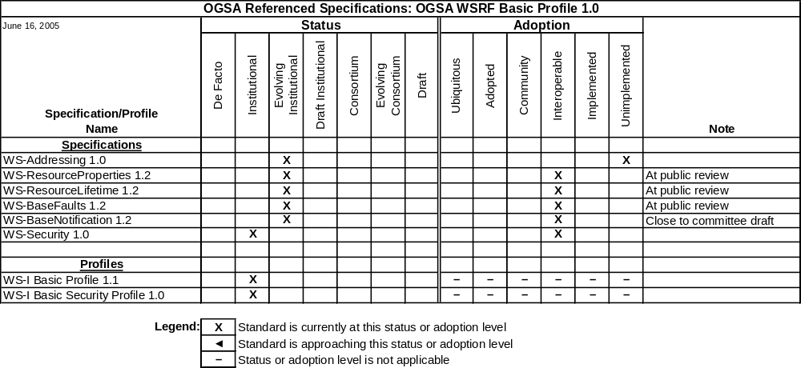
Table 5-23 OGSA WSRF Basic Profile 1.0 referenced specifications

Expected Use
This profile is expected to be the foundation for numerous specifications and profiles being developed by OGSA-WG and other working groups, including ByteIO, ACS, and BES.

Future Profiles
In this section we list some recommended profile documents that are expected to be developed in the future, but for which no significant planning has yet been done.

OGSA Basic Data Profile Version 1.0
The OGSA-D Working Group or a separate profile team will develop a series of OGSA Basic Data Profiles. Specifications that have the potential to be integrated into an OGSA Basic Data Profile 1.0 later in 2005 or early in 2006 might include:
- WS-DAI, SRM, RNS: first versions of these specifications are about to be released in GGF. There is reasonable implementation experience of each; WS-DAI has only a single implementation, while SRM and RNS have multiple implementations.
- ByteIO: This specification is being developed in synchrony with implementations. There is little experience yet but the timescale for ByteIO should lead to adoption in the same timeframe as the initial profile.
- CGS: The CIM Grid Schema gives a specification of relational databases in the CIM model.

OGSA Basic Execution Management Profile Version 1.0
The EMS design team or a separate profile team will develop a series of OGSA Basic Execution Management Profiles. Specifications that have the potential to be integrated into an OGSA Basic Execution Management Profile 1.0 (OGSA-BEM 1.0) later in 2005 or early 2006 might include:
- WS-Agreement, JSDL: First versions of these specifications have been, or are about to be, released by GGF, although as yet have little implementation experience or adoption. Acceptance into OGSA-BEM 1.0 would require that such experience be gained, probably producing revised versions of these specifications.
- OGSA-BES: Similarly to WS-Agreement and JSDL above there is as yet little implementation experience or adoption. Acceptance into OGSA-BEM 1.0 would require that such experience be gained, probably producing revised versions of these specifications.
We will also look into the following specifications.
- WSDM: First version has been published as an OASIS standard. Consider if appropriate implementation experience is obtained.
- WS-CIM: Being developed within DMTF. Consider if appropriate implementation experience is obtained.

OGSA Basic Security Profile Version 1.0
The Security design team or one or more separate profile teams will develop a series of OGSA Basic Security Profiles. Specifications that have the potential to be integrated into an OGSA Basic Security Profile 1.0 (OGSA-BSP 1.0) in the future might include:
- OGSA-SAML Authz: The last call draft of its first version is being submitted by OGSA-Authz-WG to GGF14. This draft still depends on OGSI 1.0 and SAML 1.1 specifications. The specification defines the service interface of an authorization service in OGSA. The next version of the specification is expected to adapt to WSRF specifications as well as to the latest version of SAML (SAML 2.0) and XACML (XACML 2.0).
- OGSA-Authz-Attribute: The last call draft of its first version has been submitted by OGSA-Authz-WG. The specification defines a standard syntax and semantics of attribute assertions as well as profiles for X.509 attribute certificate and SAML Attribute Assertion which are to be used for authorization decisions in OGSA.
We will also look into the following activities, but these are still in their early stages (and they will not develop concrete specifications), so the actual integration would be done in the longer term:
- FI-RG (Firewall Issues Research Group): This research group is to study issues and categorize the related devices around perimeter control stated in the OGSA 1.0 specification.
- TC-RG (Trusted Computing Research Group): This research group is to discuss experiences with Trusted Computing and to develop a use-case document for trusted computing in grid middleware or applications.

OGSA Informational Profile Schedule
This chapter is intended to provide the development schedule of OGSA Informational Profile documents. These documents will be created by OGSA-WG or by other domain-expert working groups.
There are no plans to develop any informational profiles at present.

Collaboration with Other Organizations

Liaisons
In order to keep effective and productive communication and solve technical issues with concerted efforts, GGF as a whole or individual working groups maintain liaisons with other standards development organizations and with industry organizations.
Table 7-24 shows OGSA-related liaisons and their goals.

Organization | OGSA-WG Liaison | Goals
DMTF CIM | Fred Maciel | Research how to apply the CIM model in OGSA resource management.
DMTF Utility Computing | Tom Maguire | Research how to apply Utility Computing specifications within OGSA.
OASIS WSRF & OASIS WSN | David Snelling | Input OGSA requirements into the WSRF and WSN specifications.
OASIS WSDM | Fred Maciel | Research how to apply MUWS and MOWS in OGSA resource management.
EGA | Andrew Grimshaw | Understand the EGA use cases and requirements, and evangelize OGSA to their enterprise grid.
Table 7-24 OGSA liaisons and their goals

Standards Development Organizations Collaboration on Networked Resources Management (SCRM)
As a consequence of the successful completion of the OGSA Use Case [OGSA Use Cases] and Architecture documents [OGSA Arch, OGSA Glossary], it is now clear that the magnitude and scope of the work that still needs to be done is greater than the OGSA-WG or even the GGF should attempt on its own. In seeking a way to proceed, we can see that a lot of related work is already carried out in other standards development organizations (SDOs), for example DMTF, IETF, ITU-T, OASIS, SNIA, TMF, and W3C.
In mid-2004, major SDOs began a dialogue to improve comprehensive collaboration on next generation standards for Web service-based management of networked and individual resources. The SDOs have agreed to form a cross-institutional technical working group which will create a technologies and specifications landscape document and sort out terminology and taxonomy. This activity is called “Standards Development Organizations Collaboration on Networked Resources Management,” or SCRM (pronounced “scrum”).
The scope of SCRM centers around the standards associated with the management of resources that are used either in a network or individually, by means of structured data standards. “Management” includes the functions of discovery, deployment, resource availability, statefulness, event coordination, notification and lifecycle tracking. 'Resources' to be managed include data objects as well as physical objects such as devices. However, SCRM does not comprehend all standards associated with distributed computing—just those related to the management of networked resources.
The SDOs plan to form a new working group (WG) in GGF. However, this does not mean GGF will lead the SCRM work: GGF will provide an infrastructure for SCRM-WG, but all participating SDOs will equally contribute to and promote the SCRM work. The SCRM-WG is a regular public GGF working group, and anyone can join it.
The first deliverable of the collaboration is a “standards landscape document.” The document is an annotated list of interacting standards that enable management of networked resources including gaps, overlaps and timeframes. Table 7-25 shows the development schedule for this document.

Milestone | Date
First draft available | October 2005
Ready for public comment review | January 2006
GFD-I publication | April 2006
Table 7-25 Standards landscape document schedule

Open-Source Software Projects
OGSA is expected to be implemented by multiple open-source software (OSS) projects and commercial software vendors. OSS projects, such as Globus, the Business Grid Computing Project, the NextGrid Project, the NAREGI Project, University of Virginia Global Bio Grid, UK e-Science, Gridbus and others will contribute.
The Globus Toolkit (Globus) is one example of a major OSS grid project. The Globus Alliance is contributing to the development of OGSA by supporting the design and implementation of open-source software that implements specifications detailed in OGSA Profiles, and the participation of the implementers of that software in relevant standards processes. With its current version, GT4, based on early implementations of WSRF and WS-Notification and including implementations of all relevant security standards, Globus provides a comprehensive software infrastructure that allows developers and users to work with OGSA concepts now. Additional standards will be incorporated into future versions of the toolkit as they evolve.
The Globus Consortium is a group of companies with a common interest in promoting the development and adoption of the Globus Toolkit for commercial use. Consortium participants also have a strong interest in standards in general, and in OGSA in particular.
The team at the University of Virginia (UVA) is committed to implementing several pieces of the OGSA Roadmap described here. Specifically, UVA will implement open versions of ByteIO, BES, RNS, and the WS-Naming specifications.
The Business Grid Computing Project (BG) is based on the OGSA Architecture specification. It is developing several services using specifications described in this Roadmap. In particular, BG will make available as open source software implementations of the Application Contents Service, JSDL, and WS-Agreement. BG intends to use the OGSA WSRF Basic Profile 1.0.

The National Research Grid Initiative (NAREGI) is a Japanese national e-science grid project aiming at developing a computational infrastructure for supporting scientific and engineering research. One of the primary goals of the NAREGI Project is to contribute to the GGF standardization activities. NAREGI has been interested in, participated in, and, where possible, given feedback to numerous GGF working groups and research groups. Amongst the various groups, NAREGI has recently placed high emphasis on the OGSA-WG activities, being the first project or group to implement the EMS architecture described in the OGSA Architecture v1.0 specification, in its alpha incarnation of the software stack that was released in 1Q 2005. Future plans will have NAREGI contribute to and provide reference implementations for Basic Execution Services (BES), Resource Selection Services (RSS), and Application Contents Service (ACS).
The Gridbus Project at the University of Melbourne is a major OSS project focused on the design and development of service-oriented, utility computing grid technologies. The Gridbus project has designed and implemented an open-source version of Grid Service Broker (GSB), a grid workflow management system, GridBank (grid authorization, authentication, and accounting services), an SLA-based facility for allocation of grid resources, and a .NET-based enterprise grid manager.
All of these technologies either currently support or are committed to supporting interfaces that are compliant with specifications from GGF and other bodies. Gridbus makes use of WSRF-compliant technologies in its development of advanced grid services. The project contributes to and provides reference implementations of GSB, with interfaces conforming to JSDL and Portlets specifications, the GridBank database conforms to Resource Usage Record (RUR), its access interfaces conform to WSRF, and its workflow management system interfaces confoS-Business Process Execution Language (WS-BPEL). Release of the various components under development is planned for late 2005.

Security Considerations
It is recognized that there are security requirements related to OGSA. Some aspects of security are covered in OGSA profiles and related specifications.

Editor Information
Jem Treadwell
Hewlett-Packard
Phone: +1 856-638-6021
Email: Jem.Treadwell@hp.com

Contributors
We gratefully acknowledge the contributions made to this document by Michael Behrens, Dave Berry, Abdeslem Djaoui, Ian Foster, Andrew Grimshaw, Hiro Kishimoto, Mark Linesch, Allen Luniewski, Mark Morgan, Takuya Mori, Manuel Pereira, Kazushige Saga, Andreas Savva, David Snelling, Steve Tuecke, and Peter Ziu,

Acknowledgments
We are grateful to numerous colleagues for discussions on the topics covered in this document, and to the people who provided comments on the public drafts. Thanks in particular to (in alphabetical order, with apologies to anybody we have missed) Mathias Dalheimer, Donal Fellows, Fred Maciel, Steve McGough, Jim Pruyne, Ravi Subramaniam, and Jay Unger.

Intellectual Property Statement
The GGF takes no position regarding the validity or scope of any intellectual property or other rights that might be claimed to pertain to the implementation or use of the technology described in this document or the extent to which any license under such rights might or might not be available; neither does it represent that it has made any effort to identify any such rights. Copies of claims of rights made available for publication and any assurances of licenses to be made available, or the result of an attempt made to obtain a general license or permission for the use of such proprietary rights by implementers or users of this specification can be obtained from the GGF Secretariat.
The GGF invites any interested party to bring to its attention any copyrights, patents or patent applications, or other proprietary rights which may cover technology that may be required to practice this recommendation. Please address the information to the GGF Executive Director.

Full Copyright Notice
Copyright (C) Global Grid Forum (2004, 2005). All Rights Reserved.
This document and translations of it may be copied and furnished to others, and derivative works that comment on or otherwise explain it or assist in its implementation may be prepared, copied, published and distributed, in whole or in part, without restriction of any kind, provided that the above copyright notice and this paragraph are included on all such copies and derivative works. However, this document itself may not be modified in any way, such as by removing the copyright notice or references to the GGF or other organizations, except as needed for the purpose of developing Grid Recommendations in which case the procedures for copyrights defined in the GGF Document process must be followed, or as required to translate it into languages other than English.
The limited permissions granted above are perpetual and will not be revoked by the GGF or its successors or assigns.
This document and the information contained herein is provided on an "AS IS" basis and THE GLOBAL GRID FORUM DISCLAIMS ALL WARRANTIES, EXPRESS OR IMPLIED, INCLUDING BUT NOT LIMITED TO ANY WARRANTY THAT THE USE OF THE INFORMATION HEREIN WILL NOT INFRINGE ANY RIGHTS OR ANY IMPLIED WARRANTIES OF MERCHANTABILITY OR FITNESS FOR A PARTICULAR PURPOSE."

References
[OGSA Arch] Foster, I., Kishimoto, H.,. Savva, A., Berry, D., Djaoui, A., Grimshaw, A., Horn, B., Maciel, F., Siebenlist, F., Subramaniam, R., Treadwell, J. and Von Reich, J.: The Open Grid Services Architecture, Version 1.0. GGF OGSA Working Group (OGSA-WG), 2005. http://www.ggf.org/documents/GWD-I-E/GFD-I.030.pdf.
[OGSA WSRF Basic Profile] Foster, I., Maguire, T. and Snelling, D.: OGSA WSRF Basic Profile 1.0. GGF OGSA Working Group (OGSA-WG), 2005. URL to be supplied.
[OGSA Glossary] Treadwell, J. (ed.) Open Grid Services Architecture Glossary of Terms. Global Grid Forum OGSA-WG. GFD-I.044, January 2005. http://www.ggf.org/documents/GWD-I-E/GFD-I.044.pdf.
[OGSA Profile Definition] Maguire, T. and Snelling, D.: OGSA Profile Definition Version 1.0. GGF OGSA Working Group (OGSA-WG), 2005. Reference to be supplied.
[OGSA Use Cases] Foster, I., Gannon, D., Kishimoto, H. and Von Reich, J. (eds.): Open Grid Services Architecture Use Cases. GGF OGSA Working Group (OGSA-WG), GFD-I.029, October 2004. http://www.ggf.org/documents/GWD-I-E/GFD-I.029v2.pdf
[WS-I AP 1.0] WS-I Attachments Profile 1.0:
http://www.ws-i.org/Profiles/AttachmentsProfile-1.0-2004-08-24.html
[WS-I BP 1.1] WS-I Basic Profile 1.1: http://www.ws-i.org/Profiles/BasicProfile-1.1.html
[WS-I BSP 1.0] WS-I Basic Security Profile 1.0:
http://www.ws-i.org/Profiles/BasicSecurityProfile-1.0-2005-01-20.html

Appendix A – Summary of Referenced Standards
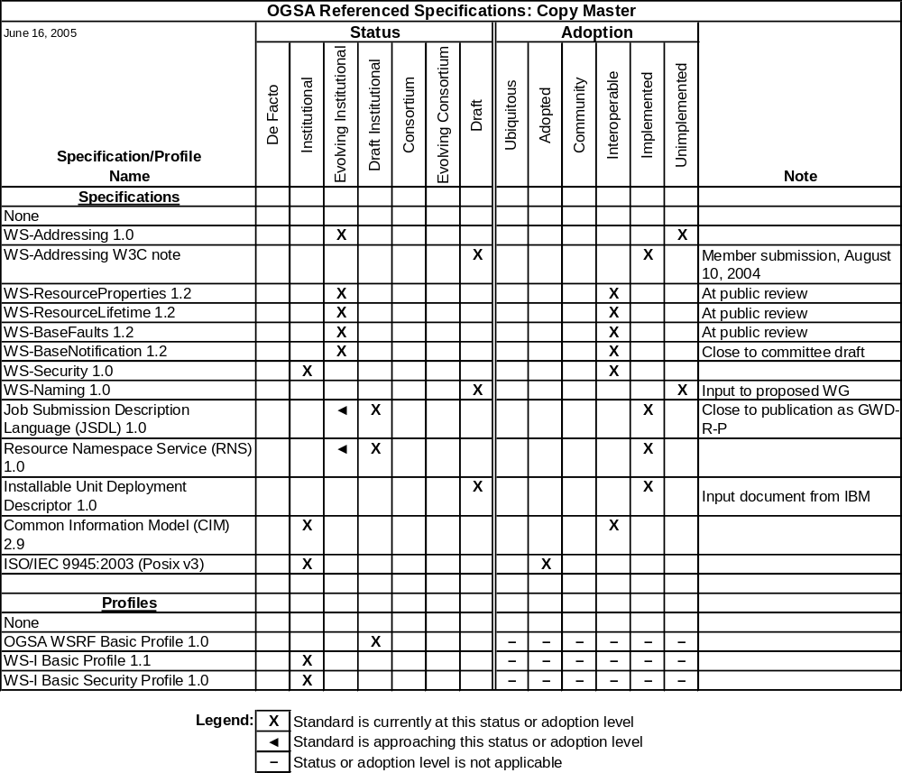

http://www.gridalliance.org
Globus Alliance: http://www.globusalliance.org
Business Grid Computing Project: http://www.ipa.go.jp/about/english/project/grid.html (English), https://www.ipa.go.jp/software/bgrid/index.html (Japanese)
NextGrid Project: http://www.nextgrid.org
NAREGI Project: http://www.naregi.org/index_e.html (English), http://www.naregi.org (Japanese)
Gridbus project: http://www.gridbus.org/intro.html

