Defining the Grid:
A Roadmap for the Open Grid Services Architecture

Table of Contents
1 Introduction 1
2 Open Grid Services Architecture: Goals and Status 2
3 The Standards Landscape 2
4 OGSA Definition Process 2
5 Dependencies and Priorities 3
6 Materials from OGSA F2F 3

Introduction
The Global Grid Forum (GGF)’s Open Grid Services Architecture working group (OGSA-WG) has recently completed two major work products. The OGSA Use Cases document describes a set of use cases from a range of enterprise and scientific settings, intended as a source of requirements for OGSA services. The OGSA Version 1 document collates requirements for an Open Grid Services Architecture and identifies a large number of service interfaces that may be required to meet those requirements.
The completion of these two documents leads to the question: what is the path by which OGSA should now be further developed and defined? An answer to this question is important to a variety of people.
- Many GGF participants have bought into the notion that OGSA can serve as an overarching architectural framework for different GGF activities. They now want to understand what this framework implies for their work.
- Developers and users want to know “what they can expect when” in terms of standards, so that they can make plans for product developments and technology acquisitions.
- Arguably the credibility of OGSA, GGF, and Grid as a whole depends in part on a coherent answer to this question.
These and other pressures encourage the view that we must move quickly to fill out the OGSA definition and produce a set of normative specifications that define in great detail what it means to be OGSA compliant.
However, before rushing into this task, we must also be aware of a number of other factors:
- The broad importance of Grid and the tight alignment of OGSA with Web services means that further work on OGSA cannot proceed as a purely GGF activity, but must rather be viewed as one (hopefully important) input to a larger process aimed at defining service-oriented solutions to distributed computing problems.
- As in any standardization process, we need to be acutely sensitive to the dangers of premature standardization, i.e., standardization without adequate experience and/or buy in from its eventual users. These issues are particularly important in the case of OGSA, due to the particularly large gap between our ambition and experience.
- While the OGSA design team has worked hard and considered a variety of use cases, the team remains relatively small. It would seem likely that there are important perspectives that have not yet been considered.
- The human resources available to work on OGSA activities are small, certainly far fewer than are needed to do justice to the full spectrum of issues described in OGSA Version 1.
These considerations motivate this document, which seeks to clarify the role of OGSA and the steps required to refine its definition by addressing the following three issues.
- With a view to identifying external constraints on OGSA, we review major relevant standardization activities external to GGF. We discuss both past activities that have produced specifications on which OGSA can build, and current and planned future activities that may contribute to, and/or constrain, OGSA’s evolution.
- With a view to identifying factors that might help prioritize work on OGSA, we identify dependencies among different OGSA interfaces and the interfaces that appear needed within different deployment and application profiles.
- With a view to clarifying the process by which OGSA definition may proceed, we recommend a process by which technical specifications developed within or outside GGF can be identified as meeting OGSA requirements.

Open Grid Services Architecture: Goals and Status
A few brief words on goals and status, referring to other documents for details of course.
- Overarching goals.
- Documents produced.

The Standards Landscape
The roles of GGF, OASIS, W3C, DMTF, WS-I, IETF. Products that may be expected from each of these groups in the coming 1-2 years, and their relevance to OGSA. Approaches that may be taken to facilitate coordination.
The following are a few rough notes that may be relevant.
There are many places where bilateral coordination has worked, e.g. WSDM/CMM, but there is still a lot of potential for conflict, e.g. Notification and Eventing.
Several low hanging pieces of fruit were identified: Notification, WMX, CML,
Naming, Reliable Messaging, Workflow (CAF/BEPL), Code footprint vs. minimal functionality, common data model, policy models/languages (constraints and capabilities), provisioning and deployment (Solution Installation Schema, CDDLM).
Mechanisms for coordination: Work registers, the concept of a "profile", the need for an architecture in order to identify gaps and overlaps.

OGSA Definition Process
The process by which we see OGSA being further refined. Figure 1 may be relevant here.
A key point that Foster wants to see expressed here is that the “top down” and “bottom up” worlds are to be coordinated as follows:
- OGSA-WG is concerned with defining requirements and overall architecture: the lighthouse towards which others may steer.
- WGs within GGF or other bodies may (hopefully will!) be formed to develop specifications that speak to requirements identified by OGSA-WG. However, OGSA-WG is not in the business of endorsing such activities ahead of time.
- The steps by which a technical specification may become identified as “OGSA compliant” remains to be clearly defined. I’d suggest that a key requirement should be identification as a “recommendation” in the sense that there are two or more interoperable implementations.

Dependencies and Priorities

Materials from OGSA F2F

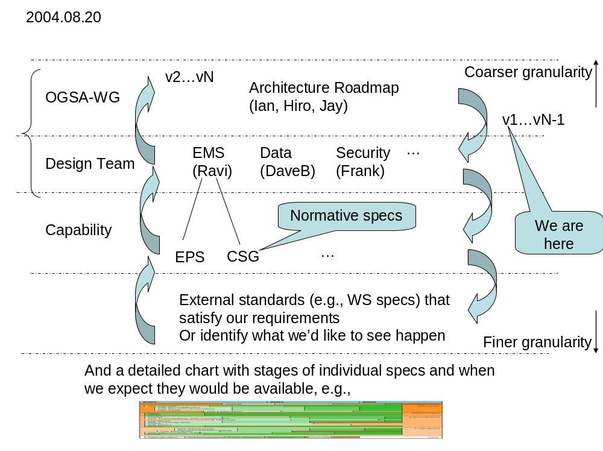
Figure 1: Powerpoint put together on the last day of recent OGSA F2F. This speaks to what kind of roadmap documents to produce and the interactions between different OGSA areas
* Roadmap discussion
- Identify dependencies and priorities we have received by the community
- Also to help people looking from the outside on what is OGSA and what is happening
- List of what is required and in what order
- Intended audience: need to identify in more detail.
Resolved (and see also Figure 1):
- Roadmap document per design team and a document that links them for OGSA. OGSA document to also describe dependencies between the design teams' roadmaps.
- And a one page powerpoint slide that shows the overall map (and dates)
- Documents are internal to ogsa-wg; the one page powerpoint slide is public
- Agreement that it is ok to continue working on higher levels based on the expection of specs at lower level that will define some needed functionality; as long as there is a description of what can be expected of the lower spec (in terms of requirements).
- Create an ordering of the specs, and how easy it is to do things; which are the low hanging fruits)
Proposal: That roadmap should be independent of the dependencies but should include the dependencies)
- (Essentially milestones; but need to do more work before that can be done.)
- Agreed that relations and dependencies with other groups need to be explicitly spelled out:
- What we will work with them or defer to them, priorities, etc. Document decisions and what they imply and who is doing what.
- Need to communicate to them our requirements. This is not just liaison work; someone should 'own' that piece of work.
- E.g., a joint work/document or some more explicit understanding
- In the case of WSDM we have identitified:
  - Naming/identity
  - Events
  - EMS overlap (or EMS usage of WSDM) --- as an initial 'application' area
  - (Metadata --- query to data design team)
- (IP policy issues; when work is done in different standards bodies)
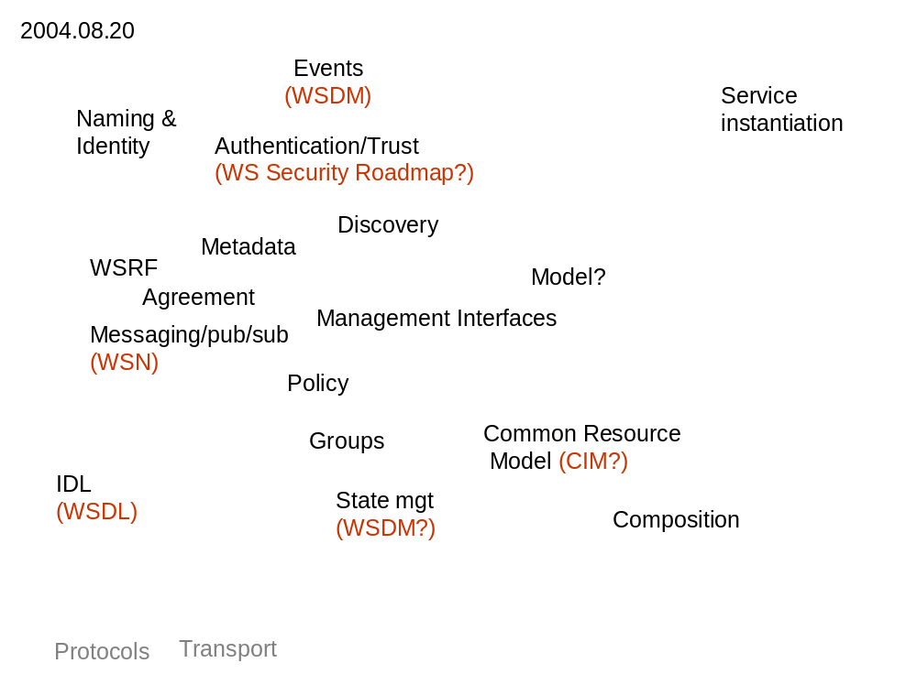
Figure 2: An attempt to map things at the low end, identifying things that are needed for higher-level work. Distributed state is not included as “we cannot decide what model to use.” (not sure what that means). We also discussed going up the stack or sorting the entries between those that fall in WS and those that don't. We postponed that for later)

Action: Jay to talk with Ian and Hiro to form a core design team to work on dependencies at architecture level (and roadmap)
Call 2.
Figure 2 is the result of a brainstorming session (& was put to the side on the next day).
Dave talked about the importance of the meeting that Hiro attended last week
- Inter-standards bodies meeting focusing on WS-management (as a common area of interest) to discuss collaboration between standards bodies
- At the moment all collaboration is at the grassroots level only
- Trying to come up with ways to collaborate at a higher level
- The OGSA roadmap could be used as one important input to this discussion
- In particular we should express OGSA priorities and feedback
- OGSA v1 (currently in public comment) will hopefully act as milestone/catalyst to push this work forward
- Currently only WSDM MUWS/MOWS is the other similar document
- (Jem trying to get OGSA v1 comments from HP; other people are encouraged to do the same within their companies.)
- (Draft roadmap shouldn't have to go into public comment)
- Comments to Ian:
- Top level roadmap should (also) be in 2-dimensions: time and level of detail
- At the moment we have 2 levels of detail; need a coarser level of detail for the top level roadmap.
- At the OGSA level talk in terms of EMS/Data/Security (and maybe Naming)
- (Lowest level: specification and implementations)
- Dave also volunteered to get involved to this effort.
- Postpone further discussion to next call (next week)

