Open Grid Services Architecture:
Second Tier Use Cases

Status of this Memo
This document provides information to the community regarding additional Grid use case scenarios used in the definition of Open Grid Services Architecture (OGSA) Platform components. Distribution of this document is unlimited. This document continues to be revised.

Abstract
Successful realization of the Open Grid Services Architecture (OGSA) vision of a broadly applicable and adopted framework for distributed system integration requires definition of a wide variety of Grid use case scenarios of both e-science and e-business applications. Described in this document are some of the incomplete or ‘to be reviewed’ use cases submitted at various times by industry leaders and academia and standards organizations.


GLOBAL GRID FORUM
office@gridforum.org
www.ggf.org

Full Copyright Notice
Copyright © Global Grid Forum (2003). All Rights Reserved.
This document and translations of it may be copied and furnished to others, and derivative works that comment on or otherwise explain it or assist in its implementation may be prepared, copied, published and distributed, in whole or in part, without restriction of any kind, provided that the above copyright notice and this paragraph are included on all such copies and derivative works. However, this document itself may not be modified in any way, such as by removing the copyright notice or references to the GGF or other organizations, except as needed for the purpose of developing Grid Recommendations in which case the procedures for copyrights defined in the GGF Document process must be followed, or as required to translate it into languages other than English.
The limited permissions granted above are perpetual and will not be revoked by the GGF or its successors or assigns.
This document and the information contained herein is provided on an "AS IS" basis and THE GLOBAL GRID FORUM DISCLAIMS ALL WARRANTIES, EXPRESS OR IMPLIED, INCLUDING BUT NOT LIMITED TO ANY WARRANTY THAT THE USE OF THE INFORMATION HEREIN WILL NOT INFRINGE ANY RIGHTS OR ANY IMPLIED WARRANTIES OF MERCHANTABILITY OR FITNESS FOR A PARTICULAR PURPOSE.

Intellectual Property Statement
The GGF takes no position regarding the validity or scope of any intellectual property or other rights that might be claimed to pertain to the implementation or use of the technology described in this document or the extent to which any license under such rights might or might not be available; neither does it represent that it has made any effort to identify any such rights. Copies of claims of rights made available for publication and any assurances of licenses to be made available, or the result of an attempt made to obtain a general license or permission for the use of such proprietary rights by implementers or users of this specification can be obtained from the GGF Secretariat.
The GGF invites any interested party to bring to its attention any copyrights, patents or patent applications, or other proprietary rights which may cover technology that may be required to practice this recommendation. Please address the information to the GGF Executive Director (see contact information at GGF website).
Contents
1 Introduction 4
2 IT Infrastructure and Management 5
3 Application Use Cases (Peer to Peer WG) 10
4 Reality Grid 17
5 The Learning GRID 25
6 HLA-based Distributed Simulation Usecase 39
7 GRID based ASP for Business 47
8 Grid Monitoring Architecture Use Case (from EU Grid) 60
9 Editor Information 64

Introduction
This document is a collection of the use case scenarios contributed by OGSA-WG participants or solicited from others, which form the second tier of OGSA use cases based on which the OGSA architecture is formed. These use cases are either not complete with respect to the template format of OGSA Use Case specifications, or they are waiting to be reviewed by the OGSA community. However these use cases are just as important and valid as the first tier usecases.

Table 1: Use cases and contributors in this document
Chapter | Title | Contributors
2 | IT Infrastructure and Management | Ravi Subramaniam
3 | Application Use Cases (Peer to Peer WG) | Dejan Milojicic (PtoPWG), Andreas Savva (use case editor)
4. | Reality Grid | Stephen Pickles, David Snelling
5 | The Learning GRID | Pierluigi Ritrovato
6 | HLA-based Distributed Simulation Usecase | Pierluigi Ritrovato
7 | GRID based ASP for Business | Pierluigi Ritrovato
8 | Grid Monitoring Architecture Use Case (from EU Grid) | Abdeslem Djaoui & Steve Fisher ( RAL), James Magowan & Paul Taylor (IBM UK ), Brian Tierney ( LBNL )

IT Infrastructure and Management

Two Scenarios
Since the scenarios for IT infrastructure and management are many, a couple of possible scenarios are chosen for a first/initial set of capabilities determination. More such scenarios can be added in future. The two chosen are:
- Cycle sharing and job execution (batch and interactive)
- Provisioning (OS selection, software distribution (on-demand) to satisfy license requirements, apps availability, create Web service example, convert the capabilities and primary focus, limits that are triggered). Will focus specifically on software distribution
Table 1: Typical scenario for cycle sharing in the grid

Seq.  No. | Operations | Key Capabilities | OGSA Service Mapping
 | User submits job; job specifies a type and set of resources | Discovery: Discover the queue to submit to  Authentication: System authenticates the user  Authorization: Queue manager validate authority of user to queue job  Resource specification Language: to specify the resources  Fault Tolerance: Faults in locating queue, transmission errors, automated routing.  Encryption: Encrypt the communication at the very least the payload | Services  - Registry  - Authentication  - Authorization  Schemas, Protocols  - Resource Specification Language or Framework  Horizontal capabilities (required in all participating services)  - Fault tolerance  - Encryption
 | Job is queued | Queue: To store the job  Notification/Messaging: Status of submission communicated to “user”  Logging: log status | Services  - Generalized Queuing  - Notification  - Messaging services (reliable delivery)  - Logging  Schemas, Protocols  - Event schema  - Message schema  Horizontal capabilities (required in all participating services)  - Fault tolerance  - Encryption
 | Job is scheduled | Resource selection: Resources matching requirements are determined  Brokering and arbitration: Multiple requests for resources and managed and conflicts resolved using defined policy.  Scheduler: matches job to resources  Reservation: All resource determined are reserved  Data staging and provisioning: Ensure that data required for computation is available in the highest performance repository. Data storage space for temporary of storage of intermediate computation made available.  Logging: log status | Services  - Registry  - Resource selector  - Broker  - Reservation  - Scheduler  - Common Resource Model services  - Data management services  - Logging services  Schemas, Protocols  - Policy schema  - Resource specification  - Resource description  - Reservation  Horizontal capabilities (required in all participating services)  - Policy framework  - Fault tolerance  - Encryption
 | Job dispatched to “consume” the resources and begins execution | Hosting environment: Ensure that hosting environment is available and initialized.  Validate user and enable execution environment:  Staging: Make sure that all entities for job execution available (app, data, credentials, authority)  Data Migration: Data is migrated to the hosting environment that will execute the job (or made available in or via a high performance infrastructure)  Fault tolerance: Ensure that collaterals available. Handle exceptions.  Monitoring: Reporting job status and resource consumption  Quota management: Watch and manage the resource consumption of job. Enforces SLA or contract between consumer and provider. | Services  - Registry  - Authentication  - Authorization  - Caching services  - Data services  - Hosting services (or provisioning services)  - SLA manager  Schemas, Protocols  - SLA schema  Horizontal capabilities (required in all participating services)  - Fault tolerance
 | Job executes | Hosting environment: Job executes in environment  Single application: Standard execution profile  Flow i.e. multiple applications: Many applications can be wrapped in scripts or process that requires licenses and other resource from multiple sources. Applications co-ordinate using the file system or based on events. | Services  - Services co-ordination  - Data grids  Schemas, Protocols  - Event schema  - Logging schema  Horizontal capabilities (required in all participating services)  - Fault tolerance
 | Job completes | Logging: Log completion/error status | Services  - Logging  Schemas, Protocols  - Event schema  - Logging schema  Horizontal capabilities (required in all participating services)  - Fault tolerance  - Encryption

Table 2: Typical scenario for software provisioning

Seq.  No. | Operations | Key Capabilities | OGSA Service Mapping
 | User needs to execute application (could be a need for a proxy i.e. a batch job or done interactively) | Authentication: System authenticates the user  Authorization: User obtains the credentials in the local VO and possibly remote VO if the application is remote.  Fault Tolerance: Faults in locating queue, transmission errors, automated routing. | Services  - Registry  - Authentication  - Authorization  Schemas, Protocols  Horizontal capabilities (required in all participating services)  - Fault tolerance
 | A set of servers that can serve the applications is found; server can be a peer that is near in network segment or a dedicated server. | Registry: Lookup the registry to determine location and handle to available application. Determine if it is local or remote  Resource specification: To provide inventory of applications on machine and record in the registry  Notification/Messaging: Registry notified of application inventory and changes to inventory  Fault Tolerance: Manage alternative application servers | Services  - Registry  - Notification  - Messaging services (reliable delivery)  Schemas, Protocols  - Resource specification language  - Message schema  Horizontal capabilities (required in all participating services)  - Fault tolerance
 | License requirements are evaluated | Resource selection: Resources matching requirements are determined; available licenses are determined  Policy schema: Specify policy  Brokering and arbitration: License scheme is evaluated against policy (this is only if there are multiple license types are supported for the same application)  Reservation: All licenses required by application are reserved  Logging: log status | Services  - Resource selector  - Broker  - Reservation  - Model services  - Logging services  Schemas, Protocols  - Policy schema  - Resource specification  - Resource description  - Reservation  Horizontal capabilities (required in all participating services)  - Policy framework  - Fault tolerance
 | Application is copied to required workstation and installed | Hosting environment: Ensure that hosting environment is available and initialized.  Data Migration: Application is migrated to the computer that will execute the application  Fault tolerance: Ensure that collaterals available. Handle exceptions.  Monitoring: Reporting installation resource. | Services  - Registry  - Authentication  - Authorization  - Data services  - Hosting services (or provisioning services)  Schemas, Protocols  - SLA schema  Horizontal capabilities (required in all participating services)  - Fault tolerance
 | Monitor application usage for auditing and billing | Monitoring: Reporting job status and resource consumption  Metering: Record the usage and duration; especially meter the usage of licenses.  Auditing: Audit usage and application profile on machine  Billing: Based on metering bill the user. | Services  - Monitoring and Logging  - Metering  - Billing  Schemas, Protocols  Horizontal capabilities (required in all participating services)  - Fault tolerance

Resources and Services
Infrastructure should support:
- Geographically distributed environment with varied usage, management and administration policies across organizations and government/civil policies that need to be honored and managed.
- A high level of security and management of multiple security infrastructures.
- Heterogeneous platforms and varied hosting environments
- A global, cross-organizational and consistent view of resources and assets for project and fiscal planning
- Usage models that provide batch and interactive access to resources.
- Applications that can be single process, multi-process (local and distributed) and flows (i.e. multiple applications stitched together with intermediate processing and automated provisioning for data and/or resources).
- Support to enable, manage and monitor data usage (spatially, temporally and quantity (for example: disk space management), email management).
- Automated provisioning to meet peak demand. For example: bring more Web servers on line as demand exceeds a threshold. Permit multi-use environment that can be flexibly transitioned to the different tasks as required.
- Need to optimize resource usage while meeting cost targets (i.e. deal with finite resources). Mechanism to manage conflicting demands from various organizations, groups, projects and users and implementing a fair sharing of resource and access to grid.
- Need an environment that can represent policy at multiple stages in the hierarchies to automate the policies that are implemented as organizational processes or managed manually.
- Need a high degree of fault-tolerant environment (fail-over, redistribution of load).
- The self-healing capabilities of resources, services and systems are required. Significant manual effort should not be required to monitor, diagnose and repair faults. Ability to integrate intelligent self-aware hardware such as disks, networking devices etc.
- Need strong monitoring the environment for defects and ability to identify misuses including virus/worm attacks. Ability to migrate attacks away from critical areas.
- Mechanisms to self-organize and self-describe so that configuration of the environment is manageable. (System should automatically manage low level configuration based on administrator set higher-level configurations and management. Reduce personnel headcount)
- Be able to “codify” and “automate” the normal practices used to manage the environment.
- A requirements definition language or schema to specify and identify resources.
- SLA or contract violations by all available parties should be tracked and flagged.
- Applications and schemas for metering, auditing and billing

Application Use Cases (Peer to Peer WG)

In order to understand “peer-to-peer” applications and their requirements, we provide a set of use cases that cover three of the more common peer-to-peer applications: pc grid computing, file sharing, and content delivery.

PC Grid Computing

The overall objective of PC Grid Computing is to leverage the unused processing power of desktop computers for non-desktop related activities. Such activities may include data services [farsite, oceanstore, and avaki], compute services [entropia, ud, and platform] or some combination. Here, we focus on compute services.

Figure 1 shows the overall architecture of a generalized PC Grid Computing system. There are three main actors: Users define jobs and decompose a job into a set of tasks that are submitted to the system; the Desktop Clients receive tasks from the system and manage their execution on the host machine; and finally the System Manager maintains resource and capability information regarding the desktop clients, maintains task resource requirements, schedules tasks to clients, and manages the overall fault tolerance and system behavior.

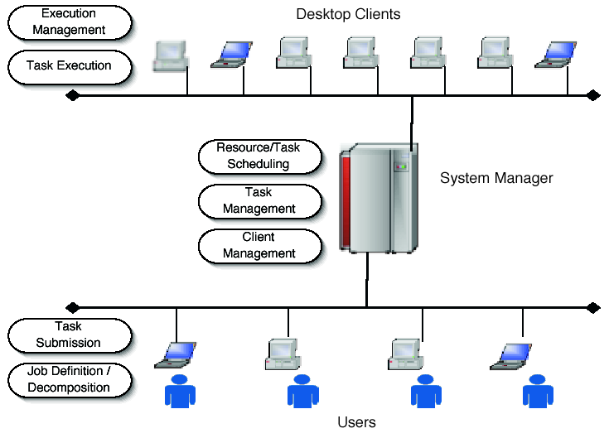
Figure 1: Generalized Architecture of a PC Grid Computing System.

We describe the following use cases:
- User submits Job,
- User Queries the System Manager for Status,
- Desktop Client Joins the System,
- Desktop Client Executes a Task,
- Job Completes and results are returned to the User,
- Desktop Client Leaves the System.

User submits Job

A user interfaces to the system through a desktop computer. This computer may or may not function as an execution resource (for the purposes of this document, we assume that it does not). There may be a single user (e.g. seti@home), or a many users (we assume many users).

A job is a computational task that the user wishes to execute. A job is composed of a set of tasks, where each task is a single computational unit. Job decomposition may or may not be part of the PC Grid Computing system, and may range from trivial (e.g. parameter sweep style jobs) to quite difficult.

The job is decomposed into a set of task descriptions that includes all the information necessary to execute the task: command executables or locations where they can be found, input parameters, input files or their locations, required output files or their locations, and resource requirements. These task descriptions are sent to the System Manager for scheduling and the System Manager returns a unique job ID for that batch of tasks. The JobID can be used to query the System Manager for the job status.

Note: there may be a firewall or NAT between the User and the System Manager.

User Queries the System Manager for Status

Using the jobid returned by the System Manager for a previously submitted job, the user can query the system to determine the status of the set of tasks. The System Manager returns the job statistics (number of tasks completed, number of tasks currently being executed, number of tasks pending, number of errors, etc).

Note: there may be a firewall or NAT between the User and the System Manager.

Desktop Client Joins the System

When a new Desktop Client joins the system (that is, when the client installs the PC Grid Computing Client software), the software first determines the resource characteristics of the machine: laptop versus desktop, operating system and version, available RAM and disk, processor speed, etc. These resource characteristics are sent to the System Manager that records the characteristics of the machine, its current IP address and generates some unique client ID that is returned to the software.

The client ID is used for all future communications with the System Manager. Note: the client ID cannot be the IP address of the machine, since in this environment, IP addresses may change dynamically. By tagging all communication by a unique client id, the System Manager can identify client machines as their IP addresses change.

After receiving the client ID, the client and System Manager periodically communicate to ensure that the client is available.

Note: there may be a firewall or NAT between the Client and the System Manager.

Desktop Client Executes a Task

When the System Manager schedules a task for execution by allocating the task to an appropriate client. The client, through either a push or a pull mechanism, receives the task description and downloads the necessary files (input files, databases, executables, etc). The client then launches the task typically in some type of sandbox, where the client software can have tight control of the task’s execution.

The client software monitors the execution of the task, ensures that the task does not cause any interference with the desktop user and if so, kills or pauses the task.

The task may need to communicate with other tasks during its execution.

When complete, the a signal is sent to the System Manager that the task completed, and the resulting files (or locations) are copied to their external locations, as described in the task description.

If the desktop client is a laptop, it may disconnect from the network and continue to execute the task. When the task is complete, the client software waits until the network is available, and then sends the notification to the System Manager. When disconnected, communication with other tasks is not possible and the task blocks.

If the desktop client is rebooted, the client software is automatically restarted and the task is either continued from a checkpoint file (if available) or restarted from the beginning. If tasks are communicating, then restarting a task due to failures must be done in such a way to ensure consistency and validity of the results.

Note: there may be a firewall or NAT between the client and the System Manager and between any two clients.

Job Completes and results are returned to the User

When the set of tasks are complete, the result files, and return codes are sent to the user’s desktop machine. Future queries of the task show the task as complete.

Desktop Client Leaves the System

A desktop client could leave the PC Grid Computing system for a number of reasons, both expected and unexpected. Expected leaves can occur when the software is uninstalled, or the machine is gracefully halted. Unexpected leaves can occur if the machine crashes or has a hard stop. In the first case, the client software can send a notification to the System Manager that the client machine will no longer be part of the PC Grid Computing system. In the latter case, the periodic communication to or from the System Manager will eventually detect that the machine is no longer responding.

File Sharing

File Sharing applications such as Napster and Gnutella are still the most popular peer-to-peer applications in the peer-to-peer space with on the order of millions of users (Napster alone had by some estimates over 57 million individual users). Figure 2 shows a generalized file sharing application. It consists of a number (perhaps millions) of Users and a System Directory. The users may belong to a number of different Groups, where each Group has a unique name. Users have files that they share with other members of groups to which they belong. Groups may be created dynamically by any user who is then identified as the “owner of the group”. The owner of the group can control the subsequent membership of that group. All users belong to the special group “all users”. The System Directory maintains the list of groups, their owners and members, and some metadata of the files that are shared for every user and group. The System Directory allows users within a group to search for files of certain type or content. This directory is a logical entity. It may be implemented in either a centralized way with a single group that includes all users (e.g. Napster), or in a distributed fashion (e.g. Gnutella). We make no assumptions about implementation.

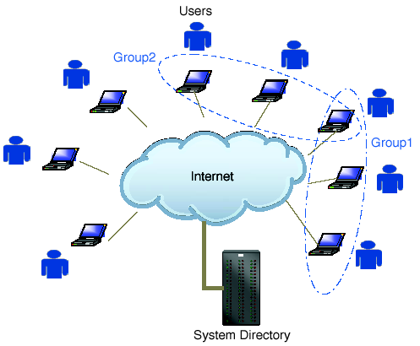
Figure 2: Generalized File Sharing Application

Use cases:
  - client joins the network and logs in
  - user creates a group among which file sharing is possible
  - client publishes files
  - client searches for and downloads files
  - client leaves the network

User Creates a New Group

Any user in the system may be able to create a new group. The user runs a client program on his or her desktop computer that connects to the system and authenticates the user. The user can then request a new group to be created with a particular group name. A group is created by the System Directory on behalf of the user who is then acknowledged as the “owner of the group”. A group has a group name and a group id. The name is arbitrary, but the group id is unique and assigned by the System Directory and returned to the user’s client program. The user is automatically added as the first member of that group.

The group name and id are stored on by the System Directory and are indexed so as to enable discovery by other users. Groups may be hidden or visible, and have open or closed enrollments; all defined by the user at the time the group is created. Visible groups can be discovered by other users not in the group, hidden groups can not. Open-enrollment groups allow any user to become a member automatically; closed-enrollment groups require approval from the owner.

User Joins a Group

In order to join a group, a user must either know the group id of the group he/she wishes to join, or search through the directory of visible group stored by the System Directory. The user then issues a join request to the System Directory.

If the requested group has an open enrollment policy, the user is automatically added. If it is closed, the user is marked as “wanting to join” and awaits approval from the owner of the group. Once given, the user is added to the membership.

Once a member of the group, the shared files that the user has on his desktop computer is indexed and their metadata are sent to the System Directory to allow other member of the group to discover them.

User Shares Files Within a Group

Once a user is a member of a group (and note that all users are members of the special group “all users”), they can search for content (i.e. files) that are shared among all the members of that group.

Using the client program on the user’s desktop machine, the user contacts the System Directory with the search criteria. The System Directory returns to the user’s client program a list of member that have a related file and that are currently connected and logged into the system. The user’s client program can then contact the “peer members” directly and request a copy of the file of interest.

If the peer member disconnects or logs off, then the user’s client program must retry the transfer with a different peer member.

Note that most users are likely to have firewalls or NATs installed between themselves and the System Directory.

P2P Content Delivery

Peer-to-peer content delivery addresses the problem of delivery of large files from a single source server to multiple client destinations. In general, Content Delivery Networks (CDNs) (ref akamai) use specialized content caches located throughout the network to deliver common content such as large images, software updates, or streaming media. Doing so reduces the bandwidth bottleneck at the originating server and improves performance from the client’s perspective.

Peer-to-peer content delivery applications are based on the same idea, but instead of using specialized machines that serve as caches, they use the client’s themselves. Figure 3 shows the general idea: The Server originates the content that is delivered to the client on the right. Subsequently, the client on the left requests the same content from the server. Instead of pushing the content through the internet once again for the second client, a peer-to-peer content delivery network would redirect the file transfer to the first client who, after all, has an identical copy of the content. This redirection is seamless to the second client and the operation completes sooner (since the bandwidth within the enterprise is typically larger than the internet) and more cost effectively (since no bandwidth is used by the server).

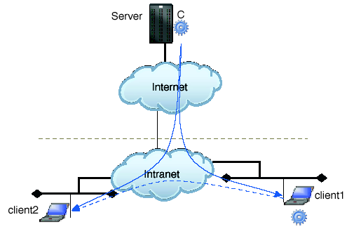
Figure 3: Peer-To-Peer Content Delivery

We consider the following use cases:
  - client1 retrieves the content file from server (no peer caches are available)
  - client 2 retrieves the content file from a peer cache at client1

Client Retrieves Content Directly from Server

For this example, the server holds the content file marked C and receives a request for C from client1. Client1 is situated within an intranet, perhaps a corporate network. The content may be a large file such as a streaming media file, or a software update. C has meta-data associated with it that describes the version information and is not updated by the clients (i.e., the content is read only).

Client1 sends a request to the server for file C. They Peer-to-peer Content Delivery Network intercepts that request and determine that there are no peer caches that hold C. Therefore, the request is sent directly to the server who then sends the file to the client.

When C is received by the client, the client software creates a peer cache at the client and stores both the content and metadata associated with the content. The P2PCDN is updated with client1’s new cached information.

Client Retrieves Content from Peer Cache

When Client2 requests content C from Server, the P2PCDN again intercepts the requests and determines that C is available from a nearby peer. The content request is redirected to client1 and C is retrieved. Client2 then also becomes a peer cache and the P2PCDN system is updated to reflect this cache for future requests.

Security Area - Site Authentication Authorization and Accounting Research Group (http://www.gridforum.org/2_SEC/SAAA.htm)

Reality Grid

Summary
The Reality Grid project (http://www.realitygrid.org) aims to predict the realistic behavior of matter using diverse simulation methods spanning many time and length scales and the discovery of new materials through integrated experiments. A central theme of Reality Grid is the facilitation of distributed and collaborative exploration of parameter space through computational steering and on-line, high-end visualization [1, 2, 3, 4, and 5]. A typical Reality Grid scenario involves a large-scale simulation at one site coupled to a high-end visualization system at another site with the steering and display interfaces running at one or more remote sites. Simulations usually consist of a single component, but multiple-component simulations are becoming more common. Each simulation component is typically implemented in C or FORTRAN, and may be serial or parallelized using e.g. MPI and/or OpenMP. The simulation component periodically (or as demanded by the steering client) emits “samples” for consumption by the visualization component. These components can be started and stopped independently and connected and disconnected dynamically.

Customers
The customers of the use case are computational scientists who use computational steering and/or on-line visualization in their research. By monitoring the progress of simulations, aided by on-line visualization, users avoid losing cycles to redundant computation or even doing the wrong calculation. By tuning the value of steerable parameters, users quickly learn how the simulation responds to perturbations and can use this insight to design subsequent computational experiments. Users require the ability to access multiple computational, visualization, data, display and network resources simultaneously and at a time of their choosing. These hardware resources are heterogeneous, remote, and typically managed by organizations that have established relationships with the end-user but not necessarily with each other. The number of users simultaneously engaged in a computational steering session varies from one to a handful of collaborators, sometimes located in different time zones as in [1, 4, and 5].

Scenarios

Computational steering and on-line visualization
Computational steering [3, 6, 7, 8, and 9] is the ability to interact with, and change the behavior of, a running application. In Reality Grid, an application is instrumented for computational steering through the Reality Grid steering library [6]. A fully instrumented application supports the following operations:
- Pause/resume
- Set values of steerable parameters
- Report values of monitored (read-only) parameters
- Emit "samples" to remote systems, e.g. for on-line visualization or other 'down stream processing.
- Consume "samples" from remote systems, e.g. for visualization or resetting boundary conditions
- Checkpoint and wind back.
Emit and consume semantics are used because the application should not be aware of the destination or source of the data. Wind back here means revert to the state captured in a previous checkpoint without stopping the application. In Reality Grid, the act of taking a checkpoint is the responsibility of the application.
An OGSI-based middle tier, implemented in OGSI::Lite [10], facilitates bootstrapping of communication between components, as illustrated in Figure 4. The “knobs” (steerable parameters) and “dials” (monitored parameters) of the application are exposed as operations of an OGSI-compliant “Steering Grid Service” (SGS), and controlled by remote users through a graphical client tool or web-based portal. The registry, currently implemented using OGSI ServiceGroup constructs, is the central point through which clients discover steerable applications (and visualizations). The application registers (at run-time) its monitored and steerable parameters, which are published through the SGS.
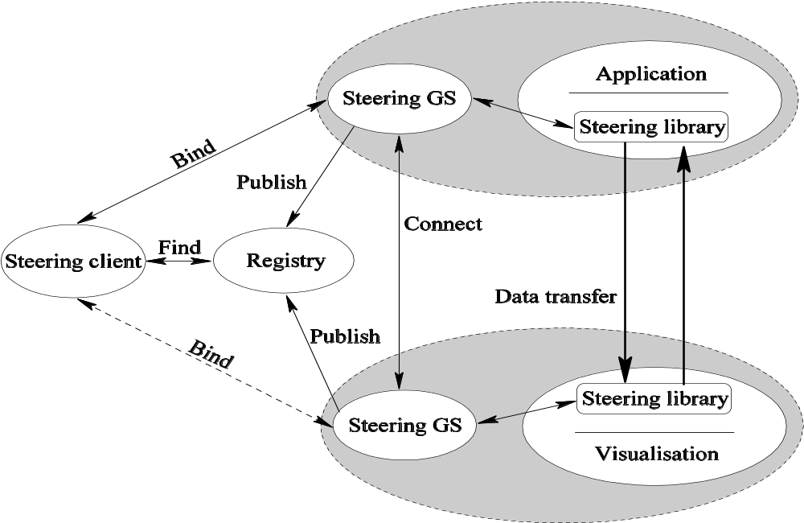
Figure 4: The architecture of steering in Reality Grid
On-line, real-time visualization is an important adjunct for many steering scenarios. SOAP over http or https is a suitable transport protocol for the low volume data exchanged between the steering client and the steered application. The data exchanged between application and visualization is typically much larger, requiring high performance transport mechanisms and ideally a direct connection, but this is sometimes impossible, owing to the presence of firewalls or configurations where the parallel application executes on processors that have no connection to the Internet.
The visualization output must be streamed to display devices which are often remote to the visualization system. This can be accomplished by writing directly to a multicast address used by Access Grid, and/or through the use of proprietary software such as SGI OpenGL VizServer. The latter also permits a remote collaborator to take control of the visualization.

Parameter space exploration and checkpoint trees
Computational steering benefits from checkpoint/recovery functionality in a variety of scenarios [12]. Sometimes the scientist realizes that an interesting transition has occurred, and wants to study the transition in more detail; this can be accomplished by winding back the simulation to an earlier checkpoint, and increasing the frequency of sample emissions for on-line visualization. Similar techniques can be employed when testing a new algorithm; often, the coarse-grain control provided by checkpoint-enhanced computational steering is a more convenient way of reaching the point where things start to go wrong than is stepping through the execution with a parallel debugger. An even more compelling scenario arises when computational steering is used for parameter space exploration [1, 4, 5].
A scientist may be studying a physical system which is suspected to contain a rich phase structure, but does not have sufficient resources available to embark on a brute-force exploration of its multi-dimensional parameter space. Instead, the scientist uses computational steering to begin mapping out this space. The simulation evolves under an initial choice of parameters until the first signs of emergent structure are seen, and a checkpoint is taken. The simulation evolves further, until the scientist recognizes that the system is beginning to equilibrate, and takes another checkpoint. Suspecting that further equilibration will not yield any new insight, the scientist now rewinds to an earlier checkpoint, chooses a different set of parameters, and observes the system’s evolution in a new direction. In this way, the scientist assembles a tree of checkpoints — Reality Grid’s use of checkpoint trees was inspired by GRASPARC [13] — that sample different regions of the parameter space under study, while carefully husbanding his or her allocation of computer time. Different branches of the tree can be explored in parallel. The scientist can always revisit a particular branch of the tree at a later time should this prove necessary. This process is illustrated in Figure 2, in which a Lattice-Boltzmann simulation is used to study the phase structure of a mixture of fluids. Here one dimension of the parameter space is explored by varying the surfactant-surfactant coupling constant g_{ss}.

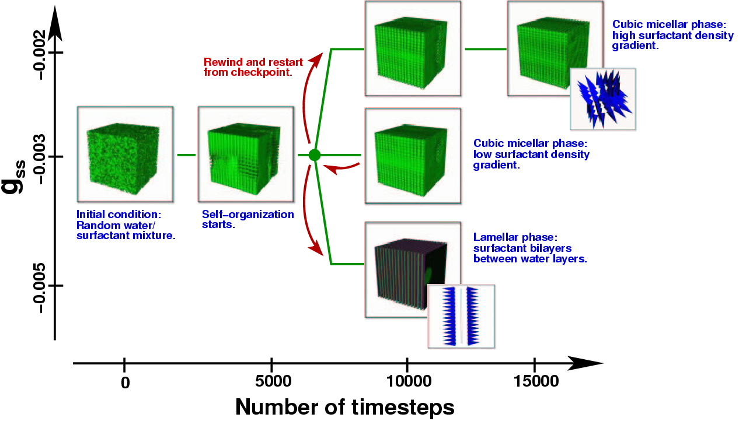
Figure 5: Parameter space exploration gives rise to a tree of checkpoints.

This exploration of parameter space can be conducted in various ways. When more than one user is involved, there are implications for access control to checkpoint data and metadata. When more than one computational resource is involved, transfer of or remote access to checkpoint data and metadata is required. Unless the exploration is completed in a single steering session, then persistence of checkpoint data and metadata is also required; as checkpoints can be large, it is unreasonable to demand that checkpoint data persist indefinitely, so the ability to manage checkpoint metadata is indicated.
Each node in the Reality Grid checkpoint tree is implemented as a persistent, long-lived Grid service containing metadata about the simulation, such as input decks, location of checkpoint files and so on.

Job migration and job cloning
It is often useful to migrate a running job from one computational resource to another. In Reality Grid, a steered application is migrated by disconnecting the visualization (if any), telling the job to checkpoint and stop, transferring the checkpoint files to the new resource, restarting the job on the new resource, and re-connecting the visualization. Sometimes it is desirable to clone the job (similar to job migration but the original job is not terminated), then steer the clone into a different region of parameter space, in order to conduct the exploration of different branches of the checkpoint tree in parallel. Job cloning raises the possibility of race conditions on the checkpoint files, which must not be overwritten by the original application before the copy operation completes. Since job migration and job cloning involve the creation of copies of checkpoint files, we have a replica management scenario.

Coupled models and performance control
A simulation can itself be composed from a number of interacting components, each of which must be deployed onto (possibly remote) resources at run-time. This can be the case when two or more physical models are coupled together. Reality Grid’s Performance Control System aims to optimize the collective performance of the components comprising a distributed application based on performance information collected at run time. Initially, the set of resources will be assumed to be fixed during execution, and it is by redistributing components across this set of resources that the performance control system hopes to achieve performance improvement. Ultimately, however, the ambition is to adapt to utilize new resources that become available during execution.
In the performance control system, the redistribution is achieved by migrating each component of a distributed application. The checkpoints must be malleable, by which we mean that a job initially running on N processors can be restarted on M processors. The checkpoints should also permit restarting on a different architecture.

Involved resources
The hardware resources are typically managed by organizations that have established relationships with the end-user(s) but not necessarily with each other. Hardware resources required by simulation components vary from workstation class through to massively parallel systems with thousands of processors and Terabytes of main memory; such high-end systems are more likely to be found within national HPC services than within the user’s own institution. Visualizations vary in scale and complexity; in some cases the capabilities of the end-users laptop are sufficient, while in others, specialist graphics hardware and software are required. Data resources, both input and output, are strongly application dependent, but it is common to have sets of checkpoint files that encapsulate the state of the physical system being modeled. Display resources vary from the screen on a single user’s laptop or workstation to a collection of Access Grid nodes.
These resources are geographically distributed, and consequently networks are implicated. Migration of jobs from one computational resource to another requires transfer of often bulky checkpoint files (up to 1 TB), which implies the need for high performance networks and efficient file transfer mechanisms. The size of a sample transferred from simulation to visualization is typically an order of magnitude smaller than the size of a complete checkpoint, but the need for network quality of service (here expressed in terms of a guaranteed minimum bandwidth) is greater, as the user will notice every second of the delay between sample emission and the delivery of the rendered image to the screen. For remote visualization, up to 100 Mbps with good latency and jitter characteristics are required.
Software resources include the simulation and visualization codes. These must be deployed on appropriate computational and visualization resources.
In addition to OGSA platform services, Reality Grid uses services such as the Steering Grid Service(s), Registry, and Checkpoint Tree. These require systems to host them.

Functional requirements for OGSA platform
File transfer services are required by job migration.
Job execution services are required to launch the components of Reality Grid simulations and visualizations on appropriate resources on the Grid. Even the simplest computational steering scenarios require co-allocation of computational and visualization resources [14]. Reservation of network bandwidth is also desirable. For a scheduled collaborative steering session, it is also necessary to reserve these resources in advance at a time that suits the people involved. When Access Grid is used to provide the collaborative environment, one usually needs to book the physical rooms and node operators as well.
Reality Grid supports file-based and socket-based mechanisms for exchanging data between simulation and visualization. In file-based communications, samples are written to disk by the emitter and read from disk by the consumer, relying on either a shared file system or a daemon charged with moving samples from the emitter’s file-store to the consumer’s. In socket-based communications, the emitter writes to one end of a socket and the consumer reads from the other. In the former case, we take a performance hit by involving two file systems. In the latter case, we frequently encounter problems establishing the connection due to the presence of firewalls or the absence of an internet connection at the emitter. The existence of file streaming services, roughly analogous to Unix pipes, could prove a boon.
The Steering Grid Services used in Reality Grid are transient, with lifetimes corresponding to that of the simulation or visualization being steered. In principle, these services can be deployed at run-time in a container hosted anywhere on the Grid, if necessary, on resources under the user’s own control. In practice, it is sometimes desirable for performance reasons, or necessary due to the presence of firewalls or the absence of an internet connection on the processors where the application is executing, to host these services close to, or on the same resource as, the steerable component. Thus we have a requirement to deploy dynamically created services on someone else’s resources
It is the experience of Reality Grid users that porting simulation and visualization codes to all the resources on which they are to run is highly non-trivial. Today, it is in general necessary to log in to and become familiar with the vagaries of each system in order to deploy the application codes. In the ideal world, it would be possible to describe everything necessary to build and run the application in a manner that abstracts away all site- and platform-specific considerations. In the absence of this “Holy Grail”, it is desirable for end-users to be able to discover resources that have a required application pre-deployed, and then to ascertain the version of and path to the application.
Reality Grid’s multifaceted use of checkpoint/recovery raises requirements for checkpoint/recovery services which are being fed into the Grid Checkpoint/Recovery Working Group (GridCPR-WG) of GGF.
Provenance explains how a particular result has been derived; it typically includes the sequence of steps that are involved, their inputs and their outputs. It can also include annotations that explain why a scientist performed a given operation or changed the value of some parameters, or that contain a scientist's opinion about another scientist's experiment. As computational steering becomes more widely used, the need for provenance support has been identified at two different levels:
Fine-grained provenance: This is the provenance associated with the steering commands a user issues during a single session. Such a form of provenance is quite similar to a logging facility: it includes the commands, their parameters, their effects and order. Ultimately, if all the useful information is being recorded properly, such a fine-grained provenance can be used to generate the script that will replay an execution fully; in other words, experiments can be repeated using fined-grained provenance.
Lab-book provenance: This form of provenance is associated with the long term exploration of the parameter space undertaken by collaborating users. It contains a set of annotations to the tree of checkpoints with information such as who ran the job, for what particular purpose, the number and identity of resources it used, the inputs and the outputs (precisely where they were left); some of these annotations may be automatically generated, while others are manually entered by the scientists. Such a provenance can be seen as a form of electronic lab-book containing high-level description of the in silico process scientists go through during the exploration of the parameter space.

OGSA platform services utilization
Review section 4.2 of OGSA platform document which proposes services of OGSA platform and choose necessary services from them.
Explain which of these services your use case uses and how it utilizes them in detail. Please include figures if possible.
If desired service is not included in section 4.2, you should specify what service is required.

Security considerations
Data, services, and applications used in Reality Grid are shared by collaborating users, but cannot be made universally accessible. Thus access control is required on: inputs, outputs, and checkpoints; Steering Grid Services, Registries, and Checkpoint Trees; on application codes. A related notion is that the SGS should in principle present different interfaces to the steerable application (which writes monitored parameters and reads steered parameters) and the steering client (which reads monitored parameters but writes steered parameters). This is more naturally achieved in WSRF than in OGSI.
Secure transport mechanisms between services and between simulation and visualization components are required. In environments where security is not paramount, it should be possible to disable encryption to boost performance, and to make this choice at run-time.

Performance considerations
Explain performance considerations of the use case.

Usecase situation analysis
A discussion of what services relevant to the use case are already there, to what extent they are satisfactory/unsatisfactory, and an articulation of what else needs to be done.

References

- S. M. Pickles, R. J. Blake, B. M. Boghosian, J. M. Brooke, J. Chin, P. E. L. Clarke, P. V. Coveney, N. Gonzalez-Segredo, R. Haines, J. Harting, M. Harvey, M. A. S. Jones, M. Mc Keown, R. L. Pinning, A. R. Porter, K. Roy, and M. Riding, The TeraGyroid Experiment, Workshop on Case Studies on Grid Applications, March 13, 2004, Berlin, Germany, held in conjunction with GGF10. (http://www.zib.de/ggf/apps/meetings/ggf10/TeraGyroid-Case-Study-GGF10-final.pdf)
- J. M. Brooke, P. V. Coveney, J. Harting, S. Jha, S. M. Pickles, R. L. Pinning and A. R. Porter, Computational Steering in Reality Grid, Proceedings of the UK e-Science All Hands Meeting, September 2-4, 2003 (http://www.nesc.ac.uk/events/ahm2003/AHMCD/pdf/179.pdf).
- J. Chin, J. Harting, S. Jha, P. V. Coveney, A. R. Porter and S. M. Pickles, “Steering in computational science: mesoscale modeling and simulation”, Contemporary Physics 44, 417-434, 2003.
- Stephen M. Pickles, Peter V Coveney and Bruce M Boghosian, Transcontinental Reality Grids for Interactive Collaborative Exploration of Parameter Space (TRICEPS), Winner of SC’03 HPC Challenge competition in the category “Most Innovative Data-Intensive Application”,
(http://www.sc-conference.org/sc2003/inter_cal/inter_cal_detail.php?eventid=10701#5).
- Mathilde Romberg, John Brooke, Thomas Eickermann, Uwe Woessner, Bruce Boghosian, Maziar Nekovee, Peter Coveney, Application Steering in a Collaborative Environment, SC Global conference, November, 2003 (http://www.sc-conference.org/sc2003/inter_cal/inter_cal_detail.php?eventid=10719).
A Windows Media Stream archive of this session is available at
mms://winmedia.internet2.edu/VB-on-Demand/AppSteering.asf.
- Jurriaan, D. Mulder, Jarke J. van Wijk, Robert van Liere, A Survey of Computational Steering Environments, Future Generation Computer Systems 15 (1999), pp. 119-9.
- S. G. Parker, D. M. Weinstein, and C. R. Johnson. The SCIRun computational steering software system. In E. Arge, A.M. Bruaset, and H.P. Langtangen, editors, Modern Software Tools in Scientific Computing, pages 1-44. Birkhauser Press, 1997. (http://citeseer.nj.nec.com/parker97scirun.html)
- G. A. Geist, J. A. Kohl, P. M. Papadopoulos, CUMULVS: Providing Fault-Tolerance, Visualization and Steering of Parallel Applications, International Journal of High Performance Computing Applications, Volume 11, Number 3, August 1997, pp. 224-236.
- T. Eickermann and W. Frings, Visit – a Visualization Interface Toolkit, Version 1.0, 2000. (http://www.fz-juelich.de/zam/docs/autoren2000/eickermann.html)
- M. Mc Keown, OGSI::Lite – a Perl implementation of an OGSI-compliant Grid Services Container. (http://www.sve.man.ac.uk/Research/AtoZ/ILCT).
- Stephen Pickles, Robin Pinning, Andrew Porter, Graham Riley, Rupert Ford, Ken Mayes, David Snelling, Jim Stanton, Steven Kenny, Shantenu Jha, The Reality Grid Computational Steering API, Version 1.0, 9 July 2003, unpublished.
- Stephen Pickles, On the use of checkpoint/recovery in Reality Grid, January 2004, (http://gridcpr.psc.edu/GGF/docs/ReG-GridCPR-use-cases.pdf).
- K. W. Brodlie, L. A. Brankin, G. A. Banecki, A. Gay, A. Poon and H. Wright. GRASPARC: A problem solving environment integrating computation and visualization. In G. M. Nielson and D. Bergeron, editors, Proceedings of IEEE Visualization 93 Conference, p. 102. IEEE Computer Society Press, 1993.
Karl Czajkowski, Stephen Pickles, Jim Pruyne, Volker Sander, Usage Scenarios for a Grid Resource Allocation Agreement Protocol, GGF Memo, February 2003.

The Learning GRID

Summary
The Learning and teaching processes could play an important role in promoting Grid. Indeed, the implementation of future learning scenarios, based on collaborative, personalized, ubiquitous, experiential-based and contextualized learning paradigms, could benefit from Grid technology.
Currently, teaching and learning practices are mainly based on the information transfer paradigm. This focuses on content, and on the key authoritative figure of the teacher that provides information, without taking in account any finer features such as his starting skill or his learning capabilities.
In order to advance the effective learning, we need to promote a new paradigm that focuses on the learner and on new forms of learning. In this paradigm, the learner has an active and central role in the learning process. The learning activities aim at facilitating the construction of knowledge and skills in the learner, instead of the memorization of information.
The knowledge construction occurs through new forms of learning which are based on:
- the understanding of concepts through direct experience of their manifestation in realistic contexts (i.e. providing access to real world data) which are constructed from sophisticated software interfaces and devices, and represented as services;
- “social learning” – active collaboration with other students, teachers, tutors, experts or, in general, available human peers, by using different kinds of collaboration technologies, including enhanced presence.
In this approach, the collaboration is considered as a complex conversational process that goes far beyond a simple information exchange. In order to support such a “ubiquitous conversational process”, one needs to take into account also the social context in which the learning process develops. Accordingly, we do not consider the learner’s ability in an abstract way; instead we will relate it to a specific situation (the context). Here the term “ubiquitous” does not simply refer to “anytime / anywhere”, but more generally to the ability to support multiple diverse learning contexts and to automatically adapt to them.
In summary, the user-centered, contextualized and experiential based approaches for ubiquitous learning, imply the full exploitation of location-transparent access to distributed services such as simulation environments, real-world input, 3D visualization systems and digital libraries, in the framework of a Virtual Organization. This allows a transition from current content-oriented e-Learning solutions towards a user-centered, collaborative model.
To support learners during the whole cycle of their learning process, from the definition of objectives to the assessment of results through the construction of custom courses, several actors form a VO. This VO is a learning community able to continue its existence after the graduation of members, involving external actors and promoting a real long-life learning process.
The actors of this use case are mainly grouped in:
Users, registered actors in the VO and they act a specific role in the VO
Organizations, enterprises or agencies acting as grid service providers that provide services inside the VO.

Customers
The key customers belong to the user group and they can have different roles:
- Learner: is a student registered in the VO. Learner acquires knowledge through learning experiences provided by specific learning training services.
- Expert Learner: a learner skilled about some topics. He can offer mentoring support to the other learners on some topics, usually for free.
- Freelance Tutor: is a professional tutor offering his specialized mentoring support to learners about specific topics, usually under the payment of some price.
- Skill Searcher: is an enterprise manager interested in hiring certified staff.
- Content Provider: builds didactic materials and constructs metadata on it using Knowledge Management System tools.
- Knowledge Manager: is a didactic domain expert who manages Domains, Concepts, Ontologies and other Knowledge Structures using Knowledge Management tools.
A user can change its role during its long-life learning process. For example, a learner becomes an expert learner when he obtains a given quota of credits and an expert learner can accept to be a freelance tutor.

Scenarios
To introduce some scenarios, we describe the other actors of the use case. Organizations are primary concerned with the provision of services inside the VO. Furthermore, they can act as clients when they need to use services or resources belonging to other Organizations. Between Organizations, we find:
- Publishing Houses (PH). They store training content and provide remote access to it. They provide search and retrieval functions on the local repository via metadata-based queries.
- Knowledge Agencies (KA). They maintain and manage knowledge structures (concept dictionaries and ontologies) for the VO.
- Tutor Agencies (TG). They work as entry point for freelance tutors; they manage the freelance tutor archive (containing tutor models) and provide searching facilities on such archive.
- Brokerage Offices (BO). They research, prepare and provide learning activities for learners on demand, based on customisation information (learner model, learning strategies, price, learning goals).
- Training Agency (TA). It provides the environment for learning experiences and Tutor support activities. Training Agency assigns credits to learners in order to gradually lift up him/her to an Expert Learner status.
- Skill Agency (SA). It performs queries on distributed repository in order to localize learner with particular skills. Furthermore, Skill Agency tracks user queries in order to provide statistics like most required skills.
- Bank (BA). It manages all transactions inside VO and releases receipts for successful transactions.
- Café (CA). It provides virtual discussion tables between learners based on their learner models and between a learner and his/her mentor. Café provides communication and collaboration tools (forums, chat etc) to virtual tables.
- WebCatcher Agency (WA). It performs searches on web and semantic web in order to discover and acquire new didactical material to provide to learners.

Content Provider Scenario
Content Providers build Learning Objects and metadata describing those using off-line Knowledge Management tools. Content Provider can upload a folder of Learning Objects and Metadata into a specific Publishing House previously selected, querying an information service, from the ones belonging to the VO. The upload operation includes also the indexing of the uploaded material and the storing of this material into a repository. The Content Provider receives a payment from the Bank organizations for the development of the content.
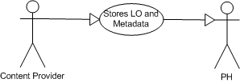
Figure 1 - Content Provider Scenario

Mentoring Scenario
In this scenario can participate Expert Learners and Freelance tutors. Freelance Tutor uses Tutor Agency in order to manage his/her list of current jobs. A job is a structured summary of the activities related to collaboration tasks between the tutor and a learner. Freelance Tutor can also receive some reports about learner activities and specific learning experience in order to give suggestions to his/her learner. Tutor can access to a Café and sit on a virtual discussion table in order to use collaboration/communication services Freelance Tutor receives payment from Bank organizations.
Expert Learners are only able to access to a Café in order to help, for free, the learners.
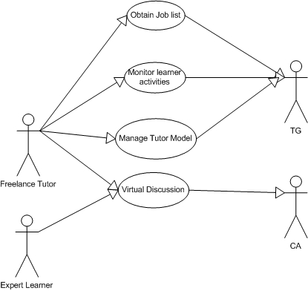
Figure 2 - Mentoring Scenario

Knowledge Manager Scenario
Knowledge Manager is a domain expert who builds knowledge structures like concept dictionary and ontology. Knowledge Manager builds these structures using off-line Knowledge Management tools and updates Knowledge Agency information, once obtained its reference from an information service.
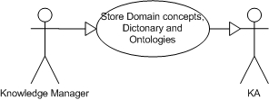
Figure 3 - Knowledge Manager Scenario

Skill Searcher Scenario
Skill Searcher can perform queries on a Skill Agency in order to retrieve learners with desired specific skills. It will pay for this service.
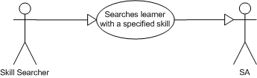
Figure 4 - Skill Searcher Scenario

Learner Scenario
Learner, once accessed to the VO, is able to obtain a list of learning activities provided as services, which can be personalized on the basis of personal requirements. Learner is able to negotiate the QoS of these services and to reach a Service Level Agreement.
Learner can ask to the Training Agency a set of activities specifying his/her requirements and optionally his/her learning objectives. Learner can also decide to request system help in order to obtain a suggested set of learning objectives that has been built using current learner cognitive state and using most required skills. When Learner receives the offers, he/she can select a personalized learning experience and pay fort it. The Training Agency will notify to Learner when his/her personalized learning experience publishing has been realized, so Learner will run it and possibly will ask for remedial work if his/her in order to improve test results.
Learner can also manage his/her collaboration with a mentor that can be free (Expert Learner) or paid (Freelance Tutor) selecting a new one for a specific learning experience, sending feedback about a current or a previous tutoring activity and accessing to a Café in order to communicate/collaborate with mentors or other learners.
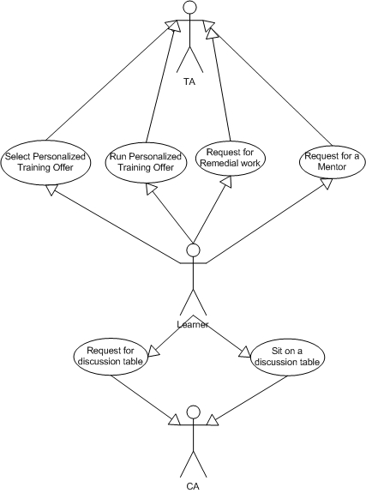
Figure 5 - Learner Scenario

VO Scenario
In this section, we present a simple scenario that explicit also some VO services used for provisioning of personalized and customized learning activities. In this scenario, a registered and authorized learner asks for a personalized training session. This scenario aims to emphasize the interaction inside a VO when a learner asks for a training session.
A learner registered in the VO asks for a training session and he, through the Accessor Component (A) that is an internet entry point, performs a query against the VO Monitoring and Discovery Service (VO MDS) (1). He obtains a list of services provided by (collaboration of) different Organizations inside the VO. He decides to gain experience in the business field and to play with a Business Game, but he provides some visualization constrains (e.g. he asks for 3D representations of business game data) so he requires narrowing requirements on the visualization performance of the service. Through the Accessor Component, he negotiates with a Negotiator Service (2) the QoS for the required service. The Negotiator interacts with TA Organization (3), which starts a simple workflow. The first operation is to map the required constrain with the resource requirements needed to satisfy it. The QoS Component of the TA organizations (see section 5.4) performs this task. Obtained the results, the second step is to query the VO MDS (4) to obtain a list of available resources and/or services of the VO that are able to satisfy the requirements, obviously on the basis of the current status. Once the TA has the list of the available resources, it contacts the VO Resource Manager Service (VO RM) (5). The VO RM asks the RM Components of the Organizations, which are able to provide the required resources, the reservation of the resources (in the Figure 6 - VO Scenario, we suppose that all the necessary resources can be provided by the BO and PH Organizations and this operation is shown with the dashed lines). At the end, a SLA is caught up and returned to the learner.
The Learner asks for the personalized learning activity to his/her TA (6) starting from a concepts list of the business game that he/she wants to learn (Target Concepts). Training Agency calls the KA (7) passing to it the target concepts in order to build the learning path, it will be composed by all concepts necessaries to the learner to reach the target concepts. KA builds the learning path using the owned knowledge structure, ontology and concepts dictionary, and the learner acquired knowledge. Once the learning path is ready and the best learning strategies for the learner is fixed, the TA calls the BO (8) of the VO in order to obtain the activities to propose to the learner. Each BO starting from the data received by TA (learning path, learning strategies, learner model, etc) will prepare an own learning session. To do this the BO calls the PH (9) asking it to provide the list (list entry are the metadata that describe the single Learning Object) of available material, that best fit the Training Agency requirement.
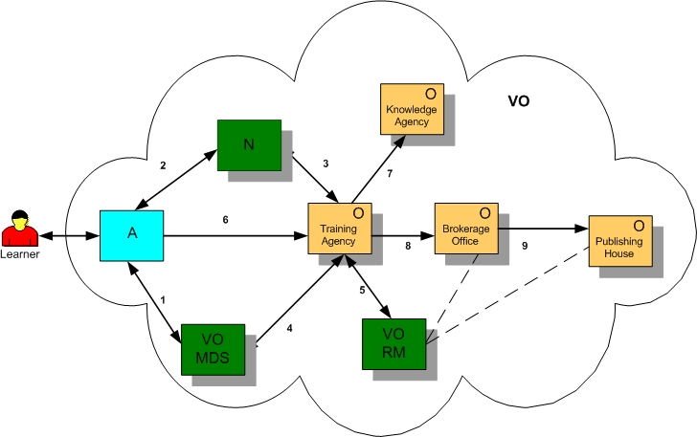
Figure 6 - VO Scenario

Experiential and collaborative based scenario.
This is a simple scenario that emphasizes the features of a collaborative and experiential based learning model. In this scenario, a mentor creates a group and invites some learners, with common needs and similar skills, to join a collaborative learning session. He accesses the Café organization providing the target concepts and he relies upon the collaborative features of the organization to provide highly realistic virtual scientific experiments. Café asks Brokerage Office to prepare and define, interacting with other organizations, a standard didactical model for the achievement and representation of such experiments. The learners belonging to the Group can access to the virtual experiment and interacts with it, using a group Accessor Component that interacts with the Café organization.
In this type of model, a learner is immersed in a specific context, which, through appropriate simulations, develops active learning processes with progressive abstraction levels, leading to the construction of knowledge in a dynamic way. In this learning model, the student can also receive the support of other users (collaborative aspects) and, through the comparison with them; they can build a new “mediated” knowledge.
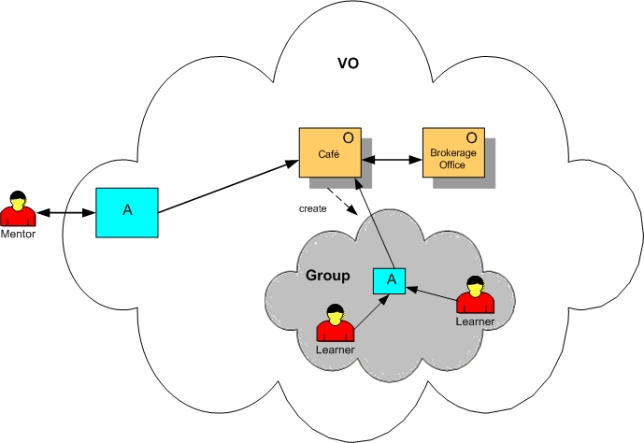
Figure 7 - Collaborative and experiential based scenario

Involved resources
Organization itself can be seen as resource of the VO. Below is depicted the core infrastructure of an Organization.
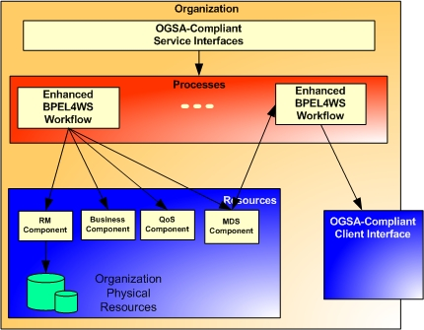
Figure 8 - Organization Infrastructure
Organizations provide OGSA compliant services and can manage Processes, Resources and other Organizations. Processes express and are realised by the collaboration between Organisations or by the collaboration between Organisations and resources. Organizations provide complex services obtained by composition and coordination of simple services. Workflows, in this model, are BPEL4WS scripts enhanced with metadata in order to manage the Grid features (e.g. lifetime management) of the services to compose. Each Organization has a BPEL enhanced engine able to parse the enhanced scripts and execute the workflow. This engine is exposed as OGSA service and accessible in a standard way.
Each Organization has a component called “MDS Component”, which is functionally equivalent to a Grid Resource Information Service (GRIS) . It maintains information about the service/s provided by the Organization and the resources of the Organization and it has the capabilities to monitor the resources in order to obtain updated information about their status. This component provides a standard interface. Furthermore, there are specialized Business Components that implement business rules and perform business tasks, a QoS Component that performs the mapping between high level figures of QoS (e.g. Time response) and low level figures (e.g. Required memory, Bandwidth) that can be monitored and measured and a Resource Manager (RM) Component that implements logic to manage the local resources and exposes a standard interface.
The Organizations are Grid Service Providers but, by the other side, they take the role of clients when they negotiate or use services provided by other Organizations, so there is another interface that allows an Organization to interact with other members of the VO. The communication with external services happens with this standard interface.
Obviously, computational resources are needed. Each Organization has a set of own distributed servers hosting the simple services to be orchestrated. Servers are needed for the hosting of common VO services (e.g. the negotiator, the MDS) and to host the Accessor component. High-Bandwidth Networks are required for the provisioning of special contents (e.g. video, animations, high quality multimedia contents, and 3D rendered simulation data). As well as high quality video for live collaborations with application sharing and multimedia contents sharing sessions.

Functional requirements for OGSA platform
The following functions are required for the realization of the presented scenarios.
- Discovery and brokering. Users and Organizations must be able to discover services and resources inside the Grid. As we can see in VO Scenario, a learner must be able to use discovery services in order to obtain a detailed list of learning services and a TA organization must be able to discover services/resources needed to provide the personalized offer. Discovery functionalities must be improved in order to perform intelligent searches and provide similar features to those made available by Semantic Web research. Furthermore, brokerage functionalities are needed to prepare the learning offer.
- Metering and accounting. These functions are the base upon which is possible to realize a “pay per use” mechanism where clients pay for the effective resources/services usage. Learners pay for their learning sessions. These offers are personalized also on the basis of user requirements and the resources needed to provide the offers are not known a priori. Each organization must have its Metering/Accounting/Billing subsystem in order to record and account resources usage and duration and to provide, on the basis of its business policies, a bill to the BA organization, which is able to provide a business transaction. Business transactions can happen also between organizations.
- Service Level Agreement Negotiation. This functionality is needed for personalized learning training. Learners pay for the training sessions and they must be guarantee on the QoS provided. SLA Negotiation functionalities are required every time an agreement between a client and provider must be reached. SLA contains information about the cost of the service, the QoS guarantee and the penalties for the provider and it must be human and machine understandable.
- Monitoring. Information on the status of the resources is very important to realize learning sessions based on SLA. Monitoring has to be managed on two levels. Each organization has to monitor its own resources and a global VO monitoring of resources is needed. Application and service monitoring systems are needed to control if the SLA is respected.
- Data, information and knowledge management. Data management and sharing is addressed by but also functionalities for information and knowledge management are useful for our purpose. Many organizations need them. For example, KA organizations rely on services for acquire, use, retrieve and maintain knowledge. The meaning of Information and Knowledge, as well as the set of functionalities needed, is defined in .
- Virtual organizations and groups. Creation and management of VOs and groups are needed. The provisioning of learning session happens only after the creation of a group inside the VO. Groups can be created by mentors and are finalized to provide a session with the learners. The mentors rely on these functionalities to add the interested learners in a group and to invite expert learners in a group. Groups can have a short lifetime (e.g. the time of a single learning session) or a long lifetime (e.g. a complex offer composed of multiple learning sessions). Generally, lifetime of a group is dynamic and it should be possible to manage it (e.g. extend the group lifetime if a learning activity has required more time). Functions for the management of relationships between groups are useful.
- Load Balancing. Strong load balancing functionalities are used by the organizations, in combination with the monitoring ones, to guarantee that low-level requirements on QoS (e.g. CPU usage, memory available) are respected.
- Fault tolerance. Used to support fault management and load redistribution. Fault tolerance functionalities are particular important during specialized learning sessions, e.g. a videoconference between a tutor and some learners. Mechanisms are required in order to avoid the Grid shut down during this period.
- Advance Resource Reservation. Based on user requirements, it must be possible to reserve the resources needed for delivery of requested QoS. Furthermore, advance resource reservation is needed also to reserve particular kinds of resources for specialized learning session, e.g. a collaborative lesson between a tutor and some learners.
- Notification/Messaging. Used by the actors when they request something (learner requests a mentor sending messages to his TA, a learner requests a remedial work to his TA, etc…) or when they need to obtain information on which they express a kind of interest. Furthermore, these functionalities are also used for create virtual discussion needed by the CA organization (e.g. instant messaging in a chat room).
- P2P/Collaboration. These functionalities are fundamental in a cooperative and collaborative environment. Members of a VO or a group can use these functionalities for realizing basic collaboration activities. Also CA organization is based on these features. For example, every time learners with a similar skill sit on a discussion table they can be able to join a peer group in which the can collaborate sharing knowledge. Furthermore, these functionalities are used for the provisioning of collaborative and experiential learning session based on human centred methodology and on the learning by doing paradigm.
- Workflow management. Organization provides complex services developed as workflows that coordinate resources and services form other organizations. Functionalities to parse and execute these workflows are required.
- Certification. A trusted party certificates a particular content provided by a Content Provider.
- Authentication, Authorization and Accounting (AAA). These functionalities are needed when a user access to the VO. They are used, also, to establish the privileges of different users (learner, expert learner and so on). Single Sign On capabilities must be supported inside a VO in order to reduce the number of authentications and authorizations on the different resources.
- Trust Management. The emerging of new forms of collaboration, based on the concept of Virtual Organization, requires the set up of a secure environment where the controls and procedures are automated based on clear specifications of trust. Based on these motivations, trust management functionalities are required.
- Digital and intellectual rights. Functionalities needed to prevent an unauthorized use of digital contents and to guarantee some rights to content developers.

OGSA platform services utilization
Our scenarios rely upon the following services:
- Discovery services. These services have to provide a standard interface. They must allow metadata-based queries against the registries.
- Service Group services. They are used for the realization of registries and repository.
- Monitoring services. Between them, there are:
  - Resource Monitoring services, which monitor the status of the resources.
  - Application/Service Monitoring services, which monitor the domain specific parameters of the SLA.
  - Learning Activities Monitoring services, which are used to monitor the job list of a learner.
These kinds of services provide an interface that allows queries to obtain information about the resource/service monitored and to delivery notifications (e.g. violation of a SLA parameter, report about activities) on the basis of trigger events.
- Metering and Accounting services. They provide the metering and accounting functionalities.
- Negotiation services. They are used to negotiate SLA between a client and a provider. These services expose standard interfaces taking in input the user requirements. On the basis of a well-defined negotiation protocol a negotiation service is able to interact with the organizations in order to define all the field of a SLA.
- Resource Management services. They provide load balancing, reservation and scheduling of jobs. Organizations have their own resource managers that dynamically allocate the resources. The VO has a VO Resource Manager, which manages organizations and asks for the reservation of organization resources.
- Fault Management services. These services have to manage the faults. On the basis of recovery policies, they take appropriate decisions invoking the Resource Manager. Their interfaces act as a notification sinks that are able to obtain notification events from the systems that generate faults.
- Orchestration service. Organizations provide services that are composition of other services. Composed services are developed as workflows, which are parsed and executed by an engine. The orchestration service acts as the workflow engine. It exposes an interface that takes in input BPEL4WS scripts enhanced with metadata used to manage the grid features of the services to compose.
- Security services. They correspond to AAA, Trust management, Certification and Digital and Intellectual rights functionalities. They must be able to manage, and interact with, proprietary security systems.
- Collaboration/Communication services. They are used to support collaboration and communications between services. They implement the Notification/Messaging and the P2P functionalities,
- VO services. They provide the functionalities for creation, management, join and resign of a VO and of groups inside a VO
- Data, Information and Knowledge Management services. These services have to provide the functionalities for storing, retrieving and managing of data, information and knowledge. Their interfaces should provide transparency to the user, e.g. he should be able to perform a query against a data, information or a knowledge structure in the same way. Furthermore, they need to manage replica, ownership and consistency among replicas.
The following picture summarizes a simple mapping between the presented scenarios, the required functionalities and the services implementing these functionalities. The VO and the Experiential and collaborative-based Scenarios are not depicted in this mapping and some functionality are internal to the Grid infrastructure, so there is not an explicit relation between the scenarios and some functionalities.

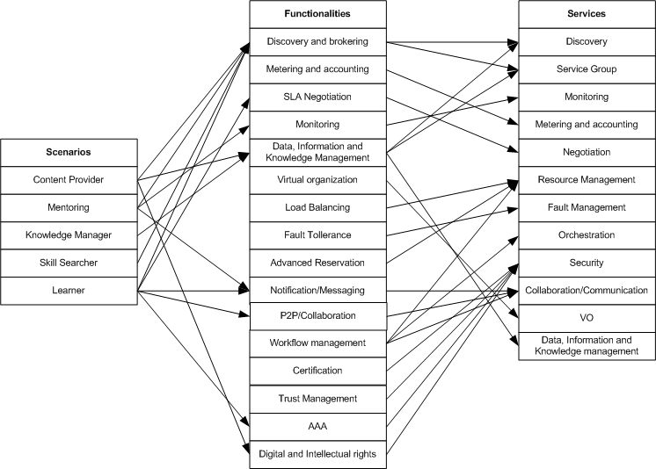
Figure 9 - Mapping

Security considerations
Each organization, as a Grid Service Provider, has its own security policies and systems that must be supported. Malicious intrusions in proprietary resources have to be avoided. In general, the mechanisms proposed in are sufficient to address general security issues.
Our scenarios must deal with digital and intellectual rights of the contents. The Grid has a geographically distribution and spans across different regions with different laws. Contents have a license associated, which is a grant of permissions. Unauthorized use of the contents should be avoided. Furthermore, a trusted third party must certify contents.

Performance considerations
Performance depends on:
- the required QoS. In a learning scenario, the user negotiates the offer on the basis of custom requirements in the form of High-Level figures (e.g. response time, video quality). These last ones are mapped in Low-Level figure measurable and controllable (CPU usage, required bandwidth) using domain specific algorithms and/or tables. This is difficult, especially in a collaborative and experiential based environment, in which the learners uses interactive applications distributed on different resources. The mapping algorithms have enormous importance in the performance of the overall system,
- Extraction of training contents. Some organization must be able to extract training content, concept dictionaries and ontologies from the repositories. This operation is time and resource consuming, also due to the complexity of the “reasoning” algorithms for the extraction of ontologies, and has to be optimized (e.g. using of optimized query evaluator engine) in order to optimize the overall performance,
- Low latency high bandwidth networks. Required mainly for the large amount of multimedia data transferred during learning and collaborative sessions.

Use case situation analysis
Some functionalities of this use case are already present in while other functionalities, as metering/accounting/billing and monitoring are also addressed in . Currently, this use case is in a research phase and we are investigating the Semantic Web/Grid approach to representation and management of data, information and knowledge and we will follow recommendations provided in for dynamic negotiation between clients and providers inside a VO. Probably, extension should be done to improve the discovery services providing semantic features.

References
[1] P. Ritrovato, M. Gaeta, G. Laria, T. Dimitrakos, D. Mac Randal, F. Yuan, S. Wesner B. Serhan, K. Wulf, “AN EMERGING ARCHITECTURE ENABLING GRID BASED APPLICATION SERVICE PROVISION” to be appear in the proceeding of 7th IEEE International Conference EDOC - September 16-19 2003, Brisbane, Australia
[2] C. ALLISON, S. A. CERRI, P. RITROVATO, M. GETA AND S. SALERNO, "Human Learning as a Global Challenge: European Learning Grid Infrastructure" Tampere, Finland: University of Tampere Press.
[3] http://www.friends-partners.org/GLOSAS/Global_University/Global University System/UNESCO_Chair_Book/Manuscripts/Part_IV_Global_Collaboration/Ritrovato, Pierluigi/E-LeGI_web/E-LeGIv9.htm.
[4] “Diogene: A Training Web Broker for ICT Professionals” FP5 Project (IST-2001-33358). http://www.diogene.org
[5] Foster I., Gannon D. Kishimoto H “The Open Grid Service Architecture” November 2003
[6] “Business Process Execution Language for Web Service V1.1” 5 May 2003 http://www-106.ibm.com/developerworks/webservices/library/ws-bpel/
[7] Foster, C. Kesselman and S. Tuecke, “The Anatomy of the Grid” 2001
[8] De Roure D. et al. “The Semantic Grid: A Future for e-Science Infrastructure”
[9] Foster, Tuecke et. al. “OGSA Security Roadmap”
[10] Czajkowski, K., Dan, A., Rofrano, J., Tuecke, S. and Xu, M. “Agreement-Based Grid Service Management (WS-Agreement)”. Global Grid Forum, Draft 2003
[11] N. Capuano, A. Gaeta, G. Laria, F. Orciuoli and P. Ritrovato “How to use GRID Technologies for building the Next Generation Learning Environments” 2003

HLA-based Distributed Simulation Usecase

Summary
One of the most useful tools to face very complex problems that are difficult to handle in an analytical way is surely represented by simulation and in particular distributed simulation. To set up a distributed simulation is a hard task as it requires to take into account communication and synchronization issues, handling of huge amount of data and in case of real-time simulations also performance and fault-tolerance requirements. Hence it seems evident that many advantages will be gained in using the Grid infrastructure as substrate of a distributed simulation. In addition, if with simulation it is not referred just to the execution phase, Grid technologies will result extremely useful also for both the modeling and data-analyzing phases, by means of VOs for the collaborative generation of models and collection and analysis of data.
HLA is an affirmed IEEE standard for distributed simulation and its role is to separate the communication tasks between atomic simulation component (called federate) from the pure simulation tasks, within a simulation execution (called federation). Hence it is useful to combine this standard with Grid technologies [1] so to obtain a HLA-domain-specific GRID (HLA-GRID).
The HLA-GRID is hence thought as a distributed and a collaborative environment that enable to develop and run HLA-compliant simulations. As it will be expressed more in detail in the scenario section, it can be imagined that more than one institutions participate to a simulation, with different responsibility, that imply accounting, policy and security issues, sharing data and resources. In addition as the GRID architecture involves the collection of heterogeneous resources, it is required also to consider monitoring and fault-tolerance issues together with QoS requirements.

Customers
User
The User is the end user of the simulation, i.e. the one that models and runs a specific simulation, and that retrieves information by the output data. Actually many users can actively co-operate in running and analyzing data, and they can be involved in the simulation at different levels of depth. For example a user can just have summarized information from a simulation, i.e. a typical client, or in opposite s/he can be involved in the control or interaction with the simulation itself, e.g. in a virtual experiment.
Developer
The Developer is the one responsible for the creation of simulation components. In HLA terminology s/he creates new federates and/or assembles complete federations by combining their federate components. Likely this task is performed in a collaborative environment,
Administrator
The Administrator is responsible for managing simulation subparts. His/her activity does not involve directly the simulation but principally problems of policy, security and performances.
It is useful to consider also the federates itself as actors of an HLA-GRID simulation.
Federate
The Federate is, in the HLA terminology, each atomic component of an entire simulation (called Federation). The federates make up a simulation by realizing a behavior and by exchanging messages. As better described in the following list, federates can be of two types active or passive. A federate can belong to more that one of the following typologies.
Simulation Federate
Simulation Federates constitute the active part of a simulation. They work out the data, and by interacting and behaving, make up the simulation. The simulation is realized by exchanging objects, changing their properties and exchanging messages. The data (objects) can be retrieved/stored both from/in repositories or generated/used by other federates.
Sensor Federate
Sensor Federates are the interface between the external environment and the simulation environment (federation). They usually do not directly act on simulation data. An instance of Sensor Federate could be a physical device able to receive data in the real world, or it could be an input interface to enable a user to interact at run-time with the simulation.
Actuator Federate
Actuator Federates have the complementary function of the Sensor Federates as they interface the federation with the outside. For instance an Actuator Federate could be a simple output interface displaying simulation data or an agent that can make request of a workflow service in the case of the activation of a threshold trigger.

Scenarios

Simulation Execution
A user or a set of users require to execute a simulation. The simulation can be already active, as in the case described in the Severe Storm Modeling use-case, or it needs to be set up. In both cases both active and non active simulations (federations) are retrievable by discovery services. In principle more instances of a same kind of federation can be executed.

The execution of a federation requires the executions of its federates that are then themselves discovered and activated in order to create the Federation VO (FedVO). The FedVO makes use of special HLA-GRID services, the RTIGrid services, in order to allow inter-federate communications. In addition each federate can have access to specific data by using Grid data services. The activated federates can be naturally imagined distributed all over the grid. They can be furnished and belong to different organizations and run, according to the given policies, on specific resources. For example the simulation of vehicle traffic can require information about the landscape, people densities, forecast news and statistical analysis of flow intensities taken at run-time by sensors on the roads. This information could be useful to predict alternative paths in case of accident or to control cross lights. Each type of information, e.g. landscape or sensors, could be managed by different organizations that co-participate to the simulation furnishing not all the inner details of the models but just part of them. Administrator users are the ones responsible to assign and modify the policy and security specifications that restrict or enlarge federates access permissions. In addition it is possible to imagine cases where some organizations provide as service specific typologies of federates such as federates to collect and visualize data independently of the kind of data.

Instead to execute a pre-existing federation, a user could be also able to assemble a new federation by combining its federates. In this case the user him/herself will look for the required federates discovering them by means of their specification (in HLA terminology by looking at their Simulation Object Model – SOM). In this case the access to specific federates depends also on the user’s privileges. Federates can be available either singularly or in group. For instance in a simulation that involves a simulation of a car, this car can be composed by many federates but accessed as a single group.


Fed-VO
Federation Discovery
Federation Register
VO1
Fed1
Fed2
RTI
Federation Creation
Federate
Federate Group
Register

VO2
Fed1
Fed2
Fed3
1
2

Simulation Modeling
This scenario refers to the modeling/developing phase of a simulation where a single component (federate) is developed, or a group of federates or a whole federation are defined by collecting federates. Then a VO is instantiated that sets up a collaborative development environment.

Simulation Analysis
As simulations often produce huge amounts of data that require post-simulation processes to be analyzed, similar to the previous scenario, it can be imagined to have a VO that implements a virtual collaborative environment.

Concrete examples
In the following we report three concrete examples of utilization of the HLA-GRID environment
- Virtual Scientific Experiment
In this context the simulation is used to reproduce a virtual experiment in a virtual laboratory. In this case the developers are the teachers that have designed the model of the virtual experiment and developed its components. The user is instead the learner. S/he after being authenticate can discovery the list of Virtual Scientific Experiments (VSE) available for his/her knowledge level, select one and interact with it. Depending on the topic, e.g. physics, chemistry, mathematics, different typologies of components, i.e. federates, are assembled together in order to set up the experiment that represent the FedVO. Taking as instance a virtual experiment in physics, federates can represent physical objects such as rigid bodies, constraints, forces etc. together with federates necessary to visualize the experiment and to let the learner change the parameters in order to observe different experiences. In addition other types of federates can be used to keep track of the user behavior during the experience to follow his/her learning process.
- Network design
In this case the user could be a Network designer that has to design a new network for an enterprise defining its topology and the hardware resources. The federates simulate the hardware components, and likely they are developed by the hardware factoring companies. In this case the designer creates the federation by assembling the system components and by defining the network topology. Some federates are developed in order to simulate network data traffic, and they can be furnished for instance by organization, s.a. universities, that study probabilistic models for self-similar processes. The components that simulate the hardware resources can require historical data available in data storage. This case of simulation is one that does not need stringent requirements on performances of the simulation. Differently it would be the case in which the simulation is used to intervene in case of network faults or congestions where the simulation is used to reroute all the traffic hence having to take decisions in very short time. The simulation eventually can also take actions by means of workflow grid services.
- Business Game
In the Business Game (BG) case, the users of the simulation are managers that train themselves individually or in group in managing a single enterprise or facing scenarios of complex company systems. There will be federates that simulate the market trend and others the behavior of the enterprises. The models for these entities can be developed by different organizations expert in different typologies of enterprises. In addition the simulation for BG can also rely on historical data, for instance in the reproduction of the trend of the financial stock market. As the simulation of BG is used to create an interactive and collaborative environment where different users play concurrently it could require QoS specifications. In fact the simulation has to be synchronized for the different players, and has to follow a time line that has to be comfortable for the users. A BG simulation could be used also to train a manager to manage his/her specific enterprise, and this could give him/her access to enterprise’s private data making necessary stringent security requirements.

Involved resources
Any simulation is equipped with all sorts of IT resources including servers, storage, data and networks. In addition there can be the need to have sensor and actuators.

Functional requirements for OGSA platform
This use case uses the following OGSA functionalities:
- Basic Functionality
- Discovery and brokering
These functionalities are required in order to allow the discovery of federations, federates and group of federates. The discovery should allow to select the federates also by mean of their HLA Simulation Object Model (SOM).
- Data sharing
As simulation often requires huge amount of data, so federates must have access to data sharing functionalities in order to store and retrieve data.
- Virtual organizations
FedVO is a Virtual Organization and it needs the mechanisms to support VO creation and management.
- Monitoring
Monitoring is required in order to have always information about the status of the simulation in terms of resources and also in terms of internal information. This is often required to realize if the simulation is running correctly and sometime to stop it to restart with different parameter’s values.
- Policy
Policies are necessary to define the rights of the federates and users belonging to the FedVO to access the data, instruments and resources of the various VOs involved.
- Security Functionality
- Multiple security infrastructures
Security controls are required to isolate and protect data, resources and information form not-authorized accesses.
- Authentication, Authorization, and Accounting
These are functionalities essential for management of federates in the FedVO and establishing their privileges.
- Resource Management Functionality
- Transport management
It can be important to be able to schedule or provision bandwidth dynamically for data transfers or in support of other data sharing applications during the simulation execution.
- Notification/Messaging
Notification and messaging are critical in this very dynamic scenario. This functionality could be used also by the RTI infrastructure (defined in the sequel) to manage federate messages.
- Logging
Processes like obtaining/deploying application programs might be logged, and the information might be used for accounting. When the execution of a federate involved in the simulation fails, last process might be logged and the information might be used for accounting.
- Workflow management
This functionality could be used in specific type of simulation, in which trigger activation can result in an execution of others processes.
- System Properties
- Fault Tolerance
Due to the heterogeneous and unreliable nature of the Grid environment, this functionality can be essential during the simulation execution, especially for real-time simulations.
- Disaster Recovery
In a distributed simulation, as for all distributed systems, the failures must be considered one of the natural behaviors and disaster recovery mechanisms must be considered an essential component of the design.
- Other Functionality
- Platforms
The scale of simulation make plausible that several platforms including a variety of operating systems, hosting environments, and devices are involved.
- Administrative environments
The simulation involves several federates belonging to different VOs in geographically distributed environments whit different usage, management, and administration policies that need to be managed.
- Extra Functionality
- Runtime Infrastructure (RTI)
This functionality is the one responsible to enable HLA-based simulation on the GRID architecture. It is required for the communication among federates belonging to the same FedVO. It is implemented by the RTI Grid services according to the HLA specification.

OGSA platform services utilization
Required Services:
- Name resolution and discovery service
This service is used for the Grid as discovery functionality.
- Brokering service
This service is used for resource brokering.
- Data management service
This service is used by federates and users to access and share data. It is also used for disaster recovery purposes.
- Virtual organizations service
This service is used for Virtual organization functionality.
- Policy service
This service is used for Policy functionality.
- Security service
This service is necessary for OGSA Authentication, Authorization and Accounting functionality. Resource access control also needs the security service.
- Messaging, Queuing, Logging Services
These services are used for Notification/Messaging and Logging functionalities.
- Monitoring service
This service is used for Monitoring functionality.
- Orchestration and Workflow services
These services are used for Workflow functionality.
- Fault Management service
This service is used for Fault Tolerance and Disaster Recovery functionalities.
- RTI-FM service
This service is used for the RTI functionality; in particular this service implements the Federation Management services according to the HLA Specifications.
- RTI-DM service
This service is used for the RTI functionality; in particular this service implements the Data Management services according to the HLA Specifications.
- RTI-ObM service
This service is used for the RTI functionality; in particular this service implements the Object Management services according to the HLA Specifications.
- RTI-OwM service
This service is used for the RTI functionality; in particular this service implements the Ownership Management services according to the HLA Specifications.
- RTI-TM service
This service is used for the RTI functionality; in particular this service implements the Time Management services according to the HLA Specifications.
- RTI-DDM service
This service is used for the RTI functionality; in particular this service implements the Data Distribution Management services according to the HLA Specifications.

Security considerations
Security issues are related to the access of restricted information and/or to the unauthorized control of the simulation by some users and/or federates. For example a not authorized federate can take part to a federation having access to federation information and/or modifying improperly the behavior of the simulation.

Performance considerations
Performance considerations depend on the type of simulation it is performed. There can be situations such as real-time simulations where performances are very important and so given QoS requirements must be respected.

Usecase situation analysis
What is essential to enable an HLA simulation on Grid is the HLA specific RTI grid-services that make possible the communication among the federates of a federation. These grid-services are not present in the basic Grid architecture. Then the other functionalities of a HLA-GRID can be implemented successively or using existing services or by developing new ad-hoc ones.

References
[1] K. Zajac, A. Tirado-Ramos, Z. Zhao, P. Sloot and M. Bubak "Grid Services for HLA-based Distributed Simulation Frameworks”, 2003 Annual Crossgrid Project Workshop & 1st European Across Grids Conference, http://grid.cesga.es/multicast.html
[2] IEEE Standard for Modeling and Simulation (M&S) High Level Architecture (HLA) - Framework and Rules
[3] IEEE Standard for Modeling and Simulation (M&S) High Level Architecture (HLA) – Federate Interface Specification
[4] IEEE Standard for Modeling and Simulation (M&S) High Level Architecture (HLA) – Object Model Template (OMT) Specification
[5] IEEE Recommended Practice for High Level Architecture (HLA) Federation Development and Execution Process (FEDEP)

GRID based ASP for Business

Summary
With this Use Case we present the main results of the GRASP project that aims to define an infrastructure for Application Service Provision (ASP) based on GRID technology. In the frame of the GRASP project we are facing problems concerning the implementation of high level Grid Services such as mechanism for metering and negotiating QoS, advanced security mechanism, dynamic orchestration and search of resources and services, etc. both from the technical and the requirements specifications point of view.

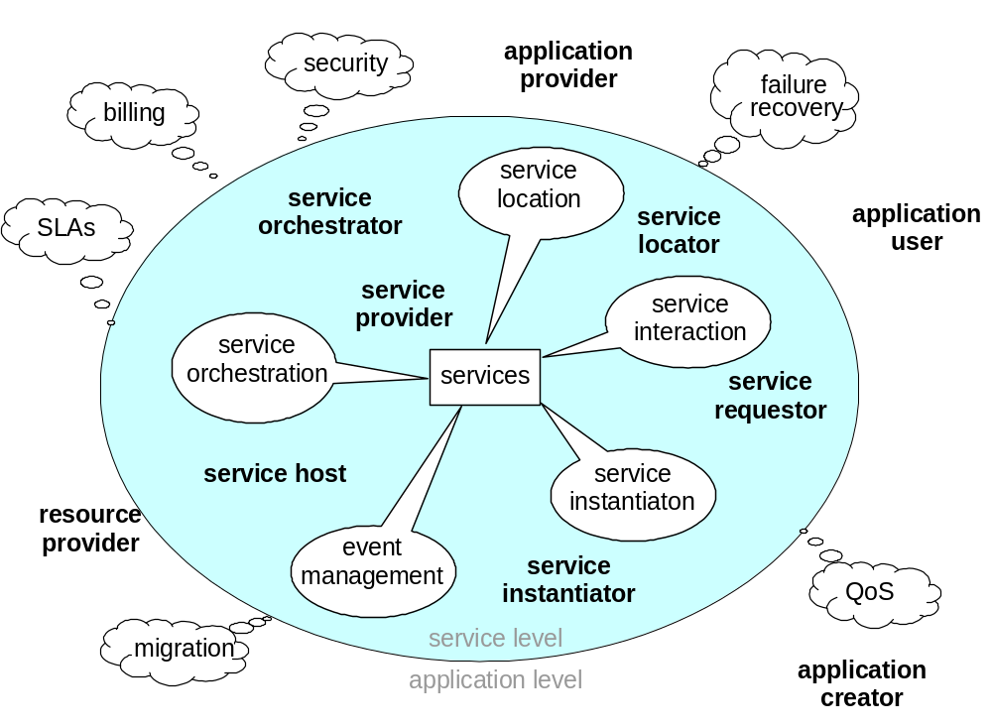
Figure 6: The GRASP environment
The above Figure 6 shows the main roles, entities and interactions in the GRASP environment. An Application Service is one or a set of services packaged to offer specific functionality to users, i.e. it provides an end-user solution. It packages the software (basic component services) and infrastructure (system/network) ingredients together with related business and professional services (e.g. contract negotiation, authorization, accounting, etc.) to satisfy a single coherent business requirement of whatever scale (i.e. it could be a simple web calendar or a complete ERP solution).
An Application is an Application Service packaged with a GUI to create a finished offering to present to the end customer.
A Service does not provide users with a GUI, but a single programmatic interface over the network for an application developer to use. It should support/implement a predefined protocol. Services are assumed to be Grid services, but may also be just Grid-aware, i.e. using Grid facilities via an API. Lifetime management of a Service by a Service Provider is assumed to be handled using Grid facilities.

Customers

The four main customers and their relationships are shown in Figure 7 below.
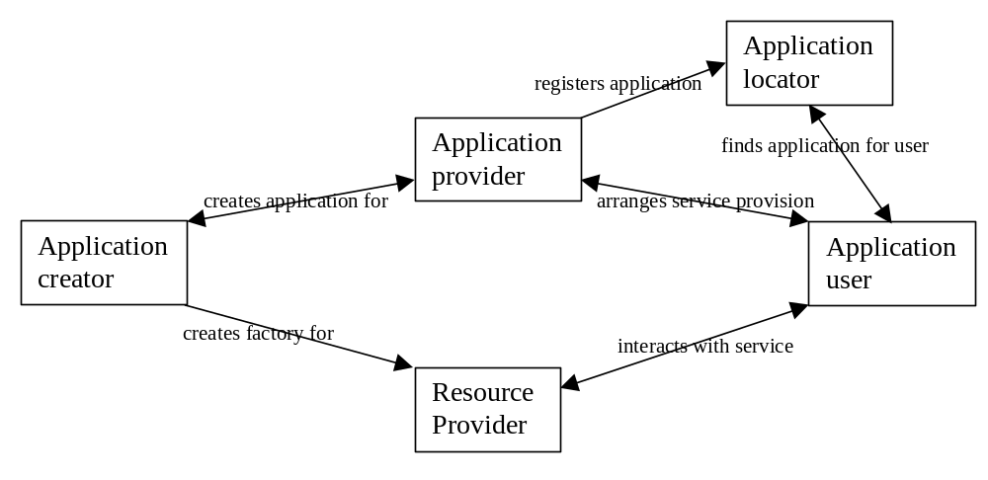
Figure 7: GRASP Customers
Application Creator – a business software specialist who creates the software and Application GUI for an Application Provider to run. Functionality required includes:
- Generate application system (code/workflow/GUI) for Application Provider
- Create factory for Service Host(s)
- Provide application description
Application Provider – an ASP provider who “owns” and “runs” the service, i.e. carries liability for the service delivery. Functionality required includes:
- Create application service (with code/workflow from Application Creator)
- Describe Application
- Publish, i.e. register with locator
- Negotiate SLA with Resource Provider
- Receive request for Application from Application User (or another provider)
- Negotiate service level agreement (SLA) with Application User
- Query Service Host capabilities (current status)
- Start a service instance running on the Service Host
- Return a “pointer” to service (+ authorization) to requestor
- Subcontract Services, Execute Service Workflow (via Service orchestrator)
- Act as Application User for subcontracted services
- Monitor service instance running on Service Host (via provided interface)
- Manage service instance (inc migration) running on Service Host(s)
- Terminate service instance running on Service Host
- Invoice requestor for service
- Pay Resource Provider invoices
Application Locator – a directory owner who act as a service broker. Functionality required includes:
- Create a directory
- Advertise the directory to Application Users
- Receive registrations from Application Providers
- Manage the directory (insert, delete, update)
- Receive Lookup requests from Application Users )or providers)
- Search Directory and filter results
- Return result list to requestor
- Forward lookups to other Application Locators (and merge returns?)
Resource Provider – a system owner who executes service instances on their resources on behalf of an application provider. Functionality required includes:
- Describes resources available, i.e. the Service Host(s)
- Negotiate SLA with Application provider
- Receive request from Application Provider
- Instantiate service
- Run service (interacting with service requestor)
- Manage service, including termination
- Notify Application provider of service status, and QoS
- Invoice application Provider

Application User – an end customer who access an Application Service. Note, this could also be another Application Provider wishing to sub-contract this Application Service. Functionality required includes:
- Specifies required Application Service
- Requests a search from a Application Locator(s)
- Selects an Application Provider from the search results
- Negotiates SLA with the Service Provider
- Requests the Application Service from the Application Provider
- Uses the service on the Service Host
- Monitors the service status via Application provider and/or Service Host
- Terminates the service
- Pays the Application Provider

Scenarios
The generic use case on which GRASP is focusing consists of the customers that participate in a Virtual Organization. ASP business models are present in many scenarios (energetic sector, fleet management software, car industry, complete hosting services for small enterprises, e-Learning environment, etc). Concretely, GRASP explores two major scenarios. The former is related to an e-Learning application for engineering colleges of a university that offers Virtual Laboratory services together with computational centers. The latter consists of a management system for Primary Health Attention Centers.
e-Learning scenario
ASP model fits perfectly in e-Learning scenarios. Many companies are looking to cut their training costs and they are betting on ASP e-Learning approach for covering their needs. Other companies want to dip a toe in the water by using or introducing an ASP before investing in an in-house system or simply the small companies will decide to stick with an ASP if it provides enough levels of flexibility and performance.
In this scenario, we are focusing in a virtual organization that University and Computational Center form in order to offer Virtual laboratory services for the Technical Colleges (Civil Engineering School, Industrial Engineering School, Telecommunication Engineering School, etc). The academic subjects of these schools have a high computation demand. The learning institution adopts ASP role and it shares resources and application parts with Computer Center.
This e-Learning scenario can be extended to a federated model if we consider several universities collaborating and acting as ASP to provide the service of virtual laboratory.
Concretely, the use case is based on an application of Signal Theory and Digital Communication department of a Telecommunication engineering school. According to the learning-by-doing e-learning approach, students wishing to perform simulations, which involve an orchestration of distributed GRID services, will access the college portal from their home or university PC facilities. Students will select a number of simulation parameters of the application that GRASP framework will transform into a number of QoS parameters that are relevant for the accounting, the location and dynamic instantiation of GRID services. The university will manage internal costs of each college that launch simulations exercises of academics subjects and make use of the resources of Computer Center. The Computer Center will bill the university not only for the virtualized hardware service but also for the generic engineering application modules that offers.
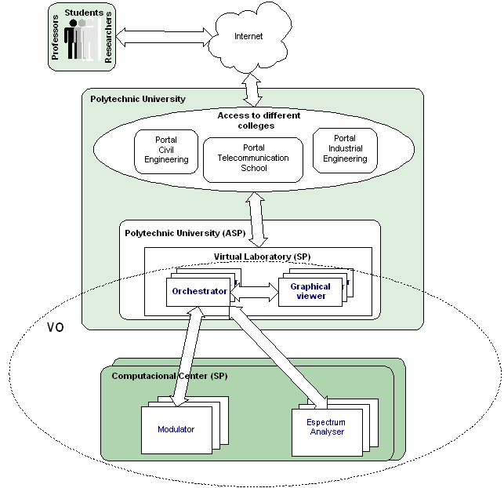

Primary Health Attention Centers scenario
The medical attention management system focuses on new organization of primary health centers (called CAPs) in Catalonia (Spain). Recent years, Social Security (Public Health service) in Spain has evolved due to changes in law administrative and Local governments have got the possibility of assuming the competences of Health services. This has implied the apparition of semi-private primary health centers whose cost-effective management has become an important issue. Most of CAPs are public institutions but there are a lot self-managed although supervised by the Public Health Service department.
The independent COMB institution (the Professional Association of Doctors in Barcelona) is developing new strategies to expand its services to CAPs in this context. COMB adopts the form of ASP provider in order to offer hosting services and a management application system for small and medium size CAPs since they do not want to get involved in running large IT infrastructure.
By means of GRASP infrastructure, COMB offers the extended functionality “optimization cost calculus” for CAPs. Concretely, the system provides an algorithm that allows a temporal syndication of CAPs for buying together in order to optimize global expenditures in pharmaceutical products according to laboratory discounts.
The resulting scenario can be considered a many-to-many model since big CAPs (users) offers their resources (critical data information and computing capacity) through the GRID in order to syndicate with small CAPs (users) whose critical information is located in the COMB (ASP).
This scenario implies the need of having a full dynamic structure in which is possible the access and participation of all entities in the application. Grid offers this dynamicity. On the other hand, security aspects become a key aspect in this Virtual Organization. The application must guarantee the privacy of data in this distributed environment. This is achieved by means of using the security modules of GRASP framework.

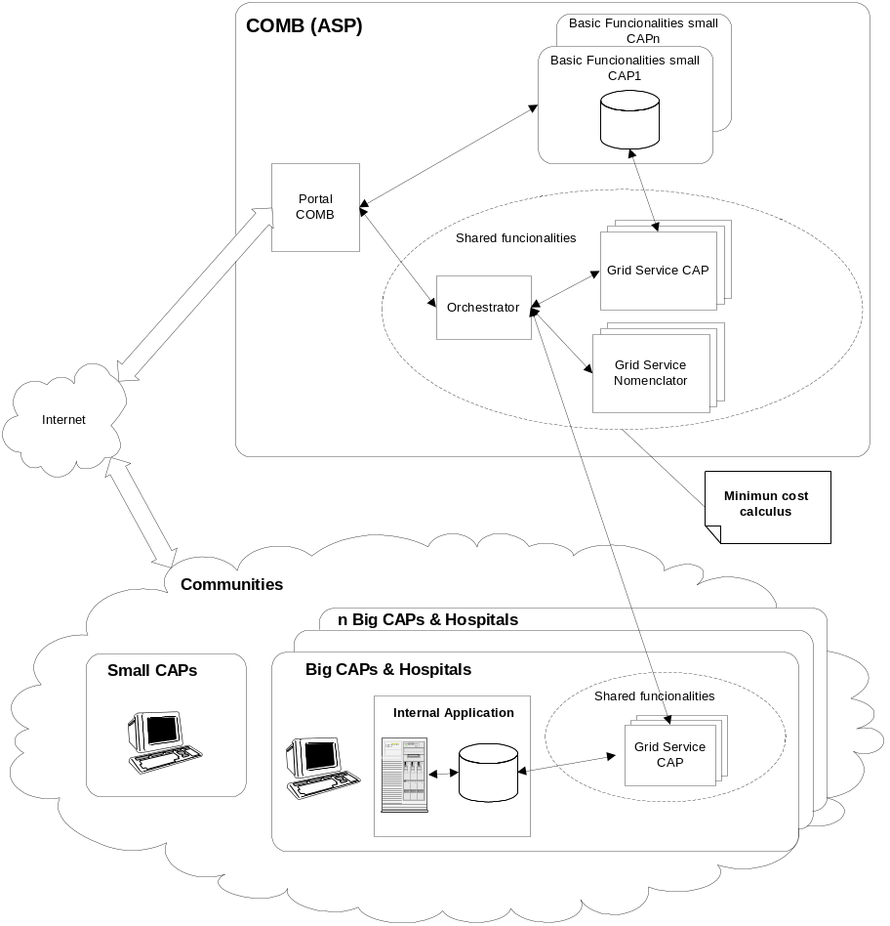

Involved resources
The above described scenarios involve the following resources.
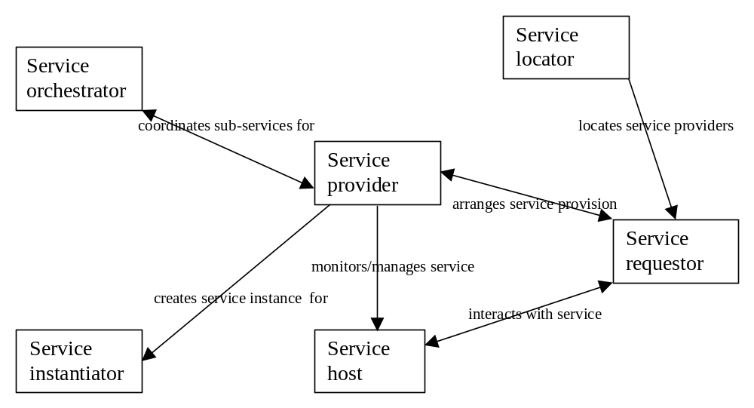
Figure 8: The involved resources
Note: Unlike an external Application Service, an internal Service provides just one specific piece of functionality, either to an Application User as part of an Application Service, or to another Service Provider as part of a composite Service being offered by that Service Provider.
Service Requestor (to make service requests on behalf of an Application User or on behalf of a composite service Provider). Implements the necessary functionality to invoke and operate a service (c.f. Application User) and creates GUIs to Application Service, Locator, infrastructure, etc
Service Provider (to manage the service or application, authorizing access, calculating fees, etc). Implements the necessary functionality to provide a specific service (c.f. Application Provider) apart from functionality delegated to the Service Orchestrator and the Service Instantiator, plus:
- Maintains registry of running Service Instances for this service
- Ensures required sub-services are available
- Updates service “pointers” in client GUI if service migrates or restarts
Service Host (to actually run/execute the application code, or part thereof). Implements the functionality for the Service Provider above, plus runs the factory provided by the Application Creator
Service Locator (to locate a service instance or factory for the required service). Implements the necessary functionality to locate services (c.f. Application Locator), plus: Handles Services as well as Applications
Service Instantiator (to create new service instances). Handles the service instantiation task for a Service Provider, plus:
- Manage Service Instance pool, if required
- Maintain registry of local Service Instances (active and idle)
- Creates new instance with specified state (for instance migration)

Service Orchestrator (to execute business process definition/description submitted by a Service Provider). It
- Handles execution of workflow for the Service Provider:
- Locates and starts sub-services
- Coordinates sub-services and their interactions
- Maintains “business process” state for Service provider
Event and Message Manager (also handles asynchronous communication between entities). The main entities in the system are:
- Service Instances – the code that carries out the service, interacting with the service requestor and reporting to the service provider,
- Service Descriptions (including service workflows for composite services),
- Factories,
- Service Directories (which contain service descriptions and pointers to provider)
- Service Registries (which contain service instance descriptions and pointers to host/instance)
- Events (timers, keep-alive mechanisms, etc)
- Clients (the interface for the service user) – a W3C web services concept

Functional requirements for OGSA platform
In the following we will describe the general functional requirements for the Grasp infrastructure. As this is an infrastructure for deployment and execution of different kind of Grid Services, there might be many additional requirements introduced by the application domain of specific services. Below we enumerate the requirements that we consider as basic.

Discovery
This is one of the core Grasp function and is done by the Locator subsystem. Whether a client looks for a grid service in order to perform a specific task or an ASP looks for a grid service to sell it as intermediate, they will always perform a search in order to find the most suitable. Obviously this comprises the search for functionality, but due to the business domain of Grasp we have to consider many other search criteria such as price or a specific service behavior based on business rules. The totality of functional, technical and business requirements searched by a client, are called a Service Level Agreement SLA which is a unique contract between a client and a service provider. The provider will publish SLA templates on the Locator which might be either fixed or adaptable. The Locator must be able to process a SLA request from the client and returns some appropriate service endpoints for further actions

Instantiation
The VOs in the context of Grasp are built upon Hosting Environments HE containing a Gateway machine and different Hosts. Thus the client of a service will not make a direct call to the service factory, but will be served by the Instantiator subsystem.
In general the Instantiator must be able to answer a client request for the instantiation of a service with a specific SLA running on behalf of a specific client. In opposite to the Locator he must also consider the current situation of the HE. Thus the Instantiator itself interacts with different other subsystems such as Monitoring or Security. As a result the client receives a confirmation or a rejection of the request. In the current implementation there is no mutual negotiation phase, thus there is no need for a service reservation system

Load Balancing
Hosting Environments usually comprise more than one Host that could be able to execute a service with a specific SLA. Obviously this strongly depends on the current load of the Host, the character of the grid service and the kind of related SLA. Therefore Grasp requires a kind of Load Balancing system that first looks for potential Hosts in the HE that would be in general able to serve the request but after that it must transform this into a priority list, based on the criteria mentioned above. This list will be used by the Instantiator system.

Metering and Monitoring
We already described the need for load balancing in the Grasp environment. Naturally this can only be done if we are able to measure certain system metrics. Beside this quite common measurement of general system related data, Grasp again envisages special metering and monitoring requirements due to its business context. In addition we must provide metering and monitoring for service related data. This service related data are often important for other subsystem, for example the number of invocations for Accounting or a service performance metric for SLA monitoring. In addition, there might be the need for custom metrics. Thus we see a general requirement for an extensible metering and monitoring system.

Service Level Agreements Management
The usage of sophisticated SLAs raises three important requirements for a SLA management system. First we need a kind of SLA language for description. Second we need some kind of parsers that are able to process a SLA and return different kind of information for different kind of requestors. For example the Locator might do a fuzzy search on the SLA while the Load Balancer looks for a single metric. Finally, the SLA management system must be able to watch any running service instance regarding the compliance with the according SLA. In case of SLA violation it must either inform Accounting about penalties or decide to destroy the service.

Accounting
Due to the fact that Grasp targets the domain of commercial ASP, Accounting is an essential key concept. Basically this comprises the accounting of all services running on behalf of a client. As these services might be running under different SLA, which might lead to different prices based on different metrics, the Accounting must be able to extract all necessary data from the appropriate monitoring systems and bring them together in order to calculate the total cost for a service user. As mentioned above, Accounting must also be able to consider information from the SLA system regarding penalties. Furthermore has to be able to manage composed service.

Orchestration
Grasp aims to support different business models for ASP. Beside the simple one, where an ASP couples or extends his legacy applications with different Grid Services, we foresee the general concept where an ASP resells orchestrated Grid Services in an OGSA compliant way. Thus our infrastructure must be able to expose orchestrated Grid Services as new Grid Service. Obviously this requirement is one of the most ambitious and introduces many problems for example regarding Accounting and SLA monitoring of the orchestrated service.

Security
Obviously security is a big issue for business and thus for the Grasp infrastructure. It includes authorization and authentication between different possible roles such as Client and Service Provider. Security is explained more detailed in the section below.

Deployment
The deployment of a Grid Service comprises physical deployment on the Host and registration at different entities of the Grasp infrastructure, such as the Locator. The same applies to the update or removal of service information. Therefore we need automatic deployment mechanism.

Notification
The execution of service instances introduces many dependencies between services and different subsystems. Examples are dependencies between management services and Grid Services or a Grid Service that uses another Grid Service and must be informed about change of state. As this can not be obtained solely with a request/response approach, a notification system is a must.

Legacy Application Management
As it is quite unlikely that an existing ASP is able to change directly from his Legacy Application to a Grid solution, we assume that there will be a need for tools and libraries that support the connection of legacy systems to the Grasp infrastructure. Therefore we have to keep track of COTS and emerging standards from other than Grid communities

OGSA platform services utilization
The Grasp infrastructure utilizes the following services
- Location Service for service discovery
- Instantiation Service
- Management Services for Load Balancing
- Service Level Agreement Services
- Accounting Services
- Monitoring and Metering Services

Security considerations
From the GRASP viewpoint, security involves three major aspects:
ASP security, focusing on the interactions between the ASP and End User
OGSA security infrastructure, focusing on the definition and check of the policies required to access to a service instance in the GRASP environment
GRASP security infrastructure, focusing on the interactions between single GRASP services involved in delivering an application service.
The ASP security is outside the GRASP security subsystem goals.
The OGSA security infrastructure is related to the Grid service security model and it implements:
A security model to secure Grid services in general
A Grid service must be able to define or publish the credential expected from the service requestor, integrity and confidentiality requirements, and so on. To invoke a service instance, the service requestor has to adhere to the required policy constrains.
Security services that provide the necessary functionalities such as: Authentication service, Identity mapping service, Authorization service, VO Policy service, …
The GRASP security infrastructure is primarily concerned with achieving secure services collaboration. Collaborating services can run in different Hosting Environments controlled by diverse institutions. Each institution defines its own security policy dictating the way service instances can be accessed.
To address secure collaboration, we use group oriented mechanism relaying on an encryption schema. We define a group as a set of services that can establish a P2P communication. All members share a common group certificate and they can perform P2P interactions using this certificate to sign the exchanged messages. In this way, every member can verify if an incoming message is originated from another member of the same group.
A group, or security perimeter, contains all service instances cooperating to create an application and it excludes everyone else. It is administrated by a Group Manager and it is characterized by:
A set of certificates, based on PKI infrastructure, to manage group membership and privileges
Roles based security policies describing permissions, prohibitions and obligations within the collaboration group
Mechanism for end-entity enforcement of the security policies that protects individual members with the group and the group as whole
A group can be created on demand and it can include members belong to different security domains. Furthermore, the group membership list can be dynamically altered in terms of membership and policy constraints.
The P2P communication schema presents only one exception since the group manager can cross the security perimeter and exchange information with group members realizing a centralized community management model.
The GRASP security framework, also, has to enforce the access restrictions and contractual obligations at the services themselves; this task can be built on a master/slave model by using enforcement agents.
The enforcement agent can be realized in a variety of ways, two options are:
Use of specific “service wrappers” that can be attached and wrap grid services in order to enforce the security perimeter becoming a part of the grid service instance.
Use of a proxy service companion that accompanies each grid service and is in charge for enforcing contract and security policies for its companion service
In either case the enforcement agent is responsible for enforcing the security policies set by the Group Manager. At its simplest, the enforcement agent ensures that messages arriving for or originating from a service instance are encrypted with a valid key and signed with a valid certificate and are valid service communications.
Finally, the GRASP security framework provides the following functionalities:
Group membership management mechanisms to support component authentication, group formation and evolution
Encryption schemas to ensure secure communication channels between the components involved in delivering an application service
Preventive security enforcement mechanisms to control access at each end-point (component service), i.e. addressing what actions one component service or user client is allowed to enact on another component service.

Usecase situation analysis
Service discovery. The primary requirement here is the ability to discover services, inside a VO, by submitting a query to the service registries. At this aim, the service registries need to support both the ability to specify and publish rich information on the services being registered, and the ability to query this rich information using a well-known (easy to use) query language. Other requirement is the ability to publish, update or delete services in the registry in automatic manner.
The discovery service will have a distributed architecture that allows a bottom-up approach in the publication phase. The result of a search against this service will provide a list of services that allow the creation of instance with the specified requirements.
The idea of Service Groups, proposed in the latest draft of the GS specification, could provide support to the creation of discovery services that address the above features.
Instance creation. The primary requirement here is the ability to create a complete and correct instance of service with fixed set of requirement. The “Factory Pattern”, employed by OGSA specification in order to create a new instance of services, provides a complete support at the service creation. However the creation of new service instance has to be performed only after the negotiation of a set of requirements (service level agreement (SLA) negotiation), and ensure that the service has access to required CPUs, memory, storage space, etc.
OGSA specification, through the service listed in the “resource management service”, should address the requirement described above.
Service Orchestration. The primary requirement of this service is the ability to coordinate and compose different instances of Grid Services in order to provide a more complex service. Respect to OGSA specification for service orchestration, improvements are needed in order to perform location and instantiation based on a set of metadata. Furthermore, business process should be BPEL4WS scripts extended to manage the grid features of the services to compose.
Accounting service. The primary functional requirements of these services are described in the section 7.5.6. Other requirements concern the ability to manage composed services and the ability to use extensible policies (supported by WSLA, plus business extensions) in order to provide a flexible, dynamically configurable accounting. This service will also be able to support the “multi-accounting” of a service: this means that it should provide multi purpose accounting (e.g. billing purpose, statistical purpose etc).
OGSA specification presents the “Accounting Service” that currently doesn’t define the above aspect.
Metering and Monitoring service. The primary functional requirements of these services are described in the section 7.5.4, and OGSA specification addresses most of our requirements. However the central idea is that controlling a Grid service is different to using a Grid service. Though, to control a Grid service requires using an interface. Metering and monitoring is a concern of management services that will retrieve metering and monitoring data on the service instance itself. They need to be able of providing metrics in a flexible way, and the management services should be able to understand them dynamically.

References
[1] P. Ritrovato, M. Gaeta, G. Laria, T. Dimitrakos, D. Mac Randal, F. Yuan, S. Wesner B. Serhan, K. Wulf, “AN EMERGING ARCHITECTURE ENABLING GRID BASED APPLICATION SERVICE PROVISION” to be appear in the proceeding of 7th IEEE International Conference EDOC - September 16-19 2003, Brisbane, Australia
[2] The GRASP Project http://www.eu-grasp.net

Grid Monitoring Architecture Use Case (from EU Grid)

Summary
In a Grid environment information and monitoring is a fundamental technology that is needed to provide a virtual organizational view of the computing fabrics, networks and mass storage sub-systems as well as from instrumented end-user applications. A Grid monitoring system must be scalable across wide-area networks and able to encompass a large number of dynamic and heterogeneous resources.
The monitoring system is responsible for the collection and forwarding of monitoring data from producers to consumers of such data in an efficient manner. The data itself can be gathered from hardware and software sensors, entire monitoring systems (e.g. Nagios [1]) or application monitoring tools (e.g. NetLogger [2] and GRM/PROVE [3]). Data produced in a Grid is a mix of very slowly changing data such as the version of operating system and frequently changing quantities such as the number of running jobs. Since the amount of monitoring data available is very large, while the actual amount used is small, the monitoring system should be able to pose powerful queries on the generated data and only return information that satisfies the query.
From a user perspective there are two basic visible components of a monitoring system: a producer and a consumer. Monitoring data is made available to a Grid using producers and is retrieved using consumers. These components can be combined to produce, for example, an aggregator that uses a number of consumers to collect data, generate new derived data and make that available through a producer interface.
The way monitoring data is published to a Grid and queried does not have to be exposed by the monitoring system, which might make use of other components such as registries and schemas for that purpose. Since a Grid is unlikely to be built using a single monitoring system, it is of paramount importance that OGSA defines the common interfaces needed to ensure interoperability between existing and future monitoring systems.

Customers
Any user in a Grid needs information about the current or past status of their resources and applications to make resource selection decisions (i.e. most appropriate for their purpose) and for performing tasks such as fault detection, recovery, performance analysis, prediction, and application adaptability.
Monitoring data is also required for accounting and billing, and for logging and auditing purposes.

Scenarios
Monitoring is cited as a required service in practically every one of the "Open Grid Services Architecture Use Cases". Since the scenarios for monitoring are numerous, we only present here a few examples.

Network monitoring
A site network manager uses monitoring tools to get performance information such as round trip time (RTT) between pairs of hosts, percentage loss of packets; inter-packet delay variation and throughput achieved for file transfers. He needs to perform these measurements over periods of days or weeks to ensure that the promised QoS is delivered. He also makes the data available to other potential consumers including end-users and applications (e.g. schedulers and file transfer tools). The availability of the data for further analysis and evaluation is crucial.
- An end-user or application are more likely to be interested in the most recent measurements to adjust, in “real-time”, their usage of network resources and make sure that the agreed QoS is honored. The availability of the data is necessary if further action is to be taken when the agreed QoS is not delivered.

Scheduling
- A scientist wants to run an interactive simulation/rendering job that must be finished within the next half hour. He must find a computing element that is fast enough, has enough memory and is linked to a fast network connection. He needs up-to-date information since information that is an hour old is unlikely to be useful. He submits a complex query to an information system and after a very short time gets the information on the computing elements that satisfy his query. He selects one and proceeds with his job.
- A long running job specified in a job description file is submitted for batch processing. The scheduler tries to find the best match between the job requirements and the resources available on a Grid, whose characteristics are retrieved from an information service. In particular information such as policies to access resources, characteristics and status of resources and availability of the required application environment is needed. The scheduler cannot afford to wait long for information. It does not need to find the best solution, but merely one near the optimum. The scheduler might do some historical predictions of what might happen to the load on the resources when the job runs and choose the less “risky” option. As an example a scheduler might ask the following: "Are there Computing Elements that the user is allowed to use, from which the RTT to a Storage Element (that the user is allowed to use), is less than 1000 and the probability of crashing while the job is running is less than one percent, and if so want are their Id's and RTT’s.". To answer that question relevant producers distributed across a Grid, which publish information about RTT, computing elements and storage elements must be located and their data combined to answer the query.

Logging and Bookkeeping
- A user submits a job to a job control system (JCS). The JCS assigns a jobId finds an appropriate scheduler and logs the submission event to the Logging and Bookkeeping (L&B) service. The job is now in the “SUBMITTED” state. The job goes through different states until the final “CLEARED” state is achieved either when output data are retrieved or when a pre-specified timeout is reached. If the job fails, the monitoring data can be used to help determine the cause. The L&B service relies on various components such as computing resource actively sending messages whenever certain events occur (e.g. job state transitions). An L&B event in a message embodies at least information on its type, the time it was generated and the source. In this L&B context, information that is retained for debugging, auditing and statistical purposes is referred to as logging and information about currently active jobs is called bookkeeping.
Here are some additional example scenarios that are mentioned in the OGSA Use Case document.
- For a “Commercial Data Center (CDC)”, a customer needs to monitor his/her application running on a remote data center, while the administrator needs to be able to easily monitor the thousands of hardware and software resources on the CDC to reduce resource management costs.
- In the “IT infrastructure and Management” there is a need for strong monitoring of the environment for defects and the ability to identify misuse including virus/worm attacks.
- For “Service-Based Distributed Query Processing” a coherent way of collecting and relating several classes of metadata (capacity of a grid node, dynamic real time network load information, type of service offered by a grid node) is needed to improve the performance of the distributed query. Query planning needs access to comprehensive information on the costs of using the services of relevance to a query, and also requires information on the computational resources available for evaluating a query.
- In the “Severe Storm Modeling” case, instrument data must be constantly streamed from Doppler radar, satellite imaging and ground-based sensors to data mining agents looking for dangerous patterns. When one is detected a notification is sent and simulations are started automatically. The simulations must be monitored to make sure they have the necessary compute resources to continue and finish on time, even when systems go offline by reassigning tasks to new resources. Up-to-date monitoring information on Grid resources is crucial in this case.

Involved resources
Hardware and software sensors, application instrumentation and other sources of monitoring data are needed by producers. The monitoring system itself will require some distributed processing and storage resources as well as secure networks.

Functional requirements for OGSA platform
This Use Case requires the following from the “Basic Functionality Requirements” section of the OGSA document [4]:
- Discovery and brokering: Mechanisms are required for discovering producer and consumer services that a user is allowed to use.
- Data Sharing: Replication, archiving and caching mechanisms are examples of technologies that are required for accessing and managing data and metadata.
- Policy: producers and consumers publish their properties so agreements with them can be negotiated based on certain criteria. An error and event policy could be used for self-managing and failover of the monitoring system itself.
This Use Case splits the monitoring functionality into:
- Producing information and monitoring data.
- Consuming information and monitoring data.

OGSA platform services utilization
Some services required by the monitoring system are:
- OGSI: OGSI provides some basic mechanisms for monitoring Grid services but lacks a complete solution for monitoring resources as well as applications. Missing functionality is added by building on top of OGSI.
- Handle resolution: The monitoring system should not concern itself with resolving GSH to GSR. Instead each hosting environment should provide a HandleResolver service that performs that function.
- Messaging: A monitoring system must provide efficient and reliable transfer of events between producers and consumers.
Required services that not included in the OGSA document [4] are:
- Producer: for publishing events.
- Consumer: for retrieving events.
- Registry: for grouping producers and consumers.
- Schema/Events: standards for events and event descriptions.
- Mediator and Query Planning: used to find producers which can satisfy a consumer’s request (i.e. query) for information.

Security considerations
Authentication and Authorization for consumer/producer interaction is required. A producer should be authenticated and authorized to publish information in the monitoring system. It should be able to specify the consumers that are allowed to query and read its data.

Performance considerations
Monitoring systems in general should have minimal impact on the monitored resource and should scale with increasing number of producers and consumers. Being a service on which many OGSA services depend, it is essential that the system is reliable and fault tolerant.

Use Case situation analysis
There are many monitoring systems in existence today: MDS [5], pyGMA [6], R-GMA [7], Nagios [1] and Ganglia [8] for example. They were developed independently and as a result interoperability between them remains elusive or very difficult to achieve. OGSA is an open and extensible architecture can benefit from experience from the existing systems to address a monitoring specification that will facilitate interoperability between the different Grid monitoring systems.

References
[1] Nagios: http://www.nagios.org/
[2] NetLogger: http://www-didc.lbl.gov/NetLogger/
[3] GRM/PROVE: http://hepunx.rl.ac.uk/edg/wp3/documentation/grm/guide.pdf
[4] “The Open Grid Services Architecture“ GWD-R (draft-ggf-ogsa-013a)
http://forge.gridforum.org/projects/ogsa-wg
[5] MDS : http://www.globus.org/mds/
[6] pyGMA : http://www-didc.lbl.gov/pyGMA/pyGMA_text.html
[7] R-GMA : http://www.r-gma.org/
[8] Ganglia : http://ganglia.sourceforge.net/

Editor Information
Jeffrin J. Von Reich, Software Engineering Business Unit,
Hewlett Packard, Fort Collins, CO, USA - 80528
Phone: +1-9708980700, Email: jeffrin_von-reich@hp.com

Acknowledgements
This work was supported in part by Fujitsu, Hewlett Packard, Intel, IBM, Peer to Peer Working Group of the Global Grid Forum, Open Grid Services Architecture of the Global Grid Forum, and the contributors of the use cases given in this document.
We gratefully acknowledge the contributions made to this document by Ravi Subramaniam, Dejan Milojicic, Stephen Pickles, GGF Working groups and all other members of OGSA working group members who discussed and reviewed the material.

References
Each chapter has reference section.

