Firewall Issues Research Group
Thijs Metsch Metsch (Editor), German Aerospace Center
Leon Gommans, University of Amsterdam
Egon Grünter, Reserch Center Jülich
Ralph Niederberger, Research Center Jülich
Alan De Smet, University of Wisconsin
Gian Luca Volpato, RRZN LUH

Title of Document

Status of This Document

This document provides information to the Grid community about firewall issues in grid environments. Distribution is unlimited.

Copyright Notice

Copyright © Open Grid Forum (2007). All Rights Reserved.

Trademark

Open Grid Services Architecture and OGSA are trademarks of the Open Grid Forum.

Abstract

This document evaluates approaches and solutions (for firewall issues) such as application level gateways, host based firewalls, VPN style gateways etc., which are currently available to solve any problems Grid applications face when dealing with firewalls located between source and destination of the communication path.

Contents

Abstract 1
1. Introduction 3
2. Requirements from document #1 3
2.1 General Requirements 3
2.2 Requirements on Hardware on the communication path 4
2.3 Requirements for the Support of Grid Middleware Solutions/Protocols 4
2.4 Requirements on Data Transfers and Storage 4
2.5 Requirements on Performance and Configuration 4
3. Solutions 5
3.1 High speed firewalls 5
3.2 Load balancing firewalls 5
3.3 Dyna-Fire 6
3.4 Cooperative On-Demand Opening 7
3.5 Generic Connection Brokering 7
3.6 UDP Hole Punching 8
3.7 Application Level Gateway / Proxies 10
3.8 A framework for Token Based Firewalling in Hybrid GMPLS networks 11
4. Matching requirements and solutions 13
5. Summary 14
6. Contributors (in alphabetic order) 14
7. Glossary 15
8. Intellectual Property Statement 17
9. Disclaimer 17
10. Full Copyright Notice 17
11. References 18

1. Introduction
This document deals with existing and upcoming solutions for firewall issues in grid environments. Therefore it summarizes the requirements on firewalls and tries to match these items to the solutions. Requirements which can not be covered by any existing solution are summarizes and analyzed further on in this document.

The first document [FI-RG-1] of the firewall issues research group has summarized and identified the requirements on grids. This document has been published in August 2006.

So far we have identified the following requirements:

- Some applications need high-throughput data channels; firewalls must be able to cope with large amount of data traffic.
- Some applications use only a set of well-known ports.
- Some applications use a set of well-known ports and a set of detectable dynamic ports. Detectable means that through analysis of the traffic between the server and the client it is possible to determine which dynamic ports will be used by the applications.

- Some applications use a set of well-known ports and a set of obscured (non detectable) dynamic ports. “Obscured” means that the analysis of the traffic between server and client does not provide enough information to determine which dynamic ports will be used by the applications. This may happen because the traffic is encrypted or because the necessary information is not exchanged at all between server and client. Because there is not enough information available, the firewall cannot decide which data streams (well known port connections and dynamic port connections) belong together.

2. Requirements from document #1
The following requirements have been identified in our first document [FI-RG-1]. This short summary sums up the requirements. All requirements are grouped. Every group is described by a table holding an identifier for the requirement, a short description, and severity of the issue (Which can be low, medium or high)

2.1 General Requirements

ID | Requirement | Severity | Details
G010 | Use a single port/socket connection for simple transfers | Medium | Using a single (well defined) port allows firewall administrators to open those ports especially and only to the specified servers (Minimum Uncertainty).
G020 | Grid resources need to be protected by firewalls | High | Grid resources are resources as any other equipment, but reachable from outside, and should be therefore protected against attacks. Moreover these resources are often well known by outsiders and interesting for attacks, because of large storage capacity, extreme computing power and high bandwidth connectivity.
G030 | Detect number of ports needed before, after, and during execution | High | It is always recommended to use well formed program structures, so that at any time full control and knowledge of the status of the running tasks are available. Using only well defined ports allows best monitoring of communication streams.
G040 | The network and application need to deal with security policies | High | Applications, that are not aware of security issues, should not be allowed to use the network. Though a netiquette is well known there are always people outside which do not bother with those “hindering” rules.

2.2 Requirements on Hardware on the communication path

ID | Requirement | Severity | Details
H010 | Routers/Firewalls need to deal with high bandwidth Networks | High | Common firewalls are specialized routers, which have to analyze packets and dependent on results forward those packets to inside/outside or block them. Because firewalls are located at ingress/egress points of organizations they have to deal with a) aggregated traffic and b) any kind of traffic sent “single streamed”.
H020 | Number and kinds of hardware in a routing path need to be known | Medium | Either the number and kind of hardware within a routing path needs to be known or the application has to provide any kind of network relevant info via the standard communication path.

2.3 Requirements for the Support of Grid Middleware Solutions/Protocols

ID | Requirements | Severity | Details
M010 | Support connection from an ephemeral port (EPR) on client to a grid service port on server | High | To support Globus Toolkit (GT) or Unicore
M020 | Support connection from a controllable ephemeral port on the client to a grid service port on the server | High | To support GT
M030 | Support connection from a controllable ephemeral port on the client to a controllable ephemeral port on the server | Medium | To support GT
M040 | Support the usage of internal and external service EPR | Medium
M050 | Support the usage of ephemeral internal EPRs which are mapped to external EPRs | Medium
M060 | Audio and Video ports must be supported | Medium | AccessGrid

2.4 Requirements on Data Transfers and Storage

ID | Requirements | Severity | Details
D010 | A single socket connection for control channels is needed | High | GridFTP Connection channel, GSIdCap for dCache, SRM protocol
D020 | Support usage of arbitrary numbers of sockets (which can vary in time) | High | GridFTP data channel, i.e. predefine or signal port usage

2.5 Requirements on Performance and Configuration

ID | Requirements | Severity | Details
P010 | High Performance Links in Grids of 10/40 Gb/s | High | Special applications require high speed data connections. Allow a.) high speed (single stream), b.) load balancing or c.) firewall bypass
P020 | Dynamic configuration of Firewalls by authorized users | High | Define an adequate protocol with authentication and authorization facilities or use/misuse existing ones.

3. Solutions
This section describes existing or upcoming solutions which try to solve the requirements listed above.

3.1 High speed firewalls

Most of the current high speed firewalls are able to process not more than 5 or 6 Gb/s of data traffic due to internal CPU speed and forwarding engines. Often special hardware is used to allow this high throughput. A market overview of high speed firewalls as of August 2006 can be accessed at the DGrid project web page [D-Grid].

Current routers could act as a packet screen as long as it fits the needs of a local security policy. A performance of tens of Gb/s could be achieved. But only a limited number of routers is able to handle extended access lists to allow stateful inspection. If any stateful inspection has to be done a “packet screen” solution is insufficient.

3.2 Load balancing firewalls

An alternative is the use of "load balancing firewalls". Multiple firewalls can be deployed for scalability and reliability by balancing the traffic on inbound and outbound paths through different firewalls. There are different ways to realize this idea.

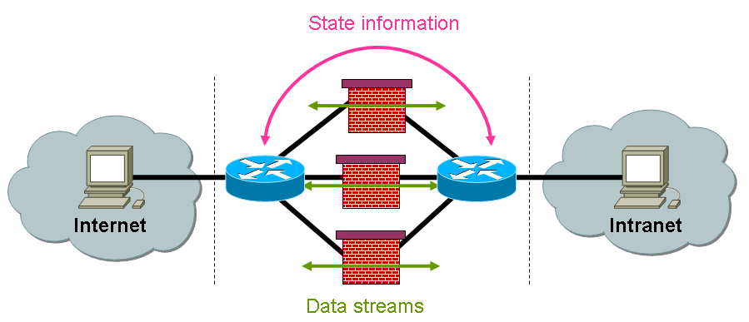
Multiple firewalls are combined to a firewall farm. One single firewall is called the firewall master which delegates traffic to the other firewall slaves. It may use a hashing algorithm based on information of the TCP/IP-Headers to allocate traffic to the slaves. The firewall master uses ICMP-Redirects to specify which firewall slave will deal with the incoming packet. The redirect information is sent to the routing instance in front of the incoming interface. This algorithm guarantees that routers and firewalls of various vendors interact well. In fact this algorithm means that single streams are balanced and not really the load itself is balanced, i.e. a single stream of 10 Gb/s is transferred across one firewall slave.

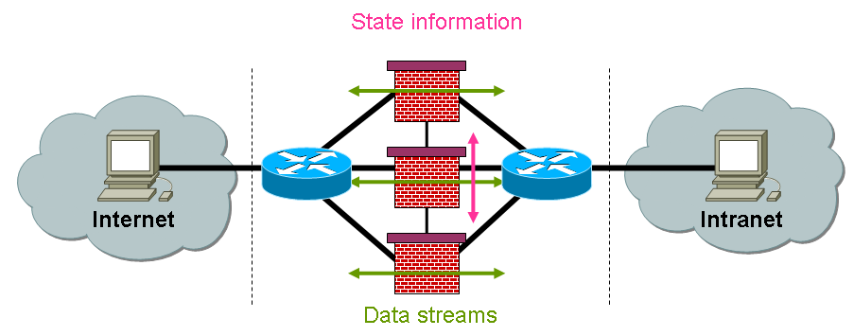
Figure 1 master/slave load balancing controlled via ICMP redirects

Another approach is the usage of a round robin algorithm. Each incoming packet is delegated to a different firewall. However since this is real load balancing because the stream is distributed across different firewall slaves new problems arise. First an algorithm has to be found how to delegate the packets. Using ICMP-Redirects results in additional load and this leads to degradation of the network performance. The introduction of special load balancing devices located in front and behind the firewall farm could solve this problem. These devices use routing tables and exchange routing information. The second problem is, that firewalls may or may not be synchronous: Synchronous firewalls share connection information among each other, so the data for a given connection can go through any firewall. Non-synchronous firewalls do not share connection information and traffic must be revalidated each time it goes through a new firewall. Because of the huge amount of state information to be exchanged the round robin algorithm is currently not used in any of the firewalls available at the market.

Figure 2 load balancing devices

The use of load balancing devices in front of and behind the firewall is a common approach. Although they do currently not use a round robin approach, they use configurable algorithms. Some vendors allow the definition of certain hash algorithms and load balancing based on different sessions. Moreover the devices allow a proper handling of certain protocols like FTP. However it is not sufficient to use such devices as long as they do not fit the performance requirements.

Currently load balancing is based on hashing algorithms using address and port information from the protocol headers. Though load balancing systems allow the distribution of different streams, they do not allow load balancing of one single high speed data connection.

3.3 Dyna-Fire

Dyna-Fire is an extension of the Netfilter iptables software capable of configuring new filtering rules in response to valid requests from users' applications. Its main features are:

- The use of Port Knocking as signaling protocol.
- The deployment of a central database where all users and resources information is stored.
- The integration with the Globus Gatekeeper.

Port Knocking consists in a client-server communication method in which information is encoded in the form of connection attempts to closed ports. The server initially presents no open ports to public networks and monitors all connection attempts. A client initiates a connection by sending TCP packets carrying SYN flag to a specific sequence of ports. When the server detects a valid knock sequence it triggers a server-side process, usually the opening of the requested port. The knock sequence may contain additional information such as the IP address of the client host, the requested resource (application name or port number), the opening time of the port, and a user identifier.

Dyna-Fire daemon must be integrated into the existing network firewall. In this way it can monitor connection attempts from external entities. When it detects a valid knock sequence it tries to validate it. If all verification criteria are satisfied, Dyna-Fire adds a new filtering rule into the iptables firewall. This rule allows access to the destination host and port number only from the IP address that sent the knock sequence and only for a length of time corresponding to the validity of the user proxy certificate.

Dyna-Fire has been developed at the Center for Computational Research, University at Buffalo, New York. Though this concept has been implemented for iptables firewalls, it could be used for any kind of commercial firewalls also by integrating additional code into the vendor firewall software stack or by analyzing syslog output of those firewalls. Whereas the concept seems promising a closer look shows a lot of data packet flows and confirmation overhead. Trying to get one additional connection opened a lot of signalling (port knocking) packets have to be sent to provide used port, allowed IP addresses, and user info. [Dyna-Fire]

3.4 Cooperative On-Demand Opening

CODO is an extension of the Netfilter iptables software capable of configuring new filtering rules in response to valid requests from user applications. Its main distinctive features are:

- The use of SSL for the signaling channel.
- The use of an memory table to register applications authorized to traverse the firewall.
- The ability to control both incoming and outgoing connections.

The existing network firewall must be integrated with a CODO Firewall Agent. The firewall initially presents only three open ports. The CODO agent uses these ports to listen for signaling messages: one port is used by internal applications to register themselves as available destination entities; another port is used by external applications to request connections to internal destination entities; the third port is used by internal applications to request connections to external destination entities.
All signaling messages are exchanged over an SSL channel enforcing mutual authentication with X.509 digital certificates. The CODO agent defines in its configuration parameters a list of trusted Certification Authorities. Requests coming from external applications are allowed only if the destination entities are already registered in the memory table. If all controls are successfully passed the CODO agent adds a new filtering rule into the iptables firewall. This rule allows access to the destination host and port number only from the IP address and port number indicated in the connection request. [CODO]

3.5 Generic Connection Brokering

Generic Connection Brokering enables firewall traversal by decoupling the direction in which connections are made between clients and servers. A brokering system arranges which party should initiate the communication, based on the network configuration of each party.

In the traditional Berkeley socket system a connection is always established from the client to the server, however when the server is placed behind a firewall it usually cannot receive incoming connections. GCB implements an intermediate layer between the application software and the Berkeley sockets and it reverses the direction of the connection without application's notice. GCB broker decides, based on the network situation of the client and the server, who should actively connect and arranges accordingly. If neither can connect to the other, because for example they are both inside a protected network, both parties connect to the GCB broker and it relays packets between them.

GCB requires that applications be linked with GCB libraries. Applications linked against GCB should have no change in their behavior until the GCB functionality is specifically enabled. GCB aims to provide semantics as close to Berkeley sockets as possible, but some applications will require minor modifications to take advantage of GCB's functionality. All connections using GCB require contacting the broker, either to negotiate a connection or to use the provided relay. (Client can still directly contact the server, but will not get the firewall traversing capability of GCB.) To support GCB getsockname() returns the IP address of the broker, not the server. The server is expected to transmit this address to potential clients using existing advertising functionality.

As described above it is possible for a GCB-enabled server hidden behind a firewall to be contacted by a non-GCB enabled client. In this case all communications are relayed by the broker.

An extended discussion of how GCB works is available at [GCB-1]

GCB requires one or more "brokers" to handle negotiating and relaying connections. All machines involved need to be able to make outgoing connections to the broker.

GCB is in use by several groups using Condor's "glide-in" functionality to create dynamic Condor pools of hundreds of machines on top of existing grids.

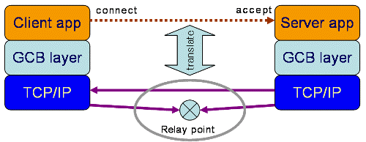

Figure 3: GCB architecture (© http://www.cs.wisc.edu/condor/gcb/basic.html)

3.6 UDP Hole Punching

Firewall traversal through UDP hole punching is a method for establishing bidirectional UDP communications between Internet hosts protected by such firewalls. It can be used by communications across firewalls that simulate connections for UDP traffic.

As a prerequisite to use UDP hole punching the local firewall has to allow outbound TCP and UDP connections, it has to simulate connections for UDP data transfers. A relay server has to be installed which controls a secure communication establishment.

The server is a central part of this concept. Each client connects to this server using a persistent TCP connection. Simultaneously the relay server recognizes the public IP addresses of the clients.

The connection is established in several steps. The initiator (client A) sends a TCP segment to the relay server containing the information that the client wants to talk to client B using a specific dynamic UDP port. The server notifies client B about client A’s IP address and that it expects a UDP connection on this specific port. Client B sends his dynamically generated UDP port also to the relay server and simultaneously sends a UDP datagram from this port to the earlier predefined port of client A.

Client B’s local firewall forwards the UDP datagram, stores a connection entry and the dynamic access rule which allows responses to traverse the firewall into its internal data base. In this phase Client A’s local firewall rejects the packet but this does not matter at all. The relay server informs client A via the existing TCP connection to A that client B is accessible on the preefined UDP port.

Client A now sends a UDP datagram to B. Client A’s local firewall now creates also a dynamic entry. However, the dynamic entry in B’s local firewall is still active and valid, so that the UDP datagram from A to B passes the firewall. Now the communication channel is established although the static ruleset of each firewall would normally deny inbound connections according to the parameters of the protocol headers.

The concept of UDP hole punching can easily be extended to be used in Grid environments[GUDPH]. The relaying server is changed to an authenticarton and authorization service which is located inside client B’s domain on a special server or directly onto host B . It listens on a well defined TCP port and waits for user connections. At connect time, the remote user and the server authenticate each other using X.509 certificates. If the TCP connection between the participants has been established UDP data transfers can take place as described in the UDP hole punching concept above.

The advantage of an AAA service is obvious. The relay server and client B can be the same host without using an outside relaying server which is not administrated by one of the involved organizations. Mutual authentication between client and server is necessary only once at connect time. Once the TCP connection is established the data transfers are allowed to start. Even more there are no problems resulting from NAT. Any server accessible from the public network is exempted from the NAT algorithm and the server only sees the public IP address of the client.

Often it is useful to transfer data using multiple parallel connections. The client has to indicate how many connections should be used in parallel. It allocates the sockets and sends the port numbers to the server. The server reads the information and tries to initiate the maximum number of UDP connections available by sending small UDP datagrams to the client. This may depend on the system load. The server sends the local UDP port numbers to the client and the client starts the data transfers.
Starting two TCP connections, one from A to B and one from B to A vice versa, is not possible, because the firewall recognises the not matching TCP sequence numbers and deletes the dynamic access entries.

A new challenge arises from encrypted UDP data traffic. One approach to encrypt the data could be a simple symmetric algorithm. Because the TCP connection between client and server is secured via X.509 certificates the exchange of a shared secret could be done via this channel.

There are some more challenges to be faced with. Data transfers within Grid applications should be fast and reliable. Because UDP has no three-way-handshake and no acknowledgement it is faster than TCP, but UDP is not reliable. Each UDP datagram is an instance of its own and the application has to make sure that all the data has arrived. In fact this means that Grid applications have to be changed. They have to use UDP and need an instance to implement reliability.

This can be accomplished by the UDP-based Data Transfer Protocol (UDT) [UDT06].

UDT uses UDP as transport protocol but it guarantees reliability through an upper layer. Of course Grid applications have to be modified also, but the effort is very small because an API using UDT can be provided. Only interfaces of subroutines allocating sockets have to be changed.

UDT is available as open source and distributed under the LGPL. It is designed and implemented by the National Center for Data Mining at the University of Illinois at Chicago. A first internet draft has been released in August 2004. The latest stable release including documentation can be downloaded from Sourceforge.

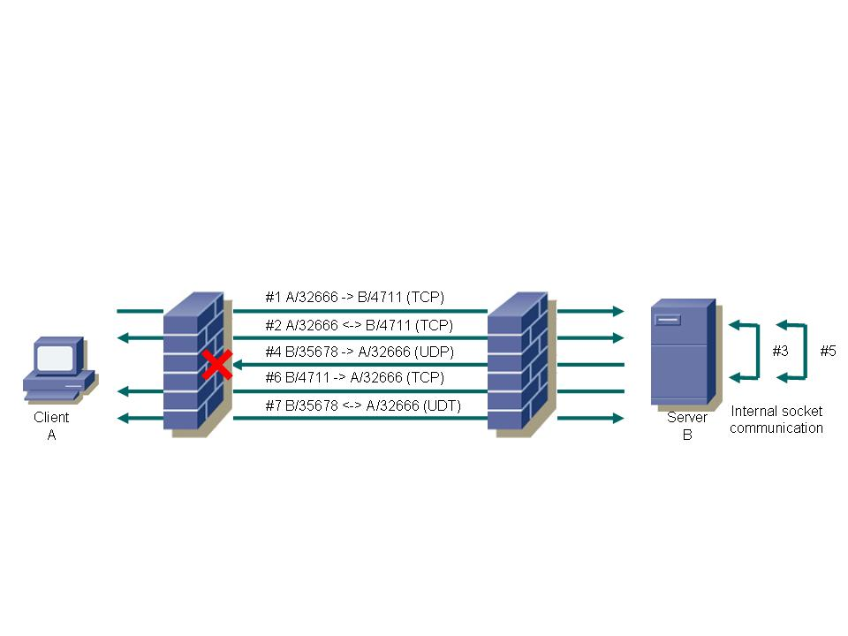

Figure 4 UDP hole punching in Grid environments

The general concept of Grid UDP hole punching can be described in more detail as follows:

The Grid client application at host A connects to an AAA server at host B using a predefined port number e.g. 4711 via A’s local firewall and the remote firewall at B’s location (see Figure 3 above, #1). The specified port has to be opened at each firewall for every host which provides this service. After mutual authentication using X.509 certificates or any other method used by Grid middleware has been performed successfully, data exchange using dynamic ports can take place.

Client A and Server B exchange securely authentication and authorization information as well as key information for a later secure communication with the required service on this host (let us call it: any grid application, AGA) (#2).

The AAA service informs the AGA service on host B that host A wants to connect to service AGA via e.g. UDP port 32666 (#3). AGA looks for a free port number e.g. 35678. Then AGA sends a UDP packet to host A at port 32666 and uses as source port 35678 (#4). The packet traverses host B’s firewall because outgoing UDP packets are allowed, but gets rejected at host A’s firewall. Nevertheless, host B’s firewall assumes an UDP stream between A/32666 and B/35678.

After the first UDP datagram has been sent from host B to host A, host B’s AGA now informs host B’s AAA service about the port to be used as destination by A (#5). The AAA service informs host A via the open TCP connection that AGA is waiting for UDP communication at port 35678 (#6).

Now host A connects to service AGA on host B with the agreed UDP port 35678 and uses as source port 32666 (#7). Hosts A and B are now able to use the UDP-based Data Transfer protocol (UDT) via the established communication path (also #7). The firewall has been opened securely and dynamically without any firewall modifications.

The security impact of Grid UDP hole punching depends directly on the secure implementation of the AAA service. If authentication and authorization of remote users/processes has been programmed with standard and up to date security tools, then the dynamic firewall rules can be created because access rights to the service have been assigned by the administrator of the service. The described concept of Grid UDP hole punching can be seen as a further step in providing solutions for Grid applications dealing with existing firewalls. It can be easily used by most of the Grid applications known today to overcome time delays until “real” dynamic configurable firewalls are available on the market.

3.7 Application Level Gateway / Proxies

Current developments in Grid Computing are based on Web Services as the underlying means of communication. The extension of Web Services with all required features for Grid Computing is called Grid Services, defined by the Open Grid Services Architecture (OGSA). The newest development is the Web Services Resource Framework (WSRF) by the Globus Alliance.

The architecture of Grid Computing standards is still under development, but nevertheless Grid Computing is already being used in a variety of projects and applications. Current approaches and software implementations are usable in a variety of hardware and network setups (e.g., local networks and intranets). Today one of the largest drawbacks for using Grid Computing in real world applications and network scenarios is the lack of support for existing firewalled security infrastructures. Almost all internal networks of companies and organizations are being protected by various kinds of security means. Currently no standardized and accepted method for accessing computation and storage resources behind firewalls in today's Grid Computing infrastructures is available. Therefore a strong demand for developing a service for a secure passage through firewalls for Grid Computing requests exists.

To securely access Grid resources in networks protected by firewalls, a security proxy for Grid Services can be developed. This proxy validates and verifies all incoming requests from Grid clients in the outside world (internet) and mediates all valid requests to and from Grid Services within the internal network (intranet, protected by a firewall). The proxy evaluates and validates the requests (SOAP requests) on the application level. It acts as a Grid ("Proxy Grid") to the internet and as a Grid client to the intranet. Being placed between two firewalls, the ALG is accessible from both sides.

3.8 A framework for Token Based Firewalling in Hybrid GMPLS networks

Application of the IETF Generalized Multi Protocol Label Switching (GMPLS) architecture is becoming increasingly popular as a control plane solution for optical networks working in parallel with a common routed IP network. Such an approach is called hybrid networking. The Dutch SURFnet-6 is one of the first examples of such networks. GMPLS deploys a separate data forwarding plane and control plane. The control plane uses the ReSerVation Protocol (RSVP), modified to allow Traffic Engineering (TE) as signaling protocol. The EU-IST funded Phosphorus project, the NSF funded DRAGON project, the MCNC enLightened testbed and the Internet2 HOPI project are examples of initiatives that research and develop deployment of GMPLS. Commercial interest is also emerging. “Token Based Firewalling in Hybrid GMPLS networks” describes an innovation that enhances the secure use of GMPLS based networks by creating a firewall function that can sit between a routed (connection-less) packet based network and the switched (connection-oriented) GMPLS network, which needs protection against unauthorized usage. Tokens will be used to mark the authorization of certain IP streams to make use of resources inside a GMPLS network. The firewall will route non-authorized IP streams to a transit network.

GMPLS RFC3471 is a generalization of the MPLS architecture RFC3031, which is intended to create connections across packet- or cell (ATM) based networks. In MPLS, packets or cells are forwarded using labels carried inside the data. Such an approach requires a minimum amount of processing during the forwarding process as a label already identifies a path, which is pre-established by a separate control plane using a signaling protocol called RSVP RFC2205. GMPLS removes the requirement for switching devices to be able to recognize packets or cells and consequently the requirement to forward data based on label information. As such, GMPLS adds capabilities to forward data based on for example time-slot numbers, wavelengths, physical ports or Virtual LAN number instead. As such GMPLS can support an intermix of various network technologies based on SONET TDM switches, MEMS fiber switches, 802.1Q VLAN switches etc. In order to support signaling for 3 additional classes of switching (based on Time, Wavelengths and Ports) inside the GMPLS control plane, the RSVP protocol has been enhanced with Traffic Engineering extensions (RSVP-TE) as defined in RFC3473.

The basic security mechanisms of MPLS using RSVP signaling are defined in RFC2747. The defined mechanisms provide signal message integrity and node authentication. Apart from an additional end-to-end security requirement for notification messages, the GMPLS standard itself does not impose additional security requirements. Furthermore, the security considerations of RSVP-TE in RFC3473 state that the control plane of a GMPLS network must not accept any message from nodes that are not known to the recipient to be authorized to make such requests. RFC2747 defines a mechanism that protects the control plane against corruption and spoofing of control messages and it provides hop-by-hop message integrity. GMPLS was originally designed to serve on-demand requests. Therefore, the information kept at each end to maintain a security association, does for example not identify a particular reservation. The security association kept between two corresponding nodes using RSVP maintains only information about the keys lifetime, the information identifying the sending station and sequence number information. Such state may therefore be insufficient to support a more complex set of access control requirements, which Grid middleware systems may demand from a GMPLS network.

Policy based Access Control requirements in GMPLS networks to support Grids.

Within Grid systems, (meta-) schedulers may need to reserve, cancel or (re-)allocate network connections that are co-allocated with other Grid resources to (competing) applications. The scheduler may continually re-evaluate the most optimal resource allocations for a given system and network workload. Given the fact that GMPLS based network resources are available, the scheduler needs to determine that certain applications should access a specific connection across a GMPLS network. However it may not be clear at the time of reservation which application will use a particular connection at what time and for how long. This question can only be answered by the scheduler, sometimes only a few seconds in advance. Furthermore the scheduler can only determine a correct answer if it assumes guaranteed availability of a number of different resources, including the network. Schedulers may also determine that certain applications should use the best effort Internet in order to achieve the most optimal solution for a given workload.

When considering the concept of a GMPLS domain, RFC4726 recognizes that the ingress point of a GMPLS domain is a natural point for policy control. In order to assist one or more scheduler to ensure that assumptions of network availability are accurate, it helps if the ingress point can enforce access based on a secured reservation-id. As multiple scheduling agents may reserve network resources, the concept of accepting a ticket or secure token at the ingress point of a network has proven to be pragmatic. Many examples such a systems can be found in transportation networks such as airline-, train- and bus networks. In our research case, the RSVP protocol allows ticket or secure token information to be contained in a POLICY_DATA object as described in RFC2750. In this context, we define a secure token as a signed list of attributes, where at least one attribute identifies a particular service instance. In order to recognize the authenticity and integrity of the token, key material must be shared between the authority issuing the right to access the service instance and the network ingress point that enforces the access. The authority may be a complex set of middleware functions, which includes a scheduler. As such the GMPLS Network ingress point can be considered as a firewall, admitting only an Authorized Label Switched Path (ALSP).

The figure below shows some basic network elements around the concept of a GMPLS firewall.

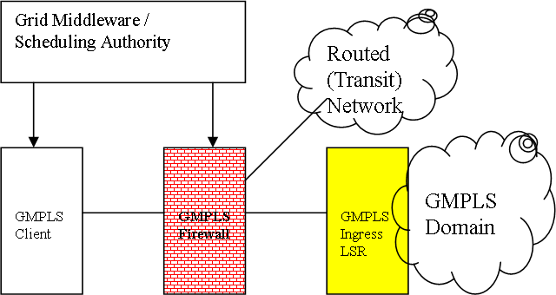

Figure 5 GMPLS

The GMPLS firewall sits in between a network that connects a GMPLS client. In effect the GMPLS firewall acts as a proxy for the GMPLS Ingress LSR to which it would normally connect. The GMPLS firewall is connected to the GMPLS Ingress LSR and to the Routed Internet, offering transit (i.e. connectivity to the entire Internet). Both the Firewall and GMPLS client are provisioned with the propper key material, such that the content of the POLICY_DATA object can be signed by the client and recognized by the GMPLS firewall. The content of the POLICY_DATA object is dependant on the application, but for scalability reasons it should be minimal. If the content of the POLICY_DATA object, acting as a secure token, only refers to some pre-provisioned behaviour, that is programmed into the firewall, it has the advantage that the GMPLS client does not have to be aware of- or required to handle the associated attributes. The pre-provisioned behavior could identify future time-slots, source/destination constraints, route and bandwidth constraints etc. As a minimum the POLICY_DATA object should carry some ID and signature.

The above is intended to act as a framework describing an approach to use the RFC2750 POLICY_DATA object as secure token. Further research needs to be performed to identify what attributes should be carried inside the POLICY_DATA object, how key material should be distributed and what policies should govern the issuing of the keys, in particular in multi-domain GMPLS network scenario’s.

4. Matching requirements and solutions

This document has described various kinds of solutions to overcome when Grid applications communicate across firewalls. None of these solutions seems to fulfil all requirements. All deal with one or the other aspect. The table below tries to categorize the impacts of solutions to requirements, so that grid users can see on the fly which one fits best to their applications.

High speed and load balancing firewalls can not handle any kind of dynamic port issues, but they can deal with high speed data throughputs (assumed real load balancing is done; see discussion above).
Dyna-Fire, in principle usable with any kind of firewalls, has the disadvantage of potential high overhead. This disadvantage can be ignored if the single data streams are very large, so that the overhead for opening one port is relatively small compared to the overall amount of data transferred.
Cooperative On-Demand Opening relies on the knowledge of the IP address of the CODO agent. Any application has to be rewritten to allow to access the CODO agent first, to authenticate there, and requesting the opening of ports. Also local clients and server have to be rewritten, to request the traversal of the firewall to external servers or to register themselves as servers awaiting client connections from outside. Having headed this overhead, applications can communicate without any problems.
Generic Connection Brokering has similar disadvantages than CODO because the GCB server has to be known or instead of this has to be invisible for the applications, which assumes traffic can be routed through the server without knowledge of the application endpoints. The main disadvantage seems to be the bottleneck which is introduced by letting traverse all the traffic one GCB server.
UDP Hole Punching gets it security by the server site hosted AAA server. This server has to deal with all kinds of applications or alternatively any kind of application needs its own AAA server. The required TCP ports for authentication and authorization have to be known. This could be an overhead as long as a “well known” port number has not been officially announced. Additionally any kind of outgoing UDP traffic has to be allowed on both sides of the connection partners. As a goody a high speed data transfer (no TCP acknowledgements and timeouts) can be used.
Application level gateways can be perfectly used to allow specific traffic passing a firewall. The main disadvantage is that they are highly application dependent. So every new application has to have its own application level gateway. This allows using this kind of solutions for specific needs to overcome current firewall limitations, but with the drawback of programming a specific application level gateway for every single application. Though not generally utilizable, application level gateways fit specific needs for short time solutions.
Token based Firewalling in hybrid GMPLS networks allow ….
!!! Leon could you please describe Pros and Cons !!!

The following table shows which requirement is solved by which solution described in the previous section.

Name of Solution / ID of requirement | G010 | G020 | G030 | G040 | H010 | H020 | M010 | M020 | M030 | M040 | M050 | M060 | D010 | D020 | P010 | P020
High speed FWs | N/A | X | N/A | N/A | x |  | N/A | N/A | N/A | N/A | N/A | N/A | N/A | N/A | X | N/A
Load Balancing FWs | N/A | X | N/A | N/A | x |  | N/A | N/A | N/A | N/A | N/A | N/A | N/A | N/A | X | N/A
Dyna-Fire | X | X |  | X | N/A |  | X | X | ?
Cooperative On_Demand Opening | X | X | ? | X | N/A |  | X | X | ?
Generic Connection Brokering | X | X |  | X | N7a |  | X | X | ?
UDP hole Punching | X | X |  | X | N/A |  | X | X | ?
Application Level Gateway / Proxies | X | X | ? | X | N/A |  | X | X | ? | X | X |  | ?
Token Based FWing in Hybird GMPLS Networks | X | X |  | X | N/A |  | X | X

5. Summary

The previous chapter described the matching of Grid requirements for Firewalls and existing solutions. As discussed there are a lot of solutions available currently which can be used on a case by case basis having analysis the implemented local security policy of the individual organization. None of them fit all needs, but most of them have their right to exist. What’s missing up to now is a general protocol which fits all needs, that is simple to implement, highly responsive (throughput), globally applicable (standard well known as well as dynamic connections), secure, and highly recognized (commonly known and implemented) and last but not least standardized.
The FI-RG work group plans to investigate on this issue in the future. The objective will be to design, implement, and validate, i.e. verify such a protocol for future usage in Grid environments.

6. Contributors (in alphabetic order)

Name | Institution
Alan De Smet | University of Wisconsin  <Address>
Leon Gommans | University of Amsterdam  lgommans@science.uva.nl
Egon Grünter | Research Center Jülich  e.gruenter@fz-juelich.de
Thijs Metsch | German Aerospace Center - DLR e.V.  thijs.metsch@dlr.de
Ralph Niederberger | Research Center Jülich  r.niederberger@fz-juelich.de
Gian Luca Volpato | RRZN - Leibniz Universitaet Hannover  volpato@rrzn.uni-hannover.de

7. Glossary

AccessGrid | The Access grid is a collection of resources and technologies for audio and video collaboration between workgroups working apart.
ALG | Application Level Gateway, see chapter 3.3
Condor | The goal of the Condor® Project is to develop, implement, deploy, and evaluate mechanisms and policies that support High Throughput Computing (HTC) on large collections of distributively owned computing resources. Guided by both the technological and sociological challenges of such a computing environment, the Condor Team has been building software tools that enable scientists and engineers to increase their computing throughput.  (© http://www.cs.wisc.edu/condor/)
dCAP | dCache native protocol providing access to dataset contents and supporting regular file access functionality. The dCache software package includes a C-language client implementation of this protocol offering the POSIX file I/O operations as well as the standard file system namespace operations.
dCache | The goal of this project is to provide a system for storing and retrieving huge amounts of data, distributed among a large number of heterogenous server nodes, under a single virtual filesystem tree with a variety of standard access methods. Depending on the Persistency Model, dCache provides methods for exchanging data with backend (tertiary) Storage Systems as well as space management, pool attraction, dataset replication, hot spot determination and recovery from disk or node failures. Connected to a tertiary storage system, the cache simulates unlimited direct access storage space.  (© http://www.dcache.org)
D-Grid | The German Grid Initiative is a joint research initiative between German research and industry funded by the Federal Ministry of Education and Research (BMBF) to develop a distributed, integrated resource platform for high-performance computing and related services to enable the processing of large amounts of scientific dta and information.
DMZ | Demilitarized Zone. DMZ is a firewall configuration for securing local area networks (LANs). In a DMZ configuration, most computers on the LAN run behind a firewall connected to a public network like the Internet. One or more computers also run outside the firewall, in the DMZ. Those computers on the outside intercept traffic and broker requests for the rest of the LAN, adding an extra layer of protection for computers behind the firewall. Traditional DMZs allow computers behind the firewall to initiate requests outbound to the DMZ. Computers in the DMZ in turn respond, forward or re-issue requests out to the Internet or other public networks. The LAN firewall, though, prevents computers in the DMZ from initiating inbound requests.
DWDM | Dense Wavelength Division Multiplexing is a fiber-optic transmission technique that employs light wavelengths to transmit data parallel-by-bit or serial-by-character.
Globus Alliance | The Globus Alliance is an international collaboration that conducts research and development to create fundamental Grid technologies. The Grid lets people share computing power, databases, and other on-line tools securely across corporate, institutional, and geographic boundaries without sacrificing local autonomy.  (© http://www.globus.org/alliance/)
Globus Toolkit | The Globus Toolkit is an open source software toolkit used for building Grid systems and applications. It is being developed by the Globus Alliance and many others all over the world. A growing number of projects and companies are using the Globus Toolkit to unlock the potential of grids for their cause.  (© http://www.globus.org/)
GPFS | General Parallel File System, developed by IBM, is a high-performance shared-disk file system. It provides fast, reliable data access from all nodes in a homogenous or heterogeneous cluster running AIX or LINUX operating systems.
GridFTP | Special FTP protocol for Grids, see chapter 4.2.2
GSI | Grid Security Infrastructure, the basis for Globus Toolkit Security layer.
GSIdCap | Extension of the dCap protocol using GSI authentication wrapper (tunnel). Communicating with the GSIdCap servers (door nodes) requires opening ports into a firewall.
IPSec | IP Security, a set of protocols developed by the IETF to support secure exchange of packets at the IP layer. IPsec has been deployed widely to implement Virtual Private Networks (VPNs).
SOAP | Simple Object Access Protocol. It is a lightweight protocol intended for exchanging structured information in a decentralized, distributed environment. It is an XML based protocol that consists of three parts: an envelope that defines a framework for describing what is in a message and how to process it, a set of encoding rules for expressing instances of application-defined datatypes, and a convention for representing remote procedure calls and responses.
SRM | Storage Resource Manager. This protocol uses HTTPS as transport protocol and negotiates data transfers between clients and servers as well as between different servers.
SSL | Secure Socket Layer is an encryption standard that prevents anyone from intercepting and reading the data streams between the clients and servers
Unicore | UNICORE (Uniform Interface to Computing Resources) offers a ready-to-run Grid system including client and server software. UNICORE makes distributed computing and data resources available in a seamless and secure way in intranets and the internet.  (© http://www.unicore.eu)
WSRF | The WS-Resource Framework (WSRF) is a set of six Web services specifications that define what is termed the WS-Resource approach to modeling and managing state in a Web services context. To date, drafts of three of these specifications have been released, along with an architecture document that motivates and describes the WS-Resource approach to modeling stateful resources with Web services. To be released soon are the other specifications, an overview document describing the relationship among the different specifications, and a document that compares the WS-Resource Framework with the Open Grid Services Infrastructure.  (© http://www.globus.org/wsrf/faq.php#wsrf1)

8. Intellectual Property Statement

The OGF takes no position regarding the validity or scope of any intellectual property or other rights that might be claimed to pertain to the implementation or use of the technology described in this document or the extent to which any license under such rights might or might not be available; neither does it represent that it has made any effort to identify any such rights. Copies of claims of rights made available for publication and any assurances of licenses to be made available, or the result of an attempt made to obtain a general license or permission for the use of such proprietary rights by implementers or users of this specification can be obtained from the OGF Secretariat.
The OGF invites any interested party to bring to its attention any copyrights, patents or patent applications, or other proprietary rights which may cover technology that may be required to practice this recommendation. Please address the information to the OGF Executive Director.

9. Disclaimer

This document and the information contained herein is provided on an “As Is” basis and the OGF disclaims all warranties, express or implied, including but not limited to any warranty that the use of the information herein will not infringe any rights or any implied warranties of merchantability or fitness for a particular purpose.

10. Full Copyright Notice

Copyright (C) Open Grid Forum (2007). All Rights Reserved.

This document and translations of it may be copied and furnished to others, and derivative works that comment on or otherwise explain it or assist in its implementation may be prepared, copied, published and distributed, in whole or in part, without restriction of any kind, provided that the above copyright notice and this paragraph are included on all such copies and derivative works. However, this document itself may not be modified in any way, such as by removing the copyright developing Grid Recommendations in which case the procedures for copyrights defined in the OGF Document process must be followed, or as required to translate it into languages other than English.

The limited permissions granted above are perpetual and will not be revoked by the OGF or its successors or assignees.

11. References

[CODO] | S.Son, B.Allcock, M.Livny, CODO: Firewall Traversal by Cooperative On-Demand Opening, 14th IEEE Symposium on High Performance Distributed Computing, (HPDC14), Research Triangle Park, July 2005  http://www.cs.wisc.edu/ sschang/papers/CODO-hpdc.pdf
[D-Grid]. | M.Meier, E.Gruenter, R.Niederberger, Th.Eickermann, Überblick zur Marktrecherche – Hochgeschwindigkeitsfirewalls, D-Grid Integrationsbericht Fachgebiet 3-5, Forschungszentrum Jülich, August 2006, https://bscw.zam.kfa-juelich.de/bscw/bscw.cgi/d127712/ueberblick_hochgeschwindigkeitfirewalls.pdf
[Dyna-Fire] | M.L.Green, S.M.Gallo, R.Miller, Grid-enabled virtual organization based dynamic firewall, Grid Computing, 2004. Proceedings. Fifth IEEE/ACM International Workshop on Grid Computing, ISBN 0-7695-2256-4, pp. 208-216, Nov. 2004
[FI-RG-1] | R. Niederberger, W. Allcock, L. Gommans, E. Grünter, T. Metsch, I. Monga, G. L. Volpato, C. Grimm Firewall Issues Overview. Open Grid Forum, Lemont, Illinois,  U.S.A., GWD-I.083, August 2006.  http://www.ogf.org/documents/GFD.83.pdf
[GCB-1] | GCB: Generic Connection Brokering, http://www.cs.wisc.edu/condor/gcb/
[GUDPH] | E.Gruenter, M.Meier, R.Niederberger, F.Petri,, Dynamic Configuration of Firewalls - Using UDP Hole Punching, Oct. 2006, http://www.d-grid.de/fileadmin/user_upload/documents/DGI-FG3-5/Dynamic_Configuration_of_ Firewalls.pdf
[RFCxxx] | Do we have to include all the RFCs mentioned in Leons “token solution” or are these references “selfdefining”. Letz’s say e.g.  For all RFCs see: http://www.ietf.org/rfc/rfcxxxx.txt
[UDT06] | Y.Gu, R.L.Grossmann, UDT – UDP based Data Transfer: Breaking the Data Transfer Bottleneck:, 2007, http://udt.sourgeforge.net

