Remote Instrumentation Services In Grid Environment (RISGE-RG)
Information about project/research involved in work of the group

(Logo - optional)
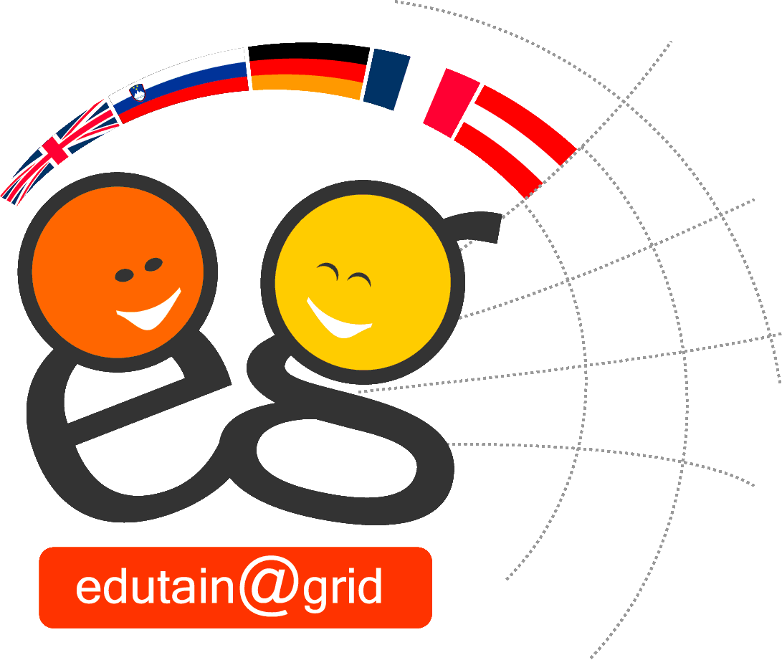

Project acronym:
edutain@grid
Project (Research) full name:
A scalable QoS-enabled Business Grid Environment for Multi-User Real-time Online Interactive Applications
Start date:
1.09.2006
Duration:
3 years
Project web site:
http://www.edutaingrid.eu
Project coordinator:
Thomas Fahringer, University of Innsbruck, Austria
Contact person (in terms of OGF):
Thomas Fahringer
Project participants (institution name,country):
Participant name | Country
Universität Innsbruck, Institut für Informatik | Austria
Westfälische Wilhelms Universität Münster, Institute für Informatik | Germany
University of Southampton, IT Innovation Centre | United Kingdom
Johannes Kepler Universität Linz, Institut für Graphische und Parallele Datenverarbeitung | Austria
Darkworks S.A. | France
BMT Cordah Ltd. | United Kingdom
Amis d.o.o. | Slovenia

Project(Research) summary(1/4-1/2 page max):
edutain@grid is an exciting and ground breaking new project making use of Grid technology. The project will identify and define a new class of applications that are highly significant for Grid computing but have not been studied in the past, which we characterise as Real-Time Online Interactive Applications (ROIA). The distinctive features that make ROIA unique include large user concurrency to a single application instance, ad-hoc connections, competition-oriented Virtual Organisations, real-time interactive response, dynamically changing control and data application flows whilst maintaining high Quality of Service (QoS), user friendly security, and novel Business-to-Consumer market models. In order to overcome these challenges, the project team will develop a new middleware layer that will allow ROIA to exploit Grid computing and validate the system using two pilot applications from online gaming and e-learning domains.
edutain@grid is expected to be of key interest to game developers and publishing companies by tackling some current key industry challenges:
- larger user concurrency and high QoS ranging between 64−128 players for fast action online games to thousand of players in persistent Massively Multi-user Online Role Playing Games (MMORPG);
- standard API and scalable networks for cheaper integration and online game hosting.
Similarly the benefits to the e-learning community are expected to be significant where large numbers of geographically disparate students can interact with instructors making use of large operational data sets. In particular this will be relevant to online simulations in scientific modelling applications used in the energy, defence, transport and legal market sectors. Furthermore edutain@grid is expected to attract new developers and development ideas that were not previously possible or simply cost prohibitive.
User communities(short description):
To meet the requirements of the market and consumers, two interest groups, one for the online gaming and the other for the e-learning communities, are being established. The size of the organisations that invited to sit on the interest groups is variable in that the consortium believes that edutain@grid has the potential to help expand smaller companies in the EU to compete at a world wide level by reducing development costs. For the e-learning interest group members are invited from key market sectors, governments, non government and academic organisations. The online games interest group comprises commercial and academic members

Project(Research) relation with objectives of RISGE-RG group:

For some years, Grid computing has been successful in certain academic research disciplines, allowing researchers to share their computational resources or data to achieve an agreed research goal that none could pursue on their own. In industry, Grid computing has also been partially successful to improve time to market through rapid deployment of resources for new projects in areas such as pharmaceutical industries and risk analysis of financial services.
However, Grid technology has yet to make an economic or societal impact similar to that achieved in the last 15 years by Web technologies. There are many reasons for this, including the lack of convergence of underlying specifications, the economic cost of porting applications, the inaccessibility of Grids from a usability perspective, especially with respect to Grid and Virtual Organisation (VO) security models, the high economic cost and static nature of Grid deployments and operation, the limited support for guaranteed performance, scalability, failover and recovery, or the lack of support for business models that provide an attractive balance of risks and rewards for both providers and consumers of services.
Possibly the most important (but rarely mentioned) reason for the slow pace of progress compared with Web technologies is the lack of any obvious “killer” applications for the Grid. In this project, we identify and define a new class of applications that are highly significant for Grid computing but have not been studied in the past, which we characterise as Real-Time Online Interactive Applications (ROIA). We classify ROIA as a new class of Grid applications with the following distinctive features that makes them unique in comparison to traditional parameter study or scientific workflows, highly studied by previous Grid research:
- the applications often support a very large number of users connecting to a single application instance;
- the users sharing an application interact as a community, but they have different goals and may compete (or even try to cheat) as well as cooperate with each other;
- users connect to applications in an ad-hoc manner, at times of their choosing, and often anonymously or with different pseudonyms;
- the applications mediate and respond to real-time user interactions, and typically involve a very high level of user interactivity;
- the applications are highly distributed and highly dynamic, able to change control and data flows to cope with changing loads and levels of user interaction;
- the applications must deliver and maintain certain Quality of Service (QoS) parameters related to the user interactivity even in the presence of faults.
Grid technology still does not provide good support for all these key features. The performance overheads of current Grid protocols and logically centralised resource management act against real-time interactivity, for example. Traditional Grids also do not provide good support for sharing application instances among communities of users with different (possibly conflicting) goals from each other or from resource providers.
The edutain@grid project therefore seeks to overcome these barriers and implement Grid-based ROIA. The key scientific and technical objectives (see Error: Reference source not found) of the project are:
- To define ROIA as a new class of socially important applications and provide complete Grid support for their key features through well-chosen sample applications;
- To provide a QoS-enabled middleware for SLA negotiation and ROIA provisioning that copes with dynamic Grid and highly populated user environments;
- To develop mechanisms that provide the necessary real-time performance, scalability, manageability, and QoS;
- To devise business models that make the provision of large-scale ROIA economically viable;
- To make the Grid accessible to large numbers of users of such applications by overcoming usability barriers including those associated with Grid security;
- To make the resulting technology cost-effective for application developers;
- To disseminate and promote exploitation and take-up of the technological results.
The sample applications chosen to validate the scientific and technological developments are in multi-player online gaming and e-learning. By targeting these socially important sectors (education and entertainment), edutain@grid seeks to accelerate the emergence of killer Grid applications and promote accelerated take-up of the technology by European business and society.

