OGSA® EMS Architecture Scenarios

Version 1.1 (draft 003)

Status of This Document
This document provides information to the community on the scenarios used to refine the OGSA EMS architecture. It does not define any standards or technical recommendations. Distribution is unlimited.

Obsoletes
This document obsoletes GFD-106 [REFERENCE].

Copyright Notice
Copyright © Open Grid Forum (2006, 2007). All Rights Reserved.

Trademarks
OGSA is a registered trademark of the Open Grid Forum.

Abstract
The OGSA EMS (execution management services) architecture defines a number of services and XML document types. To illustrate their combined use a set of scenarios is described in this document. The scenarios cover basic job submission, file transfers, selection of resources, and deployment of resources. The emphasis is on using already published specifications, or specifications in the last stages of approval. In all scenarios a list of required specifications is included. In some cases scenarios have been identified where specifications, for clearly defined capability, still need to be defined.

Contents
1 Introduction 3
1.1 Summary of Specifications Used in the Scenarios 3
2 Fundamental Job Execution 5
2.1 Direct Job Execution 5
2.2 Indirect Job Execution 6
2.3 Job Termination 7
3 Job Execution and File Transfers 9
3.1 File Transfer specified by JSDL DataStaging URIs 10
3.2 File Transfer specified by EPRs 11
4 Selected Job Execution 12
4.1 Simple Selected Job Execution 12
4.2 Complex Selected Job Execution 13
5 Deployment and Configuration 14
5.1 Deploying an Application 14
5.2 Deploying an Application Using the Application Contents Service 17
5.3 Undeploying an Application 19
6 Security Considerations 21
7 Glossary 21
Intellectual Property Statement 23
Disclaimer 23
Full Copyright Notice 23
Appendix A. Running a BLAST (Basic Local Alignment Search Tool) job 25
A.1. JSDL document submitted to the Job manager 25
A.2. Candidate execution plan returned by Execution planning service to Job manager 27
A.3. CDL document retrieved by Job manager to prepare for deployment 29
A.4. CDL Document submitted by Job manager to Deployment service 30
A.5. CDL document after deployment has finished 32
A.6. JSDL document submitted to BES 33

Introduction
The OGSA™ EMS (execution management services) architecture ([GFD.80] §3.4) has been under discussion for many years. In its entirety it is, quite rightly, a complex set of interdependent services. However, not all of these services are required to perform simpler operations within the EMS space. This document describes a set of scenarios that build upon each other to move towards the full EMS architecture.
The initial focus is on fundamental job execution scenarios as these are well understood and in common use in Grid infrastructures such as EGEE and OSG. Scenarios describing the selection of resources for execution as well as the deployment of the necessary software on the resources are also included. Later versions of this document will expand on other more advanced EMS scenarios, such as the interaction of execution and data services in support of job execution; the use of file & data transfer services; the role of selection services in deployment and configuration; and provisioning.
The emphasis is on using already published specifications, or specifications in the last stages of approval. In all scenarios a list of required specifications is included. A summary of the specifications used in the scenarios is given in §1.1. A number of special terms, abbreviations, and acronyms are explained in the Glossary (see §7).

Summary of Specifications Used in the Scenarios
This section gives a brief overview of the specifications used in the scenarios: OGSA Basic Execution Service (BES) [BES]; Job Submission Description Language (JSDL) [GFD.56]; HPC Basic Profile (HPCBP) [GFD.114]; and the OGSA Resource Selection Services (RSS) [RSS].
Earlier versions of this document described some of the scenarios using the CDDLM Deployment API [GFD.69]; CDDLM Configuration Description Language (CDL) [GFD.85] and the Applications Contents Service (ACS) [GFD.73]. As there seems to be no activity within the working groups in moving these specifications from proposed to full recommendations they have been omitted from this version of the document. Details of these specifications remain in the document for reference purposes.

OGSA Basic Execution Service
OGSA BES is a set of Web services interfaces for creating, monitoring, and controlling activities. Clients define activities using JSDL (see §1.1.2) and create an activity instance by submitting a JSDL document to a BES container—a container providing the BES interfaces. A BES container implementation executes each activity that it accepts on an appropriate computational resource. Examples of such resources are a single computer; a cluster managed through a resource manager such as Load Leveler, Sun Grid Engine, Portable Batch System, or Condor; a Web service hosting environment; or even another BES container.
Activities are referenced by an EPR (endpoint reference [WS-Addressing]) and may provide their own (management) interfaces.
Although the BES is a key enabling specification in job submission, many implementations are using it in the context of the HPC Basic Profile (see below). The profile clarifies how BES can be composed with a specific job description dialect for HPC Applications (based on JSDL) and components of the WS-Security specification to enable secure remote job submission, monitoring and management. The HPC Basic Profile will be used as the specification to support basic job submission in this document.

Job Submission Description Language
JSDL provides an XML-based language specifically for describing single job (activity) submission requirements.
The JSDL vocabulary is informed by a number of existing job management systems such as Condor, Globus, Load Sharing Facility, Portable Batch System, Sun Grid Engine, and Unicore. It includes elements for describing job identification (e.g., job name, project); application to execute (e.g., application name, version), including additional description specifically for POSIX applications (e.g., path to executable); data requirements (e.g., files to stage in or stage out); and resource requirements (e.g., type and characteristics of CPU, memory requirements, operating system).

CDDLM Deployment API
The CDDLM Deployment API is a Web services (WSRF-based) API for deploying applications to one or more target hosts; and for managing the deployment lifecycle. A deployment descriptor described in XML (e.g., CDL, see §1.1.4) defines the deployment dependencies. Once an application is deployed a set of properties and operations defined by the CDDLM component model (not described here) are provided, which can be used to examine the state of the deployed application and retrieved information about its environment.

CDDLM Configuration Description Language
CDL is an XML-based language that supports the declarative description of system configuration as a hierarchy of components. A CDL document defines the order and deployment requirements of a system. Examples of systems are the installation of a POSIX application such as BLAST; and the installation of a complex application such as a three-tier application.

Applications Contents Service
ACS defines a Web services interface to a repository containing grid application content—for example, program binaries; configuration scripts and data; descriptions of required hardware environments. Each application is logically contained in an Application Archive, which may be retrieved in its entirety in a standard format. The ACS repository manages the application content and provides access to it by other services; it does not act on (interpret or execute) the contents.

OGSA Resource Selection Services
RSS defines Web services interfaces, such as an Execution Planning Service, for choosing services or resources on which to perform an operation or execute an activity. An EPS takes an abstract plan of an execution—JSDL document—and suggests particular execution services—HPCBP endpoints—upon which the abstract plan may be carried out. It returns a set of (concrete) candidate execution plans.
Reservation of resources is not part of RSS and there is no guarantee that a candidate execution plan can in fact be executed.

High Performance Computing Basic Profile
The High Performance Computing Basic Profile (HPCBP) brings together the Basic Execution Service and the JSDL. The HPCP working group has also defined the High Performance Computing Application (HPCPA) specification, an extension of the Job Submission Description Language (JSDL). The HPCBP defines the WS-Security components that are to be used with these specifications to achieve interoperability in common usage scenarios.

Fundamental Job Execution
Fundamental job execution deals with direct or indirect job submission and management. Direct here means that the user, through some user agent, submits and monitors a job execution; indirect that the user delegates the management of the job to a job manager.

Direct Job Execution

Assumptions
- The User agent knows which HPCBP endpoint to use.
- The required HPCBP endpoint is already available.

Entities
- User agent
- HPCBP Endpoint

Description
The client (User agent) contacts the HPCBP endpoint directly and submits a request to start an activity described by a simple HPCA document extending the JSDL schema. Progress is monitored directly by the User agent. (It may also be possible for the User agent to poll or receive notifications directly from the Activity (not shown).)
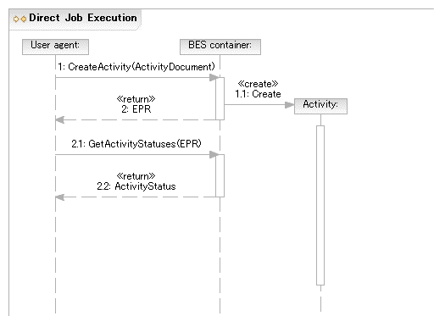
Figure 1 Direct Job Execution

Required Specifications
This scenario requires the HPCBP [GFD.114] specification.

Indirect Job Execution

Assumptions
- The User agent knows which Job manager to use.
- The Job manager knows which HPCBP endpoint to use.
- The required HPCBP endpoint is already setup.

Entities
- User agent
- Job manager
- HPCBP Endpoint

Description
To enable more sophisticated EMS scenarios it is important that the user can delegate decision making and control to an entity that is more sophisticated than a user agent—a job manager. The User agent contacts the Job manager, specifying the job, which is then executed on an established HPCBP endpoint. Once the Activity is established it is monitored by the Job manager through the HPCBP endpoint or directly (not shown).

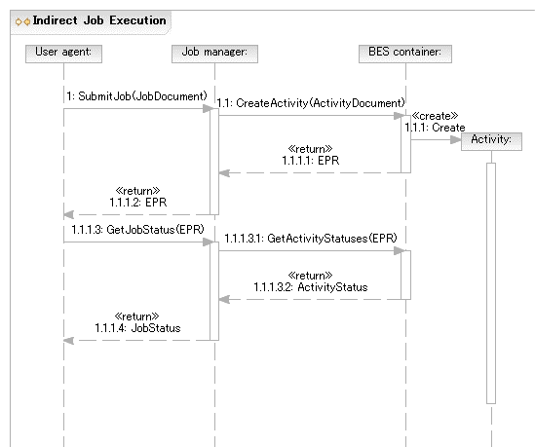
Figure 2 Indirect Job Execution

Required Specifications
This scenario requires the HPCBP[GFD.114] specification. A Job manager specification may also be required.
The HPCBP endpoint and Job manager have different responsibilities and are distinct roles in the sequence in Figure 2. It is possible, however, that a Job manager may have the same interface as the HPCBP endpoint by using the BES specification.

Job Termination
The User agent may wait for the Activity to terminate—successfully or not—or request that the Activity is terminated.

Normal Termination of Job

Assumptions
- The User agent has a reference to the activity through its endpoint reference.

Entities
- User agent
- BES compliant container
- Activity

Description
The User agent waits until the Activity terminates normally. The User agent detects this by polling or receiving a notification (not shown).
It may also be possible for the User agent to poll or receive notifications directly from the Activity (not shown).
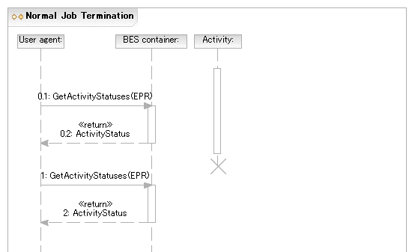
Figure 3 Normal Job Termination

Required Specifications
This scenario requires the BES[BES] specification.

Job killed by User Agent

Assumptions
- The User agent already has a reference to the activity through its endpoint reference.

Entities
- User agent
- BES compliant container
- Activity

Description
The User agent requests that the Activity is terminated.
It may also be possible for the User agent to terminate the Activity directly (not shown).

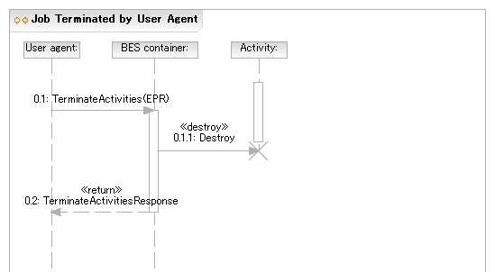
Figure 4 Job killed by User Agent

Required Specifications
This scenario requires the BES[BES] specification. a

Notes
In Figure 4 the Activity is shown as actually terminating before the TerminateActivities operation returns. This is for convenience only and is not required behavior according to the BES specification. An activity may, in fact, not terminate for some time after the TerminateActivities operation returns. Eventual termination of an activity should be determined by other means [BES].

Job Execution and File Transfers
In many scenarios the execution of an application on a remote resource is dependent on input files and, in turn, the application will produce output files. Many distributed resource management systems support the transfer of standard input from the client to the target machine and the standard output or error from the target machine back to the client – and indeed this support is also provided in some Grid execution systems. However, general support for file transfer directly from the submitting client machine, an intermediate file store, or the selection of a file from a catalogue (possibly replicated) system are all common use cases in the EMS space. Within an execution resource there may be systems that optimize the staging of files through caching and concurrent transfers from a file server to individual compute nodes. Through these pre- and post- job execution activities it is possible to ensure that applications are not waiting for the files to arrive at the compute node once the job has started. While these technologies are important for optimizing job execution and cluster utilization they are rarely visible outside of the network around the cluster and are therefore currently out of scope in our consideration of file transfer scenarios within EMS.

File Transfer specified by JSDL DataStaging URIs
The following scenario is based around an HPCBP endpoint, a HPC Basic Profile complaint BES container, which supports the HPCBP File Transfer extension and accepts job requests based around the HPCA document schema which used the HPC Application profile to extend the JSDL document.

Assumptions
- The user agent has a reference to an HPCBP Endpoint.
- The HPCBP Endpoint supports the ‘File Transfer’ extension and the protocols needed for any specified file transfers.
- The file to be transferred is accessible from the HPCBP Endpoint using a protocol and credential supported by the extensions.
- The BES container is notified or made aware in some fashion, that may not be be exposed to external agents, that the file transfers have completed so any application execution can take place.
- The Source (s) and Target(s) elements specified in the JSDL document will contain credentials as specified in the File Transfer extension if they are required.

Entities
- User Agent (client)
- HPCBP Endpoint (BES Container conforming to HPC Profile)
- Activity
- Remote File Access mechanism

Description
This scenario can be composed with several EMS scenarios – we will build upon Direct Job Submission (2.1) scenarios. The client (User agent) contacts the HPCBP endpoint and submits a request to start an activity, described by an HPCA document, that specifies:
  - the files that need to be transferred on to the machine before the application defined by the activity can enter the running state and
  - the files that need to be transferred from the machine before the activity can enter the completed state after the application has finished running.
Progress of the file transferring activity, which is now part of the HPCBP FileTransfer extension state model, can be monitored directly by the User agent by polling or receiving notifications from the activity (not shown in the UML diagram – to be drawn).
The job document is sent to the HPCBP endpoint and used to create the application activity and the file transfer ins & outs needed to support the application execution. An activity endpoint is returned to the User agent. Once the activity is no longer in the pending state, it enters the Running:StageIn state while the file transfers from the remote file access mechanisms to the local file system. Once all the staging in transfers are complete the application is initiated and the activity moves to the Running state. When the application execution is successfully over the activity moves into the Running:StageOut state while files are transferred from the local file system to its remote destination. On successful completion of all staging out activities the activity enters the Completed status. On failure at any point the activity moves into the Failed state and does not progress any further.
The status of the activity can be determined at any point during its existence using the established operations.

Required Specifications
This scenario requires the HPCBP and supporting specifications and the HPCBP File Transfer extension.

File Transfer specified by EPRs
How to link this scenario with an execution to make it an EMS Scenario
Andrew edit to include the general use of EPRs to specify file transfer within a JSDL document. To use DMI DEPRs and Byte-IO EPRs to specify transfers.

Assumptions
- The BES compliant container is able to interpret the EPRs describing the file transfers contained in the JSDL document.

Entities
- User Agent
- BES compliant container
- Endpoints specified in the JSDL document.

Description
This description does not detail the internal interactions within the DMI Endpoint. The User agent (client) invokes the create DTI operation (requestDataTransfer) on the DTF specifying Data Endpoint References (DEPRs) for the source and sink data sources that have been obtained previously by the client , and some transfer options. The DEPRs encapsulate the different possible data transfer protocols for accessing the source and sink data locations. An EPR to the DTI is returned to the client by the DTF. The client can monitor the progress of the data transfer through the EPR.
NB: This is taken from the current draft specification which may change.

Required Specifications
This scenario uses the DMI specification [DMI] and any native file transfer protocols.
XML fragments for the various pieces

Selected Job Execution

Simple Selected Job Execution

Assumptions
- The User agent already has a reference to a Job manager.
- The Job manager already knows which Execution Planning Service (EPS) to use.
- The BES container has not been determined at submission time.
- There is a BES container already setup that can run the submitted job.

Entities
- User agent
- Job manager
- BES container
- EPS

Description
The User agent submits a JSDL document requiring the BLAST application to the Job manager as in the scenario described in §2.2. The Job manager uses the Execution Planning Service (EPS) (part of the Resource Selection Services (RSS)) to select a BES container. It submits the JSDL document to the EPS and receives a, possibly null, list of candidate execution plans for the job. A candidate execution plan is made up of at least a JSDL document (possibly refined) and a reference to a BES container. An example of a candidate execution plan is given in Appendix A.2. (Note that the JSDL document included in this plan requires further refinement before submission, however such refinement is not always necessary.)
For the purposes of this scenario the first plan returned is considered to be the best choice. The Job manager starts the requested activity by submitting the JSDL document returned in the candidate execution plan to the selected BES container as described in §2.2.
If the submission to the BES container in the first plan fails (not shown) then the next plan may be chosen instead as a failover option; or if there are no other plans left the job execution overall fails.
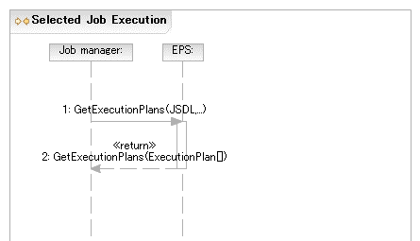
Figure 5 Selected Job Execution

Required Specifications
This scenario requires the BES[BES], JSDL[GFD.56], Job manager, and RSS[RSS] specifications.

Notes
- The JSDL document returned in the candidate execution plan may be refined to allow the rewriting of things such as abstract resources (such as one identifying the abstract name of some sequence database) into a set of requirements for making that resource available at the suggested BES container (e.g. by extending the set of DataStaging elements, or by providing an appropriate CDL document).
- Internally, the RSS may use a simple selection algorithm (e.g., number of pre-defined BES containers to round-robin the job request from the Job manager to one of these interfaces; or could obtain and select BES containers using an information service such as a service registry). With a defined selection language the RSS implementation can be more sophisticated by allowing a user defined selection policy to be applied to the available services in the registry.

Complex Selected Job Execution

Assumptions

Entities

Description
Description of the scenario focusing on the incremental result return and the activity creation failure.
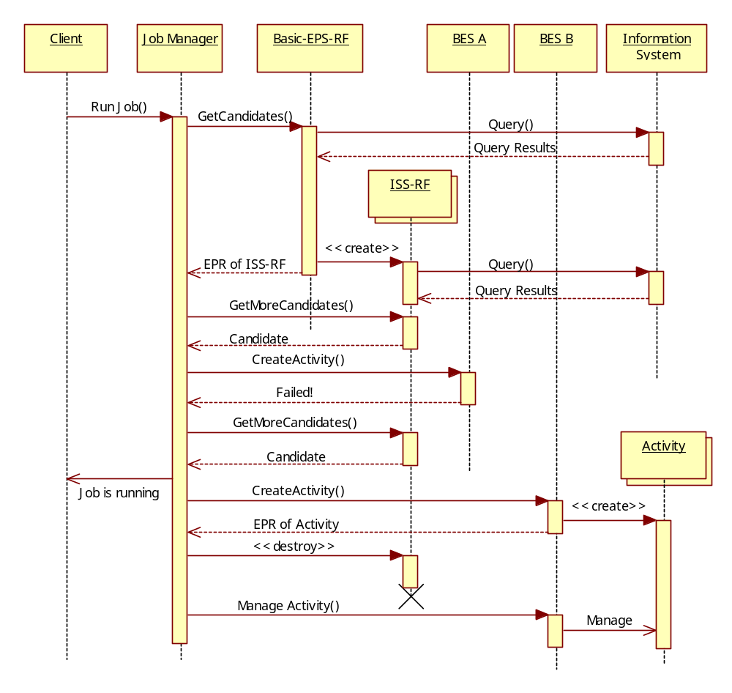
Figure 6 Selected Job Execution with incremental results and handling of activity creation failure

Required Specifications

Notes

Deployment and Configuration

Deploying an Application
A simple POSIX application (BLAST) is deployed to support an activity that is to be initiated within a BES container.

Assumptions
- The User agent already has a reference to a Job manager.
- The Job manager already knows which EPS to use.
- The BES container is determined at submission time—e.g., it may be specified as an argument to the submission operation—but the actual resource, a.k.a. host, will be chosen at deployment time.
- The BES container is not already setup to run the job.
- The Job manager has suitable binaries and other relevant information required to setup the BES container.
  - For example, a BLAST binary, a BLAST database—possibly created by an earlier preparatory job—as well as a BLAST Application CDL document describing the deployment requirements. A later scenario (see §5.2) describes how such data can be retrieved from a repository service.
  - The BLAST Application CDL document (see Appendix A.4) may have a number of lazy elements—e.g., Hostname, PathName. Also it can be assumed that the JSDL and CDL documents are created by tooling and are consistent—but not necessarily complete.
- The Job manager knows which deployment service can be used to deploy to the specified BES container.

Entities
- User agent
- Job manager
- Information service
- Deployment service
- BES container
- BLAST system

Description
The User agent submits to the Job manager a JSDL document requiring a BLAST application execution on a specific BES container. An example of such a JSDL document is given in Appendix A.1.
The Job manager queries the Information service, or the platform directly, and discovers that the specified BES container does not have the BLAST application installed on it.
The Job manager submits the BLAST CDL document to the Deployment service. An example of such a CDL document is given in Appendix A.4. The Deployment service completes any remaining lazy elements in the CDL document—e.g., the name of the resource (host) on which to deploy is a lazy element in this scenario—carries out the installation and returns an EPR (endpoint reference [WS-Addressing]) to the Job manager providing a reference to the installed software—the BLAST system. An example of a CDL document after deployment has been carried out is in Appendix A.5
The Information service entry of the resource is updated with the location of the BLAST application. (This update may be done by the resource itself, the Deployment service, the Job manager, etc.) This prevents the removal of the resource as the BLAST application is using it.
The Job manager uses the EPR to the installed software to retrieve information it may need if it has to refine the JSDL document further before submission. This is effectively an operation to retrieve relevant chunks of the XML deployment tree (i.e., the instantiated CDL document) back to the Job manager for insertion into the JSDL document. An example of such a refined JSDL document is given in Appendix A.6.
The, now complete, JSDL document is submitted to the BES container on that platform.
The Information service entry of the BLAST application is updated with the information that the Activity now uses the application (not shown). (This update may be done by the Activity, the Job manager, etc.) If another Activity uses the same BLAST application a similar update to the Information service entry is carried out to make sure that the BLAST application remains available as long as it is in use.
Once the Activity completes successfully the Information service entry of the BLAST application is updated accordingly (not shown). The User agent is informed that the job is complete.

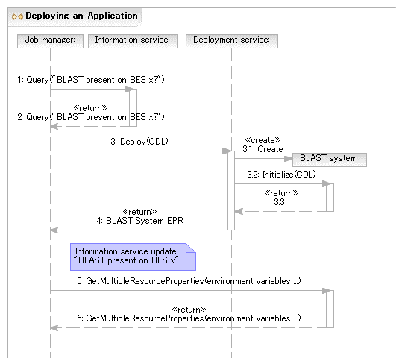
Figure 7 Deploying an Application

Required Specifications
This scenario requires the BES[BES], JSDL[GFD.56], Job manager, CDL[GFD.85], CDDLM Deployment API[GFD.69] and other supporting component specifications such as a CDL POSIXApplication component, Deployment service and (unspecified) Information service specifications.

Notes
In the simplest case the deployment service may be located on the platform hosting the BES container, or there is some other well known (pre-configured) relationship. In general a deployment service may, however, act as a proxy for deployment on platforms other than the one it is running on. It may also be possible that there are multiple such services in a system. It is therefore recommended that a deployment service advertises (somewhere, in a currently unspecified manner) where it is capable of deploying stuff to, for example, front end node for a cluster.
The deployment service operations called by the Job manager in the sequence in Figure 7 are different from those defined by the CDDLM Deployment API. The operations called by the Deployment service are those of the CDDLM Deployment API. The CDDLM Deployment portal is not shown for simplicity.
In the scenario above it is suggested that the Job manager may carry out some simple refinement of the JSDL document perhaps by retrieving information available after deployment. This functionality is not required of the Job manager and it is expected that, if necessary, a specialized service (currently undefined and left out for simplicity) may be available to carry out such refinements.

Deploying an Application Using the Application Contents Service
In this scenario a simple POSIX application (BLAST) needs to be deployed to support an activity that is to be initiated within a BES container.

Assumptions
- The User agent has a reference to a Job manager.
- The BES container is determined at submission time— e.g., it may be specified as an argument to the submission operation—but the actual resource, a.k.a. host, will be chosen at deployment time.
- The BES container is not already setup to run the job.
- The Job manager does NOT have suitable binaries and other relevant information required to setup the BES container.
- The Job manager has a reference to an Application Contents Service (ACS) Repository.
- The Application Contents Services Repository already has registered a BLAST Application Archive (AA)—addressable by an EPR—that contains all information required to install and configure BLAST.
- The Job manager knows which Deployment service can be used to deploy to the specified BES container.

Entities
- User agent
- Job manager
- ACS repository
- BLAST AA
- Deployment service
- BLAST system
- BES container

Description
As in the previous deployment scenario the User agent submits a JSDL document, which requires the BLAST application, to the Job manager. The BES container is specified as an argument to the submission operation. The Job manager determines that the BES container does not have BLAST.
The Job manager uses the contents of the JSDL ApplicationName and ApplicationVersion elements to search for a matching Application Archive (AA) in the ACS repository using the LookupArchives operation. The EPR of the AA that has the matching BLAST application is returned—the BLAST AA.
The Job manager uses the AA GetContents operation to retrieve the CDL document describing the BLAST deployment requirements. An example of such a CDL document is shown in Appendix A.2. (Comments made in previous scenarios about this CDL document also apply here.)
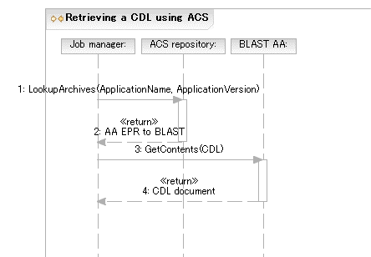
Figure 8 Retrieving a CDL document using ACS
The CDL document (which may still contain lazy elements) is then submitted to the Deployment service that can deploy to the platform hosting the BES container (see previous scenarios).
As part of the deployment the binary and other data required for deployment are retrieved from the ACS repository. For example, the BLAST system can use the ACS GetContents operation to retrieve the BLAST binary and possibly the BLAST database from BLAST AA.
The remaining steps are the same as in previous scenarios.
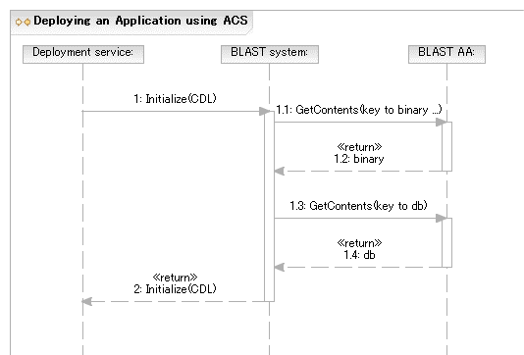
Figure 9 Deploying an Application using ACS

Required Specifications
This scenario requires the BES[BES], CDDLM Deployment API[GFD.69], JSDL[GFD.56], Job manager, ACS[GFD.73], CDL[GFD.85] and supporting CDL component specifications, and (unspecified) Information service specifications.

Notes
For simplicity it is assumed that matching ApplicationName and ApplicationVersion with an Application Archive is sufficient. In scenarios using the EPS this search-and-match may be done by the EPS and it may include a matching of Archive requirements with the Job description.
Alternatives to using the LookupArchives operation to locate an appropriate archive exist and may be preferable in real deployments. For example, it is possible to provide the EPR to the required Application Archive as part of the submission, e.g., inside the JSDL document as an extension to the Application element. Also systems may support naming applications using RNS (Resource Namespace Service [RNS]). For example, the JSDL ApplicationName element may contain an RNS application name, which can then be used to locate the corresponding archive in an ACS repository.

Undeploying an Application

Assumptions
- The Activity has terminated
- The Job manager knows which Deployment service can be used to undeploy the application represented by the BLAST system.

Entities
- Information service
- Deployment service
- BES container
- BLAST system

Description
Once the Activity completes successfully the Information service entry of the BLAST application is updated accordingly. When no other activities are registering an interest in a specific instance of a BLAST application on a resource then the Undeploy operation may be invoked on the Deployment service to remove this BLAST application from the resource.
The application may remain installed for some period of time if it is expected that it may be re-used, even if no activity is registering a specific interest for it.
If the BLAST application is removed then its entry in the Information service is also removed.
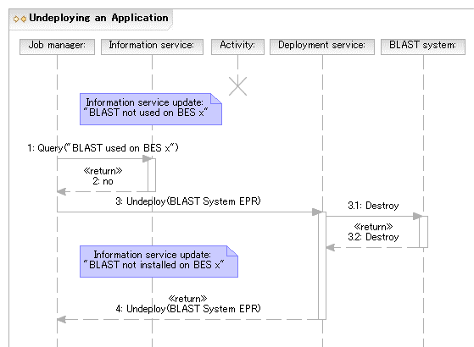
Figure 10 Undeploying an Application

Required Specifications
This scenario requires the Deployment service, CDDLM Deployment API[GFD.69] and (unspecified) Information service specifications.

Notes
Since the Job manager has the EPR to the BLAST system it is possible to call the Destroy operation directly. In the scenario, the Deployment service is used instead because further operations (not shown) may also be necessary to complete the removal. One example is updating the information service entry.

Security Considerations
This is a use case document and does not deal with security issues.
Security considerations of the referenced specifications should be thoroughly reviewed and appropriate mechanisms should be used to secure all service interactions.
It is worth calling out the requirement for appropriate authentication and authorization mechanisms. Also mechanisms for delegation of rights are required. In particular, the Job manager has to be able to delegate requestor access rights in such a way that each service provider involved in a job execution receives the appropriate (restricted) set of rights it needs. OGSA 1.5[GFD.80] §3.7 offers a detailed discussion of some of these issues.

Contributors
Editor Information:
Hiro Kishimoto
IT Core Laboratories
Fujitsu Laboratories
4-1-1, Kamikodanaka, Nakahara, Kawasaki City, Japan
Email: hiro.kishimoto@jp.fujitsu.com
Andreas Savva
IT Architecture Lab.
Fujitsu Laboratories
4-1-1, Kamikodanaka, Nakahara, Kawasaki City, Japan
Email: andreas.savva@jp.fujitsu.com
The following persons have contributed to this document: Donal Fellows, Andrew Grimshaw, Chris Smith, Jun Tatemura.
We are grateful to numerous colleagues for discussions on the topics covered in this document, in particular (in alphabetical order, with apologies to anybody we have missed) Michael Behrens, Dave Berry, Michel Drescher, Keisuke Fukui, Tom Maguire, Steve McGough, Dejan Milojicic, Mark Morgan, Jem Treadwell, as well as to the whole OGSA team for their invaluable input.

Glossary
A number of terms used in this document are defined here. These definitions draw from and are consistent with the OGSA Glossary[GFD.81] and offer additional explanation or clarification.
In the following table, words or phrases in italics are themselves defined in the table.

Term | Definition | Ref’s
Activity | The smallest part of possibly a larger sequence of activities generated from a single submitted job.  In this document a job consists of exactly one activity and the terms ‘job’ and ‘activity’ are sometimes used interchangeably.
Candidate Execution Plan | A plan for executing an activity.  At a minimum it consists of a JSDL document and a reference to the BES container where the JSDL document should be submitted to instantiate the required activity. Other information that may be used to prepare the environment for the activity, such as a CDL document and a reference to a deployment service, may also be included.
BES | Basic Execution Service  The entity that accepts requests (essentially JSDL documents) to instantiate an activity.  Note that BES does not do provisioning or deployment. | [BES]
BLAST | Basic Local Alignment Search Tool | [GFD.81]
CDL | Configuration Description Language | [GFD.85]
Deployment | The instantiation of an environment on a resource to meet the needs of a specific activity such as a submitted job.  Deployment is generally a ‘lightweight’ action in that it may just provide a binary, dataset, etc., onto the resource. This is in contrast to provisioning. Once used by the specified activity that environment may be removed immediately; or left as part of a ‘cache’ to be cleaned up or reused at a later date. (A ‘keep-alive’ model might be needed in the latter case.)  For example, an activity wants to run Gaussian. The deployment actions would be to download and install the required version for the selected platform.
Deployment Service | The entity that accepts a deployment (or undeployment) action defined by a CDL document to instantiate an environment on a resource to support an activity.
EMS | Execution Management Services  A capability defined by OGSA. | [GFD.80]
EPR | A WS-Addressing Endpoint Reference | [WS-Addressing]
EPS | Execution Planning Service  Part of the Resource Selection Services. | [RSS]
Job Manager | The entity that accepts a job (defined by a JSDL document) from the user agent. The Job Manager coordinates further invocations and interactions with other elements of the EMS architecture, such as the EPS.
JSDL | Job Submission Description Language | [GFD.56]
Provisioning | The instantiation of an environment on a resource (i.e., a deployment) that may be used by more than one activity.  Generally such deployments are ‘heavyweight’ in that they may take substantial time to instantiate.  Provisioning actions may be triggered by a specific activity (e.g., following a job submission); or they may be the result of a general response to the state of the current resources in the system, possibly defined by a policy. An example of such a policy: “If my free Red Hat Enterprise Linux Version 4 resources drop to 5%, dynamically provision new nodes until the total free nodes have increased to 15%.”
RNS | Resource Namespace Service | [RNS]

Intellectual Property Statement
The OGF takes no position regarding the validity or scope of any intellectual property or other rights that might be claimed to pertain to the implementation or use of the technology described in this document or the extent to which any license under such rights might or might not be available; neither does it represent that it has made any effort to identify any such rights. Copies of claims of rights made available for publication and any assurances of licenses to be made available, or the result of an attempt made to obtain a general license or permission for the use of such proprietary rights by implementers or users of this specification can be obtained from the OGF Secretariat.
The OGF invites any interested party to bring to its attention any copyrights, patents or patent applications, or other proprietary rights which may cover technology that may be required to practice this recommendation. Please address the information to the OGF Executive Director.

Disclaimer
This document and the information contained herein is provided on an “As Is” basis and the OGF disclaims all warranties, express or implied, including but not limited to any warranty that the use of the information herein will not infringe any rights or any implied warranties of merchantability or fitness for a particular purpose.

Full Copyright Notice
Copyright (C) Open Grid Forum (2006, 2007). All Rights Reserved.
This document and translations of it may be copied and furnished to others, and derivative works that comment on or otherwise explain it or assist in its implementation may be prepared, copied, published and distributed, in whole or in part, without restriction of any kind, provided that the above copyright notice and this paragraph are included on all such copies and derivative works. However, this document itself may not be modified in any way, such as by removing the copyright notice or references to the OGF or other organizations, except as needed for the purpose of developing Grid Recommendations in which case the procedures for copyrights defined in the OGF Document process must be followed, or as required to translate it into languages other than English.
The limited permissions granted above are perpetual and will not be revoked by the OGF or its successors or assignees.

References
[BES] A. Grimshaw, S. Newhouse, D. Pulsipher, M. Morgan, “OGSA Basic Execution Service Version 1.0 (Draft 26),” OGSA BES-WG, Open Grid Forum, 7 September 2006.
[GFD.56] A. Anjomshoaa, F. Brisard, M. Drescher, D. Fellows, A. Ly, S. McGough, D. Pulsipher, and A. Savva (ed.), “Job Submission Description Language (JSDL) Specification, Version 1.0,” Global Grid Forum, Lemont, Illinois, U.S.A., GFD.56, November 2005. http://www.ogf.org/gf/docs/?final
[GFD.69] S. Loughran (ed.), “Configuration Description, Deployment and Lifecycle Management: CDDLM Deployment API,” Global Grid Forum, Lemont, Illinois, U.S.A., GFD.69, March 2006. http://www.ogf.org/gf/docs/?final
[GFD.73] K. Fukui (ed.), “Application Contents Service Specification 1.0,” Open Grid Forum, Lemont, Illinois, U.S.A., GFD.73, May 2006. http://www.ogf.org/gf/docs/?final
[GFD.80] I. Foster, H. Kishimoto, A. Savva, D. Berry, A. Djaoui, A. Grimshaw, B. Horn, F. Maciel, F. Siebenlist, R. Subramaniam, J. Treadwell, and J. Von Reich, “The Open Grid Services Architecture, Version 1.5,” Global Grid Forum, Lemont, Illinois, U.S.A., GFD.80, July 2006. http://www.ogf.org/gf/docs/?final
[GFD.81] J. Treadwell (ed.), “Open Grid Services Architecture Glossary of Terms Version 1.5,” Global Grid Forum, Lemont, Illinois, U.S.A., GFD.81, July 2006. http://www.ogf.org/gf/docs/?final
[GFD.85] J. Tatemura (ed.), “Configuration Description, Deployment and Lifecycle Management: Configuration Description Language Version 1.0,” Open Grid Forum, Lemont, Illinois, U.S.A., GFD.85, August 2006. http://www.ogf.org/gf/docs/?final
[RNS] M. Pereira, O. Tatebe, L. Luan, T. Anderson, “Resource Namespace Service Specification,” Open Grid Forum, Lemont, Illinois, U.S.A., GWD-R, September 2006. Available at http://www.ogf.org/Public_Comment_Docs/Documents/Oct-2006/RNS-Specification-20060922.pdf
[RSS] D. Fellows, “OGSA Resource Selection Services (Draft 3),” OGSA RSS-WG, Open Grid Forum, December 2006. Available at https://forge.gridforum.org/sf/go/doc14076
[WS-Addressing] Gudgin, M., Hadley, M., Rogers, T. (eds.), “Web Services Addressing 1.0 – Core (WS-Addressing),” W3C Recommendation, 9 May 2006. http://www.w3.org/TR/2006/REC-ws-addr-core-20060509
- Running a BLAST (Basic Local Alignment Search Tool) job
  - JSDL document submitted to the Job manager
This appendix shows an example JSDL document that may be initially submitted to the Job Manager. According to the scenarios in this document the JSDL document must contain at a minimum the Application name.
Highlighted text (in yellow) indicates portions that may need refinement or have linkage to CDL. This JSDL document is missing the following elements: Executable, Environment, CandidateHosts and part of the configuration for the required Filesystems. These will be provided after deployment is finished.
It should be noted that according to JSDL 1.0[GFD.56] the Executable element is required by the schema definition. This element is treated as optional in the examples to illustrate how refinement may be carried out.

<?xml version="1.0" encoding="UTF-8"?>
<jsdl:JobDefinition
xmlns:jsdl="http://schemas.ggf.org/jsdl/2005/11/jsdl"
xmlns:jsdl-posix="http://schemas.ggf.org/jsdl/2005/11/jsdl-posix"
xmlns:xsi="http://www.w3.org/2001/XMLSchema-instance">
<jsdl:JobDescription>
<jsdl:JobIdentification>
<jsdl:JobName>Blast1</jsdl:JobName>
<jsdl:Description>Blast query number 1</jsdl:Description>
<jsdl:JobProject>BlastProject</jsdl:JobProject>
</jsdl:JobIdentification>
<jsdl:Application>
<jsdl:ApplicationName>BlastN</jsdl:ApplicationName>
<jsdl:ApplicationVersion>2.2.13</jsdl:ApplicationVersion>
<jsdl:Description>BlastN performs nucleotide similarity
searching</jsdl:Description>
<jsdl-posix:POSIXApplication>
<!-- EXECUTABLE LOCATION NOT KNOWN YET -->
<jsdl-posix:Argument>-p</jsdl-posix:Argument>
<jsdl-posix:Argument>blastn</jsdl-posix:Argument>
<jsdl-posix:Argument>-d</jsdl-posix:Argument>
<jsdl-posix:Argument>/db/ncbiblast/est
</jsdl-posix:Argument>
<jsdl-posix:Argument>-T</jsdl-posix:Argument>
<jsdl-posix:Argument>T</jsdl-posix:Argument>
<jsdl-posix:Input filesystemName="HOME">sequences1.txt
</jsdl-posix:Input>
<jsdl-posix:Output filesystemName="HOME">sequences1.html
</jsdl-posix:Output>
<jsdl-posix:Error filesystemName="HOME">sequences1.err
</jsdl-posix:Error>
<jsdl-posix:WorkingDirectory filesystemName="HOME">
blastqueries</jsdl-posix:WorkingDirectory>
<!--ENVIRONMENT TO BE INSERTED POST DEPLOYMENT-->
<!--Limits to be defined based on what user is allowed-->
<jsdl-posix:UserName>csmith</jsdl-posix:UserName>
<jsdl-posix:GroupName>bio</jsdl-posix:GroupName>
</jsdl-posix:POSIXApplication>
</jsdl:Application>
<jsdl:Resources>
<!--Once the host is determined it is included here-->
<jsdl:FileSystem name="TMP">
<jsdl:FileSystemType>temporary</jsdl:FileSystemType>
<jsdl:Description>Well-known ‘name’ for temporary space
that does not necessarily persist after the job
terminates.
</jsdl:Description>
<jsdl:DiskSpace>
<jsdl:LowerBoundedRange>10737418240.0
</jsdl:LowerBoundedRange>
</jsdl:DiskSpace>
<!--Detailed setup to be provided by a CDL document.-->
<!--Some values may be added here when refining.-->
</jsdl:FileSystem>
<jsdl:FileSystem name="HOME">
<jsdl:FileSystemType>normal</jsdl:FileSystemType>
<jsdl:Description>Chris's home directory
</jsdl:Description>
<!--Detailed setup to be provided by a CDL document.-->
<!--Some values may be added here when refining.-->
</jsdl:FileSystem>
<jsdl:FileSystem name="DB">
<jsdl:FileSystemType>normal</jsdl:FileSystemType>
<jsdl:Description>Formatted BLAST database
</jsdl:Description>
<!--Detailed setup to be provided by a CDL document.-->
<!--Some values may be added here when refining.-->
<jsdl:MountPoint>/db/ncbiblast</jsdl:MountPoint>
</jsdl:FileSystem>
<jsdl:ExclusiveExecution>true</jsdl:ExclusiveExecution>
<jsdl:TotalCPUCount>
<jsdl:Exact>1.0</jsdl:Exact>
</jsdl:TotalCPUCount>
</jsdl:Resources>
<jsdl:DataStaging>
<jsdl:FileName>blastqueries/sequences1.txt</jsdl:FileName>
<jsdl:FilesystemName>HOME</jsdl:FilesystemName>
<jsdl:CreationFlag>overwrite</jsdl:CreationFlag>
<jsdl:Source>
<jsdl:URI>
http://csmith.otherhost.com/blastqueries/sequences1.txt
</jsdl:URI>
</jsdl:Source>
</jsdl:DataStaging>
<jsdl:DataStaging>
<jsdl:FileName>blastqueries/sequences1.html</jsdl:FileName>
<jsdl:FilesystemName>HOME</jsdl:FilesystemName>
<jsdl:CreationFlag>overwrite</jsdl:CreationFlag>
<jsdl:Target>
<jsdl:URI>
http://csmith.otherhost.com/blastqueries/sequences1.html
</jsdl:URI>
</jsdl:Target>
</jsdl:DataStaging>
<jsdl:DataStaging>
<jsdl:FileName>blastqueries/sequences1.err</jsdl:FileName>
<jsdl:FilesystemName>HOME</jsdl:FilesystemName>
<jsdl:CreationFlag>append</jsdl:CreationFlag>
<jsdl:Target>
<jsdl:URI>
http://csmith.otherhost.com/blastqueries/sequences1.err
</jsdl:URI>
</jsdl:Target>
</jsdl:DataStaging>
</jsdl:JobDescription>
</jsdl:JobDefinition>
  - Candidate execution plan returned by Execution planning service to Job manager
An example of a candidate execution plan returned by the Execution planning service to the Job manager includes a JSDL document; a reference to the BES container; a quality of service element; and a validity period. In this case the JSDL document returned in the plan is unchanged. (It is the same as in A.1.)
<?xml version="1.0" encoding="UTF-8"?>
<eps:CandidateExecutionPlan
xmlns:eps="http://schemas.ggf.org/rss/2006/eps-draft"
xmlns:jsdl="http://schemas.ggf.org/jsdl/2005/11/jsdl"
xmlns:jsdl-posix="http://schemas.ggf.org/jsdl/2005/11/jsdl-posix"
xmlns:wsa=" http://www.w3.org/2005/08/addressing"
xmlns:xsi="http://www.w3.org/2001/XMLSchema-instance">
<jsdl:JobDefinition>
<jsdl:JobDescription>
<jsdl:JobIdentification>
<jsdl:JobName>Blast1</jsdl:JobName>
<jsdl:Description>Blast query number 1</jsdl:Description>
<jsdl:JobProject>BlastProject</jsdl:JobProject>
</jsdl:JobIdentification>
<jsdl:Application>
<jsdl:ApplicationName>BlastN</jsdl:ApplicationName>
<jsdl:ApplicationVersion>2.2.13</jsdl:ApplicationVersion>
<jsdl:Description>BlastN performs nucleotide similarity
Searching
</jsdl:Description>
<jsdl-posix:POSIXApplication>
<!-- EXECUTABLE LOCATION NOT KNOWN YET -->
<jsdl-posix:Argument>-p</jsdl-posix:Argument>
<jsdl-posix:Argument>blastn</jsdl-posix:Argument>
<jsdl-posix:Argument>-d</jsdl-posix:Argument>
<jsdl-posix:Argument>/db/ncbiblast/est
</jsdl-posix:Argument>
<jsdl-posix:Argument>-T</jsdl-posix:Argument>
<jsdl-posix:Argument>T</jsdl-posix:Argument>
<jsdl-posix:Input filesystemName="HOME">
sequences1.txt
</jsdl-posix:Input>
<jsdl-posix:Output filesystemName="HOME">
sequences1.html
</jsdl-posix:Output>
<jsdl-posix:Error filesystemName="HOME">
sequences1.err
</jsdl-posix:Error>
<jsdl-posix:WorkingDirectory filesystemName="HOME">
Blastqueries
</jsdl-posix:WorkingDirectory>
<!--ENVIRONMENT TO BE INSERTED POST DEPLOYMENT-->
<!--Limits to be defined based on what the user is
allowed-->
<jsdl-posix:UserName>csmith</jsdl-posix:UserName>
<jsdl-posix:GroupName>bio</jsdl-posix:GroupName>
</jsdl-posix:POSIXApplication>
</jsdl:Application>
<jsdl:Resources>
<!--Once the host is determined it is included here-->
<jsdl:FileSystem name="TMP">
<jsdl:FileSystemType>temporary</jsdl:FileSystemType>
<jsdl:Description>Well-known 'name' for temporary space
that does not necessarily persist after the
job terminates.
</jsdl:Description>
<jsdl:DiskSpace>
<jsdl:LowerBoundedRange>
10737418240.0
</jsdl:LowerBoundedRange>
</jsdl:DiskSpace>
<!--Detailed setup to be provided by a CDL document.
Some values may be added here when refining.-->
</jsdl:FileSystem>
<jsdl:FileSystem name="HOME">
<jsdl:FileSystemType>normal</jsdl:FileSystemType>
<jsdl:Description>Chris's home directory
</jsdl:Description>
<!--Detailed setup to be provided by a CDL document.
Some values may be added here when refining.-->
</jsdl:FileSystem>
<jsdl:FileSystem name="DB">
<jsdl:FileSystemType>normal</jsdl:FileSystemType>
<jsdl:Description>Formatted BLAST database
</jsdl:Description>
<!--Detailed setup to be provided by a CDL document.
Some values may be added here when refining.-->
<jsdl:MountPoint>/db/ncbiblast</jsdl:MountPoint>
</jsdl:FileSystem>
<jsdl:ExclusiveExecution>true</jsdl:ExclusiveExecution>
<jsdl:TotalCPUCount>
<jsdl:Exact>1.0</jsdl:Exact>
</jsdl:TotalCPUCount>
</jsdl:Resources>
<jsdl:DataStaging>
<jsdl:FileName>
blastqueries/sequences1.txt
</jsdl:FileName>
<jsdl:FilesystemName>HOME</jsdl:FilesystemName>
<jsdl:CreationFlag>overwrite</jsdl:CreationFlag>
<jsdl:Source>
<jsdl:URI>
http://csmith.otherhost.com/blastqueries/sequences1.txt
</jsdl:URI>
</jsdl:Source>
</jsdl:DataStaging>
<jsdl:DataStaging>
<jsdl:FileName>
blastqueries/sequences1.html
</jsdl:FileName>
<jsdl:FilesystemName>HOME</jsdl:FilesystemName>
<jsdl:CreationFlag>overwrite</jsdl:CreationFlag>
<jsdl:Target>
<jsdl:URI>
http://csmith.otherhost.com/blastqueries/sequences1.html
</jsdl:URI>
</jsdl:Target>
</jsdl:DataStaging>
<jsdl:DataStaging>
<jsdl:FileName>
blastqueries/sequences1.err
</jsdl:FileName>
<jsdl:FilesystemName>HOME</jsdl:FilesystemName>
<jsdl:CreationFlag>append</jsdl:CreationFlag>
<jsdl:Target>
<jsdl:URI>
http://csmith.otherhost.com/blastqueries/sequences1.err
</jsdl:URI>
</jsdl:Target>
</jsdl:DataStaging>
</jsdl:JobDescription>
</jsdl:JobDefinition>
<eps:BESReference>
<wsa:Address>
http://server.com:8000/serv/BasicExecution
</wsa:Address>
<wsa:ReferenceProperties>
SomeReferenceData
</wsa:ReferenceProperties>
</eps:BESReference>
<eps:QualityOfService>
<eps:StartDelays>
<!-- May take up to 10 minutes to get through the queue -->
<eps:DelayRange from="0" to="600"/>
</eps:StartDelays>
<eps:ExecutionDuration>
<!--Will take 60 to 90 seconds to
actually run once started-->
<eps:RuntimeRange from="60" to="90"/>
</eps:ExecutionDuration>
</eps:QualityOfService>
<!-- Most validities would be shorter than this! -->
<eps:Validity
notBefore="2006-01-01T00:00+00:00"
notAfter="2008-12-31T23:59+00:00"/>
</eps:CandidateExecutionPlan>
  - CDL document retrieved by Job manager to prepare for deployment
This appendix shows an example initial CDL document that may be retrieved by the Job manager. This CDL document assumes the definition of BasicPosixComponent, which is not described in this document.
A number of elements, highlighted (in yellow) in the document below, are defined as lazy by extension from the assumed BasicPosicComponent: PATH, TMPDIR, HOSTNAME. The values of these elements will be provided as part of the deployment.
<?xml version="1.0" encoding="UTF-8"?>
<cdl:cdl
targetNamespace="http://cddlm.org/component-model-example"
xmlns="http://cddlm.org/component-model-example"
xmlns:cdl="http://www.gridforum.org/namespaces/2005/02/cddlm/CDL-1.0"
xmlns:cmp="http://www.gridforum.org/cddlm/components/2005/02"
xmlns:bpc="http://www.gridforum.org/ogsa/BasicPosixComponent/2006/06"
xmlns:xsd="http://www.w3.org/2001/XMLSchema">
<cdl:system>
<Blast cdl:extends="bpc:PosixApplication">
<cdl:documentation>
Configuration data for BLAST binary deployment.
</cdl:documentation>
<BlastApp cdl:extends="bpc:Application">
<Binary type="tar">http://blast.app.com/blast.tar</Binary>
<UserName>csmith</UserName>
<GroupName>bio</GroupName>
<Mode>755</Mode>
</BlastApp>
<TmpFileSystem cdl:extends="bpc:FileSystem">
<cdl:documentation>
Configuration data for temporary file system.
</cdl:documentation>
<FileSystemType>temporary</FileSystemType>
<DiskSpace>
<LowerBoundedRange>10737418240</LowerBoundedRange>
</DiskSpace>
</TmpFileSystem>
<HomeFileSystem cdl:extends="bpc:FileSystem">
<cdl:documentation>
Configuration data for home file system.
</cdl:documentation>
<FileSystemType>normal</FileSystemType>
<MountSource>server.acme.com:/home/csmith</MountSource>
<MountPoint>/home/csmith</MountPoint>
</HomeFileSystem>
<DataBaseFileSystem cdl:extends="bpc:FileSystem">
<cdl:documentation>
Configuration data for formatted database file system.
</cdl:documentation>
<FileSystemType>normal</FileSystemType>
<MountSource>server.acme.com:/db/ncbiblast</MountSource>
<MountPoint>/db/ncbiblast</MountPoint>
</DataBaseFileSystem>
<PATH cdl:extends="bpc:EnvironmentVariable"/>
<!--Proper value of PATH environment variable -->
<!-- will be available after deployment.-->
<TMPDIR cdl:extends="bpc:EnvironmentVariable"/>
<!--Proper value of TMPDIR environment variable -->
<!--will be available after deployment.-->
<HOSTNAME cdl:extends=”bpc:HostName”/>
<!--Proper value of HOSTNAME ‘variable’-->
<!--will be filled in before submission.-->
<!--Note this is not according to the CDDLM spec-->
<!--and is mainly for illustration.-->
</Blast>
</cdl:system>
</cdl:cdl>
  - CDL Document submitted by Job manager to Deployment service
The CDL template after the Job manager has (possibly) added some values. In this example the Job manager has added the HOSTNAME value (highlighted in blue). Otherwise the CDL document is identical to the one shown in A.2. (Portions highlighted in yellow have not been resolved yet.)
<?xml version="1.0" encoding="UTF-8"?>
<cdl:cdl
targetNamespace="http://cddlm.org/component-model-example"
xmlns="http://cddlm.org/component-model-example"
xmlns:cdl="http://www.gridforum.org/namespaces/2005/02/cddlm/CDL-1.0"
xmlns:cmp="http://www.gridforum.org/cddlm/components/2005/02"
xmlns:bpc="http://www.gridforum.org/ogsa/BasicPosixComponent/2006/06"
xmlns:xsd="http://www.w3.org/2001/XMLSchema">
<cdl:system>
<Blast cdl:extends="bpc:PosixApplication">
<cdl:documentation>
Configuration data for BLAST binary deployment.
</cdl:documentation>
<BlastApp cdl:extends="bpc:Application">
<Binary type="tar">http://blast.app.com/blast.tar</Binary>
<UserName>csmith</UserName>
<GroupName>bio</GroupName>
<Mode>755</Mode>
</BlastApp>
<TmpFileSystem cdl:extends="bpc:FileSystem">
<cdl:documentation>
Configuration data for temporary file system.
</cdl:documentation>
<FileSystemType>temporary</FileSystemType>
<DiskSpace>
<LowerBoundedRange>10737418240</LowerBoundedRange>
</DiskSpace>
</TmpFileSystem>
<HomeFileSystem cdl:extends="bpc:FileSystem">
<cdl:documentation>
Configuration data for home file system.
</cdl:documentation>
<FileSystemType>normal</FileSystemType>
<MountSource>server.acme.com:/home/csmith</MountSource>
<MountPoint>/home/csmith</MountPoint>
</HomeFileSystem>
<DataBaseFileSystem cdl:extends="bpc:FileSystem">
<cdl:documentation>
Configuration data for formatted database file system.
</cdl:documentation>
<FileSystemType>normal</FileSystemType>
<MountSource>server.acme.com:/db/ncbiblast</MountSource>
<MountPoint>/db/ncbiblast</MountPoint>
</DataBaseFileSystem>
<PATH cdl:extends="bpc:EnvironmentVariable"/>
<!--Proper value of PATH environment variable-->
<!--will be available after deployment.-->
<TMPDIR cdl:extends="bpc:EnvironmentVariable"/>
<!--Proper value of TMPDIR environment variable-->
<!--will be available after deployment.-->
<HOSTNAME cdl:extends=”bpc:HostName”>node0.cluster1</HOSTNAME>
<!--Value of HOSTNAME was filled in by Job manager.-->
<!--Note this is not according to the CDDLM spec -->
<!--and is mainly for illustration.-->
</Blast>
</cdl:system>
</cdl:cdl>

  - CDL document after deployment has finished
After deployment the completely resolved CDL document contains no lazy elements. The values for PATH and TMPDIR have now been added (highlighted in blue).
<?xml version="1.0" encoding="UTF-8"?>
<cdl:cdl
targetNamespace="http://cddlm.org/component-model-example"
xmlns="http://cddlm.org/component-model-example"
xmlns:cdl="http://www.gridforum.org/namespaces/2005/02/cddlm/CDL-1.0"
xmlns:cmp="http://www.gridforum.org/cddlm/components/2005/02"
xmlns:bpc="http://www.gridforum.org/ogsa/BasicPosixComponent/2006/06"
xmlns:xsd="http://www.w3.org/2001/XMLSchema">
<cdl:system>
<Blast cdl:extends="bpc:PosixApplication">
<cdl:documentation>
Configuration data for BLAST binary deployment.
</cdl:documentation>
<BlastApp cdl:extends="bpc:Application">
<Binary type="tar">http://blast.app.com/blast.tar</Binary>
<UserName>csmith</UserName>
<GroupName>bio</GroupName>
<Mode>755</Mode>
</BlastApp>
<TmpFileSystem cdl:extends="bpc:FileSystem">
<cdl:documentation>
Configuration data for temporary file system.
</cdl:documentation>
<FileSystemType>temporary</FileSystemType>
<DiskSpace>
<LowerBoundedRange>10737418240</LowerBoundedRange>
</DiskSpace>
</TmpFileSystem>
<HomeFileSystem cdl:extends="bpc:FileSystem">
<cdl:documentation>
Configuration data for home file system.
</cdl:documentation>
<FileSystemType>normal</FileSystemType>
<MountSource>server.acme.com:/home/csmith</MountSource>
<MountPoint>/home/csmith</MountPoint>
</HomeFileSystem>
<DataBaseFileSystem cdl:extends="bpc:FileSystem">
<cdl:documentation>
Configuration data for formatted database file system.
</cdl:documentation>
<FileSystemType>normal</FileSystemType>
<MountSource>server.acme.com:/db/ncbiblast</MountSource>
<MountPoint>/db/ncbiblast</MountPoint>
</DataBaseFileSystem>
<PATH cdl:extends="bpc:EnvironmentVariable">
/usr/bin:/usr/local/bin:/usr/local/bio/bin</PATH>
<TMPDIR cdl:extends="bpc:EnvironmentVariable">
/tmp</TMPDIR>
<HOSTNAME cdl:extends=”bpc:HostName”>
node0.cluster1</HOSTNAME>
</Blast>
</cdl:system>
</cdl:cdl>

  - JSDL document submitted to BES
The final, refined, JSDL document submitted to BES for execution. The JSDL document was refined using information extracted from the deployed system CDL. Refinements of the initial document are highlighted (in blue).
<?xml version="1.0" encoding="UTF-8"?>
<jsdl:JobDefinition
xmlns:jsdl="http://schemas.ggf.org/jsdl/2005/11/jsdl"
xmlns:jsdl-posix="http://schemas.ggf.org/jsdl/2005/11/jsdl-posix"
xmlns:xsi="http://www.w3.org/2001/XMLSchema-instance">
<jsdl:JobDescription>
<jsdl:JobIdentification>
<jsdl:JobName>Blast1</jsdl:JobName>
<jsdl:Description>Blast query number 1</jsdl:Description>
<jsdl:JobProject>BlastProject</jsdl:JobProject>
</jsdl:JobIdentification>
<jsdl:Application>
<jsdl:ApplicationName>BlastN</jsdl:ApplicationName>
<jsdl:ApplicationVersion>2.2.13</jsdl:ApplicationVersion>
<jsdl:Description>BlastN performs nucleotide similarity
searching</jsdl:Description>
<jsdl-posix:POSIXApplication>
<jsdl-posix:Executable>/usr/local/bin/blastall
</jsdl-posix:Executable>
<jsdl-posix:Argument>-p</jsdl-posix:Argument>
<jsdl-posix:Argument>blastn</jsdl-posix:Argument>
<jsdl-posix:Argument>-d</jsdl-posix:Argument>
<jsdl-posix:Argument>est</jsdl-posix:Argument>
<jsdl-posix:Argument>-T</jsdl-posix:Argument>
<jsdl-posix:Argument>T</jsdl-posix:Argument>
<jsdl-posix:Input filesystemName="HOME">
sequences1.txt</jsdl-posix:Input>
<jsdl-posix:Output filesystemName="HOME">
sequences1.html</jsdl-posix:Output>
<jsdl-posix:Error filesystemName="HOME">
sequences1.err</jsdl-posix:Error>
<jsdl-posix:WorkingDirectory filesystemName="HOME">
blastqueries</jsdl-posix:WorkingDirectory>
<jsdl-posix:Environment name="PATH">
/usr/bin:/usr/local/bin:/usr/local/bio/bin
</jsdl-posix:Environment>
<jsdl-posix:Environment name="TMPDIR"
filesystemName="TMP"/>
<jsdl-posix:WallTimeLimit>60</jsdl-posix:WallTimeLimit>
<jsdl-posix:FileSizeLimit>1073741824
</jsdl-posix:FileSizeLimit>
<jsdl-posix:CoreDumpLimit>0</jsdl-posix:CoreDumpLimit>
<jsdl-posix:DataSegmentLimit>32768
</jsdl-posix:DataSegmentLimit>
<jsdl-posix:LockedMemoryLimit>8388608
</jsdl-posix:LockedMemoryLimit>
<jsdl-posix:MemoryLimit>67108864</jsdl-posix:MemoryLimit>
<jsdl-posix:OpenDescriptorsLimit>16
</jsdl-posix:OpenDescriptorsLimit>
<jsdl-posix:PipeSizeLimit>512</jsdl-posix:PipeSizeLimit>
<jsdl-posix:StackSizeLimit>1048576
</jsdl-posix:StackSizeLimit>
<jsdl-posix:CPUTimeLimit>30</jsdl-posix:CPUTimeLimit>
<jsdl-posix:ProcessCountLimit>8
</jsdl-posix:ProcessCountLimit>
<jsdl-posix:VirtualMemoryLimit>134217728
</jsdl-posix:VirtualMemoryLimit>
<jsdl-posix:ThreadCountLimit>8
</jsdl-posix:ThreadCountLimit>
<jsdl-posix:UserName>csmith</jsdl-posix:UserName>
<jsdl-posix:GroupName>bio</jsdl-posix:GroupName>
</jsdl-posix:POSIXApplication>
</jsdl:Application>
<jsdl:Resources>
<jsdl:CandidateHosts>
<jsdl:HostName>node0.cluster1</jsdl:HostName>
</jsdl:CandidateHosts>
<jsdl:FileSystem name="TMP">
<jsdl:FileSystemType>temporary</jsdl:FileSystemType>
<jsdl:Description>Well-known ‘name’ for temporary space
that does not necessarily persist after the job
terminates.
</jsdl:Description>
<!--Mount point could also be defined in the initial
JSDL. Added here because this value may be needed to
construct full paths for other elements.-->
<jsdl:MountPoint>/tmp</jsdl:MountPoint>
<jsdl:DiskSpace>
<jsdl:LowerBoundedRange>10737418240.0
</jsdl:LowerBoundedRange>
</jsdl:DiskSpace>
</jsdl:FileSystem>
<jsdl:FileSystem name="HOME">
<jsdl:FileSystemType>normal</jsdl:FileSystemType>
<jsdl:Description>Chris's home directory
</jsdl:Description>
<!--Mount point could also be defined in the initial JSDL
Added here because this value may be needed to
construct full paths for other elements.-->
<jsdl:MountPoint>/home/csmith</jsdl:MountPoint>
</jsdl:FileSystem>
<jsdl:FileSystem name="DB">
<jsdl:FileSystemType>normal</jsdl:FileSystemType>
<jsdl:Description>Formatted BLAST database
</jsdl:Description>
<jsdl:MountSource>server.acme.com:/db/ncbiblast
</jsdl:MountSource>
<jsdl:MountPoint>/db/ncbiblast</jsdl:MountPoint>
</jsdl:FileSystem>
<jsdl:ExclusiveExecution>true</jsdl:ExclusiveExecution>
<jsdl:TotalCPUCount>
<jsdl:Exact>1.0</jsdl:Exact>
</jsdl:TotalCPUCount>
</jsdl:Resources>
<jsdl:DataStaging>
<jsdl:FileName>blastqueries/sequences1.txt</jsdl:FileName>
<jsdl:FilesystemName>HOME</jsdl:FilesystemName>
<jsdl:CreationFlag>overwrite</jsdl:CreationFlag>
<jsdl:Source>
<jsdl:URI>
http://csmith.otherhost.com/blastqueries/sequences1.txt
</jsdl:URI>
</jsdl:Source>
</jsdl:DataStaging>
<jsdl:DataStaging>
<jsdl:FileName>blastqueries/sequences1.html</jsdl:FileName>
<jsdl:FilesystemName>HOME</jsdl:FilesystemName>
<jsdl:CreationFlag>overwrite</jsdl:CreationFlag>
<jsdl:Target>
<jsdl:URI>
http://csmith.otherhost.com/blastqueries/sequences1.html
</jsdl:URI>
</jsdl:Target>
</jsdl:DataStaging>
<jsdl:DataStaging>
<jsdl:FileName>blastqueries/sequences1.err</jsdl:FileName>
<jsdl:FilesystemName>HOME</jsdl:FilesystemName>
<jsdl:CreationFlag>append</jsdl:CreationFlag>
<jsdl:Target>
<jsdl:URI>
http://csmith.otherhost.com/blastqueries/sequences1.err
</jsdl:URI>
</jsdl:Target>
</jsdl:DataStaging>
</jsdl:JobDescription>
</jsdl:JobDefinition>

http://www.eu-egee.org/
http://www.opensciencegrid.org/
Web Services Resource Framework, see http://www.oasis-open.org/committees/wsrf/.

