Resource Management on Grids

Status of This Memo

This memo provides information to the Grid community on resource management on Grids. It does not define any standards or technical recommendations. Distribution is unlimited.

Copyright Notice

Copyright © Global Grid Forum (2003). All Rights Reserved.

Abstract

Document Abstract.

Contents

Abstract 1
1. Introduction 2
2. Management on Grids 2
3. Management in OGSA 3
4. TBD 4
5. Security Considerations 4
Author Information 4
Glossary 4
Intellectual Property Statement 4
Full Copyright Notice 5
References 5

Introduction

Grid computing involves many forms of management: many of its technologies are, or are related to, some form of systems management. Consequently, Grid computing has many overlaps with the management of IT systems in general. Some examples of these overlaps are job management, storage management, security management, etc. As Grid technologies are increasingly adopted on IT systems in general, the overlap will become bigger and the differences will probably blur.

This document organizes what is involved management in OGSA, including the management of the OGSA infrastructure. Its targets are the CMM-WG gap analysis and the OGSA spec.

Management on Grids

[Here I try to define things like management on Grids and “resources”. The remaining of the text is based on these definitions, so they are quite critical.]

Management (in Grids or otherwise) can be defined as the process of monitoring an entity, controlling it, maintaining it in its environment, and responding appropriately to any changes of internal or external conditions. Management actions are initiated by a manager, which might be either a management console, operated by a human or a software entity that is able to monitor and control its targets without human intervention.

Management acts on manageable entities. Manageable entities can be:
- physical (e.g., a node, a network switch or a disk) or logical (e.g., a process, a file system, a print job, or a service).
- discrete or composite (e.g., a cluster)
For an entity to be managed, it must implement manageability interfaces – a set of standardized interfaces that allow a manager to interact with it in order to perform common management actions such as starting it, stopping it and gathering performance data.

Manageability is important to Grid computing. While it is not impossible to build a Grid with entities that are not manageable, that is simply not practical. For instance, any problem on the Grid would require the whole Grid to be reset, since no form of problem determination and fault recovery would be possible. Also, adaptive functionality would be impossible, since it needs monitoring and control.

Manageable entities are usually called resources. There are two ways of defining “resources”:
- A narrow definition of “resource” follows its dictionary definition: “an available supply that can be used when needed”. Therefore, processing power, network bandwidth and storage capacity are resources (and consequently hosts, networks and storage are considered resources, despite they themselves are not a “supply” but instead provide it). Also, on a more abstract level, a service fits this definition of resource (since it “supplies” a service). Software licenses are also a resource (which is “recycled” after the software is uninstalled). However, a print job doesn’t fit this definition. Therefore, under this definition, resources are manageable entities, but not all manageable entities are resources.
- A wider definition makes resources the same as manageable entities.
The distinction between resources and manageable entities in the narrow definition is not very useful in practice, so unless otherwise mentioned, they will be used interchangeably (i.e., resources in this document will follow the wider definition).
[TBD: check the definitions used by OASIS WSDM and sync if needed].

Resource management is a generic term for several types of management applied to resources (mostly, but not always, to its narrow definition). Some examples are:
- reservation / brokering / scheduling
- aggregation (VO management, service groups, etc.)
- installation / deployment / provisioning
- accounting / metering
- discovery
- problem determination, fault management
A resource manager is a manager that implements one or more resource management functionalities.

Management in OGSA

Management in OGSA consists of many services and activities. These can be categorized in four levels, based on the levels of the OGSA service taxonomy:
- Domain specific services level
- OGSA services level
- Platform services level
- Resource level

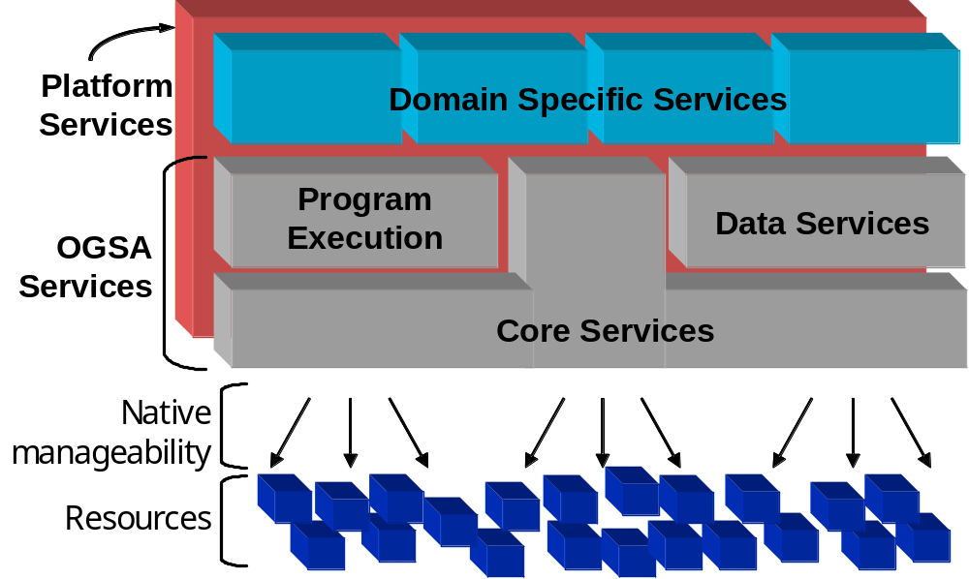
Figure 1: the OGSA taxonomy

At the resource level, the resources are managed through their native manageability interface (for resources, that is usually SNMP, CIM, or proprietary protocols). This involves monitoring (i.e., obtaining the state of the resource, which includes events), setup and control (i.e., setting the state of the resource), and discovery. This manageability may be provided by the resource itself, or by a separate means.

At the OGSA services level, many services by themselves are a form of management (e.g., the resource managers mentioned in the previous section). It is worth mentioning that while discovery appears both in the OGSA and resource levels, the activities on both levels are different. For instance, discovery at the OGSA level might involve multiple UDDI repositories containing available resources, while at the resource level it might involve scanning a network to discover the devices attached to it.

Notice that a service in the OGSA service level (including a manager) may also be a managed entity. This service will thus have a functional interface (through which the service provides its functionality) and a manageability interface (through which the service is managed).

Between the resource and the OGSA services levels there is the Platform services level. The services in this level should provide the basis for both manageability and management, linking the resource and the OGSA service levels. On manageability, it should provide:
- The base manageability model (i.e., how to show resources as services, especially OGSI services, i.e., base interface, service data, etc.)
- Basic functionality that is common to the OGSA services, e.g.:
- portTypes for common functionality (e.g., start/stop/pause/resume)
- Lifecycle representation and operations
- Relationships
On management, it should provide common functionality, such as DataManagement on the OGSA data services.

[Not clear yet how, and how much the services in the domain specific services level relate to management. Ideas?]

TBD

- Add models, both standard and Grid-specific ones. Add also resource and usage descriptions used for brokering, provisioning, billing, etc.
- How far does the OGSA-WG (or the GGF) need to define manageability of the OGSA infrastructure? E.g.: performance monitoring of a registry.
- Virtualization? We will certainly have multiple forms of it around. It might be worth writing about it to make the term more concrete.

Security Considerations

Naaaaah… [Add standard text: “security issues are orthogonal to our work, and besides that’s up to some other WG to define, therefore there’s no need to worry about it”]. Sorry, I couldn’t resist…

Author Information

Editor: Fred Maciel (fred-m@crl.hitachi.co.jp)

With contributions from Jem Treadwell, and help from Latha Srinivasan, Bryan Murray, Ravi Subramaniam, and Hiro Kishimoto.

Glossary

Recommended by not required.

Intellectual Property Statement

The GGF takes no position regarding the validity or scope of any intellectual property or other rights that might be claimed to pertain to the implementation or use of the technology described in this document or the extent to which any license under such rights might or might not be available; neither does it represent that it has made any effort to identify any such rights. Copies of claims of rights made available for publication and any assurances of licenses to be made available, or the result of an attempt made to obtain a general license or permission for the use of such proprietary rights by implementers or users of this specification can be obtained from the GGF Secretariat.

The GGF invites any interested party to bring to its attention any copyrights, patents or patent applications, or other proprietary rights which may cover technology that may be required to practice this recommendation. Please address the information to the GGF Executive Director.

Full Copyright Notice

Copyright (C) Global Grid Forum (date). All Rights Reserved.

This document and translations of it may be copied and furnished to others, and derivative works that comment on or otherwise explain it or assist in its implementation may be prepared, copied, published and distributed, in whole or in part, without restriction of any kind, provided that the above copyright notice and this paragraph are included on all such copies and derivative works. However, this document itself may not be modified in any way, such as by removing the copyright notice or references to the GGF or other organizations, except as needed for the purpose of developing Grid Recommendations in which case the procedures for copyrights defined in the GGF Document process must be followed, or as required to translate it into languages other than English.

The limited permissions granted above are perpetual and will not be revoked by the GGF or its successors or assigns.

This document and the information contained herein is provided on an "AS IS" basis and THE GLOBAL GRID FORUM DISCLAIMS ALL WARRANTIES, EXPRESS OR IMPLIED, INCLUDING BUT NOT LIMITED TO ANY WARRANTY THAT THE USE OF THE INFORMATION HEREIN WILL NOT INFRINGE ANY RIGHTS OR ANY IMPLIED WARRANTIES OF MERCHANTABILITY OR FITNESS FOR A PARTICULAR PURPOSE."

References

