ByteIO Use Cases

Status of This Memo

This memo provides information to the Grid community regarding Grid use case scenarios which include the reading and writing of a sequence of bytes. It does not define any standards or technical recommendations. Distribution is unlimited.

Copyright Notice

Copyright © Global Grid Forum (2005). All Rights Reserved.

Abstract

The OGSA Data design team has identified a need for an interface for reading and writing sequences of bytes from a variety of sources. No existing WG or standards body seems to address this need. The objective of the OGSA ByteIO working group is to define a minimal Web Service interface for this functionality. The interface should fit into the overall architecture, e.g. as regards naming. The working group will liaise with other GGF groups, especially the OGSA, GFS, GSM, DAIS, InfoD and SAGA working groups, and also with active projects such as OGSA DAI, Globus, NextGrid and WSRF.Net.

The WG will produce a use case informational document, a recommendation document and an experience document. It is expected that the use cases will include reading from and writing to a binary file, reading the results of certain DAIS queries and reading data from a sensor, among other scenarios. The intention is that existing APIs, such as the POSIX API, should map easily to the Web Service interface. The use case document should explore the use cases in sufficient detail to demonstrate that the chosen design will meet the detailed environment in which it is to be used.

Issues to be resolved by the working group will include how to interface to efficient transport mechanisms, whether to store offsets on the service or the client, and which properties the interface must expose in order for the client to make sensible decisions about the functionality available.

Contents

Abstract 1
1. Introduction 3
2. File Resources 4
2.1 Summary 4
2.2 Scenarios 4
2.3 Involved Resources 6
2.4 Functional Requirements 7
2.5 Situation Analysis 7
2.6 Security/Reliability Considerations 7
2.7 Performance Considerations 7
2.8 References 8
3. DAIS Use Case 8
3.1 Summary 8
3.2 Scenarios 8
3.3 Involved resources 10
3.4 Functional requirements 11
3.5 Situation Analysis 11
3.6 Security / Reliability Considerations 11
3.7 Performance Considerations 11
3.8 References 11
4. VizService Streams Use Case 11
4.1 Summary 11
4.2 Scenarios 11
4.3 Involved resources 12
4.4 Functional requirements 12
4.5 Situation Analysis 12
4.6 Security / Reliability Considerations 12
4.7 Performance Considerations 12
4.8 References 13
Security Considerations 14
Editor Information 14
Acknowledgements 14
Intellectual Property Statement 14
Full Copyright Notice 14
References 14

Introduction

One component of the ByteIO-WG charter is to
“produce a use case informational document. […] The use case document should explore the use cases in sufficient detail to demonstrate that the chosen design will meet the detailed environment in which it is to be used.”
This document is a collection of the use case scenarios contributed by ByteIO-WG participants or solicited from others. It should be read in association with the ByteIO interface specification documents. This document contains use cases following a template (see Appendix) which is based on the OGSA-WG use case template. Each use case will be slightly different from others in terms of level of detail and style of authoring, since each use case is contributed by a different author/entity.
Each use case starts with a ‘Summary’ description outlining the content and scope of the use case. This is followed by a section listing the different ‘scenarios’ which apply to the use case. The ‘Invloved resources’ describes the resources, their scale and geographical distribution that are provided or managed by the Grid system in this use case. The ‘Functional Requirements’ aims to draw together applicable requirements for a ByteIO use case from the use cases. The ‘situation analysis’ section covers a discussion of existing services and specifications and how they might require extension. ‘Security/Reliability Considerations and ‘Performance Considerations’ cover the primary non-functional requirements for the use case. Finally, ‘ References’ lists any pertinent references for the use case.

Table 1 lists all of the use cases presented in this document.
Table 1: Use cases and contributors in this document
Chapter | Title | Contributors
2 | File Resources | Mark Morgan
3 | Database access via DAIS | Neil Chue Hong, Mario Antonioletti
4 | Streamed resources | Pascal Kleijer, Dave Berry

File Resources

Summary

Many scientific applications in production and research tracts rely heavily on flat file data availability. In the medical research field, numerous protein sequence databases are freely and publicly available as flat file downloads from FTP sites. Likewise, satellite image data for tornado prediction and weather prediction all exist as flat file data that applications need to have raw, direct access to, or need to either stage in and out. While a data staging solution is appropriate for some applications, it is not necessarily appropriate for every problem, nor is it necessary to force complete file staging on applications which require only small pieces of available file information. This use case looks at ByteIO from the point of view of flat file data stored on a disk somewhere in the grid which needs to be accessed by a remote service of some kind.

Scenarios

For the purposes of this use case, we will list three distinct use cases. The first is the case where some software client wishes to read and write blocks of data to and from a remote file. This client is fully aware of the distributed nature of the ByteIO endpoint with which it is involved and can take advantage of that knowledge. The second use case is the case where the interaction is being initiated by a client which is unaware of the grid aspect involved. As far as this legacy client is concerned, the file resides locally on its own machine and the data is access transparently while a backend service handles the details. The final use case involves a third party “wrapper” endpoint which can be created to facilitate a more stream-oriented file access pattern rather than a ByteIO block pattern.

One important note to make about all of these use cases is that while they are written from a “read” point of view, they apply equally well and transparently for the write case as well. Client-side libraries may have to make more careful decisions regarding caching, but this is mostly a client-side implementation detail rather than an issue for the use case.

Grid-Aware ByteIO Access

For the Grid-Aware ByteIO access pattern, we assume that a client has been written which is able to speak with ByteIO endpoints in their native language (i.e., through well defined and well known WSDL interfaces).

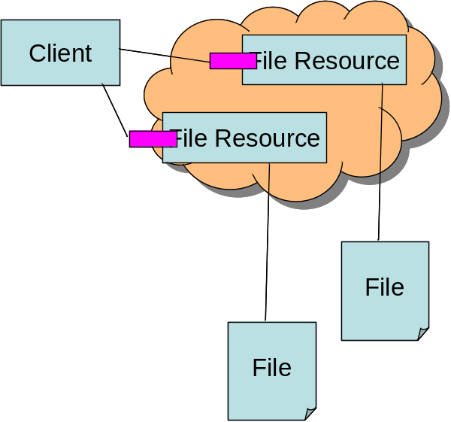

Imagine a client application which has been specifically designed to read blocks of data directly from ByteIO endpoints. Such a client could potentially take tremendous advantage of its application domain and the distributed nature of the file system it is accessing to improve performance drastically. For example, such a client could asynchronously begin reception of required blocks of file data while simultaneously beginning computation on those blocks of data which have already arrived. Further, a client which was writing back large blocks of data to the back end resource could also asynchronously begin transmitting blocks of the data without necessarily proceeding in lock-step. Another advantage to a grid aware ByteIO client is the ability to take advantage of grid specific mechanisms that may not be in place in a local file system such as asynchronous notification of content changes, metadata describing properties of the ByteIO endpoints such as read-only attributes and consistency window attributes, etc.

NFS or CIFS Server

Another interesting use case with the ByteIO access to remote files is that of legacy applications accessing the endpoints without necessarily being aware of the grid nature of the underlying data source. Previous grid systems such as the Avaki Data Grid and the Legion system have implemented such interfaces to great advantage and results have shown that various optimizations including pre-fetching, caching, and replication can lead to tremendous performance benefits [ADG Performance Results].

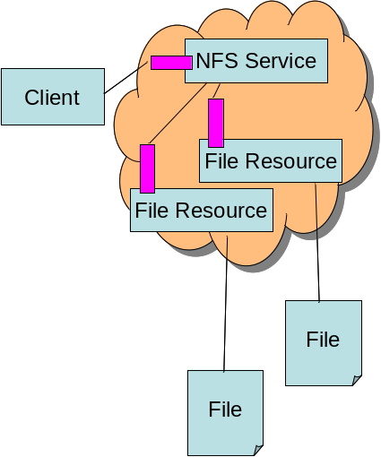

This particular use case is worth mentioning due to its overwhelming applicability to legacy applications like BLAST. Further, from a human interface perspective, users appreciate being able to use tools that they are familiar with to perform simple tasks such as browsing, configuration, etc. The distributed nature of a ByteIO endpoint should not prevent users from the access that they are used to and NFS and CIFS are perfect ways to allow them manipulate and monitor grid files. Despite the differences from the client’s perspective between this use case and the previous one (2.2.1), in the limit this is merely a specialization on the Grid-Aware access pattern where the NFS or CIFS service acts as an intermediary between the ultimate client, and the backend ByteIO endpoints.

Stream-Oriented Access

The last use case scenario deals with the case where a client of some kind wishes to access a remote ByteIO endpoint in a grid aware way, but without fetching blocks of data in a random fashion. In particular, this client wishes instead for the data to be streamed back down to it sequentially. Again, as with the NFS/CIFS server example, this is not truly a distinct use case from the first one, but rather a specialization where an intermediary service (which becomes the client from scenario 2.2.1) acts as a proxy between the ultimate client and the ByteIO endpoint. In this case, the intermediary service endpoint wraps the ByteIO endpoints in a stream oriented façade, giving the illusion to the client that the access is sequentially streamed down to him/her without requiring that the ultimate source of the data be an endpoint type other then ByteIO. Because of the streaming, sequential nature of this access, various optimizations can be implemented in the service wrapper to pre-fetch imminent blocks of data for the client.

Involved Resources

Due to the extreme simplicity of the ByteIO interface, few if any external resources need to be involved. However, it is worth mentioning a couple of endpoint types that, if not directly involved, at least are important players in the data access game.

RNS and WS-Naming both play in important role in basic file access, not so much from the point of view of access to data, but rather to the hierarchical structure that they can lend to grid endpoints. Because RNS and WS-Naming allow human readable names to be associated with various grid resources, it clearly plays a role in also allowing for a more “file-system-like” view to be mapped on to the ByteIO endpoints. In particular, in the case where the client is interacting with an NFS/CIFS service, RNS and WS-Naming provide the basis on which directories and folders can be built. In this sense, RNS and WS-Naming combined with ByteIO might act very much like the /proc file system on some Unix systems.

Another important grid resource which should be kept in mind when thinking of ByteIO use cases is the stream-oriented wrapper service described in 2.2.3. This service is not strictly part of the ByteIO interface or specification, but rather is an important example of wrapping ByteIO endpoints with additional, or specialized functionality.

Functional Requirements

The functional parts that make up this particular use case include the ability to efficiently transfer blocks of data (possibly sequentially ordered and possibly randomly ordered) between various endpoints in a grid. These endpoints may or may not all be grid endpoints and it should be possible to access a ByteIO endpoint regardless of the relative geographic and topographic locations of the various participants. While it isn’t required (nor expected) that the data and control channels for ByteIO resources be the same, whatever solutions for the control channels that allow for NAT and firewall traversal should be applicable to the data transfer channels. Further, security must be considered as well for this data channel.

NFS/CIFS-like access to these ByteIO endpoints will play an increasingly important role in the adoptability of grids in the future. Users are often more willing to adopt grid solutions when access to those solutions is transparent to them, and legacy applications remain a significant part of the scientific computing arena. To facilitate this type of access to distributed ByteIO resources, RNS and WS-Naming are essential and must be available on a similar time frame to the ByteIO outputs.

Situation Analysis

It’s quite likely that a number of independent scenarios will build on the ones outlined here. In particular, ByteIO is likely to be far more of a low level interface then many of the other OGSA working group scenarios. I envision ByteIO playing almost a pure interface role in the grid. One that can be applied to any number of services (schedulers, service containers, user authentication objects, etc). In much the same way as the /proc filesystem on some Unix operating systems provides textual interaction with various OS components, so ByteIO will provide the same types of interactions with various grid components.

Some examples of external scenarios that may make use of ByteIO include:
- A stream-like resource being created which will wrap ByteIO sources to provide a more session-like interaction for a client.
- A “locking” resource being used in conjunction with ByteIO resources in order to provide a common advisory locking mechanism.

Security/Reliability Considerations

The control channels for the ByteIO interface is expected to utilize whatever security mechanisms become popular in the OGSA Basic Profiles. Beyond that assumption, security as it relates to ByteIO seems largely out of scope for this document. However, an important caveat is that, while it is not unexpected that the data channels will be separated from the control channels (for performance reasons), any security applied to the control channels should likewise be applicable to the data channels where such a policy makes sense. For example, clients should be able to require that the data channels be encrypted or signed and likewise the ByteIO endpoints should be flexible enough to support those security policies as well as the more preferment, clear accesses which are possible.

Performance Considerations

Performance is of the utmost importance in the ByteIO use cases. Applications wishing to transport large amounts of ByteIO data will have more stringent performance requirements then other grid services typically indicate. In order to be effective, it must be the case that ByteIO performance is competitive with complete file staging in the cases where a ByteIO access pattern makes logical sense.

References

- H. Huang, and A. S. Grimshaw. "Grid-Based File Access: The Avaki I/O Model Performance Profile,” Computer Science Technical Report, University of Virginia, CS-2004-25, September, 2004

DAIS Use Case

Summary

Many applications (both scientific and commercial) rely on data available in databases. For instance, data warehousing can be used to bring together customer information from several sources to carry out data mining. Experimental data can be cross-referenced with citation databases to determine patterns of results. The DAIS WG is defining interfaces [1] for interacting with databases and, more generally, structured data resources. Asynchronous querying and integration of data services often requires a means of allowing clients and services to read bytes. This use case looks at ByteIO from the point of view of access to data services which expose structured data as data resources on the grid

Scenarios

For the purposes of this use case, we will list three distinct use cases. The first is the case where some software client queries a grid data service, which also implements a ByteIO interface as well as the DAIS interface, and gets back the result via some asynchronous method, i.e. not in the SOAP response. wishes to read and write blocks of data to and from a remote file. The second use case turns things around and instead of pulling data from a service, gives the example of an insert operation into a data resource where the service may pull bytes from the client, or the client push bytes to the service. The final use case describes an example of a copy operation involving two services which combines elements of the first two use cases, into a pattern which does not require explicit coordination from the client.

Asynchronous Query

In a simple asynchronous query, the consumer (client) issues a query to the data service which in turn queries the data resource it represents and returns the results to the consumer. One way of doing this is to define an interface which allows the results to be read as chunks of bytes from a buffer on the data service. This allows the consumer to access the data in their own time.
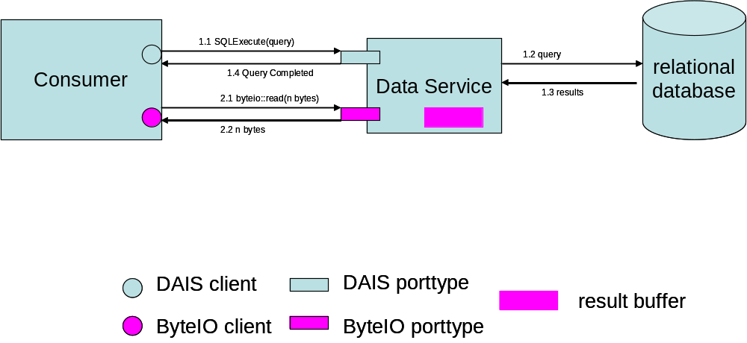

The DAIS use cases also discuss the possibility of creating a Result Set Data Service which would be a special instance of a data service which would hold the data from the query for future use. This allows the original data service to continue serving queries, and not worry about holding the results for a possibly unknown length of time.

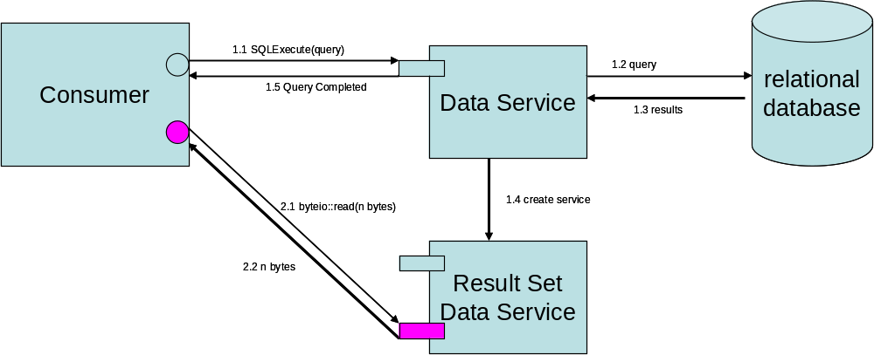

Insert

In an insert operation, the consumer (client) issues an insert statement to the data service which in turn inserts information into the data resource it represents. To get the data to the data service to be inserted, it could be supplied in the body of the SOAP message via the DAIS interface, but for large amounts, it would be better to use a lightweight interface to push bytes to the service. Here the only issue is identifying when all the data has been received.

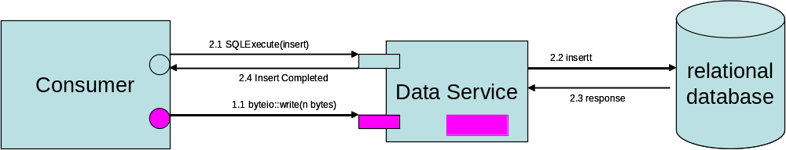

A more complex insert operation might involve the data to be inserted being sourced from a third party provider. This could be done in a similar fashion to the diagram above. In this case, the main issue is understanding how the provider can locate the data service and prove to the data service that it is authorized to push bytes into the buffer. Another scenario is that the data service itself pulls the data from another source, as shown in the diagram below.

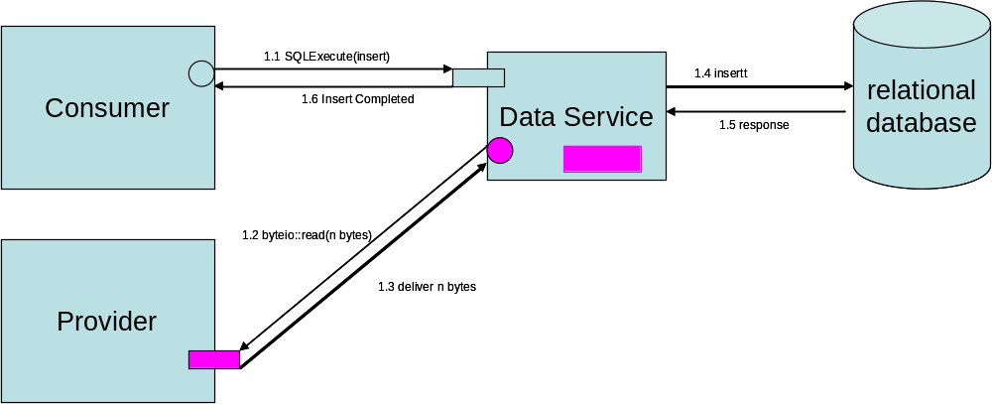

Copy

The final scenario incorporates elements of the previous two scenarios to represent a copy operation between two data resources, initiated by a client, but coordinated by the data services themselves. This has potential issues with delegation of credentials if authorization is required.

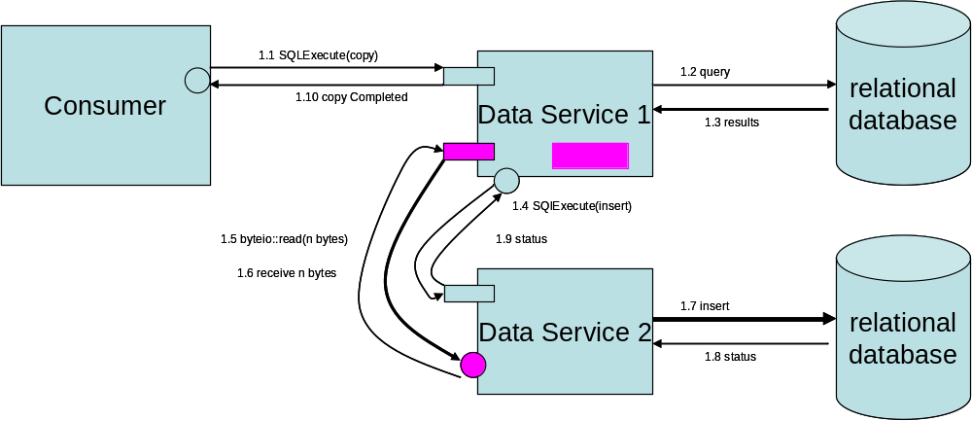

Involved resources

Few external resources, in addition to ByteIO and DAIS, are involved. However there are some elements which may be required in some implementations of the scenarios.

It is necessary to have some sort of naming scheme and service to identify data sets and also ongoing operations. Authentication and authorization mechanisms may also be necessary to ensure data security at a level above the ByteIO interface.

Functional requirements

Functional requirements include the ability to efficiently transfer data between endpoints. It may also be necessary to allow many-to-one patterns such that data can be delivered from a variety of providers and assimilated by a single sink. Authentication and authorization are important, as it will be necessary at some level to identify the “owner” of a transfer. If this interface can be used to effectively hide lower level implementations and provide a simple interface for transfer, it will be useful in many DAIS situations.

Situation Analysis

To be added.

Security / Reliability Considerations

To be added.

Performance Considerations

To be added.

References

[1] DAIS-WG, WS-DAI Specification, http://forge.gridforum.org/projects/dais-wg

VizService Streams Use Case

Summary

A Visualisation Service for the Grid Use Case [1] has been defined as part of the SAGA groups efforts, from work done in the NAREGI (National Research Grid Initiative) framework. The goal of the project is to provide a Grid Service Framework for Massive Data Visualization of various simulations' types, including coupled simulations.

Most simulations in any scientific fields can never accomplish their purpose without visualization (either concurrently or in post-processing), which enables researchers to observe and analyze their unrecognizable numerical results.

The ViZService aims to define and API which serves to connect two remote systems client and server by the grid medium and offers the client a set of tools to perform visualization of large-scale simulations. The visualization is based on images transferred from the server to the client and visualization controls sent by the client to the server. Additional features such as Tracking/Steering may also be included in the future.

Scenarios

To help understand the following scenario some terms are defined:

- Server: A visualization capable solver, data-mining program, third party application, etc. running on a grid resource.
- Service provider: A grid service or any program that interface the client and server. The provider can run on a different resource as both server and client, it can also be part of the server application.
- Client: The visualization application running on the user's local computer.

We assume that we have already located a resource to host a simulation (with visualization capability). This should be done automatically based on the nature of the simulation the user is preparing. The simulation server is launched on the resource, and a set of visualization control commands are sent.

As a result of this, the client receives a sequence of images back via some streaming interface. This sequence may be played immediately, or stored on a remote resource. The set of images may change as a result of steering, however the stream between the server and client does not change, only the contents of the stream.

Involved resources

The software is currently using Unicore and/or Globus as middleware. Later, any OGSA or WSRF implementation will do. The server utilizes an HPC system (not necessarily a dedicated visualization device). The resources may be geographically distributed. Many tasks may be executing at the same time – in the case of coupled simulations the interactions between the different tasks can be quite complex.

A registry is required that allows the components of the system to find each other. We would like to use registries such as GIIS or UDDI for resource discovery, but own registry usage is also possible. This will depend on the deployment environment.

Functional requirements

To be added.

Situation Analysis

Simulation servers are generally written in FORTRAN or C. The visualization library has bindings in FORTRAN and C. The Grid Service wrappers can be written in Java, C/C++ depending on the application wrapped. Most likely target will be the same as the simulation/visualization servers. This may cause difficulties with creating stream interfaces, however it is expected that the client side will be Java based.

Security / Reliability Considerations

The information transmitted on the grid by each peer is on most cases highly sensitive. The middleware (communication layer) must ensure tight security. For the moment we exclusively rely on the UNICORE or Globus kits. For the setup phase we require authentication and authorization; during runtime we require encryption of the data streams.

Another thing which is important is a facility to detect and restore communication if the stream falls down. The model for the ByteIO interface should be designed so that when someone can add a reliable (automatic reconnection) layer on top it without too much hassle.

Performance Considerations

The interface must be capable of streaming images at a rate of at least 1 frame per second. This will depend on the size of the images, and the protocol using to stream (this will be transparent to the interface, which sees only bytes).

The second important matter is the network latency, the faster the response the better. Network capacity is dependent on the resolution of the image the user wants, not on the size of the problem to simulate.

References

[1] Pascal Kleijer, Eiichi Nakano, Toshifumi Takei, Hiroshi Takahara, Arihiro Yoshida: "API for Grid Based Visualization Systems" GGF 12 Workshop on Grid Application Programming Interfaces.

Security Considerations
This document is informational, and does not contain recommendations. Security considerations are noted in individual use case sections.

Editor Information
Neil Chue Hong, EPCC, University of Edinburgh, JCMB, Mayfield Road, Edinburgh, EH9 3JZ, UK
Phone: +44-131-650-5957, Email: N.ChueHong@epcc.ed.ac.uk

Acknowledgements
This work was supported in part by the UK eScience Grid Core Programme.

Intellectual Property Statement
The GGF takes no position regarding the validity or scope of any intellectual property or other rights that might be claimed to pertain to the implementation or use of the technology described in this document or the extent to which any license under such rights might or might not be available; neither does it represent that it has made any effort to identify any such rights. Copies of claims of rights made available for publication and any assurances of licenses to be made available, or the result of an attempt made to obtain a general license or permission for the use of such proprietary rights by implementers or users of this specification can be obtained from the GGF Secretariat.

The GGF invites any interested party to bring to its attention any copyrights, patents or patent applications, or other proprietary rights which may cover technology that may be required to practice this recommendation. Please address the information to the GGF Executive Director.

Full Copyright Notice

Copyright (C) Global Grid Forum (2005). All Rights Reserved.

This document and translations of it may be copied and furnished to others, and derivative works that comment on or otherwise explain it or assist in its implementation may be prepared, copied, published and distributed, in whole or in part, without restriction of any kind, provided that the above copyright notice and this paragraph are included on all such copies and derivative works. However, this document itself may not be modified in any way, such as by removing the copyright notice or references to the GGF or other organizations, except as needed for the purpose of developing Grid Recommendations in which case the procedures for copyrights defined in the GGF Document process must be followed, or as required to translate it into languages other than English.

The limited permissions granted above are perpetual and will not be revoked by the GGF or its successors or assigns.

This document and the information contained herein is provided on an "AS IS" basis and THE GLOBAL GRID FORUM DISCLAIMS ALL WARRANTIES, EXPRESS OR IMPLIED, INCLUDING BUT NOT LIMITED TO ANY WARRANTY THAT THE USE OF THE INFORMATION HEREIN WILL NOT INFRINGE ANY RIGHTS OR ANY IMPLIED WARRANTIES OF MERCHANTABILITY OR FITNESS FOR A PARTICULAR PURPOSE."

References
Please refer to references in each individual use case section.

