Interoperation of Resource Information Schema and Services (DRAFT)
Yuji Saeki and Satoshi Matsuoka
The NAREGI Project

The ability to efficiently access and manipulate information about applications, resources and services in the grid environment is an important capability in the execution management service which allocates appropriate resources and schedules for various users’ jobs or workflows according to their requirements, where information services are utilized to discover the appropriate resources. If resources available in grid systems are to be discovered for subsequent management or use, they must be described in a precise and systematic manner among information consumers and resource providers according to some schema or information model for abstraction and representation of heterogeneous entities in a managed environment. Most of the represented production grid projects today use some form of the GLUE schema for historical reasons. The GLUE schema is the result of a collaboration effort started in April 2002 by the EU-DataTAG and US-iVDGL projects and EGEE, LCG, Grid3/OSG, Globus and NorduGrid are now participating in this activity. It models information about site, service, cluster and storage resources associated with one another. It presents the data model that is mapping in the form of LDAP and XML schema as well as graphical rendering using UML class diagram and textual language definition to represent the model.
In order to make ease of monitoring and managing resources produced by different venders with increasingly complicated system configuration, it is valuable to abstract and represent broader range of entities than GLUE schema does and define manageability interface, which can have many implementations and be mapped to different protocols. A representative of developments in these activities is CIM schema being specified by DMTF. CIM schema is an object-oriented information model defining management information about system, network, application, service and so on with UML class diagram and textual MOF files including verbal description of each class and property. DMTF is starting to work closely with the grid community through its alliance with GGF taking into account industrial grids as well as scientific grids. OGSA-WG would side with CIM schema because of its extensibility, potential for wide coverage of requirements, implementation options of manageability, reusability of existing work and expertness of DMTF for resource modeling. Some newer major Grid projects such as NAREGI are adopting CIM schema as the resource model to be compliant with such major industrial efforts.
In the near term (2006) it might be appropriate to pick a monitoring tool (mds4 could do this) and have a set of sites all communicate some minimal set of data (a simple subset of GLUE schema) picked from schemas the sites want to use, where some schema-neutral temporary exchange language should be applied. A set of attributes to start with, for example, would be the 20-ish TG is now advertising - very basic cluster and queue data and the monitoring tool could show which sites are up, defining some basic up-down tests deployed in the sites. And then it might bring a translational function in different implementations of Information Services according to mapping data between GLUE schema and CIM schema. A viable action item is to investigate the relationships as learned from the GLUE and CIM experiences, and how that can be expressed in terms of industrial standards that are set on CIM. There have been some precedent works in the UK looking at the difference at the Schema level. Based on such work, translational function in different implementations of Information Services according to mapping data between GLUE schema and CIM schema could be devised. Information service in grid A accesses to interface of another information service to retrieve resource information in grid B and the form of information is translated according to resource information schema in grid A so that the clients could retrieve resource information in grid B through interface of information service in grid A.
For example, for 2006 NAREGI plans to enhance its CIM based information service so that the clients could retrieve resource information managed by Globus or G-Lite with a translational function from GLUE schema to CIM schema in terms of the minimal set of attributes (Figure 1) and demonstrate a capability of resource selection among multiple of grids at SC06. Once this is achieved, the following would be achieved: NAREGI has developed a light-weight CIMOM (CIM Object Manager) service which collects and classifies resource information represented as CIM objects according to experimentally extended CIM schema to be applicable to grid. Information provider programs managed by the light-weight CIMOM service output resource information in the form of CIM/XML format specified by DMTF; the aggregated information is accumulated into distributed RDB to archive logs and accounting information. The clients can retrieve resource information through OGSA-DAI interface and give SQL queries to OGSA-DAI Data Service with Java-API via client library utilizing the OGSA-DAI client toolkit. With the “GLUE information providers” which accesses to retrieval interface of Globus/MDS and G-Lite/R-GMA to take the contents and translates it to CIM objects according to mapping data between GLUE schema and CIM schema to push them into the distributed RDB, the clients could retrieve information mapped to CIM based schema about resources managed by Globus and G-Lite through NAREGI/OGSA-DAI client interface. Translation from CIM schema to GLUE schema would be possible in a similar way.
In long term the profile of resource information model should be specified with full schema agreement within GGF as such difference in the contents of information services among multiple grids would diminish. Standardization of interface of OGSA information services would lead various types of implementations to be compatible or compensated with one another, where the abstract information model is mapped to data models like RDB and XML schema based on some rules and interface to publish and consume information is implemented using vocabularies and languages consistent with the data models, as exemplified by the OGSA CIM profile effort. GGF discusses objectives, scenarios, models, patterns, functional capabilities and properties of OGSA information services which are built on top of OGSA infrastructure capabilities such as WS-Notification and satisfied with a variety of requirements for reliability, security, and performance.
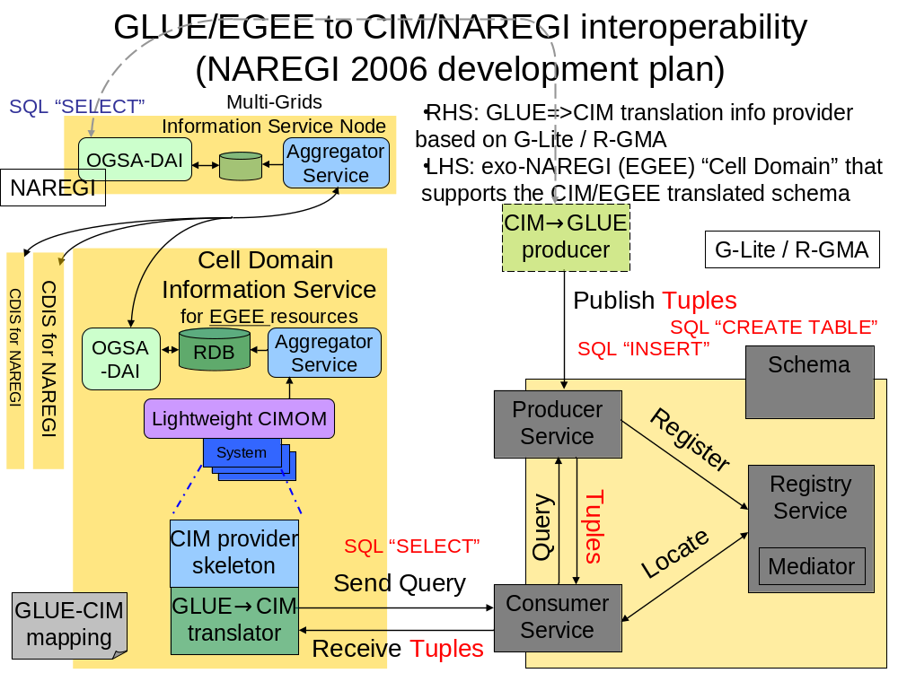Figure 1

