Service Level Attainment Loop
Provisioning in a Grid system is the process of scheduling and allocating sufficient Grid resources and then deploying and configuring those resources. The provisioning process is carried out in support of executing an activity or function or providing a capability of some sort. It is triggered by other entities in the Grid. Examples include, job submission, activity control loops, query processing, nested requests of the provisioning process itself, etc.
Provisioning encompasses the following activities:
- Receiving the resource requirements.
- Scheduling the resources from an available (space-time) pool some time prior to the start of the activity.
- Allocating the specific set of resources to be used when the activity starts.
- Creating (if necessary), deploying, and configuring the resources after they have been allocated
- Making sure that the resources are in a ready state for the activity to start, including starting executable resources so they are running before the activity starts.
Unprovisioning is the process opposite to provisioning and encompasses the following activities:
- Stopping the resources, that is bringing the resources to the state that they are no longer used by the activity
- Un-deploying the resources of all deployed contents (binary or data)
- De-allocating the resources
- Releasing unused resources to the resource pool for use in subsequent scheduling activities.
Grid resources include hardware (for example processors, memory, storage and networking resources), software (for example applications, data and any applicable licenses), Grid services (upon which the requesting Grid service depends) and other configurable entities (for example user accounts, expert support teams, etc.).
Operating outside the provisioning process and employing it, the service level attainment activity ensures that a Grid service maintains a specified QoS. It is an instance of a generic control loop pattern that may be used to control and adjust various system activities. The service level attainment activity is a cycle consisting of the following phases.
- Analysis and Projection:
Analyze information such as overall resource utilization and information acquired in the Execution and Monitoring phase to estimate future resource requirements. This is the initial step when a new service’s requirements are examined. The information from this step is used as input to the Provisioning phase.
- Provisioning, unprovisioning, or adjustment
Allocate appropriate resources to the service, based on the estimated utilization of resources, resource allocation requests from the IT business activity managers, and resource allocation policy of the Grid administrator.
For each of the allocated resources, the Grid system prepares the environment required for running the service. For example, installation and configuration of OS and middleware, and deployment and configuration of programs and data required for running the service. When the resources are no longer needed they are unprovisioned. (TBD: Adjust configuration)
- Execution and Monitoring:
Service execution and monitoring of resource utilization, for example, monitoring the load and utilization of resources, the running states of service components, and detecting faults. Such information is used as input to the Analysis phase.
Service level attainment may apply to multiple Grid services simultaneously and thus analysis and projection, provisioning, unprovisioning, adjustment, and execution and monitoring may all occur concurrently in a given Grid system.
Figure 1: Service Level Attainment Loop
Analysis and Projection
Execution and Monitoring
Allocating
Deploying
Releasing
Scheduling
Provisioning
Service level attainment loop
Unprovisioning
Stopping
CDDLM Lifecycle management from here…?

…CDDLM Lifecycle management to here?

Overlap with CDDLM Lifecycle Management?
Matches CDDLM Deployment?
Provisioning
Starting
Undeploying
Deallocating
Adjusting

Provisioning activities may be carried out at different levels. Activity details may depend on the level on which they are carried out:
- Job Level:
Provisioning when executing a job may be performed automatically or by the IT business activity manager as part of job management. It includes the case of initial job provisioning, provisioning due to changes in execution environment or due to load balancing.
- Grid System Level:
Provisioning performed for the whole Grid system, possibly by the Grid administrator. It includes adding or removing resources due to events external to the system (such as rapid increase or decrease of the number of users) or internal events (such as failure of a resource, performance bottlenecks). Resources can also be added or removed at any time. Provisioning at this level can affect multiple jobs running on the Grid system.

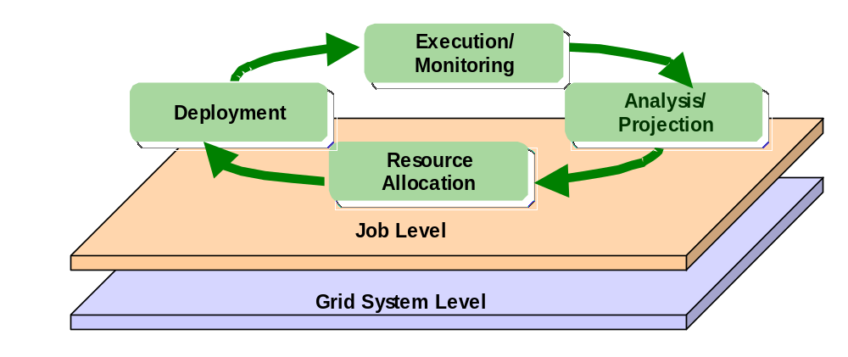Figure 2: Provisioning Cycle and Layers

Job Level Loop
The service level attainment activity ensures that a Grid service maintains a specified QoS. The QoS required for executing a job is described in an agreement created when the IT business activity manager submits the job. The job must be executed so that it satisfies the agreement.
In the service level attainment loop, the provisioning steps are triggered as a result of changing conditions such as submitting new jobs or updating agreements by IT business activity managers, increasing workloads, detecting faults on provisioned resources and so on. Here we explain how OGSA services collaborate to perform the service level attainment loop in case changing and not changing agreements.

Scenario I : IT business activity managers trigger the provisioning steps by creating or changing agreements.
An IT business activity manager submits a job to the Job Manager and the Job Manager creates an agreement after negotiation. At the later stage, the IT business activity manager may re-negotiate with the Job Manager to update the existing agreement. For example, the IT business activity manager may determine to reduce the number of servers for the actual load is less than expected, or there may be any matter of business to change the requirements for executing the job.
When the agreements is created or updated the Execution Planning Service allocates or re-allocates resources for the job based on the agreement. In this step, the Candidate Set Generator selects candidate sets of available and suitable resources referring to the information held by Grid Resource Information Service Reservation Service, and provides them to the Execution Planning Service.
If a specific type of resource is not available in current resource pool the Grid system may trigger new provisioning step to create the required grid resources including OS, network, and middleware, etc. That is a case when an IT business activity manager request to execute a job on a linux server but there is no resource lebeled "linux" left. The Deployment Service unprovisions some resources labeled "windows" and installs and configures linux OS on them.
The Deployment Service is started at the scheduled time by the Job Manager. The Deployment Service prepares the environment required for running the job by installing and configuring the resources, loading application programs and data on the resources, and configuring application. After the provisioning step, it is assumed that the resources are in a ready state for the job to start, including starting executable resources such as application server or DBMS. When the resources are no longer needed after job execution the Deployment service clears all of the deployed contents.
The job is started and stopped by the Job Manager. The IT business activity manager can monitor the load and resource utilization of the provisioned resources using the Monitoring Service or the Metering Service. The IT business activity manager also can obtain the state of running job from the Job Manager.

Scenario II : Grid system triggers the provisioning steps without changing agreements.
n the Analysis and Projection phase, a Projection Service analyses information such as the amount of resource usage of the job or states of the job and the provisioned resources acquired in the Execution and Monitoring phase to estimate future resource requirements for satisfying the agreement. When the Projection Service determines from the outcome of the analysis that it will fail to maintain the agreement in the present condition, it takes appropriate actions. For example, the Projection Service may ask the Execution Planning Service to allocate additional web servers to the web application job if requests to the web application increase so much that it cannot process the required amount of transactions. Or it may ask the Deployment Service to adjust the CPU resource control so that the batch job can complete its task before specified time.
Once the resource requirements for executing the job are determined, the provisioning steps follow as same as scenario I. The Execution Planning Service re-schedules and re-allocates appropriate resources to the job in cooperation with the Candidate Set Generator, the Grid Resource Information Service, the Reservation Service and so on. Then the Deployment Service configures the allocated resources and deploys the application contents required for running the job.
In the Executing and Monitoring phase, also as same as scenario I, the Monitoring Service and the Metering Service measures the load and utilization of resources and the Job Manager monitors the running state of the job. Such information is used as input to the Projection Service.
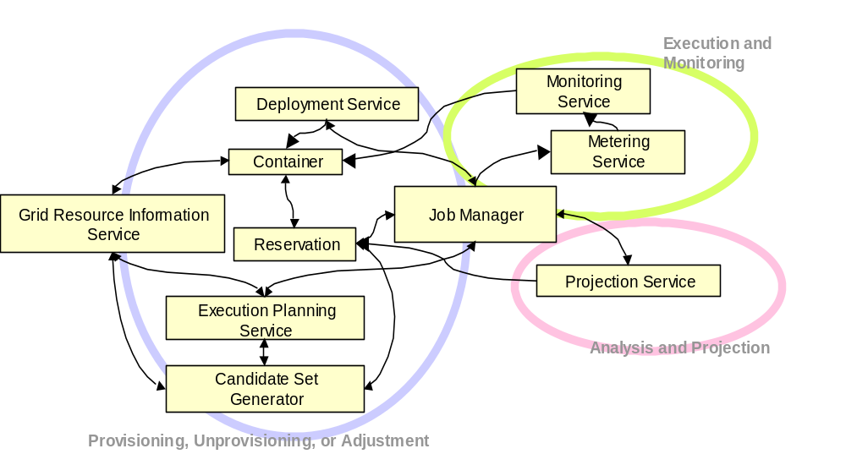 Figure 2: Service Relationship (Job Level)

Grid System Level Loop
The main purpose of SLA loop at the Grid System level is to improve resource utilization and aid administration of a Grid system, while maintaining the QoS of running jobs. The Grid administrator manages resource configuration of the whole Grid system by adding new resources to the system, releasing surplus resources, and suspending resources temporarily for maintenance, etc. The administrator also configures policy, e.g, by setting priorities and constraints, so that resources are allocated appropriately. .Moreover, the administrator may change the amount of resources allocated to a running or reserved job.
Information about resources in the Grid system and the relationship between them are registered in the Grid Resource Information Service. Such information is used by the Execution Planning Service and Candidate Container Set Generator to allocate resources.
In the Analysis and Projection phase, the Projection Service or the Grid administrator evaluates the available resources and determines the location of problems such as load imbalance based on the resource information from Grid Resource Information Service and Reservation Service, as well as estimates the future utilization of resources and plans resource allocation.
In the Provisioning phase, resource allocation policy is defined based on the resource allocation plan and notified to the Execution Planning Service. The Execution Planning Service allocates resources for a job based on this policy.
At Grid System level, the addition/removal of resources to/from a Grid system is also included in the Provisioning phase. The Grid administrator physically installs the hardware and configures basic software required to make the Grid system aware of the new hardware. After that, the Grid Resource Information Service is updated manually or automatically. Another scenario may be taken into consideration where resources are added to or removed from a job, or are rent from another Grid system (TBD).
In the Execution and Monitoring phase, the Monitoring Service retrieves resource utilization information from the system and registers it to the Grid Resource Information Service. Other information such as fault events is registered in the Grid Resource Information Service, as well as notified to the Grid administrator. Static or dynamic resource information can be retrieved by inquiring the Grid Resource Information Service.

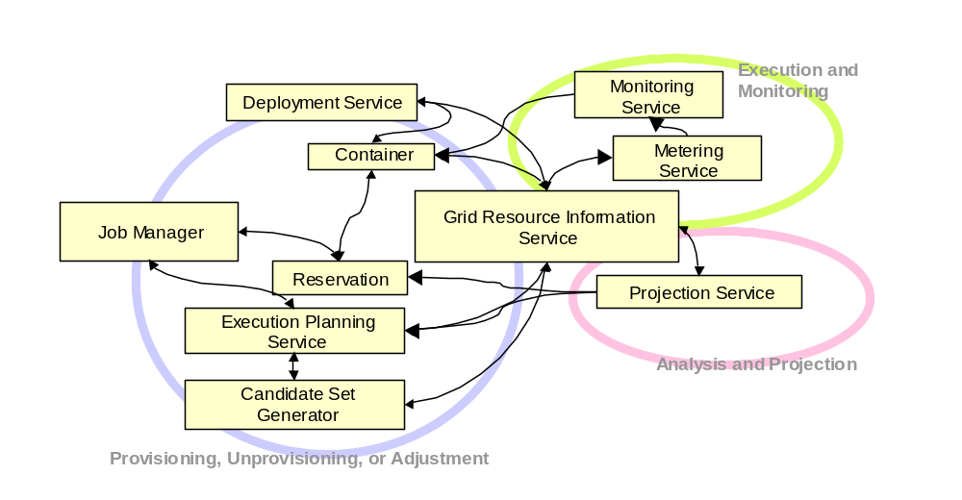 Figure 3: Service Relationship (Grid System Level)

