On line Processing in Experimental Science

General Information on the application
Contributor: Roberto Pugliese (Sincrotrone Trieste S.C.p.A.)

Summary
Experimental stations in facilities like Synchrotrons and Free Electron Lasers produce huge quantities of data. These data need to be analyzed on-line, which requires considerable computing power and often teamwork. The problem is even more difficult considering the increased efficiency of the light sources and detectors. Complex calculations are required to take diffraction images and convert them in a 3D protein structure. Similarly, complex calculations are required to calculate tomography and then perform an analysis of the result.
The results of these analyses often need to be visualized by a distributed team and used to modify interactively the data collection strategy. Data from instruments and sensors are saved in distributed repositories, computational models are executed, and finally an interactive data mining process is used to extract useful knowledge.
This kind of application requires both the support of a standard Grid computing environment, that is a virtual organization, a set of distributed storage and computing resources and some resource brokering mechanism, a workflow definition and execution environment and the capability to integrate instruments (the detectors) and interactively collaborate in the data analysis process. QoS handling mechanism is necessary to use effectively the available network structure.
This application can be considered actually as a group of applications since each beamline and experimental station represents a completely different data collection process, with specific processing, storage, analysis and sharing and visualization requirements.

Customers
The beamline scientist and experimental scientist working at these research laboratories, the users of the laboratory beamlines, remote collaborators.

Scenarios
Actors involved in this use case are software developers, beamline scientists, and users of the experimental stations. The developers can perform all the activities of the scientists and also deploy software and define the collective behavior (workflows and scripts). The beamline scientist can perform all the activities of the users plus control the beamline instrumentation and the detectors. The user can access and visualize data even remotely, collaborate with other users, beamline scientists and developers, define the data collection strategy, start stop data acquisition and monitor the acquisition and online processing process. The user can also run scripts and workflows and monitor their execution and perform offline processing of the available data.
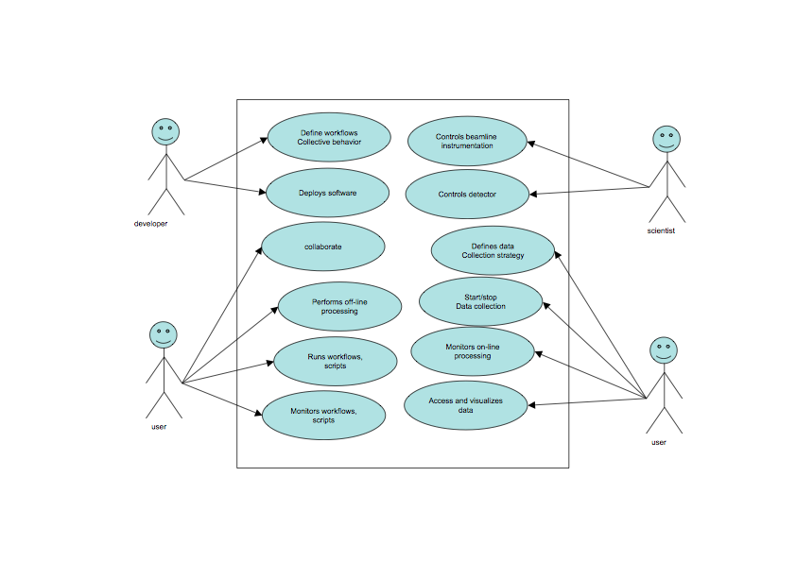

Involved resources
The resources involved in the online processing related to experimental science are instruments, sensors and detectors (for example X-Ray Diffraction detectors, and other Imaging Detectors mounted beamlines and experimental stations). These are the data sources and we will refer to them as Instrument Elements (IE) from now on. These IE are generally co-located but sometimes can be distributed geographically (e.g. antennas of a radio telescope).
Data acquired need to be stored in Storage Resources and processed by Computing Resources. We will refer to them respectively as Storage Elements (SE) and Computing Elements (CE).
Brokers of resources both storage and computing and other support systems (information, security, …) are also involved.
User interacts with the involved resources and collaborates with the other users via User Interaction Elements. These components are generally web portals and we will refer to them as Virtual Control Rooms.

Functional requirements
Incl. quality control / validation of data
The following diagram describes how these components interact during a typical workflow of the online processing in experimental science.
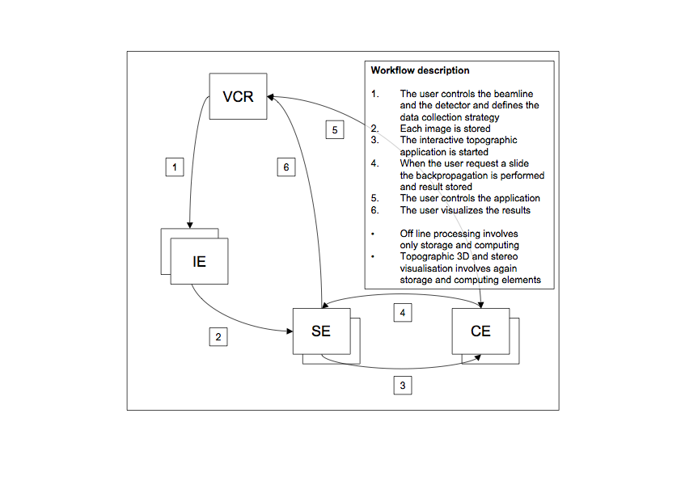

Non-functional requirements
An appropriate AAA-mechanism is required. Normal VO management systems can solve the problem.
The online processing requires adequate quality of service and performance on the whole pipeline from instrument control, to data acquisition, transfer to storage resources, fast computation and data transfer back to storage and visualization to the end user. Interactivity is also required both at when interacting with instruments and during job execution and finally when visualizing the results.

Related work / Experience in the field
Even if some form of remote operations was implemented using different middleware (GRIDCC and CIMA), online processing can be considered quite new. It includes some form of remote operations but is demanding in terms of resource interaction and transparence to the end user.

Use case situation analysis
These use case and the required support is under development at Sincrotrone Trieste S.C.p.A. within the EC funded project DORII (Deployment of Remote Instrumentation Infrastructure).

References
www.gridcc.org
www.dorii.eu
www.lkightsources.org

