Remote Operations of Experimental Facilities

General Information on the application
Contributor: Roberto Pugliese (Sincrotrone Trieste S.C.p.A.)

Summary
Remote operations of experimental facilities like Accelerators, Synchrotrons and Free Electron Lasers, but also experimental stations, involve planning of the operations, maintenance and troubleshooting, repair of delicate equipment, understanding and pushing performance limitations, performing commissioning and set ups and various routine operations. All these activities are based on large amounts of information, normally accessible only at the site where the facility is located.
Operators of the experimental setup and remote experts through a Virtual Control Room can collaboratively operate the experimental setup both in a routine and in a troubleshooting scenario.
All the high level software and workflows is suitable to be implemented using Grid technologies. One example is the implementation of feedback workflows where a high level of integration of instruments and traditional Grid resources is required.
In the feedback parameters of the setup are sent via Grid to a remote computing center where the feedback correction code is executed and the corrections are feed back to the equipment thus improving some working parameters of the controlled equipment.
Remote control of an experimental facility has the potential of revolutionizing the mode of operation and the degree of exploitation of large experimental physics facilities. Grid technologies facilitate the sharing of these resources across a distributed computing environment. In particular, the Grid handles issues of authentication, authorization, resource description and location, data transfer and resource accounting. Moreover Grid technologies can be used to integrate operations with computing farms where complex models of the experimental facility can run.

Customers
The potential customers are operators of the experimental facility and the remote experts, which are scientist (e.g. machine physicists for an accelerator) and experimental scientist working at these research laboratories.

Scenarios
Actors involved in this use case are software developers, scientists (the experts) and operators of the experimental equipment. The developers can perform all the activities of the scientists and also deploy software and define the collective behavior (workflows and scripts). The scientist can perform all the activities of the operators plus control and monitor the equipment. The operators can define the operations parameters, run the workflows involved in the operations and monitor the evolution of the workflows. The can access and visualize historical data for example when they need to do post mortem analysis. In specific situations (for example for troubleshooting) they need to collaborate with experts to understand where the problem is and how to solve it. They can also run simulations and then compare the simulated results with historical data and possibly understand how to improve the performance of the equipment.
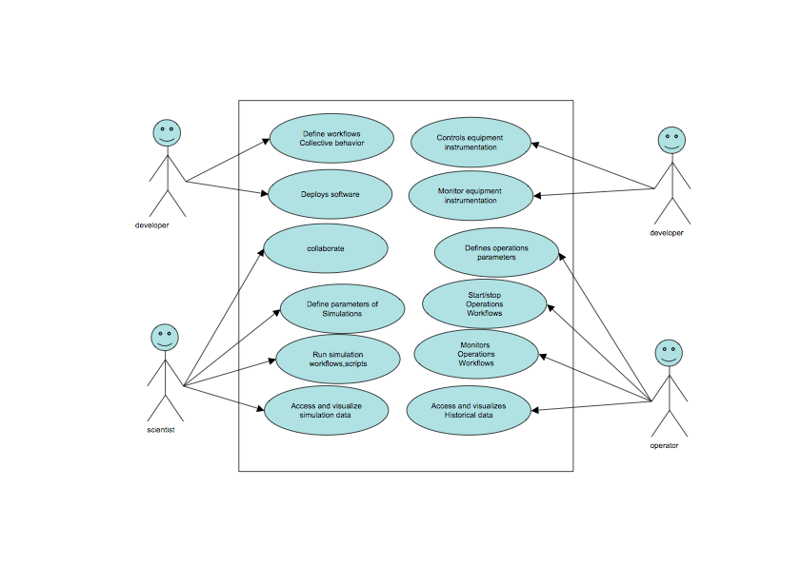

Involved resources
The resources involved in the remote operations are instruments, sensors and detectors interfaced with the equipment. We will refer to them as Instrument Elements (IE) from now on. These IE are generally co-located but sometimes can be distributed geographically (e.g. antennas of a radio telescope).
Data acquired need to be stored in Storage Resources and processed by Computing Resources. We will refer to them respectively as Storage Elements (SE) and Computing Elements (CE).
Brokers of resources both storage and computing and other support systems (information, security, …) are also involved.
User interacts with the involved resources and collaborates with the other users via User Interaction Elements. These components are generally web portals and we will refer to them as Virtual Control Rooms.

Functional requirements
Incl. quality control / validation of data
The following diagram describes how these components interact during operations workflows.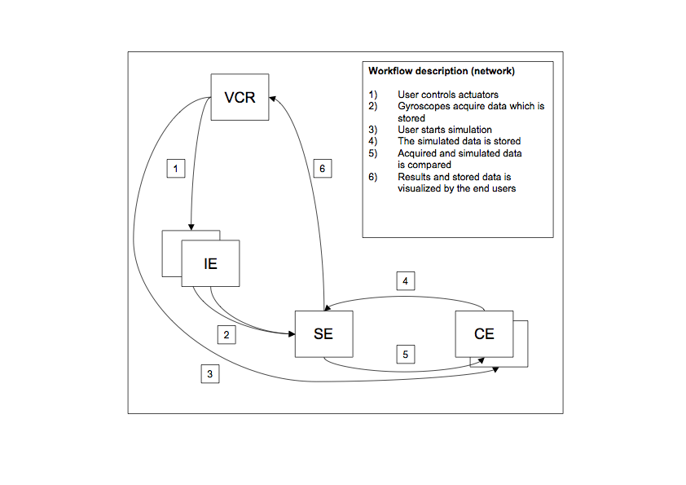
The following diagram is a challenging scenario. It represents an orbit correction workflow (i.e. a feedback via Grid). The orbit correction loop, in order to be effective need to be run at 1 Hz, which has challenging implication in the middleware.
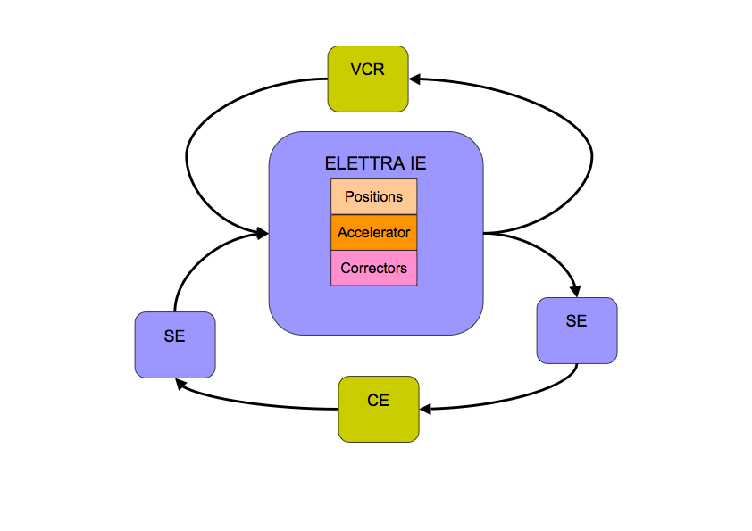
Video and Audio conference support is also requested for collaboration.

Non-functional requirements
An appropriate AAA-mechanism is required. Normal VO management systems can solve the problem.
Remote operations requires adequate quality of service and performance on the whole pipeline from instrument control, to data acquisition, transfer to storage resources, fast computation and data transfer back to storage and instruments. The feedback via Grid to perform orbit correction is a typical example where real time response is needed. This can be achieved by locking all the required resources including bandwidth. Interactivity is also required when interacting with instruments.

Related work / Experience in the field
“Remote operations” was one of the pilot applications of the GRIDCC project. Other experiences have been carried out using CIMA middleware. The same problem was implemented using a different (not Grid) approach by the EUROTeV project and resulted in the implementation of a system called Multipurpose Virtual Laboratory for a Global Accelerator Network.

Use case situation analysis
These use case and the required support was tested at Sincrotrone Trieste S.C.p.A. within the EC funded project GRIDCC (Grid enabled Remote Instrumentation with Distributed Control and Computation).
In the testbed the high level software of a Synchrotron Radiation Facility (ELETTRA) was implemented using the GRIDCC middleware. The most interesting part is a feedback via Grid to implement an orbit correction.

References
www.gridcc.org
www.dorii.eu
www.eurotev.org
www.elettra.trieste.it

