Device Farm Use Case

Summary
This is an experiment in the area of Telecommunications Engineering, which aims at evaluating the effects of noise and fading on a video transmission performed over a wireless channel.

Customers
The primary actor would be the Engineer, who has to perform measurements over a wireless channel. The owner of the equipment in this case might be the manufacturer itself. Imagining a scenario where a user should perform measurements by means of devices that are too costly for the user's budget, or too infrequently employed to justify buying even a single piece of equipment, manufacturers might offer a pool of devices for temporary lease, without physically moving them. A matter to be considered on the basis of the specific experiment is whether the Device Under Test (DUT) may still reside at the user's premises or it should be moved and placed at the same location of the measurement instrumentation. In any case, the user would perform the experiment by operating the measurement instrumentation remotely.

Scenarios
The system under inspection is a wireless telecommunication channel that may belong to different types (e.g., IEEE 802.11 WLAN, Bluetooth, GSM, UMTS, WiMax, etc.). In the specific case considered, the system is an IEEE 802.11b channel, and the measurement devices are a channel emulator (used to generate fading and noise) and a spectrum analyzer. A video sequence is transmitted over the WLAN at the remote location, and the effects of adding fading and noise are evaluated both qualitatively (observing the corrupted video sequence) and quantitatively (e.g., packet loss) (see Figure 1).
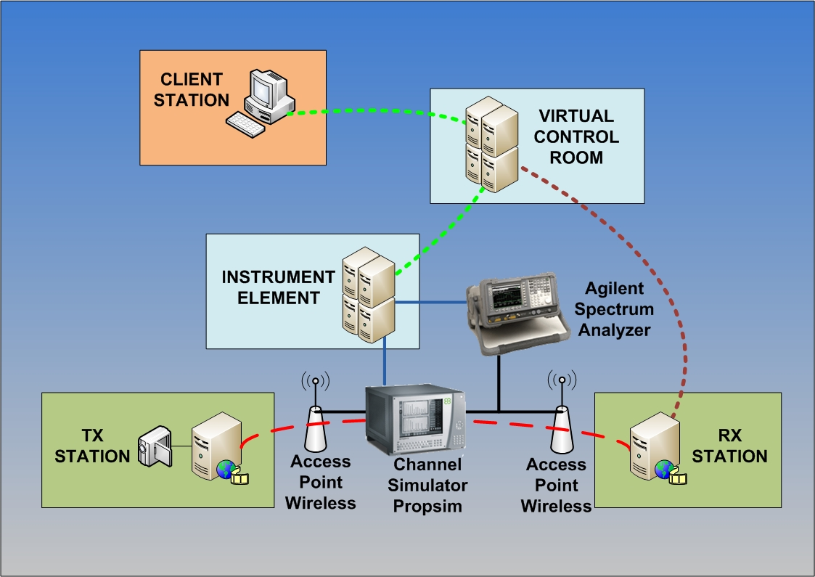Figure 1: Device Farm Experimental Setup
Preconditions:
- Video received on receiver without channel simulator
Minimal guarantee:
- Packet loss and missing video frames when generating fading and additive noise.
Success guarantee:
- Poor video quality observed on receiver in the presence of heavy fading and/or noise levels.

Main success scenario
- Logging in to client that transmits video
- Setup video transmitter
- Logging in to client that receives video
- Setup video receiver
- Connect the wireless Access Point output at the transmitter end to the input of the channel simulator (Elektrobit PropSim C2) [must be performed by remote operator, unless already in place (or connected to a remotely controllable signal switching matrix)]
- Connect the output of the channel simulator to the input of the wireless Access Point at the receiver end [must be performed by remote operator, unless already in place (or connected to a remotely controllable signal switching matrix)]
- By using a directional coupler, connect the output of the channel simulator to the input of the Spectrum Analyzer (Agilent E4404B) [must be performed by remote operator, unless already in place (or connected to a remotely controllable signal switching matrix)]
- Turn on channel simulator, spectrum analyzer and access points
- Start the receiver
- Start video transmission
  - Video not received
    - Ping the receiver from the transmitter
    - Check physical connection [needs remote operator]
    - Restart access point
  - Poor video quality on receiver
    - Change transmitted video (e.g., reduce bit rate)
- Choose a fading profile, switch on and configure the channel simulator
- Set noise level in the channel simulator
- Observe the effects of fading and noise on the decoded video stream [needs VNC or other tool to transfer the decoded video stream to the remote location (without video compression)]
  - Video not received
    - Select another fading profile
- Observe the spectrum
- Measure the packet loss and missing video frames [by means of a software monitoring tool]
- Repeat the measurement after changing noise level and/or fading profile
- Switch-off channel simulator, spectrum analyzer, access points, transmitter and receiver

Involved resources
The testbed consists of:
- a video transmitter station (Video LAN Client running on Windows XP)
- a video receiver station (Video LAN Client running on Windows XP)
- two wireless access points
- a channel simulator (Elektrobit Propsim C2)
- a spectrum analyzer (Agilent E4404B)
- an Instrument Element (running on Windows XP)
- a Virtual Control Room (running on Debian GNU/Linux)
- a Data Collector Broker (running on Scientific Linux)

Instrument Element related software/components
- Instrument Abstraction Layer (IAL)
- NI 488.2 (ENET/GPIB interface device driver)
- AgilentInstumentManager (Agilent E4404B Instrument Manager )
- Data Collector
- E4404B IAL wrapper
  - Agesa E4404B (Agilent E4404B device driver)
- SpectrumAnalyzerInstrumentElement (Elektrobit Propsim C2 Instrument Manager)
  - PropSimC2 IAL wrapper
  - Propsim VISA (PropSimC2 device driver)

Virtual Control Room related components
- mceremotedesktop (used to show video at receiver station)

Functional requirements
User interfaces. It is important in this application to reproduce (totally or partially) the front panel(s) of the instrument(s) with a certain fidelity. A more realistic user interface can be employed both to display measurement outputs (e.g., in the form of graphics) and to input configuration parameters in a fashion as close as possible to that of the real instrument (i.e., pushing buttons, turning knobs, and moving sliders).
Data collection. Measurement data can be acquired from the Instrument Elements controlling the various pieces of equipment in the Device Farm in (at least) two possible modes. One consists in continuously polling the Instrument Element for new data; the other mechanism is based on a publish/subscribe paradigm, to allow asynchronous communication between the Instrument Elements and the user clients (possibly through a Virtual Control Room). The choice between the two operating modes can be based on performance considerations (see below).

Non functional requirements

Security considerations
Each observer must be authenticated to allow video data
Some authorized users allowed to remotely manage instruments

Performance considerations (incl. real-time properties)
Polling the IE for instruments' readings (e.g., from the spectrum analyzer) may result in excessive data transfer delays towards the client stations for waveforms' visualization.
In these cases, the adoption of a publish/subscribe mechanism employing, for instance, JMS for event notification and automatic measurement data transfer is recommended.

Related work
The CNIT teams at the Universities of Genoa and Bologna, and at the National Laboratory for Multimedia Communications in Naples, Italy, have over 8 years experience in the field. In particular, they have conducted the LABNET project [1], part of the experimental activity of the VICOM project [2], and they have participated in European projects GRIDCC ( http://www.gridcc.org), RINGrid (http://www.ringrid.eu), and DORII (http://www.dorii.eu). Participation in the activity of the NoE SatNEx (http://www.satnex.org) has allowed to establish a liaison between Remote Instrumentation Services and the usage of satellite links for data transfer (an important aspect when accessing harsh or secluded environments).

References
GridCC Device Farm Demo Video:
- http://www.gridcc.org/cms/index.php?option=com_content&task=view&id=17&Itemid=9

- F. Davoli, G. Spanò, S. Vignola, S. Zappatore, "LABNET: towards remote laboratories with unified access", IEEE Transactions on Instrumentation and Measurement, vol. 55, no. 5, pp. 1551-1558, Oct. 2006.
- L. Berruti, F. Davoli, G. Massei, A. Scarpiello, S. Zappatore, "Remote laboratory experiments in a Virtual Immersive Learning environment", Advances in Multimedia, vol. 2008 (2008), Article ID 426981, 11 pages, doi:10.1155/2008/426981.
- F. Davoli, S. Palazzo, S. Zappatore, Eds., Distributed Cooperative Laboratories: Networking, Instrumentation, and Measurements, Springer, New York, NY, 2006; ISBN 0-387-29811-8.
- L. Berruti, L. Caviglione, F. Davoli, M. Polizzi, S. Vignola, S. Zappatore, "On the integration of telecommunication measurement devices within the framework of an instrumentation Grid", in F. Davoli, N. Meyer, R. Pugliese, S. Zappatore, Eds., Grid-Enabled Remote Instrumentation, Springer, New York, NY, 2008; ISBN 978-0-387-09662-9.
- L. Berruti, F. Davoli, S. Vignola, S. Zappatore, "Interconnection of laboratory equipment via satellite and space links: investigating the performance of software platforms for the management of measurement instrumentation", in E. Del Re, M. Ruggieri, Eds., Satellite Communications and Navigation Systems, Springer, New York, NY, 2007, pp. 657-666.

