Security Services
This section describes objectives, models, functional capabilities, and properties of the security services, and discusses the interactions with the rest of OGSA.

Objectives
OGSA Security Services are to facilitate the enforcement of the security-related policy within a (Virtual) Organization.
In general, the purpose of the enforcement of security policy is to ensure that the higher-level business objectives can be met. This is often a delicate balance, as there is an increased cost associated with increased policy enforcement, and an increased loss exposure with less stringent enforcement, while potential profits or rewards may be adversely affected by the increased complexity and inflexibility of stricter policy requirements. Note that in some cases, legislative rules and regulations mandate conformance to associated security policy.

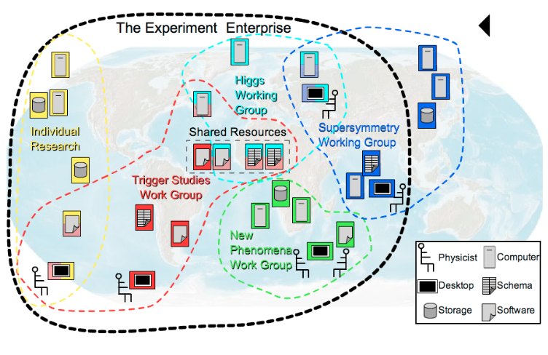
Figure 1. Cross-Organizational Collaborations

The property that Grid-specific applications span multiple administrative domains implies that each of these domains will have its own business objectives to meet, which translates in an enforced security policy by each domain that can differ greatly in complexity and strictness between domains. Note, that all interactions associated with a thread of work in a Grid application have to adhere to the domain-locally enforced policies as well as the policies established for the VO, i.e. the cross-organizational (business) agreement.
To meet the business and associated security objectives, the security policy can for example specify the enforcement of:
- Message integrity and confidentiality
- Authentication of interacting entities
- Minimum authentication strength
- Secure logging and audit
- Separation of responsibilities
- Intrusion and extrusion detection
- Authorization policy checks
- Least privilege operations
- Mandatory access control mechanisms
- Discretionary access control mechanisms
- Avoidance of DoS attacks
- Redundancy
- Training
- …

OGSA security architectural components must support, integrate, and unify popular security models, mechanisms, protocols, platforms, and technologies in a way that enables a variety of systems to interoperate securely. A preliminary OGSA Security Architecture document, developed within GGF’s OGSA-Sec working group seeks to address these goals in a manner consistent with the security model that is currently being defined for the Web services framework. An associated OGSA Security Roadmap document enumerates the security related specifications that will be needed to ensure interoperable implementations of the OGSA Security Architecture.

Model
This section describes a model to facilitate the reasoning about and the specification of the OGSA security services. The presented model is not a formal model in the mathematical sense, but is meant to provide a language to describe, and to obtain common understanding about, the security policies that are to be enforced.

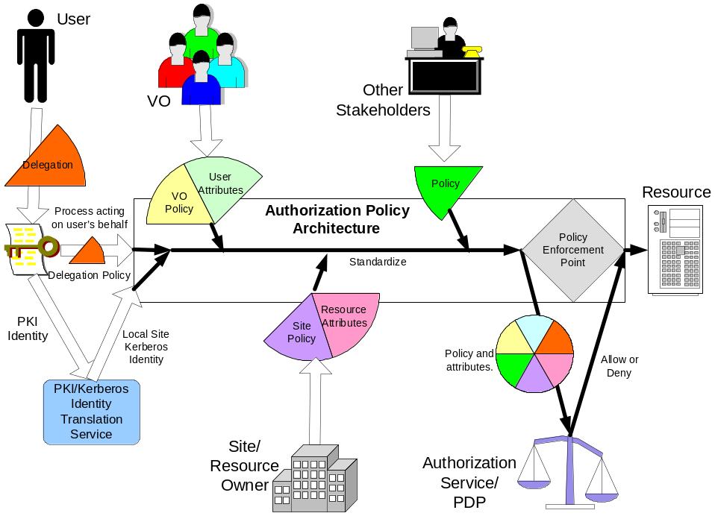

Figure 2. Input for the Policy Enforcement

In general, one can make the observation that entities are interacting through mechanisms within a context. Entities are things like users, subjects or services. Interaction mechanisms span all the different communication methods, like mail, telephone, http, soap, ssl, etc. A context puts the interaction in perspective, and could localize the interaction to a single machine, or could be associated with a service invocation within a VO, and/or with an established secure association, and/or with a distributed transaction.
All these entities, mechanisms and contexts can be described by sets of attributes or properties. Some of these attribute types and values may be used for unique identification, others are used for classification or grouping. Furthermore, some of these attributes are so-called inescapable, like a shared secret, private/public key, fingerprints, etc. Each of these inescapable attributes will identify an entity by themselves. All other attribute values are essentially bound to an entity’s inescapable attribute by an issuer or attribute authority. An example is the X.509 identity certificate, where a trusted third party, the Certification Authority (CA), binds the subject’s name to a public key.
Security policies are statements about these different entities, interaction mechanisms and contexts, and specify restrictions on the associated attribute values, properties and their relationships.
The model defines the security services as entities with interaction patterns that facilitate the administration, expression, publishing, discovery, communication, verification, enforcement and reconciliation of the security policy. In other words, the security policy enforcement is the ultimate goal, and the security services are designed and deployed to support that goal.
To make this model more concrete, we will identity a number of these entities, interaction mechanisms and contexts, and discuss some of their attributes and common relationships. Figure 2 shows an example of the policy enforcement to protect the use of a resource. In order to understand the model, it helps to walk through the example in Figure 2 from the two opposite ends: on one side the initial user authentication, and on the other the enforced authorization, and realize that a user will only be allowed to access the resource if the authorization policy evaluated at the enforcement point will yield permit. The resource’s authorization policy will be expressed as rules for the attribute values of the relevant entities, like for example the user’s name, her role, her VO-membership, etc. With the initial authentication of the user, only inescapable attribute values are presented and verified, like the possession of the private key associated with the presented public key. Normally, there is a mismatch between the fact that the policy is expressed in derived attributes and the initial authentication only yields a key, and this can be resolved by finding the matching attribute assertions that bind the key to the attributes used in the policy expression. One can see in Figure 2 that several security services are depicted, which are used to federate the user’s public key credentials to Kerberos ones, and to obtain attribute from different sources, like the VO or the local site that assert specific attribute bindings used in the enforced policy statements.
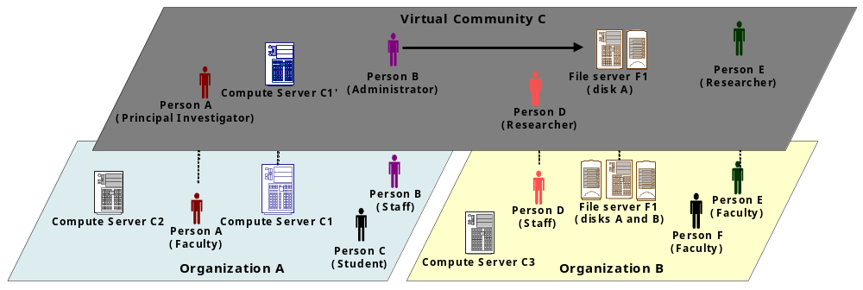
Figure 3. The Virtual Community Concept

Conceptually, the presented model is no different from the general Web Services Security model and other distributed computing architectures. The Grid applications, however, put a distinct focus on the entities and patterns related to cross-organizational settings, and the security services that enable those interactions. For example, Figure 3 shows two organizations and an overlaid virtual community that is governed by its own policy. Note that the entities within this virtual community context have their own specific attributes and properties, which are different and have no relation to those in their home domain. This highlights that our security services model has to support the concurrent enforcement of multiple policies that each have to be evaluated within their own proper context.

Functional Capabilities
In the OGSA model, the functional capabilities are translated into service descriptions and usage patterns.

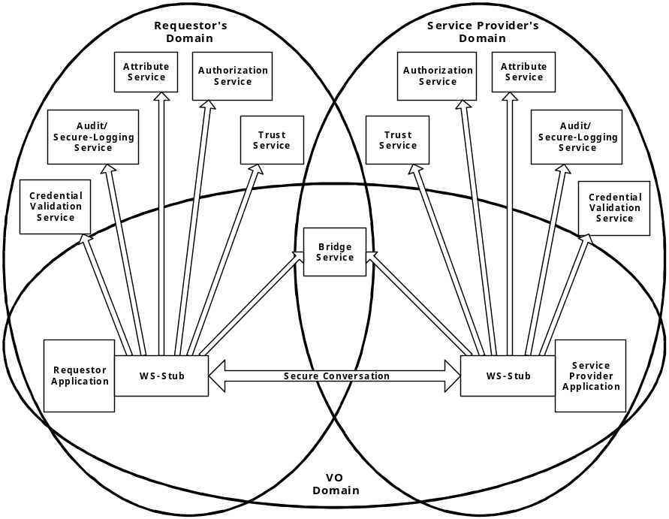
Figure 4: Security services in a virtual organization setting
As an example, Figure 4 illustrates how the requester and service both call-out to different infrastructure security services to ensure policy compliance. Note that in the picture the call-outs are made from within the stubs, and outside and transparent of the application. In many cases, this setup could enforce most of the security policy outside and transparent of the application code.
The functional capabilities can be enumerated as a set of Grid security services:
- An authentication service: An authentication service is concerned with verifying proof of an asserted identity. One example is the evaluation of a User ID and password combination, in which a service requestor supplies the appropriate password for an asserted user ID. Another example involves a service requestor authenticating through a Kerberos mechanism, and a ticket being passed to the service provider’s hosting environment, which determines the authenticity of the ticket before the service is instantiated.
- Identity mapping service: The identity mapping service provides the capability of transforming an identity that exists in one identity domain into a identity within another identity domain. As an example, consider an identity in the form of an X.500 Distinguished Name (DN), which is carried within a X.509 V3 digital certificate. The combination of the subject DN, issuer DN and certificate serial number may be considered to carry the subject’s or service requestor’s identity. The scope of the identity domain in this example is considered to be the set of certificates that are issued by the certificate authority. Assuming that the certificate is used to convey the service requestor’s identity the identity mapping service via policy may map the service requestor’s identity to a identity which has meaning (for instance) to the hosting environment’s local platform registry. The identity mapping service is not concerned with the authentication of the service requestor; rather it is strictly a policy driven name mapping service
- Authorization service: The authorization service is concerned with resolving a policy based access control decision. The authorization service consumes as input a credential that embodies the identity of an authenticated service requestor and for the resource that the service requestor requests, resolves based on policy, whether or not the service requestor is authorized to access the resource. It is expected that the hosting environment for OGSA compliant services will provide access control functions, and it is appropriate to further expose an abstract authorization service depending on the granularity of the access control policy that is being enforced.
- VO Policy service: The VO policy service is concerned with the management of policies. The aggregation of the policies contained within and managed by the policy service comprises a VO’s policy set. The policy service may be thought of as another primitive service, which is used by the authorization, audit, identity mapping and other services as needed.
- Credential Conversion service: The credential conversion service provides credential conversion between one type of credential to another type or form of credential. This may include such tasks as reconciling group membership, privileges, attributes and assertions associated with entities (service requestors and service providers). For example, the credential conversion service may convert a Kerberos credential to a form which is which is required by the authorization service. The policy driven credential conversion service facilitates the interoperability of differing credential types, which may be consumed by services. It is expected that the credential conversion service would use the identity mapping service. WS-Trust defines such a service.
- Audit Service: The audit service similarly to the identity mapping and authorization services is policy driven. The audit service is responsible for producing records, which track security relevant events. The resulting audit records may be reduced and examined as to determine if the desired security policy is being enforced. Auditing and subsequently reduction tooling are used by the security administrators within a VO to determine the VO’s adherence to the stated access control and authentication policies.
- Profile Service: The profile service is concerned with managing service requestor’s preferences and data which my not be directly consumed by the authorization service. This may be service requestor specific personalization data, which for example can be used to tailor or customize the service requestor’s experience (if incorporated into an application which interfaces with end-users.) It is expected that primarily this data will be used by applications that interface with a person.
- Privacy Service: The privacy service is primarily concerned with the policy driven classification of personally identifiable information (PII). Service providers and service requestors may store personally identifiable information using the Privacy Service. Such a service can be used to articulate and enforce a VO’s privacy policy.

All security interfaces used by a service requester and service provider need to be standardized within OGSA. Compliant implementations will be able to make use of existing services and defined policies through configuration. Compliant implementations of a particular security related interface would be able to provide the associated and possibly alternative security services.

Properties

I’m not sure how to use this section…

Intersections with other OGSA services
In general, the invocation of any OGSA service will be subject to security policy enforcement. In some cases, this enforcement is implicit and hard-coded; in other cases the ability to plug-in or call-out to external security infrastructure services is essential for deployment.
In some cases, the security services and requirements are intimately connected to other OGSA services on a higher level. A few examples are discussed below.
The delegation of rights is a fundamental capability needed to let services work on behalf of other entities. With this rights delegation comes the associated risk that any of these services may be compromised and use those right in inappropriate ways. To limit the exposure, one would like to limit the delegated rights to only those rights truly needed by the service. This least privilege delegation model requires that one is able to match the invoked service operations with the exact “amount” of rights, which is a non-trivial requirement. Many Grid applications use the concept of jobs, which job directives are specified in their own language. The job requirements are then matched with the capabilities and availability of resources by discovery, brokers, and scheduler services. The language used for the expression of these job directives and resource capabilities should be able to match up with the directives used to express the equivalent rights needed. Any mismatch will result in deployment where essentially too many rights will have to be given to services to ensure the possible execution of the job directives. This issue is illustrated in Figure 5.

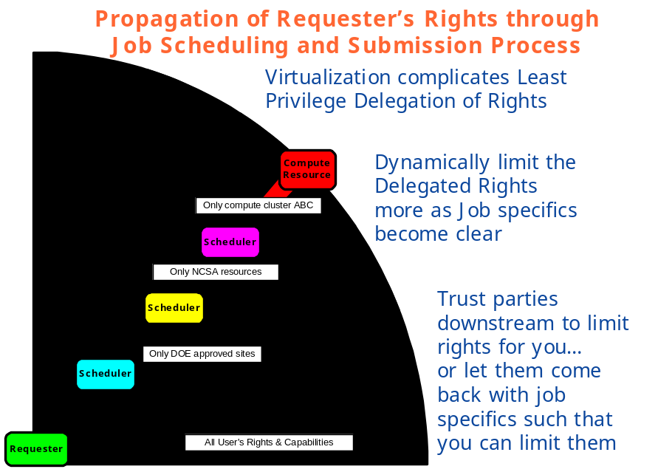
Figure 5. Least Privilege Delegation and Job Description

Logging services and the secure access to the logs for reconciliation purposes, becomes a much harder problem in a distributed setting where the services and associated logs reside in different administrative domains as is depicted in Figure 6.

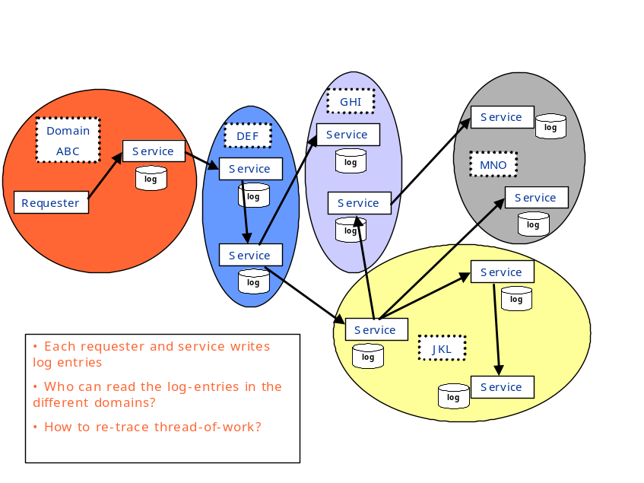
Figure 6. Distributed Logging

