
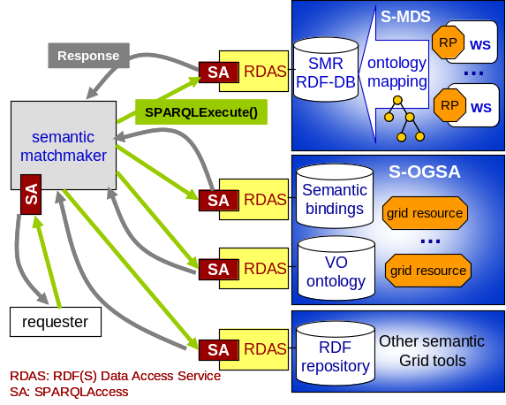
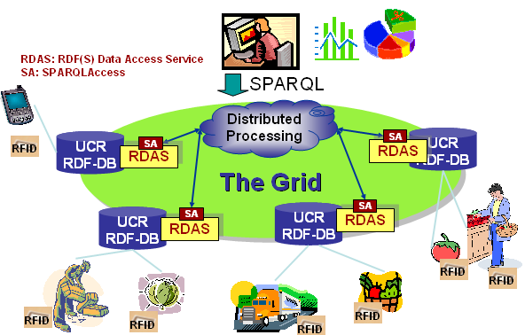

Said Mirza Pahlevi and Isao Kojima, Grid Technology Research Center, AIST, Tsukuba, Ibaraki 305-8568, Japan http://dbgrid.org {mirza|kojima}@ni.aist.go.jp
Querying RDF Data: Use Cases
Motivation. The grid includes a large number of resources with various capabilities distributed across different organizations. To facilitate effective grid resource discovery and selection, semantic grid applications and architecture such as S-MDS [1], MyGrid [2], and S-OGSA [3] describes grid resources using a metadata framework such as RDF/OWL.
Goal. Given repositories and services that store the semantic descriptions created by various semantic grid applications, the goal is to query the semantic descriptions using a high-level RDF query language, SPARQL, and order the matched resources based on a specific ordering criteria such as class subsumption relationship.
Use Case. Figure 1 shows a SPARQL-based semantic matchmaking system designed for the querying specification. RDF data access services (RDAS) provide a standard access method for the RDF data resources. A requester sends a SPARQL query as a resource request to a matchmaker, and the matchmaker forwards the query to one or more repositories. On receiving query results, the matchmaker orders the results according to class subsumption relationships. Similar work has been proposed and implemented in a semantic web environment [4].
Motivation. Ubiquitous code (ucode) [5] is a unique code in the form of 128-bit binary data assigned to real-world objects for identification purposes. It is stored as a ucode tag attached to the identified object; this is often physically implemented as an RFID tag. A relation between objects (ucodes), which is called a ucode relation (UCR), is modeled as a triple, consisting of subject, predicate, and object. For example, this apple (subject ucode) is produced by (predicate relation ucode) the JA Tsugaru-Minami Farm (object ucode). The triples, which are usually large in number, are stored in a wide area distributed database (UCR database). There have been efforts to implement UCR databases using SPARQL-supported RDF databases [6].
Goal. Given such RDF databases, the goal is to provide a robust and scalable federated database that supports seamless access over the heterogeneous RDF databases.
Use Case. Figure 2 shows an overview of a grid-based distributed RDF database, which federates various (UCR) RDF databases. The service-based SPARQL query interfaces provide a uniform access to the heterogeneous RDF databases for distributed query processing. The indirect data access of the proposed specification (SPARQLAccess) can be used in the distributed query processing, as was done in [7]. Another attempt at distributed SPARQL query processing is described in [8].
◄WS-DAI RDF(S) Querying Specification►

Distributed RDF Storage for Ubiquitous Objects

Figure 1. Semantic Matchmaking using SPARQL

Semantic Matchmaking of Grid Resources

Figure 2. Large scale distributed RDF Database
References
[1] M.P. Said et.al., "S-MDS: A Semantic Information Service for
Advanced Resource Discovery and Monitoring in WS-Resource
Framework", GGF16, 3rd Semantic Grid Workshop, 2006.
[2] MyGrid Project: http://www.mygrid.org.uk
[3] O.Corcho, et.al, "An Overview of S-OGSA: a Reference Semantic
Grid Architecture", J. of Web Semantics, Vol. 4, pp. 102-115, 2006.
[4] M.P. Said, et.al, "SPARQL-based OWL-S Service Matchmaking",
SMR 06 in conjunction with VLDB’06, pp. 35-50, 2006.
[5] T-Engine Forum, "Ubiquitous ID Architecture”, UID-CO00002-
0.00.24, Nov. 2006 (in Japanese).
[6] Nihon Unisys SSDB: http://dev.tyzoh.jp/trac/semi-structured-db/
[7] OGSA-DAI-RDF: http://www.dbgrid.org/OGSA-DAI-RDF/
[8] Federated SPARQL, http://www.w3.org/2007/05/SPARQLfed/

