Basic Execution Services Container Profile

Status of This Memo
This document is in draft stage and should be considered as in flux. Distribution is unlimited.

Copyright Notice
Copyright © Global Grid Forum (2006). All Rights Reserved.

Abstract
This memo provides information to the Grid community on the Basic Execution Services (BES) Container Profile for OGSA (Open Grid Services Architecture). It defines the BES container profile, based on the container object proposed for inclusion in DMTF’s Common Information Model and DMTF’s profile guideline document. The attributes of the BES profile are based on experience with Globus, Condor, and GLUE and uses industry standard definitions from DMTF’s Common Information Model where applicable. Distribution is unlimited.
Contents

1. Overview 3
2. The Basic Execution Services Profile 3
2.1 Synopsis 3
2.2 Description 3
3. UML 6
3.1 Container 7
3.2 Operating System 8
3.3 Processor 9
3.4 Computer System 10
3.5 Networking 10
3.6 Storage 10
3.7 Filesystem 11
4. Discussion of the New Model Elements 12
4.1 New Classes 12
4.2 New Associations 12
4.3 Properties Added to Existing Classes 12
4.4 Methods Added to Existing Classes 12
5. Managed Object Format (MOF) for New Elements 12
6. XML 12
7. Security Considerations 12
8. Glossary 12
9. Author Information 12
10. Acknowledgements 13
11. References 13
12. Full Copyright and Intellectual Property Notices 13

Overview
The Basic Execution Services (BES) profile describes the managed objects necessary (required and optional) that a system needs to provide so grid applications can determine whether a given system has the environment necessary for it to execute.
The basis for describing the BES profile is the experience gained with Globus, Condor, and GLUE and uses definitions from DMTF’s Common Information Model (CIM) v2.10 final schema and v2.12 experimental schema as applicable. Where we find gaps in CIM that are filled using definitions from other schemas such as GLUE, we will propose modifications and extensions to DMTF’s CIM. And finally, we use the yet-to-be-released DMTF profile guidelines document to guide us in the type of information that needs to be described in a profile that commercial and academia will implement.
In this document we describe the BES profile in text/diagrams, UML, DMTF CIM Managed Object Format (MOF), and suggest, as a strawman, an XML schema that could be used by OGSA-compliant Grid Services to exchange the information in the model presented. DMTF provides their XML representation via automatic conversion tool (MOF to CIM-XML, via CIM DTD).
The keywords “MUST”, “MUST NOT”, “REQUIRED”, “SHALL”, “SHALL NOT”, “SHOULD”, “SHOULD NOT”, “RECOMMENDED” and “MAY” used in this document are to be interpreted as described in [RFC2119].

The Basic Execution Services Profile

Synopsis
- Profile name: OGSA Basic Executive Services
- Version 1.0.0
- Organization: Global Grid Forum (GGF)
- CIM schema version: 2.10.0 final + 2.1.12 experimental

Description
The BES container is a container constrained by a profile and not a subclass of the Container class. The Container acts as an aggregator of the managed properties necessary for the use of the container through its various relationships with the ManagedElement class. The BES container can be logically depicted as having managed information in the following categories. Although there may be other categories of information that are useful to BES, this profile is the initial base profile of attributes that are not controversial, and the attributes have been shown to be useful in placement of jobs. Future versions of the BES profile may expand the categories and the information within the categories.
Where existing CIM elements are used, the details descriptions are found in the CIM schema [ ]. New model elements are described in Section 4 following the presentation of the UML in Section 3. The ManagedObject Format (MOF) description for new elements is given in Section 5. (MOF is a textual rendering of UML, defined in the CIM Specification [CIMspec] published by the DMTF.) Section 6 offers a corresponding XML description for all BES profile elements (existing and new).
Note: It is expected that any additional CIM classes, attributes, and methods defined will be added to CIM in a timely manner.

Category | Description
Container Information | Information from the Container class
Operating System Information | OS information such as type, version, memory statistics
CPU Architecture | CPU information such as processor and load
Computer System Environment | Information such as hosting environment, hyperthreading
Network Bandwidth | Bandwidth information such as type, speed, load
Storage Space | Size information about the available storage
Filesystem | Filesystem information such as type, size, space, access

Each category is described by three pieces of information: (1) attribute type: required or optional, (2) attribute name (taken from the CIM class), and (3) the name of the CIM class in which the attribute resides. We additionally add a third type labeled ‘Other Optional Interesting Information’ that serves to show future direction or other optional information that needs definition and concurrence for inclusion in this BES base profile.

Container Information
This is information / characteristics of the BES container from the container class. See [Container] for details.

Operating System

Type | Attribute (CIM) | CIM Class
Required | OSType | CIM_OperatingSystem
Required | OtherTypeDescription | CIM_OperatingSystem
Required | Version | CIM_OperatingSystem
Optional | LocalDateTime | CIM_OperatingSystem
Optional | LastBootUpTime | CIM_OperatingSystem
Optional | TotalSwapSpace | CIM_OperatingSystem
Optional | MaxNumberOfProcesses | CIM_OperatingSystem
Optional | NumberOfProcesses | CIM_OperatingSystem
Optional | TotalVirtualMemorySize | CIM_OperatingSystem
Optional | FreeVirtualMemorySize | CIM_OperatingSystem
Optional | FreePhysicalMemory | CIM_OperatingSystem
Optional | TotalVisibleMemorySize | CIM_OperatingSystem
Other Optional Interesting Information | MeanTimeToReboot | New, to be added to TBD at a later time
Other Optional Interesting Information | <OS availability metric> | New, to be added to TBD at a later time
Other Optional Interesting Information | <OS reliability metric> | New, to be added to TBD at a later time
Other Optional Interesting Information | <libraries / packages installed> | New, to be added to TBD at a later time

Processor

Type | Attribute (CIM) | CIM Class
Required | Vendor | New – use GLUE definition, to be added to CIM_Processor
Required | Model | New – use GLUE definition, to be added to CIM_Processor
Required | Version | New – use GLUE definition, to be added to CIM_Processor
Required | Family (really instruction set) | CIM_Processor
Required | MaxClockSpeed | CIM_Processor
Required | LoadPercentage | CIM_Processor
Optional | CurrentClockSpeed | CIM_Processor
Other Optional Interesting Information | Hyperthreading | New (Boolean), to be added to CIM_ComputerSystem

Computer System

Type | Attribute (CIM) | CIM Class
Other Optional Interesting Information | Load | New, to be added to CIM_ComputerSystem; needs definition – many dimensions

Networking

Type | Attribute (CIM) | CIM Class
Optional | Speed | CIM_LogicalPort
Optional | MaxSpeed | CIM_LogicalPort
Optional | LinkTechnology | CIM_NetworkPort
Optional | OtherLinkTechnology | CIM_NetworkPort
Optional | OtherTypeDescription | CIM_ProtocolElement
Optional | IPv4Address | CIM_IPProtocolEndpoint
Optional | IPv6Address | CIM_IPProtocolEndpoint
Optional | SubnetMask | CIM_IPProtocolEndpoint

Storage
TBD – awaiting input from Tom Maguire. Needs to be discussed. Information is potentially optional.

Filesystem

Type | Attribute (CIM) | CIM Class
Required | Root | CIM_FileSystem
Required | AvailableSpace | CIM_FileSystem
Required | ReadOnly | CIM_FileSystem
Optional | FileSystemSize | CIM_FileSystem
Optional | FileSystemType | CIM_FileSystem
Optional | CaseSensitive | CIM_FileSystem
Other Optional Interesting Information | PerformanceRWRate | New, to be added to TBD
Other Optional Interesting Information | <FS availability metric> | New, to be added to TBD
Other Optional Interesting Information | <FS reliability metric> | New, to be added to TBD
Other Optional Interesting Information | BackupFrequency | New, to be added to TBD

Where existing CIM elements are used, the details descriptions are found in the [CIM2.10final]. New model elements are described in Section 4 following the presentation of the UML in Section 3. The ManagedObject Format (MOF) description for new elements is given in Section 5. (MOF is a textual rendering of UML, defined in the CIM Specification [CIMspec] published by the DMTF.) Section 6 offers a corresponding XML description for all BES profile elements (existing and new).

UML
The figure below depicts the classes, attributes, and methods that the BES profile uses. Each class represents the aggregate leaf (composite) class required by the BES profile. The existing classes, attributes, and methods needed by this profile are blue. The new classes, attributes, and methods are highlighted in blue bold and marked as experimental ({E}). If a class is marked as experimental, then all attributes in that class area implicitly marked as experimental. Any attributes marked in red are DMTF-defined experimental ({E}) or deprecated ({D}). The information is black is existing in DMTF classes/attributes and not used by the BES profile.

Container
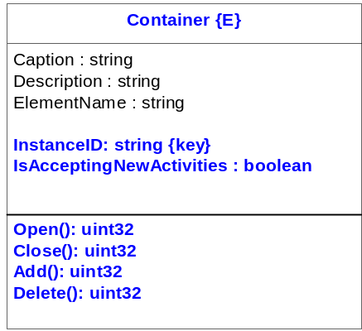

Question: do we need an attribute to denote the environment of container, such as whether the container is a queuing service, a J2EE hosting environment, a host (operating system based), other hosting environments such as .NET, JBOSS, etc?

Operating System
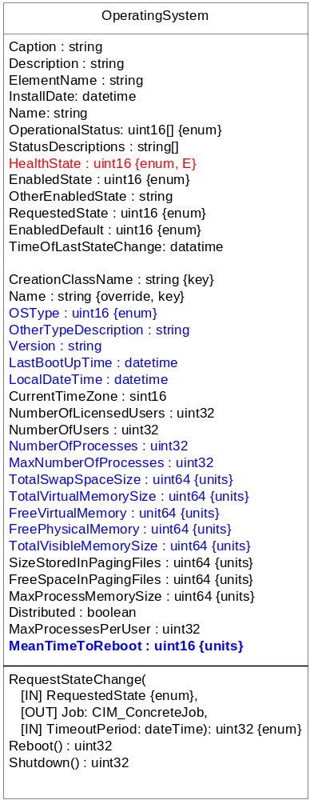

Note: Still need to resolve definition and where to add operating system availability metric, operating system reliability metric, and libraries/packages that are installed – or remove them from this base profile.
If the decision is to include, then the installed libraries/packages get pulled from the application model. Need to look at the metrics model for development of availability/reliability metrics.
Suggest they do not get included in the base profile, but rather in a future version of the profile, for expediency. To include requires someone to take ownership to define now.

Processor
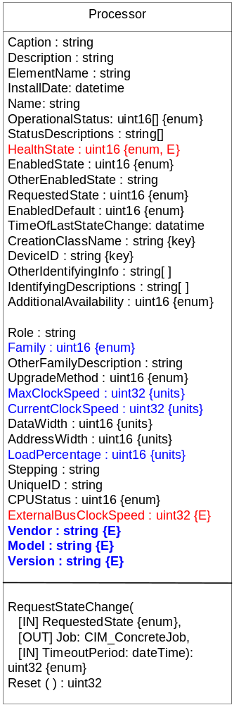

Computer System
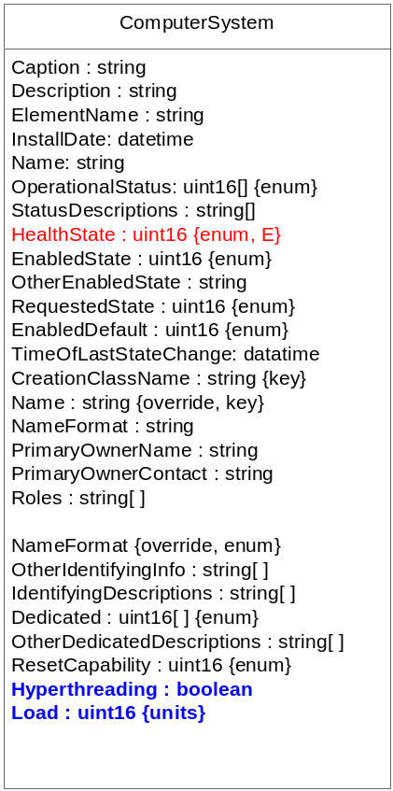

Networking
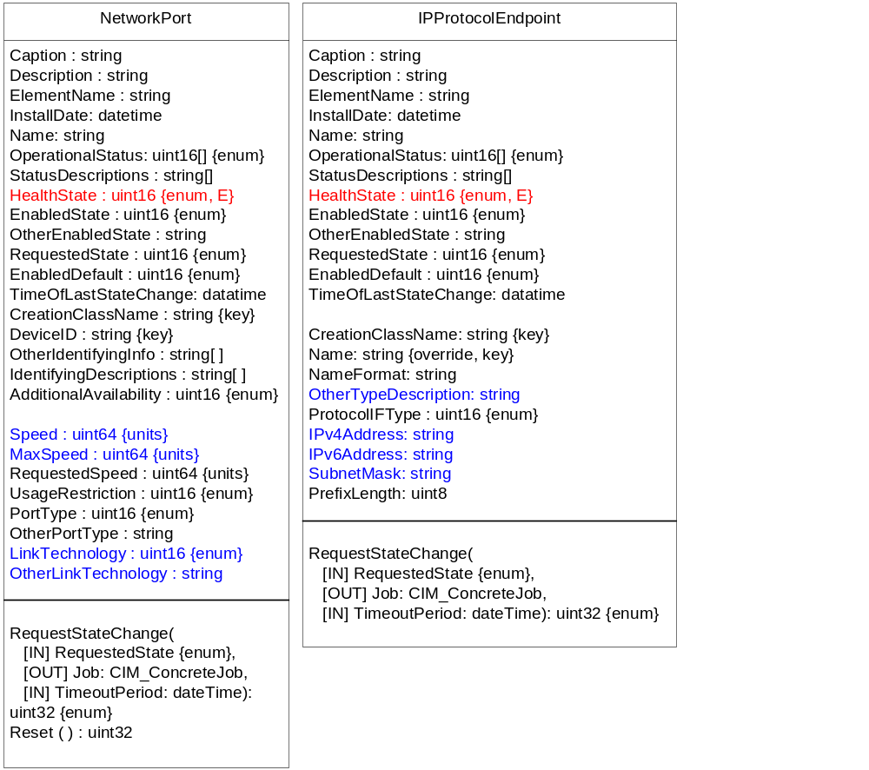

Storage
TBD

Filesystem
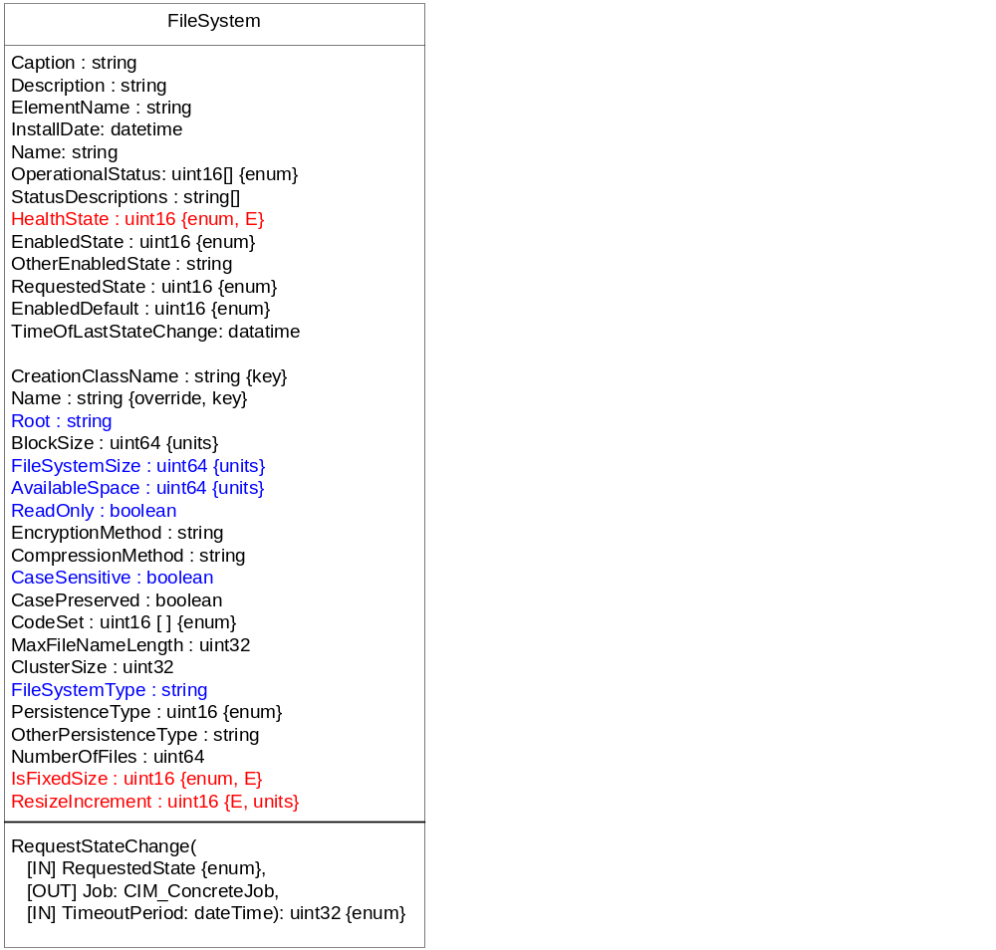

Note: Still need to resolve definition and where to add PerformanceRWRate, filesystem availability metric, filesystem reliability metric, and BackupFrequency.
Need to look at the metrics model for development of availability/reliability metrics.
Suggest they do not get included in the base profile, but rather in a future version of the profile, for expediency. To include requires someone to take ownership to define now.

Discussion of the New Model Elements
This section describes the new classes, associations, properties, and methods proposed to be added to CIM v2.12 experimental in support of a BES profile.

New Classes
TBD.

New Associations
None.

Properties Added to Existing Classes
TBD.

Methods Added to Existing Classes
TBD.

Managed Object Format (MOF) for New Elements
The schema is described in Managed Object Format, defined in [CIMspec]. This section describes only the new elements that need to be added to CIM.
The MOF below reflects the UML from Section 3. It is provided here because this is what will be submitted as a change request to CIM.
<insert MOF>

XML
An XML representation of the schema required for this BES profile as an XSD is being developed.
<insert XML>

Security Considerations
This specification defines the model and XML Schema for containers. While the interactions of containers with its activities must be secured, the security details are outside the scope of this specification. Instead, it is assumed that security is addressed in specifications that define how this model and XML Schema are bound to specific communication protocols (such as [CIMOPS] or [OGSA]) and programming environments.

Glossary
<any terms we should list?>

Author Information
Ellen Stokes
IBM Corporation
11400 Burnet Rd
Austin, TX 78758
+1 512 838 0552
stokese@us.ibm.com

Acknowledgements
We are grateful to numerous colleagues for discussions on the topics covered in this document, in particular (in alphabetical order, with apologies to anybody we've missed): <list the names>.

References
[RFC2119] Bradner, Scott, "Key Words for use in RFCs to Indicate Requirement Levels", RFC 2119, http://www.ietf.org/rfc/rfc2119.txt
[CIM2.10final] DMTF CIM Schema, Version 2.10 Final, http://www.dmtf.org/standards/cim_schema_v210.php
[CIM2.12prelim] DMTF CIM Schema, Version 2.12 Experimental, http://www.dmtf.org/standards/cim_schema_v212.php
[CIMspec] DMTF, CIM Specification V2.2, http://www.dmtf.org/standards/documents/CIM/DSP0004.pdf
[CIMXML] DMTF, Representation of CIM in XML, http://www.dmtf.org/standards/documents/CIM/DSP0201.pdf
[BES] GGF, OGSA Basic Execution Service Specification, http://www.ggf.org/XXX.pdf
[Container] GGF, OGSA Container Model, http://www.ggf.org/XXX.pdf

Full Copyright and Intellectual Property Notices
Full Copyright Notice
Copyright © Global Grid Forum (2006). All Rights Reserved.
This document and translations of it may be copied and furnished to others, and derivative works that comment on or otherwise explain it or assist in its implementation may be prepared, copied, published and distributed, in whole or in part, without restriction of any kind, provided that the above copyright notice and this paragraph are included on all such copies and derivative works. However, this document itself may not be modified in any way, such as by removing the copyright notice or references to the GGF or other organizations, except as needed for the purpose of developing Grid Recommendations in which case the procedures for copyrights defined in the GGF Document process must be followed, or as required to translate it into languages other than English.
The limited permissions granted above are perpetual and will not be revoked by the GGF or its successors or assigns.
This document and the information contained herein is provided on an "AS IS" basis and THE GLOBAL GRID FORUM DISCLAIMS ALL WARRANTIES, EXPRESS OR IMPLIED, INCLUDING BUT NOT LIMITED TO ANY WARRANTY THAT THE USE OF THE INFORMATION HEREIN WILL NOT INFRINGE ANY RIGHTS OR ANY IMPLIED WARRANTIES OF MERCHANTABILITY OR FITNESS FOR A PARTICULAR PURPOSE."

Intellectual Property Statement
The GGF takes no position regarding the validity or scope of any intellectual property or other rights that might be claimed to pertain to the implementation or use of the technology described in this document or the extent to which any license under such rights might or might not be available; neither does it represent that it has made any effort to identify any such rights. Copies of claims of rights made available for publication and any assurances of licenses to be made available, or the result of an attempt made to obtain a general license or permission for the use of such proprietary rights by implementers or users of this specification can be obtained from the GGF Secretariat.
The GGF invites any interested party to bring to its attention any copyrights, patents or patent applications, or other proprietary rights which may cover technology that may be required to practice this recommendation. Please address the information to the GGF Executive Director.

To describe the aggregate of attributes necessary for the BES profile in terms of an information model, we use the DMTF CIM. Insert reference to container object.
Note: It is expected that any additional CIM classes, attributes, and methods defined will be added to CIM in a timely manner, i.e. the next DMTF experimental release.

