Table of Contents

Section 1 – New Group Formation 1
Determine and Document Focus of the Proposed Group 1
Submit a Draft Charter and Propose a Group 2
Section 2 - Agendas, Minutes and Participants for all meetings 4
Posting Agendas and Minutes 4
Section 3 Draft Documents and Charter 7
Finding Current Drafts & Charter 7
Loading Current Drafts and Charter Documents 8
Submitting Drafts for GGF Conferences 10
Section 4 Submitting a Grid Working Draft to the GGF Editor 10
Grid Working Draft Template 11
Naming Convention 11
Intellectual Property Statement and Copyright 11
The Editor Pipeline 11
Section 5 Revisions to Documents 13
Creating Trackers for Document Revisions 13
Customizing a Tracker 14
Submitting Revisions 17
Updating Current Versions of Drafts 18
Section 6 Milestones and Tasks 18

Section 1 – New Group Formation

While the majority of forming a new group does not involve GridForge tools, there are critical junctures where GridForge tools and processes are used to communicate proposed group information and provide a two-way channel between the proposing parties and the GFSG. Proposing a group is essentially a four step process:

Determine and Document Focus of the Proposed Group

Individuals interested in forming a new group identify the boundaries of the group, potential leadership, and timelines. These are normally documented in a draft charter, which is the primary mechanism used to communicate between the proposing parties and the approving committee (GFSG). A template for a charter is available in the Chair project at: http://forge.ggf.org/projects/Chairs/Charter_Template.

Steps to obtaining a template for a new group charter:
- Logon to GridForge.
- Browse to the Chair project and click “Document Manager” on the left Navigation bar.
- Open the Templates folder and click the document entitled “Charter_Tempate”.
- Download this document to your machine and revise it to describe the focus of your proposed group.

Submit a Draft Charter and Propose a Group

At times, a critical mass of interest has not yet been formed and the proposing parties wish to invite additional participation to obtain a broader perspective on the topic of the proposed group. This can be done through a Birds-of-a-Feather (BOF) session at a GGF meeting. This can precede the drafting of a charter, however it is helpful for parties proposing the BOF to have some written description of the focus of the proposed group from which BOF discussions can be launched. To propose a BOF, one typically initiates interaction with an Area Director or the GGF Chair. This can be done via email, or by visiting the area project in which the proposing parties believe their group focus would reside. In each area project is a tracker titled “Propose New Group”. Submitting a tracker item and providing a description of the focus of the group while attaching a draft charter (if one is available) is the best way to initiate AD involvement in the new group formation.

Steps for submitting a request for a proposed new group to an Area Director:
- Logon to GridForge.
- Select the “GGF GridForge Directories” link on the left navigation bar and then click on “GGF GridForge Site Map” link.

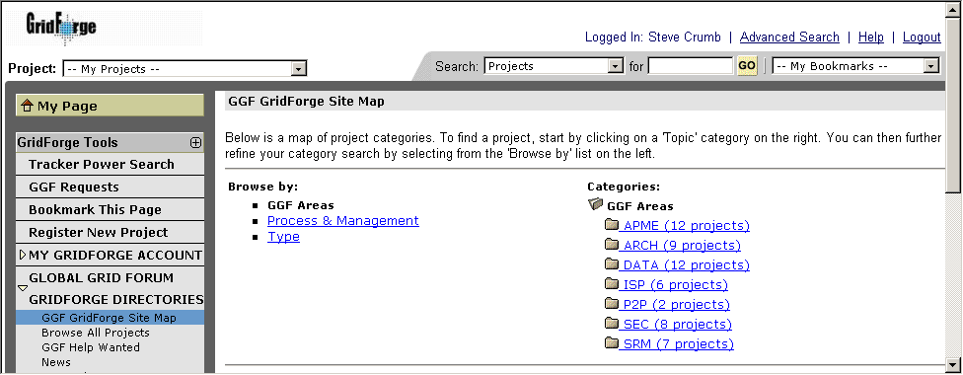

- Select the “Type” link under the “Browse By” heading.

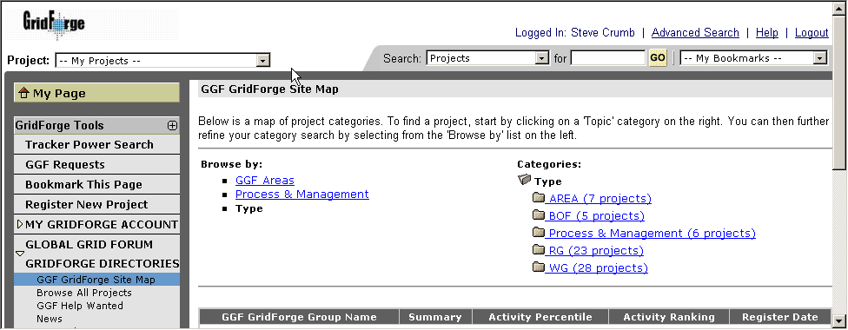

- Select the “AREA” link under the “Type” heading. This will result in a list of all Area projects. Browse to the area you think best encompasses the subject matter of the proposed group (e.g., Data).
- Once at the project, click on the triangle next to the “TRACK IT” link on the left navigation bar. This will unveil a list of trackers. Select the “Submit” link under the tracker entitled “Propose New Group”.
- In the subject field, type the proposed name of the group and then give a paragraph description of the group focus in the Description field.
- Select the appropriate status of your request from the “Category” field (e.g,. Request BOF, Request AD input, etc.) and then select either Research Group or Working Group in the “Group Type” field. Leave the “Group” field as the default.
- If you have a draft Charter, attach the file in .doc or .pdf format in the “Attach File” field.
- Press the “Save” button.

The Area Directors will automatically receive an indication that a new group has been proposed. As the AD’s make updates to the tracker, you will receive notification of the changes and may visit the tracker item, read their comments, and reply by adding additional comments and pressing “Save”. AD’s may also interact with you using email and other means to gain a greater appreciation for the focus of the proposed group.

After interaction and approval by the area director, he/she will propose the group to the GFSG by a similar process in a private, GFSG project. The AD’s may continue to use the tracker item as a mechanism for recording and requesting information from the proposing parties. Eventually, however, the group will either be approved or rejected. This answer will flow from the GFSG through the AD with which you were interacting.
Once a group has been approved, the AD will request a mailing list and GridForge project for the new group. Finally, a member of the secretariat will contact you when the list and project have been created and orient you to the usage of GridForge to manage the group activities.

Section 2 - Agendas, Minutes and Participants for all meetings

The Intellectual Property (IP) policy of GGF implies that all interactions, whether face-to-face, teleconference, or electronic in nature, where contributions are made should be recorded to protect the rights of the contributors as well as implementers of resulting standards. As a result, one of the most critical responsibilities of a group chair is to ensure that minutes of all meetings, regardless of venue, are recorded and posted for the GGF community. Minutes should include a list of attendees as well as the subjects discussed. GridForge provides a simple way of recording minutes using the Forum tool.

Posting Agendas and Minutes

In a lifecycle of a typical meeting, an agenda is posted, is bashed (i.e., revised), the meeting is held, minutes are posted, and revisions to minutes noted. GridForge forums provide a single discussion thread where all of this information can be connected.

Steps for posting a meeting Agenda and Minutes:
- Logon to GridForge and go to your GridForge project.
- List the available Forums by clicking on the triangle next to the “Forums” link on the left navigation bar.
- Click on the “Meeting Agendas and Minutes” forum.

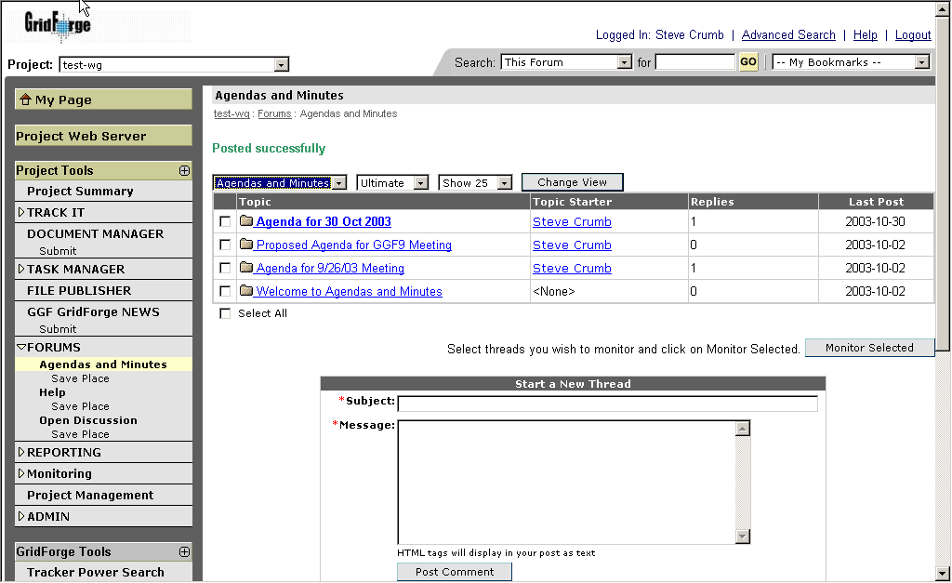

- For a new meeting, create a new discussion thread (form at bottom of page). Type in a brief description of the meeting in the subject line (e.g., TEST-WG Agenda 23 October 2003). Type in the Agenda in the Message field (or paste in) and press “Post Message”.

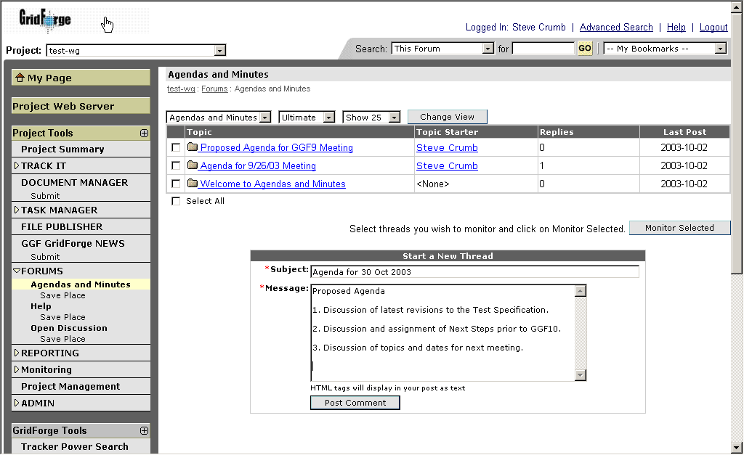

- Those with revisions to the agenda may follow steps i-iii, select the meeting agenda thread (i.e., title of the Agenda to be revised under “Topic” heading) and post a reply to the Agenda message, by selecting the “Reply” link directly to the right of the Agenda title.

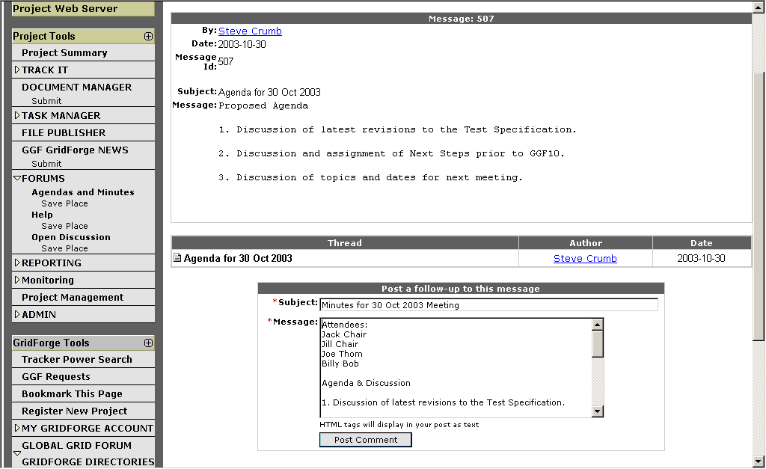

- After the meeting has been concluded and minutes are ready to be posted, then another reply (as in step vi) can be posted containing the minutes.
- Like revisions to the agenda, revisions to the minutes may also be posted as replies as in step vi.

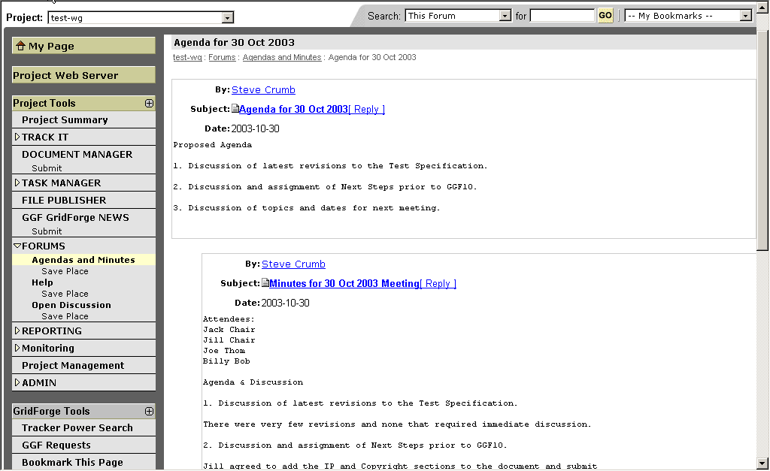

In some cases, text-only meeting minutes may not have sufficient formatting to accurately convey some portion of the minutes (e.g., formatted tables containing action items). The same can be said of sign-in sheets from GGFn meetings. In this case, GGF suggests that the formatted minutes (in pdf format) and scanned sign-in sheets are stored in a Document Manager category such as Meeting Materials and URL(s) to those artifacts are included in the forum-based, text-only minutes.
Finally, when a project is created, two aspects of the standard template will be a Forum named “Meeting Agendas and Minutes” and a standard link from the front page entitled “Meeting Agendas and Minutes” which points directly to the contents of the aforementioned forum. This gives a project visitor a quick method of accessing meeting agendas and minutes.

Section 3 Draft Documents and Charter

Finding Current Drafts & Charter

Two of the most important artifacts in a given project will be the current version of the group’s draft documents and it’s Charter. As such, they should be easy to find. Each project will have twos link on the project’s front page called “Current Drafts” and “Charter”. These links will point to one of two folders that will be present in every project (Current Drafts and Charter). The Current Drafts folder should always contain current versions of the group’s draft Grid documents. Similarly, the group should store their Charter document in the “Charter” folder.

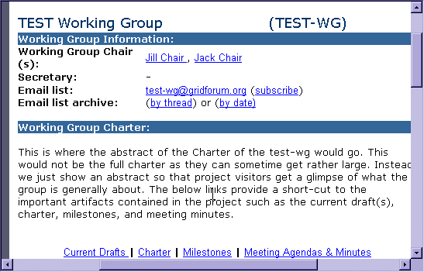

- Click on current drafts
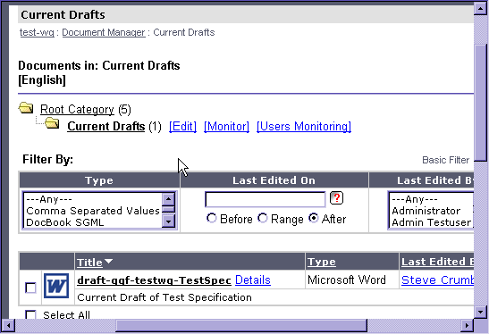

- Next you may click on the appropriate draft document you are looking to view.

Loading Current Drafts and Charter Documents

In order for project visitors to find the Charter and current draft documents, someone must initially load these documents into their respective folder and maintain them.

Steps for Loading Current Drafts or Charter
- Logon to GridForge
- Browse to the project front page.
- To submit a document to a project, you select the “Submit” link under Document Manager in the left navigation bar.

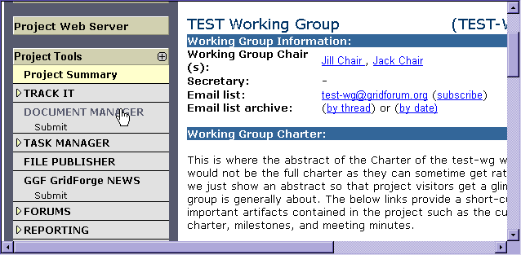
- Once the submit document form appears, you first fill in the document title (mandatory) and description.
- Next, browse and select the document you wish to submit.. Note that you may also paste non-binary document text into the Paste Document pane on the form and not use the browse feature. This is determined by which radio button you select.
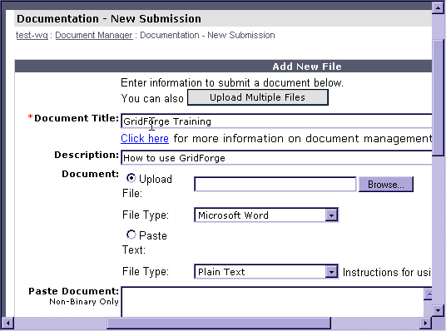
- Next select the type of document (PDF, DOC, TXT). Take care that there is not a mismatch in the type of document as this will result in an error. Charters should be in PDF format.
- Select the access type, category (either Charter or Current Drafts) into which the document will be placed, and the language of the document. Do not select the Lock or Review check boxes, but take care to read the Acceptable Document Usage information and check its check box (mandatory).
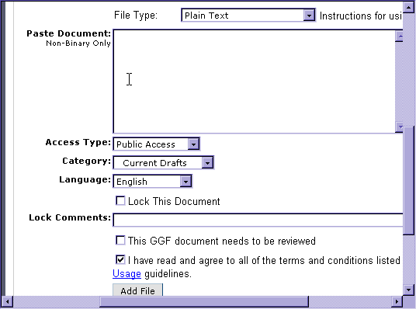
- After the form has been fully filled in, press the “Add File” button. Note that if you successfully submitted the document, a URL for the document will be presented at the top of the form. If this URL is not present, you will likely have an error message (in red) toward the top of the form indicating something did not submit correctly and you must repeat the process.

Submitting Drafts for GGF Conferences

In the past, the GGF secretariat has requested that chairs submit drafts to be discussed at an upcoming GGF meeting. However, if all current drafts are now posted with GridForge and these can be found in the Current Drafts folder of every group project, then there no longer is a need for submitting them to a central repository.
However, since the Secretariat does promote the activities of each meeting in advance, it would be helpful for the chairs to send the URL(s) of the drafts to be discussed at the next GGF to the Secretariat. The URL provided will be displayed on the GGF website where individuals can click directly to view the document that will be discussed during their working session. You may submit the URL(s) along with the meeting agenda and other information required while requesting a session at the GGF meeting (see section x below).

Section 4 Submitting a Grid Working Draft to the GGF Editor

When GGF documents have gained consensus within a working group or research group, then the draft document may be submitted to the GGF Editor for review and processing. Prior to submitting the document, the draft must have certain attributes of name and format to make it consistent with other Grid working drafts.

Grid Working Draft Template

The document format of all grid working drafts must be consistent. Thus, it is best to obtain a copy of the GWD template and conform the content of the document to its format. The GWD template may be downloaded from:
http://forge.ggf.org/projects/ggf-editor/GFD-Template.

Naming Convention

All Grid working drafts must follow a consistent naming convention. There are two naming formats depending on whether draft is submitted be a group or by an individual.

For drafts accepted as working groups documents, acronym is that of the working group:
- draft-ggf-[acronym]-[short title]-[version].doc
For individual submissions:
- draft-ggf-[author]-[short title]-[version].doc

Intellectual Property Statement and Copyright

Although it is hoped that the IPR and Copyright statements would have already been included in earlier drafts, these statements MUST be included in drafts submitted to the GGF Editor.

The Editor Pipeline

The GGF Editor uses GridForge to manage the pipeline of Grid Working Drafts vying for publication. Thus, it is critical to use the proper submission process to reduce the potential for delays or lost submissions via email.

Steps for Submitting a Draft to the GGF Editor:
  - Logon to GridForge
  - Go to the following URL: https://forge.gridforum.org/tracker/index.php?func=add&group_id=90&atid=414
  - This will display a tracker submit form.
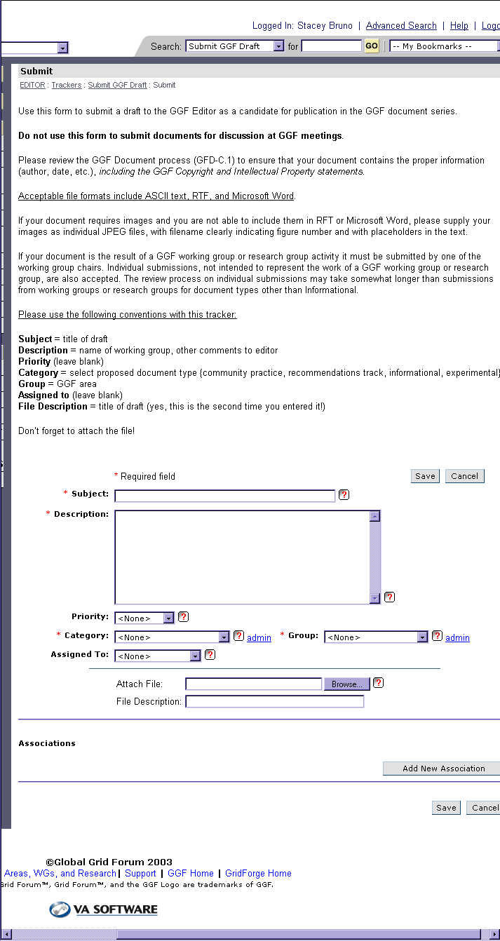
  - You should first put the document title (mandatory) and description. Please use the naming convention that is listed in Section 4.
  - Leave the Priority box blank.
  - Under category select proposed document type {community practice, recommendations track, informational, experimental}
  - Group should be your GGF area.
  - Assigned to leave blank.
  - File description should be the title of the draft (yes, this is the second time you entered it!). Acceptable file formats include ASCII text, RTF, and Microsoft Word.
  - Attach the file and click save.

Section 5 Revisions to Documents

A typical activity of a GGF group is to create, revise, and submit documents to the GGF Editor for publishing. GridForge provides useful mechanisms to aid in the document finalization process within a group. Particularly, GridForge provides a document manager with capabilities of versioning documents. Additionally, GridForge provides trackers, which can be used to report, assign, track, and archive revision requests on a particular document.

Creating Trackers for Document Revisions

When a group is working on a document, the project administrator should create a tracker for requesting and tracking revisions to that tracker. There should be one tracker for each document being revised.

Steps for creating a new Tracker for reporting revisions on a document:

- Logon to GridForge as a project administrator.
- Browse to the project in which the draft document resides.
- Click on the triangle next to the ADMIN link on the left navigation bar and select “Tracker Admin”.
- Below the list of existing trackers is a form that can be used to create a new tracker. Type in the name of the tracker (e.g., Test Spec Revisions). Then type in a brief description of the purpose of the tracker.

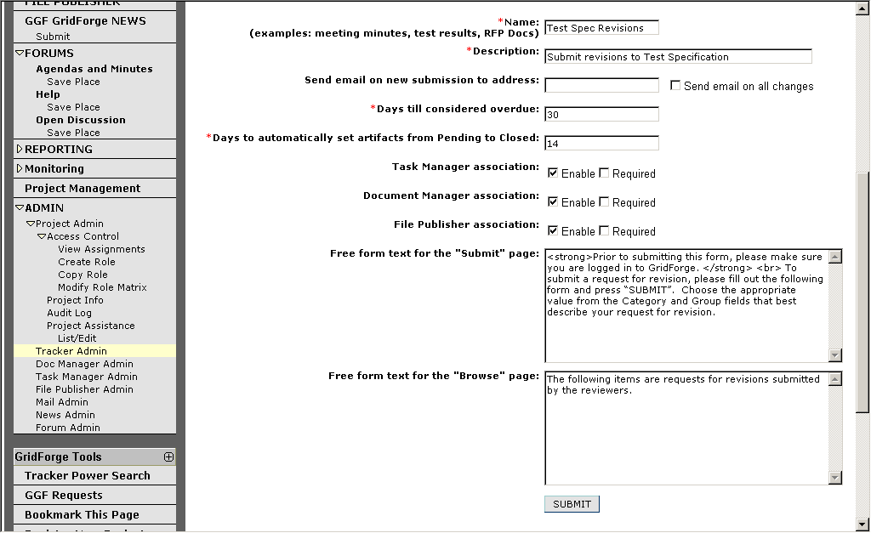

- Type in the email address of the individual you wish to act as a “moderator” of the tracker (i.e., the one who should first be aware of it and make appropriate updates to status and assignment). Deselect the “Send mail on all changes” check box.
- Leave the next several fields as the default.
- In the “Free form text for Submit page” pane, copy and paste the following text:
<strong>Prior to submitting this form, please make sure you are logged in to GridForge. </strong> <br> To submit a request for revision, please fill out the following form and press “SUBMIT”. Choose the appropriate value from the Category and Group fields that best describe your request for revision.”
(Note: If you wish to give more explicit instructions about the custom values of the Category and Group field, feel free to do so.)
- In the “Free form text for Browse Page” pane, copy and paste the following text:
“The following items are requests for revisions submitted by the reviewers.”
(Note: If you wish to be more explicit in your description of the items that are
listed, feel free to do so.)
- When you have filled out the form, press the “SUBMIT” button to create the new tracker.

Customizing a Tracker

Once a tracker is created, an administrator will want to customize the fields and field values of the tracker to gather the information pertinent to the reason for the tracker (i.e., in this case, recording revision requests).

Steps for Customizing the Fields and Field Values of a Tracker

- Logon to GridForge as a project administrator.
- Browse to the project in which the tracker resides.
- Click on the triangle next to the ADMIN link on the left navigation bar and select “Tracker Admin”.

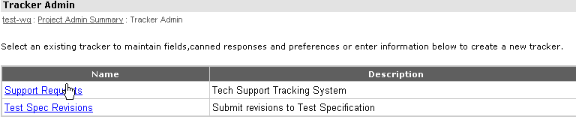

- Select the tracker to be customized from the list of existing trackers displayed.

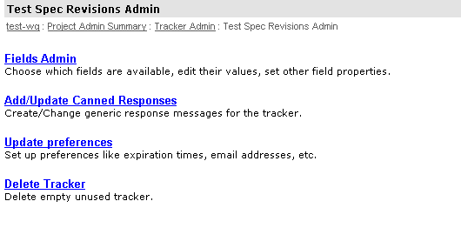
- Select “Fields Admin”.
- Scroll down to the row containing “Group” and select the “Configure” link on that row to the far right.

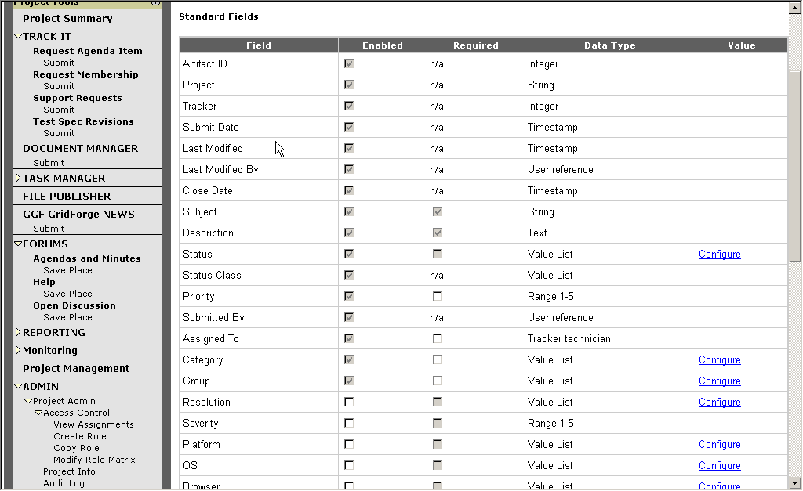

- Type in the values of the “Group” list you wish to have. Examples might be “Typo”, “Missing Figure”, “Reference Needed”, “Unclear”, or any number of other groups of revisions. Type these (four or less at a time) into the “New Value” table and press “Update”.
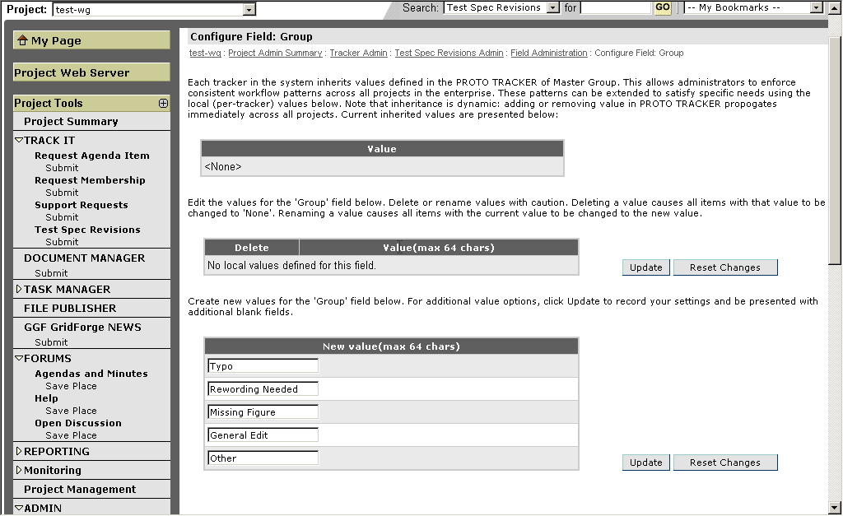

- Return to the “Fields Admin” page and select the “Configure” link to the far right of the row containing “Category”.
- Determine the values for the “Category” list you wish to have. These are typically sections of the document like chapters or sub-sections. If you have particular contributors that are responsible for particular sections, you may wish to give these sections meta-names (e.g., WSDL section). Type these values into the “New Value” table (up to 4 at a time). Prior to submitting, if you wish that submitted item be sent directly to the contributor responsible for the selected section, then select the contributor’s name from the “auto-assign to” drop-down. When the table is filled out, press the “Update” button.

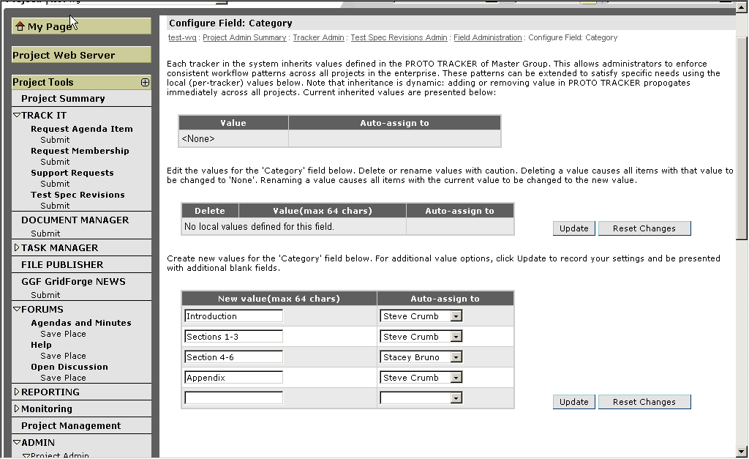

Submitting Revisions

Once the tracker is created and customized, document reviewers may use it to request revisions to documents.

Steps for Submitting Document revisions using a tracker:

- Logon to GridForge and go to the project in which the document resides.
- Select the triangle next to the “TRACK IT” link in the left navigation bar.
- Select the “Submit” link immediately below the Tracker referencing the document for which you wish to submit revisions.
- Fill out the tracker item form, selecting the appropriate values from the “Category” and “Group” drop-downs.

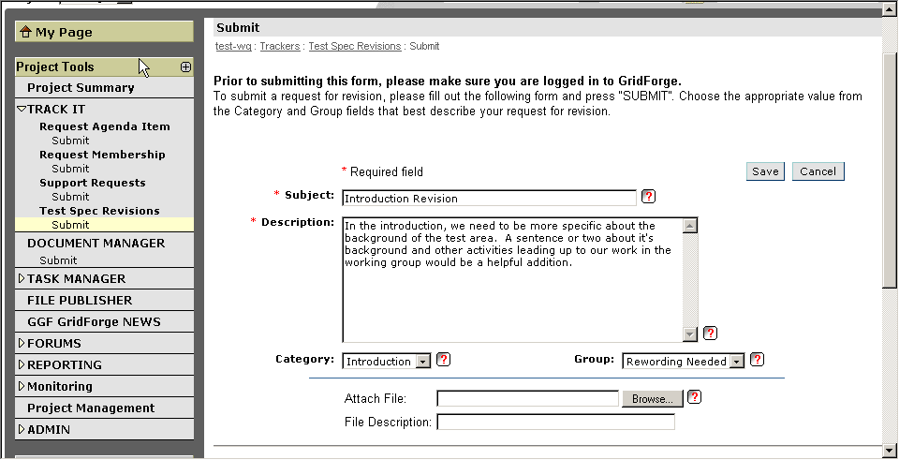

- You may choose to attach a marked-up version of the document in the “Attach File” field by browsing and selecting a document accessible on your local machine.
- After the form is complete, press the “Save” button to create the tracker item.

Updating Current Versions of Drafts

Once requests for revisions begin to come in via the tracker, document authors and editors will want to make updates and create new versions of the draft. A typical draft document will go through many versions prior to being sent to the GGF Editor for comment. The previous sections indicated that it is important to keep the current versions of drafts available in the “Current Drafts” folder. However, group members often want to view previous versions and may even wish to keep a certain version as “public” while a newer version is being reviewed. GridForge document manager supports both of these needs with having to keeping copies of the document’s previous versions.

Steps for Loading an Updated Draft

- Logon to GridForge and browse to the project containing the document you wish to update.
- Click on the “Document Manager” link from the left navigation bar.
- Browse to the folder containing the document you wish to update and open it.
- Find the document you wish to update and click on the “Details” link next to the document title.
- Press the “Edit” button at the bottom of the next form.
- This displays the Edit Document form.

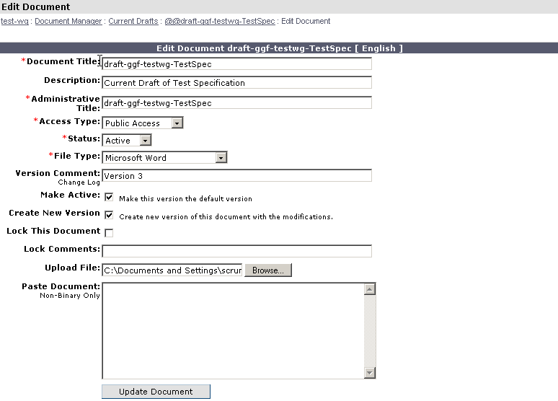

- Press the “Browse” button and find the updated version of the document on your local machine. You may wish to supply a Version Comment as well.
- When complete, press the “Update Document” button and GridForge will replace the old version of the document with the uploaded version you provided.

Section 6 Milestones and Tasks

As part of the group approval process the GFSG requires that a group set specific milestones for productivity. These milestones may be workshops held, documents completed, or a variety of other deliverables. GridForge provides a task management tool, similar to project management software that can be used to record the milestones and track progress and completion. Milestones are becoming an important metric in determining a group’s effectiveness. Area Directors and the steering group in general will begin using GridForge’s project management capabilities to track progress toward the milestones of each group. It is vital, then, that groups load their milestones, record progress toward completion, and mark milestones completed.

Each group will be created with a master task group called “GGF Group Milestones” and a sub-group that has the same name as the group (e.g., test-wg). Chairs should record the milestones of the group and mark progress toward completion of the milestone in this sub-group.

Steps for initially loading milestones:

- Logon to GridForge and browse to your project.
- Click on the triangle next to “Task Manager” in the left navigation bar.
- Click on “Add Task”
- You will be presented with an Add Task Form.

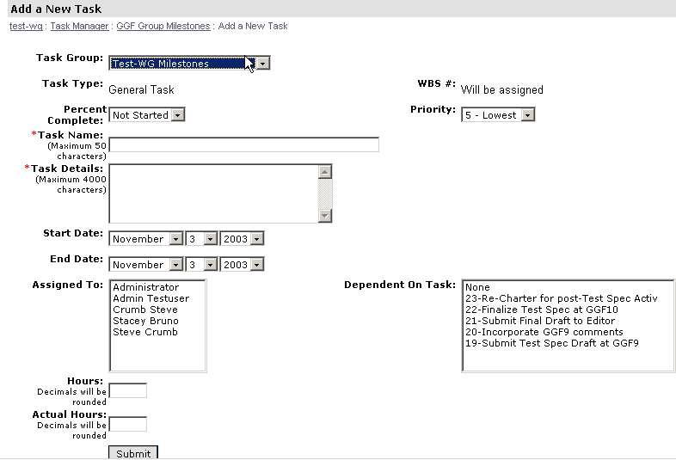

- The Task Group should already reflect the name of your group. Fill in the Task Name and Task Details with your milestone name and a brief description.
- Set the start and end dates. (Note: If your milestone is related to a particular GGF meeting, Spring meetings are normally held in early March, summer in early June, and Fall in early October.
- Select the Assigned To person(s) (if applicable).
- If the task is dependent on the completion of another previously defined task, select it from the “Dependent On Task” pane.
- Press the Submit button to add the milestone into task manager.

Steps for updating progress toward milestones:

- Logon to GridForge and browse to your project.
- Click on the triangle next to “Task Manager” in the left navigation bar.
- Click “GGF Group Milestones” and you will be presented with a list of tasks resident in the project.

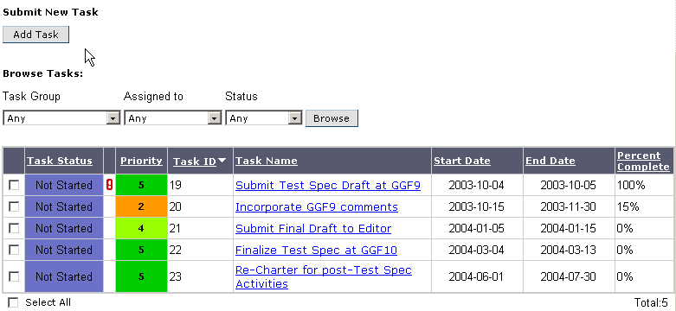

- Select the task name of the task you wish to update. This will result in a modify task details form.

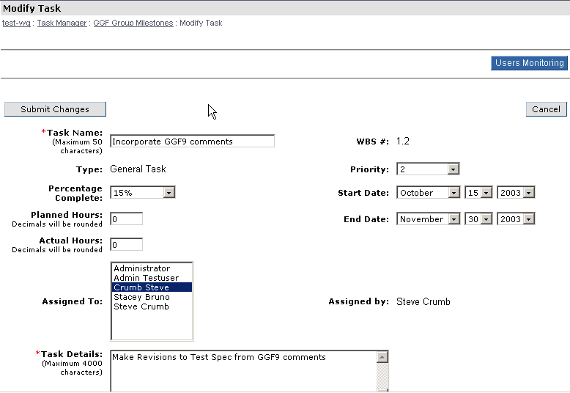

- You may make what ever updates you wish to the details. Since the milestone end dates are linked to your charter milestones, please do not update milestone end dates without first discussing it with your Area Director.
- When updates are complete, press the “Submit Changes” button to update the task.

Steps for closing a task:

- Logon to GridForge and browse to your project.
- Click on the triangle next to “Task Manager” in the left navigation bar.
- Click “GGF Group Milestones” and you will be presented with a list of tasks resident in the project.

- Select the task name of the task you wish to update. This will result in a modify task details form.

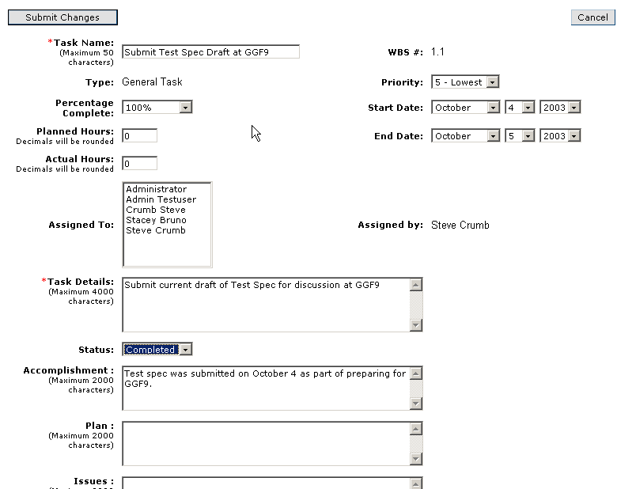

- To close a task, select “Completed” from the Status drop-down. Also, you may wish to select 100% from the Percentage Complete drop-down and fill out the Accomplishment pane with details on the completion of the task.
- Press the “Submit Changes” button when you are done.

- Area Directors
  - Interacting with ADs
  - Trackers (or Forum?) for each Group?
- Sessions at GGF meetings
  - Tracker in Chair Project?
  - Post agenda
- General Project Information
  - Email
  - Request Information from Chair Tracker
- Group shutdown and re-chartering
  - Interact with AD
  - AD submits Group-Infra tracker
  - Re-chartering
- Chair Project
  - IP Policy (i.e., make aware that it is in effect)
Copy available in the Editor project along with the GWD template

