OGF  Category: Community Practice  Grid and Virtualization Working Group  http://forge.gridforum.org/sf/projects/gridvirt-wg | Editors:  Wolfgang Reichert, IBM  Erol Bozak, SAP  Created: July 2007  Last update: January 2008

Grid and Virtualization
Use Cases

Status of This Memo

This memo provides information to the Grid community regarding server virtualization technology. It does not define any standards or technical recommendations. Distribution is unlimited.

Copyright Notice

Copyright © Open Grid Forum (2007). All Rights Reserved.

Abstract
This document defines the use cases wherein the grid infrastructure is seen participating in an virtualized system infrastructure. The use cases are described from the application point of view and benefit rather than from a technical infrastructure perspective.

A communication model is developed which is in alignment with the OGF Reference Model and the DMTF System Virtualization standard. The use cases are described in the terminology of these models.

In the second part of the paper new high level application interfaces are proposed.

Contents
Abstract 2
Contents 3
1 Introduction 4
1.1 System Virtualization 5
1.2 The OGF Reference Model 6
1.3 DMTF System Virtualization Standard 9
1.4 Conclusion 10
2 Use Cases 10
2.1 Migration of Virtual Systems during Runtime 11
2.1.1 Power Saving 11
2.1.2 (Planned) Maintenance 12
2.1.3 Changing capacity requirements 13
2.1.4 Changing capacity offering / availability 13
2.2 Dynamic Resizing 13
2.2.1 Changing Capacity Requirements 13
2.2.2 Changing Capacity Offering / Availability 14
2.3 Snapshotting 14
2.3.1 Stateful Cloning 14
2.3.2 Protecting (long running) Jobs from Software or Hardware Failures 15
2.3.3 Reproducing Situations 15
2.4 Isolation 16
2.4.1 Metering of Job Resource Consumption 16
2.4.2 Resource Consumption Control & Enforcement 16
2.4.3 Protection against Malware 16
2.4.4 Ensuring Security 17
2.4.5 Avoiding Conflicts 17
2.5 Provisioning Scenarios 17
2.5.1 Emulating an Environment for Legacy Jobs 17
3 Refining Runtime Scenarios 17
3.1 Grid Virtualization Model 17
3.2 Model Extensions 20
3.3 Interface Specification Proposal 23
3.3.1 Query available systems and their topology 23
3.3.2 Query available resources and capabilities 23
3.3.3 Resize system 24
3.3.4 Live migration 24

Introduction
A virtualization platform (like a hypervisor or virtual machine) provides functions and capabilities which allow to decouple virtual systems and virtual resources from their physical representation. Although a virtual system may behave like a physical system, there is not necessarily a direct or permanent relationship between a virtual system and the physical host system.

Virtualization is designed to be transparent. This means that all previously known grid scenarios apply to virtual systems as well. Nevertheless, the concept of virtualization introduces new capabilities. They allow for additional use cases. These new use cases are described here.

In this document the use cases are arranged by virtualization capabilities. Each section is dedicated to one virtualization capability. The respective use cases are described in alignment with the DMTF System Virtualization standard and the OGF Reference Model.

In November 2007, the DMTF releases the long-awaited standard for System Virtualization Management. Implementations have been already made available for several platforms. See http://www.dmtf.org.

The reference model has been first published by the Enterprise Grid Alliance (EGA) consortium with the purpose of defining a common context in terms of enumerating and classifying the set of components to be managed within an enterprise grid. See http://www.gridalliance.org.

For terms and definition used within this document refer to the adjoining paper “Grid and Virtualization – Terminology” at http://forge.gridforum.org/sf/projects/gridvirt-wg.

System Virtualization
Virtualization is a broad term that refers to the abstraction of computer resources. One useful definition is "a technique for hiding the physical characteristics of computing resources from the way in which other systems, applications, or end users interact with those resources. This includes making a single physical resource (such as a server, an operating system, an application, or storage device) appear to function as multiple logical resources; or it can include making multiple physical resources (such as storage devices or servers) appear as a single logical resource." It can also include making one physical resource to appear, with somewhat different characteristics, as one logical resource. (http://en.wikipedia.org/wiki/Virtualization)

In 1972, IBM introduced VM (Virtual Machine) on the mainframe, today known as z/VM. IBM System z evolved to a sophisticated virtualization platform integrating hardware, hypervisor and operating system. See http://ibm.com/systems/z/.

System virtualization has gained mass popularity with VMware (http://vmware.com), XEN (http://xen.com), Advanced POWER Virtualization (http://ibm.com/systems/p/), and other. Virtualization concepts are today available on all hardware architectures and for all kind of operating systems. Capabilities, features and interfaces are different.

In the context of this document we focus on system or platform virtualization. Other areas of virtualization (like network or storage virtualization) are implicitly assumed by some use cases but not explicitly referred to.

The following illustration shows the various concepts of virtualization. Virtualization decouples the presentation of the system resources to the consumer/application from the actual physical resources.



Illustration 1: Virtualization Concepts
Virtual Machine
Sharing
…
Virtual Machine
Hardware
Virtual Machine
Aggregation
…
Virtual Machine
Hardware
Virtual Machine
Emulation
…
Virtual Machine
Hardware
Virtual Machine
Insulation
…
Virtual Machine
Hardware

Sharing: System resources (like processors, memory, i/o adapters) are shared among multiple virtual systems. This concept allows more flexibility and better utilization.

Aggregation: Virtual resources span multiple physical resources. The physical boundaries (like capacity of a single disk drive) are not visible to the consumer.

Emulation: Old, no longer available hardware is emulated to allow execution of legacy applications. New, not yet existing hardware is simulated to develop and test new software concurrently with the hardware it shall run on.

Insulation: Hardware can be exchanged on-the-fly without disturbing running applications. Another example is live migration of a virtual system to a different location.

Besides the basic concepts several platforms allow for dynamic resource allocation and assignment. An application should not assume that resource attributes (e.g. capacity) are fix during its lifetime.

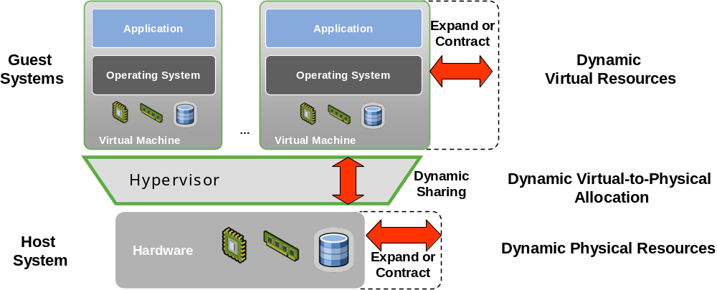
Illustration 2: Virtualization Concepts

The OGF Reference Model
When describing use cases it makes sense to rely on existing concepts and terminology. We decided to use the OGF Reference Model. We are aware that any model might be negotiated. For our purpose we believe that the conclusions – here in the context of system virtualization – are more relevant than any details of the underlying model. See heading “ ”.

The OGF reference model defines an enterprise grid as a collection of interconnected (networked) grid components under the control of a grid management entity.

The grid component is a super class of object from which all of the components that are managed within an enterprise grid are descended or derived. This may include, but is not necessarily limited to –
- Traditional resources such as servers, network switches, routers, SAN switches, disk arrays and so forth.
- Applications or services such as databases, an ERP service, an online bookstore etc.
- Everything in between which could be considered to be a meta-resource or a component of a service.

The Grid Management Entity (GME) is that logical entity that manages –
- The grid components.
- The relationships between various grid components.
- Their life cycles.

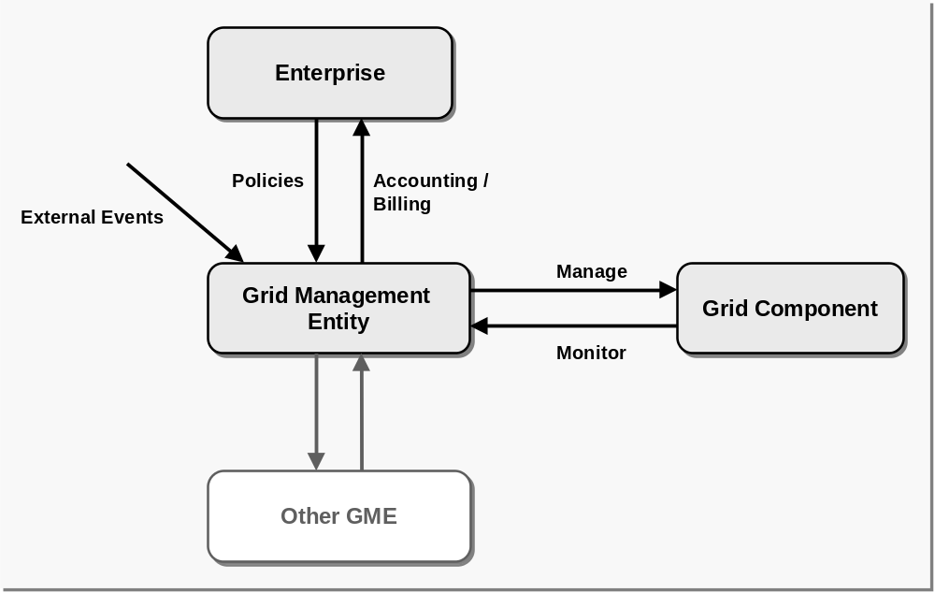
Illustration 3: The role of the Grid Management Entity (GME)
The GME is logically distinct from the managed grid components. All management functionality resides in the GME.

A grid component is monitored and managed by exactly one GME. A GME may communicate with other GMEs. GMEs may build up a hierachical system of GMEs. Management commands / policies / events propagate top down through the GMEs, whereby each GME applies the action accordingly to its own grid component(s).

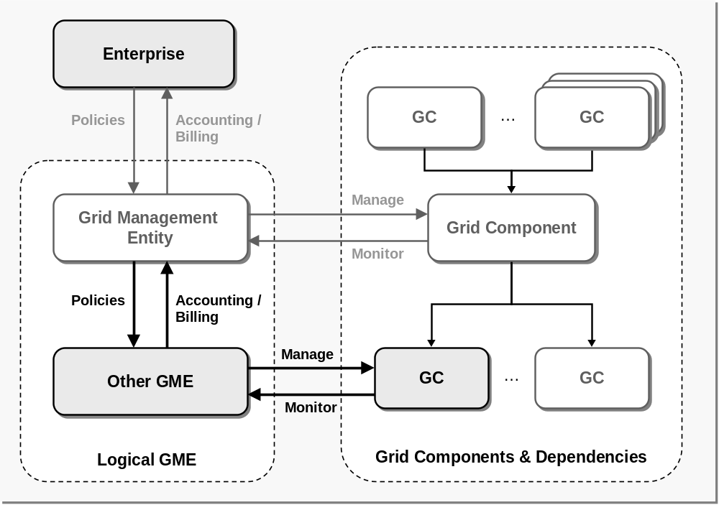
Illustration 4: Hierarchy of grid components and grid management entities
The GME is also responsible for applying the service level agreements within its scope.

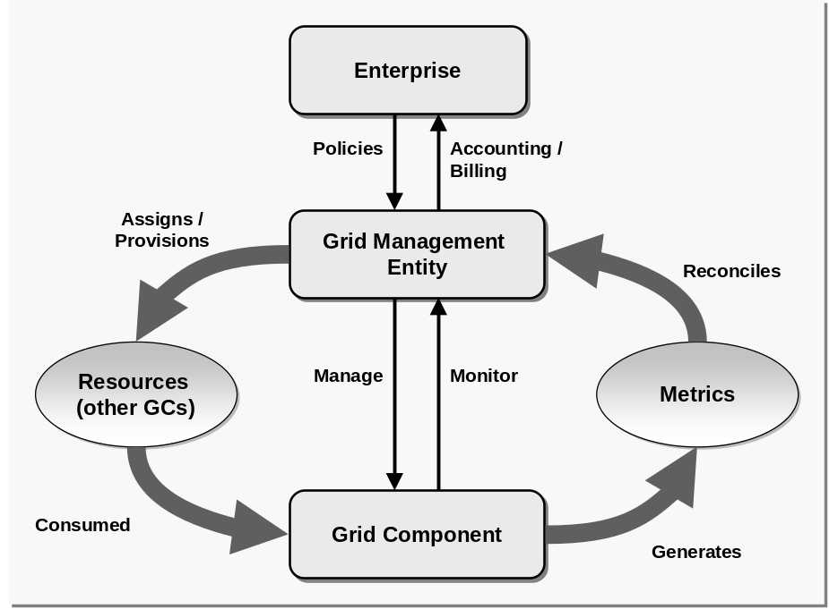
Illustration 5: Service Level Management

DMTF System Virtualization Standard
In November 2007, the DMTF released an open standard on system virtualization. The standard has been prepared by the System Virtualization, Partitioning and Clusterung (SVPC) working group. The standard is described by so called profiles. Most relevant for us are:
- System Virtualization Profile (http://www.dmtf.org/standards/published_documents/DSP1042.pdf)
- Virtual System Profile (http://www.dmtf.org/standards/published_documents/DSP1057.pdf)

The System Virtualization Profile defines a top-level object model for the inspection and control of system virtualization facilities provided by host systems. It supports the following range of functions:
- the detection of host systems that provide system virtualization facilities
- the discovery of scoped host resources
- the discovery of scoped resource pools
- the inspection of host system capabilities for
  - the creation and manipulation of virtual systems
  - the allocation of resources of various types
- the inspection of resource pool capabilities
- the discovery of hosted virtual systems
- the inspection of relationships between host entities (host systems, host resources, and resource pools) and virtual entities (virtual systems and virtual resources)
- the creation and manipulation of virtual systems using input configurations, predefined
- configurations available at the host system, or both
- the creation and manipulation of snapshots that capture the configuration and state of a virtual system at a particular point in time

The Virtual System Profile focuses on virtualization aspects that relate to virtual systems and their virtual resources, such as modeling the structure of virtual systems and their resources.
The profile introduces the concept of virtual system configurations allowing the inspection of virtual system configuration and state information.

DMTF describes virtualization as a dualism between a virtual and a physical world. Applications use a virtual system with virtual resources. They do not see the physical world. The following illustration shows the model in a very simplied way.

The Virtual System is hosted by a Host System. In the model both are of the same abstract type CIM_ComputerSystem.

Physical resources are grouped into resource pools. The Virtual System allocates resources from these pools. This way resource sharing is modeled.

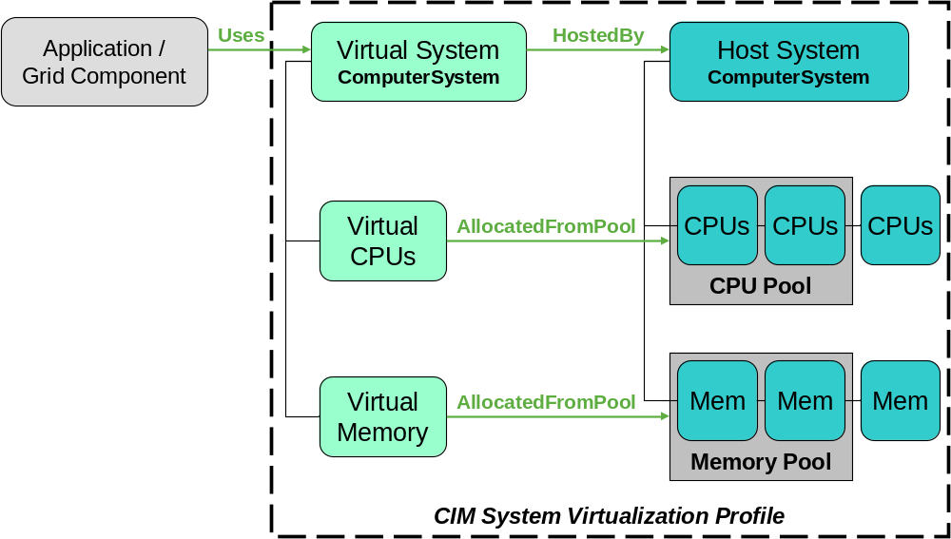
Illustration 6: DMTF System Virtualization Model (very simplified)

Conclusion
The following important conclusions are taken from the described model:

- Application logic is separated from and independent of any system management.

- The application code (Grid Component) need not and should not have any “intelligence” or knowledge to manage its runtime environment. It is platform-agnostic.

- It is desired that the application (Grid component) is “virtualization friendly”. The application shall allocate resources only when needed and deallocate them if no longer needed. It shall not assume that any allocated resources are physical and dedicated nor that resource attributes and capacity are unchanged during lifetime. Furthermore, it is desired that the application is instrumented for monitoring (e.g. progress indicator).

- Any management capabilities and communication with the platform should be handled by a management entity (GME). This component needs to be virtualization aware and enabled.

- The virtualization platform manager is considered to be an implementation of the CIM profiles and classes (like CIM_ComputerSystem) as described in the DMTF System Virtualization standard. It is assumed that the application GME understands CIM to the extent it exploits system capabilities. It directly communicates with the respective CIM Object Manager(s).

Use Cases
A use case describes what a user or administrator wants to do. The technical capability is one method to achieve the desired task.

Since we want to define the communication paths and methods later on, the use cases are sorted here by virtualization capabilities.

Virtualization use cases
Power saving
Planned maintenance
Changing capacity requirements
Changing capacity offering/availability
Stateful cloning
Protecting long running jobs from system failures
Reproducing situations
Metering of job resource consumption
Resource consumption enforcement
Protection against malware
Ensuring Security
Avoiding conflicts
Emulating an environment for legacy jobs
Live migration
Dynamic resizing
Snapshotting
Isolation
Provisioning
Virtualization capabilities

Migration of Virtual Systems during Runtime
Some virtualization platforms (e.g. IBM System p, VMWare, XEN) support live migration of a virtual system to another physical server. This happens transparently to the applications which run on the virtual system.

Power Saving
The resource manager may pool virtual systems to a reduced number of physical systems in order to save power.

Power Saving
Trigger | Action
- Policy-driven  - Monitor event  - Resource utilization below threshold  - Temperature above threshold  - External event  - From hierarchically higher GME | - Communication with System Virtualization GME(s) for live migration  - Resource allocation / deallocation  - Notification of grid component (before and after live migration)  - Accounting event

(Planned) Maintenance
The physical system as well as the hypervisor could require maintenance activities to be performed (e.g. install patch, hw upgrade or driver etc.). The running job could be migrated to other machines without downtime.

(Planned) Maintenance
Trigger | Action
- External event | - Communication with System Virtualization GME(s) for live migration  - Resource allocation / deallocation  - Notification of grid component (before and after live migration)  - Accounting event

Changing capacity requirements
During runtime the job may require additional capacity (e.g. CPU capacity, Memory capacity, I/O bandwidth). If the underlying physical system is not able to serve the requirements the resource manager may migrate the job / virtual system to another physical system that fulfills the capacity requirements.

Changing capacity offering / availability
Capacity availability may change in the environment because of recently freed resources by the completed jobs or additional physical systems may be introduced. In these situations the resource manager may decide to utilize available capacity for the running jobs through migration.

Dynamic Resizing

Changing Capacity Requirements
During runtime the job may require additional capacity (e.g. CPU capacity, Memory capacity, I/O bandwidth etc.). If the underlying physical system is able to serve the requirements more capacity for the job / virtual system can be provided locally on the same physical system.

Dynamic Resizing
Trigger | Action
- Policy-driven  - Monitor event  - SLO is going to be missed (progress indicator, trend analysis)  - Grid component event  - Dynamic resource requirements  - External event  - Dynamic resource availability | - Communication with System Virtualization GME for system resizing  - Virtual resource reallocation  - Changing system parameters/settings  - Notification of grid component (before and after resizing)  - Accounting event

Changing Capacity Offering / Availability
Capacity availability may change in the physical system (e.g. CPU capacity, Memory capacity, I/O bandwidth etc.) because of recently freed resources by the completed jobs. In these situations available capacity can be utilized for the running jobs.

Snapshotting

Stateful Cloning
The execution of a job may require costly preparation steps, e.g. retrieving data from the backend, which might be common to all jobs of an activity / application. Rather than doing the preparation separately for each job one (or the first) job can be snapshotted after the preparation and the state can be cloned and distributed.

Stateful Cloning
Trigger | Action
- Policy-driven or external request from top-level GME  - Subsequent provisioning scenario using the snapshot | - Communication with System Virtualization GME to take snapshot  - Notification when snapshot has been taken  - Accounting event  Top-level GME manages  - Cloning of the snapshot (distribution, post-processing)  - Provisioning scenario

Protecting (long running) Jobs from Software or Hardware Failures
By providing recovery points that can be re-activated (long running) jobs can be restarted at a certain persisted state potentially on a different physical system.

Reproducing Situations
For purpose of diagnosis (error or performance analysis etc.) the user may repetitively re-run the same job from a certain persisted state.

Reproducing Situations
Trigger | Action
- External event to take snapshot  - External event to restart from persisted state | - Communication with System Virtualization GME to take snapshot  - Communication with System Virtualization GME to restart from snapshot

Isolation

Metering of Job Resource Consumption
For the purpose of accounting and billing, metering via the virtualization platform provides more accurate data.

Resource Consumption Control & Enforcement
Through isolation the amount / degree of resource consumption can be controlled and leveled, i.e. greedy jobs can be controlled.

Protection against Malware
To protect jobs from other jobs that may fail and consequently impact other jobs from proper execution the jobs may be executed isolated in dedicated virtual systems. The hypervisor ensures that a malfunctioning virtual system does not impact other parties.

Ensuring Security
To protect the job from spyware the job can be executed in its own dedicated and certified virtual system. The system is cleaned up after the job has completed.

Avoiding Conflicts
Jobs may require certain resources from the system to be allocated statically, e.g. a certain port number. To resolve conflicts between different jobs the jobs may be executed isolated in virtual systems while sharing physical resources.

Provisioning Scenarios
Standard grid provisioning scenarios are extended in a virtual system environment:
Rather than searching for and allocating resources for the job resources can be “created” on demand. Available physical systems and resources can be divided into smaller parts as needed. The provisioning manager needs to understand the additional capabilities. We expect that over time the trend will be to run every workload in its own virtual environment (e. g. LPAR, Container). The software stack is created as needed and the system is cleaned up afterwards.

This has several advantages as listed below.

Emulating an Environment for Legacy Jobs
Legacy applications / jobs may require certain physical resources or a certain runtime environment (e.g. operating system). In this situation a virtual system may emulate the legacy environment.

Refining Runtime Scenarios
In this section the runtime scenarios Live migration and Dynamic resizing are refined. These covers the dynamics of a virtual system that are feasible during the lifetime of an application/job.

It includes the following use cases:
- Power saving
- Planned maintenance
- Changing capacity requirements (on behalf of the application)
- Changing capacity offering/availability (on behalf of the system)

System provisioning and cloning is left for a later chapter.

Grid Virtualization Model
The component model used for the grid virtualization use cases is introduced. This model shows the relationships and communication paths. This model is based on the DMTF System Virtualization standard and the OGF Reference Model.

The following illustrations show various aspects and relationships etc. of the same model. Similar to the DMTF model a dualism is choosen:
- The application view is a logical view on the grid components. The management hierarchy is independent of any systems. “Enterprise” is logically the top manager of a grid. One of more layers of Grid managers can be below. At the bottom are the individual grid components which are implementations of the application logic. A grid component is managed by exactly one GME.
- The server view is the management view of the datacenter administrator. It contains all Virtual and Host Systems and their resources within a datacenter.

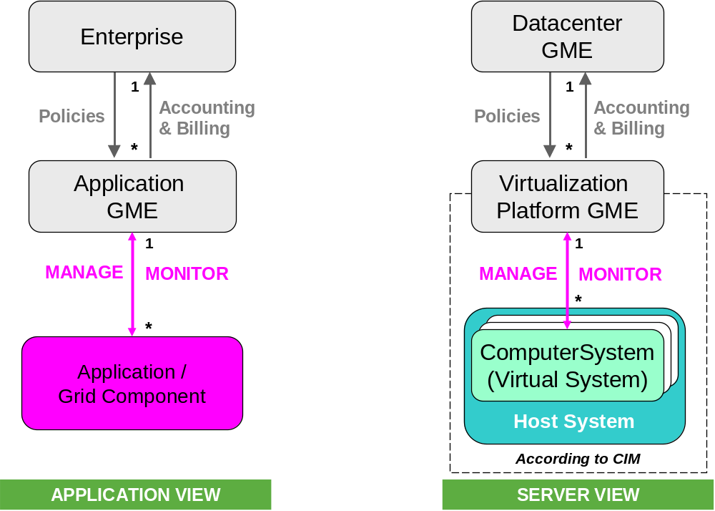
Illustration 7: Management Hierarchy
The next illustration shows the USE relationships. The Grid Enterprise is deployed in one or more datacenters. The individual application/grid component runs on a Virtual System and implicitly uses resources owned by this Virtual System.

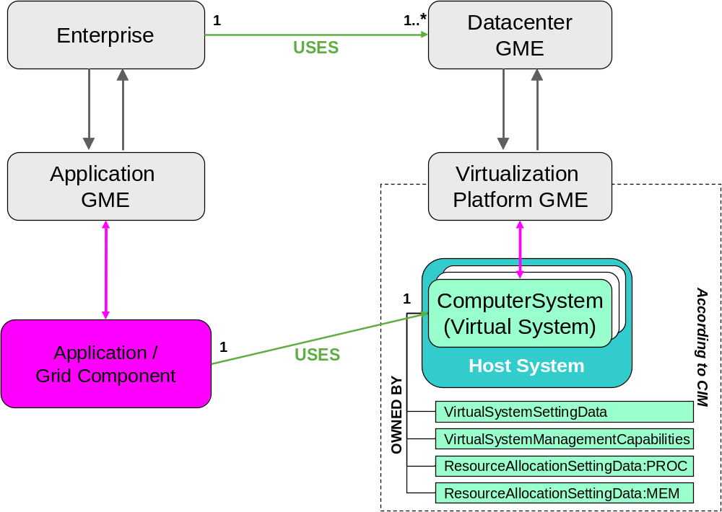
Illustration 8: Use Relationship
The Enterprise communicates with the management system of the datacenter(s). The Application GME communicates with the Virtualization Platform manager. There is no direct communication between the Application/Grid Component and the computer systems because the application logic should be platform-agnostic.

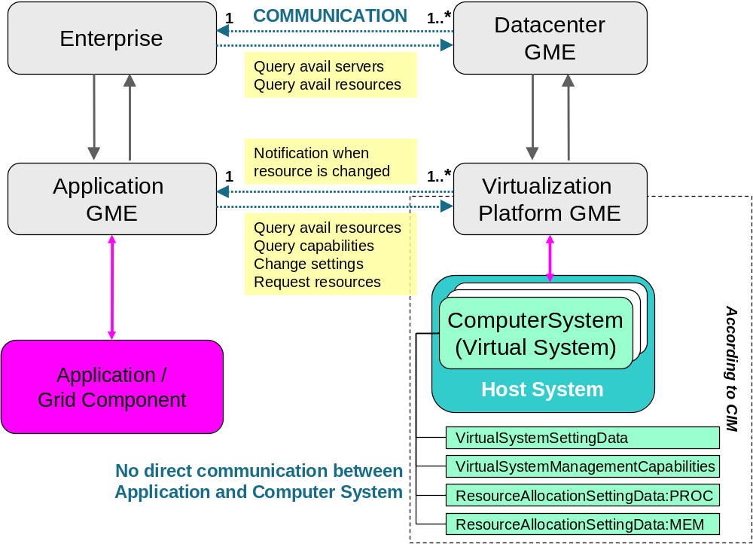
Illustration 9: Communication Paths

Model Extensions
The described model implies that the Grid Managers explicitly allocate servers and resources. This works well if an application runs either on dedicated servers/resources or, on the opposite, is entitled to use idle resources only. Resource allocation, however, becomes difficult if various, unrelated applications compete for the same servers or resources.

One approach is to define Business Policies. Typically priorities and goals are specified on a higher level in business terms, e.g. desired completion time or throughput, relative business priority etc. It is now the job of the Grid Manager to calculate derived policies and abstract resource requirements for the individual Grid components which are understood by the respective system management entity.

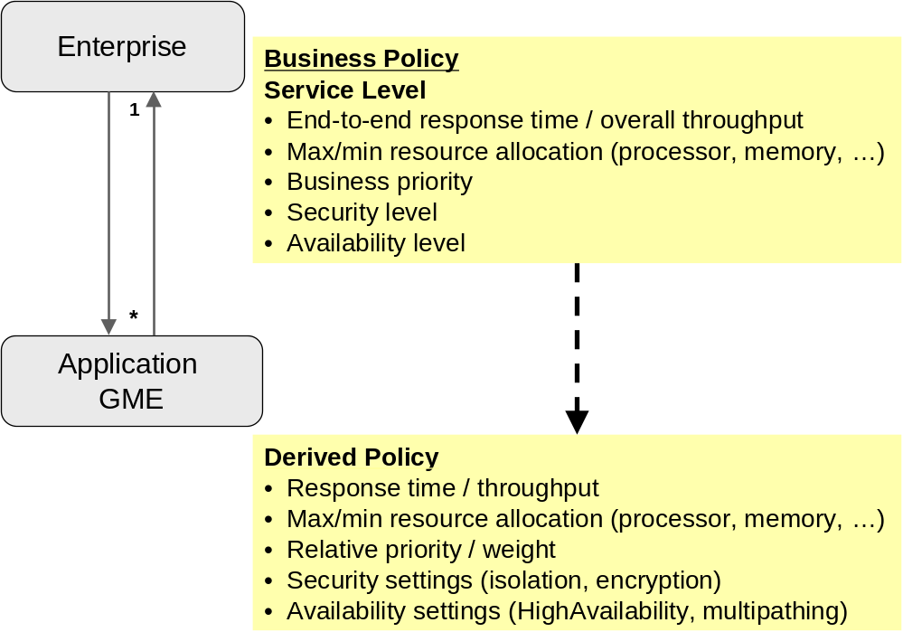
Illustration 10: Policy Hierarchy
Some platforms offer workload management capabilities. Efficient workload management is quite important in the context of virtualization. Grid Managers should be aware of such a feature and exploit it when appropriate.

A Local Workload Manager is responsible for resource balancing and arbitration within a system. A workload manager on the host system level balances the resources between the co-located virtual systems. An operating system workload manager handles workload within a single virtual system. Both levels of workload management must collaborate seemlessly to be efficient.

Local workload management is to be considered part of the Virtual Platform management. For the Grid manager it should not be an additional communication partner, rather an extension to the basic interface.

An Enterprise Workload Manager works on the datacenter level. Especially for distributed applications (like Grid) such a global coordinator is valuable and allows an end-to-end view. Assuming well instrumented applications, the Enterprise Workload Manager monitors the contribution and relevance of the individual components on the end-to-end goal and advices the local workload managers accordingly.

Again, the Enterprise Workload Manager should not add a communication channel. Rather it should add the capability to pass some kind of business policy through the existing communication path.

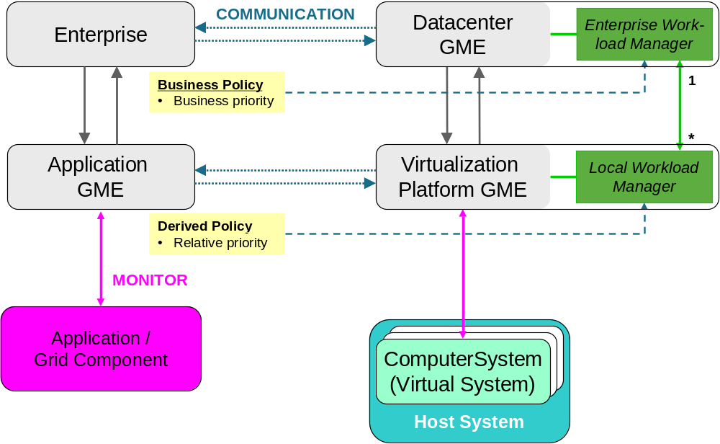
Illustration 11: Workload Management
In fact, Grid load balancing and dispatching cannot be done independent of existing workload managers. Otherwise this could be counterproductive and inefficient. A mutual understanding on the respective levels is desired, as indicated in the following illustration.

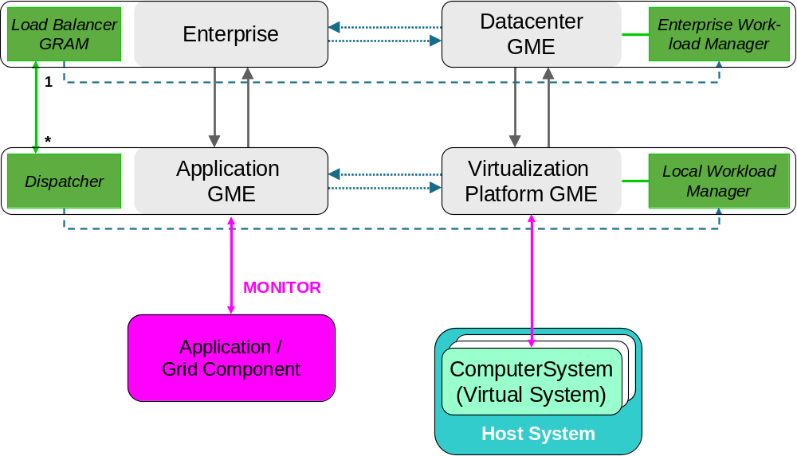
Illustration 12: Workload Management

Interface Specification Proposal
This section describes what data need to be exchanged to implement the particular runtime scenarios Live migration and Dynamic resizing.

Query available systems and their topology

GetAllHostSystems
Input:
- With Filter: Hardware architecture (INTEL, POWER, …)
- With Filter: Virtualization type (XEN, VMware, z/VM, …)
Output:
- List of hostnames

GetAllVirtualSystems
Input:
- With Filter: State (Active, Defined, …)
- With Filter: RunningOperatingSystem (Linux, Windows, AIX …)
Output:
- List of hostnames

GetAllVirtualSystemsOnHost
Input:
- With Filter: State (Active, Defined, …)
- With Filter: RunningOperatingSystem (Linux, Windows, AIX …)
Output:
- List of hostnames

Note that virtualization is not limited to two layers. In fact it is a tree. A virtual system might be a host system for other virtual systems. The tree is navigated starting with the physical = lowest level host system. (Navigation from the virtual system to the underlying host system is – for various reasons – not supported on some platforms nor defined in the DMTF System Virtualization standard.)

In this proposal, the filters are added for convenience. The CIM Object Manager returns a list of all known CIM_ComputerSystems. Then the attributes and associations need to be queried for each system one by one.

@To be extended and discussed…

Query available resources and capabilities
GetVirtualSystemSettings
Input:
- Hostname
Output:
- VirtualSystemSettingData

GetVirtualSystemCapabilities
Input:
- Hostname
Output:
- VirtualSystemManagementCapabilities

GetResourceAllocationSettings
Input:
- Hostname
Output:
- ResourceAllocationSettingData
- Available resources in the pool

@To be extended and discussed…

Resize system
ChangeVirtualSystemSettings
Input:
- Hostname
Output:
- VirtualSystemSettingData

ChangeResourceAllocationSettings
Input:
- Hostname
Output:
- ResourceAllocationSettingData

@To be extended and discussed…

Live migration
MigrateVirtualSystemToHost
Input:
- Hostname of virtual system to be migrated
- Hostname of target host system
Output:
- JobID

MigrateVirtualSystemToHost_Test
Input:
- Hostname of virtual system to be migrated
- Hostname of target host system
Output:
- Indicator (TRUE, FALSE)

MigrateVirtualSystem_FindTargetHosts
Input:
- Hostname of virtual system to be migrated
Output:
- List of possible target host systems

@To be extended and discussed…

