Grid Scheduling Architecture -
Requirements

Status of this Memo
This document provides information to the community regarding the requirements on a Grid scheduling architecture. It reflects the discussions and results of the research group on Grid Scheduling Architecture. Distribution of this document is unlimited. This is a DRAFT document and continues to be revised.
Abstract
Grids will provide a large variety of complex services. The interactions of those services require an integrated and extensible scheduling and management of the resources involved, something which is currently not readily available. Access to resources is typically subject to individual access, accounting, priority, and security policies of the resource owners. Those access policies are typically enforced by local management systems. Therefore, an architecture that supports the interaction of independent local management systems with higher-level scheduling services is an important component for Grids. Furthermore, users of a Grid may also establish individual scheduling objectives. Future Grid scheduling and resource management systems must consider those constraints in the scheduling process. Taking into account different scheduling policies is also important for the implementation of various economic and business models.
The goal of the Grid Scheduling Architecture Research Group (GSA-RG) is to define a scheduling architecture that supports cooperation between different scheduling instances for arbitrary Grid resources. Candidate resources include network, software, data, storage and processing units. The research group will particularly address the interaction between resource management and data management. Co-allocation and the reservation of resources are key aspects of the new scheduling architecture, which will also include the integration of user or provider defined scheduling policies.
In this document the required components of a modular scheduling architecture and their interactions are identified. This does not include detailed information about the protocols and interfaces involved. Instead, the need of specific services and protocols are compiled from the view of a designer of Grid scheduling strategies. The output should serve as a starting point of discussion between existing efforts between scheduling initiatives and current core services to facilitate the setup of a Grid scheduling architecture with individual implementations of specific scheduling strategies.


GLOBAL GRID FORUM
office@gridforum.org
www.ggf.org

Full Copyright Notice
Copyright © Global Grid Forum (2005). All Rights Reserved.
This document and translations of it may be copied and furnished to others, and derivative works that comment on or otherwise explain it or assist in its implementation may be prepared, copied, published and distributed, in whole or in part, without restriction of any kind, provided that the above copyright notice and this paragraph are included on all such copies and derivative works. However, this document itself may not be modified in any way, such as by removing the copyright notice or references to the GGF or other organizations, except as needed for the purpose of developing Grid Recommendations in which case the procedures for copyrights defined in the GGF Document process must be followed, or as required to translate it into languages other than English.
The limited permissions granted above are perpetual and will not be revoked by the GGF or its successors or assigns.
This document and the information contained herein is provided on an "AS IS" basis and THE GLOBAL GRID FORUM DISCLAIMS ALL WARRANTIES, EXPRESS OR IMPLIED, INCLUDING BUT NOT LIMITED TO ANY WARRANTY THAT THE USE OF THE INFORMATION HEREIN WILL NOT INFRINGE ANY RIGHTS OR ANY IMPLIED WARRANTIES OF MERCHANTABILITY OR FITNESS FOR A PARTICULAR PURPOSE.

Intellectual Property Statement
The GGF takes no position regarding the validity or scope of any intellectual property or other rights that might be claimed to pertain to the implementation or use of the technology described in this document or the extent to which any license under such rights might or might not be available; neither does it represent that it has made any effort to identify any such rights. Copies of claims of rights made available for publication and any assurances of licenses to be made available, or the result of an attempt made to obtain a general license or permission for the use of such proprietary rights by implementers or users of this specification can be obtained from the GGF Secretariat.
The GGF invites any interested party to bring to its attention any copyrights, patents or patent applications, or other proprietary rights which may cover technology that may be required to practice this recommendation. Please address the information to the GGF Executive Director (see contact information at GGF website).
Contents
1 Introduction 4
1.1 Background 4
2 Requirements for Grid Scheduling 6
2.1 Information Service 13
2.2 Job/Workflow/Requirement Description 14
2.3 Resource Discovery 15
2.4 Reservation Management/Agreement and Negotiation 16
2.5 Accounting and Billing 17
2.6 Job Management 18
2.7 Monitoring 19
2.8 Interaction with Data Management 20
2.9 Interaction with Network Management 21
3 Grid Scheduling Architecture and OGSA 22
4 Editor Information 23

Introduction
The goal of the Grid Scheduling Architecture Research group (GSA-RG) is to define a scheduling architecture that supports cooperation between different scheduling instances (see Section 2) for arbitrary Grid resources. Candidate resources include network, software, data, storage and processing units. The research group will particularly address the interaction between resource management and data management. Co-allocation and the reservation of resources are key aspects of the new scheduling architecture, which will also include the integration of user or provider defined scheduling policies.
In this document the required components of a modular scheduling architecture and their interactions are identified. This does not include detailed information about the protocol and interfaces. Instead, the need of specific services and protocols are compiled from the view of a designer of Grid scheduling strategies. The output should serve as a starting point of discussion between existing efforts between scheduling initiatives and current core services to facilitate the setup of a Grid scheduling architecture with individual implementations of specific scheduling strategies.
In a following step, existing services and protocols from other GGF groups are considered as potential basic building blocks of such a scheduling architecture. To this end, the existing services/protocols will be compared with the requirements which are discussed in this document. Based on the comparison it will be possible to name existing components which fit into the proposed scheduling architecture as well as potential gaps and holes,
Note, that it is not the task of the research group to define protocols or algorithms. Instead, the GSA-RG identifies the requirements for Grid scheduling and designs a suitable Grid scheduling architecture including existing services as well as currently missing components and their interaction.

Background
A Grid typically consists of diverse resources with different owners/providers. Those resources are often not exclusively dedicated to Grid use. For instance, a computational resource may temporarily be removed from the Grid to work exclusively on other problems. Many of those Grid resources use local management systems that often include local scheduling instances.
In general, sites can participate in Grid computing by offering resources, provided that certain conditions such as security requirements are met. The interaction between those Grid resources during the execution of a job requires a scheduling layer that uses a different scheduling paradigm from that of local or centralized schedulers. While local scheduling usually involves a single scheduling instance that has access to all system information, Grid scheduling requires interaction to remote sites and their local scheduling systems. This situation suggests the use of several scheduling layers for the Grid. Although the details of this scheduling architecture have not yet been decided, those layers clearly need to interact with each other.
In this context, a distinction is made between lower-level scheduling instances, used for the local scheduling of resources, and higher-level scheduling instances, used for interaction in coordinated scheduling in a Grid. Both scheduling instances must work efficiently together in order to make optimal use of the Grid resources. Currently, it is not clear whether the various scheduling instances in a Grid will form a static hierarchy. Therefore, we use the expression higher-level Grid scheduler to denote a scheduler that is actually querying another scheduler for possible allocations for a query. That other scheduler is called a lower-level scheduler. Hence, the expression "higher" results from the direction a query takes during the process of scheduling and does not necessarily indicate a fixed hierarchy of schedulers. That is, a higher-level scheduler at one moment may be a lower-level scheduler during another scheduler communication. Lower-level schedulers may be part of queuing systems, such as e.g. PBS (see http://www.openpbs.org ), LSF (see http://www.platform.com/products/lsf ), or they may already include scheduling features, such as those provided by GARA in the Globus Toolkit (see http://www.mcs.anl.gov/qos).
Typically, the Grid scheduler itself has no direct control over resources. Therefore, it must communicate with and appropriately trigger lower-level scheduling instances. Those lower-level schedulers either control resources directly or have some kind of access to their local resources. The concept is not restricted to two levels of scheduling instances, however. The lower-level scheduling instance can be a local scheduler for a single resource, or it may be a scheduling system that manages several resources. The type of the resources handled by lower-level schedulers is not restricted to computing resources but may include other resources, for example, some network bandwidth that is controlled by a bandwidth broker.
The GGF document GFD.4 “Ten Actions When SuperScheduling” gives an overview about the typical steps for the Grid scheduling process. Within this document we first compile a set of use-case in which Grid scheduling is used. These examples show common approaches and requirements for the actual design of Grid scheduling solutions. Next, we identify common functionalities or protocols that are required in such scenarios. The goal is the creation of a common Grid scheduling architecture that provides such interfaces and which facilitates the implementation of individual, different scheduling strategies. A Grid scheduler has to interact with many of the available Grid services and relies on the provided functionalities. Therefore, it is difficult to create an efficient Grid scheduling system without sufficient support by the different core Grid services and protocols. Therefore, this document is intended to compile these requirements for further discussions within the scheduling community as well as to other working groups.

Requirements for Grid Scheduling
The size of Grids, the different application scenarios, and the diversity of the user and owner policies lead to a difficult allocation problem that cannot be manually executed by the user. This task does not only include the search for suitable resources but also the coordination of the actual allocation times in the selected set of resources. Therefore, an efficient and flexible Grid scheduling system is eventually required to manage the user or application requests. Further, the independent resource providers typically want to maintain control of their Grid resources by use of local management systems. This increases the complexity of the allocation problem, as those local management systems usually do not provide all system information due to their architecture or due to policy restrictions. The same is true for the consideration of the individual job requirements and complex scheduling objectives of the different users. Due to the heterogeneity of a typical Grid, the quality of service and the costs will vary for the different resource providers. This will obviously influence the user preference for a specific resource. Consequently, Grid scheduling significantly differs from the conventional job scheduling on parallel computer systems, which has been addressed frequently in the past.

In general, it can be seen that Grid scheduling is eventually required for many applications. It can also be assumed that not a single Grid scheduling strategy will suit all application scenarios. Therefore, independent and individual implementations will be necessary. The following examples depict several scheduling infrastructures that can be used to derive some general concepts about a generic grid scheduling architecture.

Example 1: Enterprise Grids represent a scenario of commercial interest in which the available IT resources within a company are better exploited and the administrative overhead is lowered by the employment of Grid technologies. The resources are typically not owned by different providers and are therefore not part of different administrative domains.

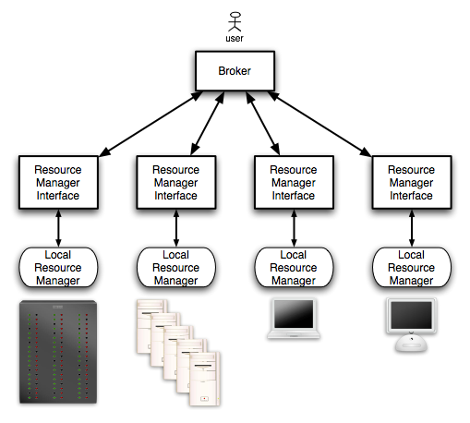

Figure 1. Example of a scheduling infrastructure for Enterprise Grids

In this scenario we have a centralized scheduling architecture; i.e. a central scheduling instance is the single access point to the whole infrastructure and manages directly the scheduling instances that interact directly with the local resource managers (see Figure 1). Every user must submit jobs to this centralized entity.
This architecture can guarantee scheduling decisions in short times, because it does not need to split the problem into sub-problems, to aggregate the decisions, or to forward it to different scheduling instances.

Example 2: High Performance Computing Grids represent a scenario in which different computing sites, e.g. scientific research labs, collaborate for joint research. Here, compute- and/or data-intensive applications are executed on the participating HPC computing resources that are usually large parallel computers or cluster systems. The total number of participating sites in such a Grid is commonly in the range of tens or hundreds; the available number of processing nodes is in the range of thousands. In this case the resources are part of several administrative domains, with their own policies and rules.

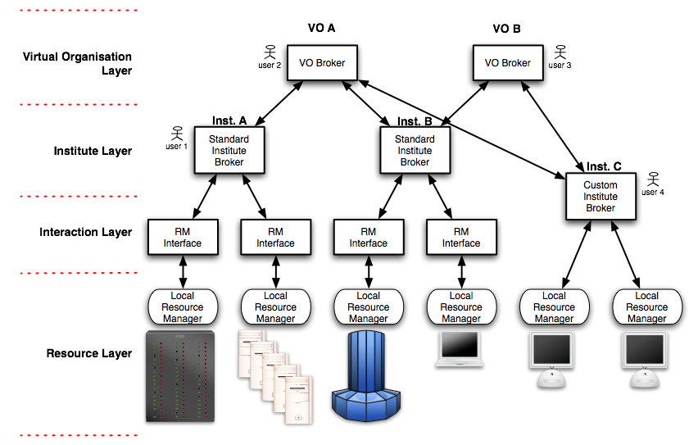

Figure 2. Example of a scheduling infrastructure for HPC Grids

In the scenario pictured in Figure 2 we have several institutes that share resources to build an HPC Grid. The institutes may organize their own resources in a centralized infrastructure, while the different institutes are connected through Virtual Organizations in a hierarchical way to build a specific VO scheduling architecture. Every instance on the institute layer can interact with instances in the relevant institute or the responsible instance on the Virtual Organisation layer, depending on the user’s affiliation. Please note that no topology is enforced with respect to the possible interactions between the different entities.
A user can submit jobs to the scheduling instances at institute or VO level. The scheduling instances can split a scheduling problem into several sub-problems, or forward the whole problem to different scheduling instances in the same VO.
This infrastructure is fault tolerant, but the hierarchical behaviour can impose a serious performance limit if the number of institutes or VO increases.

Example 3: Global Grids might comprise all kinds of resources, from single desktop machines to large-scale HPC machines, which are connected through a global Grid network.

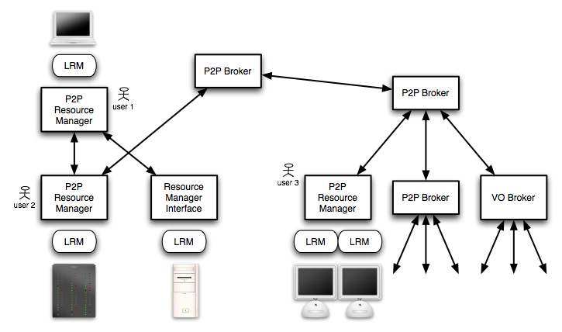

Figure 3. Example of a scheduling infrastructure for Global Grids

This scenario is the most general one, covering both cases illustrated above and introducing a fully decentralized architecture. Every scheduling instance can accept jobs to be scheduled, as Figure 3 depicts.
Like in Peer-to-Peer systems, the fault tolerance is high, but the time needed to find a solution to a scheduling problem can be long and unpredictable

It is possible to consider the different blocks in the previous examples as particular implementations of a more general software entity called scheduling instance. In this context, a scheduling instance is defined as a software entity that exhibits a standardised behaviour with respect to the interactions with other software entities (which may be part of a GSA implementation or external services). Such scheduling entities cooperate to provide, if possible, a solution to scheduling problems submitted by users, e.g. the selection and planning of resource allocations for a job.

The scheduling instance is the basic building block of a scalable, modular architecture for scheduling tasks/jobs/workflows/applications in Grids. Its main function is to find a solution to a scheduling problem that it receives via a generic input interface. To do so, the scheduling instance needs to interact with local resource management systems that typically control the access to the resources. If a scheduling instance can find a solution for a submitted scheduling problem, the generated schedule is returned via a generic output interface.

From the examples depicted above it is possible to derive a high level model of operations for a generic set of cooperating scheduling instances. To provide a solution to a scheduling problem, a scheduling instance can exploit several options:

- It can try to solve the whole problem by itself interacting with local resource managers that it is able to interact with.

- If it can partition the problem in several sub-problems, it can try to:
  - solve some of the sub-problems, if possible,
  - forward the unsolved sub-problems to independent scheduling instances,
  - wait for potential solutions coming from other scheduling instances, or
  - aggregate localised solutions to find a global solution for the original problem.

- If it cannot partition the problem or cannot find a solution by aggregating sub-problem solutions, it has two options:
- it can report back that it cannot find a solution or
- it can
  - try to forward the whole problem to another, different scheduling instance or
- wait for a solution to be delivered by the instance the problem has been forwarded to.

A generic Grid Scheduling Architecture will need to cover these behaviours, but actual implementations do not need to implement all of them. This model of operations is clearly modular, and permits to implement several scheduling infrastructures, like the ones depicted in the following examples.

From the previous examples we can infer that a generic scheduling instance can exhibit the following abilities:

- interact with local resource managers;
- interact with external services that are not defined in the Grid Scheduling Architecture, like information, forecasting, submission, security or execution services;
- receive a scheduling problem (from other scheduling instances or external submission services), calculate a schedule, and return a scheduling decision (to the calling instance or an external service);
- split a problem in sub-problems, receive scheduling decisions and merge them into a new one;
- forward problems to other scheduling instances.
However, an instance might exhibit only a subset of such abilities. This depends on its interactions with other instances/services and its expected behaviour (e.g. the ability to split and/or forward problems).
If a scheduling instance is able to cooperate with other instances, it must exhibit the ability to send problems or sub-problems, depending on the case, and receive scheduling results. Looking at such an instance, we call higher level instances the ones that are able to directly forward a problem to that instance, and lower level instances the ones that are able to directly accept a problem from that instance. A single instance must act as a decoupling entity between the actions performed at higher and lower levels: it is concerned neither with the previous instances through which the problem flows (i.e. it has been submitted by an external service or forwarded by other instances as a whole problem or as a sub-problem), nor with the actions that the following instances will undertake to solve the problem. Every instance will need to know just the problem it has to solve and the source of the original scheduling problem that helps to resolve, to avoid potential forwarding issues.

From a component point of view abilities as described above are expressed as interfaces. In general, the interfaces of a scheduling instance can be divided in two main categories: functional interfaces and non-functional interfaces. The former are necessary to enable the main behaviours of the scheduling instance, while the latter are concerned with the management of the instance itself (creation, destruction, status notification, authorization, etc.).
We want to highlight that we considered only the functionalities that must be directly exploited to support a general scheduling architecture; for example, security services are from a functional point of view not strictly needed to schedule a job, so they are considered external services or non-functional interfaces.

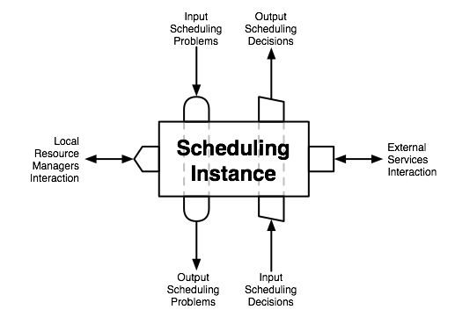

Figure 4. Functional interfaces of a scheduling instance

The functional interfaces that a scheduling instance can expose are depicted in Fig. 4 and in detail described in the following:

- Input Scheduling Problems Interface: The methods of this interface are responsible to receive a description of a scheduling problem that must be solved, and start the scheduling process. This interface is not intended to accept jobs directly from users; rather an external submission service (e.g. portal or command line interface) can collect the scheduling problems described with a user-defined formalism, validate them and produce a neutral representation accepted as input by this interface. In this way, this interface is fully decoupled from external interactions and can be exploited to compose several scheduling instance as in the examples illustrated above, where an instance can forward a problem or submit a sub-problem to other instances using this interface.
Every scheduling instance must implement this interface.

- Output Scheduling Decisions Interface: The methods of this interface are responsible to communicate the results of the scheduling process started earlier with a problem submission. Like the previous one, this interface is not intended to communicate the results directly to a user, rather to a visualization/reporting service. Again, we can exploit this decoupling in a modular way: if an instance received a submission from another one, it must use this interface to communicate the results to the submitting instance.
Every scheduling instance must implement this interface.

- Output Scheduling Problems Interface: If an instance is able to forward a whole problem or partial ones to other scheduling instances, it needs the methods of this interface to submit the problem to lower level instances.

- Input Scheduling Decisions Interface: If an instance is able to submit problems to other instances, it must wait until a scheduling decision is produced from the one which the problem was submitted to. The methods of this interface are responsible for the communication of the scheduling results from lower level instances.

- Local Resource Managers Interface: The final goal of a scheduling process is to find an allocation of the jobs to the resources. It means that sooner or later the whole process has to interact with local resource managers to allocate the jobs to the resources. While some scheduling instances can be dedicated to the “routing” of the problems, others interact directly with local resource managers to find suitable schedules, and propagate the answers in a neutral representation back to the entity that submitted the scheduling problem.
Different local resource managers can require different interaction interfaces.

- External Services Interaction Interfaces: If an instance must interact with an entity that is neither a local resource manager nor another scheduling instance, it needs an interface that permits to communicate with that external service that is exploited by the scheduling architecture. For example, some instances may need to gain access to information, billing, security and/or performance predictor services.
Different external services can require different interaction interfaces.

It is not in the context of this work to define exactly the interfaces described above, their interactions and the relative communication protocols. However, the implementation of efficient Grid scheduling systems and strategies requires interaction with many Grid services that provide the core functionalities. Therefore, the existence of certain information, protocols, services and functionalities is required to build an efficient Grid scheduling architecture that allows the implementation of different Grid scheduling strategies. In the following the corresponding requirements are defined and ordered with respect to the service type they refer to. Those requirements have been identified in discussions within the GSA research.

Note that the following requirements on functionalities are focused on the parts which are relevant for Grid scheduling. That is, it is not the task of this document to collect all general requirements for certain Grid services or protocols. There are several solutions available in the community, and there are several groups working on the definition of certain services and protocols within the GGF. This collection is intended to provide input to these activities in order to improve the design and implementation of Grid scheduling services in the future.

Information Service
Relevant to Grid Scheduling:
- Coherent access to static and dynamic information.
- Dynamic information including data about planned or forecasted future events:
  - e.g.: existing reservations, scheduled tasks, future availabilities
  - not available by most current implementations
- Privacy concerns have to be considered:
  - not all of the information can be made available
  - but depersonalised information would help also
- Information service should also cover resource types as network and data resources.
- Access to historic information is useful:
  - e.g. for scheduling strategies that make predictions

Job/Workflow/Requirement Description
Relevant to Grid Scheduling:
- Access to information about the job specifics (what is the job?)
- and job requirements (what is required for the job?).
- Need for workflow description:
  - the Grid scheduler should be able to schedule a whole workflow
  - e.g. DAG formulation

Resource Requirements Description
Resource Requirements Description contents & scope
R1. Resource requirements description for a given Grid job MUST contain all requirements that must be satisfied by Grid resources in order to run this job.
R2. Requirements description language MUST allow expressing requirements concerning various levels of detail and aspects of Grids (e.g. resource parameters such as free memory as well as more high-level metrics such as time, cost, reliability etc.)
R3. Resource requirements description MUST contain means for definition of requirements with regard to co-allocation of resources for distributed jobs (which run on multiple clusters/computers). Resource requirements for total (aggregated) amounts of resources as well as for distinct nodes MUST be allowed.
R4. Requirements description language MUST/SHOULD enable users to define their preferences in the form of business objectives. In this way a user could require not only a machine with at least certain amount of memory but also a machine with as large memory as possible, i.e. asking a scheduler to maximize the amount of memory of the selected machine).
R5. Requirements description language MUST/SHOULD enable users to specify required guarantees (e.g. requested reservation of resources for requested time period).

Resource Requirements Description Language features
R6. Requirements description language MUST be extensible (i.e. it MUST be possible to specify requirements concerning arbitrary metrics rather than limiting them to a pre-defined set).
R7. It MUST be well structuralized language in order to allow precise definition of expressions and easy automated processing by Grid entities.
R8. It SHOULD be possible to be edited by humans, i.e. not to complex to enable advanced users to define requirements using this language directly (at least for basic functionality)?

Relation to other descriptions/languages
R10. It MUST be possible to be referenced or included by other descriptions such as job and workflow descriptions. For instance, a workflow language MUST be able to refer to particular sets of resource requirements in definitions of single workflow nodes.
R11. It SHOULD allow using various constraint definition languages and arithmetic expressions languages (e.g. standard languages if ones are available).

Resource Discovery
Relevant to Grid Scheduling:
- For large scale Grids it is not feasible to search and analyze all available resources.
- Therefore, a flexible and scalable way to discovery “good” resources is necessary:
  - this should include a flexible parameterization of the search
  - e.g. support for giving prioritised information of resources
  - limit and steer the search
  - ability to request resources iteratively
- Consolidated interface to support systems with index services as well as peer-to-peer approaches.

Reservation Management/Agreement and Negotiation
Relevant to Grid Scheduling:
- Interaction between scheduling instances, between resource/agreement providers and agreement initiators (higher-level scheduler).
- Access to tentative information necessary.
- Consider that negotiations might take very long.
- Individual scheduling objectives to be considered.
- Probably market-oriented and economic scheduling needed.
- Such approaches often require many negotiation steps.
- Need for combining agreements from different providers.
- Coordinate complex resource requests or workflows.
- Maintain different negotiations at the same time.
- Probably several levels of negotiations, agreement commitment and reservation.

Accounting and Billing
Relevant to Grid Scheduling:
- Access/interface to budget information-
- Charging for allocation, reservations; preliminary allocation of budgets.
- Refunding in terms of resource/SLA failure, re-scheduling etc.

The job history, user identity, input data, output data, and charging algorithms must be tracked and leveraged over the life of the workflow. This requires aggregating monitoring information over several different resources. At the lowest level, providers must exist to acquire the needed information from Grid resources. At the highest level, Grid schedulers must be able to query accounting services for historical information about jobs as well as users. One approach to achieve this is described by the RUS- WG [1]. This specification describes a means of tracking usage on Grid resources. For more robust meta-scheduling, another service is required to track data and resolve namespace issues.

Job Management
Relevant to Grid Scheduling:
- Link to execution services to fulfill scheduled allocations.
- Establish feedback mechanism/notifications on failures of resources or job execution.
- Interface to cancel or modify scheduled job executions.
- Need for monitoring of the agreement and execution status.

Monitoring
Relevant to Grid Scheduling:
- Monitoring of:
  - resource conditions,
  - agreements,
  - schedules,
  - program/job execution,
  - SLA conformance,
  - workflow status.

Interaction with Data Management
Relevant to Grid Scheduling:
- Access to information about the location of data sets.
- Information about transfer costs.
- Maintaining schedules about planned/future data transfers and data availabilities.
- Coordination with network or other resources.
- Data management has many similarities with general grid scheduling:
  - access to similar services
  - similar tasks to execute
  - interaction necessary

Interaction with Network Management
Relevant to Grid Scheduling:
- Necessary for many other application scenarios:
  - efficient data management
  - telecommunication/videoconferencing etc.
- Aspects are similar to the previously mentioned requirements:
  - access to predicted or planned future allocations (e.g. bandwidth predictions)
  - negotiation, reservation and provisioning of SLAs
- More difficult is the identification of responsible service-level providers:
  - end-to-end or
  - individual setup of routes (how to find, how to negotiate)

Interaction with Performance Prediction
Relevant to Grid Scheduling:
- In general, prediction of a future behaviour of
  - Grid jobs
  - Grid infrastructure
- Prediction of the following values
  - job execution times
  - job start times
  - job resource requirements, e.g. memory, disc space etc.
  - resource characteristics, e.g. free memory, CPU load etc.
  - other?
- Providing metrics useful for estimation of possible prediction errors

Functional requirements
R1. A performance prediction system MUST provide prediction of future behaviour of Grid jobs and Grid infrastructure.
R2. The following estimated values MUST/SHOULD be provided by a performance prediction system:
  - job execution times
  - job start times (e.g. queue waiting times)
  - job resource requirements, e.g. memory, disc space etc.
  - resource state, e.g. free memory, CPU load etc.
R3. A performance prediction system MUST/SHOULD provide metrics useful for estimation of possible prediction error, e.g. standard deviation, variance, minimal & maximal values etc.
R4. A performance prediction system SHOULD handle queries concerning multiple jobs and/or resources at the same time (among others for performance reasons).
R5. A performance prediction system SHOULD be able to provide predictions for an arbitrary time moment in the future (e.g. particular hour, days of the week etc.).
R6. Predictions SHOULD be calculated on the basis of an input consisting of a job description, state of resources, and historical data (gathered knowledge).

Non-functional requirements
R7. The system SHOULD provide predictions even if descriptions of jobs and/or resources are incomplete.
R8. The system SHOULD provide relatively low rate of prediction errors (low enough to improve overall performance taking the advantage of performance prediction).
R9. Answer of the performance prediction system SHOULD be relatively fast compared to a duration of jobs.

Grid Scheduling Architecture and OGSA

Editor Information
Philipp Wieder
Research Centre Jülich
Central Institute for Applied Mathematics
52425 Jülich, Germany
ph.wieder@fz-juelich.de

Ramin Yahyapour
Computer Engineering Institute
University Dortmund
44221 Dortmund, Germany
Ramin.yahyapour@udo.edu

Nicola Tonellotto
Information Science and Technologies Institute
Italian National Research Council
Via G. Moruzzi 1, 56100 Pisa, Italy
nicola.tonellotto@isti.cnr.it

