Grid Scheduling Use Cases

Status of this Memo
This document provides information to the community regarding the Grid scheduling use case scenarios used in the definition of a Grid Scheduling Architecture (GSA-RG). Distribution of this document is unlimited. This is a DRAFT document and continues to be revised.

Abstract
Grids will provide a large variety of complex services. The interactions of those services require an extensible and integrated resource management. Although such a coordinated scheduling of services is currently not readily available. Access to resources is typically subject to individual access, accounting, priority, and security policies of the resource owners. Those policies are typically enforced by local management systems. Therefore, an architecture that supports the interaction of independent local management systems with higher-level scheduling services is an important component for Grids. Further, user of a Grid may also establish individual scheduling objectives. Future Grid scheduling and resource management systems must consider those constraints in the scheduling process. Taking into account different policies is also important for the implementation of various economic and business models.
The goal of the Grid Scheduling Architecture research group (GSA-RG) is to define a scheduling architecture that supports cooperation between different scheduling instances for arbitrary Grid resources. Considered resources include network, software, data, storage and processing units. The research group will particularly address the interaction between resource management and data management. Co-allocation and the reservation of resources are key aspects of the new scheduling architecture, which will also include the integration of user or provider defined scheduling policies.
The group will begin with identifying a set of relevant use-cases based on experiences obtained by existing Grid projects. Then, it will determine the required components of a modular scheduling architecture and their interactions.


GLOBAL GRID FORUM
office@gridforum.org
www.ggf.org

Full Copyright Notice
Copyright © Global Grid Forum (2003). All Rights Reserved.
This document and translations of it may be copied and furnished to others, and derivative works that comment on or otherwise explain it or assist in its implementation may be prepared, copied, published and distributed, in whole or in part, without restriction of any kind, provided that the above copyright notice and this paragraph are included on all such copies and derivative works. However, this document itself may not be modified in any way, such as by removing the copyright notice or references to the GGF or other organizations, except as needed for the purpose of developing Grid Recommendations in which case the procedures for copyrights defined in the GGF Document process must be followed, or as required to translate it into languages other than English.
The limited permissions granted above are perpetual and will not be revoked by the GGF or its successors or assigns.
This document and the information contained herein is provided on an "AS IS" basis and THE GLOBAL GRID FORUM DISCLAIMS ALL WARRANTIES, EXPRESS OR IMPLIED, INCLUDING BUT NOT LIMITED TO ANY WARRANTY THAT THE USE OF THE INFORMATION HEREIN WILL NOT INFRINGE ANY RIGHTS OR ANY IMPLIED WARRANTIES OF MERCHANTABILITY OR FITNESS FOR A PARTICULAR PURPOSE.

Intellectual Property Statement
The GGF takes no position regarding the validity or scope of any intellectual property or other rights that might be claimed to pertain to the implementation or use of the technology described in this document or the extent to which any license under such rights might or might not be available; neither does it represent that it has made any effort to identify any such rights. Copies of claims of rights made available for publication and any assurances of licenses to be made available, or the result of an attempt made to obtain a general license or permission for the use of such proprietary rights by implementers or users of this specification can be obtained from the GGF Secretariat.
The GGF invites any interested party to bring to its attention any copyrights, patents or patent applications, or other proprietary rights which may cover technology that may be required to practice this recommendation. Please address the information to the GGF Executive Director (see contact information at GGF website).
Contents
1 Introduction 5
2 Scheduling in Loosely-Coupled Grids with GridWay 6
2.1 Summary 6
2.2 Customers 6
2.3 Scenarios 7
2.4 Involved resources 8
2.5 Functional requirements 8
2.6 Workflow of Scheduling Process 9
2.7 Involved Scheduling Components/Services 9
2.8 Failure Considerations 14
2.9 Security Considerations 14
2.10 Accounting Considerations 14
2.11 Performance Considerations 14
2.12 Use case Situation Analysis 15
2.13 References 15
3 Editor Information 16

Introduction
One of the first milestones of the GSA-RG’s charter is the identification of relevant use-cases for Grid scheduling.
This document is a collection of the use case scenarios contributed by GSA-RG participants or solicited from others.
Based on this document the GGSA-RG will identify and specify common requirements to support the creation of Grid schedulers which serve the use-cases. This information will be used to identify components, services and protocols for a Grid scheduling architecture. Services and protocols from other GGF groups are considered as potential basic building blocks of such an architecture and will be used wherever possible.
Note, that it is not the task of the Research Group to define protocols or algorithms. Instead, the RG identifies the requirements for Grid scheduling, designs a suitable Grid scheduling architecture including existing services as well as currently missing components and their interaction.

Scheduling in Loosely-Coupled Grids with GridWay

Summary
In spite of the great research effort made in Grid computing, application development and execution in the Grid continue requiring a high level of expertise due to its complex nature. In a Grid scenario, a sequential or parallel job is commonly submitted to a given resource by manually performing all the scheduling steps.
Moreover, one of the most challenging problems that the Grid computing community has to deal with is the fact that Grids are highly dynamic environments. An application should be able to adapt itself to rapidly changing resource conditions, namely: high fault rate and dynamic resource availability load and cost.
Therefore, in order to obtain a reasonable degree of both application performance and fault tolerance, a Grid scheduler must be able to adapt a given job according to the availability of the resources and the current performance provided by them. GridWay [GW] is a Globus-based submission framework that allows an easier and more efficient execution of jobs on such dynamic Grid environments. GridWay automatically performs all the job scheduling steps, provides fault recovery mechanisms, and adapts job scheduling and execution to the changing Grid conditions.

Customers
This use-case is intended for average Grid users, who mainly execute on the Grid compute-intensive stand-alone jobs with no special requirements, and high throughput computing applications. These jobs/tasks can be both parallel and sequential. The are two kinds of costumers, each one devoted to:
- Execution: The scheduler should provide an easy and efficient way to execute jobs on a Grid. The user specifies the Grid job through a job template, which contains all the necessary parameters for its execution in a submit & forget fashion. The underlying scheduling and execution system, automatically performs all the job scheduling steps, and watches for its correct and efficient execution.
- Development: Grid developers need an interface to distributed applications among Grid resources. These distributed applications consist mainly in communicating jobs that follow typical distributed paradigms like: asynchronous embarrassingly distributed, master worker, or complex workflows. The Distributed Resource Management Application API (DRMAA) [DRMAA] specification constitutes a homogenous interface to different Distributed Resource Management Systems (DRMS) to handle job submission, monitoring and control, and retrieval of finished job status. In this way, DRMAA could aid scientists and engineers to express their computational problems by providing a portable direct interface to DRMS.

Scenarios
We first describe the main characteristics and assumptions made about the scheduling scenario dealt by GridWay. There exist different kinds of Grids, form tightly-coupled environments, being dedicated to the execution of high-performance applications, to loosely-coupled systems, dedicated to the execution of high-throughput and complex applications. We focus on computational Grid infrastructures, build up from uncoupled resources and interconnected by high-latency public networks, dedicated to the execution of high-throughput applications, which could be MPI-coded, and complex workflows, which consist of transformations performed on the data.
These Grid environments inherently present the following characteristics:
- Multiple administration domains and autonomy
- Heterogeneity
- Scalability
- Dynamism or adaptation
These characteristics completely determine the way that scheduling and execution on Grids have to be done. For example, scalability and multiple administration domains prevent the deployment of centralized resource brokers, with total control over client requests and resource status. On the other hand, the dynamic resource characteristics in terms of availability, capacity and cost, make essential the ability to adapt job scheduling and execution to these conditions. Finally, the management of resource heterogeneity implies a higher degree of complexity.
From the user point of view, we assume the following application model:
- Executable file: The executable must be compiled for the remote host architecture. The scheduler should provide a straightforward method to select the appropriate executable for each host.
- Input files: These files are staged to the remote host. The scheduler should provide a flexible way to specify input files and supports Parameter Sweep like definitions. Please note that these files may be also architecture dependent.
- Output files: These files are generated on the remote host and transferred back to the client once the job has finished.
- Standard I/O streams: The Standard Input file is transferred to the remote system previous to job execution. Standard Output and Standard Error streams are also available at the client once the job has finished.
- Re-start files: Restart files are highly advisable if dynamic scheduling is performed. User-level checkpointing managed by the programmer must be implemented because system-level checkpointing is not possible among heterogeneous resources.
In addition the user must specify a set of job requirements, and a ranking criterion (see Section 2.7 below). Also, it is possible for the application to generate a performance profile as a registry of its activity (see Section 2.11 below).

Involved resources
This use case focuses on computational resources. In the present context we adopt a rather simple management of storage resources, but more advanced techniques (like third-party transfers, meta-data catalogues, access to online databases…) could be possible.

Functional requirements
- Support for adaptive scheduling: Given the dynamic characteristics of Grid environments, it is necessary to periodically re-evaluate the schedule initially performed. So, the schedule can be dynamically adapted to the available resources and their characteristics, normally considering the number of pending and running jobs, and the history profile of completed jobs. Adaptive scheduling has been widely studied in the literature, and it has been demonstrated that periodic re-evaluation of the schedule can result in significant improvements in both performance and fault tolerance.
- Support for adaptive execution: Additionally, it could be necessary to migrate running applications to more suitable resources. Adaptive execution can improve application performance by adapting it to the dynamic availability, capacity and cost of Grid resources. In this case the overhead induced by job migration is the key issue that must be considered. Migration is commonly implemented by restarting the job on the new candidate host. Therefore, the job should generate restart files at regular intervals in order to restart execution from a given point. However, for some application domains the cost of generating and transferring restart files could be greater than the saving in compute time due to checkpointing. Hence, if the checkpointing files are not provided the job is restarted from the beginning. In order not to reduce the number of candidate hosts where a job can migrate, the restart files should be architecture independent.
- Support for self-adaptive applications: An application could take decisions about resource selection as its execution evolves, and provide its own performance activity to detect performance slowdown.
- Fault tolerance: Job failures should be automatically detected, allowing the user to abort or retry it execution or automatically migrating it to a new machine.
- Log information: Most relevant information about the jobs should be obtained from several log files.
- Unix-like command interface: Commands should be very similar to those found on Unix systems and resource management systems like PBS or SGE. Users should be able to submit, kill, migrate, watch and wait for jobs or array of jobs.
- Programming interface: DRMAA should be supported to develop distributed applications.
- Use of standard Grid services: It should be based on the functionality provided by Globus basic services [GLOBUS]:
  - Grid security infrastructure: GSI
  - Grid execution service: GRAM
  - Grid information service: MDS
  - Grid file transfer service: GridFTP
- Extensibility and adaptability of the functionality: the architecture should be modular in order to support different middleware versions (middleware access driver and wrapper modules for access Grid execution services, resource selector module for access Grid information services, prolog/epilog modules for access Grid file transfer services). Moreover, the architecture should be decentralized, allowing to be deployed as a client tool.

Workflow of Scheduling Process
In a Grid scenario, a sequential or parallel job is commonly submitted to a given resource by taking the following path [GGF]:
- Resource discovery and selection: Based on a set of job requirements, like operating system or platform architecture, a list of appropriate resources is obtained by accessing to an information service mechanism. Then a single resource is selected among the candidate resources in the list.
- Preparation: The selected host is prepared for job execution. This step usually requires staging executable of input files.
- Submission and migration: The job is submitted to the selected resource. However, the user may decide to restart its job on a different resource, if a performance slowdown is detected or a better resource is discovered.
- Monitoring: The job evolution is monitored over time.
- Termination: When the job is finished, its owner is notified and some completion tasks, such as output file staging and cleanup, are performed.

Involved Scheduling Components/Services
The core of the GridWay framework [SPE] is a personal submission agent that performs all submission stages and watches over the efficient execution of the job. Adaptation to changing conditions is achieved by dynamic rescheduling. Once the job is initially allocated, it is rescheduled when performance slowdown or remote failure are detected, and periodically at each discovering interval. Application performance is evaluated periodically at each monitoring interval by executing a performance evaluator program and by evaluating its accumulated suspension time. A resource selector module acts as a personal resource broker to build a sorted list of candidate resources.
The submission agent consists of the following components:
- Request manager (RM): To handle client requests.
- Dispatch manager (DM): To perform job scheduling.
- Submission manager (SM): To execute and migrate jobs and monitorize its correct execution
- Performance monitor (PM): To evaluate the job performance.
The flexibility of the framework is guaranteed by a well-defined API (Application Program Interface) for each submission agent component. Moreover, the framework has been designed to be modular to allow adaptability, extensibility and improvement of its capabilities. The following modules can be set on a per job basis:
- Resource selector (RS): Used by the dispatch manager to select the most adequate host to run the job according to the host's rank, architecture and other parameters.
- Middleware access driver (MAD): Used by the submission manager to provide an interface with the underlying resource management middleware.
- Performance evaluator (PE): Used by the performance monitor to check the progress of the job (not supported in the current version).
- Prolog: Submited by the submission manager to create the job directory hierarchy on the remote machine and transfer the executable, input and restart files.
- Wrapper: Submitted by the submission manager to run the executable file and captures its exit code.
- Epilog: Submitted by the submission manager to transfer output or restart files, clean up the GASS cache and remove the job directory from the remote machine.
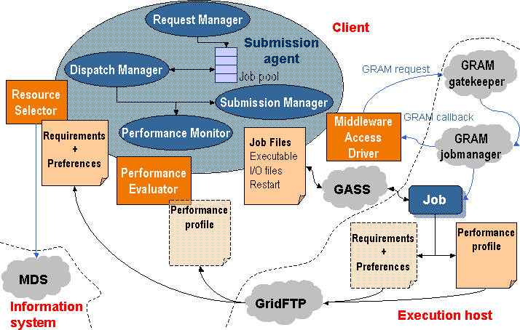
The following actions are performed by the submission agent:
- The client application uses a Client API to communicate with the request manager in order to submit the job along with its configuration file, or job template, which contains all the necessary parameters for its execution. Once submitted, the client may also request control operations to the request manager, such as job stop/resume, kill or reschedule.
- The dispatch manager periodically wakes up at each scheduling interval, and tries to submit pending and rescheduled jobs to Grid resources. It invokes the execution of the resource selector module corresponding to each job, which returns a sorted list of candidate hosts. The dispatch manager submits pending jobs by invoking a submission manager, and also decides if the migration of rescheduled jobs is worthwhile or not. If this is the case, the dispatch manager triggers a migration event along with the new selected resource to the job submission manager, which manages the job migration.
- The submission manager is responsible for the execution of the job during its lifetime, i.e. until it is done or stopped. It is initially invoked by the dispatch manager along with the first selected host, and is also responsible for performing job migration to a new resource. The Globus management components and protocols are used to support all these actions through the middleware access driver. The submission manager performs the following tasks:
  - Prologing: Preparing the RSL and submitting the prolog executable.
  - Submitting: Preparing the RSL, submitting the wrapper executable, monitoring its correct execution (as explained in subsequent sections), updating the submission states via GRAM callbacks and waiting for migration, stop or kill events from the dispatch manager.
  - Cancelling: Cancelling the submitted job if a migration, stop or kill event is received by the submission manager.
  - Epiloging: Preparing the RSL and submitting the epilog executable.
- The performance monitor periodically wakes up at each monitoring interval. It requests rescheduling actions to detect better resources when performance slowdown is detected and at each discovering interval.
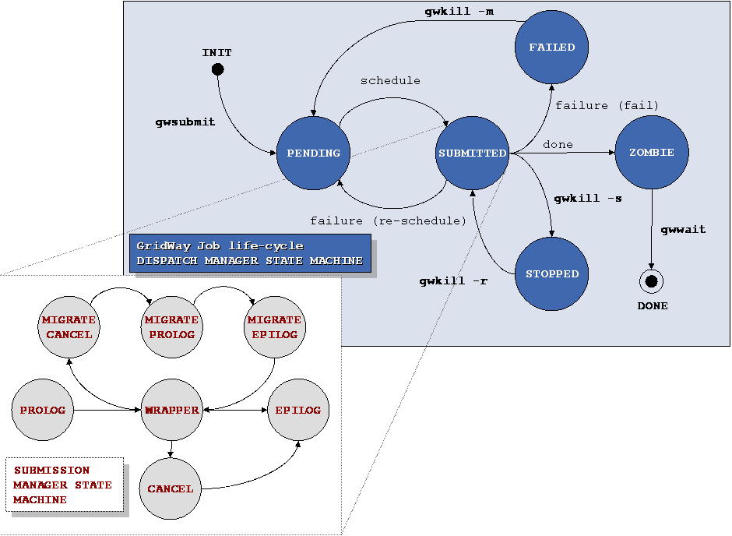
Due to the heterogeneous and dynamic nature of the grid, the end-user must establish the requirements that must be met by the target resources (discovery process) and criteria to rank the matched resources (selection process). The attributes needed for resource discovery and selection must be collected from the information services in the grid testbed, typically the Globus Monitoring and Discovery Service (MDS). Usually, resource discovery is only based on static attributes (operating system, architecture, memory size...) collected from the Grid Information Index Service (GIIS), while resource selection is based on dynamic attributes (disk space, processor load, free memory...) that can be obtained from the Grid Resource Information Service (GRIS) or by accessing the Network Weather Service.
The resource selector is executed by the dispatch manager in order to get a ranked list of candidate hosts when the job is pending to be submitted or a rescheduling action has been requested. The resource selector is a script or a binary executable, specified in the job template, which receives the parsed job template itself as an argument (so it can be easily sourced in a script) and some other needed parameters in the environment.
The resource selector module performs the following actions:
- Available compute resources are discovered by accessing the GIIS server and, those resources that do not meet the user-provided host requirements are filtered out. At this step, an authorization test (via a GRAM ping request) is also performed on each discovered host to guarantee user access to the remote resource.
- Then, the dynamic attributes of each host and the available GRAM job managers are gathered from its local GRIS server.
- This information is used by an user-provided rank expression to assign a rank to each candidate resource.
Finally, the resultant prioritized list of candidate resources is used to dispatch the job.
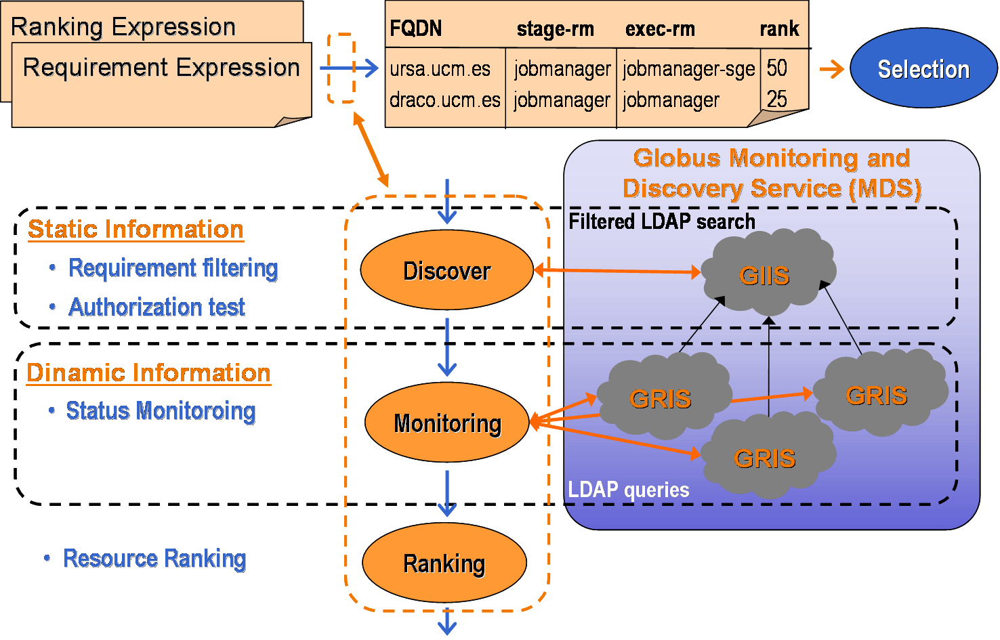
Job execution is performed in three steps by the following modules:
- Prolog: This module is responsible for creating the remote experiment directory and transferring the executable and all the files needed for remote execution, such as input or restart files corresponding to the execution architecture. These files can be specified as local files in the experiment directory or as remote files stored in a file server through a GridFTP URL. Once the files are transferred to the remote host, they are added to the GASS cache so they can be re-used if they are shared with other jobs.
- Wrapper: This module executes the submitted job and writes its exit code to standard output, so the submission agent can read it and can be used to determine whether the job was successfully executed or not. The capture of the remote execution exit code allow users to define complex jobs, where each depends on the output and exit code from the previous job. It is interesting to note that versions previous to 3.9 of the Globus Toolkit do not provide any mechanism to capture the exit code of a job.
- Epilog: This module is responsible for transferring back output files, and cleaning up the remote experiment directory. At this point, the files are also removed from the GASS cache.
File transfers are performed through a reverse-server model. The file server (GASS or GridFTP) is started on the local system, and the transfer is initiated on the remote system using Globus transfer tools (i.e. globus-url-copy command).
The prolog and epilog modules are always submitted to the fork GRAM job manager. In this way, our tool is well suited for closed systems, such as clusters, where only the front-end node is connected to the Internet and the computing nodes are connected to a system area network, so they are not accessible from the client.
Job migration is performed in the following way. The execution of the wrapper module is cancelled (if it is still running). Then, the prolog module is submitted to the new candidate resource, preparing it and transferring all the needed files to it, including the restart files from the old resource. After that, the epilog module is submitted to the old resource (if it is still available), but no output file staging is performed, it only cleans up the remote system. And finally, the wrapper module is submitted to the new candidate resource.
Briefing, the execution of jobs in three separate steps has the following advantages:
- Support for closed systems (like clusters).
- Easy and efficient way to implement job migration.
- Possibility to separately schedule transfers and executions.
- Better adjustment of job definition parameters (RSL language), as MaxCPUTime.
- Implementation of different transfer strategies (caching, compression, access to replica catalogues or online databases…) doesn’t affect the compute nodes.

Failure Considerations
GridWay provides the application with the fault detection capabilities needed in such a faulty environment:
- The GRAM job manager notifies submission failures as GRAM callbacks. This kind of failures includes connection, authentication, authorization, RSL parsing, executable or input staging, credential expiration and other failures.
- The GRAM job manager is probed periodically at each polling interval.
- The standard output of prologue, wrapper and epilogue is parsed in order to detect failures. In the case of the wrapper, this is useful to capture the job exit code, which is used to determine whether the job was successfully executed or not. If the job exit code is not set, the job was prematurely terminated, so it failed or was intentionally cancelled.
When an unrecoverable failure is detected, it retries the submission of prologue, wrapper or epilogue a number of times specified by the user and, when no more retries are left, it performs an action chosen by the user among two possibilities: stop the job for manually resuming it later, or automatically generate a rescheduling event.

Security Considerations
In a loosely coupled environment, security decisions must be performed at the resource or site level.

Accounting Considerations
The gwps and gwhistory commands provide status and accounting information about the submitted hosts. Nevertheless, in a loosely coupled environment, accounting must be performed at the resource or site level.

Performance Considerations
The framework provides two mechanisms to detect performance slowdown:
- A performance evaluator is periodically executed at each monitoring interval by the performance monitor to evaluate a rescheduling condition. Different strategies could be implemented, from the simplest one based on querying the Grid information system about workload parameters to more advanced strategies based on detection of performance contract violations. The performance evaluator is a script or a binary executable specified in the job template, which can also include additional parameters needed for the performance evaluation. A mechanism to deal with application own metrics is provided since the files processed by the performance evaluator could be dynamically generated by the running job. The rescheduling condition verified by the performance evaluator could be based on the performance history using advanced methods like fuzzy logic, or comparing the performance with the initial performance attained, or a base performance.
- A running job could be temporally suspended by the resource administrator or by the local queue scheduler on the remote resource. The submission agent takes count of the overall suspension time of its job and requests a rescheduling action if it exceeds a given threshold. Notice that the maximum suspension time threshold is only effective on queue-based resource managers.

Use case Situation Analysis
GridWay is currently available [GW] with some limitations.

References
[DRMAA] The DRMAA Working Group. www.drmaa.org.
[GGF] J. Schopf: “Ten Actions when Superscheduling”.
[GLOBUS] The Globus Alliance. www.globus.org.
[GW] The GridWay Project. www.gridway.org.
[SPE] E. Huedo, R. S. Montero, I. M. Llorente: “A Framework for Adaptive Execution on Grids”. Software: Practice and Experience 34(7): 631-651 (2004).

Editor Information

